# Decline section TOC

Chapter 1. Introduction  
Why we need to understand oil depletion. Rationale for our analysis and a motivation for analysis beyond oil.

Chapter 2. The Problem  
Who has tried to qualitatively model oil depletion? An analysis of how the current models fall short.

Chapter 3. The Premise  
What fundamental ideas do we apply? Mathematical groundwork and premise for the analysis to follow.

Chapter 4. The Facts in the Ground and Finding Needles in a Haystack.  
Where do we find oil reservoirs? Basics of modeling discovery followed by more detailed analysis.

Chapter 5. The Analysis of Growth and the Shock Model.  
When does the extraction kick in? Basics of modeling growth and decline. The main analysis for modeling production and depletion.

Chapter 6. Applying Dispersive Discovery and Reserve Growth  
How discovery affects production. Combining discovery and production as an integrated model. How estimates of oil evolve. Modifications needed to account for new and evolving information. New Bakken info described starting on p.15 in [this white paper](http://contextearth.com/wp-content/uploads/2016/05/C-diffusive_growth.pdf)

Chapter 7. The Context of Discovery and Oil Production.  
How do we simplify the search model and verify the extraction model? Supplemental analysis for modeling discovery and production.

Chapter 8. The Results.  
Which data sets support the model? Lengthy chapter on applying models to regional data.

Chapter 9. The Discussion: Alternate Consensus Approaches and Cornucopian Conundrums  
Which conditions can impact the model? Caveats to the analysis with comparison to other models. How do other pessimistic projections fit in? And how do we reconcile against optimistic analyses? Addressing alternative counter theories.

Chapter 10. An Oil Level Check and Diagnosis  
While we have gotten this far, what can we conclude? What current situation do we find ourselves in? How do recent and evolving developments figure in?

Chapter 11. The Implications and Prognosis  
Why should you believe in scientific models? Addressing concerns over modeling. What can we extrapolate for the future?

# Renewal section TOC

The second volume is a companion text and exists to explain how what was learned from the oil age will be used to a post-fossil-fuel world. This includes analysis of the most important considerations for renewable energy, alternative energy carriers, and of smart energy conservation. At the moment, both volumes are packaged together in the PDF draft and sections incorporated as needed. This is a rearranged Volume 2 TOC based on the responses of the reviewers:

Chapter 12. Introduction and Energy Transition  
Application of stochastic math beyond oil depletion. Projection of future energy demands (*not in current draft,* [*this analysis*](http://peakoilbarrel.com/the-energy-transition/))

Chapter 13. Wind energy  
How to characterize the statistics of wind variability.

Chapter 14. Solar energy   
Physics of mass-produced photovoltaics.

Chapter 15. Battery technology   
Physics of Lithium-ion batteries (*not in current draft, but in a* [*white paper*](http://entroplet.com/ref/foundation/lithium_batteries.pdf))

Chapter 16. Thermal sources   
Transport of heat

Chapter 17. Wave energy   
Characterizing waves (*not in current draft, but in a* [*white paper*](http://contextearth.com/?attachment_id=1233))

Chapter 18. Climate  
Models of climate prediction (*not in current draft, but in* [*research presentation*](http://contextearth.com/2016/11/21/presentation-at-agu-2016-on-december-12/))

Chapter 19. Travel and Terrain  
Statistics of travel. Statistics of elevation (not in current draft, but in a [white paper](http://contextearth.com/wp-content/uploads/2016/05/B-terrain_characterization.pdf))

Chapter 21. Resilience and Durability  
Building things to last, models of failure and corrosion (*new information in* [*white paper*](http://contextearth.com/?attachment_id=1234))

Chapter 22. Pollution  
Dispersion and half-life in the context of nuclear energy and pollutants.

Chapter 23. Noise and Uncertainty  
How to characterize imperfect information. An example from GPS

Chapter 24. Econophysics and Information Science  
The statistics of humans in the loop. How to best disseminate information (*not in current draft, but in a* [*white paper*](http://contextearth.com/?attachment_id=1235))

Chapter 25. Conclusion  
Wrap up of the two sections

PREFACE

About thirty years ago there was much talk that geologists ought only to observe and not theorise; and I well remember some one saying that at this rate a man might as well go into a gravel pit and count the pebbles and describe the colours. How odd it is that anyone should not see that all observation must be for or against some view if it is to be of any service!

— Charles Darwin

I began writing this book thinking that it would stay on topic. But then I started finding all sorts of supporting evidence for my original topic in other fields of natural science. Eventually I ran across this quote from Richard Feynman

“When you have put a lot of ideas together to make an elaborate theory, you want to make sure, when explaining what it fits, that those things it fits are not just the things that gave you the idea for the theory; but that the finished theory makes something else come out right, in addition.”

Volume 1 — Decline

“In any field, the Establishment is seldom in pursuit of the truth, because it is composed of those who sincerely believe that they are already in possession of it.“

— E.T. Jaynes

Volume 1 discusses aspects of oil depletion and the potential downward trajectory with respect to fossil fuel energy availability we have found ourselves on.

Volume 2 discusses positive aspects of this crisis. What we can learn from studying oil depletion we can apply to potential new opportunities in renewable energy and in interacting with our environment.

I consider myself put in the same position as a huge fraction of the world’s population. We don’t understand the nature of the fossil fuel energy crunch that has hit us, and, even if we did understand it, we may remain unconvinced of the seriousness of the situation as we will likely never see the supporting data. Having seriously searched for the bottom-line numbers, I along with many other similarly curious people realize that widely-accepted data concerning world reserves of oil simply doesn’t exist.

So why, and how, with the billions of dollars invested in the fossil fuel industry, can we not get a projection of our reality-based future?

Volume 1 — Decline. I had several objectives for my approach to modeling fossil fuel depletion:

• Introducing something fundamentally new to the discussion.

• Going beyond heuristics and empirical relationships to an more mathematical approach.

• Resurrecting some old but perhaps forgotten techniques buried in the literature.

• Using the derived formulation to historically analyze or make projections based on current data.

• Demonstrate an alternative to and weaknesses of the conventional approaches such as the logistic curve and Gaussian (questioning empiricism).

Volume 2 — Renewal. The second volume extends the analysis to alternative energy.

• Showing analogies to other physical processes, like an RC circuit in electronics or a 1st order damped system in mechanical dynamics.

• Expand on the math to model domains and application areas that will become part of our renewable energy future.

• And above all, to make sure the constituent parts fit together and don’t contradict each other.

Although the arguments contains a bit of technical math, the modeling of oil depletion derives from some very simple and fundamental concepts. I tried to attack the premise from many different angles and eventually arrived at the same conclusion each time. This adds to the level of confidence we have for the models that we lay out.

## CHAPTER 1 Introduction

Why we need to understand oil depletion

We have a relatively poor understanding for oil production trends, with much of the analysis based on heuristics and empirical data. The root of the problem resides in a simple observation: most forecasts for oil production derive from predictions for demand. In other words, industry analysts often use demand as a projection yardstick. Where we encounter elastic supplies, an increase in demand usually gets met with an increase in supply. And so we see the typical expectation level of an increasing demand met by an increasing supply of oil.

But when the unrelenting force meets the immovable object, something must give.

Engineers such as the geologist M. King Hubbert have sought to explain the finite nature of the resource. However, his explanations universally lacked a real quantitative flavor and he ended up guiding much of the work via intuition and the use of heuristics. Laherrere and Deffeyes have also done much work, essentially picking up where Hubbert left off.

These are the set of premises that we apply:

1. Accelerating growth in technology and human consumption. The growth in consumption eventually leads to diminishing returns of supplies. We can explain this in terms of both micro and macro effects.
2. We sweep the volume of the earth's crust to explain past and future oil discoveries and the possibility of reserve growth. We can understand the problem by incorporating the concept of dispersion, which amounts to varying the rates of search with time and geographical region.
3. Production dynamics and the effects of perturbations. We present the shock model as an intuitive way of analyzing the situation.

If we want to understand the problem, we need to bridge the separation between the mathematical abstraction of economic/human flows and that of geology. Ideally, we could discuss the flow of an arbitrary material and the math concepts would remain nearly the same as modeling oil extraction.

Of course, we can describe or emulate anything we want by applying empirical methods not backed by theory (what we call heuristics), we still have no universally accepted theory. For instance, all the economists that try to predict when or whether we come out of a recession, or estimate GDP growth, work essentially with one hand tied behind their back without the benefit of a good oil depletion theory. The lack of that theory constitutes the problem and the steps outlined above provides a solution from which we can derive analytic and quantitative predictions and trends. This perspective comes from drawing on basic first principles of math, probability, and statistics.

Industry estimates often trend on the optimistic side. What we want to do is explain in depth how this analysis came about and the mathematics behind it. As it is often difficult to determine what the industry or government base their numbers on, having an independent analysis is vital for future estimates.

Concerning oil depletion, we know that three things will happen in sequence.

1. Conventional oil reserves will peak.
2. Conventional oil reserves will decline.
3. Extraction and use of oil will become counter-productive and expensive.

The dates of these events remain unknown.[1](#0_pgfId-914849)

Given those rather safe assertions and the underlying timing uncertainty, the premise is that we can *understand* oil depletion via mathematics. Fortunately, nothing in the oil discovery, extraction, or production process relies on esoteric math models; thus, basic intuition paves the way for a deeper understanding. At most, the modeling comprises a set of pragmatic probability considerations which approaches the practical equivalent of a statistical bean-counting exercise. Indeed, some of the problem-solving approaches are no more difficult than estimating how many jelly-beans are in a jar. Such relative simplicity gives us confidence that we can make some headway in modeling the global oil life-cycle.

To get a handle on the entire life-cycle of oil, we break it down into three components that we can be handled individually: *growth*, *discovery*, and *extraction*.

The first component drives the whole process. Intuitively, we need a rate function that describes how fast technology and consumption pressure stimulates the search and extraction process. This rate can either accelerate in cases of restraint-free growth or perhaps decelerate if we hit the law of diminishing returns.

The second component describes the search for undiscovered reserves. The basic premise describes a hard constraint – that we have a finite search space to deal with. There are approximations that we can make given that the volume is not precisely known but this sets a target and foundation to work from.

The last of the three components describes the extraction process. Extraction can only happen after a discovery occurs. The basic premise is that we can separate it sequentially from the discovery process and so incorporate the extraction as an independent process. The implication is that that we can create models of these processes independently and then combine them later.

Although the components of growth, discovery, and extraction remain largely independent (mathematicians refer to these as *orthogonal* components), we suggest that the role of basic human need for energy provides a consistent stimulus, thereby projecting the model forward from the basic premise. The human need for energy is essentially like an unrelenting consumer demand which provides the impetus for growth. So, the outputs of extraction (i.e. cheap energy) form the supply for supply and demand model.

For modeling, it is important to establish that demand remains consistent over time. So even though conservation and efficient uses of oil has improved since the oil shock of the 70's and 80's, the fact that inflation-adjusted prices have remained constant implies that demand of the same order-of-magnitude exists. And that a cheap supply spurring technology growth has in turn consistently promoted demand. For the USA, oil still doesn't cost us much to use in practical terms. We still see the same price-based consumer buying decisions that we always have. Which means that we can draw a straight-line from the early days of oil consumption until now, and use essentially similar math. Therefore, demand becomes an invariant as described in mathematical terminology[[1]](#footnote-1). So, the lack of a universal paradigm shift in fossil fuel consumption practices allow us to apply perturbations to the analysis to discover how scenarios such as current and future oil price shocks might play out.

This set of premises may exist as tacit knowledge but we spell them out to establish our working model. ~~Extracting any kind of knowledge from industry insiders remains one of the most frustrating problems we face.~~ By pulling together a model describing the entire life-cycle, we hope to codify and make explicit this perhaps implicit information that may not be widely known. As an oil industry optimist had to say: "*Here it is pertinent to note that peak oil forecasters do not enjoy an undiluted view of the state or corporate portfolios that contain these internal and hidden assessments which their models logically require*” [Clarke 2007]

That basically outlines the entire premise of dispersive discovery and the oil shock model that we will explore. It basically says find as much as you can while you can, and turn on the taps as much as they can handle.

Granted that we may hit a peak in oil consumption (or have already), the conventional wisdom holds that this peak to look symmetric on the way up as well as on the way down. This leads to the familiar "bell-shaped" curve of peak oil. Shell Oil geologist King Hubbert in the late 1950's sketched a largely symmetric bell curve to reinforce the idea that maximum oil production would naturally and eventually occur.

The outcome of a symmetric curve has consequences for the pessimists and the cornucopians alike. By inspection one can see that the 50% consumption point obviously occurs at the peak for purely symmetric profiles such as the Logistic curve and Gaussian normal. This rule for depletion has in fact become the conventional wisdom among certain analysts, dating back to Hubbert. On the pessimistic side, it means that we have used half our oil at peak. On the cornucopian side, it means we still have half of the oil left. Yet, only some models of oil depletion assume a symmetric production profile, our model makes no such assumption.

Figure 1 The classically symmetric Hubbert Bell curve

The following argument implies that economic forces can extend the curve into asymmetric territory.

William L. Fisher, director of the school of geosciences at the University of Texas at Austin, contends that application of the Hubbert curve for resource assessment or for projection of production peaks is seriously flawed.

*It assumes that the amount of oil or gas is known, which it is not. It assumes that the peak will come midway through the production of the resource, thus the symmetry of the curve, which is not necessarily the case. It also assumes that resources are inelastic, not responding measurably to economics and technology.*

<http://www.ogj.com/display_article/182316/7/ARCHI/none/none/1/Debate-grows-over-US-gas-supply-crisis-> as-harbinger-of-global-gas-production-peak/

So, it may turn out that in practical terms and only under certain circumstances, can we get the idealized symmetric curve. In the subsequent chapters, as we introduce the basic concepts for analyzing oil depletion dynamics, the presence or absence of symmetry will become apparent and thus better understood.

The comprehensive framework for oil depletion analysis described here has aspects of probability-based forecasting[6](#0_pgfId-915099). Applying probabilistic-based models results from applying reasoning in the face of uncertainty. We never have had and probably never will have perfect and complete data to accurately analyze, much less predict, the complete oil situation. Lacking this, imperfect probabilistic approaches serve us very well in our understanding of the fundamentals of oil depletion.

The following figure lays out a flowchart of the current understanding of the different phases of the oil production life-cycle. The heading row provides short names for the life-cycle phases. The top row lists some of the conventional practices used to describe the phases, primarily as a set of heuristics. Below this row appear the model interconnections, which establish the architectural foundations of the comprehensive model. Distinct stages which traverse the conventional phases of the life-cycle draw from elements of probability theory which we use to model the behavior of the phases. Several surprising outcomes derive from the application of the model. For example, we can derive the well-known Logistic heuristic and explain the field size distributions observed. Further, we can use the dynamic elements to track shocks in the production process and extrapolate into the future.

The two darkened bubbles at the baseline contain the essential probability ideas that we use for aspects of the discovery process along with the oil production model. The combined model replaces a longstanding set of heuristics that in the past have been used in analyses of the aggregated oil production life-cycle[7](#0_pgfId-915120).

As market consumers, we can imagine ourselves running out of some necessity or convenience very occasionally. Though annoying, we usually don’t worry, as we can remedy our local shortage by replenishing our supply at a local store. Occasionally, we also hear about the dire story of someone getting stuck in a precarious situation and facing a real shortage that they cannot do anything about. However, considering that we live in a technologically advanced society, we rarely find ourselves in a situation where we confront a complete and potentially long- lasting shortage. In the past, we have routinely replaced a shortage of one item with another one that served the same need. But what happens when the consumable has no replacement, and technology cannot provide an immediate solution?

That has rarely happened on a large scale before, yet we can try to understand possible scenarios. For example, how do we deal with what we would consider as necessities if they are in short supply? Invariably, the most critical of our supplies fall under the class of materials called non-renewable resources. Renewable resources differ from their non-renewable counterparts in that once a non-renewable gets consumed, it will never get recycled. If you think about it, this comprises a small portion of all our categorized resources yet a significant part that we rely on daily to maintain our lifestyles. Fortunately, most materials do not simply vanish, as enterprising individuals can always recover their constituent parts, what we commonly refer to as recycling. We can partly thank salvage yards, pawn shops, and E-bay for this mechanism. Or else the materials gradually get recycled by natural processes. Either way they get recycled, these constitute our renewable resources.

Figure The roadmap for the analysis includes reuse of simple laws

So, in terms of recycling, we find materials such as iron and gold which fit the scrap renewable category — and water and carbon which fit the naturally renewable class of materials. And then we have the broad categories of plant and animal life that biologically get recycled, with extinction events proving the sure path to non- renewal to the inhabitants of the animal and plant kingdom.

The actual list of resources that fall under the completely non-renewable category remains fairly limited in scope. One that we normally don’t think about, helium gas, essentially disappears into the ozone when we use it for just about any application, whether it frivolous (balloon toys) or critical (cryogenics). The big concern - the one that we have always worried about — hydrocarbon-based fossil fuels takes up the bulk of the remaining non-renewable resource category.

Although fossil fuels can technically become renewable, through plant and animal life interacting with geological forces, the fact that the rate of renewal takes place over the course of millions of years, makes this an inconsequential and therefore irrelevant detail. Facing the inevitable, once fossil fuels disappear, we won’t see a plug-and-play replacement reappear anytime soon. When that depletion occurs, not what happens after, has become a challenge to predict, and a concern that many people share. Unfortunately, not everyone shares this concern and, in fact, much misinformation purposely gets broadcast to obfuscate the reality of the situation.

Start the Way Back Machine.

Fossil fuels have sat in the ground, virtually untouched, for millions of years prior to the 19th century. Certainly, both liquid and vapor forms of the fuel, such as natural gas, have continuously seeped out of the ground over the ages, and people have longed used brown and black coal, but our knowledge of substantial reserves have only emerged in the last two centuries. With the help of humans that have mined or pumped it out of the ground, fossil fuels have provided a convenient combustion source for a relatively short time. In fact, humans have developed such convenient and efficient ways of combusting fossil fuel that we can quickly use up whatever we can find. Quite naturally, that free lunch cannot last forever as eventually we use up more than we can freshly discover. That and the finite nature of the resource give us the concept of “peak oil”.

So, we have the three stages of fossil fuel: the pre-history that lead up to the near simultaneous industrial discovery of oil in both hemispheres in the 1800’s, the production phase that has spanned the oil age, and the post oil age that we will eventually have to face. The first stage has become water under the bridge[[2]](#footnote-2) — although it helps a bit to understand how fossil fuels formed and how we first discovered the oil-rich regions of the world, we will never again reproduce those conditions again. So, can’t expect our oil resources to recover as a threatened animal species might. However, we can indeed learn much from the historical data and the modeling of trends describing the evolution of commercial oil production. As no better information exists, we have concentrated on the available industrial data and specifically tabulations of reserve and production estimates for this investigation.

Into the Future. We have no generally accepted model of oil depletion or the effect of constrained resources on the economy. The intensity of discussion surrounding economic theory during recessionary crises (such as the one which started in 2008) seems particularly perplexing considering this huge gap in our knowledge. So, we don’t really know how much of an impact our oil predicament has on an economic downturn, and may instead try to scape-goat the role of speculators and our financial institutions themselves. This becomes really a failure of the mainstream economists in the world, and extra fault lies with the oil companies[[3]](#footnote-3) for not releasing any data on depletion. In the greater scheme of things, obtaining detailed historical oil production data should not turn into an unknowable problem[[4]](#footnote-4).

If anyone has taken classes in subjects such as ecology, early on you learn that all freshwater lakes go through a life-cycle, from birth through death[[5]](#footnote-5). I figure that since we all have some interest in the production of oil, however transient its existence may eventually pan out, that we might as well get to know its life-cycle[[6]](#footnote-6).

So, to develop our understanding, we reformulate the problem domain. We know all the hand-wavy arguments about why oil depletion will affect us, but I contend we should recast the “why” arguments into something more formal, yet avoiding undue complexity.

1. So as a rule, we should strive to teach the first-order effects first. Just about everything in engineering relates to first -order effects. If you don’t do the first-order stuff first, you need to find a new line of work. They call it first-order for a reason.
2. We do not even necessarily need to specifically invoke geology. In other words, we use practical mathematical and probability models to represent geology. To open the entry criteria for understanding oil depletion we need to use representative analogies and abstractions from other disciplines[[7]](#footnote-7). I fear that the minute we start to appeal to higher authorities such as experts in petroleum engineering, geology, or commodity economics on understanding this stuff, we start to lose the battle.

The Questions we will attempt to answer. So far, I have covered why we need to understand oil depletion. Since the name of the book includes the word conundrum, you can imagine that we have many remaining questions that need addressing. In the rest of the text, I will answer other w’s that seem pertinent.

1. Why we need to understand oil depletion? (this chapter)
2. Who has tried to qualitatively model oil depletion?
3. What fundamental ideas do we apply to the model?
4. Where do we find oil reservoirs?
5. When does the extraction kick in?
6. How do we model the depletion of oil?
7. How do we model the discovery of oil?
8. How does discovery affect production?
9. How do estimates of oil evolve?
10. How do we simplify the search model?
11. How do we simplify the extraction model?
12. Which sets of available data support the model?
13. Which conditions can negatively (or positively) impact the model?
14. How do we reconcile against overly-optimistic oil supply analyses?
15. How do other more pessimistic projections fit into the analysis?
16. What current situation do we find ourselves trapped within?
17. What can we extrapolate for the future?
18. How can we apply this to other resources besides oil (natural gas, phosphates)?
19. While we have gotten this far, what can we conclude?
20. Why should you believe any of this?

The answers that we have historically received in response to these questions have lacked a quantitative foundation.

## CHAPTER 2 The Problem

Who has tried to qualitatively model oil depletion?

The Pioneers. To figure out a glide path, we can first look to the people that Les Magoon said seemed to care about our oil predicament. Engineers such as the geologist M.King Hubbert have sought to explain the finite nature of the resource.

However, his explanations universally lacked a real quantitative flavor and he ended up guiding much of the work via intuition and the use of heuristics. Laherrere and Deffeyes have also done much work, essentially picking up where Hubbert left off. This small group provided enough of a foundation to encourage others to kickstart an ongoing discussion. The widespread use of computers clearly has helped motivate many to analyze the situation for themselves.[[8]](#footnote-8)

So, let us understand the problem by explaining quantitatively how we got here.

1. Accelerating growth in technology and human consumption. The growth in consumption eventually leads to diminishing returns of supplies. We can explain this in terms of both micro and macro effects.
2. We sweep the volume of the earth’s crust to explain past and future oil discoveries and the possibility of reserve growth. We can understand the problem by incorporating the concept of dispersion, which amounts to varying the rates of search with time and geographical region.
3. Production dynamics and the effects of perturbations. We present the shock model as an intuitive way of analyzing the situation.

If we want to understand the problem, we need to bridge the separation between the mathematical abstraction of economic/human flows and that of geology. Ideally, we could discuss the flow of jellybeans and the math concepts would remain nearly the same as modeling oil extraction.

To the best of my knowledge, no one has tried to cast the problem in mathematically modeled terms. Not all highly regarded depletion analysts put much faith in such an approach. For example, Matt Simmons has shown similar reservations:

Moreover, generating a good quantitative approach provides needed ammunition to defend against cornucopian arguments. In addition to individual cornucopians such as Lynch and Huber, you have oil industry stalwarts such as CERA (Cambridge Energy Research Associates) who sell “insider” information and statistics to those who can afford to pay the steep price. But these people don’t do too much better:

**Impressive track record?**

It is surprising the kind of standing CERA has among politicians and the media, given their track record. If you look at the report they published in May of 2005 their forecast for 2005 was a capacity of 87.85 million b/d. Yet by the release of CERA’s October report in 2008 the 2005 figure had been revised down by 1.4 million b/d to 86,45. Not very impressive real time data.

CERA makes a big issue out of their fantastic database, that it is why their forecasts are so superior to everyone else’s. If they are far away from other forecasts the reason is simply that they claim they have much better data to back up their views.

It is therefore an interesting experiment to size them up in a country where the data is simple, transparent and public, and where “a better database” therefore is not really a competitive edge. Let us take Norway. In their 2005 report they were expecting Norway to produce 3 million b/d of liquids in 2010. In their 2006 update this figure had been revised up to 3.15 million b/d.

According to the latest IEA figures and the Norwegian Petroleum Directorate it is expected that Norway to produce about 2.1 million b/d in 2010. This actually means that in 2006 CERA was more than 50% too high in their estimate for capacity 4 years down the road for a country with relatively few fields and the most transparent and public statistics in the world.

The UK is also a fairly transparent country. In CERA’s 2005 report the UK should have a capacity of 2.1 million b/d by 2010. According to the latest forecast from the IEA the production in 2010 will be 1.2 million b/d. This time they are 75 percent too high.

When they are that much off in such a near future in transparent countries like Norway and the UK, how likely is it that their forecast for countries like Azerbaijan or Iran 10 years into the future are meaningful at all? [Ref 6]

Wishful thinking, or Production Estimates = Demand Estimates? So, we know that industry estimates trend too optimistic. Why again does that exactly happen? The following conference call in 2008 organized by the American Petroleum Institute with Chevron executives gives an idea of the corporate viewpoint:

Figure: (note the top line provides the EIA’s estimate for domestic oil production) [Ref 157]

“John Felmy, API’s Chief Economist, then pointed out what is easy to miss. EIA’s top line is really an estimate of demand. Demand is estimated based on an economic model that includes the desired level of economic growth together with a growth in efficiency equal to what it has been in the past -about 1.6% per year, plus the expected impact of the new fuel economy requirements from the 2007 legislation. Thus, Chart 5 does have some efficiency growth built into it, but even including the efficiency gains, it is indicating an increase in expected oil consumption.” [Ref 157]

At present, we may have to come to the realization that we may have gone up and past peak without any real analysis, either economic or scientific, that has gone beyond heuristics (on the pessimistic side), or worse, plain wishful thinking (on the optimistic side).

Thinking even further, we may hit the next resource problem with the same lack of insight. We still need to think, which inevitably leads to arguments, and thus the problem with coming up with a good mathematical foundation.

## CHAPTER 3 The Premise

What fundamental ideas do we apply?

Concerning oil depletion, we know that three things will happen in sequence.

1. Conventional oil reserves will peak.

2. Conventional oil reserves will decline.

3. Extraction and use of oil will become counter-productive.

The dates of these events remain unknown.

Given those rather safe assertions and the underlying timing uncertainty, I would state as a premise that we need to believe that we can mathematically understand oil depletion. If we can’t grasp the fundamentals we will end up relying on what the corporations and governments tell us. Fortunately, nothing in the oil discovery, extraction, or production process relies on any magical incantations; thus, basic intuition paves the way for a deeper understanding. Further, I would say that the accompanying mathematics does not devolve into formal posturing, but instead comprises a set of pragmatic probability considerations which approaches the practical equivalent of a statistical bean-counting approach. Such relative simplicity gives us confidence that we can make some headway in modeling the global oil life-cycle.

The Premise What fundamental ideas do we apply?

To get a handle on the entire life-cycle of oil, I prefer to break it down into three components that we can attempt to handle individually: growth, discovery, and extraction.

The first component drives the whole process. Intuitively, we need a rate function that describes how fast technology and consumption pressure stimulates the search and extraction process. This rate can either accelerate in cases of restraint-free growth or perhaps decelerate if we hit the law of diminishing returns.

The second component describes the search for undiscovered reserves. The basic premise describes a formidable constraint — we have a finite search space to deal with. This explains the finite nature of the world’s resources.

The last of the three components describes the extraction process. Extraction can only happen after a discovery occurs. If one can accept this premise, then can we separate it from the discovery process and incorporate the extraction as an independent process. Which implies that we can solve them independently.

Although the components of growth, discovery, and extraction remain largely independent (mathematicians refer to these as orthogonal components), consider that the invariant nature of human needs plays a role in supplying a consistent stimulus, thereby providing what’s called a forcing to the model of extraction and production. Some actually suggest that oil drives the process.

The Greed Invariant. The shorthand of greed serves as a constant reminder that the demand for oil existed since day one. In the early days, greed revealed itself as wasteful production practices and inefficient use due to the abundance of a cheaply available resource. One way or another “Oil is always used as fast as it’s pumped out of the ground” [Ref 183]. This illustrates one variant of “the tragedy of the commons”:

“Apart from considerations of economic waste, great physical wastage was also taking place due to the drilling of hundreds of unnecessary wells, permitting wells to flow unchecked (with a resulting high gas-oil ratio), wasting reservoir energy, and decreasing amounts of ultimate production.” The most deplorable practice was the flaring of huge quantities of natural gas, which instead of being returned to the oil reservoir for the maintenance of pressure was burned in such volume that the glow from the flames in some fields was visible for fifty miles. Experts estimated in 1939 that 95 percent of the gas produced—some 134 billion cubic feet— was flared. [Ref 7]

Think about this. During the 1930’s, albeit locked in a depression, crude oil prices dropped to a low of 10 cents per barrel. Unprocessed, this meant that you could get 4 gallons per penny. On the other hand, in 2008, prices rose enough to make the refined product rise to at least $10 for that same four gallons. Much of that increase in price came about due to inflation, a fact that becomes quite apparent when you consider the inflation-adjusted price of oil has largely remained constant since the 1970’s.

Texas Railroad Commission Milestones [Ref 8]

October 9, 1930 — East Texas Field discovered. Production of one million barrels per day drops price from $1.10 to 10 cents per barrel.

November 12, 1932 — Legislature passes law to limit production to market demand. RRC given jurisdiction.

April 13, 1935 — Comprehensive oil and gas law passed to prevent wasteful production.

March 17, 1947 — Fields ordered to shut down to prevent wasteful flaring of natural gas.

So even though conservation and efficient uses of oil has improved since the oil shock of the 70’s and 80’s, the fact that inflation-adjusted prices have remained constant implies that greed of the same order-of-magnitude exists. For the USA, oil still doesn’t cost us much to use in practical terms. We still see the same price-based consumer buying decisions that we always have. Which means that we can draw a straight-line from the early days until now, and use basically the same math. Greed becomes an invariant in mathematical parlance[[9]](#footnote-9). So, the lack of a universal paradigm shift in fossil fuel consumption practices allow us to apply perturbations to the analysis to discover how scenarios such as current and future oil price shocks play out.

I don’t know if this set of premises exists as tacit knowledge4 or not. Extracting any kind of knowledge from industry insiders remains one of the most frustrating problems we face. By pulling together a model describing the entire life-cycle, we hope to codify and make explicit this perhaps innate information hidden behind boardrooms and chalkboards in the corporate culture. As an oil industry optimist had to say: “Here it is pertinent to note that peak oil forecasters do not enjoy an undiluted view of the state or corporate portfolios that contain these internal and hidden assessments which their models logically require.” [Ref 165] If I could cast one conspiratorial idea to substantiate such thinking: I would say that it essentially goes against the corporate oil culture’s best interests for this knowledge to filter out and fall under a wider sphere of acceptance.

Symmetry in the eye of the beholder: Granted that we may hit a peak in oil consumption (or have already), the conventional wisdom holds that this peak to look symmetric on the way up as well as on the way down. This leads to the familiar “bell-shaped” curve of peak oil. Shell Oil geologist King Hubbert in the late 1950’s sketched a largely symmetric bell curve to reinforce the idea that maximum oil production would naturally and eventually occur.

The outcome of a symmetric curve has consequences for the pessimists and the cornucopians alike. By inspection one can see that the 50% consumption point obviously occurs at the peak for the Logistic curve, Gaussian normal, and other symmetric profiles. This rule for depletion has in fact become the conventional wisdom among certain analysts, dating back to Hubbert. On the pessimistic side, it means that we have used half our oil at peak. On the cornucopian side, it means we still have half of the oil left. Only the most rudimentary and restricted models of oil depletion assume a symmetric production profile. But once again, asymmetry does not necessarily sway the outcome to either a pessimistic or cornucopian outlook. This geologist echoes Milton Friedman’s words from the introduction:

William L. Fisher, director of the school of geosciences at the University of Texas at Austin, contends that application of the Hubbert curve for resource assessment or for projection of production peaks is seriously flawed.

It assumes that the amount of oil or gas is known, which it is not. It assumes that the peak will come midway through the production of the resource, thus the symmetry of the curve, which is not necessarily the case. It also assumes that resources are inelastic, not responding measurably to economics and technology.[Ref 11]

This argument implies that economic forces can extend the curve into asymmetric territory.

So, it may turn out that in practical terms and only under certain circumstances, can we get the idealized symmetric curve. In the subsequent chapters, as we introduce the basic concepts for analyzing oil depletion dynamics, the presence or absence of symmetry will become apparent and thus better understood.

Understanding the plan. The comprehensive framework that I advocate has aspects of probability-based forecasting[[10]](#footnote-10). The salient reason for using probabilistic based models must do with reasoning in the face of uncertainty. We never have had and probably never will have perfect and complete data to accurately analyze, much less predict, our current situation. Lacking this, imperfect probabilistic approaches serve us very well in our understanding of the fundamentals of oil depletion.

The following figure lays out a flowchart of the current understanding of the different phases of the oil production life-cycle. The heading row provides short names for the life-cycle phases. The first-row lists some of the conventional practices used to describe the phases, primarily as a set of heuristics. Below this row appear the model interconnections, which establish the architectural foundations of the comprehensive model. Distinct stages which traverse the conventional phases of the life-cycle draw from elements of probability theory which I use to model the behavior of the phases. Several surprising outcomes derive from the application of the model. For example, we can derive the legendary Logistic heuristic and explain the field size distributions observed. Further, we can use the dynamic elements to track shocks in the production process and extrapolate into the future.

Again, I don’t consider the math behind the models that difficult to understand. The two darkened bubbles above contain the essential probability ideas that I use for parts of the discovery process along with the oil production model. In terms of a strong model, I find parsimony an important characteristic and the interpretations of the model replace a longstanding set of heuristics that in the past have served to cobble together a rather poorly-formed understanding of the aggregated oil production life-cycle[[11]](#footnote-11)

## CHAPTER 4 The Facts in the Ground and Finding Needles in a Haystack.

Where do we find oil reservoirs and how do we discover oil?

Let us consider everything that occurred before the first real commercial extraction of oil began in the mid 1850’s as pre-history. Suffice it to say that a small fraction of the population probably had some idea of petroleum’s potential prior to this time via the commercial utility of coal and whale oil. But without a practically available petroleum source it reduces to a historical “what if” exercise, as understanding how prospectors came across fossil fuels doesn’t really help explain what came afterwards. However, a few aspects of geology and fossil fuel formation become critically important as we look at the depletion process.

Let us consider first the geological process that leads to oil formations. A good model of this will effectively describe the randomness of oil sources, both in size and location. A fraction of oil that gets created eventually becomes trapped in natural occurring reservoirs that have laid dormant for many years. The locations and sizes of individual reservoirs probably has some form of pattern but for the most part has huge elements of randomness to it. The places that oil can congregate and readily accessible occur sporadically. Structurally the earth must provide trapping layers, otherwise the oil becomes too dispersed within the earth’s crust — in that case, we end up with oil shale or oil sands which contain a suspension of oil that becomes much more difficult to extract. Ideally the “best” traps occur in structural layers that may lie along fault lines (similar to those that can cause earthquakes).

In terms of a timeline, a portion of the oil that initially gets formed in huge beds of dead biological material subsequently migrates from a dispersed state through porous rock until it ultimately reaches these semi-permanent traps lined by impermeable rock. In John McPhee’s book *Basin and Range*, he described the effect of geological forces that can move continents over the course of millions of years:

*Oil also moves after it forms. You never find it where God put it. It moves great distances through permeable rock. Unless something traps it, it will move on upward until it reaches daylight and turns into tar. You don’t run a limousine service on tar, let alone a military-industrial complex. If, however, the oil moves upward through inclined sandstone and then hits a wall of salt, it stops, and stays — trapped. [Ref 180]*

As fault lines and similar structural and strata-related defects don’t occur uniformly, we end up not finding oil wherever we look. Add to that, the fact that oil itself did not form everywhere, we are left with a sporadic set of needles in a haystack to look through.

One can analogize the distribution of these structural traps with the number of defects in so-called perfect crystals, such as a gem-quality diamond. Although occurring on a microscopic scale, the crystalline faults share much in common with their macroscopic cousins. They also play a big part in the electronics industry where defects such as these lead to poor performance and even failures in crystalline solid-state devices. Although difficult to find the defects through a microscopic scan, we have indirect means to quantitatively characterize their density. This becomes the problem that oil prospectors face: that of adequately characterizing the number of oil-bearing faults that the earth’s crust contains. However, unlike the semiconductor industry, we want to seek out and maximize the number of these defects. Only by finding more structural anomalies do we have hope in finding more oil.

The other aspect must deal with the sizing of individual reservoirs. Through years of discovering and then estimating reservoir sizes, analysts have empirically guessed at various probability distributions for reservoir sizes. In general, we unsurprisingly reach the conclusion that smaller reservoirs occur much more frequently than larger reservoirs. And the largest, the so-called super giants, occur very rarely.

With the empirical evidence for reservoir size distributions at hand, we can justify statistically to some degree how it came about. A few parameters have important consideration to how the sizes of reservoirs evolved: migration rate, available supply, and time. A concept that we will revisit several times over involves the randomizing factor of dispersion.

Filling the Reservoirs. If not for these structural traps, we may never have had the chance to even encounter reservoirs of oil. The natural driving force of entropy tends to mix materials to a uniform consistency over time and only the addition of energy or the formation of enclosures with a sufficient energy barrier allows some sort of homogeneity of matter such as we find with oil reservoirs. How the oil gets there we can reason with some clarity.

Assume that the formation of oil over millions of years involves the following basic steps:

1. Formation of a layer of organic material (mainly prehistoric zooplankton, algae) at the bottom of a lake or ocean under anoxic conditions (no oxygen).
2. Sediment burial and diagenesis: the rise in pressure and temperature is transforming the organic materials into kerogen.
3. Catagenesis (or cracking): organic kerogen transforms into lighter hydrocarbons.
4. Migration: because most hydrocarbons are lighter they migrate in adjacent rock layers.
5. Entrapment: eventually the oil is collected within a reservoir rock below a seal or cap rock, with low permeability that impedes the escape of hydrocarbons from the reservoir rock.

From considerations of steps 4 and 5 and drawing parallels to material nucleation and growth processes[[12]](#footnote-12), one can grasp the fundamentals that go into oil reservoir size distributions. Deep physical processes go into the distribution of field sizes, yet some basic statistical ideas surrounding kinetic growth laws may prove more useful than understanding the fundamental physics of the process. To make the case even stronger, we can use the same ideas from the model of Dispersive Discovery to demonstrate how as humans sweep through a volume searching for oil leading to oil discoveries, so too can oil diffuse or migrate to “discover” pockets that lead to larger reservoirs.

The premise that varying rates of advance can disperse the ultimate observable measure leads to the distribution we see. For oil discovery, the amount gets dispersed with time, while with field sizes, the dispersion occurs with time as well, but in a much slower glacially-paced geological time. For the latter, we will never see any changes in our lifetime, but much like tree rings and glacial cores can tell us about past earth climates, the statistics of the size distribution can tell us about the past field size growth dynamics.

Laherrere estimates that worldwide we have had on the order of 10,000 crude oil discoveries; other estimates range up to 50,000. If this is considered over a range of 100 years there is a relatively small sample size to deal with per year. This small sample number over a reservoir size distribution has traditionally followed a log-normal function[[13]](#footnote-13), which has the property of preventing negative sizes by transforming the independent variable by its logarithm (i.e. logs of the values follow a normal distribution). This pattern also seems to work for natural gas reservoirs:

Lognormal distributions — a method based on the observation that, in large well-explored basins, field-size distributions approximate to a lognormal distribution. The method is most reliable with large datasets, i.e., in mature basins, and may be unreliable with small datasets.[Ref 12]

As the variance tightens around the mean, the shape of the curve peaks away from zero. But importantly, a large variance allows the larger-than-average sizes (the “super-giants”) to appear.

**Dispersive Aggregation Model**

From consideration of the fundamental process, we can assert that a peaked distribution (away from small sizes) likely arises from coalescence and agglomeration of deposits. Much like cloud droplet and aerosol particulate distribution (which also show a definite peak in average size due to coalescence), oil deposits have a similarity in structure, if not scale, that we can likely trace to similar fundamental processes.

The model derived next seems to work better than conventional heuristic models (such as the Pareto, log-normal, and fractal) and it derives in a similar manner to the discovery process itself. If oil can tend to seek out itself or cluster via settling in low energy states and by increasing entropy via diffusing from regions of high concentration, this we can consider as a discovery process. So as an analogy we assume that oil can essentially “find” itself and thus pool up to some degree. By the same token, the ancient biological matter tended to accumulate in a similar way. In either case, this process has taken place over the span of millions of years. After this “discovery” or aggregation takes place, the oil doesn’t get extracted like it would in a human-accelerated discovery process but it gets stored in situ, ready to be rediscovered by humans. And of course, consumed in a much shorter time, by many orders of magnitude, than it took to generate.

We first assume that oil does indeed migrate from its original creation point through permeable rock to such traps. The buried organic material exists at great depth where it transforms into lighter hydrocarbons by heat and pressure. Then the hydrocarbons eventually start migrating from the source rock to adjacent rock layers. The rate *r* at which it does this we treat as a stochastic variable with a probability density (oil migration acts as a random process whereby the diffusion rate follows an exponential law):

|  |  |
| --- | --- |
|  | 4.1 |

This introduces two concepts at once: the idea that we do not assume a single rate (i.e. assume instead dispersion) together with the idea that we can only assume at best a mean (as the growth rate *g*) and treat the standard deviation as equivalent to the mean. This type of assumption makes the least presuppositions as to what has happened — we know we have a mean value but beyond that, the rate can vary to the maximum entropy limit. To put a label on it we will refer to this mechanism as entropic dispersion.

If we next assume that a collection of these rates can act to sweep out a selected volume of somewhat uniformly deposited oil, then over time we can imagine that a structural trap can collect this migrating oil. Intuitively, we can imagine since these formed over many different timescales of the earth’s history, that we will get a distribution of partially filled reservoir sizes according to how long they have collected migrating oil.

Let’s say that the oil diffuses upwardly from the source rock, so for a given time period *t*, oil will diffuse over a distance *x = rt*, a simple variable change gives[[14]](#footnote-14)

|  |  |
| --- | --- |
|  | 4.2 |

Over time, the probability that some oil will migrate at least a distance is:

|  |  |
| --- | --- |
|  | 4.3 |

Alternatively, the following relation tells us the cumulative probability of the distance covered by material after time *t*. This again assumes a distance travelled *x = rt*.

|  |  |
| --- | --- |
|  | 4.4 |

This relation also crops up in terms of the population balance equation. It basically relates a conservation of particles law, in that we do not lose track of any material due to a flow. If no oil trap (or seal cap) exists, all the migrating oil will ultimately dissipate and disappear.

So next we must accumulate this over a volume or depth at which we think the oil exists within. Let us assume that a seal cap exists at some depth x. The simplest approximation assumes that the oil gets distributed to a mean depth (L) with a similar exponential distribution

|  |  |
| --- | --- |
|  | 4.5 |

Combining the two relations turns into an a priori probability for the expected cumulative transfer after time *t* through the volume. Integrating over the entire earth crust column (this vertical column has an horizontal cross-section of unity), gives the average oil trapped, *U*, at a mean depth:

|  |  |
| --- | --- |
|  | 4.6 |

For the last assumption, we note that if t gets evenly spread from the start of prehistory, some hundreds of millions of years ago, then the value gt becomes the effective collected thickness W of a distribution of reservoirs by W = k ⋅ g ⋅ t, where we add a factor k to indicate collection efficiency. The collection or trap efficiency factor works in conjunction with the migration drift factor g (understood as some product of reservoir rock porosity, oil saturation, formation factor and seal impermeability factor). Alternatively, we can interpret the stochastic variable, *W*, as the maximum net reservoir thickness that would develop over a diffusion time t if a perfect seal cap situated near the mean depth L (see Figure 4-1). The term *kL* sets the potential maximum net thickness achievable if all the reservoir rock between the source rock and the seal cap saturates with oil, so it turns into a type of hyperbolic discounting probability distribution.

|  |  |
| --- | --- |
|  | 4.7 |

This relation states that the cumulative probability of reservoirs of less than or equal to W starts at 0 for very small reservoirs and slowly approaches 1 (unity) for the largest possible reservoir. In practical terms, if L remains close to zero, nature has a greater chance to capture large amounts of migrating oil. On the contrary, if L takes on a large value, there will be no significant accumulation because of the large distance between the source rock and the reservoir rock[[15]](#footnote-15).

From now on, we can work in terms of field size Size = W⋅A by integrating on a given geographical area A

|  |  |
| --- | --- |
|  | 4.8 |

Note that if we set <Size> to the characteristic median field size (defined by the cumulative distribution equaling 0.5) then the equation reduces to:

|  |  |
| --- | --- |
|  | 4.9 |

This again describes the cumulative distribution of all reservoirs below a certain size. If we need to know the cumulative distribution above a certain size, we take the complement of this distribution, which results in the subtle difference of inverting the ratio in the denominator.

|  |  |
| --- | --- |
|  | 4.10 |

In a moment we will see how this gets compared to actual data in terms of a rank histogram, but we can glean some insight by looking at the probability density function corresponding to the derivative of the cumulative:

|  |  |
| --- | --- |
|  | 4-11 |

This clearly shows a declining probability of large reservoirs in comparison to small reservoirs. It also limits the frequency of small reservoirs to a finite probability. This occurs because of the relatively long passage of time and fast dispersers in the mix allow for initial nucleation of volumes away from size 0.

**Comparison with real data**. Michel provided a useful set of data for reservoir size distribution ranking of North Sea fields in 2008 [Ref 13]. In his paper, Michel tried to make the point that the shape follows a Pareto distribution, which shows an inverse power law with size.

This kind of rank plot is straightfoward to generate and shows the qualitative inverse power law, close to 1/Size in this case. The curve also displays some anomalies, primarily at the small field sizes portion and a bit at the large field sizes.

This derivation competes against other heuristics. Background on the Pareto as well as the Parabolic Fractal Law is described in [Ref 14], with analysis of the log-nor- mal as used by USGS in [Ref 15] and some case studies for Norway [Ref 16] and Saudi Arabia [Ref 17].

Neither the Pareto nor the Parabolic Fractal Law fit the extreme change of slope near the small field size region of the curve. The log-normal does better than this for small fields (as it does not blow up) but does not appear universally accepted[[16]](#footnote-16).

The following figure takes Michel’s rank histogram and exchanges the axis to convert it into a regular (binned) histogram. The fitted curve assumes the Dispersive Aggregation model[[17]](#footnote-17). The curve essentially describes the cumulative , where <Size>=20 Mb is the characteristic median dispersion size derived from the original exponential distribution used. The plotting algorithm for the original curve essentially traces the following expression where a normalized cumulative expressed as a fraction varies between 0 and 1. Note that this formulation makes it look much like a conventional odds function:

|  |  |
| --- | --- |
|  | 4-12 |

For field sizes, we can equate this to a natural growth accumulation, where the average growth rate integrated over fixed a length of time would start to see the effects of aggregation above the median. In other words, the median value 20 Mb describes the equivalent size that a columnar aggregation process would need to sweep through before it reaches the 50% rank in population

One can see another straight line through points which would give a slope of, but in general, for this region a single parameter controls the curvature via . If put into the context of a time-averaged rate, where the inflection point Size = k×Time = 20 Mb, and where k is in terms of average amount migrated per geological time in a region, you can get a sense of how slow this migration is. If Time is set to 300 million years, the constant k comes out to less than 1/10 barrel per year on average. The dispersion theory gives a range as a standard deviation of this same value, which means that the rates slow to an even more glacial crawl — as well as speed up enough to contribute to the super-giant fields over the course of time (millions of years in this case).

Besides relying on kinetic (not equilibrium) arguments, we can also consider a conservation of mass argument. If a volume gets completely swept out, via diffusion and seepage, and all the oil in a region congregates, it becomes the biggest possible reservoir with a rank equal to unity or 1. Yet, it has to equal the volume of the original distribution. The curve essentially shows cross-sections of the advancing mean at various stages of time, i.e. a moving finish line. So, we assume that the last, rank=1, point is the finish line. Since the dispersion assumes a constant standard deviation relative to the mean, the stationary assumption implies that the rest of the distribution fractionally scales to match the extent of the fastest flow.

In a global context and given enough time, this simple kinetic flow model would eventually grow to such an extent that a single large reservoir would engulf the entire world’s reserves. This does not happen however and since we deal with finite time, the curve drops off at the extreme of large reservoir sizes. We also can’t wait for an infinite amount of time so we have never and likely will never see the biggest reservoir sizes (Black Swan events notwithstanding).

So, if we extended the following figure to show 1/Size dependence over an infinite range, this would of course only hold true in an infinite universe. We can’t confirm this because of poor statistics, i.e. N=small, but the super-giants may well be found at the edge of the finite time we have to deal with.

Now we can return to the question of what other behaviors might influence the rate of accumulation and aggregation underground. Oil does move around through the processes of drift, diffusion, gravity drainage, buoyancy, and it does this at various rates depending on the porosity of the region. The reason that small particles, grains, and crystals show this same type of growth also is explained by a dispersion in growth rates. Initially, all bits of material start with a nucleating site, but due to varying environmental conditions, the speed of growth starts to disperse and we end up with a range of particle sizes after a given period. The size distribution of many small particles and few large ones will only occur if slow growers exponentially outnumber fast growers. The same thing must happen with oil reservoirs; only a few show a path that allows extremely “fast” accumulation ( “fast” because this still occurs over millions of years). From studying the distributions of other naturally dispersive behaviors such as marathon races, we essentially can confirm the same intuitive behavior. Only the fastest of the dispersers (runners) will maximize the amount of ground covered (or material accumulated) in a certain period.

Before applying a more refined size distribution to the analysis, we must incorporate some caveats and assumptions. Most importantly, one should not use field size distribution arguments alone to estimate Ultimately Recoverable Resources (URR) because no “top” exists for the cumulative size. This arises from an inability to represent the constrained size of the container that all the fields will eventually fit into. We can only do this proportionally according to the distribution we observe. So, we know this would track to a value proportional to the volume of the earth’s crust, yet we can’t pin down exactly this proportionality constant.

The dispersive discovery model considered later (which uses the same math) only considers the size of the container, while the dispersive aggregate models the distribution of sizes within the container. By explicitly including a URR-style limiting container, it becomes much more useful for extrapolating future reserves. If discoveries occur in a largely unordered fashion (with the assumption that we do not necessarily find large oil reserves first), applying the dispersive discovery curve independently makes the analysis more rigorous and straightforward[[18]](#footnote-18).

Foucher and Laherrere make some good points concerning the Parabolic Fractal Law as some curves show significant “bending” as this size distribution from Mexico demonstrates:

We need to run Monte Carlo simulations to determine what noise we can expect on the histograms and perhaps whether it accounts for deviations at extreme values. Let us go back to the North Sea data. The figure below shows a Monte Carlo run for the Dispersive Aggregation model where I sampled from the inverted distribution with P acting as a stochastic variate:

|  |  |
| --- | --- |
|  | 4-13 |

where P=[0:1]. For a run of 200 samples, the results look like:

One can linearize this curve by taking the reciprocals of the variates and replotting. Note the sparseness of the endpoints which means that random fluctuations could change the local slope significantly (which has big implications for the Parabolic Fractal Model as well).

Plotting the Monte Carlo data simulated for 430 points on top of the actual North Sea data and we get this:

The following figure 4-17 gives a range for the single adjustable parameter in the model. For the North Sea oil, I replotted using the MaxRank and two values of C which bounded the maximum value.

The parameter C acts like a multiplier so it essentially moves the curves up or down on a log-log plot.

**Geologic Time and URR**

One can try to estimate URR from the closed-form solution, but the lack of an asymptotic “top” to the statistical data makes it uncertain. The actual distribution goes like 1/ Size so that this integrates to the logarithm of a potentially large number — in other words, it diverges. So, unless one can put a cap on a maximum field size, ala the PFM’s curvature, the URR can look infinite. From the model’s perspective, one can emulate this behavior by eliminating/censoring a narrow window of probability for those large reservoir sizes.

From our current perspective, we think that growth has occurred up to the current time. Yet, the growth lifetimes for the dispersion to occur correspond roughly to all the points between now and the early history of oil formation some 300 million years ago. So, we must integrate to average out these times.

|  |  |
| --- | --- |
|  | 4-14 |

where the value of Now one can consider this as roughly 300 million years from the start of the oil age. Small values of *t*=time correspond to the start of dispersion at longer times ago and higher values result in values closer to the present (Now) time. The number *t* itself scales proportionately to the rank index on a field distribution plot if dispersion proceeds more or less linearly with time (*kt ~ Size*). Also, a rank value of unity corresponds to the largest value on a rank histogram plot from which can estimate the Maximum Field Size. Given a mature enough set of field data, this provides close to the ceiling for where fields cannot aggregate further.

We essentially blank-out a probability window for field sizes above a certain value. This gives the following renormalization based on the Dispersion relation:

|  |  |
| --- | --- |
|  | 4-15 |

and then inverting

|  |  |
| --- | --- |
|  | 4-16 |

The following set of curves shows the dispersive aggregate growth models under the conditions of a maximum field size constraint, set to L=1000.

Converting this graph to a rank histogram and you will notice an interesting constrained transformation taking place. Since we now do have a constraint on field size, we can calculate an equivalent URR for the area under the curve.

We need to use the rank histogram to get the counting correct. Then the URR derives to:

|  |  |
| --- | --- |
|  | 4-17 |

for most cases, this approximates to:

|  |  |
| --- | --- |
|  | 4-18 |

**Case Studies**

Note that the URR has a stronger dependence on the characteristic median parameter C=<Size> than the maximum field size L, which has a weak logarithmic behavior. We will discuss the case of the USA later in this chapter but keep in mind that Americans have drilled more oil fields by far than anyone else in the world, i.e. a huge MaxRank, yet the USA’s URR does not swamp out everyone else.

To test the model against reality, we use size data from Foucher’s study on oil field sizes [Ref 14] and Latherer’s paper on “Estimates of Oil Reserves”[Ref 18].

* + North Sea (see above)
  + Mexico
  + Norway
  + World (minus USA/Canada)
  + West Siberia
  + Niger

Plus, one estimate

* + USA

This chart from Laherrere shows data from Mexico superimposed with the Dispersive Aggregation model (no field size constraint). Note that the super-giant field Canterell may fall in the predicted path and not form some sort of outlier[[19]](#footnote-19).

For Norway (courtesy of Foucher and Laherrere) we get the following two curves with data separated in time by several years. Note how the Maximum Rank shifts right as the value of C grows with time. Production decisions might play a large role in how this curve transforms over time. Producers may decide to activate smaller sized fields only later in a cycle and therefore rank data may get deferred for several years from the earlier histogram data. This points to real analysis ambiguity: we can’t easily separate (1) the decision of not developing smaller fields from (2) an actual physical limit on the number of small fields that we count as production-level discoveries. Either of these choices, the first man-made and the second geologically dispersive lead to the bending of the curve at high rank. The World data plot (excluding USA and Canada) from Laherrere does not collect rank info from the smaller oil fields, so the vertical asymptote shown here gives a prediction of a Maximum Rank, approximately 9000 fields worldwide.

This gives a range in URR’s from 1100 Gb to 1850 Gb, for values of C from 15 to 25 and a Maximum Field size of 250 Gb. An estimate for MaxRank in this model from Robelius’ thesis [Ref 19]:

An article by Ivanhoe and Leckie (1993) in Oil & Gas Journal reported the total amount of oil fields in the world to almost 42000, of which 31385 are in the USA. According to the latest Oil & Gas Journal worldwide production survey, the total number of oil fields in the USA is 34969 (Radler, 2006). The number of fields outside the USA is estimated to 12500, which is in good accordance with the number 12465 given by IHS Energy (Chew, 2005). Thus, the total number of oil fields in the world is estimated to 47500.

From Foucher, the parabolic fractal model gives a low-end estimate ignoring the missing parts of the rank histogram:

Using his (Laherrere's) parameters, we can compute a world URR (excluding the US and Canada, conventional oil) equals to 1.250 Trillions of Barrels (Tb) without considering oil fields with sizes below 50 Mb.

This chart from West Siberia bins histogram data on a linear plot.

As a counterexample, Niger Delta data does not match the model. This could potentially provide a candidate for the case of constrained reservoir sizes, yet we cannot rule out the possibility that some large fields have avoided discovery thus far.

There is no official field size distribution specifically for the USA, but we can generate the following figure as a prediction. A maximum rank of 34500 is taken from Robelius’ thesis and this generates two curves, with one assuming a maximum field size of 10 Gb (lower curve). This latter curve corresponds to a URR of 185 Gb. If we use C=0.7 and Max Field of 15 Gb, this gives an URR estimate of 217 Gb. Later we will add data from the USA to see how closely the Dispersive theory will agree with such a large (34,500) statistical sample[[20]](#footnote-20).

Overall, most of the characteristic size (C) parameters for all the field size distribution curves fall in the range of 15 to 30 Mb (Siberia at 44), except for the USA which looks less than 1 Mb. What exactly does this mean? For one, it might indicate that the USA has a much higher fraction of smaller oil fields than the rest of the world. Is this due to more resources invested into prospecting for smaller oil fields than the rest of the world? Or is it because the USA has a physical preponderance of smaller oil fields? This could result from different accounting mechanisms and the difference between a field and a reservoir.[[21]](#footnote-21)

We can also ask why the curve nose-dives so steeply near the maximum rank. In fact, it only looks that way on a log-log plot. The distribution flattens out near zero and this creates a graphical illusion of sorts. The dispersion model says that up to a certain recent time in geological history, many of the oil fields have not started dispersing significantly — at this point the slow rates have not yet made their impact and the fast rates haven’t had any time to evolve. This manifests as an unknown distribution of sizes for oil fields before this point[[22]](#footnote-22). The typical USA field perhaps has a much slower dispersive evolution than the rest of the world, so we have a much higher fraction of small fields that have not yet aggregated. Or, alternatively, we may have exploited more of these smaller fields. However, in terms of a bottom line, this extra exploitation does not help significantly in extending a region’s URR.

An interesting and supportive subset of USA data comes from the former Minerals Management Service (MMS) now the Bureau of Ocean Energy Management, Regulation and Enforcement (BOEMRE) and their data of reservoir sizes in the Gulf of Mexico [http://www.gomr.boemre.gov/PDFs/2009/2009-064.pdf].

On the basis of proved oil, for 8,014 proved under saturated oil reservoirs, the median is 0.3 MMbbl, the mean is 1.8 MMbbl.

Plugging the median number into the dispersive aggregation model, the cumulative size distribution of reservoirs (ranked small to large) goes as P(Size)=1/(1+0.3/ Size) if we assume a median of 0.3. On the Preston plot scale that the MMS preferred to use instead of a rank histogram, we show very good agreement.

The USA as a Case Study. The somewhat dated paper (1986 [Ref 20]) on USA oil field size has a few interesting statistics. The authors roll up a few of the numbers from the curves.

The distribution of about 14,000 United States oil fields (Figure 2)—a partial sample of those in the lower 48 states— illustrates the importance of the larger fields. The sample includes almost all larger fields as known about 1970 and excludes many tiny fields as well as all of the more recent discoveries. The lower dotted line is made of 13,985 points representing the fields ordered according to increasing reserves size.

Only 440 fields, or about 3%, are major ones larger than 50 million bbl. The upper curve tracks the percentage of the total oil volume occurring in fields greater than each size. From this curve, we read that the major fields, constituting only 3% of the total number, contain 80% of the total oil. Obviously, in this type of distribution one can account for the bulk of the oil by assessing the larger field possibilities only.

Selecting an effective minimum field-size cutoff is very important, because it affects every major factor in the assessment—the prospects to be counted and the success and risk levels, as well as the average field size. Normally, the minimum size is taken at or just below the assumed economic minimum for the area. This approach ensures that all prospects of real interest are included. It also avoids getting bogged down in hundreds or thousands of fields that are inconsequential to early exploration stages. Furthermore, the comparative data base for assessing sub-economic fields is very weak, as the true sizes of these fields have rarely been scaled. If desired, one can assess the small fields by statistical extrapolation or by estimating a lump-sum proportion from a volume curve like that of Figure 2.

Economic limits always truncate the lower ends of observed field-size distributions (Arps and Roberts, 1958; Kaufman et al, 1975; Grender et al, 1978; Drew et al, 1982; Vinkovetsky and Rokhlin, 1982). In nature's distribution, numbers of deposits probably increase progressively in successively smaller sizes down to droplets and molecules; such a distribution is not lognormal. But we deal exclusively with artificially truncated distributions whose plots almost invariably curve upward near the low-side truncation point (upper curve, Figure 3). Our United States distribution (lower curve, Figure 2) has no data below 1,000 bbl, and many of the data points below 10,000 bbl, where the graph ends, are questionable. If the plot were continued to the left, it would ultimately curve upward at the point of economic truncation beyond which there are no data.

We use the computational convenience of the lognormal distribution, appropriately truncated, but would not argue that this scheme is better or worse than other computational ones for strongly right-skewed distributions that have many more little fields than big fields. Some investigators (e.g., Ivanhoe, 1976; Folinsbee, 1977; Coustau, 1980) plot field size bi-logarithmically against rank order. For our assessment approach, we must normalize field numbers at this stage by plotting “percent greater than” against log size. Depending on purpose and data, we may express field size as recoverable volumes of oil or of gas, or of oil plus gas on an energy-equivalent basis. [Ref 20]

The new numbers fill in the following points from Figure 4-26 49.

The authors state that 3% of the highest rank of fields contain 80% of the oil, which includes rank up to 440 in this chart. Or this means that 20% of the oil resides in the lowest 97% of the rank. The following relation provides a model dependent way of quantifying this effect:

|  |  |
| --- | --- |
|  | 4-19 |

With the Dispersive Aggregation model for the extra 21,000 fields reported, the amount of oil contributed to those above 50Mb has dropped to 50%.

TABLE 1. Estimated cumulative number of production fields in the USA

|  |  |  |  |
| --- | --- | --- | --- |
| **Year** | **Size** | **Fraction of Total** | **#Fields** |
| 1986 | >50 Mb | 0.80 | 13,985 |
| Today | >50 Mb | 0.51 | 34,969 |

Another recent study by IOGCC showed 397,362 marginal oil wells produced 311 million bbl in 2004, or an average of 2.14 b/d/well [Ref 167]. Note that this makes sense with the total number of fields as multiple (>10) wells exist per field [Ref 169]. In the last 20 years, we probably have gained much extra mileage (though not necessarily huge boosts in URR) from the low volume fields, which we can also likely explain:

1. Smaller fields get deferred for production due to economic reasons
2. Smaller fields have a smaller cross-section for discovery so therefore show up later in the historical process. This 2nd order effect plays a smaller role in dispersive discovery than one would intuit. [[23]](#footnote-23)

Placing this consideration of varying C into a global context, we can average the geological rates over a range of values. In this case, the overall fit works much better and we can account for a more gradual knee in the size distribution curve. I have found much similarity between this behavior with what ecologists observe with respect to relative species abundance. We will cover this further in Volume 2.

Contrary to the Dispersive Aggregation model, which maps to a type of power-law, the results described in[Ref 20] assumed that the field size distribution followed a log-normal. The Dispersive Aggregation mimics the general shape of the log-normal under certain regimes, especially under a wide variance, while at the same time generating the heavy Pareto-like tail (i.e. 1/x) that much of the data seems to indicate.

The following chart shows a cumulative field size distribution from the Canadian Williston Basin. The referenced article shows how they use a log-probability chart to map onto a log-normal curve; I pasted on a set of points corresponding to Dispersive Aggregation and as you can see, it also mimics the behavior of a log-normal distribution. Some of the other field size distribution models map similarly [[24]](#footnote-24)

The Dispersive Field Size Aggregation falls into the dispersion theory category of models that appear to have a high degree of cohesion and universality. It appears like we can connect the dots from dispersive field sizes to the Logistic shape of the Hubbert Peak as the underlying statistical fundamentals have much commonality even across temporal and spatial behaviors.

We thus gain much by the way of fundamental understanding from working out the statistics of oil field size distribution. Estimates of potential reservoir sizes in terms of the next “super-giant” oil discovery gets mentioned enough by the media that it pays to quantitatively keep track of where it will fit into the global rank histogram. Unfortunately, without a real “top” to the probability of occurrences, we can’t make definitive projections on URR. Thus, we need statistics on the discovery process itself, which we can (and will) eventually explain.

**Finding Needles in a Haystack.**

How we discover oil

Consider the task of finding needles in a haystack. Scaled to relative terms, the ratio of needles to hay compares intuitively to the ratio of oil to the earth’s crust. So first and foremost, this rather naive analogy allows us to get our arms around a problem with just enough initial insight to get started — the description of which amounts to nothing more than imagining that the haystack acts like the earth’s crust and the needles serve as the pockets of oil. Statistically speaking, happening across a random needle in a haystack has much in common with running across a pocket of oil. We can also add technology and human incentive to the mix to extend the simple analogy before we migrate to the real problem. So, here is a premise to help solve the problem:

Given many needles dispersed in a random spatial manner throughout a good-sized haystack, at what point in time would we find the maximum number of needles? As a nod to technology we get to monotonically increase our search efficiency as we dig through the stack, and we can add human helpers as we progress.

On average, the maximum discovery of needles occurs as we sift through the last of the volume, and once finished, the discovery rate drops to nil. So, the instantaneous “discovery” rate appears like the curve at the right. The acceleration upward in the curve occurs as we get more proficient over time and can attract some help. Note that if we mixed larger nails and smaller pins with the needles and instead measured total weight or volume instead of quantity, we would have the same curve (this has implications for the oil discovery problem).

Next, let’s make the premise a bit more sophisticated. Say that instead of dispersing the needles randomly through the entire haystack, we only do it to a certain depth, and to top it off, we do not reveal to the needle-and-pin searchers the value of this depth. They basically must oversample the haystack to find all the needles. If you look at the following figure, we separate out the “easy” part of the search from the “difficult” part (i.e. difficult as in not finding much even though we expend the effort). The boxes represent monotonically increasing sampling volumes, which we use to sweep out the volume of the haystack.

If we search top to bottom, we will similarly reach a peak, but the peak will also contain a gradual backside. Intuitively, we can sense that the sharpness of the peak reduces as the sampling volume overlaps the region that contains the needles with the region absent of needles. And then as the sampling volume drifts even deeper, the amount discovered drops closer and closer to zero.

For us to draw the peak as a smooth curve, we need to add stochastic behavior to the search process. This can occur, for example, if the individual searchers have varying skills.

a stochastic variable is neither completely determined nor completely random; in other words, it contains an element of probability. A system containing one or more stochastic variables is probabilistically determined.

What really makes the haystack illustration different than the global oil discovery problem doesn’t lie in the basic word problem but rather in the application of randomness or dispersion to the problem. We have much greater uncertainties in the stochastic variables in the oil discovery problem, ranging from the uncertainty in the spread of search volumes to the spread in the amount of people/corporations involved in the search itself. We don’t just deal with a single haystack, but multiple haystacks all over the world. So, the sharply defined geometric discovery profile shown to the left (and that we used in an earlier chapter) gets washed out because of the statistical mechanics of the oil industry worker-bees hard at work, all individually looking for oil.

To firm up the problem solution, we jump from haystacks to oil discovery and apply some math. We solve the problem by making the generally useful assumption that the current swept volume search rate has an estimated mean, and a variance equal to the square of the mean. In other words, in the absence of having any knowledge in the distribution of instantaneous swept volumes, we assume a maximum entropy estimator and set the standard deviation to the mean. A damped exponential probability density function follows this constraint with the least amount of bias, maximum uncertainty, and a finite bound[[25]](#footnote-25). Figure 7-2 112 demonstrates how the spread in values gets expressed in terms of error bars.

We essentially want to solve the discovery success rate of a swept volume realizing that part of the volume straddles empty space. In other words, to account for the effects of the dispersion of oversampled volume, we must integrate the exponential probability density function (PDF) of volume over all of space, and determine the expected value of the cross-section. To solve the problem step-wise, we first look at the one-dimensional version of the problem, then extend it to three-dimensions, and finally add the time variation.

First, consider the following single-dimension formulation to solve the reserve growth enigma of a single reservoir [Ref 162].

**Dispersive Discovery**

We assume that any kind of prediction must deduce from a probability model. To keep things simple, say that a volume has a finite depth L0, which corresponds to a given extractable oil volume. Importantly, we do not know the exact value of L0, but can make educated guesses based on a depth that we do have confidence in. We call this the “depth of confidence” and assign it to the random variable . This has the property that as we go beyond this depth, our confidence in our prediction becomes less and less concrete, or alternatively, more and more fuzzy. With this simple premise providing a foundation, we can use basic probability arguments to estimate a value for the unknown L0 which we call .

This derivation has many similarities to modeling the reservoir size distribution described in an earlier chapter. With that in mind, consider the following line by line analysis of the derivation depicted in Figure 7-3 113:

1. Probability density function for the depth of confidence.
2. Estimator for reservoir depth, a mean value.
3. Estimator shows a piecewise integration; the first part integrating to the actual depth, and the second part adding in a higher confidence factor as we probe below the actual depth.
4. Solution to the integration, giving the reserve growth dynamics as? increases with time.
5. Parameterize the temporal dynamics of ?
   1. If increases linearly with time
   2. If increases with a parabolic dependence, matching a diffusional process.
   3. If increases with a power-law dependence
   4. If increases with an exponential dependence

? = “depth of confidence”L0 x

L = apparent bottom of reservoirFIGURE 7-3. Derivation of dispersive discovery assuming a uniform finite bounded volume of search space L0. Solving for a particular growth rate involves the parametric substitution for .

|  |  |
| --- | --- |
|  | 7-1 |

The conservative nature of the estimation comes about because rises monotonically with time but always has uncertainty. We can either treat the spread in as a fuzzy indicator of confidence or as a range in search rates as shown in Figure 7-2 112.

In the three-dimensional case, the stochastic variable represents the current mean swept volume, the term x integrates over all volumes, and L0 represents the finite container volume Vd. The outcome L represents a kind of pro-rated proportion of discoveries made for the dispersed swept volume at a point in time.

By itself, the function corresponding to L doesn’t look like anything special, and indeed looks much like the cumulative of the exponential PDF. However, the fact that monotonically increases with time, together with L appearing in the denominator, gives it interesting temporal dynamics as shown in Figure 7-4 113, which I contend follows the empirical observations of cumulative oil discovery and that of reserve growth as well.[[26]](#footnote-26)

From first principles, we would expect that swept volume growth approaches a power-law, and likely a higher-order law. For example, considering the “gold-rush” attraction of prospecting resources alone, we would expect that linear growths in (a) oil exploration companies, (b) employees per company, and (c) technological improvements would likely contribute at least a quadratic law[[27]](#footnote-27). In terms of the bottom-line, multiplying two linear growth rates generates a quadratic growth[[28]](#footnote-28), and multiplying more linear rates leads to higher order growth laws. As an example, you can see this power-law increase play out as evidenced by the historical increase in average oil well depth over the years[[29]](#footnote-29), see Figure 7-5 115.

But of course, this only accounts for one dimension in the sampling volume. So, if we assume that the effective horizontal radius of the probe also increases with a quadratic law, we end up with a power-law order of n = 2 x 3 = 6, where the 3 refers to number of dimensions in a volume. Because we use cumulative volume in the stochastic derivation, the order becomes 6 in the result shown below. When we assume that the parameter k denotes a fraction of the swept volume that results in a cumulative discovery D(t), we can replace Vd with Dd, where Dd is essentially equivalent to a URR for discoveries.

|  |  |
| --- | --- |
|  | 7-2 |

and the derivative of this for instantaneous discoveries (e.g. yearly discoveries) results in:

|  |  |
| --- | --- |
|  | 7-3 |

For a family of power-law growth functions, the trend appears like the following set of curves. The salient point to note relates to how we trend toward an asymptotic limit at the volume Vd as the power-law index gets larger.

To briefly summarize how dispersion of prospecting effort affects the discovery process, consider the curve below. Initially, as the sampling probe stays well within the Vd limit, the dispersed mean comes out as expected since we do not oversample the volume. However, as the standard deviation excursions of the cumulative volume starts to bleed past Vd, the two curves start to diverge and a rounded discovery peak results. We have a better hope of a “soft” landing rather than a hard gold-rush style crash due to this natural dispersion.

Examples of Non-Dispersive Peak. The following figure came from a fairly well- known study called “The introduction, increase, and crash of reindeer on St. Mathew Island”[Ref 32].

This illustrates a classic example of non-dispersive growth hitting a hard-physical limit. The absence of any variation caused by the extremely localized population on the isolated island essentially removed any rounding on the peak. Note the similarity between a hypothetical non-dispersive oil discovery model in the Figure 7-7 116 and the reindeer growth. Like micro-organisms in a Petri dish, the reindeer basically scoured (i.e. searched) the island for food and then died off quickly.

Recall why we do not see this for discovery of oil — both the locations for oil and the effective search rates over a world-wide geographical area have such a large dispersion that we do not hit that sharp peak, and subsequent collapse. So instead we see the broadened peak in Figure 7-7 116.

The harvesting of sturgeon from the Caspian area have empirically behaved similarly to the reindeer on St. Mathew Island — perhaps a little more dispersed, yet still geographically constrained with a focused harvesting pressure. The rounding could also occur due to Gompertz dynamics. This results from acceleration in the proportional growth culling of a resource, which manifests as a law of exponentially diminishing returns instead of a hard constraint. The Gompertz has less sharp of a collapse, but a collapse nonetheless.[[30]](#footnote-30)

The same behavior likely occurred for historical localized production of gold during the 1850’s.[[31]](#footnote-31) Essentially gold discovery became the production model, and any further smoothing of the curve due to shock model extraction phases essentially disappears. That phase smoothing due to construction, maturation, and extraction latencies basically explains why we rarely see the sharp asymmetric curve for oil production, even in the absence of discovery dispersion. In other words, we may see a collapse of discovery of oil in localized regions, but not for the final production, due to the accumulated latencies (or due to reserve growth which we will discuss later).

Dispersive Discovery as a Hubbert Curve. Scores of depletion analysts, including Laherrere, have pointed out the similarity of yearly discovery curves to the classic Hubbert curve itself. For the following discovery curve from Shell Oil one can see the same general trend, albeit buried in the noisy fluctuations of yearly discoveries.

To remove the noise, we can generate a cumulative discovery curve. Apart from missing out on the cumulative data from the years post-1858 to the initial year of collected data, we can generate a reasonable fit to the curve with an n=6 power-law dispersive growth function. (Note that the curve has a constraint to start in 1858, i.e. t=0, the “official” date which signaled the beginning of serious oil exploration)

In general, the curve for oil production lags the discovery curve by several decades. Applying the modelled discovery curve to the Oil Shock production model, we can come up with the production extrapolation shown in Figure 7-12 119.

We can further substantiate the discovery fit by applying it to the USA data subset. For instance, let’s consider what would happen if we used the same parameters from the global data to estimate U.S. discoveries. Note that the same constants (i.e. k and n=6) are used, but we change the Dd to reflect a fractional area of the US in comparison to the world.

World Land Area = 150,000,000.0 km2 USA Land Area = 10,000,000.0 km2

So, to first-order, the Dd for USA is 1/15th that of the world’s Dd . The following figure lays the cubic-quadratic discovery curve on top of Laherrere’s data.

Within an order-of-magnitude, the fit doesn’t look out-of-place. In the context of swept volume, it means that the USA reached its limit of easily discovered oil quicker than the rest of the world, which makes sense as serious oil exploration started in the USA — and so likely would reach its limits first.

8. A similar sanity check with reference to USA and world URR in [Ref 35].

Assumptions and Concerns. As far as word problems go, I don’t consider the discovery model solution difficult in terms of the basic math. Perhaps we lack only an intuitive sense of how probabilities fit into the model. From one perspective, the uncertainty we have of the swept volume in relation to the finite volume of oil-bearing reservoirs reflects in our uncertainty with respect to reserve growth. In fact, I originally derived the discovery model to understand the dynamics of reserve growth in a single reservoir (see chapter 9) and found that it has applicability to the larger global dynamics. Remember that the estimated discoveries themselves have uncertainties built into them and only become solidified with the passage of time. As shown in Figure 7-3 113, the “depth of confidence” ? term represents a real uncertainty of how much volume we have actually swept out. Only after over- sampling the volumes do we sufficiently increase our confidence of our original estimate. Analysts typically use backdating to update earlier conservative estimates; in a way, we build backdating into the model by smearing out the estimate. Note that the roles of backdating discoveries and the maturation phase in the production model have a symbiotic relationship; if we must deal with backdated data then the maturation phase takes longer and if we don't get backdated data, then the maturation gets reflected by delta discoveries that extend over time[[32]](#footnote-32).

To account for potential criticisms, one could question the actual relevance of a power-law growth as a driving function. In fact, the formulation described here supports other growth laws, including monotonically increasing exponential growth[[33]](#footnote-33). Furthermore, one could question whether we can sustain a power-law growth in the future, which together with extraction rate extrapolations, will have a significant impact on how future production will conceivably pan out. And to account for any further reserve growth, the fact that much of the fitted curve occurs before the peak happens means that past discovery estimates have had a chance to mature and we have more confidence in the discovery decline profile. In my opinion, this makes it a conservative estimator; to substantiate this look at the huge effective URR for the Shell discovery data, which likely includes reserve growth, and note how it only impacts the peak date a few years from the current day. Or, one could question the impact of super-giant discoveries on the smoothened discovery plot. Statistically, super-giants get treated like anything else in this model and they populate the volume with the same randomness, which we can demonstrate via Monte Carlo simulations. Predictably, one could also question the absence of deep geologic or economic considerations in the model. The canned response to that line of questioning becomes second nature to a seasoned statistical mechanic; physicists and other scientists apply such stochastic approximations all the time without much of fundamental problems. Why should this stochastic model become an exception to the rule?

I also have not considered the future possibility of a levelling out or even general decline in discovery search effort. One can give this some serious consideration, but then you would realize that this would give too pessimistic a prediction and perhaps too much of an artificial constraint. This argument appears at best a second- order competitive effect as technology if nothing else will continue to accelerate the search rates.

Oil depletion model as a two-stage word problem. The first part of the word problem relates to production (illustrated by the Oil Shock model earlier) and the second part provides a model of the discovery input used to feed production (i.e. the basis of the Dispersive Discovery model described in this chapter). The relationship of two interacting models has some similarity to an aspect of software debugging instanced by the occasional defect that takes enormous resources to resolve. Or it resembles in some ways to the laboratory anomaly that no one can pin down precisely by experiment. Invariably, the most difficult bugs to resolve result from two or more interacting defects. In my opinion, these remain the most elusive problems to solve simply because you don’t normally think that more than one fundamental issue contributes to the cause of a root problem. And there you have an example of a real-world word problem — no one has thought to separate discovery from production in just this manner.

A Two Stage Model

While everyone wants to analyze oil depletion in the context of a single logistic curve, as though that contains the key to the kingdom, we realize that oil depletion may have two underlying forces at work — namely, the discovery process followed by the extraction process. And so, we rely on the wisdom of a divide-and-conquer strategy — figure out the extraction/production problem all the while knowing that the discovery problem lays in waiting, or vice-versa. Now think back to the original “needle in the haystack” problem; notice that in that case, discovery and extraction occur at the same time. Once you find the needle you can extract it. But not so with oil, as discovery only starts the process that culminates in extraction and production. In my opinion, when we can understand the two problems individually, we have solved the penultimate word problem of our times.

## CHAPTER 5 The Analysis of Growth and the Shock Model.

When does the extraction kick in and how we deplete oil?

If we knew the statistics and historical data for every oil production project ever put into play, we could simply sum the estimated reserves and then aggregate the actual production and arrive at a very accurate picture for our current global outlook (known as a “bottom up” analysis). The production data would tell us our current and past situation while the reserve data would allow us to extrapolate toward the future. Unfortunately, because of corporate (and national) secrecy and competitive advantage concerns, no one really knows the collective view of the historical and current production aggregates. Ideally, if we could obtain such data that would give us an optimal deterministic view of future estimates, what one might refer to as a dead-reckoning view of our path forward. All the analysis work would essentially turn it into a “bean counting” exercise, like what we see for census data or when the government wants to collect our taxes.

Arguably, this deterministic approach gives us a level of confidence that we would normally not have; yet, all is not lost if we don’t have the exact information. The key lies in the application of stochastic methods to fill in the missing pieces to the puzzle. The term stochastic indicates (in simplistic terms) that randomness plays an important part in the outcome. And the mathematical tools of probability and statistics allow us to predict likely outcomes given that we can place scopes and constraints on the randomness we observe or postulate. Just as we can estimate the census data using probability and statistics, via the stochastic elements of human population growth, so too can we do the same for a variety of other biological and physical processes — including the human-assisted process of oil production. If you believe in the idea that insurance companies can make money based on actuarial analysis, and that casinos make money (but of course!) based on detailed analysis of stochastic processes, then you have some reassurance that it will work just as well for oil depletion analysis.

**Basic Model**

Beyond the practical application of estimation, in certain ways the understanding of how oil production and discovery plays out becomes much easier if one applies stochastic principles. We don’t need to know each one of the individual oil-producing reservoirs to understand how the trends have evolved over time. All the spikiness and noise observed in real-world data literally disappears, and we discover a smoothened outcome which proves eminently useful for guiding intuition, if not for making future predictions with greater confidence.

In lieu of the missing historical data to project our oil future, the key ingredient lies in the foundation of a good underlying model. Currently, many forecasts hinge on the interpretation of purely statistical trends in data, amounting to a generalization of the rule “whatever stays in motion, will continue in motion”[[34]](#footnote-34). As a starting point, everyone seems to at least eyeball and extrapolate from the slope of the last few known points. We can do much better than this though. Having at our disposal some simple and intuitive models allows us to feed the trend analysts the right dynamic inertia. So instead of predicting the equivalent of “rain for the next day, if it rains today”, we can generate some long-range forecasts that show some variation from a straight-line extrapolation.

How it applies. Things don’t schedule out deterministically for a collection of oil production projects. Certainly, for any development, the owners have planned a timeline that they will expect to meet. A deterministic schedule (by definition) would mean that all milestones get met according to pre-defined and preordained milestones but realistically that schedule may go out the window, and we know that over a span of projects, variability in timelines will provide more exceptions to the rule than a single project could ever achieve. Often this gets expressed as “the first casualty of war is the plan”.

I will give examples of how variability in scheduling plays out. These all have some basis in common sense and the mechanics of how business and bureaucracies operate in the real world. We will go through the math in the next chapter, but first we will walk through the narrative described by the stages shown in Figure 5-2 59.

1. Lying Fallow. In historical terms, the date of an oil discovery gets reported with very good accuracy. First, we only have to go back to the middle-1800’s for petroleum. As the discovery itself provides good marketing fodder for the investors it obviously pays off to advertise the date of an important find. So we basically know the discovery dates with some precision. The period after a discovery and before the start of the extraction process, I refer to as the Fallow Stage. We know less about the duration that a discovered reservoir stays dormant, waiting for extraction[[35]](#footnote-35). Clearly, the time a reservoir lays fallow can play out quickly under the right circumstances, or take much longer if, for example, the original prospectors don’t own the land the reservoir sits on, or that it sits on a remote region, or restrictions get placed on land usage. The decision process can also include an appraisal period with exploratory testing. These all play a part in modeling a fallow period.

Consider the following figure that shows several time-lines that start at the same point but have different lengths. If we make the connection between the lengths and time, then we have the analogy to a timeline, with the beginning dot indicating the start of an activity (or inactivity), and the ending dot indicating the finish. So, we can generate a distribution in possible timeline lengths, corresponding to a range in fallow periods. In practical terms, we might associate this distribution of values with an average value, and a standard deviation describing the range. The most conservative approach to model a two-term distribution leads to what we refer to as an exponential probability density function (PDF). The conservatism comes from not knowing the standard deviation accurately so that we set the mean to equal the standard deviation. This gives the widest range of values that also produces a finite mean, which agrees with the Maximum Entropy Principle (MaxEnt) popularized by E.T. Jaynes.

See the figure below 5-4 for a PDF of a damped exponential function.

In practical terms, we can read the plot as indicating that we can have a high occurrence of short fallow periods, but these get averaged out by the occasional long period of fallow time. Very long fallow periods rarely occur as they get suppressed by the strong exponential damping with time[[36]](#footnote-36).

In statistical terms, the wide standard deviation becomes a MaxEnt estimate, made with the minimal knowledge available. It basically provides an automatic scaling on how much a value will change about its mean. Mathematically, about 85% of the values will land within plus or minus one standard deviation of the mean, or 63% of the values less than the mean (37% above the mean). Importantly, the premise disallows negative times, which essentially guarantees causality, simply put, the idea that things can’t happen before the stimulus that provokes them occurs. For example, this prevents the start of work on extracting a discovery from occurring before the discovery happens! (as we do not wish to violate causality)

2. Building the Infrastructure. More than likely a significant fraction of people believe that a newly discovered oil reservoir immediately gushes oil and that by clamping a hose to the gusher we can start filling up oil barrels in a matter of minutes. Although this possibility does exist[[37]](#footnote-37), in general, the actual production only occurs after the extraction infrastructure gets put in place. The scenes of Jed Clampett of the “Beverly Hillbillies” accidentally shooting a hunting rifle in the direction of a reservoir (“black gold, Texas tea”), noticing bubbling crude, and then in the next moment living in luxury don’t occur instantaneously[[38]](#footnote-38).

Obviously, situations like that could only happen in Hollywood, yet such preconceived notions I imagine have had some impact on several generations growing up; picturing that petroleum existed as some sort of immaculate conception, with little effort required to reap the riches of a discovery. In fact, extracting the resources does require a finite period to build the infrastructure.

Once again, we do not know the exact distribution of the Construction Stage, but in probability terms it likely plays out in a similar manner to the Fallow Stage. Therefore, we can use the same mathematical setup. We elaborate a premise that an average time exists to construct the infrastructure, and that statistically a range of times describes the difficulty or complexity in completing the construction. On one end of the spectrum, Jed Clampett likely didn’t have much trouble. Interpreting his fictional world, he likely sold the land to investors, who waited out the fallow period, and then constructed rigs quite quickly to tap a reservoir that appeared very close to the surface. On the other hand, prospectors who make a discovery in some deep off-shore location have lots of construction time to look forward to. In any event, An average finite time exists to construct a rig or platform, and we use the same conservative estimate to map a standard deviation on to the distribution.

In practical terms, this model premise means that within a sample set we will see quite a few construction times that finish well within the mean and we will find progressively fewer reservoirs that go on well beyond the mean. This has an economically limiting effect in that the longer the time it takes to construct an extraction facility (or the logistics surrounding the transportation, etc.) the less likely that area will become financially viable.

3. **Ramping up to Maturity.** Once the extraction infrastructure gets put in place, you might expect that the peak extraction efficiency occurs and the flow reaches a maximum immediately. For various reasons, the operators may decide to ramp up slowly.

Compared to the previous Fallow Stage and Construction Stage, the Maturation Stage serves more as virtual period whereby we can pinpoint when maximum flow occurs once flow initiates. If our goal remains to accurately model the average extraction of a collection of reservoirs from around the world, we also need to get a handle on what kind of latencies exist for the individual reservoirs or regions. Taken from discovery to actual production, each latency adds to deferring the aggregated peak from the point of discovery, and if we don’t understand where these latencies come from, we will have difficulties interpreting the data. Therefore, the maturation period likely plays a large role in the eventual peak value as either of the previous two stages.

The idea of reserve growth also plays into the concept of maturation although it may need to be treated separately as part of the discovery process. Here, a specific production operation does not know the potential reserve until it reaches a typical maturation period. In perhaps more familiar terms, consider equating a hidden reservoir with an iceberg. You see the tip of the iceberg yet it may take a while to figure out how big a volume lies underneath it (perhaps 90%). If you knew the iceberg’s size right away then you would never need to do a reserve growth analysis. So that over the passage of time, the early reserve estimates usually underestimate the available quantity of oil[[39]](#footnote-39), and only as the operation gains some data, do they put in place their complete infrastructure.

The following set of interesting data from an on-line commentary [[40]](#footnote-40):

Average field distribution from 100 projects announced to be taken on-stream between the period 2005-2010 (taken from my own report, launch date now set at the end of October due to media-related reasons).

This analysis showed that:

• 23% of the projects were EOR projects (ed: enhanced oil recovery)

• 12% of the projects were discovered before 1980

• 7% of the projects were discovered between 1980 and 1989

• 29% of the projects were discovered between 1990 and 1999

• 18% of the projects were discovered between 2000 and 2004

• 11% of the projects were unconventional projects (tar sands and Orinoco heavy oil)

This kind of data helps calibrate parameters as it includes estimates of the rolled up average value for how long a field stays in the fallow + development phases from the proposed analysis. Note how it shows the significant average lag and wide stochastic distribution about the mean that we might expect. These appear to follow a Gamma distribution, which is a time convolution of two or more exponentials. And that matches at least the first two of the three exponential phases -- Fallow, Development, and Maturation -- that the model will require as parametric inputs.

4. **Extraction Starts the Decay**. On an individual field or region, as a first-order approximation, we would extract at a rate proportional to how much oil in the reservoir we think we have available.

For illustrative purposes, let us look at a single hypothetical reservoir. At some point in the timeline, prospectors made a strike and then someone made an estimate of the discovered amount of oil. Based on that amount, the investors/owners applied a sufficient amount of development resources to extract profitable oil.

In Figure 5-5 64, this is referred to as a draw-down curve, as it represents the natural decline of an average reservoir, based on the original estimate of discovered reserves. However, without a replenishment curve, the reservoir will eventually deplete to the point at which the operators will decide to shut it down[[41]](#footnote-41). To maintain a production level, we require a replenishing supply of discoveries from the area — what we can call a type of reserve growth. Depending on how things pan out, and under proper circumstances, a small yearly influx of new discoveries (or newly added reserve estimates) allow the production level to continue at a constant pace. When the discoveries abate, the production levels decline.

**Basic Model**

The discovery term looks superficially like a hyperbola with a peak at time=0, and then a heavy tail providing a trail of reserve additions. This also appears close to the reserve reporting in places such as Saudi Arabia and Kuwait.

What happens if the operator does not proportionately extract in accordance with an exponentially damped regime but instead tries to maintain a steady outflow (like a battery)? Then, sure enough, they can maintain production levels without the benefit of yearly incremental reserve additions, but when it does end, the output terminates abruptly and the tails disappear. For lack of a better description we can refer to this scenario as constant drawdown followed by *falling off a cliff*.

Proportionate drawdown and constant drawdown are equally intuitive concepts but prefer the proportionate drawdown as it better matches the way statistics work out. For example, small reservoirs do not have the same constant drawdown rate as reservoirs 10 to 100 times the volume. In this case, proportionately serves as a useful scaling parameter, an ingredient missing from the constant drawdown model.

Above all, the concept of reserve growth plays an important role in how oil production evolves. The balancing act between extraction-induced depletion and reserve growth can maintain a plateau for extended periods of time.

Types of Growth

Historically, we can infer that growth in technology and economic growth play a large role in how fast we can discover and exploit resources. The implicit growth rate in discovery occurs as a volume of search space gets explored by scores of various prospectors. This can show a characteristic dispersive shape that we will address later.[[42]](#footnote-42)

As an introduction, the basic types of growth needed to mathematically model what we empirically observe include:

Table 1 Classification of types of growth and defining characteristic

|  |  |
| --- | --- |
| **Types of Growth** | Variant |
| Constant growth |  |
| Accelerating growth | * Power growth * Exponential growth * Parabolic (square root) growth |
| Decelerating growth | * Parabolic (square root) growth |
| Constrained grow |  |
| Feedback-controlled growth | * First-order negative feedback * Logistic growth (looks like a negative feed- back with an additional term preventing it from going negative) |

Constant growth. The simplest growth displays a constant cumulative increase in amount over time. This essentially models the deliberate pacing of resource usage or of searching a volume which doesn’t change over time. Significantly, we can transform an accelerating growth into a constant growth by counting cumulative numbers of discoveries as the time scale, thus factoring out the temporal aspect. This becomes very useful for analyzing creaming curves where we might not have the original time scale to work with.

Accelerating growth. An accelerated growth occurs when either technological improvements, financial incentive, or increasing population resources serve to compound the growth rate. We will talk about this in depth in the next section, but quite clearly power-law and exponential growth remain the most fundamental types of growth.

Decelerating growth. This kind of growth usually occurs due to increasing difficulties in achieving some objective. As an example, a specific kind of diffusion- limited process leads mathematically to a fractional power-law growth rate, commonly referred to as parabolic growth. Importantly, this growth may never reach a finite limit but it obeys a kind of law of diminishing rate of returns, as the growth rate monotonically decreases to zero over time. Often, technological advancements can supplant and ultimately negate a decelerating growth so the net effect becomes a positive acceleration. As another interesting consideration, all exponentially damped growth rates will lead to a finite limit; this makes it hard to distinguish this from a constrained growth or a feedback-controlled growth.

Constrained growth. The growth hits some hard limit, either because we ran out of search space or run out of resources in a specific region. Statistical considerations prevent one from seeing the hard-stop and any slope discontinuity usually transforms into a smoothened levelling off.

Feedback-controlled growth. In the case of negative feedback, this behavior manifests itself as a slowing down in growth (and potentially the physically unrealizable negative growth). Due to feedback, what can look like as an accelerating growth can turn into a decelerating growth and then a constrained growth as it passes through an inflection point[[43]](#footnote-43). If we add a positive feedback this usually leads to an exponentially accelerating growth. Feedback control mechanisms can become incredibly complex — they can possess linear terms or non-linear terms and they can transform positive real physical variables turn into non-physical negative values if an analyst models the parameters incorrectly.[[44]](#footnote-44)

We will apply growth concepts to discovery first.

Growth in Discoveries

To model discovery, the primary consideration is the rate at which we search a volume. This search rate gets calibrated only by the average size of discoveries per year — fluctuations in discovery sizes simply add to the noise. A finite search space places a cap on the ultimate number of discoveries.

Let’s look closer at the discovery dynamics of valuable yet finite resources. Consider the concept of quadratic growth. This kind of growth has an underlying mechanism of a constant acceleration term — in other words the rate of growth itself increases linearly with time. To first order, this explains scenarios that involve a rapidly increasing uptake of resources, and particularly those that spread by word of mouth. The growth of wiki-words in Wikipedia provides the best current-day example of quadratic growth. Unfortunately, wiki-words grow out of an almost endless supply of alpha-numeric strings, which shows no signs of declining. However, for non-infinite resources we all know that growth ultimately abates and (quite frequently) suddenly. We will first review two prime examples of this kind of dynamics: the old-fashioned gold rush and the extinction of species.

First, if we consider the gold rushes that occurred in places like California and Alaska during the 1800’s, we invariably witnessed an accelerated search for the mineral as prospectors swarmed to a region. This accelerating growth in claims never lasted for long though — within a few years, the region became picked clean and history usually records a decline typically more spectacular than the original rise. The consensus is that finite resources played an important role in this behavior, and numerous ghost towns remain the only concrete evidence that any type of culling activity even occurred.

The passenger pigeon extinction provides an even more dramatic example of accelerating growth followed by sudden decline. From historical accounts of the colonial days of the eastern USA, a few settlers started realizing that pigeon populations provided an easy or cheap source of food[[45]](#footnote-45) and then discovered increasingly effective ways of hunting the birds. This perhaps century-long accelerating increase in harvest numbers formed a framework for a precipitous decline in pigeon population within a few decades, ultimately followed by extinction of the species. The pigeon population essentially became a finite resource as reproduction dynamics could not overcome decimation by the sheer numbers and skills of the hunters[[46]](#footnote-46). Although I have found few reliable estimates of the actual numbers [Ref 24], no one argues that wild pigeons essentially became extinct within the span of a few years from the late 1800’s into the first few years of the 20th century.

So, we can ask the question: can we create a model of this “gold-rush”-like discovery of resources which effectively matches those of gold, passenger pigeons, or perhaps ultimately oil? Or does oil discovery show a more gradual decline than the classical gold rush?

To answer this question, we can either consider growth in discoveries as a steady year-to-year increase or as an accelerating increase. The latter refers to a quadratic growth law commonly found in many situations where increasing numbers of resources get applied to a problem over time. Much like gold spawns a fevered rush of interest which seems to accelerate through a parabolic boom before finally busting, the premise is that oil strikes might follow the same accelerating pattern.

In the context of crude oil discovery, information on the number of discoveries over time is scarce. The data often shows quite a bit of noise, which tends to hide or obscure much of the underlying trend. As an example of this, consider the historically noisy data in oil publicly released discovery curves. This chart of global discoveries appears unfiltered, but then production dynamics effectively filters this out (more on this later):

The following chart commonly cited has a 3-year moving average:

Some say that the discovery curves approximate a bell curve hidden below the noise yet clearly the noise still exists even with a moving average applied:

The area under the complete discoveries curve must equal the area under the eventually completed global production curve, whatever it's math description – if the numbers are accurate, oil discovered must eventually equal oil produced. The discovery process is controlled heavily by the math laws of probability with the bigger, easy-to-find pools of oil found first. Resource discoveries fall on bell curves too. Deffeyes makes the point that even with changing technology, this is the way discoveries play out. The global discoveries curve peaked in the mid-1960s and, despite the immense tech revolution since then, the charted yearly discoveries have approximated a bell curve, particularly if they are “smoothed” by grouping into 5-year bars in a bar graph [Ref 26].

Although useful, this description contains many assumptions. First, one can only equate discoveries to production if there are good estimates of initial discovery or if the discovery estimates get continuously updated, i.e. via backdating. And according to Schopper:

“Pearson's r” test found no correlation between oil discoveries from one year to the next, i.e. discoveries appear to be random. [Ref 27]

The fluctuations become very apparent essentially because of the limited number of discoveries we have had or can make in a finite amount of time. We can easily demonstrate this effect via simulation. By running a Monte Carlo analysis, one can see the natural statistical fluctuations which occur in yearly discoveries. The following data comes from several Monte Carlo trial runs of 10,000 samples with a log mean of 16 (corresponding to 9-million-barrel discovery), and a log standard deviation (corresponding to 0.73 million barrel on the low side and 108 million on the high side). To model “gold rush” dynamics on the frequency of discovery strikes; this essentially starts with 8 strikes per year and rises to 280 strikes per year at the peak.

The first chart below shows a typical sample generation, and the rest generate the discovery curves via the application of a steadily rising and then falling yearly accumulation factor; i.e. without the noise it would look like a triangular curve.

Types of Growth

The main thing to note relates to the essential noise characteristic in the system. The fluctuation excursions well match that of the real data (see Figure 5-15 72), with the occasional Ghawar super-giant showing up in the simulations, at about the rate expected for a field size distribution.

It’s not a hard rule that the biggest fields get discovered first (Schoppers also sees no correlation and so use this conservative approximation elsewhere), only that they have a higher probability cross-section which overcomes their naturally lower frequency of occurrence, which we showed earlier. [[47]](#footnote-47)The big fields may be found later because, over time, more resources get applied to exploration (increase in number of darts thrown at the dart board). And then eventually the resources get applied to more difficult exploration avenues as that dries up. That basically accounts for the noisy rise and noisy fall, until even the noise eventually disappears into the low overall level of discoveries.

So, we can largely account for the origin of the noise. The real smoothing process comes about when we apply extraction to these discoveries, essentially dragging the data through several transfer functions that extracts at rates proportional to what is left. This does not result quite in a logistic curve, but something more closely resembling the convolution of the discovery data with a gamma distribution. Which leads us to the basic premise for the oil shock model we will use to describe extraction and production. The following figure foreshadows the result we will end up with:

**The Effect of Feedback**

Consider again the quadratic growth figure which shows a quadratic growth followed by a linear decline. Clearly, this artificial break in quadratic growth does not follow from any physical process and I did this mainly to match empirical observations.

Next, consider a hypothetical assertion that the key to modeling a finite resource limited decline lies in combining a growth term (such as the quadratic) with a first-order feedback term describing the constraint. We start with the pure growth terms:

|  |  |
| --- | --- |
|  | 5-1 |

The second expression adds a variant of exponential growth to the quadratic form. The combined growth + feedback equation appears like the following, where D(t) equals the discovery function:

|  |  |
| --- | --- |
|  | 5-2 |

Which basically says that the acceleration in discoveries follows proportionally to a constant suppressed by a drag factor that increases as discoveries accumulate. The drag term essentially describes the finite resource, which implies the rate of discoveries will decrease as we make more discoveries and thus approach the limit.

If, on the other hand, sign on the drag factor is reversed, it becomes an additional exponential growth term which eventually dominates the quadratic term, forming a type of positive feedback (which models population dynamics). However, for negative feedback, the acceleration eventually becomes negative and the discoveries get driven into the ground. You can see the behavior in the following figure, where the square root of the quantity is plotted to see the divergence from pure quadratic growth depending on the feedback sign:

We can use calculus and Laplace transforms[[48]](#footnote-48) to come up with the solution to the quadratic/feedback differential equation:

|  |  |
| --- | --- |
|  | 5-3 |

where D0 = Initial Discovery. The term a acts like a characteristic value to the solution of a third order differential equation, while the value for c sets the amplitude.

We fit this feedback model to historical estimates of oil discoveries, based on seeing the following kind of data reported:

Note that this figure shows a histogram of numbers of world discoveries which does not include the individual size of the discoveries; this is reasonable as the size forms a stochastically independent variable to the number of discoveries, and random fluctuations would certainly modulate this profile — but only in a statistical sense.

Consequently, looking more closely at USA data, as the discovery estimates provided by Laherrere [Ref 28]and the production numbers [Ref 29] generate a good dynamic range (see results section).

Via the properties of affine transforms, we can easily estimate the terms for quadratic/feedback growth by simply overlaying the scaled profile on potential discovery curves. Although the quadratic/feedback formulation looks promising, it does suffer from severe drawbacks. It has all the characteristics of a “resource collapse” model but clearly this should not happen in a realistic situation where there may exist many hidden pockets for oil to remain unexplored and undiscovered.If nothing else, the backside part of the curve probably needs modification — reflected by what I consider a different growth regime governed by a change in human dynamics:

|  |  |
| --- | --- |
|  | 5-4 |

I would justify this by suggesting that once a permanent decline kicks in by the relentlessly diminishing resources available for discovery, the incentive to discover turns into a constant (i.e. a decline in “gold rush” participants), giving a damped exponential beyond the sharp decline (see the cubic example of this behavior below).

In general, the shape of this curve tries to mimic the shape of the Logistic curve, an exponentially ramped up-slope and an exponentially damped down-slope. Of course, the solution does not match the simplicity of the Logistics curve, but we never intended to generate a concise solution; in my mind latching onto a concise thought process remains the goal.

However, if we follow the path governed by feedback we reach a dead end in terms of understanding. Since this models a deterministic response, the parameters become nothing more than tunable factors into a mathematical artifice. With that in mind and assuming a more stochastic outlook, we will generate a more useful model for discoveries in the chapter “Finding Needles in a Haystack. How we dis- cover oil” .

A Feedback Example. Just for completeness, we can add a slight variation to the feedback model to make it behave more like the classical Logistic model, particularly on the upslope. It essentially branches off from the premise of the quadratic and cubic discovery models. Keeping it simple, I switch the power-law dependence of discovery growth to an exponential law:

|  |  |
| --- | --- |
|  | 5-5 |

This has the property of the rate of discovery increase tracking the current instantaneous rate of discoveries. Although arguable in the validity of its premise, it has a basis in human nature that nothing attracts success like success, which translates into a “gold-rush” mentality for the growth in discoveries. The decline comes about as a finite supply of discoveries accumulate and provide the negative feedback in the integral term. This turns into a classic 2nd-order differential equation.

|  |  |
| --- | --- |
|  | 5-6 |

I used an online differential equation solver to seek out the regime which corresponds to the classic growth and decline in discoveries:

This appears close in shape to the cubic growth model, but showing meatier tails and a sharper profile. It also needs an initial condition to kick in, as the solution degenerates to Discovery(t) = 0 without an initial discovery stimulus. D(0) and D'(0) provide the initial “gold rush” stimulus. Unfortunately, it still lacks the tails characteristic of a gradual drop-off in discoveries.

We can always guarantee a crash by an accelerating discovery limited by a finite resource. The only way out lies in a discovery rate that slows as we find most of the oil. The feedback term only gives one side of the story, and we need to invoked dispersion to get long decline tails.

**The Path from Discoveries to Production**

Before we introduce a valid discovery model, we need to introduce the detailed model for extraction and production first. The interlocking mechanisms that tie discovery to production so tightly couple each other that it serves us best to foreshadow what happens with production before we go back and firm up the discovery model.

The fundamental concept that links discovery to production, convolution, has a name that belies its elegance and simplicity[[49]](#footnote-49). In fact, it provides the foundation of vast areas of engineering and scientific understanding. Via convolution, we can explain everything from how signal processing works to how to solve mechanical dynamics problems. In general, a signal or stimulus forms the front end of the convolution, and the response function forms the back end. So, we need to understand the two ends (back and front) individually before we can really convey the result. And the result only works if we understand convolution. So, when you see this syntax:

|  |  |
| --- | --- |
|  | 5-7 |

it indicates that the operator simply signifies that a mathematical convolution occurs to obtain a result.

In the next chapter, we will try to understand how some of the intricacies of the production process come into play and how these get modelled. As an objective, we want to understand how the details of a chart like the following come about (from Robelius[Ref 19]):

**The Shock Model.**

How we deplete oil

Let us next develop the concepts of a peak oil model to help us understand the Oil Extraction dynamics of extraction and production from a single reservoir. After that we can extend the concepts to an aggregation of reservoirs.

**The Fundamental Link between Discovery and Production**

We start by simplifying the relationship between reserves and depletion rates by relying on a first-order approximation: the rate of extraction (units per time) relates proportionately to the amount of oil left in a reservoir.

|  |  |
| --- | --- |
|  | 6-1 |

Lacking any additional information, this becomes the naive estimator for how something depletes; it also finds application in many other physical processes including thermal conduction and particle diffusion. In general, the relationship points to a reduced extraction rate as the availability or density of a resource depletes.

Of course, the first-order differential equation solves to a simple declining exponential (aka an exponential decline).

|  |  |
| --- | --- |
|  | 6-2 |

Obviously, that doesn’t complete the story as the exponential doesn’t come close to approximating the roughly symmetrical Bell curve of the Hubbert peak.

A temporal driving force applied to the exponential allows us to mathematically intuit a better symmetry. To achieve this, we use the a priori assumption that discoveries provide the stimulus for extraction. Historically and intuitively, discoveries start at zero, reach some peak, and then start declining over time. According to the data, a peak in discovering oil wells has already occurred, so this becomes valid empirical data that we can use to model depletion.

Given that we have (1) a depletion rate model and (2) an empirical discovery model, we need to combine the two by driving the transfer (depletion rate) function with a stimulus (discovery model) function. Mathematically, we solve the key third step by applying the convolution integral:

|  |  |
| --- | --- |
|  | 6-3 |

The order in the functions doesn’t matter; broadly speaking, it becomes nothing more than a moving average function applied over all points in time. We can show the continuous variant of the convolution integral as well as the discretized version to illustrate how easily we can compute this integral via a spreadsheet.

At this point instead of an empirical discovery function, we apply a simple triangular function to serve as a heuristic and something that we can easily parameterize. The following figure shows the result of the convolution:

This profile essentially shows how easily a quasi-symmetrical Bell curve derives from such a simple model. A close relative to this model are the compartmental models. Most analysts experiment with curves derived from Logistic equations, Ricatti equations, and Verhulst equations and use non-linear estimators to come up with best fits to coefficients. Those kinds of exercise typically reduce to a set of heuristics that analysts refer to as curve fitting.

‡ see “Code Snippet #1”

Assumptions. The assumption of first-order rate depletion (i.e. rate proportional to how much remains) has problems when considering extremely large reservoirs, where a constant depletion rate (or even increasing rate) can occur for a long period of time, extending until we start hitting hard limits.

So, we need to use caution and understand that proportional drawdown does not always have to occur. For example, some may view the situation of natural gas depletion as a non-proportional drawdown. I have seen many references that depletion in natural gas reservoirs does not follow the “rate-proportional-to-contents” empiricism. Like the nitrous oxide left in the whipping cream container, it maintains a steady flow of output while the can continues to hold pressure. After that, nothing. So, we get no tails in the curve, as the production of natural gas drops off the table seemingly much more quickly than petroleum[[50]](#footnote-50).

Yet even here, physics suggests that first-order rate depletion turns into a good approximation. Let us consider the ideal gas law, also known as Boyle’s Law (or PVT relationship) to understand depletion from a reservoir of gaseous resources. Only material in the gas phase (such as natural gas) can compress with the following relationship between pressure (P) and volume (V):

|  |  |
| --- | --- |
|  | 6-4 |

This basically says that when pressure increases, volume decreases proportionately, all other factors remaining equal (oil geologists also refer to this as PVT data [Ref 172]). In other words, this essentially states mathematically what we all intuitively understand in terms of compression — we can compress gas but not a homogeneous liquid.

The other terms in the ideal gas law:

* n = the number of moles of gas
* R = the universal gas constant
* T = the absolute temperature

form a constant only if the individual terms remain constant. Yet, through the process of extraction, we do remove material from a pressurized reservoir. This causes the number of moles (n) to decrease; a mole defining a unit of dimension corresponding to about 6•1023 molecules of gas.

|  |  |
| --- | --- |
|  | 6-5 |

and the volume (V) stays constant in the cavern, then the pressure must decrease as material gets removed from the reservoir. This assumes the premise that the exit of gas from the hole flows proportionally to the pressure of the gas within the volume.

This gives us the proportionality, P = kn , whereby we draw down from any reservoir a linear fraction of the amount (n) left. This forms an alternative basis for the proportionate extraction model, this time applying it to natural gas or oil in a porous media. So, this provides substantiating support that proportional drawdown remains a valid first-order approximation. This approximation also gets used heavily by petroleum engineers as they evaluate the production dynamics of a field, referring to it as exponential decline, or constant percentage decline[[51]](#footnote-51). An alternative approach uses an approximation called hyperbolic decline, which follows a sub-proportional drawdown rate, with the proportional rates declining as the actual production rate declines (we will look at this mechanism later in Chapter 9).

This brings up another interesting observation concerning the evolution of giant oil field production behavior. According to [Ref 30], a depletion rate approach works well for a large set of data. That study essentially observes a characteristic depletion rate value at peak production for a range of 261 giant oil fields. The variance of this value remains relatively small.[[52]](#footnote-52) Further, Michel shows maximum of production versus field sizes where the proportional draw-down linearity almost holds.

The characteristic rate becomes a more-or-less constant factor across a range of fields, providing more confirmation for a first-order model. So, we can substantiate that both oil and natural gas follow this proportionate draw-down behavior, but not necessarily for the same reasons.[[53]](#footnote-53)

Intuitively as well, a first-order extraction rate remains a valid assumption, as consumers historically have shown greediness in plundering any resource discovery. Market forces will tend to maximize the extraction in proportion to the amount available. Conservation of petroleum use during the late 70’s caused a huge decrease in demand; before this time, people treated oil like an endless supply of water. In other words, in the old days, the spigot effectively had an opening proportional to the size of the reservoir.

Ignoring for a moment that the first-order exponential removal works for us at all, the following graph shows the zeroth-order approximation — extraction gets fixed to a constant rate for new discoveries. However, the total extracted remains the same as the first-order rate.

You can see the disappearance of the long tails as we remove the difficulty of oil extraction for depleted reservoirs, as it eventually hits bottom. The existence of stripper wells, capable of supplying proportionate drawdown effects, essentially cease to exist in this zero-order model. This remains the best counter-argument to the constant-rate argument — in that it doesn’t make intuitive sense at the limits.

We can also change the discovery profile a bit to aid our intuition. Initially I set it as a symmetric profile which means that the peak discoveries occur at the midway point of the discovery life-cycle. However, we should equally consider the cases where we discover many of the reservoirs relatively early on (the “low hanging fruit” and “hunting elephants” phenomena). For completeness, I also added the late discovery profile to the chart.

Even though I don’t believe in a politically expedient “just-in-time” late discovery model, the shapes do imply some important considerations once the discoveries stop. For one, it means that once we discover the last reservoir, production starts its inexorable decline almost immediately. In general, the scales somewhat mirror the following (1) Early discovery - USA, (2) Symmetric discovery - The World, and (3) Late discovery - Parts unknown of Saudi Arabia and Iraq.

**Solving the Oil Shock Model**

The following derivation develops a relation suitable for an alternative numerical integration. This differs from the convolution approach in that it accumulates from the last value as a differential. The code solves the following differential equation:

|  |  |
| --- | --- |
|  | 6-6 |

where

|  |  |
| --- | --- |
|  | 6-7 |

‡ see “Code Snippet #2”

The equation basically states that the reserves accumulate by discovery but deplete by extraction proportional to the amount available for extraction, as asserted earlier. This latter proportionality allowed us do what amounts to convolution with an exponential, but the bookkeeping of a variable extraction rate caused by temporal oil shocks makes an analytical algorithm impossible. With a numerical integration, we can solve the equation due to perturbations in the extraction rate.

One can also now see how this differs from the logistic formulation favored by other depletion analysts:

|  |  |
| --- | --- |
|  | 6-8 |

This solves for the classic Hubbert curve (where Q relates to the cumulative production as a proportion of the ultimately recovered resource, and k is a constant that sets the width of the peak). Unfortunately, this formulation has no meaning in terms of a physical model. It is important to mention the logistic approach at this stage because it provides the point of departure from a purely heuristic approach to what we will turn into a first-principles model of oil depletion, referred to as the Oil Shock model.

To give an idea of the kind of temporal oil shocks that we can include in the model, consider the real-world oil shocks that occurred during our recent history. By using the time frame below showing historical oil price variations I make the intervals of shocks match the span of the political crisis in real terms.

Obviously, it helps to know the dates at which the oil shocks occurred. The oil embargo started in late 1973 and lasted until the middle of 1974. The Iranian hostage crisis started in late 1979 and the early 80’s recession officially ended by 1984. The gulf war started in 1990 and its associated recession ended in 1992. A simple algorithm interpolates the extraction rate over each of these intervals to make the suppressions in the curve a bit smoother (i.e. not as discontinuous a shock, reflecting reality).

With that in mind I developed the model to fit British Petroleum data along with the USGS cumulative value of 952 BBls. The following uses a symmetric triangular discovery curve starting in 1944 with a width of 87 years and normalized to an URR value of 2400 BBls.

The early years (pre-1970) of the model feature an oil extraction rate of 6% of total content per year. For an exponential drop-off, this gives a 1/e point of approximately 16 years.

By adding three shocks in the years 1973-1974, 1979-1980, and 1991-1992, we can simulate the effects of the oil extraction rate changing dramatically. Because of the Markovian stationary properties of the model, I can simply adjust the rates of the normalized exponential term in the middle of the convolution without violating the stochastic nature of oil extraction over time. The shocks tend to momentarily suppress and flatten the production/consumption rate.[[54]](#footnote-54)

TABLE 1. The three oil shocks correspond to the OPEC embargo, Iranian crises coupled with a deep recession, and the first Gulf war.

|  |  |  |
| --- | --- | --- |
| **Year of Extractive shock** | **Rate** | **% change** |
| pre-1973 | 6% | N/A - baseline |
| 1973-1974 | 5.1% | -15% |
| 1979-1980 | 3.4% | -33% |
| 1991-1992 | 3.0% | -12% |

‡ see “Code Snippet #2”

The output plotted against the British Petroleum data. 6-8

No doubt we will get more shocks in the future. The crucial finding in my mind: the shocks serve to delay significantly the onset of peak oil. Before the 70’s, we used oil as if it came out of the tap; we have since made significant corrections in the extraction rate and our more conservative use of oil. When I originally analyzed this data in September of 2005, on first inspection I predicted that we would likely get a suppressive shock soon. At the time, I said that suppressive shocks would not disprove the peak oil hypothesis. It has in fact served to demonstrate how unpredictable events can delay the peak from an assumed bell-curve shaped arc. In historic terms, I really believe (and the model shows) that we would have hit a peak several years ago without these 1970-1980 shocks in place.

As a check, the red curve displays the output of the above code. The yellow curve shows what would have happened without the oil shocks. The production rates may in fact have increased significantly without the suppressive shock in place. And we may have experienced a more immediate decline.

We will discuss this further in a later chapter, but by applying Hubbert Linearization (HL) to the model results, the asymptotic Ultimate Recoverable Resources (URR) fit appears like the following curve. Of course, the asymptote hits 2400 BBls because of the triangular distribution I started with. Note that the curve only starts to show linearity in the out-years, indicating that the classic Logistic model used to derive Hubbert linearization probably does not reflect reality over the entire range. This points to an early indication that HL serves as an unreliable heuristic.

Throughout this discussion, I have use the term “discovery” a bit loosely choosing some rather contrived discovery profiles. For the purposes of discussion, we also assumed that pumping activity started immediately upon discovery of the reserves. It should include some of the real latencies, described in the previous chapter, and which we will correct for in the model in the next step of the analysis.

**Full Elaboration of the Shock Model**

We start with an implicit assumption that any rate of extraction or flow always remains proportional to the amount available and nothing more; past and future history do not apply. This describes a first-order linear Markov approximation that allows one to either calculate analytically (in the simple cases) and computationally for more elaborate scenarios. The Markov model essentially describes a stochastic (random or seemingly random) trend of resource depletion over time.

The simple case reduces to the exponential model. Here, we assume two states: an undepleted state #1 (P1) that transforms into a depleted state #2 (P2) according to a Markovian rate term.

|  |  |
| --- | --- |
|  | 6-9 |

The analytical solution to these two equations reduces to two exponentials which match the initial conditions:

|  |  |
| --- | --- |
|  | 6-10 |

Graphically, we can express this set of two differential equations as a state transition diagram. We can graphically depict this as the following state transition diagram (STD):

And given a value for the rate parameter assuming a time-scale, we can easily solve these differential equations through straightforwardly-derived numerical integration routines:

Detail is added to the model by adding rate terms that describe the other state transitions that occur during the oil production life-cycle. Each transition follows a Markov rate, with the strength of the transition proportional to how quick we can “turnover” the amount in the previous state. In general, approximating the strength of extraction on the proportion left allows us to intuitively model such effects as the small amount taken from stripper wells and the infrequency of shipping small volumes of oil.

The initial conditions place all states at 0.0 except the InGround state which we normalize to 1.0 representing the full capacity of the reservoir.

For the rate parameters chosen above, we can calculate the profile after 4 years of extraction (each state gets scaled by the rate going out of that state to capture the “in-the-pipeline” effect, something the consumer can most closely identify with):The snap-shot for the state diagram at 4 years shows the maximum available at the pump. Note that a maximum in the extracted state had already occurred.

After 20 years, the depletion at the pump becomes clearly visible in Fig 6-17:

I can further interpret this analysis in terms of the larger global macroscopic view, but a few things to note from what we have modeled and simulated so far:

1. We observe an asymmetric peak from single reservoir depletion.
2. Depending on how we define the peak, it may depend on where we look in the state transition “pipeline”
3. Imagine sets of these curves laying on top of each other, representing independent reservoir depletion profiles.
4. Any reduction in the rates at any stage will push the peak to the right along the timeline
5. High relative rates in any of the transitions affect the peak location very little as these act to efficiently pass fluid flow quickly to the next state

A technically proficient analyst with access to symbolic math software can easily duplicate these curves by using the convolution operator on a set of exponentially distributed functions with appropriate coefficients. Alternatively, if the rates are all identical, we can simply plot each curve as an n-order Gamma curve (where n refers to the stage of the pipeline).

To intuit global peak oil (the macro-economics) at a larger scale we need to invoke a profile of oil discoveries along an appropriate timeline, but the shorter time frame described in this example (i.e. micro-economics) better describes effects due to local perturbations, including:

1. hurricanes
2. refinery explosions
3. transportation bottlenecks

This gives us quite a bit of control in modeling our intuition. The characteristic asymmetry of the consumption curves (i.e. steeper rise than fall-off) arises due to the first-order assumption that humans extract petroleum at a rate proportional to the amount left in the ground. This essentially repeats the arguments in the last chapter[[55]](#footnote-55). For a good example of the proportionality principle, consider the rise and decay of U.S. wildcat operations. At one time, each significant find generated a large flow, but over time the reservoir contents became depleted enough that the contents reduce to the much smaller stripper well flow. The latencies involved in collecting and delivering the oil extracted from stripper wells at least partly contribute to the extended tails we see in the post-Hubbert-peak of U.S. oil production.

We still need to isolate the key latencies while incorporating the full discovery model to reflect the reality of global oil depletion.

**The Canonical Curve**

Most of the micro-latencies due to transportation and storage have little effect on the macro model. We want to concentrate on the primary phases that have a significant influence on the production dynamics.

The following narrative describes the virtual flow of oil through the system from discovery to production, providing a problem domain description to how an oil peak occurs. Then we will run through the accompanying stochastic differential equations.

* Precondition: Oil sits in the ground, undiscovered.
* Invariant: The amount of oil in each of its states cumulatively sums to a constant.
* The states of the oil in the ground consist of fallow, construction, maturation, and extraction.

The process starts by someone making a discovery and providing an estimate of the quantity extractable. Thereafter it follows a narrative with the connections labelled by “=>”.

The oil sits in the fallow state until an oiler decides or negotiates what to do with it. Claims must be made, etc. This time constant we call *t1*, and we assume this constitutes an average time with standard deviation equal to the average. This becomes a maximum entropy estimate, made with the minimal knowledge available.

=> A stochastic fraction of the discovery flows out of this fallow state with rate 1/ *t1*. Once out of this state, it becomes ready for the next stage (and state).

The oil next sits in the build state as the necessary rigs and platforms get constructed. This time constant we call t2, and has once again an average time with standard deviation equal to the average.

=> A stochastic fraction of the fallow oil flows out of the build state with rate 1/*t2*. Once out of this state, it becomes ready for the next stage

The oil sits in the maturation state once the rigs get completed. We cannot achieve the maximum flow instantaneously as the necessary transport, pipelines, and other logistics are likely not 100% ready. This time constant we call t3.

=> A stochastic fraction of the built rig’s virtual oil flows out of the maturation state with rate 1/t3. Once out of this virtual state, it becomes ready for the next stage of sustained extraction.

The oil sits in the ready-to-extract state once the oil well becomes mature.

=> The oil starts getting pumped with stochastic extraction rate 1/t4. The amount extracted per unit time scales proportionally to the amount in the previous maturation state.

Post-condition: All oil eventually gets extracted at time infinity. But because of the proportionality extraction rate assumed, this decline only asymptotically approaches zero at long time periods. Also, the cumulative amount extracted at this time equals the total discovered. However, since we never achieve infinite time, cumulative extraction never matches cumulative discoveries, other than in an asymptotic sense.

We can consider each one of these states as a reservoir with a capacitive time lag associated with the time constant set for each stage[[56]](#footnote-56). In stochastic terminology, the flow approximates a Markovian process, with a depletion rate not dependent on previous time-history values.

The extraction from the final stage gives the average production level. Since Markov processes have well-behaved linear properties and remain conditionally independent of past states, we can apply an entire set of discoveries as forcing functions to this process flow and the result will reduce to a convolution of the individually forced solutions.

The final production profile over time approximates the classic Hubbert curve with the peak shifted in time from first discoveries. Significantly, we observe no symmetry in the derived curve, as the nature of time-causality rules out long negative tails.

Regarding the USA crude oil production curves, one can also make a very good fit over a few orders of magnitude using a Gaussian [Ref 31]. As for temporal properties of this curve over time, Staniford noted graphically that it has the property that:

|  |  |
| --- | --- |
|  | 6-11 |

where t0=PeakTime. This relationship reads that the production increase slows down over time linearly, but also scaled by the amount in production at that time — matching the behavior of a linearly decreasing positive feedback developing a linearly increasing negative feedback. At t=t0, the production increase turns into a production decrease. This is largely a heuristic model as it the behavior is quite restricted

**Laplace Transform**

Through some straightforward math, we can create a closed-form expression for the stationary solution to the oil shock model. Note that this assumes constant values for all associated rates over time and a delta value for the discovery term. As a sanity check, the solution matches that of the Gamma function in the special case of equivalent rates assumed during each phase.

|  |  |
| --- | --- |
|  | 6-12 |

The stochastic differential equations look like:

|  |  |
| --- | --- |
|  | 6-13 |

This forms a set of linear differential equations that we can alternatively cast in terms of convolution operators and the Laplace transform:

|  |  |
| --- | --- |
|  | 6-14 |

|  |  |
| --- | --- |
|  | 6-15 |

|  |  |
| --- | --- |
|  | 6-16 |

If we take the Laplace transform of the set in EQ 6-13 and do the transitive substitution, we can get the production curve in s-space.

|  |  |
| --- | --- |
|  | 6-17 |

So we can either use the Laplace transform of differential equations or the Laplace transform of the convolution and arrive at the same result. This gives one some options depending on the application.

If we assume a single delta for discoveries, then d(s)=1. The inverse Laplace transform gives the following (unscaled) time-domain expression:

|  |  |
| --- | --- |
|  | 6-18 |

For values of rates very near 2.0, the production curve appears like this:

In this specific formulation, we must make sure that no two rates identically equate or else the solution becomes degenerate as the multiple poles form singularities. I mention this because the formulation as described may prove useful in an optimization setting. By scanning through the ranges of the set of (a,b,c,d) one can quickly zero in on a first-order fit for a known discovery date and corresponding production data.

A numerical integration scheme can be used to solve these equations, but the straightforward derivation provides insight into how the phased time constants arithmetically combine the exponentials into forming the asymmetric production profile. Ultimately, the simplistic assumption of a delta discovery and constant rates prevents the recommendation of the closed-form solution for complex, highly-featured real-world production curves. This will have to wait for a real model of a discovery curve.

**Limiting Distributions**

Special Case: The Gamma Distribution

In typical use the oil shock model does not give a closed form solution. Because the input stimuli (normally provided by a set of discovery delta functions) needs to come from collected data and therefore displays a degree of randomness, we really should not expect anything approaching the symmetric simplicity of the Hubbert/ logistic function for cumulative production:

|  |  |
| --- | --- |
|  | 6-19 |

Yet, under a set of idealized conditions, a variant of the oil shock model does revert to a simple representation, that of the gamma distribution, which involves the repeated convolution of an exponential curve with itself N times total..

|  |  |
| --- | --- |
|  | 6-20 |

|  |  |
| --- | --- |
|  | 6-21 |

|  |  |
| --- | --- |
|  | 6-22 |

Then if we let D(s) consist of two exponentials convolved with one another.

|  |  |
| --- | --- |
|  | 6-23 |

Normalized, the gamma distribution derives from the inverse Laplace transform and appears like this depending on the order *N*:

|  |  |
| --- | --- |
|  | 6-24 |

Plotted below with *N*=6, the gamma (in red) shows a distinct asymmetry with longer tails than the Hubbert curve (in yellow). Note that we needed one more convolution to get from *U(t)* to *P(t).*

The next example choses *N=6* to mimic a set of discoveries (the first 2 exponentials convolved together) convolved with the remaining four exponentials representing the fallow, build, maturity, and extraction phases of the conventional oil shock model.

A gamma wound not be chose if discovery data was available, but it does have the nice property of ease of use in data fitting applications and it has enough similarities to the Hubbert/logistic curve to serve as a replacement in traditional analyses.

If we chose a different type of discovery function, D(s), then the expression in EQ 6-23 would become:

|  |  |
| --- | --- |
|  | 6-25 |

Clearly, this results in something more complicated than a Gamma.

**Special Case: The Central Limit Theorem**

The use of the gamma distribution provides some mathematical convenience that adds clarity to the understanding of the Oil Shock Model. In mathematical terms, it also plays a role in understanding the trending of certain distributions to the Normal distribution via the central limit theorem.

As stated earlier, one may often see a reference to the peak oil Hubbert curve describing it as a Gaussian or normal distribution. The reference to a Bell-shaped curve usually signifies some connection to a law of large numbers or central limit theorem argument — or less frequently to some type of rate law. We can demonstrate a path to the central limit theorem just by using the oil shock model.

First consider this (Wikipedia) statement describing the central limit theorem:

The density of the sum of two or more independent variables is the convolution of their densities (if these densities exist). Thus the central limit theorem can be interpreted as a statement about the properties of density functions under convolution: the convolution of a number of density functions tends to the normal density as the number of density functions increases without bound, under the conditions stated above.

The first sentence basically reiterates the premise of the oil shock model. We assumed that the temporal dynamics of oil production rely solely on a set of random variables representing delays in extraction occurring after the discovery point. The densities (i.e. the probability density functions) of these delays follow a declining exponential in which the standard deviation equals the mean for each random variable. The second sentence indicates that the density of the sum (i.e. the sum of the variable delays) leading to a peak comes from the repeated convolution of the individual variable densities. The definition describes how even an arbitrarily shaped density function when convolved against itself several times leads to a curve that has a “Normal” shape:

Next we give examples of the random variables that the central limit theorem refers to, in specific terms relative to the oil shock model.

|  |  |
| --- | --- |
|  | 6-26 |

So for n=4, we may find for a specific well that

1. The discovery lays fallow for 3 years (T1=3) while negotiations take place for ownership, rights, permits, etc.
2. Next, construction of the oil rigs and infrastructure takes 8 years (T2=8)
3. After completion, it takes 5 years (T3=5) for the reservoir to reach maturation (toss in reserve growth considerations)

Once pumping at full rate, the reservoir drains with a time constant of 10 years (T4=10).According to a deterministic setting, the sum of these values equals 3+8+5+10=26 years; or 26 years until the reservoir drops to its 1/e original value.

But in a stochastic world, the individual delays turn into density functions that we characterize completely by treating the delays as averages with a maximum entropy standard deviation, i.e. a decaying exponential.

So, if we pair up the four stages as two sets of convolutions, we can generate intermediate density profiles.

|  |  |
| --- | --- |
|  | 6-27 |

The first convolution pairs the fallow stage with the construction stage. The peak of this curve occurs away from Time=zero even though the individual exponentials have peaks at zero. This demonstrates the initial impact of the central limit theorem.

The second convolution pair calculates the maturation+extraction shift. Note that the shift away from Time=0 illustrates the impact of a continuous maturation probability density function — extraction will not hit a peak until the area matures to an expected value.

Next, the two pairs get convolved together to show the total shift from the initial discovery delta, with a peak at around 18 years. Note that the profile continues to sharpen and become more symmetric.[[57]](#footnote-57)

But remember that this final production profile was generated for a single discovery delta. If we include a range of discoveries, perhaps following the quadratic or cubic discovery model presented previously, the classical Bell-shaped curve will emerge more quickly and without requiring too many convolutions.

The outcome of this derivation suggests that we can use central limit theorem arguments to verify the existence of a roughly Bell-shaped curve without having to precisely match a Gaussian/normal profile. And again, the causal nature of the discovery/production process prevents us from achieving an exact match in the first place.

As a variation of this special case, consider a hypothetical situation that a discovery profile fits a Gaussian density profile in time. Then consider that each shift in the production history also follows a Gaussian mean with attached variance. It follows (in keeping with the formulation of the Shock Model) that a convolution of a Gaussian density function with a Gaussian results in another Gaussian[[58]](#footnote-58). The resultant width adds in quadrature and the Gaussian shifts by the relative offset of the two curves. This essentially means that after N repeated convolutions the peak shifts by N mean values and the width broadens by the square root of the sum of the squares of the N standard deviations. Both the Shock Model and this hypothetical analysis used the concept of the mathematical convolution to demonstrate how the oil production curve shifts in time from the initial discovery profile. In the global situation, this shift often manifests itself by latency of dozens of years (the current shift runs at +40 years).

The repeated convolutions also cause the initial discovery profile to broaden due to probabilistic considerations, essentially explainable by the uncertainties in when production and other preceding phases start on a given discovered region. The only way that the profile can sharpen after discovery occurs by increases in the extraction rate as evidenced by demand, technological advancements, or other various production shocks. These non-stochastic properties can alone counteract the relentless advance of entropy, which ultimately leads to a broadening profile.

The curves above correspond to the equations below where standard deviation=w=1 and mean latency=dt=5 years:

|  |  |
| --- | --- |
|  | 6-28 |

|  |  |
| --- | --- |
|  | 6-29 |

|  |  |
| --- | --- |
|  | 6-30 |

|  |  |
| --- | --- |
|  | 6-31 |

|  |  |
| --- | --- |
|  | 6-32 |

The use of Gaussians to describe the convolutions allows one to obtain a closed- form solution for the result and at each interim stage. Note however, that the closed form solution only holds if the Gaussians have negative time histories, which unfortunately breaks the time causality of discovery and production. But for this special case, by truncating the negative tails and eyeballing the curves, we can essentially use it to guide our intuition. In other words, it gives us an intuitive shorthand in understanding how the latencies add up and how the resultant peak can broaden given the underlying density functions.

**The Role of Geology in Production**

In this analysis, geology per se does not play a critical role. This suggests that the most difficult concept to convey remains that of the separation between the mathematical abstraction of economic/human decisions governing the flow of oil and that of geology.

Before we get to that though, we need to distinguish between the phases of the extraction process and that of discovery, which we will describe in detail next.

## CHAPTER 6 Applying Dispersive Discovery and Reserve Growth.

How discovery affects production and how estimates of oil evolve.

Large oil fields have a significant impact on the accounting of total reserves: *“almost half of the world production is coming from less than 3% of the total number of oilfields”*. [Ref 36] This fact has evolved to the conventional wisdom that we find most of the larger reserves early on. This makes some sense as larger oil reserves tend to be easier to find or alternatively, more difficult to conceal. This argument also has some basis in what physicists call scattering cross-sections[[59]](#footnote-59). Deffeyes provides evidence that the cross-section approach has some validity but shows up only a weak bias in Kansas oil field discovery data [Ref 96], so this is not a hard rule.

We can analyze what has been found and from this data estimate via stochastic models what may be waiting yet to get discovered. Based on one report, the USGS has some statistical confidence that super-giant fields may still remain and can make a substantial contribution to future reserves. Some research has duplicated the USGS results with the potential for large outliers — occurring primarily from the large variance in field sizes provided by the widely dispersed field size distribution empirically observed [Ref 15]. So, this would imply as we probe deeper and cast a wider net, we still have a significant chance of discovering large oil deposits. The mantle of the earth remains a rather large volume.

Supporting this contention, the data does not convincingly back up the early discovery model. Robelius dedicated his graduate thesis work to tabulating the portion of discoveries due to super-giants and it does in fact appear to skew to earlier years than the overall discovery data [Ref 19]. However, nothing about the numbers of giant oil fields found appears overly skewed about the peak as shown in Figure 8-3 125:

As typically shown in discovery data, there are inconsistencies in the chart as well. Superimposing a chart of total discoveries due to ASPO ([Ref 38]) on top of the Robelius data, it appears we have an inversion or two (giants > total in the 1920’s and 1930’s). Another graph from unknown origins (Figure 8-4 125) has the same 62% number that Robelius quotes for big oil contribution. Note that the number of giants before 1930 probably all gets lumped at 1930. It still looks inconclusive whether a substantial number of giants occurred earlier, and whether we can attach any statistical significance to the distribution.

The “BOE” discovery data provided by Shell offers up other supporting evidence for a more uniform distribution of big finds. As one can see in Figure 8-due to some clearly marked big discoveries in the spikes at 1970 and 1990, the overall discovery ordering appears more uniformly stationary. The suspicion though is that these big finds marked come about from unconventional sources.[[60]](#footnote-60).

Given the rather inconclusive evidence, we can make a good conservative assumption that the size of discoveries becomes a stationary property of any oil discovery model. This has some benefits in that the conservative nature will suppress the pessimistic range of predictions, leading to a best-case estimate for the future.

In general, the starting premise assumes no bias in terms of when we find big oil, in other words we have equal probability of finding a big one at any one time.

So, when do these oil finds occur, and can we mathematically describe the discovery process?

**Two processes to oil depletion**

For the model of oil depletion, we intentionally separate the Discovery Model from the Production Model. This differs from those who claim that a single equation, such as the heuristic Logistic, can effectively model the dynamics of oil depletion. However its more physically plausible that the discovery process separates orthogonally from the subsequent extraction/production process, and that the discovery dynamics acts as a completely independent stimulus to drive the production model. The two convolved together give us a complete picture of the global oil depletion process. The word dispersion is prefixed to discovery to concisely describe the origin of its derivation. In the natural world, dispersion comes about from a range of rates or properties that affect the propagation of some signal or material. In terms of oil discovery dispersion, we model physical discovery as a maximum entropy range of rates that get applied to a set of exploratory processes. Some of these proceed slowly, others more quickly, while the aggregate shows dispersion. This dispersion becomes most evident on the far side of the discovery peak. That view essentially summarizes the contents of the last chapter.

As for the production model, we use the Oil Shock Model to pair to the Dispersive Discovery model. The Shock Model can take as a forcing function essentially any discovery data, including real data or, more importantly, a model of discovery. The latter allows us to make the critical step in using the Shock Model for predictive purposes. Without the extrapolated discovery data that a model will provide, the Shock Model peters out with an abrupt end to forcing data, which usually stops at present time (with no reserve growth factor included).

As for the main premise behind the Shock Model, think in terms of rates acting on volumes of found material. To first-order, the depletion of a valuable commodity scales proportionately to the amount of that commodity on hand. Because of the stages that oil goes through as it starts from a fallow, just-discovered reservoir, one can apply the Markov-rate law through each of the stages. The Oil Shock Model essential acts as a 4th-order low pass filter and removes much of the fluctuations introduced by a noisy discovery process. The “Shock” portion comes about from perturbations applied to the last stage of extraction, which we can use to model instantaneous socio-political events. [[61]](#footnote-61)

We just need to effectively show that we can reliably pair the two models up.

**Substantiating Dispersive Discovery**

To substantiate the dispersive discovery model, we can look for evidence of a time-invariant evolution of the cumulative growth component, and also in what oil analysts refer to as creaming curves or somewhat interchangeably as reserve growth curves. The derivation basically followed two stages: (Stage 1) a stochastic spatial sampling that generated a cumulative growth curve and (Stage 2) an empirical observation as to how sampling size evolves with time, with the best fit assuming a power-law with time. Hubbert himself generated some historical data demonstrating these trends[[62]](#footnote-62). Of course finding supporting evidence reinforces the validity of the model.[[63]](#footnote-63)

The shape of the curve as found by Hubbert has the characteristic of a cumulative dispersive swept region in which we remove the time dependent growth term, retaining the strictly linear mapping needed for the histogram, see the n=1 term in the figure below:

For the n=1 solution, we get:

|  |  |
| --- | --- |
|  | 8-1 |

where h denotes the cumulative depth. An overlay with a scaled dispersive profile, which shows the same general shape in the figure

The k term has significance in terms of an effective URR. For this figure, the scaling is estimated as k = 0.7×109 and c = 250, so we get 175 instead of the 172 that Hubbert deduced.

Since the results come out more naturally in terms of cumulative discovery[[64]](#footnote-64), it helps to integrate Hubbert’s yearly discovery curves. Figure 8-10 shows the cumulative fit paired with the yearly (the former is an integral of the latter):

A least-squares fit to the curve increased the estimate from 175 to 177. Generally accepted values for USA discovery URR ranges up to 195 billion barrels; this is in the 30 years since Hubbert published this data.

Hubbert originally plotted yearly discoveries per cumulative footage drilled for both oil and natural gas [Ref 39]. If the cumulative discovery data is fit to the naive exponential, the curve seems to match very well on the upslope (see Figure 8-12) but that the asymptote arrives early, obviously missing all the dispersed discoveries covered by the alternative model. The dispersive discovery adds 20% extra reaching an asymptote of 1130, coming much closer to the value from NETL of 1190. [[65]](#footnote-65)

Although unwieldy, one can linearize the dispersive discovery curves, similar to what oil analysts do with Hubbert Linearization (which we will address later). Referring to Figure 8-13, although it swings wildly initially, it eventually settles into a linear agreement, with a correlation coefficient very nearly one and a near zero extrapolated y-intercept. (note that the naive exponential that Hubbert used in Figure 8-11 for NG overshoots the fit to better match the asymptote but still falls short of the alternative model’s asymptote, and which also fits the bulk of the data points much better)

The aggregation of the data tends to corroborate that the dispersive discovery model works quite effectively in both providing an understanding on how we make discoveries in a reserve growth fashion and in mathematically describing the real data. So, at a subjective level, one can understand how the cumulative ultimately shows the model’s strengths, both from the perspective of the generally good fit for a 2-parameter model (asymptotic value + search efficiency of discovery), but also in terms of the creeping reserve growth which does not flatten out as quickly as the exponential decline does. This slow apparent reserve growth matches the empirical data decline more accurately. In contrast, the quality of Hubbert’s exponential fit worsens when plotted in the cumulative discovery profile, only crossing at a few points and reaching an asymptote well before the dispersive model does (see Figure 8-9).

**Noise.** The amount of noise in the discovery data deserves some consideration, particularly in terms of how the effects of super fields would affect the model. One can see the noise in the cumulative plots from the Hubbert above (see Figure 8-5) even though these also have a heavy histogram filter applied) and especially in the discovery charts from Laherrere in Figure 8-14 below.

Considering that the number of significant oil discoveries runs in the thousands according to “the pyramid” (Figure 8-1 123), one could posit that noise would abate substantially and the law of large numbers would start to take over. Unfortunately, that does not happen and large fluctuations persist, primarily because of the large variance characteristic of field size distribution[[66]](#footnote-66). One can see this in terms of the derivation of field sizes , where estimating the URR from field sizes becomes difficult without a good knowledge of the extent of the data histogram and a field size maximum. By experimenting with Monte Carlo trials, we find that the fluctuations do average out in the cumulative sense — but only if the dispersive model establishes a finite volume to constrain the analysis. The USGS study unfortunately leave this rather important baseline out of their consideration. In other words, the Dispersive Discovery profile, more than anything else serves to place bounds on the URR.

The following pseudo-code (Figure 8-16 135) maps out the Monte Carlo algorithm used to generate statistics[[67]](#footnote-67). This algorithm draws on the initial premise that fluctuations in discovering is basically a stationary process, and remains the same over the duration of discovery.

The basic idea says that if you draw a depth deeper than L0 (the maximum depth/ volume for finding something), then cumulatively you can only scale to a L0 ceiling. This generates an asymptote similar to a URR. Otherwise, you will find discoveries within the mean depth multiplied by the random variable probe, H\*Lambda, below. This provides a general idea of how to do a stochastic integration. Recall, we only have an average idea of what probe depth we have, which gives us the dispersion on the amount discovered.

1. for Count in 1..Num\_Paths loop Lambda (Count):= -Log (Rand); end loop;

2. while H < Depth loop H:= H + 1.0; Discovered:= 0;

3. for Count in 1.. Num\_Paths loop

4. if H \* Lambda(Count) < L0 then

5. LogN:= exp(Sigma\*Inv(Rand))/exp(Sigma\*Sigma/2.0);

6. Discovered:= Discovered + Lambda(Count) \* LogN; end if;

end loop;

7. -- Print H + Discovered/Depth or Cumulative Discoveries end loop;

FIGURE 8-16. Algorithm for generating MC cumulative discovery curve.

Basic Algorithmic Steps:

1. Generate a dispersed set of paths that consist of random lengths normalized to a unitary mean.
2. Start increasing the mean depth until we reach some artificial experimental limit (much larger than L0).
3. Sample each path within the set.
4. Check if the scaled dispersed depth is less than the estimated maximum depth or volume for reservoirs, L0.
5. Generate a field size value proportional to Lambda drawn from a distribution described in the chapter “The Facts in the Ground. Where do we find oil reservoirs?” [[68]](#footnote-68).
6. Accumulate the discoveries per depth

If this is accumulated over all depths, the cumulative discovery profile results in Figure 8- 15.

The series of Monte Carlo experiments in the next figures apply various size sampling distributions to the Dispersive Discovery Monte Carlo algorithm (we could also use a shortcut using the simple size distribution, see left). For both a uniform size distribution and exponential damped size distribution, the noise stays small for sample sets of 10,000 dispersive paths. However, by adding a log-normal size distribution with a large variance (log-sigma=3), the severe fluctuations become apparent for both the cumulative depth dynamics and particularly for the yearly discovery dynamics. This fact suggests why many oil-depletion analysts prefer to apply a running average on the discovery profiles. In terms of raw data, good analysis methodology would dictate to leave the noise in there, as this tells us much about the statistics of discovery.

The differences between the published discovery curves result primarily from different amounts of filtering. Figure 8-3 uses a cumulative sum for each decade, which reduces the overall fluctuations. However, the discovery profile from Shell appears to have a severe lagged moving average, resulting in the discovery peak shifting to the right. Figure 8-21 has minimal filtering and includes superimposed backdating results. Figure 8-22 has a 3-year moving average, which may have been derived from the unfiltered curve due to Laherrere shown in Figure 8-14.

Instead of filtering the data via moving averages, it might make more sense to combine discovery data from different sources and use that as a noise reduction/averaging technique. Ideally, a cumulative would also work better but that suffers a bit from not having any pre-1900 discovery data so the start of the cumulative has uncertainty.

**Applying the Combined Model to Global Crude Oil Production**

In Figure 8-3, a Dispersive Discovery model is fit to the data. In this section, we explain the rational for the parameter selection.

Note that the NGL (natural gas liquids) portion of the “Crude Oil + NGL” data really has little to do with typical crude oil discoveries, so the combined discovery/ shock model better represents the lower peak of crude-only production data[[69]](#footnote-69). This essentially scales back the peak by about 10% as shown in Figure 8-24. This also means that a dispersive discovery model could be compared to the discovery data, but needed to reduce the overcompensation on extraction rate to remove the “phantom” NGL production that crept into the oil shock production profile. This essentially will defer the peak because of the decreased extractive force on the discovered reserves. I fit the discovery plot by Laherrere to the dispersive discovery model with a cumulative limit of 2800 GB and a cubic-quadratic rate of 0.01 (i.e. n=6 for the power-law). This gives the blue line in Figure 8-25.

For the oil shock production model, we use {fallow,construction,maturation} rates of {0.167,0.125,0.1} to establish the stochastic latency between discovery and production. The model was tuned to match the shocks via the following extraction rate profile:

As a bottom-line, this estimate fits in between the original oil shock profile using a heuristic discovery profile produced initially and the more recent oil shock profile that used a model of the perhaps more optimistic Shell discovery data. Given we have confidence in the discovery data by Shell[[70]](#footnote-70), this should probably better represent the total Crude Oil + NGL production profile; which makes the important point of understanding what grades of oil goes into discovery data. If we use discovery of conventional crude only, then you can’t use it to predict an “all liquids” peak, which the original model had used.

Original Model(peak=2003) < No NGL(peak=2008) < Shell data of BOE(peak=2010)

It is significant how the peak position of the models dos not show the huge sensitivity to changes that one would expect with the large differences in the underlying discovery URR.

Production as Discovery?

We can apply the discovery equation to USA data [Ref 21]. Since the model should scale from global down to distinct regions, these kinds of analyses provide a good test to the validity of the model. In particular, we concentrated on the data near the peak position to ostensibly try to determine the potential effects of reserve growth on reported discoveries. For one, the Dispersive Discovery model should prove useful for understanding reserve growth on individual reservoirs, as the uncertainty in explored volume plays in much the same way as it does on a larger scale.

As another example, over a larger range of USA discoveries, i.e. inferring from production back to 1859, the general profile for yearly discoveries should not affect the production profile that much on a semi-log plot. The shock model extraction model to first order shifts the discovery curve and broadens/scales the peak shape a bit — something well understood if you consider that the shock model acts like a phase-shifting IIR filter.[[71]](#footnote-71) So we can try fitting the USA production data to the dispersive discovery model, bypassing the shock model response completely. For this we used the USA production data from EIA ([Ref 29]) which extends back to 1859 and to the first recorded production out of Titusville, PA of 2000 barrels ([Ref 45]). This was plotted in Figure 29 on a semi-log plot to cover the substantial dynamic range in the data.

This curve used the n=6 equation, an initial t0 of 1838, a value for k of 0.0000215 (in units of 1000 barrels to match EIA), and a Dd of 260 GB.

|  |  |
| --- | --- |
|  | 8-2 |

|  |  |
| --- | --- |
|  | 8-3 |

The peak appears in ~1971, with P(t) = as the model curve

This result is intriguing because, with just a few parameters, we can effectively fit the range of oil production over three orders of magnitude, hit the peak position, produce an arguable t0 , and actually generate a predictive down-slope for the out-years. Even the only point that doesn’t fit on the curve, the initial year's data from Drake’s Titusville well, figures somewhere in the ballpark considering this strike arose from a purely discrete and deterministic draw (see the Monte Carlo simulations above) from the larger context of a stochastic model.

Staniford originally tried to fit the USA curve on a semi-log plot[Ref 31], and had some arguable success with a Gaussian fit. Over the dynamic range, it fit much better than a logistic, but unfortunately did not nail the peak position and didn’t appear to predict future production. The Gaussian also did not make much sense apart from some hand-wavy central limit theorem considerations. Even before Staniford, Hubbert [Ref 47]gave the semi-log fit a try and perhaps mistakenly saw an exponential increase in production from a portion of the curve — something that I would consider a coincidental flat part in the power-law growth curve.

Discovered Conclusions

In this section, we demonstrated that the Dispersive Discovery model shows promise at describing:

1. Oil and NG discoveries as a function of cumulative depth.
2. Oil discoveries as a function of time through an accelerating growth term.
3. Together with an appropriate field size distribution, the statistical fluctuations in discoveries. We can easily represent the closed-form solution in terms of a Monte Carlo algorithm.
4. Together with the Oil Shock Model, global crude oil production.
5. Over a wide dynamic range, the overall production shape. Look at USA production in historical terms for a good example.
6. Reserve growth of individual reservoirs.

All these factors improve our confidence in obtaining a good extrapolation on future production levels. Discovery, perhaps more than anything else, controls the ultimate peak oil profile. The other important aspect, that of reserve growth we will consider next.

**The Reserve Growth.**

How estimates of oil evolve

Definition

You might run across several meanings of the word reserves as it applies to oil. In one sense, it might indicate the amount of oil that we have, perhaps intentionally held back, as in “held in reserve”. You will see this in reference to the emergency fuel store of oil maintained by the USA’s DoE, referred to collectively as the Strategic Petroleum Reserve[[72]](#footnote-72). In a more general sense, the term reserve naturally extends from the term reservoir, and so it can also include the estimate of how much oil we have left in the reservoirs that we have collectively discovered.

So, the value of estimated reserves ends up as an interim metric lying somewhere between the total oil discovered and the total oil produced. At any one time, the following invariant should always hold:

|  |  |
| --- | --- |
|  | 9-1 |

Because of our inability to estimate the oil discovered in any area very accurately (at least initially), the continued estimates of actual reserve continue to play an important role as a reservoir matures. The producer will update the reserve value and an analyst can decide to backdate the original discovery estimate to reflect the improved estimate. As we will see, the way we treat backdating effects the mathematical modeling of projected oil extraction.

We must also consider that estimates during an early discovery phase may not play out into recoverable oil. The optimistic discovery estimate we can call Original Oil in Place (OOIP) and the pessimistic value as Ultimately Recoverable Reserves (URR). The value of URR will invariably fall below the value of OOIP as we can usually not extract all the oil in place, much as you can’t completely clean up an oil spill completely (some 70% of oil discovered will remain underground according to [Ref 172]). So, the URR becomes the important number to watch for. And therefore, the cumulative reserves become the recoverable portion of the original oil in place.

A few other terms that get discussed with regularity include the ‘3P’s for estimating reserves — which essentially indicates qualitative confidence levels for proven, probable, and possible reserve estimates. These definitions of reserve have less relevance since our model works directly with probabilities so that in the end we get the best estimate available.`

Note that these definitions become less ambiguous if we place the qualifier “at least in size” for each estimate. Then the possible, probable, and provable modifiers create a ladder of increasingly conservative estimates for reserves. As an example, if a provable reserve value has a 95% chance of occurring, you know that only a 5% chance exists for anything less than this. But again, you need to carry over all the Bayesian prior inferencing of your assumptions to create such an error margin on your original projection. Therefore, we will not pursue this approach, opting instead for only the most likely or probable outcome.

**Recovery Factor**

The recovery factor indicates how much oil that one can recover from the original estimate of OOIP. This has important implications for the ultimately recovery resources, and increases in recovery rate has implications for reserve growth.

First, we should acknowledge that we still have uncertainty as to the amount of original oil in place, so that the recovery factor has two factors of uncertainty.

The cumulative distribution of reservoir recovery factor typically appears like the following S-shaped curve. The fastest upslope indicates the region closest to the average recovery factor.

To understand the spread in the recovery factors, one must first realize that all reservoirs have different characteristics. Some are more difficult to extract from and others have easier recovery factors. One of the principle first-order effects has to do with the size of the reservoir: bigger reservoirs typically have better recovery factors and as one anonymous reservoir engineer has stated: “Reserve growth tends to happen in bigger fields because that’s where you get the most bang for your buck”

So, if we make the simple assumption that cumulative recovery factors, , have Maximum Entropy uncertainty or dispersion for a given Size:

|  |  |
| --- | --- |
|  | 9-2 |

this makes sense as the recovery factor will extend for larger fields. Then add to the mix that reservoir sizes go approximately as:

|  |  |
| --- | --- |
|  | 9-3 |

Then a simple reduction in these sets of equations (with the key insight that ranges between 0 and 1, i.e. between 0 and 100%) gives us

|  |  |
| --- | --- |
|  | 9-4 |

the ratio Median/k indicates the fractional average recovery factor relative to the median field size.

A set of curves for various k/Median values below:

9-2

From recovery factor curves originally supplied by Laherrere, I fit these to the Median/k fractions below.

9-3

Laherrere also provided curves for natural gas, where recovery factors turn out much higher.

Note that the data shows a much higher recovery factor for natural gas than for oil.

It appears that this derivation may have universality as it parsimoniously models the recovery factor curves with only one sliding parameter. The parameter Median/ k works in a scale-free fashion because both numerator and denominator have dimensions of size. This means that one can’t fiddle with it that much — as recovery factors increase, the underlying uncertainty will remain and the curves in Figure 9-2 148 will simply slide to the right over time while adjusting their shape. This gives us a good idea of where proportions of reserve growth will come from, with potentially more from smaller reservoirs. However, the relative efficiencies in the underlying recovery factors likely remain and thus we should see limitations in the ultimate smearing of the cumulative distributions. To reverse the entropic dispersion of nature and thus to overcome the recovery factor inefficiency, we will certainly have to expend extra energy.

We can model how the reserve growth behavior might evolve by looking at historical data over the years.

**Solving the “Enigma” of Reserve Growth**

As a good rule of thumb, when you have a promising model describing some physical process, you might as well put it through its paces. Not only do you shake out some stubborn corner cases, but you often find something new and revealing. We will do that later, where we derive the classic Logistic/Sigmoid-shaped Hubbert curve based on the generalized Dispersive Discovery model. In a similar fashion, I use the same discovery model to derive the upward climb of the cumulative reserve growth curve which we empirically observe on many oil reservoirs and oil-bearing regions.

Many analysts have found this reserve growth behavior both curious and, ultimately, very important. Two series of studies [Ref 23] and [Ref 48] have tracked this behavior as it plays an important role in how the peak will play out. Furthermore, I believe that the practice of “backdating” discoveries based on reserve growth updates has muddied the waters and stalled progress in the basic understanding of the fundamental growth process. Until we have a good model for the reserve growth dynamics we have resorted to using the heuristics supplied by USGS geologists, including the modified Arrington equation that others have successfully used in the past. I find nothing wrong with using a heuristic when appropriate and Foucher has explored the “un-backdating” approach with some excellent results. Still, a heuristic lacks some of the predictive power and room for insight that a fundamental model can provide.

The USGS crew have an interesting take on the reserve growth issue. Over the years, the geologists working for the government have labeled fossil fuel (both oil and NG) reserve growth an “enigma” and a “puzzle”, also underscoring its importance[[73]](#footnote-73).

For that reason the United States Geological Survey (USGS) considers [this] analysis “arguably the most significant research problem in the field of hydrocarbon resources assessment.” [Ref 49]

To try to solve the puzzle, this chapter runs through a stochastic analysis that essentially explains how reserve growth can happen, both from a bureaucratic point of view and then from the natural process of search.

Non-Speculative Estimates Only. In the USA, the federal government prohibits speculative estimates of the remaining oil in a field. The USGS defines the rule:

Operators in the United States are required by law to report only those reserves that are known with high certainty to be available for production, thus excluding resources that are at all speculative. It follows that one component of reserve growth is the difference between early estimates of recoverable resources, which in the presence of limited data are required to be conservative, and later estimates based on better knowledge of the field. [Ref 50]

This means that oil producers can’t use any heuristics based on previously measured reserve growth data. Those results, which have historically demonstrated a growth of several times from an initial estimate, when applied to new fields then becomes classified as a speculative estimate. So, instead of coming up with an estimate based on any theory or even established heuristics, the field operators always undershoot the actual amount, to safely remain below the “speculative” point.

Consider that reserve growth has a qualitatively different feel from conventional production curves. Note that the oil shock curve in Figure 9-5 151 shows an inflection point due to the addition of fallow and construction times. Reserve growth rarely shows inflection but the cumulative values of discovery and production always do. You can understand this by considering that reserve growth bypasses the fallow and construction phases; since the reserve growth accounting only begins after production starts, and thus ramps up immediately. It also does not show an extended acceleration like a discovery or production curve does because it develops over a shorter time frame.

The end-result of the anti-speculative policies, particularly in the USA, means that all the original discovery curves need continual updating and therefore backdating of the data[[74]](#footnote-74).

Censored Data. One of the technical issues that the USGS have ignored with respect to their reserve growth analysis involves the use of censored data [Ref 160]. This essentially says that you should take special care of extrapolating data backwards considering you have only a truncated time-series data set of recent vintage. The “sweet spot” for good data basically doesn’t exist, with very few values for old data and also relatively few values for the latest data (mainly due to diminishing finds). Working with such a limited data set, the USGS massaged it the best they could and adequately normalized the fractional yearly growth, but they basically punted after this point and came up with only a heuristic to “explain” the trend. Pragmatically, not much that you can do about this [Ref 160]; in the long term, complaining about the possibility of statistical shortcomings still won’t explain most of the trend, which rises steeply enough to make the cornucopians hopeful for great prospects ahead.

Yet we still have left a riddle wrapped in a mystery inside an enigma. The actual problem with the flawed reserve growth analysis has become obscured by the trickiness with using censored data. The promise of optimistic growth really stems from a lack of a good value for the initial discovery estimate. Stating it bluntly, pick this number incorrectly and you can get numbers all over the map, with the possibility for some hugely absurd values.

To provide a path forward in unwrapping the riddle, I used the generalized Dispersive Discovery Model (described more fully in the next section). In terms of modeling reserve growth, the dispersion generates a tail for accumulating further discoveries after the initial estimate occurs. For constant average growth, the model appears like this:

|  |  |
| --- | --- |
|  | 9-5 |

For the purposes of this analysis, I convert it to a reserve growth value U(t) and set

|  |  |
| --- | --- |
|  | 9-6 |

Note that at time t=0, the discovered amount starts at zero and then the accumulation reaches some value proportional to L — what one should consider as the characteristic depth or volume of the reservoir. It takes time=T for most of the search to reach this median point. The basic premise of reserve growth and what USGS geologists such as Attanasi & Root [Ref 42] and Verma [Ref 43] frame their arguments on, has to do with the reserve growth considered as a multiplicative factor of the initial estimate. They see numbers that reach a value of nearly 10× after 100 years and claim (perhaps implicitly) that this has some real physical significance, almost offering up hope for still-to-come huge reserve benefits. Figure 9-6 153 exaggerates the claim for effect, as I want to make you aware that a finite asymptote certainly exists, but it gets obscured by the data trends commonly reported.

The contrivance of the USGS explanation has to do with exactly when the original estimate becomes available. Conceivably you can make estimates that occur very early in the life-span of a reservoir, and you will get very low estimates for discovery size. To take it to one extreme, you might find the initial estimate to fill a sewing thimble. Now, if that estimate grows at all, you can get huge apparent reserve growth factors, some fraction approaching infinite in fact. In contrast, you can wait a couple of years and then report the data. The later years’ growth factor will proportionately account for much less of an increase. Now if you consider that in other parts of the world, countries report reserves less conservatively then the USA, then the reserve growth factors can vary even more wildly. In my analysis, we used USA oil data from an Attanasi and Root paper [Ref 42]. Initially, we plotted the data as a fractional yearly growth curve, basically reproducing the trend that A&R report:

To understand the growth factor in terms of the Dispersive Discovery model, one must first consider averaging the initial discovery point over a relatively small window of time starting from t = 0. This effectively scales the potentially infinite values of growth against some finite values, keeping the results finite. In other words, the use of the sampling/integration window brings down the potentially infinite (or at least very large) growth factor to something more realistic. The math on this derives easily into an analytic form, and we end up with this function, where A indicates the time integration window:

|  |  |
| --- | --- |
|  | 9-7 |

The term on the right of the main divisor assures that the average U starts at 1 for time t = 0. Alternatively, we can set A to some arbitrary value and skip the integration, which assumes that all initial discovery estimates start at t = A/2. This results in the conceptually simpler:

|  |  |
| --- | --- |
|  | 9-8 |

The latter equation obviously starts at unity and reaches an asymptotic value of 1+2T/A. Both the values of A and T describe the ultimate asymptote, but the non- zero A serves to avoid generating a singularity at the origin. For T= 24.6 and A=6.6, Figure 9-8 154 shows the negligible differences between using an integration window versus assuming a delta shift in the first estimate. The two curves essentially sit very close to one another.

So, what do these numbers mean? Essentially, A=6.6 means that the first discovery estimate occurs on average 3.3 years after they first made the discovery. This makes intuitive sense because if we make the estimate too early, we end up with the equivalent of a thimble-full of oil. For the T=24.6 number, this means that it takes about 25 years for the majority (i.e. the fast part) of the dispersive search to take place. The rest of the long tail results from the slower dispersion. The curve does eventually reach the asymptote for a cumulative growth factor of 8.5.

In terms of a spreadsheet, you can turn the cumulative growth factor (CGF as A&R call it) formula into a discrete generating function, with the yearly estimates based on the growth factor of the preceding year. we plotted the Dispersive Discovery curve directly against the A&R data in Figure 9-9 and Figure 9-10. From the goodness of fit, we realized that this model has some nice understandable properties. It essentially generates growth factors based solely on the maximum entropy dispersion in the underlying model. In other words, the “enigmatic” reserve growth has turned from a puzzle into a mathematical result resulting solely from basic stochastic effects. Interestingly, for the curve shown the characteristic time in the figure (T=24 years) indicates the point at which the reserve growth factor reaches the median or 50% of its ultimate value.

Plotting the same data against an Attanasi & Root chart in Figure 9-11, it lays cleanly on top of it, showing discrepancies only on some very old outlier data[[75]](#footnote-75).

A&R went through the rationale of discounting the outliers, but we consider all the data valuable, if it gets used in the context of a decent model[[76]](#footnote-76).

Looking at the A&R data naively and with the limited data set available, the reserve growth appears like it will continue and eventually reach infinite values — but this becomes a mathematical impossibility if we refer to the model and integrate out the “thimble”-sized initial estimates. As a bottom-line, if we continue to make poor initial estimates for discoveries, we will continue to pay the price for acting surprised at the “huge” reserve growth we come up with (by “we” we mean the oil industry and oil observers). In other words, the USGS, and condoned by the complicit oil industry, has pawned off a contrivance on us by making believe that their trend lines go beyond mere empiricism. If you look back at the previous model that the USGS’s Verma postulated [Ref 43] based on the modified Arrington approach, you will realize that the trend line comes about purely from heuristic considerations. Their equation shows a fractional order power-law growth, where YSD = years since discovery:

|  |  |
| --- | --- |
|  | 9-9 |

To top it off, this heuristic shows unlimited growth! (and an infinite upward slope at t=YSD=0!).

In historical terms, geologists and petroleum engineers who evaluate individual reservoirs, have apparently never truly understood the physical reasons for growth.

Dake, who authored a definitive textbook on reservoir engineering wrote “The reader may feel that the physical laws governing the subject of reservoir engineering are sparse.” [Ref 172]

The cynical view may be that the USGS geologists decided that by reserving judgment on the possibility of a reserve growth asymptote, that they could pawn off a fast one on the public, and defer the reality for years to come?

Clearly the A&R paper can use a retroactive critical review since understanding the data really has such a simple statistical and mathematical underlying foundation that apparently the original peer review missed.

Referring again to the literature, you find hints that support the dispersive effects of accumulated reservoir estimates. we am not sure that they use it exactly the way we do (I highlighted the word dispersion in the following passage).

A graphic illustration of the very broad URA data dispersion that occurs when grouping fields across geologic types and geographic areas was provided by the National Petroleum Council (NPC) and is reproduced with minor modification in Figure FE5. [Ref 187]

I claim that the dispersive discovery reserve growth model has the potential for filling in the back-dated discovery curves and providing better estimates of future production levels. As a path forward, we suggest starting with the USA data and using Foucher’s approach for regenerating a profile of un-back-dated discoveries [Ref 23] and then applying the Oil Shock Model to estimate extrapolated production levels, using the maturation phase to model asymptotically-limited reserve growth. It may take some time to sort out the years of incomplete data, but we likely have all the pieces necessary to formulate a complete model-based projection[[77]](#footnote-77).

Subjectively, one would almost infer that the actual enigma of reserve growth had more to do with the agenda of the USGS and the secrecy and inscrutability of the oil industry, not through any ignorance. You would think they would have figured out the reserve growth puzzle long ago9.

**Diffusional Growth**

We can quite easily account for finitely constrained reserve growth using dispersive discovery arguments, but we can get some additional insight by considering an alternative reserve growth factor mechanism[[78]](#footnote-78). This has some basis but the impact likely plays out as a second-order effect.

we preface the discussion by stating that the dynamics of fossil fuel “reserve growth” does not demonstrate compound growth by any stretch of the imagination. If it did in fact show such behavior, the growth would never reach a finite asymptote.

Compound growth in the traditional sense has a fixed proportional rate. Accumulated growth would thus show an accelerating slope. However, reserve growth has an apparently monotonically decreasing proportional rate over time which leads to a decelerating slope. Think of it this way — if the growth rate follows 1/x, then any increase in x gets balanced by a smaller proportional amount or ~ ?1 + 1 ? x?x . We plotted a 0.5/x curve (in green) on top of the moving-average fit below.[[79]](#footnote-79)

Diffusional Growth

We see an analogy to silicon in the way that reserve growth could alternatively work. Take for example, the work of Andy Grove, one of the cofounders of Intel, who did his Ph.D. thesis in diffusion-limited oxide growth, a physical process critical to building integrated circuits. In a nutshell, silicon dioxide needs a source of silicon to form, but as the SiO2 layer gets thicker, it becomes harder and takes longer for the Si atoms to diffuse to the surface and react with oxygen.

Grove used the physical analogy of diffusion to come up with a model for SiO2 growth in this regime. In chemistry and materials science, engineers use the principle of diffusion frequently to estimate rates of flow. A simple formulation, known as Fick’s first law, supposes that the rate of material flow remains proportional to the concentration gradient across an appropriate range of spatial distances. This works ideally for conditions of fixed concentration with respect to time at the boundary conditions[[80]](#footnote-80). The first law leads to a law of the following form, where F(t) gives accumulated thickness as a function of time:

|  |  |
| --- | --- |
|  | 9-10 |

Note that the fractional rate reduces to:

|  |  |
| --- | --- |
|  | 9-11 |

Note that this follows the “reserve growth” curve fit well, where the fractional growth rate slows down inversely proportional to time. Microelectronics engineers refer to this as the parabolic growth law (a parabola sitting on its side, see the overlay on the green curve below). [[81]](#footnote-81)One could simply measure the volume as an approximation to how much oil producers have extracted, with the increase over time caused by diffusional diminishing returns. Much like a thick SiO2 layer prevents fast oxidation, that drilling “deeper” into a field slows further depletion and you need to work harder and wait on average longer times to get at it. We want to demonstrate this effect via math.

This essentially describes the parabolic growth law. Yet, the parabolic growth law that individual oil reserve growth estimates seem to follow will likely hit some hard limit.

Under Fick’s first law, the rate of transport (and therefore growth) tracks proportionally the concentration difference and inversely the distance between the opposing concentration layers. If the “growth” amounts to transferring material from one side of the layer to the other, the diffusivity D assists the flow from the high concentration area (C(0)) to the low concentration layer (C(x)), while the continued growth on the other side starts to retard it (in a statistical sense due to random walk dispersion).

|  |  |
| --- | --- |
|  | 9-12 |

This first-order flow becomes self-limiting only in the sense that it starts to progressively slow down. However, given enough time, diffusion continues to happen and it will continue to grow indefinitely. In a material analogy, the oxides that form on silicon occur immediately and then start to slow down as the oxide gains thickness forming an increasingly impenetrable membrane. This generates the parabolic growth law — again perhaps better entitled the square root growth law — which states that G(t) ~ t . [[82]](#footnote-82)

**Drainage diffusion**

The practical aspect of diffusion arises in the case of gravity drainage on lengthening the life-span on many fields. The fundamental concept of gravity drainage is contained in Darcy’s Law [Ref 178] which states:

|  |  |
| --- | --- |
|  | 9-13 |

For the case of gravity drainage

|  |  |
| --- | --- |
|  | 9-14 |

where *dp/dh* is the buoyancy of the oil or difference between the fluid gradient for oil and water, and *dh/ds* is the change in elevation over a distance, or simply *sin(dipangle).*

The v term above essentially provides the flow of oil into the region. Right away from the elements of the equation, one can tell Darcy’s Law acts much the same as the ordinary Fick’s Law in diffusion problems. So, this casts Darcy’s Law into Fick’s Law of diffusion — which has a rather simple temporal behavior in the first-order case. The key involves the dh/ds term, the “dip angle”, which provides a driving gradient at the heart of any diffusion process[[83]](#footnote-83).

The ds term expresses the displacement in volume as the gravity drainage starts to move material from one volume to the other. So, whatever goes from one side of “s” goes to the other side, the “v” side. This means that the length of the partially drained volume gets bigger and bigger with time.

For a more three-dimensional view, look at the width in Figure 9-15 where x corresponds to the s term with a diffusive flow in the opposite direction as above: So as x or s will get longer and longer over time, with a cumulative increase proportional to the integral of v. With the trigonometric small angle approximation for sin (dip angle) we get:

|  |  |
| --- | --- |
|  | 9-15 |

so, rewriting this, replacing U with s to denote cumulative displaced volume

|  |  |
| --- | --- |
|  | 9-16 |

this solves simply as

|  |  |
| --- | --- |
|  | 9-17 |

which represents the time dependence of the Fick’s First Law of Diffusion. As a bottom-line progressively diminishing return in oil production over time occurs via this law. One can demonstrate this by taking the first derivative.

|  |  |
| --- | --- |
|  | 9-18 |

Note that the rate of growth slows down inversely as the square root of time. As the long lifetime of a stripper well attests, the gravity drainage does exist but it also does have physical limits, mainly because of the diminishing rate of return coupled with the finite volume that it extracts from.

Gravity drainage fields can really confuse the villagers. We have one such fld that has produced for 50 years (20 mmbo so far) and will produce for another 100 years (maybe another 20 mmbo). When the angry villagers hear such tales they begin to think there really is help out there for them. The wells in this field make about 1 bb/ per day. It obvious has no bearing on PO. But the little ma and pa operators are slowly becoming millionaires. [Ref 106]

So, the production comes from the proportional drawdown of the initial reservoir and then from the reserve growth that occurs, due to whatever process causes such behavior. Another variant of hyperbolic behavior, the so-called hyperbolic decline becomes another piece of this puzzle as it can also describe the longer lifetime of wells. Incidentally, this has the same form as dispersive discovery growth examined earlier. Another form known as harmonic decline[[84]](#footnote-84) often gets associated with gravity drainage but always overestimates reserves, precisely for the same reason that Fick’s first law shows infinite growth. As L.P. Dake discusses, some petroleum engineers have given up explaining the exponential, hyperbolic, harmonic, and any other form of decline in individual fields, as it doesn’t really have any physical basis [Ref 172]. We would state this differently; you can’t predict any one field, yet one can attempt to characterize an ensemble set through probabilities.

**Adding Finite Constraints**

Not wanting to develop Fick’s second law[Ref 174], but sensing that the concentration changes with oil depletion, we can develop a modification to Fick’s first law whereby we change the C(x) term to track the growth term G(t). This basically states that over time, the concentration differences start to level out.

|  |  |
| --- | --- |
|  | 9-19 |

Unfortunately, one can’t find an analytical solution to this equation (except for the asymptotic behavior, which drops out straightforwardly). But, alas, we do have computers that can perform the numerical integration. The following curve results for an a/C(0) ratio of 0.09 (the asymptote goes to 1/0.09=11.1).

The 90-year reserve growth from A&R (their “common monotone” data fit) is plotted on top of the curve so we can see one possible future extrapolation. The enigma of parabolic growth becomes less puzzling.

So, as the basic premises sound similar and one would expect that the Fick’s Law solution would have the same diminishing rate of return as the Dispersive Discovery case. But note the distinction and always realize that diffusion and dispersion stem from fundamentally different mechanisms, diffusion acts on its own while dispersion, like drift or convection, relies on a driving force.

This means that dispersive discovery, diminishing return diffusion, and other effects such as gravity drainage likely reinforce each other in terms of temporal behavior. In other words, they may not be separable yet can lead to the same behavior.

**Dispersive vs. Diffusion Model of Reserve Growth**

Thus, we can explain the enigma of reserve growth of oil reservoirs by simple physical considerations together with the dispersive formulation of growth rates. Most of the observed growth observed by the USGS seems to follow either a hyperbolic or “parabolic”[[85]](#footnote-85) growth law that intuitively follows from the mathematics behind dispersion and diffusion. The characteristic solution to diffusive growth as described by Fick’s law shows an increase proportional to the square-root of time. Considering that one could model an arbitrary reservoir with a semi-permeable membrane that increases thickness with time, to first-order any concentration gradient across the thickness would show the characteristic square-root growth dependence.

However, we know that this growth law cannot sustain itself. We live in a finite universe, but the boundary conditions of Fick’s law assume an infinite supply to draw from, leading to a theoretically infinite growth. Then how do we apply some type of boundary condition to reserve growth?

A self-limiting parabolic growth law seemed to fit the data effectively (see Figure 9-18 164), but it is also less parsimonious in its complexity. A better, and more statistically and physically pleasing approach would include some considerations of the dimensionality of the reservoir volume and a maximum entropy spread in possible values for diffusive growth.

This can be modelled by a variation of dispersive growth with boundary conditions. By replacing a power-law growth rate in the original dispersive discovery model with a fractional (i.e. square-root) rate, we obtain the same “parabolic” growth curve initially — but it also hits an asymptote related to the fixed volume defined by the L0 parameter. Note the parabolic term in the growth law (see Figure 7-3).

Figure 9-26 171 shows the set of curves for various growth laws (both fractional power and integral power). Whether the data values match the fractional power-law of 0.5 (square-root) or 0.6 better is difficult to determine, but the general trend demonstrates itself effectively in the following figure:

The green curve shows the 0.6 power-law, and both 0.5 and 0.6 curves reach an asymptote of 15. The asymptotic value obviously stays below infinity but it also approaches a value higher than the self-limiting numerical solution.[[86]](#footnote-86)

This model should also have some applicability to the analysis of creaming curves, where the important goal remains to identify the asymptote.[[87]](#footnote-87) We can achieve a good macro understanding using nothing more than an expected value for a hyperbolic function placed on a typical reserve growth model or creaming curve. The two curves essentially explain the same process; when we apply the numbers in a statistically valid way based on dispersive discovery and aggregated reservoir size we can get some notion of how the trend came about. This then fits well into the maturation phase of the oil shock model, if we assume a finite limit to reserve growth. But if new reserves are discovered unrelated to this process, obviously we will need to justify a modification to the model.

**The Hyperbolic Model**

Let us look at the Dispersive Discovery model and the relationship describing cumulative reserve growth for a region. Omitting the diffusion-based parabolic growth law, and assuming linear growth and an exponential PDF for depth distribution, it appears like the following equation:

|  |  |
| --- | --- |
|  | 9-20 |

where t=time from the initial production. It gets a bit tricky to nail down the initial value for growth, as that has a big influence on the ultimate growth factor. The curve basically follows Figure 9-21 on page:

From noting in the last section that this same dependence can occur for field sizes, consider that an interesting mapping into reciprocal space makes these curves much easier to visualize and to extrapolate from. So instead of plotting t against U, we plot 1/t against 1/U

|  |  |
| --- | --- |
|  | 9-21 |

On a linear-linear x-y plot where x maps into 1/t and y into 1/U, the linear curve follows this:

For field size distributions, which has the same hyperbolic form, it follows the following on a log-log plot. This shows up clearly as a straight line over the entire range of the reciprocal values for the variants, if you pull the constant term into one of the two variants. This works out very well for size distributions if we scale the values to an asymptotic cumulative probability of 1.

Laherrere has long referred to “hyperbolic” plots in fitting to creaming and reserve growth curves. He describes how well he can match the growth temporal behavior to one or more hyperbolic curves [Ref 18]. However, no explanation of Laherrere’s description or derivation of the hyperbolic can be found other than its use as a heuristic in describing the rate of production decline in an oil field[[88]](#footnote-88).

One can naively assume that a hyperbolic function describes the following type of dependence:

|  |  |
| --- | --- |
|  | 9-22 |

However, this behavior doesn’t match what we see. But then consider that Laherrere could have meant the alternate version [Ref 9-21]

|  |  |
| --- | --- |
|  | 9-23 |

The following graph shows a typical Laherrere creaming curve analysis, where he fits to a couple of hyperbolic functions. Note that he refers to “hyperbola” in the legend. As the offset curve, the Dispersive Discovery cumulative is plotted. Laherrere’s hyperbola curve if offset slightly to distinguish the two.

we assert that Laherrere’s hyperbolas map precisely into the linear Dispersive Discovery curves. So, we have turned the hyperbolic fit heuristic into a model which comes about from a well understood physical process, that of Dispersive Discovery.

On another positive note, we think the reciprocal fitting (Dispersion Linearization) may supplement Hubbert Linearization. From what we have gathered, people seem to appreciate straight lines more than curves extrapolating trends.

**Creaming Curves and Dispersive Discovery**

There is an oil industry term called the “creaming curve”. This paper gives an Exxon perspective regarding a practical definition for the distinctively shaped curve:

Conventional wisdom holds that for any given basin or play, a plot of cumulative discovered hydrocarbon volumes versus time or number of wells drilled usually show a steep curve (rapidly increasing volumes) early in the play history and a later plateau or terrace (slowly increasing volumes). Such a plot is called a creaming curve, as early success in a play is thought to inevitably give way to later failure as the play or basin is drilled-up. It is commonly thought that the “cream of the crop” of any play or basin is found early in the drilling history. [Ref 53]

We can derive how the Dispersive Discovery model fits into the dynamics of creaming curves. As the Exxon definition describes the x-axis in terms of time or number of wells drilled, one could make the connection that this corresponds to a probe metric that the linear Dispersive Discovery uses as the independent variable. The probe in general describes a swept volume of the search space. If the number of wells drilled corresponds linearly to a swept volume, then the dispersive curve maps the independent variable to the discovered volume, via two scaling parameters D0 and k:

|  |  |
| --- | --- |
|  | 9-24 |

Or the alternative hyperbolic:

|  |  |
| --- | --- |
|  | 9-25 |

and then we map the variable x to the number of wells drilled. Changing the *x* parameter to time requires a mapping of time to a rate of increase in x:

|  |  |
| --- | --- |
|  | 9-26 |

This must map at least to a monotonically increasing function, which could accelerate if technology gets added to the mix (faster and faster search techniques over time), and it could possibly decelerate if physical processes such as diffusion play a role (Fick’s law of parabolic growth):

|  |  |
| --- | --- |
|  | 9-27 |

|  |  |
| --- | --- |
|  | 9-28 |

|  |  |
| --- | --- |
|  | 9-29 |

The last relation essentially says that the number of wildcats or the number of wells drilled accumulates linearly with time. If we can justify this equivalence, then an elementary creaming curve has the same appearance as a reserve growth curve for a limited reservoir area. The concavity of the reserve growth curve or creaming curve has everything to do with how the dispersive swept volume increase with time (fig)

Regarding the historical “theoretical” justifications for creaming curves, there are a few references to modeling the dynamics of the curve to a hyperbola, i.e. an shape. This shows singularities, principle among them the lack of a finite asymptote. So, we know that this wouldn't work as a realistic model. On the other hand, the Dispersive Discovery model has (1) a statistical basis for its derivation, (2) a quasi-hyperbolic climb, and (3) a definite asymptotic behavior which aligns with the reservoir limit.

The linear Dispersive Discovery model also has a nice property that allows quick curve fitting. Because it basically follows affine transformations, one parameter governs the asymptotic axis and the other stretches the orthogonal axis. This means that we can draw a single curve and distort the shape along independent axis, thereby generating an eyeball fit fairly rapidly[[89]](#footnote-89).

We can look at a few examples of creaming curves and their similarity to dispersive discovery.

The following figure shows a creaming curve for Norway oil. 9-27

At this point we overlaid a dispersive discovery curve over the “Theory” curve that one analyst alludes to[[90]](#footnote-90):

The figure does not come close to specifying the “theory” in any detail, but the simple dispersive discovery model lays closely on top of it with a definite asymptote.

Another creaming curve analysis from the “Wolf at the Door” website results in this curve:

The red curve above references a “hyperbolic” curve fit, while the figure below includes the Dispersive Discovery fit.

The fit here proves arguably better than the hyperbolic and gives a definite asymptote that a hyperbolic would gradually and eventually overtake.

Natural Gas. One can apply the same model fitting to natural gas. The following chart shows the continuously updated creaming curve for USA NG.

We originally did a non-creaming analysis (footage only from “Applying Dispersive Discovery. How discovery affects production” ) using Hubbert’s 1970’s data and arrived at an asymptote of 1130 Tcf using linear Dispersive Discovery. An updated curve using new field wildcats instead of Hubbert’s cumulative depth drilled yields an asymptote of 1260 Tcf from a least-squares fit.

Hubbert’s plot from the 1970’s indicates the correspondence from cumulative footage to number of new wildcats; we assume that every new wildcat adds a fixed additional amount of cumulative footage. This allows a first-order approximation to dates well beyond what Hubbert had collected.

As a caveat to the analysis, we would caution that the number of wildcats drilled may not correspond to the equivalent swept volume search space. It may turn out that every new wildcat drilled results from a correspondingly deeper and wider search net. If this turns out as a more realistic depiction of the actual dynamics, we can easily apply a transform from cumulative number of wildcats to cumulative swept volume, in a manner analogous to like we did for mapping time to swept volume in the case of reserve growth.

Summary Response. Since Laherrere had pioneered much of the heuristic curve fitting of creaming curves and characterized the shape as hyperbolic, we posed a question based on a TOD post on Arctic creaming curves that he had written [Ref 55].

My question:

The one pressing question we always have is how the interpolated and extrapolated smooth lines get drawn on these figures. We all know that the oil production curves tend to use the Logistic as a fitting function, but we don't have a good handle on what most analysts use for discovery curves and creaming curves. We have seen several references to creaming curves being modeled as “hyperbolic” curves yet find little in fundamental analysis to make any kind of connection.

Based on statistical considerations we am convinced that the discovery and creaming curves result from a relatively simple model that I have outlined on TOD. I have a recent post where I make the connection from dispersive discovery to creaming curve.…

In the following figure I apply the Dispersive Discovery function to one of the data sets on your graph. This function is simple to formulate and it produces a finite asymptote which you can use to estimate the “ultimate discoverable” (150 GBoe for NG in the following).

Response from Laherrere.

Every time that I plot a creaming curve, I am amazed to see how easy it is to model with several hyperbolas, but this doesn't explain why, except that on earth everything is curved. Linear is just a local effect (horizontal with the bubble, vertical with the mean) being the tangent of a curve. I found the same thing with fractals: it is a curve, so I took the simplest second degree curve: the parabola.

For creaming, hyperbola is the simplest with an asymptote. But the most important is to use several curves because exploration is cyclical. But another important point is to define the boundaries of the area. If the area is too big, it may combine apples and oranges making it difficult to find a natural trend. If the area is too small it will have too little data to find a trend. The best is to select a large Petroleum System which is a natural domain. The Arctic area is an artificial boundary and not a geological one.

I agree that the bigger the data set the better, as the statistics improve and local geological variations play less of a factor. But still, Laherrere doesn’t claim any magic to the curve as he took the simplest function he could find.

I like how this all fits together like a jigsaw puzzle and we can get a workable unification of the concepts behind technology assisted discovery, creaming curves, and the “enigmatic” reserve growth. It also has the huge potential of giving quantitative estimates for the ultimate “cream level” thanks to the well-behaved asymptotic properties of the dispersive discovery model. And it basically resolves the issue of why no one has ever tried to predict the levels for the “hyperbolic” theory, as no clear asymptote results from any real hyperbolic curve without adding a great deal of complexity (both in understanding and computation).

Reserve Growth Composes Maturation

The likelihood of reserve growth adds a bit of complexity to the oil shock model but nothing it can’t handle. The enigma of reserve growth, at least in the USA, shows a fast rise in estimates in the first 10 years and then a slower growth spanning perhaps over the course of 90 years. If you look carefully at the growth, it appears to decompose into a fast exponential to which we superimpose a much more slowly damped exponential growth curve. If we assume that a fraction of the reserves gets discovered early and the rest gets discovered as reserves later, then we can use the shock model to evaluate the effects on production by separating the two modes. (We can also use the dispersive discovery model to allow for deferred reserve growth just as well but this decomposition guides our intuition and might turn out more practically appealing)

For demonstration purposes, I used a single spike of discovery in 1899. The fast reserve growth comprises 45% of the discovery, while the slow reserve growth comprises 55%.To model the production curve, I used 8 years for the fallow, build, and maturation phases for the quick growth. I replaced the maturation phase with a value of 40 years for the slow growth model. I chose an extraction rate of 5% of remaining reserves per year for both modes. The linear properties of this stochastic model allow us to decompose or compose the two modes freely.

Note that the peak changes by at most 5 years with the addition of a significant long-term reserve growth component. The model assumes that the reserve growth comes about from continual discoveries or improvements in recovery technology over time. This tends to extend the tails out quite a bit and suppresses the height of production peak if we hold the proportional extraction rate constant.

Whether this assumption holds true world-wide, we probably can’t yet say. We know that off-shore fields do not show extensive reserve growth because they shut down on the hint of production decrease. The same holds true for fields in other inhospitable or harsh regions or in fields that have had poor management practices over the years via excessive water cuts. If the fraction of slow growth global reserves decreases with respect to the USA proportion, the broad peak will shrink.

**Diffusive flow of Bakken Shale Oil**

Since the publication of this volume in early 2011, the scarcity of high-quality crude oil and the corresponding increase in price has provided the incentive for the oil industry to exploit regions requiring more expensive extraction technology. As the price per barrel exceeded $100, the profit margin window opened up for technologies that required $70 per barrel extraction cost.

As an example of one these more expensive technologies, the hydrofracturing approach used to release the crude oil trapped in the subsurface shale of the Bakken formation of North Dakota has supplied a supply window “relief valve” for our current oil predicament. Ignoring the economics of production via hydrofracturing or “fracking”, we can still evaluate the production of these wells, as the state of North Dakota has provided enough detail on production

“Fracking”. Recently, oil and natural gas extraction has shifted from conventional techniques to unconventional approaches as depletion of natural reserves sets in. The replacement approaches rely on novel mechanisms to enhance the recovery of what is often referred to as tight oil within less-porous and permeable deposits of shale and limestone.

The most common technique involves the hydraulically-induced fracturing of shale deposits. The fracturing of shale into crevices and fissures allows the trapped oil and natural gas to escape along random seams to collection points along the horizontally aligned drilling path. Figure 9-37 illustrates the behavior that the trapped oil will show when released from the trapped state. As the fracturing reveals a random pattern of paths, the flow of oil will also reveal a random diffusional flow away from the regions of originally high concentration as it follows the random paths.

.

The cross-sectional capture of oil is represented mathematically as the integrated flow of oil away from a dispersed volume of point sources. The uncertainty both in

(1) the volumetric extent and (2) the variable diffusivity within a multiphase porous media, makes the analysis amenable to similar MaxEnt formulations used to describe diffusion-assisted oxide growth described earlier.

Figure 9-38 below shows the application of the dispersive diffusive flow derived in the previous section to the cumulative production of a typical Bakken well. The two parameters of the model, a median diffusion time and a scaling cumulative were adjusted to give the smallest residual error to the data.

Not every well will show this good an agreement with the model, since what are referred to as “above ground” decisions can modulate the flow of oil, but in terms of a statistical average, this formulation can prove useful to estimate the expected ultimate recovery (EUR) of the typical well, after a few initial data points become available.

|  |  |
| --- | --- |
|  | 9-30 |

The model shown above can be linearized to the following form, where P(t) indicates cumulative production and n0 is the ultimate production:

|  |  |
| --- | --- |
|  | 9-31 |

When plotted and a least-squares regression is applied, the value of the intercept generates the reciprocal of the EUR, as shown below:

Another “typical” well from the North Dakota Industrial Commission report[[91]](#footnote-91) does not show as good agreement with the classical dispersed diffusion model, but when the equation is modified by the reversion-to-the-mean characteristic of an Ornstein-Uhlenbeck (O-U) process[[92]](#footnote-92), the fit markedly improves while the expected cumulative is cut nearly in half in this case.

The drag-factor-limited diffusion in the O-U process essentially prevents the oil from traveling too far from its starting point, thus limiting the collection of oil at the well bore. The classical diffusion model thus provides an optimistic projection of ultimate recovery, while the O-U model generates a pessimistic prediction.

Unfortunately, the inflection point is only visible after a sufficient duration has elapsed, meaning that the linearization technique is not as effective.

Besides oil, this model has applicability to hydraulically fractured natural gas production, as that it likely follows a similar diffusion process as for oxide and corrosion growth. This is a single impulse response profile. A typical decline curve from a set of shale gas wells is shown below.

The data source description states that the numbers were taken from the most recent 5 years of production. Since we do not know the start date, we add a term t0 to indicate this uncertainty. The instantaneous production is the derivative of the cumulative:

|  |  |
| --- | --- |
|  | 9-32 |

As a best fit, the median is 203 months or 16.9 years and t0 is 3 months, with n0 =3.7 trillion ft3.

The general trend described by the diffusive model is also supported by recent studies of shale gas located in the Barnett formation, where they report that “decline rate is the function of permeability, porosity and well depth and is proportional to 1/1 ? ” [[93]](#footnote-93). This agrees with the above formula for small times.

Petroleum engineers and geologists who specialize in fossil fuel reservoir modeling likely have similar analyses and heuristics (such as hyperbolic decline models) at their disposal, yet the dispersive diffusive model provides a useful explanation to the layman interested in future oil and natural gas supplies of a finitely constrained resource. For example, the number of fractured wells showing a diffusive fall-off needed to keep up with demand leads to a Red Queen race of extraction activity, whereby new wells cannot keep up with decline of old wells[[94]](#footnote-94).

**The History of Wrong Predictions**

The USGS has had a spotty track record in reserve estimates. Before Attanasi & Root, they gave us the Zapp Hypothesis [Ref 98].

“Instead of remaining constant, discoveries per foot have fallen drastically during the last 35 years from a maximum value of 276 bbls/ft during the period 1928- 1937 to a present figure of about 35 bbls/ft. From this, it is evident why the estimate derived deductively from the Zapp hypothesis is about 3.5 times the highest figure that can be justified by the discovery data — an over-estimate of about 425 billion barrels.” [Ref 97]

This anecdote truly demonstrates how much room for improvement exists for reserve growth predictions.

## CHAPTER 7 The Context of Discovery and the Oil Production Process.

How do we simplify the search model and how do we verify the extraction model?

“The theory of probabilities is at bottom nothing but common sense reduced to calculus.”

— Pierre-Simon Laplace, Théorie analytique des probabilités,

**Generalized Dispersive Discovery**

In the following two sections, we try to further substantiate the oil discovery and depletion models by reducing them to more canonical and therefore simpler forms. This gives us greater insight and provides useful context against what we empirically observe.

**Gold Rush Dynamics, a Dispersive Discovery Sanity Check**

Dynamics such as those that lead to extinction events and of boom-bust periods first motivated me to generalize discovery dynamics in terms of dispersive effects.

If we look into an extinction event such as passenger pigeons in the 1800’s, we find a steadily accelerating harvest per year until culling of the base population hit a critical point and then fell precipitously. The harvests went spectacularly to zero and so, unfortunately, did the pigeon population.

We can safely assume the same for boom-bust cycles, such as happened during the gold-rush days of the 1800’s. In most cases, a boom occurred on the onset of an isolated discovery as many prospectors joined the search, enough time passed to enable the building of a huge infrastructure and then suddenly everything dried up with the infrastructure left standing in place.

But that hasn’t necessarily happened with the discoveries of fossil fuel around the world. Although discoveries did increase at an accelerating pace until about the mid-part of the 20th century, reaching a peak a little after 1960, many discoveries continue to occur and the bottom did not fall out, unlike the cases of extinction and mini-boom-busts. We explain this by considering the role of dispersion in the discoveries. The following figure shows a non-dispersed discovery function, which reaches a sharp peak and then drops to zero as prospectors finish searching an isolated volume of potential finds.

This essentially happens when a highly localized search takes place, as with the case of the blanket coverage of passenger pigeon flyways by an efficient army of hunters[[95]](#footnote-95). It also happens with prospectors sifting everything with the equivalent of a fine-tooth comb in some localized gold strike area[[96]](#footnote-96).

But the discovery of oil differs as dispersion in the rates of discovery in various parts of the world lead to a broad smearing of the bust peak. In fact, the effective peak determined by equal integrated volume only occurs on the backside of the dispersed profile (to the right of the dispersed peak). So, in fact, many busts have occurred already in various parts of the world, all due to dispersion. This makes consistent sense and provides a further argument against the use of the naive Logistic function[[97]](#footnote-97) to model any of these kinds of search processes, whether they show dispersive characteristics or not.

As a fundamental concern, someone must explain why a symmetric Logistic function (ala the classic Hubbert curve) makes no attempt to explain the steep drop-off displayed in many culling-forced extinction examples and of the bust drop-off in gold-rush cases.

Of course, that turns into a moot point as a heuristic never can explain anything, it just must mimic a behavior. This all gets the hand-wave treatment by the classically trained Hubbert modelers that use the Logistic function. Which I find really and truly odd as the Verhulst birth-death equations theoretically apply most effectively in localized Petri dish style experiments. Translation: analysis by Logistic approaches does not meet any formal sanity checks and only serves as a convenient stand-in... unless we can derive it some other way.

**The Derivation of “Logistic-shaped” Discovery**

Next we address the origins and relevance of the Logistic sigmoid function as it is commonly used in projecting/modeling oil production forecasts. The analysis demonstrates one way to derive the Logistic model for oil from first principles.

Many people believe that the Logistic function adequately models the Hubbert peak. This comes with a few rationalizations:

1. We can (often/occasionally) get an adequate heuristic fit to the shape of the production data by matching it to a logistic sigmoid curve.
2. The logistic-growth formula dU/dt = U(U0-U) carries some sort of physical significance.
3. The logistic has been around for some time, therefore it must have some practical value.

There is nothing fundamentally wrong with the first reason; scientists and analysts have used heuristic curves to fit to empirical data for years and a simple expression provides a convenient shorthand for describing the shape of a data set. In the case of the Hubbert peak, we get the familiar S-function for cumulative production, and a bell-shaped curve for yearly production — both characteristics that describe the Hubbert peak effectively as a heuristic.

As for point #2, we usually see hand-wavy arguments that point to an exponential growth that causes the peak oil curve to rapidly increase and then levels off as a negative feedback term in the equation takes over. physical process must drive this effect — perhaps something similar to the constrained growth arguments popularized by Verhulst[[98]](#footnote-98):

Verhulst showed in 1846 that forces which tend to prevent a population growth grow in proportion to the ratio of the excess population to the total population. The non-linear differential equation describing the growth of a biological population which he deduced and studied is now named after him. (http://www-history.mcs.st- andrews.ac.uk/Biographies/Verhulst.html)

Unfortunately, this idea does not apply to oil production. Most proofs have simply asserted that the relationship matches intuition and then the equation gets solved with the resulting sigmoid curve[[99]](#footnote-99):

|  |  |
| --- | --- |
|  | 10-1 |

The general form of the resulting expression above can result from other fundamental principles besides the non-linear differential equation that Verhulst first suggested. For one, Fermi-Dirac statistics show the exact same S-curve relation as described by the U(t) formula above, yet again the dU/dt = U(U0-U) logistics-growth formula does not apply to that situation.

Secondly, one can play the same kind of identity games with the Normal (Gaussian) curve, which also gets used occasionally to describe the production peak. In the case of the Gaussian, we can generate a similar non-linear differential equation which also “describes” the curve. But this also says nothing about how the Gaussian comes about[[100]](#footnote-100), instead it only shows how a mathematical identity arises from its parameterized curvature.

Still, the fact that the logistic has practical value means that it won’t disappear from use. It’s convenience and mathematical properties also make it popular.[[101]](#footnote-101)

Our derivation uses the Dispersive Discovery model as motivation. This model doesn’t predict production but since production arises from the original discovery profile according to the Shock Model, this should at least generate a first- principles understanding.

In its general form, keeping search growth constant, the dispersive part of the discovery model produces the following cumulative function:

|  |  |
| --- | --- |
|  | 10-2 |

The instantaneous curve generated by the derivative is:

|  |  |
| --- | --- |
|  | 10-3 |

Adding a growth term for *x* and we can get a family of curves for the derivative: a set of curves is generated by applying growth terms of various powers, such as quadratic, cubic, etc., to replace *x*. Providing instead a positive exponential growth term here, and the characteristic peaked curve would still result, with the strength of the peak directly related to the acceleration of the exponential growth.

Overall, the curves have some similarity to the Logistic sigmoid curve and its derivative, traditionally used to model the Hubbert peak. Yet it doesn’t match the sigmoid precisely because the equations obviously don’t match — not surprising since this model differs in its details from the Logistic formulation. To match the Logistic precisely, we add another level of dispersion to the model signifying additional uncertainty in the growth rate.

In the original definition for Dispersive Discovery, variable search rates occur over different geographic areas of the world. But we can extend it to other stochastic variables, as we have much greater uncertainties in the stochastic variables in the oil discovery problem, ranging from the uncertainty in the spread of search volumes to the spread in the amount of people/corporations involved in the search itself.

So, if we start with a spread in search rates given as an uncertainty in the searched volume swept, and then lock down the total volume as the constant k=L0. The following graph shows several parts of the integration, where the uncertainties only reflect in the growth rates and not in the sub-volumes, which shows up as a clamped-asymptote below the cumulative asymptote.

The extra step involves a simple integration of the constant k=L0 term as a stochastic variable over a damped exponential probability density function (PDF) given by . This adds stochastic uncertainty to the total volume searched, or more precisely, uncertainty to the fixed sub-volumes searched, that when aggregated provides the total volume.

The following math derivation extends from the original dispersive discovery equation explained elsewhere. The first set of equations derives the original dispersive discovery which includes uncertainty in the search depth, while the second set of equations adds dispersion in the volume while building from the previous derivation.

|  |  |
| --- | --- |
|  | 10-4 |

|  |  |
| --- | --- |
|  | 10-5 |

In the next to last relation, the addition of the second dispersion term turns into a trivial analytical integration from *L=0 to L=*  . The result becomes the simple relation in the last line. Depending on the type of search growth, we come up with various kinds of cumulative discovery curves.

|  |  |
| --- | --- |
|  | 10-6 |

Note that the exponential term from the original dispersive discovery function disappears in *DD( ).* This occurs because of dimensional analysis: the dispersed rate stochastic variable in the denominator has an exponential PDF and the dispersed volume in the numerator has an exponential PDF; these essentially cancel each other after each gets integrated over the stochastic range. In any case, the simple relationship that this gives, when inserted with an exponential growth term such as , results in what looks exactly like the logistic sigmoid function, shown below with the label exponential discovery:

|  |  |
| --- | --- |
|  | 10-7 |

The last equation essentially describes the complete derivation of a discovery logistic curve in terms of exponential growth and dispersed parameters. By adding an additional stochastic element to the Dispersive Discovery model, the logistic has now transformed from a cheap heuristic into a model result. The fact that it builds on the first-principles of the Dispersive Discovery model gives us a deeper understanding of its origins. So whenever we see the logistic sigmoid used in a fit of the Hubbert curve we know that several preconditions must exist:

1. It models a discovery profile.
2. The search rates are dispersed via an exponential PDF
3. The searched volume is dispersed via an exponential PDF
4. The growth rate follows a positive exponential.

This finding now provides an alternate explanation to the Logistic curve’s origin, which have included birth-death models, predator-prey models, and other carrying capacity derivations that other fields of scientific study have traditionally applied. Here, the Logistic — in terms of oil discovery — simply models the stochastic effects of randomly searching an uncertain volume given an exponentially increasing average search rate. In contrast Verhulst derived a deterministic view of his subject matter.[[102]](#footnote-102)

Despite this derivation of the Logistic sigmoid, we can continue to use the Dispersive Discovery in its more general form to understand a variety of parametric growth models, which means that we should remember that the Logistic manifests itself from a specific instantiation of dispersive discovery.

**Hubbert Linearization**

Does the exponential-growth double dispersive discovery curve (the “logistic”) work better than the power-law variation? It is interesting that the power law discovery curve does not linearize in the manner of Hubbert Linearization. Instead it generates the following quasi-linearization, where *n* becomes the power in the power-law curve:

|  |  |
| --- | --- |
|  | 10-8 |

Note that the hyperbolic factor (leading 1/t term) creates a spike near the U=0 origin, quite in keeping with many of the empirical HL observations of oil production

{Ref 56]. Again, I don't think anyone has effectively explained the hyperbolic divergence typically observed. Although not intended as a perfect fit to the data, the following figure shows how power-law discovery modulates the linear curve to potentially provide a more realistic explanation of the dynamic behavior[[103]](#footnote-103). It also reinforces my conjecture that these mathematical identities (such as HL in particular) add very little intuitive value to the derivation of the models — they simply represent tautological equivalences to the fundamental equations.

As another corollary, given the result:

|  |  |
| --- | --- |
|  | 10-9 |

We can verify another type of Hubbert Linearization. Consider that the parameter x

describes a constant growth situation. If we can plot cumulative discovered volume

(D) against cumulative discoveries or depth (x), we should confirm the creaming curve heuristic. In other words, the factor L0 should remain invariant allowing us to linear regress a good estimate of ultimate volume:

|  |  |
| --- | --- |
|  | 10-10 |

It appears this will arguably fit curves better than with most other techniques. We used this relation in the chapter on Reserve Growth to “straighten out” hyperbolic reserve growth profiles as another form of linearization. In that case the linearization derived from an arbitrary power-law growth assumption, for exponential growth the linearization similarly becomes simple in algebraic terms. Importantly this establishes the equivalence of hyperbolic growth with the generalized form of dispersive discovery.

**General Dispersive Discovery and the Laplace Transform**

Much of the mathematics of depletion modeling arises from considerations of basic time-series analysis coupled with useful transforms from signal processing. As one example, the Oil Shock Model uses the convolution of simple data flow transfer functions expressed as cascading infinite impulse response filters acting on a stimulated discovery profile. This enables one to use basic time series techniques to potentially extrapolate future oil production levels.

The generalized Dispersive Discovery model fits into a classic canonical mathematical form that makes it very accessible to many additional time-series and spatial analysis. In particular we can apply the Laplace transform of the underling container volume density. The various densities include an exponential damping (e.g. more finds near the surface), a point value (corresponding to a seam at a finite depth), a uniform density abruptly ending at a fixed depth, and combinations of the above.

The following derivation goes through the steps in casting the dispersive discovery equations into a Laplace transform. The *s* variable in Laplace parlance takes the form of the reciprocal of the dispersed depth, .

**Laplace Derivation**. The basic idea behind dispersive discovery assumes that we search through the probability space of container densities, and accumulate discoveries proportional to the total size searched (see Figure 10-11). The search depths themselves get dispersed so that values exceeding the cross-section of the container density random variable *x* with the largest of the search variables *h* getting weighted as a potential find. In terms of the math, this shows up as a conditional probability in the 3rd equation, and due to the simplification of the inner integral, it turns into a Laplace transform as shown in the 4th equation.

|  |  |
| --- | --- |
|  | 10-11 |

And the supplemental set provides a partial set of instantiations:

|  |  |
| --- | --- |
|  | 10-12 |

The simplification starts with the premise that the container function *f(x)* becomes the target of the Laplace transform. Hence, for any *f(x)* that we can analytically describe, we can short-circuit much of the additional math derivation by checking first to see if an entry exists in any of the commonly available Laplace transform tables.

In the square bracketed terms shown after the derivation in Equation 10-12, we show a few selected transforms giving a range of shapes for the cumulative discovery function, . Remember that we still need to substitute the term with a realistic time dependent form. In the case of substituting an exponential growth term for an exponentially distributed container, , the first example turns directly into the legendary Logistic sigmoid function that we derived and demonstrated previously.

The second example provides some intuition how this all works out. A point container describes something akin to a seam of oil found at a finite depth L0 below the surface.[[104]](#footnote-104) Note that it takes longer for the dispersive search to probabilistically “reach” this quantity of oil as illustrated in the following figure. Only an infinitesimal fraction of the fast-dispersive searches will reach this point initially and it takes correspondingly longer for the bulk of the searches to approach the average depth of the seam.

The third example describes the original motivator for the Dispersive Discovery model -- that of a rectangular or uniform density. We use the classical engineering unit-step impulse function *u(x)* to describe the rectangular density. As a sanity check, the lookup in the Laplace transform table matches exactly what we derived previously in a non-generalized form, i.e. without the benefit of the transform.

An oil window “sweet spot” likely exists in the real world, which would correspond to a container density function somewhere in between the “seam” container and the other two examples. There are two alternatives that would work for this (and would conveniently provide straightforward analytical Laplace transforms). The first would involve a narrower uniform distribution that would look like the third transform. The second would use a higher order exponential, such as a gamma density that would appear like the first transform example.

|  |  |
| --- | --- |
|  | 10-13 |

Interestingly, this function, under an exponentially increasing search rate will look like a Logistic sigmoid cumulative raised to the nth power, where n gives the order of the gamma density.

The following figures represent some substantiation for the “sweet spot” theory, as it plots Hubbert’s original discovery versus cumulative footage chart against one possible distribution — essentially the Laplace Transform of a Gamma of order-2.

The following scatter plots demonstrate to visualize the potential discovery densities. Each one of the densities gets represented by a Monte Carlo simulation of randomized discovery locations. Each dot represents a discovery.

Independent of the distribution used, the tails of the instantaneous discovery rates (i.e. the first derivative of the cumulative discovery) essentially converge to the same asymptote as shown in Figure 10-11. This is due to the much stronger dispersion effect than to the particular container density function.

In summary, using the Laplace Transform technique for analyzing the Dispersive Discovery model works in much the same way as it does in other engineering fields. It essentially provides a widely used toolbox that simplifies much of the heavy-lifting analytical work.

**Scaling and the Dispersive Discovery Growth Function**

One search growth function we can use for the Dispersive Discovery model follows a T6 time dependence. The derivation comes from a quadratic growth T2 term on top of a single dimension of volume. When the quadratic gets multiplied along the three dimensions of volume, the T6 dependence results.

High-order growth terms such as T6 have some similarity to exponential growth terms as an order in the Taylor’s series polynomial expansion dominates over a certain interval. The following chart shows the cumulative dispersive discovery using T6 plotted alongside an rowth term inserted into the Dispersive Discovery equation. The two curves are normalize via an affine transformation so they intersect at T=1.

Note that the doubling time for the exponential occurs at about 10% of T at T=1, which roughly coincides to the doubling time for the T6 growth.

For world crude oil discoveries, the T=1 time point scales to approximately 100 years (the time from 1858 to the early 1960’s when we observed a global peak). This means that the discovery growth doubling time equated to roughly 10 years in historical terms. Looking closely at the two curves beyond T=1, note the exponential reaches the asymptote much more quickly than the T6 growth curve. This makes perfect sense as the higher order polynomial terms in the Taylor’s expansion of the exponential take over, and push to the asymptote more quickly, and thus minimizing the effects of dispersion.

Some might find the exponential growth model more understandable or intuitive, as this emulates technological advances such as those described by Moore’s law (i.e. which shows doubling of microprocessor speed every two years), or approximates population growth and the demand and acceleration in prospecting effort that this implies.

Whether the exponential growth provides a more realistic picture of the dynamics, it does provide a stronger growth stimulus — thus implying that a doubling of search effort must occur every 10 years for the foreseeable future. On the other hand, a high-order function such as T6, though it continues to accelerate, will show progressively longer doubling periods as T increases.

So, what happens to the oil prospecting effort as we start hitting the wall remains unknown. But we can compare the exponential growth model to the T6 growth term. The two complementary cumulative dispersive discovery curves don’t show a significant amount of qualitative difference, while the underlying model shows a certain amount of predictability in terms of parametric variation. The exponential provides a good way of calculating differential margins should we want to assume a stronger post-peak discovery search pressure. While the T6 variation will show weaker but longer-lasting tails.

The key to understanding how search occurs is to realize that much of it has become a “virtual” or “indirect” search through various seismic measurements as well as supercomputer simulations and advanced visualizations. Much of the recent accelerating search has progressed through advances in technologies[[105]](#footnote-105) so that seismic search has covered a huge portion of the volume so far, with the slower areas following, such as deep sea (i.e. the tails of the Dispersive Discovery model). Exact information won’t be forthcoming as every oil exploration company would consider the proprietary data to serve them a competitive advantage. Ultimately, if this acceleration should eventually cease, we would see the effects soon. When it comes to oil exploration, we have benefited from exponential (or power law) increases due to technology advancement. Initially, the search process methodically improved through lots of human labor. The first acceleration came about by huge influxes of prospectors who also brought in new exploration ideas. Eventually the industry went to seismic and then on to supercomputer simulations and visualization techniques. This supports the idea of a virtual search that could cut through huge swaths of the earth’s crust. Each technology improvement and the trained people involved improved the search speed by perhaps an order of magnitude.

The derivation of Dispersive Discovery model and the special reduction to the Logistic function results from this exponential assumption. Interestingly, if the accelerating search suddenly went away, the discoveries would plummet much more quickly because of diminishing returns, resulting in a cusped profile. We will still have a long tail in this case as the discoveries still occur but the rate reverts to a reduced pace of past years.

If we look at the trends of exponential discovery versus power-law discovery, we also see the effects of diminution of search effort. In the following figure note that power-law discovery will not hit as sharp a peak yet will show longer tails in the regime of diminishing resources. It all comes down to a fight between accelerating effort and rapidly diminishing resources.

Discovery models have utility for situations where we lack much of the prior data. Through the process of back-extrapolation, one can fill in missing discovery data points and then apply a production model to gain insight into historical oil production. The following figure uses a non-dispersive deterministic discovery model to estimate the historical trending of the observed data.

Placing the original discovery stimulus at year 1858 pinned the curve. If this deterministic stimulus did not exist the oil production profile would not match the model, which naively would suggest a starting value of 0 barrels/year. This adds an extra variable to the model, but it gives some insight as to how the discovery growth likely played out in the early years, not having any good discovery data before 1930. Note that removing the determinism on the discoveries (i.e. using dispersion) will extend the tail beyond peak.

**Removing the Dispersion**

More fundamentally, what exactly happens if we remove the dispersion in search rates? In that case, we have a single accelerating search rate matched against a damped exponential volume density. Essentially the solution removes the dispersion from Equation 10-4 and simplifies to this:

|  |  |
| --- | --- |
|  | 10-14 |

This states that if the depth random variable lies within the volume density of a given probability (denoted by the enclosed unit step function *u*), then that will contribute as a discovery. The non-accelerated cumulative solution appears as a damped exponential, with a characteristic length of L0. As this solution does not derive from a dispersive search term, intuitively we can eliminate the possibility of fat tails, and then the damped exponential has much thinner tails than the slow decay described by either Equation 10-4 or Equation 10-5.

If we then apply an accelerating search rate to , such that:

|  |  |
| --- | --- |
|  | 10-15 |

We get a behavior consistent with the Gompertz equation that we will further describe later.

|  |  |
| --- | --- |
|  | 10-16 |

This acts like a double exponential in that as we accelerate the search, we start reach exponentially diminishing returns. The two exponentials reinforce each other and produce a fast diminution in discoveries once we near the tails of the search volume. Such a behavior contrasts to dispersive search in which the slower dispersed search rates in unexplored regions compensate for the faster search rates, thus smearing out the discovery peak.

The Gompertz curve shows the behavior in the figure. If we require fat tails, we need to invoke dispersion in search rates. On the other hand, if we can confine the resources enough so that we can control the dispersion to within a narrow window, then we can potentially apply the Gompertz. This has implications on whether we will observe a crash or “cliff-like” behavior in discovery of resources.

TABLE 1. Depletion profiles for dispersive forms forming a 2x2 matrix.

|  |  |  |
| --- | --- | --- |
|  | No dispersion in volume | Dispersion in volume |
| No dispersion in rates. Each curve has exponentially accelerating rate. | Accelerating growth hits limits | Gompertz-like behavior |
| Dispersion in rates. Each curve has exponentially accelerating *mean* rate. Standard deviation = mean. | Slow rates create longer tails | Symmetric Logistic curve |

**The Oil Production Process.**

How do we verify the extraction model?

**Shocklets** Decomposing Depletion to Individual Regions

The Oil Shock Model uses a chained multiplier to estimate the oil production response to a discovery input. To demonstrate this, let us take a sub-case of the model. If we assume that a discovery immediately becomes extractable, then the multiplying factor for instantaneous production becomes a percentage of what remains. This turns into a damped exponential for a delta discovery (delta meaning a discovery made at a single point in time). In practice, this means that for any particular discovery in the Oil Shock model, we immediately enter a regime of diminishing returns. You can see this in the following plot.

One could argue pragmatically that we rarely enter an immediately diminishing return regime. In fact, we have all seen the classical regime of an oil-bearing region — this often features an early constant plateau, followed by a drop-off after several years. We usually take this to mean that the oil producers deliberately decide to maintain a constant production rate until the wells no longer produce, in which case we then enter the damped downslope. Or else this could imply that the oil pressure maintains a certain level and the producers extract at the naturally established equilibrium. In fact, the rationale for choosing the damped exponential for the Oil Shock model has nothing to do with the intricacies of production; instead it considers the statistics of a spread or range of oil producing wells and regions. The multiplier comes from the fact that bigger oil discoveries produce proportionately more oil than smaller oil discoveries, which naturally have less oil to offer. This model becomes unbiased statistical estimator for a collection of oil-bearing regions. In other words, the statistics of the collective reduces to a single instance of an average well if we want to think it through from a macro to a micro-perspective. So as a large discovered region starts to deplete, it tends to look statistically more and more like a small producing region, and therefore the fractional extraction estimator kicks in.

Consider a simple discovery model that matches the behavior of the early plateau observations. We still assume the fractional extraction estimator, but we add in the important factor of reserve growth. This is described in the following figure, which features an initial delta discovery at year 1, followed by a series of reserve growth additions of 10% of the initial value over the next 10 years. After that point, the reserve growth additions essentially drop to zero.

Next consider that the extraction essentially scales to the amount of reserve available, and so we set the extraction rate arbitrarily to 10% of the remaining reserve, calculated yearly. (The choice of 10% is critical if you do the math, explained below[[106]](#footnote-106)) Therefore, for a discovery profile that appears like an initial delta function followed by a fixed duration reserve growth period, for the appropriate extraction rate we can come up with the classical micro-production profile.

We note that this micro-model approximates the classical observation of the early plateau followed by a damped exponential[[107]](#footnote-107). Not coincidentally, the plateau lasts for the same 10 years that the reserve growth takes place in. We can intuit that this plateau maintains itself solely by reserve growth additions. So as the diminishing returns kick in from the initial delta, the reserve growth additions continuously compensate for this loss of production level, if the reserve growth maintains itself. After this, the diminishing returns factor extracts whatever reserves we have left, with no additional reserve growth to compensate for it. This is a practical description of the classical regime based on the Oil Shock model.

In statistical terms, the discontinuities and sharp contours disappear when you look at an ensemble of data.

To account for the build-up, we apply the Maturation phase in the Oil Shock model[[108]](#footnote-108). The figure shown aggregates several of these plateau-shaped production profiles from the UK and Norway (where the individual governments requires close accounting of production levels from the field owners):

Even though the figure looks busy, note that almost all the profiles show the build- up phase clearly. You can also observe that very few show a stable plateau, instead they mostly show a rounded peak followed by a decline. The asymmetry shows longer tails in the decline than the upward ramp during the build-up phase.

The Dispersive Discovery model of reserve growth composited with the Oil Shock model can handily generate these kinds of profiles.

**The Idea of Shocklets**

The basic premise behind wavelet-like or kernel transforms is that one can find a set of sample signals that when scaled and shifted provides a match to the profile of, say, an oil production curve under examination or some other temporal wave-form. The Oil Shock Model does not differ much in this regard[[109]](#footnote-109).

One can visualize the characteristic oil shock model profile by constructing a set of “shocklets” based on the response from a discovery profile input stimulus. The shocklets themselves become micro-economic analogies to the macro view.

The starting premise of shocklets is to mimic the plateau regime via a simple discovery/reserve/extraction shock model. That gave us the classical “flat-topped” or plateaued production profile. To modulate the discontinuities and flatness, we use the technique of convolution to combine the damped exponential extraction phase with a modeled maturation phase. The basic oil shock model proposed a simple maturation model that featured a damped exponential density of times; this described the situation of frequent fast maturities with a tail distribution of slower times over a range of production regions.

The exponential with exponential convolution gives the following “shocklet” (with both maturation and extraction characteristic times set to 10 years). Note the buildup phase generated by the maturation element of the model, with very little indication of an extended plateau[[110]](#footnote-110).

Now, with the previously established reserve growth model, we can replace the maturation curve with the empirically established reserve growth curve. There is an equivalence between a maturation process and reserve growth additions simply from the ive from how much reserve the oil producers think lies under the ground — other maturation effects we can estimate as second-order effects. This essentially makes the connection to and unifies with Foucher’s deconvolution approach from backdated discoveries, where he applies Arrington’s reserve growth heuristic to the oil shock model and its hybrid HSM [Ref 23]. We use the best reserve growth model that we have available, because this provides the most accurate extrapolation for future production.

We start with a general (non-cumulative) reserve growth curve L2 ? ?L + Time?2 derived from the Dispersive Discovery model. The following figure looks much like an exponential (the characteristic time for this lasts 10 years) but the DD reserve growth has a sharper initial peak and a thicker longer tail. Compare this to the artificially finite reserve growth profile used to generate the idealized plateau production profile in Figure 11-1 207.

The shocklet for the DD reserve growth model follows the following profile in the figure below. Note the build-up time roughly equates with the exponential maturation version, but the realistic reserve growth model gives a much thicker tail.

This matches expectations for oil production in places such as the USA lower-48 where regions have longer lifetimes, at least partially explained by the “enigmatic” reserve growth empirically observed through the years. The lack of a long flat plateau essentially occurs due to the dynamics of reserve growth; nature rarely compensates a diminishing return with a precisely balanced and equivalent reserve growth addition. And this matches many of the empirically observed production profiles. The perfectly flat plateau does exist in the real world but the frequent observation of a reserve growth shocklet shape makes it much more useful for general modeling and simulation. Furthermore, the two parameters for characterizing the shape, i.e. an extraction rate and a reserve growth time constant, makes it ultimately very simple and compact as well.

**Shocklet Envelopes**

Plotting a shocklet as a “cumulative vs. production” instead of against time allows one to infer asymptotic properties and generate an envelope. If we use a damped exponential maturation period we generate the family of curves in the following figure. Note the straight-line envelope characteristic of exponential decline.

In the figure below we also show a hyperbolic decline envelope, a characteristic often observed in fields that show a decline rate that decreases as the production rate decreases [Ref 168], also known as Arp’s hyperbolic decline. On the cumulative versus production plot, this shows up as a concave-up envelope. Interestingly, this same hyperbolic envelope occurs with the dispersive maturation shocklet. As you can see in the following figure, the creeping reserve growth makes the decline rate appear to slow down and the envelope shows the same concave-up character. This occurs because the rate of reserve growth essentially becomes the limiting factor as it continually shifts from one decline regime to another [Ref 170]. Should the reserve growth cease, then the envelope would switch back to an exponential decline.

This provides a nice intuitive model for how a hyperbolic decline can come about. Given this explanation, I don’t think anyone should treat the classical heuristic derivation of the hyperbolic decline seriously, as it adds a “fudge” factor to the exponential decline extraction rate — i.e. if R0 = average extraction rate, then it slows it down with time according to R = R0 ? ?1 + bR0t? . This factor allows one to analytically solve the modified differential equation, which petroleum reservoir engineers must find valuable as a heuristic[[111]](#footnote-111). Yet, it doesn’t produce the rounded peak that normally occurs near the start of production — a pure hyperbolic with a maximum at zero unfortunately makes it less useful for understanding the common depletion dynamics (we will show this in the next section as we compare to data from the UK North Sea).

In general, the mantra of the Oil Shock Model continues to hold firm — every year we always extract a fraction of what we think lies underground. The role of reserve growth acts to provide a long-term incentive to keep pumping the oil out of certain regions. As the estimates for additional reserve keep creeping up over time, a fraction of the oil consistently remains available. And by introducing the concept of shocklets, we essentially provide a different perspective on the utility of the Oil Shock Model.

**Shocklets in Action**

I coined the term shocklet to describe the statistically averaged production response to an oil discovery. This building block kernel allows one to deconstruct the macroscopic aggregation of all production responses into a representative sample for a single field. In other words, it essentially works backwards from the macroscopic to an equivalent expected value picture of the isolated microscopic case. As an analogy, it serves the same purpose of quantifying the expected miles traveled for the average person per day from the cumulative miles traveled for everyone in a larger population.

In that respect, the shocklet formulation adds nothing fundamentally new to the Dispersive Discovery (DD)/Oil Shock model foundation, but does provide extra insight and perspective, and perhaps some flexibility into how and where to apply the model.

Foucher noted a resemblance in post-processed oil production data to the basic shocklet curve [Ref 13]. Of the useful data reductions from the North Sea numbers, Figure 14 in Michel’s paper contained a spline fit to the aggregate of all the individual production curves, normalized to fit the production peak rate and field size (i.e. final cumulative production) into an empirically established kernel function. The red curve below traces the spline fit generated by Michel.

The green curve represents the shocklet assuming a “seam” dispersive discovery profile convolved with a characteristic damped exponential extraction rate. As one of the key features of the shocklet curve, the initial convex upward cusp indicates an average transient delay in hitting the seam depth. You can also see this in the following figure below; digitized from data in Michel’s chart and categorized vi a histogram averager to display the results. Unfortunately, the clump of data points near the origin did not get sufficient weighting, and so the upward inflecting cusp doesn't look as strong as it should (but more so than the moving average spline indicates, which is a drawback of the spline method). The histogram also clearly shows the noisy parts of the curve, which occur predominantly in the tail.

This provides an important substantiation of the DD shocklet kernel. The values for the two shocklet model parameters consist of the average time it takes to reach a seam depth and the average proportional extraction rate. Extrapolating from the normalized curve and using the scaling from Michel’s figure 13, these give a value of 3.4 years for the seam DD characteristic time and 2 years for the extraction rate time constant (I assumed that Michel’s Tau variable scales as approximately 20 years to one dimensionless unit according to Figure 11-12 215). Note that the extraction rate of 50% per year looks much steeper than the depletion rate of between 10% and 20% quoted elsewhere because the convolution of dispersive discovery reserve growth does not compensate for the pure extraction rate; i.e. depletion rate does not equal extraction rate[[112]](#footnote-112). As an aside, until we collectively understand this distinction we run the risk of misinterpreting how fast resources get depleted, much like someone who thinks that they have a good interest-bearing account without considering the compensating inflationary pressure on their savings.

The tail of the shocklet curve shows some interesting characteristics. As I said earlier, the envelope of the family of DD curves tend to reach the same asymptote. For shocklets derived from DD, this tail goes as the reciprocal of first production time squared, 1/Time2.

Turning to Michel’s paper, although I believe he did yeoman’s work in his data reduction efforts, I don’t agree with his mathematical premise[[113]](#footnote-113). His rigorously formal proofs do not sway me either, since they stemmed from the same faulty initial assumptions.

1. Field Sizes. I contend that the distribution of field sizes generates only noise to the discovery profile (a second-order influence). Michel bases his entire analysis on this field size factor and so misses the first-order effects of the dispersive discovery factor. The North Sea has a proclivity to of course favor the large and easy-to-get-to fields and therefore we should probably see those fields produced first and the smaller ones become shut-in earlier due to cost of operation. Yet we know that this does not happen in the general case; note the example of USA stripper wells that have very long lifetimes. So, the assumption of an average proportional extraction rate across all discovery sizes remains a good approximation (as shown in the Figure below).

Say we had one big reservoir of size V, or N smaller reservoirs of size v, where V=Nv. For exponential decline where the proportion extracted per unit time remains constant then P=VR=NvR. This means that at the tap you will not see much of a difference in production, where only the totality of reserves matters. Yet Michel places a large significance on the result that smaller fields contribute in a far different way than the exponential decline assumption would suggest.

So, the question is: Do we want to complicate the solution to account for second- order effects, and especially enforce the restriction that larger fields are always developed before smaller fields? The benefits/drawbacks on including this effect:

• It won’t help a basic understanding that much, and adds an extra fudge factor.

• It perhaps will improve the model fidelity and perhaps give us better predictions.

• We would have to place probabilities on big fields before small fields, as exceptions would violate the strict rule. This could reduce the error in the model even more.

• If we account for the effect at all, we get a more conservative model, which becomes more conducive to fatter tails. In other words, the Michel adjustment would make a more pessimistic model for depletion as the smaller fields would deplete a bit faster. But since they don’t make a huge contribution, in the long run it won’t make that much of a difference to the depletion.

2. Gamma Distribution. This comes tantalizing close to independently reinforcing the Oil Shock model. Michel describes the launching of production as a queuing problem where individual fields get stacked up as a set of stochastic latencies. As I understand it, each field gets serviced sequentially by its desirability. Then he makes the connection to a Gamma distribution much like the Oil Shock model does in certain situations. However, he put forward an invalid premise, because the fields don’t get stacked up to first-order but the production process stages do; so, you must go through the fallow, construction, maturation, and extraction processes to match reality. Remember, greed and competition rules over any orderly sequencing of fields put into play. The only place (besides an expensive region like the North Sea) that Michel’s premise would work perhaps exists in some carefully rationed society — but not in a free-market environment where profit and competition motivates the producers.

So, connecting this to a URR, we refer to the field size argument. Michel cannot place a cap on the ultimate recoveries from field size distribution alone, so ends up fitting more-or-less heuristically. If you base the cap on big fields alone, then a Black Swan event will completely subvert the scale of the curve. On the other hand, dispersive discovery accounts for this because it assumes a large searchable volume and follows the cumulative number of discoveries to establish an asymptote.

Because of its conservative nature, a large Black Swan (i.e. improbable) discovery could occur in the future without statistically affecting the profile.

Besides, I would argue against Michel’s maxRate/Size power-law as that convincing a trend. It follows maxRate/Size shows about 0.1 for large fields and maybe

0.2 for fields 0.01× the size. So instead of a power of unity this varies perhaps as

0.8. The fact that the “big fields first” does not follow that strict a relationship would imply that the maxRate/Size works better by making it an invariant across the sizes. He really should have shown something like creaming curves with comparisons between “unsorted” and “sorted by size” to demonstrate the strength of that law. I suspect it will give second-order effects at best if the big/small variates are more randomized in time-order (especially in places other than the North Sea). The following figure shows a North Sea creaming curve. We have suggested earlier that cumulative number of wildcats tracks the dispersive discovery parameter of search depth or volume.

The blue curve superimposed shows the dispersive discovery model with a cumulative of approximately 60 GB (the red curve shows a heuristic “hyperbolic” Laherrere curve with no clear asymptotic limit). So how would this change if we add a field size distribution to the dispersive discovery trend? I assert that it would only change the noise characteristics, whereas a true “large-field first” should make the initial slope much higher than shown. Now note that the authors of the North Sea creaming curve repeated the conventional wisdom:

This so-called hyperbolic creaming curve is one of the more powerful tools. It plots cumulative oil discovery against cumulative wildcat exploration wells. This one is for the North Sea. The larger fields are found first; hence, the steeper slope at the beginning of the curve. [Ref 59]

We emphasized a portion of the text to note that we do not have to explain the steeper slope by the so-called law of finding the largest fields first. The dispersive discovery model proves the antithesis to this conjecture as the shocklet and creaming curve fits the data adequately. Most of the growth shown comes about simply from trying to find fields from a random distribution of needles in a haystack. The size of the needles really makes no difference on how fast you find them.

We submit that it all comes down to which effect will become the first-order one. Judge on how well shocklets model the data and then try to disentangle the heuristics of Michel’s model. I just hope that the analysis does not go down the field-size distribution path, as I fear that it will just contribute to that much more confusion in understanding the fundamental process involved in oil discovery and production.

**Pipes and the Oil Shock Model**

We next describe the practical utility of mathematical convolution. To me, it seems a natural operation, as obvious as other more well-known statistical operators such as auto-correlation. Yet, you can’t find a convolution listed in the @function list of a spreadsheet program such as Microsoft Excel. This has significance because convolution remains at the heart of the Oil Shock Model.

The shock model essentially expresses an oil production curve as a series of temporal convolution operators acting on an initial oil discovery stimulus profile. Each convolution corresponds to a phase of the lifetime of an average discovery, expressed probabilistically to account for the spread in potential outcomes. So that the original discovery profile gets convolved initially by a damped exponential representing the range in fallow times. This output gets followed by a convolution of another profile representing the range in construction times. In turn, the output of this gets convolved into another range of maturation times and then into the final extraction rate profile.

Importantly, the approach allows for the introduction of the shocklets described in the previous section in a very concise and canonical fashion.

Earlier I had referenced a full program that internally generated the entire set of convolutions, but one can just as well simplify the concept and use the idea of data flow and short scripts to perhaps make the concept more accessible (and potentially more flexible). Via UNIX or a Windows command shell, one can use the operating system ideas of pipes and the standard input/output streams to generate a very simple instantiation of the Oil Shock Model in terms of a short script and data files.

The pipes in the title of this section offer both an abstraction as to what occurs in the physical world as well as a useful mathematical abstraction to enable us to solve the shock model.

A typical invocation would look something like this:

cat discover.dat | conv fallow.dat | conv cons.dat | conv mature.dat | conv extract.dat

Each one of the phases uses the standard output of the previous phase as a standard input via the operating system pipe command signified by the vertical bar “|”. The term conv refers to a shell script or executable that takes the data piped into it and convolves it with data from a file given by the script’s command line argument. The initial cat call reads from the discovery data file and pushes it into the first pipe.

In terms of a popular scripting language such as Ruby, the conv script appears like:

# conf.rb:

# convolution of stdio input array against array from file def conv(a, b)

length = a.length + b.length for i in 0..length do

sum = 0.0 i.downto(0) do |j|

sum += a[i-j].to\_f \* b[j].to\_f end

puts sum end

end

conv(STDIN.readlines, IO.readlines(ARGV[0]))

The last line essentially calls the defined convolution function with two arrays generated automatically by using Ruby’s readlines file parsing call. So that for each line in the file, representing a year’s worth of data, an array is generated both for the standard input data stream, as well as the command line file’s data. In other words, “a=the input data” and “b=the convolution data”.

Operationally, to call this file using the Ruby interpreter, one must invoke it with something akin to “ruby conv.rb file.dat”. And the data in each of the profiles must contain enough entries to cover the range of years that you desire to generate a production profile for. The convolution function takes care of the ranges automatically (i.e. the full convolution generates a range that covers the sum of the individual time ranges).

A typical data file for something with a 10-year damped normalized exponential profile would look like:

0.1

0.09048

0.08187

0.07408

…

The … would go on for N number of lines corresponding to N years. Of course, the data files themselves we can easily generate through other tiny scripts. The UNIX shell has a command called the back-tick “`” which when invoked within the command-line can generate a script call in-place. This means that we have many convenient ways, including providing a lambda function to Ruby itself, to generate the data profiles needed by the convolution operator.[[114]](#footnote-114)

We can add the Shock function to the list of scripts. It essentially acts the same as a convolution, but since it relies on perturbations to a Markov (memoryless) process, we can only add it to the end of the sequence of convolutions. The file it works with contains a list of fractional extraction rates (acting proportionally to the current reserve) matched to the years since the first discovery occurred. For a stationary process, these rates stay relatively constant from year-to-year, but due to the possibility of global events, these rates can suddenly change, leading to sudden blips and dips in yearly production numbers.

The Shock script:

# shock.rb:

# Markov extraction of stdio data using perturbed rates from file

def shock(a, b) length = b.length temp = 0.0

for i in 0..length do

output = (a[i].to\_f + temp) \* b[i].to\_f

temp = (a[i].to\_f + temp) \* (1.0 - b[i].to\_f) puts output

end end

shock(STDIN.readlines, IO.readlines(ARGV[0]))

The extraction rate file would look like this:

0.1

0.1

0.1

0.12

0.1

…

The fourth entry shows a 20% upward bump in the extraction rate. The complete shock model invocation would thus look like this:

cat discover.dat | conv fallow.dat | conv cons.dat | conv mature.dat | shock rate.dat

The following script takes the standard input and applies a constant extraction rate to the accumulated reserve data. Notice how the convolution simplifies given a Markov approximation.

The un-Shocked script:

# Markov of input array against arg value

def exp(a, b) length = a.length temp = 0.0

for i in 0..length do

output = (a[i].to\_f + temp) \* b

temp = (a[i].to\_f + temp) \* (1.0 - b) puts output

end end

exp(STDIN.readlines, ARGV[0].to\_f)

This becomes a “shock”-less model and gets invoked as “ruby exp.rb 0.1", where the argument becomes a single floating-point value instead of a file. The extraction extends for as long as the input data sustains itself, which means that you need to extrapolate the input data if you want to better extrapolate into the future. I suggest this as a useful technique for every one of the scripts.

These scripts generate a granularity of only one year so don’t expect great results if the rates have time constants that get too close to one year. I would suggest that switching over to a smaller granularity than a year in this case; you just must remember that the resultant output data will have this same granularity.

**Digging Deeper**

Figure 11-16 223 demonstrates how Dispersive Discovery transforms into production via the application of the Shock Model. It works by clearly delineating the effects of discovery growth from the delayed action of extraction/production. Each colored band corresponds to a discovery year. The variation in the thickness of the bands over several years demonstrates the salient features of the shock model. The stacked bar chart essentially shows the effects of a multiple stage convolution on a discrete set of yearly discovery inputs.

This type of chart rarely gets published for oil, unless it arises from very good accounting[[115]](#footnote-115), but it has become very common for natural gas (see the next chapter for an example). I find that rather unfortunate, because if oil companies had provided detailed year-by-year paired discovery and production data, we would find ourselves in a much better position to analyze trends.

**Summary of Analysis**

This concludes the description of the analytical approach I take to model oil depletion. The amount of data that we can process and the number of views that we can interpret based on the models provides us with a lot of grist for the mill, especially if we have the data to play with and further analyze.

## CHAPTER 8 The Results.

Which data sets support the model?

We have much (at least partial) historical data available to attempt to substantiate various aspects of oil depletion models. This ranges from strictly accounted government records from places like the United Kingdom and Norway, to reconstructed data from incomplete and inferred data from other free-market or state-sponsored oil-bearing regions. In this section, we look at data from the following regions:

1. USA

2. United Kingdom

3. Norway

4. Former Soviet Union (FSU)

5. Mexico

6. Alaska

7. Canada

8. Romania

Statistically speaking, when using a model as we have described, it makes sense to use as large a data set as possible. The biggest of the data sets — the aggregated world data — we have touched upon already. As we progressively shift to smaller data sets, the statistical effects give way to more deterministic and noisy outcomes, until we reach the smallest data set of Romania. Of the most inscrutable regions, such as that of Saudi Arabia, the lack of reliable and honest discovery and reserves reporting makes it less useful to model[[116]](#footnote-116). We essentially infer the results from the rolled-up world discovery and production models. That remains one of the main benefits of using a model based on probability.

To refresh the discussion, I started by using the ASPO global discovery curve as an input forcing function to the oil shock model. One first needs to consider all the latencies involved from the actual point of discovery, i.e. the initial “oil strike”, to the point at which each discovery starts producing oil at a mature clip. So, based on the elements of the oil shock model, we first need to justify linear composable latencies that served to shift the point of discoveries in time by the 36 years or so that others empirically observe.

The discovery curve mirrors approximately the production curve with a lag that varies from country to country. The US-48, for example, had a lag of 41 years whilst the UK North Sea production, with its urgency and technological basis had a lag of 25 years. The World's lag is estimated to be 36 years. [Ref 60]

The composable stochastic latencies include:

• Mean time from discovery to decision to extract — The “fallow” period

• Mean time from decision to extract to completing rig construction — The “build” period

• Mean time from construction complete to maturity of production — The “maturation” period

If these times remain independent, we can use the convolution technique to generate a mature discovery window. I know that the fallow period can range well over 10 years; for example, the industry knew about Alaskan oil well before they made the decision to start extracting. As for the build period, I have a few references that suggest that it takes a minimum of 3 years to construct an oil rig on land and 5 years for an offshore platform. And the maturity period includes all sorts of extraneous considerations, such as support features (building pipelines, etc.) and the possibility of dry wells caused by improper placement, which becomes part of the phase of maturation. I ended up choosing a Markovian 8-year average latency for each of these phases.

Finally, I added the previously described extraction phase to the model. The extraction rate basically relates the mean time to deplete a reservoir to 1/e of its original value (or to 36.8% of its initial volume). As suggested before, I use as an implicit assumption that any rate of extraction or flow is proportional to the amount available and nothing more; past and future history do not apply.

And as the final necessary ingredient to match the spiky/notchy behavior of global production, I add the oil shocks which tend to suppress the production during critical geopolitical periods. The following fit to the BP data assumes the initial ASPO data as the forcing function[[117]](#footnote-117), the 3 mean latencies occurring before mature production, an initial extraction rate, and the 3 shocked (or perturbed) extraction rates to match the dips. As the final perturbation, I then added a reverse shock starting after 2001 to match an uptick in production rate. As I described in Figure 8- 25, “Discovery Data + Shock Model for World Crude,” 140, the data I tried to fit included extra liquids not counted as solely crude oil discoveries, which meant that the I upped the extraction rates beyond realistic expectations.

This turned into one of the early estimates for extrapolating oil production and you can see that the lack of a continuous discovery stimulus beyond the last data point caused the production to immediately start declining henceforth. As a cautionary tale, it really demonstrates the need for a more completely modeled discovery profile which allows for future extrapolated data points to predict the out-years.[[118]](#footnote-118)

‡ see “Code Snippet #4”

The limited expressiveness and poor predictivity prompted me to develop the more comprehensive model described in the chapter titled “The Shock Model. How we deplete oil” . This early model gives a good qualitative view but it doesn’t consider the impact of a good discovery model.

**USA Discovery and Production**

The federal government does not on its own keep track of all oil production records, nor does it completely force commercial interests to give up their detailed records. Instead agencies such as EIA (Energy Information Agency) and MMS (Minerals Management Service) keep track of the data. Other sources include consulting firms and the internationally-based IEA (International Energy Administration). One can find analyzed production and discovery data easily on the internet, but you will have to bear with its quality.

Stuart Staniford reviewed the topic of USA production curves dating back to the first discovery made in 1859 [Ref 31]. He created some quite amazing fits to the entire USA oil production profile using a Gaussian function, which appears like an inverted parabola on a semi-log plot:[[119]](#footnote-119)

We used the USA lower-48 discovery table as a reference point and then eyeballed a quadratic growth factor to generate an accelerating rate of oil discoveries. The discovery peak hits about 1930 and then decreases after that point.

With the basic assumption that the size of strikes remains independent over time, I initially applied the oil shock model to the artificially constructed quadratic discovery data. I used about the same extraction rate that I previously used for the lower-48 model increasing it slightly to 0.08. I modified the fallow, construction, and maturation constants a bit from 8 years to 12 years. I did not apply any oil shocks, because they would not show up on this kind of scale in any case. This verifies that one can match the Gaussian characteristic that Staniford observed.

Note the EIA data points from 1859 and 1860 that Staniford omitted because he considered them as “outliers”.

As an assumption, we give the model an initial discrete stimulus to promote the discovery value above zero in 1859 (alternatively, I could have backed up the starting point a bit). This transient has little effect other than to keep the numbers on the graph. However, you can see that even the real data seems to plunge toward zero at the discovery — something that the Gaussian curve cannot handle. The extrapolation of the Gaussian would show 100 of barrels of oil in production many years before somebody officially discovered the oil! In other words, the idealized Gaussian curve does not consider causality correctly.

Analysis for the quadratic/feedback model. I used the same oil shock model, and plotted the results for the USA below with a contrived quadratic/feedback without dispersion discovery input. Again, it accounts for the causality in the initial discoveries by Drake in Titusville, PA in 1858 (i.e. something must start out the “gold rush”). It also models the out-years quite effectively, as the decline will become much less steep than a Gaussian will predict, especially if we extended the profile much beyond the year 2050.

Also notice when I plot the model on a linear scale (see below), it becomes nearly as symmetric as a Gaussian. One can easily explain this as the right-heavy asymmetry of the quadratic feedback model gets balanced by the left-heavy asymmetry of the gamma distributions that form the basis of the oil shock model. The convolution of the two models effectively cancels out the left/right asymmetries and a symmetric model results. The previous two sets of production plots used rather artificial discovery profiles to generate the final production data, since good discovery data does not extend much before the beginning of the 20th century. However, as we noted in Figure 8-28, “USA Production mapped as a pure Discovery Model,” 142, the entire production curve eerily fits as a shifted dispersive discovery model where the model’s parameters use the entire range of production data. As discussed earlier, the oil shock model’s repeated convolution serves to simply shift the production model over a certain number of years, on which a log chart will blur the specific details.

**Shock Model applied to USA lower-48**

If we want to use the actual discovery data for the USA, we essentially need to ignore missing data before the early 1900’s. I used the same base parameters as I used for the fit to the world data, namely each of the fallow, build, maturation phases set to a mean of 8 years, and the average Markov extraction rate set to 0.07 of volume/year (~14.2 year 1/e time). The “unshocked” fit to the data turns out to match the observed production quite nicely.

But the fit can get better. First, ignore the poor fit during the 1930’s (depression era). Next, as Laherrere has noted [Ref 63], we can likely account for the perturbations. The first one occurred during the late 1950’s:

The initial “voluntary imports quota” of 1957 did not worked and President Eisenhower made them “mandatory” in 1959. The US were disconnecting their domestic oil market from that of the rest of the world, leaving to the large foreign producers the responsibility of managing the market, what they did by creating OPEC the following year, in September 1960.[Ref 61]

So that clearly a quota-driven reduction in extraction occurred in the late 1950’s, in other words, the first local USA shock. During the 60’s, with the quota in place, the oil industry carefully modulated extraction (note that a big dependency on foreign oil did not exist), yet with a peak quickly approaching, extraction rates had to increase to make up for the continuing economic expansion at the time (and to feed the Vietnam War/Great Society war machine). Once the peak hit, the rationing reached 100% and the oil industry moved to supplant domestic oil with that from foreign sources.

In March 1971, the balance of power shifted. That month the Texas Railroad Commission set proration at 100 percent for the first time. This meant that Texas producers were no longer limited in the amount of oil that they could produce. More importantly, it meant that the power to control crude oil prices shifted from the United States (Texas, Oklahoma and Louisiana) to OPEC. A little over two years later OPEC would through the unintended consequence of war get a glimpse at the extent of its ability to influence prices. [Ref 62]

1970 marked another turning point:

The transition. It started in 1969 when the Santa Barbara oil spill triggered some important US environmental laws (Clean Air Act, Clean Water Act). They slowed down the development of domestic energies (mostly coal) at the very time when the US indigenous oil production was going to peak (1970) before decline (see graph 1416). US net imports, which since 1959 were kept at about 20% of US consumption, were relaxed and grew by 25% each annum from 1970 (3.15 Mb/d) to 1973 (6.02 Mb/d), a growth perfectly matched by Saudi net exports. World oil market became tight, as revealed by the successive upwards price revisions in Tehran, Tripoli and Geneva before the October 1973 oil price explosion. The “Club of Rome” was right, oil was unable to fulfil all energy needs, but it was wrong because oil was only scarce in the US 48 lower states but abundant elsewhere.

[...]

Transport demand in the US was hardly affected by the first oil shock because the oil quota put in place by President Eisenhower in 1959 isolated the US oil pricing system from the international oil market However, demand fell strongly at the time of the second oil shock because its timing coincided with the liberalization of the US oil prices.[Ref 61]

We use the following perturbation profile to try to fit to this evolving scenario.

Which gives this shock fit 12-10

This does show that the oil shock model demonstrates good order-of-magnitude scaling properties. If we can use the same shock model parameters on USA data as I did for the global data, it suggests that the rates have nearly a universal property. It makes some sense, if we consider that a few companies own the state-of-the-art in oil drilling technology and use the same expertise worldwide[[120]](#footnote-120). In general, though, as Foucher has noted, decline rates do vary [Ref 64]. Yet, as it turns out, if the variability in decline rates have no huge systematic bias, one can always try to get by with a single mean extraction rate for each aggregated data set.

One can I ponder why, when Hubbert correctly predicted the date of peak oil in the

U.S. around 1970, we still seem to extract a substantial fraction from domestic sources over 30 years later. In fact, several contingencies extended our run for years.

1. Alaskan oil — a form of discovery dispersion

2. Low throughput stripper wells — proportional extraction

3. Gulf oil and other offshore oil — another form of discovery dispersion

4. Easing of consumption rates — suppressive extraction rate shocks

Think of stripper wells like sucking a thick milk-shake through a straw; the rate limiting effect has nothing to do with your lung strength but of how slowly it is supplied. The combination of throttling and working near the boundaries of the possible range of exploration effectively extended the back slope of the U.S. peak a bit beyond what we would have expected. Again, the caveat to this fit is that it uses actual discovery data instead of a model to extrapolate on future discoveries. This results in the selection of higher extraction rates than a proper discovery model would supply, as the built-in reserve provides a larger potential reservoir to deplete from.

United Kingdom North Sea

We next try modeling the UK North Sea oil production data to the oil shock model. I transcribed the Laherrere data for discovery and production from the figure below:

The first cut I took assumed an immediate 4-year minimum time to construct an offshore oil platform with an exponential distribution of 1 year mean beyond that. The averages for the fallow phase and the maturation phase came out similarly low at 1 year. (Note that this differs for the worldwide fit where I assumed exponentials of 8 years for each of the fallow, construction, and maturation phases). We choose an extraction rate much closer to the world-wide average I used before of 0.07, adjusting it upward slightly to 0.1, i.e. 10% per year volume extracted. The unshocked results came out as the red curve below:

Note that a perceptible shoulder creeps up, largely due to the second set of discoveries. Importantly, the model can predict these secondary bumps given that the spacing between significant discoveries has a time gap beyond the reciprocal of the extraction rate (i.e. the characteristic time constant).

If the shocked model could account for the rest of the deviations through perturbations to the extraction rate, we can eyeball a shock profile in Figure 12-13 235. I placed one regular shock causing a dip of 10% to the extraction rate in 1988; this corresponded to the accidental offshore fire on the Piper Alpha platform. After settling back to 10% extraction rate, I placed a significant linearly increasing reverse shock starting in 1994. Whether this has any basis, I can’t really say for sure, but I needed this for the model to match the trending of the production curve.

So, is this reverse shock indicative of a need to keep up with production demands? Many people would prefer to introduce price into the oil depletion model. In my mind, I have no problem conceptually adding a profit factor to a model to trend it the right way. Maintaining profit for the North Sea oil companies must exert a huge influence in their desire to keep the production levels at a constant rate in the face of declining reserves. This may in fact help explain how the North Sea shoulder turns into a bump at the same level as the previous peak. The reverse shock of increasing extraction rate economically acts as a short-term profit maintainer, at the expense of a long-term economic outlook. This indicates an undulating plateau on an obvious time scale.

Robert L. Hirsch has tried to understand North Sea production and the mystery behind sharp peaks and sharp declines.

SUMMARY

To understand the possible character of the peaking of world conventional oil production, oil peaking in a number of relatively unencumbered regions and countries was considered. All had significant production, and all were certainly or almost certainly past their peak. The data shows that the onset of peaking can occur quite suddenly, peaks can be very sharp, and post-peak production declines can be comparatively steep (3 - 13%). Thus, if historical patterns are appropriate indicators, the task of planning for and managing world conventional oil peaking will indeed be very challenging. [Ref 65]

I could get the oil shock model to work for UK North Sea oil if I put a strong extraction increase near the peak of 1995. Up until that point the extraction rate was constant apart from some perturbations due to the Piper Alpha platform accident.

Since deep-water oil requires much more investment in upfront costs and maintenance, the oil company has an interest to pump out the oil as fast as possible. They can’t afford to man an offshore platform over the years like they would a Huntington Beach stripper well sitting next to a McDonalds. So, they go full blast once they detect peak coming — which produces a high, sharp peak, followed by a steep decline.

This style of production graph arises in other places, usually referencing natural gas.

This plot shows the decline of individual fields on top of the overall production curve, which essentially provides a compact and instructive look at trends. A UK study contained that kind of plot for North Sea oil. As the UK requires very detailed reporting of yearly production the plot comes out quite clearly.

As this data only extended to the year 2000, with only an extrapolation given for the ensuing years. The shock model extends the profile to 2005.

After combining the two sets of data, the extrapolation follows the aggregated data set:

The red line indicates the updated data trend (corresponding to the yellow dots of Figure 12-15 236).

In a sequence of updates over several months I checked the model with available data points

**First North Sea Update (about one year later)**

Oil production from the UK North Sea continues to plummet: Oil production growth dropped 4 per cent compared with May at 1,411,961 barrels per day (bpd) and down 13 per cent on the same month last year. From the previous year’s oil shock model for UK North Sea, I added an additional data point (green star):

Euan Mearns presented an extensive review of the UK North Sea oil production decline along with some of his own models [Ref 67]. I spliced the oil shock model from August 2005 on top of his chart below:

The future bumps in some of Mearns model predictions come from new fields coming on line such as the Buzzard field discovered in 2001. This one barely got included in the discovery input for the oil shock model, but more recent discoveries such as Rosewood/Lochnagar in 2004 have not. The North Sea oil region more than anywhere else demonstrates how new discoveries remain the only way to halt the inexorable decline.

**Second North Sea Update (three years later)**

As of 2008, the latest information from the BERR [Ref 68][[121]](#footnote-121) puts it at 1.2 million barrels per day, a bit higher than the oil shock model will predict without additional discoveries coming on line.

**Norway**

Next, we apply the oil shock model to the Norway depletion curves starting from the Laherrere discovery data [Ref 28].

In the oil shock simulation, the input parameter are means of 5 years for the fallow, construction, and maturation periods, and a 10% depletion rate for years up to 1992. After 1992, as for the UK, the extraction rate is doubled over a 10+ year period.

Note how close the profile of the shock perturbation approaches that of the UK North Sea model in Figure 12-13. In both cases, the increases in extraction rate occurred around 1992, and essentially targeted the same 3 MBls/day sustainable production rate.[[122]](#footnote-122)

Like in the UK, the Norway model shows how the offshore areas can suffer rapid depletion. From the range of the parameters, the British developed and matured their rigs much more quickly than the Norwegians. After maturation, extraction rates increase as the production curves started leveling off. Without new discoveries, and continuous improvements in the extractive technologies, this region will see a steep decline; and this occurs as the North Sea producers deal with diminishing returns which would cut into ultimate profits[[123]](#footnote-123).

**First Norway Update**

From the original oil shock model fit to the Norway production curve, more recent data coming in from the Petroleum Directorate of Norway reinforces the model’s prediction of a rapid and steep decline in production.

OSLO - Norwegian crude production in February was down 18%, or 528,000 barrels a day, compared with February 2004, the Petroleum Directorate said Thursday. February crude production totaled at 2.46 million b/d, compared with 2.988 million b/d in the same month of 2004. [Ref 69]

When overlay plotted on the previous model, it looks grim, even if we account for any calibration offset.

Projections of 2.64 million b/d in the 2007 and 2008 forecasts probably won’t deter the slide much.

It forecasts average production in 2006 at 2.43 million b/d rising to 2.64 million b/ d in 2007. Mathiesen said reserves grew by 975 million barrels of oil equivalent last year, with development of discoveries being approved and increased oil recovery projects. A production average of 2.64 million b/d is also forecast for 2008. [Ref 69]

**Second Norway Update**

It still appears that oil production continues to drop like a rock with the March 2006 number.

If anything, the extraction rate may have throttled down, below a value of 20% depletion of available reserves per year. This could mean that Norway’s oil producers had decided to conserve oil in the anticipation of extending the time constant beyond that of 5 years expected for a 20% depletion rate.

Foucher used the data to come up with a multiple-oil-field production profile view. The more I look at it, the more it reinforces the notion that a definite bifurcation occurred in production rates. Around 1991, extractive effort must have ramped up considerably, which has served to sharpen the production profiles in the individual regions. Look closely as the early individual production curves show rather broad profiles (with significant reserve growth in the oldest field) while the later production curves consist of half-widths of just a few years.

For 2008, Norway production stood at 122.7 million standard cubic meters or about 772 million barrels per year [Ref 72]. This remains below what the original oil shock model predicted of 800 million barrels out to 2010. Once again, Norway’s oil producers may have intended to conserve reserves by throttling the production rate well below 20% per year.

As of 2010, Norway is on track to produce less than 800 billion barrels a year.

**Former Soviet Union**

Next, I fit the Former Soviet Union (FSU) oil production data using the oil shock model. This graph shows the discovery data superimposed on to the production data.

I transcribed the data from the chart (ignoring the extrapolated data) and used the general oil shock model source code. 12-30

I used a mean value of 5 years for each of the fallow, build, and maturation phases. This came out shorter than the 8-year latencies that I chose for the global and USA- 48 model.

The green curve assumes a proportional extraction rate of 0.09/year (1/e time of about 11 years). This follows the production curve up until about the time of political instability in the Soviet Union. After that point, c.1984, I added perturbations according to the following chart, leading to the red curve which overlays the production data points.

I see a more of a dip followed by a recovery rather than a strict oil production increase, which I imagine could result from a lagged reaction to market forces[[124]](#footnote-124). The Soviets had no choice but to shut down their pumps temporarily — they did not have the technology or reserves to increase production beyond what the Soviet machine could already provide. By the time 1988 arrived, it became too late for them to do anything about it, as the eastern bloc started to implode.

The post-Soviet transition showed immediate severe reductions in extraction rates. Clearly, the new FSU republics no longer had to produce oil to continue militarizing their bloc countries and allies (including Cuba). True free-market forces replaced the fixed demand and the new capitalists also had their eye on the green curve (peak oil in 1990). Much like the USA after our peak in 1970, they likely wanted to modulate the supply.

So, what explains the reverse shock (i.e. sudden extraction increase) in the last few years?[[125]](#footnote-125) I don’t know why, but OPEC production hasn’t really gone up much over the past few years, and the FSU clearly has, or at least had the production capacity during the Soviet era. I would imagine that somebody must make up the potentially widening supply and demand gap.

The model shows that at the current proportional extraction rate, the FSU has probably hit its secondary oil peak. They can conceivably try to keep on increasing the extraction rate[[126]](#footnote-126). But remember, the law of extraction: the steeper the hill, the faster the decline post-peak.

I repeat the numbers below, which show the FSU increasing at a perhaps unsustainable 10% per year, while OPEC showed a significant increase of 7% in one year:

**TABLE 1. Production rates**

|  |  |  |  |  |  |
| --- | --- | --- | --- | --- | --- |
| **2000** | **2001** | **2002** | **2003** | **2004** |  |
| 31354 | 30628 | 28855 | 30686 | 32927 | OPEC |
| 35583 | 35541 | 36056 | 35870 | 35916 | Non-OPEC |
| 08013 | 08659 | 09533 | 10499 | 11417 | FSU |
| 74950 | 74828 | 74443 | 77054 | 80260 | Total |

Recently, the production numbers have recovered from the post-Soviet transition.

**Mexico**

Foucher analyzed Mexico’s oil production capacity [Ref 75]. He provided the following curve courtesy of ASPO.

Since the chart overlays a discovery curve alongside the production curve, I figured I could try out the oil shock model on the discovery data. I initially didn’t have much confidence in getting good results because the production seemed to start to ramp up much too quickly after the big discoveries of the late 1970’s (note that even though Mexico discovered Canterell in 1976, the overall discovery peak remains closer to 1979, the year that production on Canterell started).

I used the common approximation, last used on the Norway data, of equal values for the fallow, construction, and maturation phases of 5 years each. Initially, I also chose the same depletion rate as Norway of 10% of remaining amount per year. The fit (dashed green curve below) looked adequate, matching the general rise and estimated fall of the ASPO data[[127]](#footnote-127).

As the estimated fall lined up with ASPO’s extrapolations exceedingly well, I reasoned that the rest of the production profile could fit rather well with judicious modulation of the extraction rate in the form of a series of oil shocks. I achieved a much better fit with the following oil shock perturbation.

Note that pre-1976, I selected an extraction rate of 0.04/year (an equivalent time constant of 25 years). Then, starting in 1976 and continuing until midway through 1983, I ramped up the extraction rate quite significantly, high enough that the effective extraction rate would drain about half of the reserves every 3 years. By 1990, the extraction rate flattened out to a steady state value 0.12.

Based on the dynamics of the curve, the late 1970’s/early 80’s perturbation impacted the reserves from pre-1976 as much or more than the Cantarell-era discoveries.

The (Canterell) field reached an early peak in production of 1.1 million barrels per day in April of 1981 from 40 oil wells. [Ref 77]

This amounted to less than half of total production. Maturation also had a continuing impact as additional platforms came online in the mid 1990’s. Moreover, I have a feeling that the USA had as much to do with this ratcheting up of production as anything else. Remember this occurred as the lower-48 started its depletion downturn, instability happening in OPEC and the Middle East, and Alaskan oil had not quite hit a peak. As the world adjusted to the new oil economy during the 1980’s, oil production from Mexico similarly stabilized due to adjusted demand from the USA as it transferred to alternative sources in Alaska and the Gulf.

Mexico production does look quite strange in comparison to many other regions. It may have much do with the single super-giant (Canterell) oil field in the mix. This does influence a stochastic analysis as it adds a highly non-random and deterministic component to the dynamics.

Even with that, a few nagging questions remain. At the time, I remarked on a curiosity within the oil discovery profile from ASPO. As you can see below, the peak discovery appears around 1979, yet all references point to the discovery of the massive Cantarell oil field in 1976 (including production start that year).

As the oil shock model requires “fallow” and “construction” periods as parameters, and the discovery profile essentially squeezed this time frame to virtually nothing, I believe I erred in choosing a typical value of 5 years for these two parameters. As a by-product of selecting these numbers, I had to make the oil extraction shocks in the early 1980’s much too high to fit the historical oil production profile.

So, I re-visited the model with a “fallow” time constant of 1 year and a “construction” time constant of a bit higher at 1.25 (based on needs of the USA to find an alternate source after the 1970’s oil crisis). The resulting fit showed shocks much lower in extent, dropping from peak extraction rates of 0.3 to a more acceptable

0.08 per year value. As you can see, extraction peaked from the late 70’s into the 80’s and then dropped to a low right around the 1990 recession before rebounding during the 90’s.

What happens if we add a single large discovery to Mexico data?

Any Gulf of Mexico (GOM) finds can affect Mexico oil production. Depending on its size the so-called deep-water “Jack 2” discovery could remain insignificant for our future global oil production outlook.[Ref 78]

Industry analysts estimate that the GOM discovery could add 5 to 15 gigabarrels of oil to our reserve. In terms of the oil shock model, the discovery provides an additional stimulus to that model’s world estimate. Putting the two together and using the optimistic value of 15 GB, the new out-year estimate appears below. Recall that the oil shock model uses a stochastic estimator, so the new curve provides a probability view of expected production and ultimate depletion.Note the inset which provides a magnification of the two curves around the year 2030.

As of the end of 2008, Mexico’s oil production dropped to 2.8 million barrels per day, or 1.022 billion barrels per day, very close to the 1 billion barrels per day shown by the oil shock model in Figure 12-36 250. [[128]](#footnote-128)

**Canada - The Weyburn oil field**

Look at the following chart of production from the Weyburn oil field in Canada:

The classic shape of the green region appears like the shocklet variant of the shock model. Notice the asymmetric profile reminiscent of a gamma curve.

The Weyburn field made news as an experiment in CO2 injection and sequestration (which gives the secondary peak in Purple). Using transcribed data [Ref 81] we can understand the shape in terms of the oil shock model which works for depletion profiles in the context of a much larger macro-depletion scope. I concentrated on the initial (non-enhanced) depletion behavior first.

TABLE 2. Oil Shock Model Parameters for Weyburn

|  |  |
| --- | --- |
| **Phase** | **Parameters** |
| Discovery delta | 51 million m3 (320 million barrels) backdated to 1954 |
| Fallow phase | 1.25 years |
| Build phase | 2.5 years |
| Maturation phase | 2.5 years |
| Depletion rate | 7% of remaining total per year |

The article (which shows the original curve in m3 of crude) states that Weyburn has

1.4 billion barrels of original oil in place with about 34% of that available under water flood. That comes out to 476 million barrels available. The difference between the estimate and the model (320 million barrels) comes out to 154 million barrels extra from additional infill drilling.

An estimated 34% of the oil in place will be recoverable under waterflood. In excess of 80% of this oil has already been produced according to government statistics. Incremental production with injection of CO2 is estimated to be in the order of 15% of initial oil in place, in the area of the field to be flooded. This will produce an additional 130 million barrels (21 million m3) of oil over the anticipated 25 year life of the tertiary recovery project.[Ref 81]

If I put in the difference from the recent infill drilling, treating it as essentially a new discovery circa 1986, the new model appears like the following:

Interesting how well this model, which uses the same depletion rate as the USA lower-48 oil shock model, qualitatively fits the data from a much smaller exploration region. Even though the Weyburn field pales in comparison to the size of all the USA’s (or the world’s) fields combined, the essentially scalability of the oil shock model provides more evidence of its general applicability.

As for the remaining 15%, how much the substantial CO2 injection will cost us in dollars and sweat remains a big question.

**Alaska**

The following Alaska data from Laherrere brings up some interesting issues to contemplate with regards to depletion modeling.

Oil companies discovered oil in Cook Inlet (Swanson River) in 1957 and on the North Slope (Prudhoe Bay) in 1968. I found a forecast for North Slope of 22.3 billion barrels [Ref 83] and a total extraction of 1.06 billion for Cook Inlet [Ref 84].

For North Slope, I used the discovery date and the forecast as a stimulus to the oil shock model, and added the Cook Inlet model separately. For North Slope, I used values for fallow, construction, maturity, and extraction of 0.15 and for Cook Inlet, I used values of 0.2. The shock model production curve looked like:

I found it interesting that a strong discovery stimulus with typical rates adequately describes the curve:

Despite the conflict between the stochastic premise of the model and the determinism implicit in a single field, the shape largely matches — except for one significant area. Production only commenced on Prudhoe in 1977, as soon as workers completed the Alaska Pipeline. So, we see a sudden surge in production in the actual curve around 1977 which does not show up in the shock model. Since companies worked on construction of the rigs and pipeline in parallel, something must give. I suppose that extracted oil prior to the completion of the pipeline might have got wasted or stored in reservoirs. Naturally this does not show up in production numbers but it must pop out somewhere. Otherwise, one must suppress extraction until the pipeline opened, which would have produced a large shock right around 1977 — something entirely doable within the context of the oil shock model.

So, if I leave the extraction rate at some small number like 0.01 until 1976 and then jump up to 0.15 in 1977, the model appears like this:

In general, much of this detail gets washed out as we take larger sets of reservoirs with varying discovery dates, yet the single set provides us with much insight — without invalidating the fundamental premise of the shock model. The use of the simplified shocklet model, which basically skips the fallow and construction stage may prove more useful in such cases.

**Romania**

Based on some intriguing results regarding historical Romanian oil production [Ref 85], this country provides an additional limited data set to compare against the oil shock model. Staniford plotted against the production data (shown Figure 12-46 257), and effectively fit to the Hubbert Linearization method assuming a Gaussian shape.

This curve appears like one that Laherrere published (which also includes estimates of discoveries)[[129]](#footnote-129):

The model used here derives completely from stochastic considerations and so one would generally apply more caution for someplace like Romania (or worse yet, an even smaller producer like France) to avoid the influence of deterministic effects. This comes about from a small sample size in these countries and the approximation of applying the maximum entropy estimator of equating the mean to the standard deviation on the rate random variables. In addition, since the Romania data crosses through a sweet spot that includes the years of WWII, one could imagine a huge perturbation occurring during that time.

In any case, I tried to keep the model as simple as possible and used means of 6 years for the fallow, construction, and maturation periods, and a 16.66% depletion rate for extraction (also corresponding to a 6 year 1/e time).

The oil shock model misses the actual reported peak by a lag of less than 5 years, but does catch up on the down slope. Earlier on in the production life cycle, the model does predict the two other significant peaks (corresponding to discovery deltas), but both the location and scaling appear way off. It almost looks as if much of the very early discovery estimates either did not deliver as much oil as predicted or, less likely, went to waste for whatever reason. Based on Laherrere’s analysis that the cumulative oil production has not matched that from discoveries (see below), it would not surprise me if the “missing-in-action” pre-1900 discoveries account for the discrepancy.

**Natural Gas**

USA

As a final comparison, we consider the results obtained from modeling natural gas production. Laherrere provides data for discovery and production for USA natural gas in the following charts.

Notice the obvious time-phased shadowing of the discovery curve by the production curve, and the implied reserve depletion that this portends[[130]](#footnote-130).

It takes some reinterpretation to apply the Oil Shock Model to predict natural gas production, partly because of the lack of discovery data and partly because of the supposed abrupt dynamics of natural gas reservoirs[[131]](#footnote-131). The latter issue might imply that we can’t quite as confidently assume a depletion rate proportional to the volume as a first-order estimate. On the other hand, big reservoirs, like big aquifers, do produce quantitatively more than small ones, so this approximation holds some merit.

Again, Laherrere typically time-filters his discovery profiles (see above figure, in this case, a 7-year average). The shock model naturally accommodates the raw data and can generate a meaningful production profile, noisy or not.[[132]](#footnote-132)

In any case, given the fact that Laherrere provided some kind of discovery data, I decided to model the USA conventional NG data via the oil shock model. I chose fallow, construction, maturation, and depletion rates of 0.133/year (which is a standard 7.5 year mean, in terms of oil depletion models) and I got the following dark line fit:

What do the 0.133 numbers physically mean? In a stochastic world, all it means that it takes, on the average, about 7.5 years to start work on a discovered field, 7.5 years to get construction finished, 7.5 years for it to reach maturation, and simultaneously factor in a depletion rate of 0.133 volume per year. The aggregation of these terms causes the discovery profile to shift approximately 23 years (like Laherrere’s annotation [Ref 164]) to match the production profile. Understand that this analysis does not necessarily work on individual fields, but to first-order (a Markovian process) it does explain everything you need to know on an aggregated set of fields, any one of which can vary according to its own specific parameters (i.e. how long it sat fallow, how long construction took, etc.).

The deterministic, or shock, aspects to the model come about when political or economic effects are considered. Even though I did not add it to this model, rapid changes, due to collusion or world events or technology, can cause the extraction rate to adjust at certain points in the curve. This allows one to get insight into deviations from the general trend.

From the residual errors, you can see max deviations around depression/WWII, 1971, 1984, and 2000 (I question data before 1920 because it looks extrapolated as a straight line). I would consider these candidate time points for introducing changes in the extraction rate.

**Alternate Fit.** The previous model assumed a constant depletion rate over time and fit the real production curve in scale only. I prefaced use of the model with the caveat that natural gas reservoirs may not necessarily deplete at a rate proportional to the amount left, which forms the underpinnings of the oil shock model. One could imagine that a natural gas reservoir could deplete closer to an analogous water cooler, maintaining a steady flow until empty[[133]](#footnote-133). Yet gas reservoirs should follow Boyle’s law for a volume of gas, which implies a proportional extraction (see page 84).

As the shock model does indeed allow a variation of extraction rate over time, I decided to fit the production curve again, but this time letting the extraction rate vary quite a bit.

As a first step I adjusted the (fallow,construction,maturation) rates down to 0.1 (10 year 1/e time) from the previous 0.133 to match the early evolution of the curve.

Combining the static rates with the variable extraction rates I generated the following fit and error curve.Remember that this pertains to conventional sources of natural gas; de Sousa covers the distinction between conventional and unconventional [Ref 86]. It appears that of recent sources of NG, many come from shale deposits which require fracturing and generate short production lifetimes. So, this increase in extraction rate could come from improvements in technology allowing us to more than maintain the flow in the face of increases in demand. Withdrawing 10% per year of the volume worked fine for us for the better part of last century, but as we hit the 80% level, hard constraints must follow. And that means we could still see the steep cliff heralded for conventional natural gas depletion. [[134]](#footnote-134)

Yearly Delineated Natural Gas Analysis. Natural gas cumulative graphs typically use a unique presentation format. Note that you will rarely find graphs for oil whereby each year gets tallied separately [Ref 119].:

I presume the reason that oil cumulative graphs don’t often get presented this way arises because the maturation of oil wells do not correspond to a given year very concisely. A variable maturation time essentially spreads the actual production over several years so that the chart wouldn’t have the same columnar contrast. On the other hand, the draw from a natural gas reservoir occurs immediately and so the yearly data shows up very strikingly.

The Oil Shock Model handles the analysis passably well, as we want to handle only the short cycles. I basically set the maturation level to zero years and tried to emulate the chart’s look.

With the overlay below: 12-59

Not having the actual discovery data available, I used empirical fits to generate the individual curves. The base curve for the years prior to 1980 results in a curve that follows the relationship:

|  |  |
| --- | --- |
|  | 12-1 |

This essentially gives a fast slope and a slower slope which approximates a reserve growth component that I have described earlier as “Shocklets in Action” . The individual yearly production curves also show a similar behavior (here small t corresponds from the date of the discovery):

|  |  |
| --- | --- |
|  | 12-2 |

The slow portion contributes only 10% of the bulk of the growth, so the reserve growth doesn’t amount for much.

The other piece of the fit involved the contribution of the gain which basically generates the envelope of the curve, starting from the initial point in the data collection at 1980.

|  |  |
| --- | --- |
|  | 12-3 |

This gain function contrives to demonstrate that continually greater amounts of Natural Gas get extracted per year but the trend does not show that a peak will arrive any time soon. It instead suggests that new wells get constructed to meet the demand for Texas. The yearly time constant for each year’s output remains a short two years, so that when a drop-off in production occurs, it will happen quickly.

The caveat to this analysis like the oil analysis for the USA, is that we have relied on actual reported discovery data instead of a model. Most analysis shows that the reserve situation remains more optimistic for natural gas (due to shale deposits, etc.) than for oil in the USA. This too, will reveal as a slower decline after peak since we can extrapolate discoveries to the out years. Additionally, if we need more natural gas often it amounts to the selection of a new area to drill — as we have flow-rate limited extraction in many regions the natural gas pipeline becomes the bottleneck and thus requires extra piping to carry the natural gas away. Oil does not suffer from this flow restriction as it travels globally wherever roads or ships exist.

**New Zealand Natural Gas**

New Zealand has a small set of natural gas fields that we can enumerate. The oil shock model has no real dependence on geology per se, as it simply models rates with first-order depletion (i.e. rate proportional to quantity left). As the list of fields reaches a handful, the statistics may not prove quite as useful.

FIGURE 12-60.

Production data from the limited set of New Zealand natural gas fields [Ref 88]

So, as a caveat, the statistical data for New Zealand NG does not contain any extra data. Just a few fields contribute to the sample space. This means that the stochastic approximations I make do not have as great a bearing on the results as a larger sample would, and deterministic effects consequently have a greater effect. However, the prospect of a natural gas cliff has some potentially huge ramifications; the New Zealand case study may illustrate this as well. So, if we model correctly, the cliff will show up — whether we have determinism or not.

I used mean time constants of approximately 6 years for the fallow, build, and maturation phases and 6 years for the 1/e “half-life” extraction time constant in computing the results. This generated the red curve in the following chart.

.But clearly, right around the year 1996, you can see production (in billions of cubic feet) starting to ramp back up. To get this to work out, in the context of the oil shock model, I must add a strong linear extraction rate increase (see the dotted green line).

Assuming no future discoveries, this shortens the half-life to just over a year by the time 2020 rolls around. Like the case of petroleum (i.e. UK North Sea oil), extraction rates must increase to meet the needs of demand. Since New Zealanders can’t get the gas from anywhere else, they basically must follow the cliff down.

New Zealand Update. Since the previous model was created (November 2005 [Ref 91]), a few new natural gas fields came into production. From recent data, an uptick of natural gas production came about from these recently discovered regions

Shell's $650 million Pohokura gas field off Taranaki is on target to deliver its first contract volumes (2006). [Ref 90]

This demonstrates that new discoveries not anticipated from a non-extrapolated data set, such as that in Figure 12-60 267, will likely undershoot

projections (note that the Pohokura does not show up in the table). Again, one can remedy this shortcoming by using a model such as dispersive discovery to extend the discovery tails.

## CHAPTER 9 The Discussion : Alternate Approaches

Which conditions can impact the model and how do other pessimistic projections fit in? How do we reconcile against optimistic analyses?

As formulated, the comprehensive discovery+production model tracks the most probable trajectory of oil depletion based on historical information, with provisions for modifying its parameters to span future projections. How much the simulated trajectory differs from the actual outcome depends of course on the assumptions that we have made. Assuming we have derived the model correctly, we must question whether we have chosen the right parameters and growth dynamics. By applying sensitivity analysis to the model, we can see how robustly it behaves in response to variations. As a worst case, which provides some practical insight as well, we can drive the model hard with excursions that span the range of outcomes.

Assumptions and

Margins of Error

Some of the assumptions that crop up include:

• Reserve growth has finite limits — this has significant implications if it became infinite

• Finding big fields first occurs randomly — this tends the model to the conservative

• Discovery of oil includes only high grades of crude — see the effect of EROEI on lower grades

• Other “fat tail” or “black swan” phenomena — will another form of energy get discovered, mitigating a crisis?

Recovery factor for oil — as estimated URR < OOIP and not all this gets recovered this usually means a more conservative outcome than anticipated

Of these assumptions, I feel that the possibility of higher reserve growth holds the most immediate interest.

Even Infinite Growth Won’t Matter in The Long Run

As we found out earlier, the conventional wisdom of the USGS classifies reserve growth as an enigmatic phenomenon. It appears likely to occur, yet the current research says that we don’t understand it very well [Ref 42]. Moreover, when it comes right down to it, the potential size of the reserve growth may not even matter

Towards that end I want to present a simple idea to understand the concept of reserve growth. In general, we use the term reserve to indicate how much of something we have left. So, on a micro-scale it can mean how much gas you have left in your car’s tank. On a macro-scale, reserve indicates how much we have available in crude oil reservoirs yet unextracted. The professional analysts further categorize reserves in terms of proven, potential, and possible. Growth in reserves indicates how estimates change, almost always upwards, over time.

As a frequently cited explanation for reserve growth, consider that since reserves get reported by the owners of the reservoirs, that they do not always want to run the risk of over-speculating. This means that the corporate analysts will consistently lowball their early estimates and then raise it over the course of time as the production starts to catch up to the initial reserve level. In general, they take a conservative approach in that they appear to not know how high the final estimate will run.

Yet, however high reserve growth may get, it may not deliver the promise of extending the time to peak as much as many would predict. As a premise, let me create a hypothetical situation. Say starting from right now, i.e. Time=0, we find a growth in reserves that goes like 1/(Time+k), where we assign “k” as some small number to keep the starting number finite. Let us say that this reserve growth falls in the provable category to indicate that we can extract it.

Three interesting results spring from this premise.

1. The amount of reserve left from now until eternity sums to an infinite volume. This derives from a property of integrating a hyperbola (1/Time) over all of time. In other words, we get an ultimate recoverable reserve (URR) of infinity from such a fat-tailed distribution.

2. If production follows a rate proportional to the current reserves (the classic “greed is good” assumption which explains man’s and the free market’s capitalistic instincts), the position of peak won’t change too much. This has everything to do with rate considerations; as the rate of reserve growth cannot match consumption rates, and new discoveries clearly continue to dwindle.

And most importantly, the one aspect that explains a common puzzling question.

3. The draw-down from reserves can become vanishingly small in this scenario. Taking finite production from an infinite pool leads to the conundrum that we will continue to extract an infinitesimal fraction of that eventually available.

I consider the argument quite subtle, so that if interpreted incorrectly, it gives ammunition to the cornucopians, who can turn the argument around and assert that even pessimists anticipate that huge reserves lay in wait. However, since oil depletion occurs proportionally to current reserves, we end up seeing the classic effect of “diminishing returns”. Of course, this has real ramifications for a continuously growing energy-based global GDP economy, but the cornucopians will not spin it that way. They will instead point to a continually available reserve that doesn’t get drawn down by as much as one’s expectations can intuit. The value of the cumulative R/P (the so-called R/P statistic) essentially goes to infinity here [Ref 188].

The above figure shows an extraction term corresponding to an exponential and a reserve growth indicated by a 1/(T+k) function. The convolution of the two — shown below[[135]](#footnote-135) — roughly gives an idea of the overall extraction. (This essentially becomes a variant of the shocklet described earlier).

Having to defend this argument, a cornucopian would have to propose a reserve growth rate that will keep pushing the peak into the future. Unfortunately, this would result in a growth even more aggressive that the 1/Time variant, which already has an infinite URR! This would rely heavily on strong technical growth to keep ahead of the curve.

Based on this kind of thought experiment, we must continue to question potential reserve numbers. Obviously, corporations and nations want to maintain their competitive advantage. Continuing to ask questions counters the endless public rhetoric (such as whether to drill in the Arctic National Wildlife Refuge to maintain meager returns).

**Working with Reserves Only**

Often, we only have reserve information in the form of a discovery aggregate. Take the case of production data from the OPEC-member country of Libya. From ASPO Newsletter #34, we have a cumulative discovery and a cumulative production as our data set. If we approximate the cumulative discovery as a simple reserve growth, and apply a shock model to obtain the cumulative production, the trend becomes very easy to intuit, and then to plot.

In other words, the fact that a discovery peak occurred followed by a decline in further discoveries, indicated that we can apply a reserve growth model for that profile. The country appears to look like a large basin that we can model with a Dispersive Reserve Growth model from the initial discovery stimulus. This in effect makes Libya an example of a huge oil production shocklet, perturbed only by minor fallow and construction effects.

**Monitoring Reserve Peak**

Staniford suggested looking at peaks in the estimated reserves of oil as another way of predicting future trends [Ref 92]. He plotted the reserve estimates on top of the production curves for several geographic regions and noticed that reserves typically lead the production curves, showing, in general, an earlier peak for reserve estimates than for production.

I can’t argue with that logic and it does add a new dimension to looking at the data. Typically, we see the famous production curve (i.e. Hubbert curve) published and occasionally see a similarly peaked discovery curve that precedes the production curve by sometimes as much as 40 years. As this relationship usually holds up well, the reserve peak ends up positioning itself somewhere in between the two peaks (the first peak in Figure 13-6 276).

|  |  |
| --- | --- |
|  | 13-1 |

Then, given the above relationship, we can pinpoint the reserve peak precisely in time, and at the very least just by eyeballing the two original curves. If the reserve peak occurs when the derivative of the above relationship goes to zero, and

|  |  |
| --- | --- |
|  | 13-2 |

then

|  |  |
| --- | --- |
|  | 13-3 |

or the striking result that the reserve peak occurs when Discoveries/year = Production/year.

As an example, we can look at the Norway data (Figure 12-21 240), which has recently hit a peak and has begun the decline down the backside. The following figure shows the reserve peak overlaid with production data:

Clearly, you can see the reserve peak occurring approximately where the noisy discovery peak on its downward slope meets the production curve on its upward slope (you see quite a few intersections corresponding to many local maximum). And, like I said, you can actually — with eyeball accuracy — pinpoint the comparable (mini) reserve peaks occurring at 1987 and 1992.

This does not prove that the reserve peak will stay put. Because of backdating of discoveries, it may move around a bit. And even if more reserve growth occurs, the reserve peak, like the discovery peak, will stay in our rear-view mirror.

Waiting for Further Growth

The slow growth of reserves in the dispersive mode means that future production will get evenly spread over the out-years, thus prompting economic limit considerations which eventually lead to shutting-in of the data. For a damped exponential increase of a reserve, the pay-off time it takes for the reserve to reach an asymptote averages out to a finite duration. This essentially gets formulated as an expected value of a duration t determined by weighting with the non-cumulative reserve growth normalized as a probability P(t).

|  |  |
| --- | --- |
|  | 13-4 |

For the exponential, this becomes the reciprocal of the damping rate. The fast closing of the curve to the eventual asymptote ends generates little weight to longer times. However, for dispersive discovery, the decline in growth goes like 1/t 2 so the expected value of the duration to complete reserve growth becomes infinite[[136]](#footnote-136).

Clearly, no operator will wait forever to every drop of oil so they will decide to shutdown depending on what percentile of reserves they have achieved — in other words, they will essentially observe the creaming curve converging arbitrarily close to an asymptote before it becomes uneconomical to continue waiting. That becomes the economic limit for halting further production. If this process looks subjective, that’s because the lack of any moment computation, such as a mean or sigma, from hyperbolic growth disallows any quantitative measure.

This negative form of dollar-cost-averaging, besides cutting into an oil producers potential profits against operating costs, has the effect of censoring some data from the model[[137]](#footnote-137). For dispersive discovery, the time/cost trade-off goes according to log(1/(1-P)) where P=fraction of cumulative growth reached. So, to go from 0.9 to 0.999 of asymptotic growth will take three times as long as to go from 0 to 0.9 You can refer to this as the curse of dispersion, as it describes another form of the law of diminishing returns. In this case the diminishing returns caused by slowly tracking down the last vestiges of oil becomes counter-productive from a financial point-of- view.

**Statistical Precision**

If we run Monte Carlo simulations of the Dispersive Discovery and Oil Shock model we can potentially get a handle on peak variability. I usually work the models out analytically because that gives the most probable outcome, but the Monte Carlo approach gives you some extra insight into how the statistics play out. In other words, each set of Monte Carlo runs gives a possible “alternate history” (AH) describing the passage of the oil age.

The fact that we can have significantly different alternate histories must do with the fat-tails of the reservoir sizing curve. The rank histogram of the world’s large reservoirs suggests that we will likely find at most a couple super-giants nearing 100 GB in URR. Since these occur sporadically (as Taleb’s gray swans) yet have a significant impact on oil production, the Monte Carlo simulations should reflect the possibilities of super-giants occurring. So up to this point, we only have one alternate history to contend with, but the out years will likely show a variation from the expected analytical result due to the odd super-giant potentially still lurking.

The model used corresponds closely to the analytical Dispersive Discovery/Oil Shock model of Chapter 8. I did not retain the oil shock perturbations in the MC as the effects of the noise fluctuations in reservoir sizing can blur the distinction. So instead of the shocked curve of Chapter 8, we can analytically generate the unshocked curve below.

The noisy curves in GREEN below represent discoveries per year, while the RED curves indicate production for that year. The noise in discoveries reflects the reality of the situation; compare the curves to the data points collected by Laherrere in the figure to the right (here 100 MB/day=36,500 MB/year).

The most frequently occurring of the curves show a peak after the year 2000 but significant numbers occur in the adjacent decades. So even with average sample sizes of over 100,000 reservoirs, a few super-giants strategically placed earlier in the timeline can shift the peak quite a bit. Chart #5 place peak closer to 1980, largely due to a set of 3 super-giants (all bigger than Ghawar) occurring before 1950. By comparison, Chart #7 has the super-giants occurring right before 1980 which pushes the peak to the latter part of the next decade.

Yet, even with all this variability, if you look at the production level in the out-year of 2100, given a constant extraction rate, all the charts show approximately the same production level at that future point in time. In understanding what causes this common quasi-asymptotic behavior, just remember that all the fluctuations have settled out due to the cumulative number of reservoirs contributing to the signal. Many of the oil reservoirs now in play will continue to produce, just at reduced levels.

Overall the size of the fluctuations agrees with that observed for sporadic nature of the super-giants. If the assumption of around 130,000 reservoirs (averaging 20 MB each) holds over time, then we can expect at most one or two more super-giants left. Although impossible to verify, the current cumulative count of reservoirs world-wide stands at likely over 50,000. As a sanity check, I use the formula I originally derived here to estimate the URR from the dispersive aggregation parameters. This should match approximately 2,800,000 MB.

|  |  |
| --- | --- |
|  | 13.5 |

I would consider these simulations conservative in the sense that the URR remains on the high side of projections. Add to this the fact that size of discovery has no dependence on time (i.e. we remove the bias of anticipating finding the largest reservoirs first). So even with the large number of potential outcomes, the number of reservoirs discovered and produced so far point to a relatively small spread in peak dates. The figure below shows the results of running the Monte Carlo simulation 10,000 times and plotting a histogram of the peak dates. The standard deviation in this profile is 8.5 years and the mean/mode/median peak date of 2004 agrees with that of the analytical result shown in Figure 13-9 279, as that result gives 2004 as the predicted peak date as well.

Even though a substantial spread exists in potential outcomes, we must consider that most of these have occurred in the past and we should discount negative results in any future projection. In other words, since nearly half of those that show large variance in peak date have occurred in the past, we can eliminate the possibility that a different projection will put the actual peak much beyond the next decade. One can justify this argument by simply considering adding Bayesian priors and running the Monte Carlo from the current date. This spread in outcomes has probably contributed (along with unanticipated reserve growth) to the typical problem of predicting a premature peak date.

To gain an appreciation of the number of reservoirs that played in the simulation, we used Monte Carlo to generate a few rank histograms as shown below. According to the dispersive aggregation algorithm, one can see only a handful of super-giants occur out of the tens of thousands of natural reservoirs.

This next histogram resulted from approximately a 30% reduction in the number of reservoirs drawn. This better matches the current number of reservoirs at least 1000 MB in size (~130 according to Wikipedia's List of Oil Fields) and the tally of known reservoirs (under 50,000 according to various sources). I expect the number of reservoirs to grow as the last geographic areas get exploited. So, the rank histogram above gives an optimistic scenario for URR and the one below borders on the side of a pessimistic projection.

**Hubbert Peak in Four Steps**

Natural process can provide an alternate explanation for the classic Hubbert Logistic peak shape during a production cycle, independent of the discovery shape.

Geologists describe a process known as CHOPS (Cold Heavy Oil Production with Sand) which can enlarge a well’s streaming throughput by promoting the formation of heavily eroded channels. The following picture of the possible outcome of the behavior [Ref 238].

Note that the lower curve shows the typical output from a throttled flow. Above that curve, the modulated line shows the results of an accelerated extraction — note that a peak appears which pinpoints the maximum flow rate. In terms of the oil spill, we don’t want this behavior because it gives us less time to fix or relieve the problem well. Yet, ordinarily we want this same behavior — that of fast extraction — in practical situations because we want and need the oil right now (so that oil companies can make money, of course).

Which leads me to formulating the following very simple but physically correct model of Hubbert’s Peak. You won't find this anywhere else, because this derivation does not jive with how geologists think about oil extraction. They get many of the pieces but they never put them all together.

We offer up a derivation for this behavior leading to a Hubbert Peak in four steps.

Step 1. The standard assumption of draw-down from a reservoir results in an exponential decline over time. You can consider that the exponential shape results from a law of diminishing returns; in that a constant amount proportional to the remainder draws down per unit time. Or you can say that a maximum entropy range of extraction rates gets applied to the volume. A proportional extraction rate that we call R defines the mean and U0 is the reservoir size. U(t) gives us the cumulative reserve.

|  |  |
| --- | --- |
|  | 13-6 |

Step 2. Next, we realize that we have uncertainty over the size of the reservoir; the U0 we have defined only serves as an estimate of the size. This means we have an uncertainty over the rate of proportional extraction as well. This turns into a form of hyperbolic decline and the cumulative draw-down actually appears like this.

|  |  |
| --- | --- |
|  | 13-7 |

Step 3. Next, we assert that the constant but uncertain proportional extraction rate undergoes an acceleration starting from the original value, R(t) = R0 + k\*t. This acceleration equates to Newton’s law, first-order with time. Then the instantaneous absolute rate of extraction from the remaining reservoir appears like:

|  |  |
| --- | --- |
|  | 13-8 |

For R0=0.5 and k=2, it results in this shape

This curve we can scale and overlay on top of the CHOPS curve to validate our thought process.

Step 4. Over a larger set of reservoirs that experience a technical improvement over time, we can assume that the proportional extraction rate can accelerate even more strongly over time, R(t)=C\*exp(k\*t). This gives us a Moore's law form of acceleration, doubling every set number of years. Then

|  |  |
| --- | --- |
|  | 13-9 |

For a small starting rate, the acceleration further accentuates the subtle peak that we observe in piece 3 and it turns into a full-fledged symmetric peak as shown in the next figure:

This derives the famed Hubbert Peak, also known as the Logistic Sigmoid function.

Consistency Check. Earlier we presented an alternate derivation for the corresponding discovery peak, which we called Dispersive Discovery. There, the uncertainty involves how much volume gets explored and at what rate, otherwise the math turns out the same as a localized CHOPS analysis. Both derivations result from an assumed finite constraint but uncertainty in both rates and sub volumes. The only problem with relying completely on the four-step peak derivation is that it builds on the premise that all extractions started at the same time (globally this would pin it to the year 1858). We know that this has not happened for global production, as extraction can only start after a discovery, and then some variable hold time. And we know that all discoveries did not occur simultaneously.

By using dispersive discovery, we get a larger spread in start years, and then The Oil Shock model generates the extraction curve. In general, if the discovery peak precedes the oil production peak by many years, one should use Dispersive Discovery, but if the two coincide, then extraction tracks discovery and it doesn't really matter how rates are interpreted. This explains why this derivation works well for more localized production areas that have seen significant technology changes The technology behind discovery has undergone a wide range of technology changes over the years, so that dispersive discovery works very well in terms of global modeling.

The current derivation also points out the huge hole in the technique known as Hubbert Linearization (HL). As defined, HL derives from the observation that

|  |  |
| --- | --- |
|  | 13-10 |

Yet this only works for the one case where we can define R(t) as an exponential function, that of step 4. The formula does not work for either piece 1, 2, or 3. Therefore, HL only serves as a curious mathematical identity for that one exponential case, which we know does not always occur.

The actual linearization takes the following form:

|  |  |
| --- | --- |
|  | 13-11 |

This may not prove as handy as HL perhaps, but it has the benefit of correctness, and it works well for certain cases.

**Alternate Approaches.**

“A theory has to be simpler than the data it explains, otherwise it does not explain anything”

— G. Chaitin

**Heuristic Arguments**

I see no point in individually disputing every alternate point-of-view but enough uncertainties and confusion exist in some of the unproven heuristics used for serious oil depletion analysis, that it allows the questionable theories to maintain a life of their own. Only until we replace the heuristics (category 1 view) with alternate formal derivations can we put the perspectives from category 2 and 3 to rest. The weight of the counter-argument becomes that much stronger with a comprehensive model that we can start and end with.

In this section I will discuss symmetry, the classical Logistic model, Hubbert Linearization, and return to the Gaussian (to keep it symmetric).

Alternate Approaches. How do other pessimistic projections fit in?

The Misguided Pursuit of Symmetry

Peak oil skeptics such as Michael Lynch often dispute depletion experts such as Colin Campbell over a seemingly trivial feature of the oil production profile — that the curves show too much symmetry. I argue that much of the practical rationale for that argument arose (in the first place) from assorted media people who refer to the curves as describing a Bell shape or having a symmetric Normal or Gaussian distribution.

1. First oil strike occurred in the USA in the year 1858/1859 and around the same time across the Atlantic

2. A puzzling dichotomy occurs also in the understanding of the Logistic model, both for its similarities to the symmetric Normal curve but also via its questionable classical derivation.

The fact that many depletion experts (on the other side of the fence from Lynch) use the symmetric Bell-like curves for their analysis muddies up the waters quite a bit. In fact, the classic Hubbert curve gets expressed most simply as the derivative of a Logistic curve equation:

|  |  |
| --- | --- |
|  | 14-1 |

also known as the Verhulst equation, or as a symmetric profile in its most basic incarnation, the derivative of the sigmoid, where t is time and P is production:

|  |  |
| --- | --- |
|  | 14-2 |

Along with a select group of people who study resource usage with a critical eye[[138]](#footnote-138), I have problems with the derivation of the Logistic curve as it applies to depletion. In a hand-wavy fashion, I can understand how the differential equation can empirically match a physical process; unfortunately it contains the non-linear and deterministic factors that typically do not follow from any practical theory (see my attempts to apply differential equations in “The Strawman of Feedback” ).[[139]](#footnote-139) It essentially does not derive from any first-principles, and though it may make more sense to a population growth scenario, that doesn’t mean that it also has to apply to a depletion scenario. These two points make very little sense when looked at closely:

1. The rate of reproduction rises proportionally to the existing population, or more correctly (in the case of the Verhulst) cumulative population.

2. The rate of reproduction drops proportionally to the amount of available resources. Thus, the second term models the competition for available resources, which tends to limit the population growth

It all boils down to whether you believe that oil molecules behave like living, reproducing species. If not, then the classic Logistics/Hubbert curve only applies as a heuristic, which empirically follows some of the measured production profiles. One feature of this heuristic involves a technique called Hubbert Linearization that has gained some popularity for its predictive power. However, until we get past the basics, we will defer talking about the empirical view and concentrate on the first principles. (And as we have demonstrated earlier, we do have one derivation of the Aletrnate Approaches. How do other pessimistic projections fit in?

Logistic which has nothing to do with production, see “The Context of Discovery. How do we simplify the search model?” .)

**Logistically Impossible**

The Logistic curve routinely fails on the problem of estimating oil depletion rates. No matter what you hear and read, the classical formulation of the Logistic curve just doesn’t have the correct physical basis to stand on its own feet. To many, this may sound like heresy, as oil analysts since Hubbert have used the differential equations (the Verhulst equation) describing the Logistic curve to estimate when peak oil would hit. More than anything, I think its utility came about more through coincidental properties that just happened to match those that should come about through a more mathematically rigorous and sound physical basis. In general, I think we violate Occam’s razor by attributing something complicated and not physically possible in the oil depletion context (i.e. the Logistic Verhulst equation) to something that we can explain away much more simply and with a better qualitative understanding.

Of course, several issues crop up to make it difficult to stem the tide of use for the Logistic curve[[140]](#footnote-140). These include:

• Poor or closely-held data

• Data transformations that obscure content

• Inertia

• Convenience

I don’t think we can do anything about the first issue. I try to use historical data wherever possible, preferring to fundamentally understand where we came from rather than try to predict the future. By and large, we can only predict the peak when we hit it. But the data remains so limited that any “good” fits to the Logistic curve gain extra weight.

As for the second issue, I consistently see strange data transformations applied to the data. This includes the common integral formulation, typically used to show cumulative productions as a function of time (or some other variable). Everyone should realize that integration acts like an excellent filter, which many times serves only to obscure the original data. And when the other variable does not show independence as in Hubbert Linearization, we compound the problem.[[141]](#footnote-141)

Inertia in use of the Logistic curve results in sunk cost rationalization. The aforementioned data transformations seem to spontaneously appear whenever someone wants to “fit” to the Logistic curve. This tends to reinforce the application of the Logistic curve. Far too many analysts have seen the straight lines in their data, and immediately adopt the Logistic curve to do multi-parametric estimations and other fits to discern trends.

The convenience of the Logistic model sums up the current state-of-the-art with respect to its use. Consider again how many analysts plot dQ/dt / Q against Q to try to see the famous “linear” behavior predicted by the Logistic curve. And that remains the crux of the problem. We should not contaminate one already dependent variable onto the axis of the other variable — unless you know for sure that this fits some realistic behavior, it may significantly bias the outcome. For example, to someone familiar with the easy-way-out of mathematical modeling it appears like the “drunk looking for his car-keys under the lamp-post” scenario. Why does he look there? Of course, that’s where the light is! So, we all use this formulation because of its convenience, not realizing that it could lead us down the wrong path.

So how did the adoption of the Logistic curve come about? I don’t know all the historical roots, but you invariably find many references to modeling of analogous “Predator-Prey” relationships [Ref 95], which invariably leads to the equation leading to the Logistic curve:

|  |  |
| --- | --- |
|  | 14-3 |

In the logistic equation, you use the term “a” and “1-a” to refer to a cumulative quantity and its complement. Now I understand that most oil depletion analysts want to use “a” to refer to some economic scalar that grows exponentially, while “1-a” to refer to the oil reservoir itself. That makes absolutely no sense from a mathematical point of view, as in the familiar case of mixing apples with oranges. Unless someone establishes a physical relationship between “a” and “1-a”, I wouldn’t attempt solving this equation because it lacks a basis. And if a relationship did exist, it might not prove linear. In that case, the tidiness of the solution evaporates.

In the normal predator-prey relationships, you can get away with this approach because you deal with discrete entities that have at least an intuitive empirical relationship. For example, it takes N rabbits to sustain a single fox. Or one virus to infect one unprotected computer. Or in chemistry, an anion and a cation to generate a molecule. So, understanding how analysts have used the logistic model in the past — as a variant of the “predator-prey” class of processes — I believe the modeling premise will have greater viability when applied to other pressing issue of the day, such as the potential spread of communicable diseases.[[142]](#footnote-142) Important, yes indeed, but not a reason to use it for the study of peak oil.

Question: So, one can ask, how can this a ? ?1 – a? relationship come up hypothetically in the context of oil depletion?

From the application of the oil shock model, the terms come about from the driving function to this differential equation:

|  |  |
| --- | --- |
|  | 14-4 |

Which reads: The rate of production equals the discovery rate minus the extraction rate applied to the current reserves.[[143]](#footnote-143) The tricky term U(t) essentially acts like a forcing function. In the past, I have used a triangular discovery function as a first cut. But, discovery also acts as a self-limiting function, as in Dispersive Discovery, and I do not necessarily have to artificially constrain it with a triangular discovery window. The acceleration of discoveries over time naturally decreases. Ignoring for the moment the solution to Dispersive Discovery, it essentially does something like this:

|  |  |
| --- | --- |
|  | 14-5 |

This basically means that the acceleration in the number of discoveries decreases over time, much like the number of strikes during the Gold Rush days showed a maximum acceleration at first, but then declined over time until all discoveries stopped in practical terms.

But we do not actually see the acceleration in the real world; we instead see the velocity, or the number of discoveries made per unit time. And you get velocity by integrating acceleration over time:

|  |  |
| --- | --- |
|  | 14-6 |

And this just happens to look like the curious a ? ?1 – a? Logistic term; an upside down parabolic function (aka the Welch window, see figure at the left) that provides the driving function to solve the oil shock model. Just a bit of pure calculus straight from Newton. (Furthermore, it doesn’t give that much of a different solution to the Oil Shock Model than the triangular forcing function does)Answer: So yes, you can get the a ? ?1 – a? relationship in the context of oil depletion, with a real physical basis. Unfortunately, the a term turns into a time, t. I have no idea where and how this whole formulation got all bent out of shape other than to attribute it to the natural evolution of a heuristic. A heuristic doesn’t have to prove or signify any physical phenomena, it just must duplicate the observations.

Contrary to what many analysts believe, nothing grows exponentially when applying this heuristic. With the correct model, we instead have a cumulatively growing set of tapped reserves, which takes work and time to find, ala Dispersive Discovery. This gets offset by a depletion activity which remains proportional to the amount of oil in each new reserve tapped. Unfortunately, this logical probability-based description does not describe the Logistic’s Verhulst equations, which I find more suited to the epidemiological and ecological sciences, and to some established chemical reaction models[[144]](#footnote-144). In no way does this model work for oil depletion. It just happens to give an empirical fit. And people have started building heuristics around this model. Which remains a bad idea born out of fortuity and convenience.

This leads me into explaining the reasons for the good historical empirical match. The basic idea, first promulgated by Hubbert in 1982, and then applied by Deffeyes [Ref 96], states that the solution to the logistic equation leads to an empirical fit to real world data when plotted this way:

|  |  |
| --- | --- |
|  | 14-7 |

I think it straightforward to understand the asymptotic behavior without resorting to the logistic equation. Mathematically, consider that the differential equation governing extraction assumes a forcing function (i.e. discoveries) that have largely occurred sometime in the past when you enter the tail regime. To a good approximation, extraction stays proportional, first order, to how much is left (see stripper wells for the realization of this). So, taken far enough to the future, the forcing function appears like a delta function, and the solution set matches the exponential function. Then when you plot Y = dQ ? Q vs X=Q you get

|  |  |
| --- | --- |
|  | 14-8 |

In the regime where the Hubbert linearization graph appears linear and it gets close to 90%, so does the exponential. And the match gets better if you put a bit of a spread in the delta function. Therefore, you cannot tell the difference and the exponential model wins out because it matches a real physical process.

In other words, this has the asymptotic property of the extraction rate “appearing” to intercept the x-axis at the ultimately recoverable resources (URR) when y eventually reaches zero. However, it never gets there. It behaves correctly, but it has nothing to do with the Logistic curve. It acts more like a very thin man walking toward a wall, every second going halfway there, and then realizing mathematically that he will never hit the wall.

And then notice how the curves match best when we are deep into depletion (i.e. Texas). At that point, we do not need to figure out the URR; to use an electronics analogy, the process just discharges the capacitor in an RC circuit. The Logistic formulation just happens to work when you start fitting past peak because of the strong decline component. No one can prove that it works early on because of a weak premise and the fact that for some reason the plots get filled with “noisy” data in that regime. I believe it often looks much more hyperbolic than the data suggests. Only with the effects of Dispersive Discovery does the linearization work out precisely.

**The Misapplied Derivation of the Logistic**

The logistic function is used as a heuristic to model Hubbert’s peak oil curve. t off, the variations of the logistic curve go by a variety of names, such as the sigmoid function and solutions to the Verhulst equation, differing by the number of parameters and whether they pass through integration or differentiation phases. By most accounts, you generate the classical Hubbert curve by taking the derivative of the logistic function.

Of course, the logistic formulation comes about from studies of population dynamics, where the rate of birth and death follows strictly from the size of the population itself. This makes sense from the point of view of a multiplying population, but not necessarily from inanimate pools of oil. In any case, the derivation starts with two assumptions, the birth and death rates:

|  |  |
| --- | --- |
|  | 14-9 |

We base the entire premise on the negative sign on the second term in the birth rate — in the event of limited resources such as food, the birth rate can only decrease with size of population (and the death rate correspondingly increases).

The next step involves writing the equation for population dynamics as a function of time.

|  |  |
| --- | --- |
|  | 14-10 |

This provides the underpinnings for exponential growth, however critically modulated by the individual birth and death functions. So, if we expand the population growth rate, we get:

|  |  |
| --- | --- |
|  | 14-11 |

which matches the classic Logistic equation formulation:

|  |  |
| --- | --- |
|  | 14-12 |

Where P? becomes the carrying capacity of the environment. So, the leap of faith needed to apply this to oil depletion comes about from analogizing population to a carefully chosen resource variable. The one that history has decided to select, cumulatively extracted oil, leads to the classical bell-shaped curve for instantaneous extraction rate, i.e. the derivative dP/dt. (Note that we can throw out the death term because it doesn’t really add or mean anything to the discussion)

There are issues with both the upward part of the logistic curve derivative and the decline part. Trying to rationalize why instantaneous production would initially rise proportionally to the cumulative production only makes sense if oil itself drove the exponential growth. But we know that oil does not mate with itself as biological entities would, so the growth really has to do with human population increase (or oil corporation growth) causing the exponential rise[[145]](#footnote-145). That remains a big presumption to the model. The decline too has a significant interpretation hurdle as well. Why exactly the rate of growth after we start approaching and bypassing peak has that peculiar non-linear modifier doesn’t make a lot of sense; the human population hasn’t stabilized yet (even though oil company growth certainly has, technically declining significantly through mergers and acquisitions).

We really must admit that many apples and oranges assumptions flow into this interpretation.

The Naive Derivation of the Sigmoid. Next, to derive the actual sigmoid curve, we set up a relation representing population[[146]](#footnote-146) growth (p) as a function of time (t):

|  |  |
| --- | --- |
|  | 14-13 |

If we can solve in closed-form for p(t) and then take the derivative, we ostensibly get the Hubbert curve. (The derivation can get a bit more complicated if we add additional constant factors, but that comes out in the wash in any case).

To solve, we convert the above equation into a differential that we can integrate from time t=0 to T:

|  |  |
| --- | --- |
|  | 14-14 |

This gets factored as:

|  |  |
| --- | --- |
|  | 14-15 |

The indefinite integral of this involves the natural logarithm:

|  |  |
| --- | --- |
|  | 14-16 |

To make it definite, we put in the integration limits from t=0 to t=T, and p=P0 to

p=P.This results in:

|  |  |
| --- | --- |
|  | 14-7 |

Converting this into the exponential, one gets:

|  |  |
| --- | --- |
|  | 14-18 |

After a substitution of K=P0 /(1-P0), we get this function:

|  |  |
| --- | --- |
|  | 14-19 |

The derivative of this gives:

|  |  |
| --- | --- |
|  | 14-20 |

Note that the time progression or profile of the curve gets set by the value of p(0),

which gets buried in the k term. This fact has important implications. That an initial condition can determine the shape of the curve puts it in the class of chaotic systems based on a deterministic path. Linear systems such as the oil shock model do not suffer from this property.

Even more important than the chaotic property, the input stimulus of oil discoveries do not play into this specific logistic function formulation. If this stimulus in fact got added to the initial equation with something like the following delta function:

|  |  |
| --- | --- |
|  | 14-21 |

it would become impossible to solve in the same closed form as I have outlined above. Only numerical techniques can solve this transcendental formulation.

And even beyond that, we can drop one last monkey wrench into the works. As everyone who has studied chaotic systems understands, the most minor stimulus can have huge implications on how a system evolves.[[147]](#footnote-147)

In the end, using the Logistic curve in a context-free situation only makes sense as a cheap heuristic, something that we can get a convenient analytical solution from. I have fundamental problems with the heuristic philosophy. Quite often you want something that explains the behavior and so we refer to the dispersive discovery model as a starting context for why we observe curves that look like the logistic, yet arises out of a completely different derivation.

Analogy to Growth. To add some more context to the dynamics of a Logistic curve, I will deconstruct an alternate calculus governing the Verhulst equation. Although deceptively simple in both form and final result, you will quickly see how a “fudge” factor gets added to a simple 2nd-order differential equation (see the growth chapter) just so we end up with a convenient closed-form expression. This convenience of result essentially subverts a deeper understanding of the fundamental oil depletion dynamics.

If we consider the discovery rate dynamics in terms of a proportional growth model, we can easily derive a 2nd-order differential equation whereby the damping term gets supplied by an accumulated discovery term. The latter term signifies a maximum discovery (or carrying) capacity that serves to eventually limit growth.

Now, if we refactor the Logistic/Verhulst equation to mimic the 2nd-order differential equation in appearance, it appears very similar apart from a conspicuous non- linear damping term shown below.

That non-linear term in any realistic setting makes absolutely no sense. On the one hand, we assume an exponential growth rate based on the amount of instantaneous discoveries made. But on the other hand, believers in the context-free Logistic model immediately want to turn around and modulate the proportional growth characteristics with what amounts to a non-linear “fudge” factor. This happens to just slow the contrived exponential growth with another contrived feedback term.

Given the potential chaotic nature of most non-linear phenomena, we should feel lucky that we have a concise result. And to top it off, the fudge factor leads to a shape that becomes symmetric on both sides of the peak since it modulates the proportional growth equally around dD/dt = 0, with an equal and opposite sign. Yet, we all know that the downside regime must have a different characteristic than the upside (see the derivation of feedback growth for the explanation, and why the exponential growth law may not prove adequate in the first place).

Unfortunately, this “deep” analysis gets completely lost on the users of the Logistic curve. They simply like the fact that the easily solvable result looks simple and gives them some convenience.

The Sigmoid Fraud: Why does this thinking persist? Most of the depletion analysts continue to view the Logistic Function as something that contains some deep and significant meaning.

To the contrary, the Sigmoid curve — as the simplest manifestation of the Logistic

— remains a cheap empirical relationship that describes a value that increases and then saturates below some constrained limit. It indeed does follow from the solution of a non-linear differential equation, but this equation describes the temporal dynamics of a simplistic birth-death model used to describe interacting entities. One can choose populations of biological creatures or concentrations of chemical reagents to plug in to the equation. But you don’t insert oil molecules into the equation and expect it to make any sense.

For example, the harvesting of whales to obtain oil produced a peak in the 1800’s. Fair enough, whales do fall into a biological classification, and they do give birth and die. But whale oil harvesting never tracked a population rise in whales themselves. It tracked the reverse. So, instead of calling it a “birth-death” model we should refer to it as a “death-birth” model. The parameter “death” represents the culling of the whale population for oil and any residual “birth” comes about because the whales can reproduce themselves based on the size of their population. Then as an exercise for the reader, one can plug some values into the birth-death equations as described earlier.

But then we get to the real twist. Since whales do reproduce, if we play our cards right, then the amount of whale oil that we can harvest has no limit! The URR of whale oil essentially becomes infinite since the cumulative never abates. And unless we harvest the whales to extinction, the Logistic function will fail miserably in describing whale oil production. (cumulative whale oil production likely saturated because crude oil replaced whale oil as a harvestable resource.) See passenger pigeons if you want to get closer to a saturated harvest driven to extinction.

On the one hand, oil does not reproduce like a biological entity nor does it act like a chemical reagent. So, the equations themselves make no sense. But since oil only gets consumed and obeys the rules of a finite resource, it will eventually saturate. So, the sigmoid falls into our lap despite itself. The fraud in our understanding survives in effect only because it appears like an S-curve!

Compare this to the use of the Dispersive Discovery formulation for discoveries and the Oil Shock model for extraction/production dynamics. Under one valid and intuitive assumption, the Sigmoid function falls out of the mathematics quite naturally, and you don’t have to rely on empiricism that has the dynamic range of a dumb heuristic. The rise and fall of the oil culture deserves a better understanding than the classical derivation of the Logistic can ever offer. A fundamental first-principles functional form can offer some rationality.

**Hubbert Linearization**

We can understand Hubbert linearization in terms of the dispersive discovery dynamics we outlined earlier. The heuristics behind Hubbert Linearization has become widely accepted and does indeed make some sense in limited application areas (i.e. beyond peak).

There is a trick behind Hubbert Linearization, hinted at earlier. The conventional wisdom basically states that plotting dU/dt / U versus U, where U refers to cumulative oil extracted, you can extrapolate a negatively sloped line that intercepts the axis at ultimately recoverable resources. Most analysts use the logistic curve or Verhulst equation to prove this limiting behavior. Whereas, in practice, any peak will do.

First take dU/dt, which gives the production rate. When plotted, this will give a Hubbert-like peak somewhere in its lifetime. Any somewhat symmetric peak when Taylor-series expanded about its center point appears like this — an upside-down parabola:

|  |  |
| --- | --- |
|  | 14-22 |

And then, any cumulative production increase appears like this near the peak — a linear trend upward:

|  |  |
| --- | --- |
|  | 14-23 |

Then make the substitution for time shifted around t0, T = t - t0, and you get this relationship:

|  |  |
| --- | --- |
|  | 14-24 |

The two positively increasing terms in the numerator and denominator more or less cancel, and you get

|  |  |
| --- | --- |
|  | 14-25 |

Which basically gives the famed Hubbert linearization term. Unfortunately, it doesn’t give one any insight other than proof that you can linearize an upside-down parabola. In hindsight, someone might sarcastically say “big deal”. We need way more insight than this to make headway in our understanding of depletion. (see “The Shock Model. How we deplete oil” ).

Foucher also had an interesting point concerning residual analysis from Hubbert Linearization. (substitute U for Q in the following derivation):

I'm skeptical about the use of this method to present production data because the relative error doesn't seem to be distributed uniformly. The relative error in the log domain of the vertical ordinates according to the logistic model is the following: D(ln(aP/Q)) = Dk/k - DQ/Q x Q / (1 - Q)

where D stands for the greek symbol Delta, Dk/k and DQ/Q are the relative errors on k and Q which can be presumed constant. The error behaves has following:

• Production start Q -> 0:

D(ln(aP/Q)) = Dk/k

• Production Q -> 1 (total URR has been extracted): D(ln(aP/Q)) = -infinity

Because we are in the logarithm domain, D(ln(aP/Q)) = -infinity means that deviation around the asymptotic line will tend toward zero!

That's why, we observe these wild deviations around the line when production is starting whereas it seems to converge nicely when Q tend toward 1. This behavior can be misleading for an observer because it seems to reinforce that there is some inexorable mechanism at work pushing the production data around the line. [Ref 95]

I checked the math on this, and it really gets you thinking about what data visualization expert Tufte [Ref 99] says about graphing data in a biased fashion. That convergence on a continuously shrinking error acts like a laser beam and gives people the impression of an excellent fit that may have dubious value at best.

The technique of Hubbert linearization for estimating oil URR works perfectly for only one class of models: those which obey the logistic curve. Although a linearization technique may apply for other models, the fact that no one uses other models likely means that one does not exist — currently.

What else seems to work? Staniford fit a Logistic curve to oil production data from BP’s report on World Energy 2005. He noted:

In the beginning, the data are crazy, but after about 1958, they settle down into pretty much a linear regime (with a little noise) that has held good ever since. The nice thing about this method is that you do not need to input an estimate for the URR. Instead, you extrapolate the straight line, and it tells you the URR. [Ref 100]

I find the highlighted part revealing in that Staniford conveniently sweeps perfectly good data under the rug. I would never attribute to crazy what probably has a rational explanation.

So, what exactly causes that initial precipitous drop in the dark blue curve that nobody wants to fit to? And why do analysts want to work in the so-called “stable” regime where the Logistic curve seems to work so well? Well, I believe it must do with the use of the Logistic curve itself, which has a narrow range in applicability to how discovery works.

Just by using a naive oil shock model, we can test this conjecture using Figure 6-1 82: To match up against the Logistic curve plot, which Staniford and Deffeyes use to “linearize” the data,

|  |  |
| --- | --- |
|  | 14-26 |

I simply had to integrate the simple production curves to obtain the cumulative (Q) number. The plot appears like the following, with a depletion rate of 0.03/year tacked on to the 130-year-span triangular discovery curve:

Notice that we get a perfectly understood drop-off (perhaps quasi-hyperbolic) before it settles into a more-or-less linear regime as at heads to a zero-production rate when we hit the cumulative production limit. The mistake that Staniford made in applying the Logistic model to BP’s data came from the wrong initial (pre-1965) cumulative production. See Figure 14-8 306 and you see a telling “cusp” at the top of the curve.

That cusp disappears when one applies the right initial cumulative data; Staniford added about 100 Billion Barrels (BBls) too much to this data. This becomes obvious when you notice that his cumulative as of 2004 sits at about 1050 BBls — 10% over the generally accepted value of 952 BBls from the USGS. It also appears a bit more optimistic than the Logistic fit, as it tends to flatten out in the out years.

The fact that a logistic curve forms a straight line with negative slope if plotted as Rate/Q vs. Q (where Q = cumulative), means that it gets a lot of head-nodding agreement when data seems to fit the linearization. Of course, the oil shock model will not linearize the same way as a logistic curve will (as the curves themselves have distinct difference regarding symmetry, etc.). I find it also instructive to plot a typical delta-input (single discovery, all rates equal) oil shock depletion model with the same data transformation as the logistic curve.

If plotted on a semi-log chart, you can see the salient feature of the depletion model in a linearization context. At some point, further incremental additions of production will not affect the cumulative amount. This forms the oil extraction analog of “the law of diminishing returns”.

This clearly shows how much information can get “squished” when looking at Hubbert Linearization. We must consider the trade-offs between the convenience of obtaining a straight line (which may not exist) for a heuristic versus using a more comprehensive model like the oil shock model and comparing the entire, uncompressed production profile.

What about the Gaussian?

Staniford applied Hubbert Linearization over a range of data of US oil production using a Gaussian curve, showing promising results [Ref 102].

Recall that one can represent a Gaussian curve in terms of a rate equation. The familiar bell-shaped curve of a Gaussian follows from this partial differential equation:

|  |  |
| --- | --- |
|  | 14-27 |

where P = production, t = time, T1 = the peak date, and K parameterizes the width of the Gaussian. I suppose we can interpret the expression as an exponentially growing production with the throttle linearly pulled back through to where it switches sign at the peak. However, the T1 number looks suspiciously preordained as opposed to coming out of some intuitive process.

Although Staniford showed good empirical fits using Hubbert Linearization, he still doesn’t know why they work out so well:

and

However, we don't, at the moment, have a very good theoretical understanding of exactly why, so there remains room for doubt about whether it will continue to work as well in the future.

Where HL works well (e.g. the US), it seems to be because the production curve is close to Gaussian. Presumably there is some kind of central limit theorem “adding lots of random variables together” or “random walk through oil exploration space” kind of reason for this. If so, the asymmetry of individual field profiles may not necessarily give rise to an asymmetric overall shape. However, since we lack a clear and persuasive account of why the Gaussian shape arises, it's hard to say.[Ref 101]

The empiricism leads straight to the fact that no one has ever suggested a forcing function to cause the temporal behavior in any of these models, including the logistic curve. They remain at best a set of heuristics that tend “shadow” the production data. Without a clearly identified forcing function, it remains a curve fitting exercise.

On the other hand, I could side with Staniford and look at the Gaussian from a law-of-large-numbers/central-limit-theorem-flavored approach, which only makes sense in the context of the oil shock model if many more phases of latency get chained together. As it turns out, in the limit of many independent phases convolved together, the ensuing curve will approach a Gaussian (see “Special Case: The Central Limit Theorem” ). Unfortunately, this will not help us to much in understanding and applying the actual parameters.

**Cornucopian Conundrums.**

How do we reconcile against optimistic analyses?

“The economists all think that if you show up at the cashier’s cage with enough currency, God will put more oil in the ground.”

— Kenneth Deffeyes

Concerning the above chart (Figure 4 in his paper), Lynch suggests that asymptotic behaviors have no basis in reality:

Finally, Campbell and Laherrere use production data to estimate field size, “improving” on the IHS Energy data. By graphing production against cumulative production, as in Figure 3, they claim that a clear asymptote can be seen, allowing for a more accurate estimate of ultimate recovery from the field. The first problem with this is that there is no explanation for how often the method is employed.

[ … ]

Examining this data does confirm that some fields display a clear-cut asymptote. However, out of 21 fields whose peak production was above 2 mt/yr (or 40 tb/d), only 7 show such behavior. The rest do not show a clear asymptote (as in Figure 4), or worse, show a false one, as Figure 5 indicates. Clearly, this method is not reliable for estimating field size.

So, what happens if we plot Lynch’s Figure 4, the UK North Sea Cormorant field, another way? It appears like this:

In the following figure, I plot a simple oil shock model with the same axis as Lynch used. This curve may not follow Hubbert linearization but now Figure 15-1 315 it appears like the oil shock model along much of its range.

Now, look at some of the other curves in Lynch’s paper:

Again, the superposition of Lynch’s curve with a model curve suggests that we can understand the behavior more than Lynch can admit.

Next, I plot another shock model with the first two time constants (Fallow period and Construction period) removed. This tends to make the curve more asymmetric and brings the peak in closer to the origin. (I gave all these curves the intuitive eyeball fit. And I normalized the curves by eye as well, since I had no discovery data.) Overall, I think this kind of “integration” linearization has some validity but it does transform data by compression, which tends to make the fit look better than if we kept the time domain in there and fit the original data as an “uncompressed” set of points. Using the cumulative as an axis does a good job of filtering via integration[[148]](#footnote-148).

Does this discussion have a point? Yes, in that it basically shows how to respond to critics that attack improperly constructed heuristics. You simply need to counter with model-driven arguments that have intuitive basis, and only then can you hold sway and make a convincing pitch. The critics essentially have no model of their own, and you win by default. The empty rhetoric that they have brandished holds no match for a dialectic argument backed up by carefully modeled logic.

**The Black Swan and Fat Tails**

Many energy optimists like to think that we will eventually hit the jackpot, and discover an oil reservoir on this planet so large that it will service our needs for years to come. Nothing really supports this claim. The data we have collected suggests that this won’t happen or, more conservatively, has a small likelihood of happening. This does not mean it can’t. A controversial (i.e. interesting) analogy recently put forth relates to the case of the black swan [Ref 37]. The premise of the black swan asserts that straight probability and statistical analyses break down outside of a closed world assumption. In other words, when one considers that something odd can happen outside of the scope of your well understood reality, the infinite possibilities available can bring about some surprising new eventualities. The classic case that Taleb builds his argument around concerns the case of a previously undiscovered Australian black swan, of which European naturalists predicted would never occur, as the genetic probability of only white swans occurring amounted to 100%. But of course, the discovery of a new species of black swan turned the old paradigm on its ear and the genetics math code of the time proved worthless.

Some take this as an indication that anything occurring outside the normal (Gaussian or bell-curve) distribution has a more distinct possibility of occurring than previously imagined. Taleb refers to the fatter tails of the distribution outside of normal contributing to an unknowable factor that we need to take under consideration. However, our analysis has made a great effort to avoid using a mindless bell- curve, in what would amount to using a heuristic. Many of our curves do not show the Gaussian drop-off and in fact have much thicker tails than the Gaussian (as does the Logistic). But one place it might come into effect: the mean=standard deviation Maximum Entropy approximation for probability densities precludes a significant number of outliers.

|  |  |
| --- | --- |
|  | 15-1 |

Outside of this approximation we enter the “unknown unknown”[[149]](#footnote-149) realm and anything becomes a guess. [[150]](#footnote-150)

But that only disproves the allegory, as it doesn’t say anything about the statistical foundation of the black swan from every happening. One just needs to consider the Dispersive Discovery model to back this up. In terms of the fat tails of dispersive discovery, we must consider a strongly declining envelope compensated by small possibilities of huge spikes in chancing upon the occasional super-giant.

First let us acknowledge the conventional wisdom that large oil reservoirs get discovered first, or at least early on, during the prospecting cycle. This has some basis in intuition, as one might expect large objects, such as the proverbial “gorilla in the room” to get noticed first. Even if we couldn’t prove that this routinely occurs, it would counter any black swan argument — so we err on the safe side and allow for even more pessimistic outcomes. In other words, finding black swans early would essentially prove the exception to the rule, and so when you find all the “unexpected” black swans first, what do you have left to discover?

To make up for the loss of the black swan eventuality, oil company academics and USGS geologists have scrambled to come up with other mechanisms to provide a future surplus of oil reserves. One such scenario involves exaggerating the concept of reserve growth, and the other makes the case for generous probability distributions of discovery sizes. The optimistic analysts of the bunch have worked these mechanisms in tandem to create room for enough darkly-colored swans to populate a future projected oil supply.[[151]](#footnote-151)

**The Conundrum of Reserve Growth**

A significant conundrum that we face involves the large variation in reserve growth in various regions of the world. The USA has relatively large reserve growth rates, while production in other areas of the world show much lower rates.

I have gone back and forth a few times trying to understand the mechanisms behind the concept of “reserve growth”. As much of this must do with competing explanations presented by optimists and pessimists, I can volunteer the extenuating issues and points of contention:

1. Hard to distinguish between the ideas of reserve growth and plain new discoveries.
2. Some reserve growth rates, when extrapolated to the future, point to infinite URR.
3. Most reserve growth rates as extrapolated won’t even begin to keep up with demand.
4. Areas that show reserve growth look good for a while but when they get shut down, they quickly get removed from the data set. This makes the concept of asymptotic “reserve growth” mercurial because the contradicting evidence does not generally exist. In which case, cornucopians focus on the “still-growing” cases.
5. Certain areas show huge reserve growth (e.g. USA) but still hit peak oil. Other areas show little reserve growth, have honest reporting (e.g. UK and Norway) and of course hit peak oil.
6. Look up the concept of “creaming curves” and try to distinguish creaming from reserve growth. Hint: look at the x-axis variable.
7. Even though potentially promising regions in the world harbor dictators or fiefdoms or inhospitable natural environments, many people hold out for the hope of unknown amounts of reserve growth there. That involves counting on some daunting prospects or, at least, Black Swans to materialize.
8. Reserve growth predictions become heavily politicized and filled with legal technicalities because of the potential for fraud. The reserve growth effect itself could perhaps result more from an artifact of the reporting technique than anything else. For example, see the SEC regulations prohibiting “speculative” estimates.

In the following, I will give some pointers on how to argue this whole issue from a position of better understanding.[[152]](#footnote-152) The fact that we have a workable model based on dispersive discovery to refer to helps to hone our intuition and to explain how people misjudged this effect so seriously.

**An Enigma of Reserve Growth**

A vintage and somewhat controversial oil depletion paper refers to the “enigma” of reserve growth as described in a paper by USGS geologists Attanasi and Root [Ref 42]. I assume they call this an enigmatic phenomenon in that no one really understands reserve growth and why it occurs. Earlier, I contrasted the A&R paper to the alternate theory of dispersive discovery and dispersive reserve growth. So now that we have demonstrated how reserve growth can occur, let us note a couple of cornucopian insights from the USGS-supported research. The first attention-grabbing chart shows a growth that appears significant, perhaps an order-of-magnitude effect on reserve growth for oil and gas. However, the second and third chart shows much more moderate growth.

Notice that the first chart has a time scale that dates back 100 years. The authors do have the data that backs up the numbers on the chart, but you must ask: how effectively did the wildcatters estimate reserves 100 years ago? Therein lies the enigma — what causes this mysterious reserve growth and will it continue as strong today as it did 100 years ago?[[153]](#footnote-153)

Adding to the enigma, the authors haven’t stated their results clearly, instead relying on qualitative extrapolations and inferences. Fortunately, they do publish data so that we can muddle our way through it as well.

A&R basically developed an empirical approach to predicting reserve growth. If we plot the raw data as a scatter plot which shows only fractional increases per year since the year of discovery it appears like the chart below. Note that this plot does not visualize the “multiplier” approach which they used in Figure 15-7 321; I would say they assume this rather unwisely, because it accentuates bad early estimates. The “fractional” approach provides an accepted statistical way to look at this kind of data which avoids amplifying regions with poor statistics.

I placed a 20-point moving average filter to guide the eye (not weighted by size of field). Notice that in the sweet spot right in the middle of the chart, where we get the best statistics, the “reserve growth” fluctuates around 1% per year. You can see some growth for fields for fields older than ~80 years, but those have worse sampling statistics than the rest. The latest data also exhibits poor sampling statistics.

Basically, this approach demonstrates how to extrapolate assumed stationary data correctly.

Even so, with this moderate kind of growth, will 1% reserve growth of mature fields effectively compensate the 5% to 20% depletion rate per year routinely estimated for many fields? This reflects the promotion of the infinite URR as a cornucopian ideal that ultimately does not do us much good in the end. It merely diverts our attention away from the more serious problem of finding energy alternatives.

Diffusional Reserve Growth: No Panacea

If analyzed correctly, the concept of reserve growth should transform from enigmatic magic to a rigorous measure of extractability over time. The dispersive discovery model essentially accomplishes this and treats human diffusion (the speed of prospectors looking for oil) as a parameter.

I find this intriguing considering the “enigma” article because diffusion and dispersion have a close association in terms of outcome. The phenomena of diffusion provide a spontaneous physical mechanism for material to move into a region of lower concentration. In this case, diffusional dispersion occurs because the material does indeed spread out over the volume, and the greater the volume or distance, the slower the relative dispersion proceeds. Humans can also work in terms of diffusion, as a barrier becomes harder to overcome the larger it gets. By the same token, I use dispersion in the Dispersive Discovery model to indicate that a search through a volume proceeds at many different effective rates, with the spread in rates always proportional to the cumulative volume searched. So, in the physical diffusion case, dispersion occurs as material fills up the new volume, and in the Dispersive Discovery case, humans do the work of randomly filling up the volume. In other words, diffusion implies the material comes to us and in dispersive discovery, we (as prospectors) go to the materials. And both processes occur randomly in terms of a quantifiable stochastic density function.

Yet the irresistible temptation to consider a diffusional model — that with an infinite supply at hand, diffusion of oil will grow a reserve without bounds. The most outrageous ideas would involve some complicated source of oil deep within the bowels of the earth (via mechanisms such as the abiotic oil “theory” [Ref 107]). How big can these reserves get? Remember that the reserve growth the USGS analysts predicted follows what appears like a parabolic growth law. The name of the law refers to the quadratic or parabolic shape you get when plotting Amount versus Time (hint: tilt your head sideways to the right). More typical, if we plot Time on the x-axis and Amount on the y-axis, it turns into a square-root relationship. If we stopped right now and relied only on reserve growth, Q(t), then production can only proceed by at most the derivative of this number:

|  |  |
| --- | --- |
|  | 15-2 |

The production number shown drops off like 1 ? ? t? , which provides an even

slower drop-off than the 1/t dependence I conjured up earlier (in the Chapter 13). Like the hypothetical curve in Figure 13-1 273, the USGS’s curve also appears to generate an infinite supply of oil.

So, taken at face value, the geologists at USGS lead us to believe that reserve growth will generate an infinite supply of oil. I say they “lead us to believe” this, because no where do they say a limiting factor appears.

But even with such growth, this still leads to an incredible conundrum that peak oil deniers and cornucopians must face up to, based on their quotes of very large reserves. While reserve growth could hypothetically continue to grow as a square-root against time, the production will still drop off by the reciprocal of this number. If we indeed have reached a peak, then the reserve growth will still not make up for depletion losses and we will continue to face relentlessly diminishing supplies in the future. Only many new discoveries, sufficiently removed from known reservoirs will prevent the decline.[[154]](#footnote-154)

**Waiting for The Big One: No Panacea Either**

Another of peak-oil denier Lynch’s favorite arguments to counter the oil depletion pessimists (including Campbell and Laherrere, et al) must do with questionable interpretation of the so-called “creaming curves”[[155]](#footnote-155) from maturing fields.

Lynch essentially states that published creaming curves tend to creep up over time, implying that more oil exists than anyone currently realizes. Unfortunately, Lynch has mistaken the asymptotic properties of finite regions with the pseudo-infinite scope that some creaming curves occur under.

As an example, consider this Lynch curve 15-11:

Note that the latter curve gets plotted according to time progression. From the looks of it, it doesn’t appear to have any asymptotic properties. On the other hand, when ordered by size (i.e. sorted), it shows a clear asymptote. Lynch likes to point out that people shouldn’t look at the asymptotic curve because the other one keeps climbing. But Lynch has failed to point out an unwarranted assumption.

Within a finite field area, the asymptote eventually gets truncated artificially. The geologists or petroleum engineers declare the field “dry” when they stop finding strikes, go back and order the numbers, and figure out the creaming value. Ordering the values high to low and doing a cumulative sum gives the curve a filtered look that shows a horizontal asymptote. Graphically displaying the integration works out as a nice Power Point slide for management. Management then decides to go on to the next field, declaring the finished field at its economic limit. And the engineers and scientists don’t have to try to suck blood from a turnip.

Yet within a quasi-infinite or continuously expanding field, the asymptote continues to creep upward. You can’t make any assumptions on asymptotic behavior because the big discovery occasionally occurs, pushing the curves inexorably upward. Only when you hit the limits of your quasi-infinite world can you make any serious interpretations on the creaming asymptote. In these situations, the big discoveries will likely still occur where you haven’t looked, thus invalidating any asymptotic trend that you may have counted on.

The big issue comes about because as fields become uneconomical and therefore “shut-in” today, they may turn profitable under tomorrow’s environment. So, we still need to quantify the effect. If the reserve growth discoveries do follow an ordering according to size, big to small, you can still do some extrapolation. (The unsorted curve of Figure 15-1 315 should show a noisy but quite straight linear upward trend if the sizes show independence with respect to discovery time)

So, this illustrates an interesting property of the creaming curve. When ordered according to size, a histogram of the individual slope values gives the probability density function. Which means you can easily check against field-size distributions covered in “The Facts in the Ground. Where do we find oil reservoirs?” . If I could find a creaming curve for the entire world, we should get a good field size distribution to work with. This becomes very important as it unifies the concept of reserve growth with field size distribution. Cornucopians won’t like this because it formalizes the estimates and places them on equal footing.

**Other Areas of the World: Low Reserve Growth?**

Although the empirical A&R growth law does not show accelerating compound growth, neither does it show any signs of abatement — as it should continue to grow for years according to their heuristic formula in [EQ 9-9]. However, we still have the usual problem of varied inconsistent data from different sources.

Certain sets of data suggest that reserve growth as both an overrated effect and significant, while we find some sets striking a middle ground [Ref 110].

While global reserve growth shows an apparently self-limiting growth of 3×, well below A&R’s estimate for USA reserve growth of upwards of 10×, that still doesn't tell the whole story. For one, it all depends on when the reserve growth counter officially starts ticking. In the case of Russia, it appears the ticker only starts after 5-7 years have elapsed, potentially pushing the reserve growth to only 2× [Ref 108].

For another example, reserve growth in the UK North Sea and Norway appears even lower, hovering near the 1.3× level, or only about a 30% increase after a signal to go ahead with development (implying a long fallow stage).

Further, note how in the Norway example that the delay prior to development approval serves to effectively stabilize the estimates. Estimates prior to year 0 show an average reserve decrease initially.

But elsewhere, news comes out that Russia’s reserve estimates have jumped.

But there's one place — Russia — where reserve estimates just seem to go up and up. In its annual statistical survey of world energy, BP PLC (BP) has recently revised its estimates of Russia's total proven oil reserves to 69.1 billion barrels, 6% of the world's total, up from 45 billion bbl. in 2001.

…

According to a recent study by Dallas-based energy reserve auditors DeGolyer & MacNaughton, whose clients include leading Russian energy companies such as Gazprom and Yukos, Russia's true recoverable reserves are between 150 billion bbl. and 200 billion bbl. That’s up from industry estimates of 100 billion bbl. a few years ago.

Why such a big gap in the estimates? Because it's one thing to be sitting on oil reserves, another to be able to exploit them commercially.

…

“The biggest thing is the [new] technology being deployed in western Siberia. The results are beginning to show,” says Martin Wiewiorowski, senior vice-president of DeGolyer & MacNaughton in Moscow. [Ref 133]

Yet USGS geologists had stated it rather differently as of a few years ago:

As part of the assessment of reserve growth, Verma and others (2000) evaluated field growth in the Volga-Ural province of Russia. In their ongoing study, they also noted similar reserve growth in the West Siberian province of Russia. The Volga- Ural province has shown cumulative reserve (field) growth factors of 3-5 during the first 30 years since discovery of the oil fields. Because of the time required in

Russia to develop a field, defining field growth is more complex than in the U.S. For the study on the Volga-Ural province, the field's effective discovery years is redefined as either the year of first significant reserve reporting or the year of first production.

Volga-Ural and West Siberia provinces show most of their reserve growth in the first 5-7 years after discovery and little or no growth thereafter. It is difficult to compare the growth in Russian fields with those of the U.S. fields where growth continues even after 90 years, because in Russia oil fields are first evaluated over a 5-7 year period before being produced whereas in the U.S. both the evaluation and production of fields start shortly after their discovery. To further complicate the comparison, proved reserves in Russia generally include only primary and secondary (water flood) recoveries, although in the U.S. the reserves are revised regularly and include water flood and EOR recoveries. Other factors such as the Russian oil industry's lack of infrastructure, operational and economic problems in maintaining and developing fields, reporting requirements and documentation, and changes in the political system may have contributed to the difference in reserve growth. [Ref 108]

What appeared mature in 2000, now appears growing? According to the recent news, yes:

The growth in Russia's proven reserves is mainly happening at existing fields in western Siberia, a supposedly mature region where production had been declining until recently. DeGolyer & MacNaughton predicts that western Siberia could boost its output to 10 million bbl. a day by 2012, up from less than 6 million at present, and keep production at that level for at least 10 years. The use of even newer technologies available by then means that western Siberian oil production may not decline for decades to come. Russia's reserve potential is vaster still when undeveloped regions, such as the Arctic, the Caspian, and eastern Siberia, are factored in. [Ref 133]

In the case of Western Siberia, the Russians do emulate the USA’s 10× reserve growth heuristic (see the figure above), even though they purportedly wait until they start pumping before they label it a discovery, and therefore have a much better estimate to begin with. The USGS really should do a follow-up to their original western Siberia findings as I see many inconsistencies cropping up. If we should re-backdate all the FSU/Russian discovery curves, then a second peak will clearly reveal itself in the coming years. Laherrere has suggested that we should use the most probable reserve estimates and not use conservative numbers, as these tend to turn out more correct in the end [Ref 113]. This must do with the effects of apparent reserve growth [Ref 162], as you can only account for the oil as you start to extract it in the most conservative approximation.

Suffice to say, dealing with inconsistent data gives cornucopians ammunition for their arguments, as it contributes to the FUD surrounding dwindling supplies. Not much we can do about this but to get better data.

**More Creative Accounting**

Reserve growth curves and creaming curves have a very similar shape even though they purportedly measure different things.

Several of these papers including Attanasi and Root (quote below) point to the difficulty in separating reserve growth from new discoveries that occur near the original fields in some finite or slowly expanding area/volume. So, in one case you have backdating and in the other case you just have additional discoveries — which get counted conventionally, i.e. not backdated, as a creaming curve.

*“At the basis of all statistical extrapolations used to project field growth is the assumption that fields are well defined and that patterns of the past will continue into the future. The enigma of field growth is due, in part, to changing and ad hoc field definitions. In individual cases, fields are defined on the basis of convenience by regulatory agencies, by operators, or simply as artifacts of the historical discovery process. For example, the 1990 EIA OGIFF file had several hundred more fields than the 1991 file. Nearly all of the entries not in the 1991 file had been combined with other, larger fields. As new pools, reservoirs, and fields are developed, they are frequently included in older fields for geologic reasons and perhaps for the convenience of unit operators and regulators. When this happens, the discovery date of these more recently discovered hydrocarbons are backdated, and growth of the older fields is extended.” [Ref 42]*

.

I imagine that shrouding scant data in mysterious and vague terms will become the next step in cornucopian arguments. The optimistic reservoir engineer L.P. Dake had this to say in 2001 in his petroleum engineering text:

*The author has always believed that there should be a place in reservoir engineering for the very basic theory of physics which is (perhaps unfortunately) the Heisenberg “Uncertainty Principle” of quantum mechanics. This is not an original thought in the subject because as long ago as 1949 the ultimate reservoir engineer, Morris Muskat, had flirted with the same idea but concluded that: “In its operational sense the principle of uncertainty, which is usually considered as limited to the realm of microscopic physics, constitutes the very essence of applied reservoir engineering as a science.”*

*An excellent thought - but what can be done about it?*

*Nevertheless, the subject is vulnerable to change, the latest approach being the adoption of “Chaos Theory”. This would seem to be a convenient concept to hide behind in reservoir engineering but at the time of writing is still in its infancy - thank goodness*

I don’t understand what Dake was trying to imply, and unfortunately, I don’t think he knew either. After a while, knocking down these cornucopian strawmen becomes a bit repetitious. The probability and statistics behind the reality-based concepts described in the preceding chapters is not that difficult to apply against the skeptics.

## CHAPTER 10 An Oil Level Check and Diagnosis

While we have gotten this far, what can we conclude?

As a bottom-line and in the greater scheme of things, the diagram to the right qualitatively describes our fossil fuel predicament — on a historic, geological time-scale, we have nearly passed through a mere window of usage which coincides with the entirety of the oil age.

Exactly how have we concluded this from a modeling context?

We know that oil exploration efficiency has progressively improved over time; every year we critically evaluate bigger and bigger swaths through the earth's crust, looking for new deposits of oil. Unfortunately, the peak discovery years likely occurred during the early 1960’s and we have since started exploring the fringes of oil’s geological range. This has contributed to a monotonically diminishing rate of discovery, albeit somewhat mitigated by reserve growth.

(A) We also know that once we discover a new reservoir of oil, it takes a while to start extracting and then to complete the life-cycle. We obviously must consider that some period elapses as the region sits fallow, that some period elapses as extraction facilities get constructed, and that some period elapses as the new rigs come online and reach maximum production. These three factors have some average value that we can make an educated guess at. We can also guess at an average extraction rate that works out proportional to the amount of reserve that we have left. This extraction rate, more than anything else, responds quickly and agilely to market and political considerations.

(B) We know that a good discovery model should help us quantitatively describe

(A) and that a good extraction model should help us describe the dynamics of (B). With some work, we have arrived at a unified discovery/production model which captures this knowledge mathematically. The dispersive discovery model applies simple statistical ideas of a dispersive search space. The oil shock model uses a few intuitive stochastic parameters backed up by solid physical reasoning (at its core consisting of a time-stochastic phasing from discovery of oil regions to their maturation)

For an example of the steps A=>B=>C, the Shaybah field in Saudi Arabia, though discovered in 1968 only come on line in 1998 and hasn’t matured yet. Located in the “Empty Quarter”, a particularly desolate and imposing place, this field provides a typical example of how the latency of each of the stages adds up to explain the shift of the discovery curve to the production curve.

Although we can’t say exactly how long a field remains fallow, or how long it takes to construct the rigs, or how long the maturation process takes, or even estimate the extraction rate, a global model would suggest a spread of these values representing the uncertainty/variability of these numbers from location to location and economy to economy. A good conservative estimator of the phases would lead one to guess at a mean with a standard deviation equal to the mean — this becomes a decaying exponential distribution of latencies. The convolution of this set of exponentials generates the shifted and spread production curve originating from the tighter discovery profile.

Qualitatively we have this set of parameters:

• Discoveries first started in 1858 (the year t=0)

• Swept volume increase per year = f(t)

• Total volume and fraction containing oil = URR

• Fallow period = X years

• Construction period = Y years

• Maturation period = Z years

• Extraction rate = R% /year

We fit estimated global discovery curves and global production profile to this limited set of unknowns given the premise of a discovery model and a rate driven extraction model.

Beyond expanding on that thumb-nail premise, I set as a context to (1) lay out new modeling ideas and (2) try to place these ideas in contrast to classical depletion analysis. The latter step became quite a task since the conventional wisdom of modeling relies on either a great deal of heuristics, or the grind-it-out work of methodical book-keeping. Since a fundamental and comprehensive view of depletion has never actually existed (in a formal way at least), most of the ideas that I presented got derived from first principles. Moreover, due to the de facto preliminary nature of this work, I would venture that much more interesting results will come out of the framework.

As for the fresh fundamental ideas to consider, I have a Top 10 list:

1. We derived a way to look at the distribution of reservoir sizes from first principles that matches empirical observation well — the Dispersive Aggregation model. Although it does not place limits on cumulative sizes, it characterizes our understanding beyond that of the heuristics of Pareto, log-normal, and Parabolic Fractal relationships.

2. We derived a way to describe growth, peaking, and decline in fossil fuel prospecting — the Dispersive Discovery model. This in fact allows us to put bounds on potential cumulative discoveries. The technique uses parametric substitution to allow one to input different growth profiles as the trajectory follows a stochastic arc.

3. We showed the independence of reservoir sizing effects from the behavior of dispersive discovery. This allows the DD model to serve as a conservative estimator as balance to the “find big fields first” heuristic.

4. We proved the relevance of the Logistic function as it reduces from a general form of the Dispersive Discovery model. Not surprisingly, this has little to do with the generally accepted mechanisms of “birth-death” behaviors that many have attributed to it.

5. We provided a canonical expression to generate dispersion envelopes via Laplace transforms.

6. We solved the “enigma” to reserve growth using dispersion of rates — the Dispersive Reserve Growth model. This generates a constrained growth and explains the hyperbolic behavior of reserve growth and creaming curves.

7. We formulated and presented a comprehensive model for oil production based on stochastic waiting times and rates applied to the life-cycle stages — the Oil Shock Model.

8. We applied the Dispersive Discovery model as input to the Oil Shock model to provide “what if” extrapolations and projections of future production levels. The shocks enable perturbations to the model for evaluations of overshoot and plateauing analyses. We also demonstrated the futility of depending on infinite reserves through several examples.

9. We derived a statistical kernel model of production on smaller fields — Shocklets. This combines reserve growth and the shock model in a canonical simple relationship.

10. We provided a more flexible way to look at Hubbert Linearization including a way to linearize field size data and reserve growth curves.

If we refer again to our road map below, notice the “?”-mark under the last column marked “The Future”. Although we can extrapolate from the fit to the historical data, we must keep this last step open to interpretation due to the possibility of effects such as demand destruction. This becomes similar to the quandary of chasing a meteor in free-fall; desperately trying to keep up with it, you have nothing left to resort to in the end and you might just decide to go along for the ride.

The fact that dispersion plays into several of these derivations comes as no coincidence. I believe that too many analysts have tried to understand oil depletion as a deterministic system, governed by something akin to a misguided birth/death formalism. This has thrown most everyone for a loop, leading us to neglect plain old randomness in the form of dispersion as the more significant effect in favor of the traditional approach of solving classical dynamical systems.

So, in current usage, the workman-like “theory” of peak oil exists only as a heuristic; since we have lacked a formally quantified theory explainable through some basic probability and statistics. The hand-wavy explanations for the Logistics sigmoid of the classic Hubbert peak rest on a premise that never made any sense from the start. In other words, we have no other choice but to reject the Verhulst and Volterra equations as invalid approaches.

Having showed that a simple yet perfectly valid math model does exist, working both on the discovery level as well as the production stage, we conceivably should start making some real headway.

Yet, it will take some effort to get this foundation to overcome inertia of the prevailing common knowledge and conventional wisdom (CW) presented just about everywhere we look. Consider that the following quoted excerpts of CW come from the same on-line article [Ref 142]:

CW #1. “Every non-renewable resource coming from a finite storage can be exhausted, this exhaustion process can be described through a mathematical function and represented by a depletion curve. This theory of depletion of nonrenewable natural resources was first put forward in the 1950s by King Hubert, a US geologist, based on actual observation of oil wells' production”.

The mythologized version of peak oil theory largely rests on an intuitive gut-check (however brilliant) by Hubbert. Clearly, Hubbert never presented a first-principles mathematical model, and came well short of using any formality of theory[[156]](#footnote-156).

CW #2. “Peak oil theory is well grounded in physics and mathematics, and there is little controversy that peak oil production for the world will eventually be reached at some point in the current century.”

The mathematical equations used for practical analyses such as Hubbert Linearization work essentially as heuristics based on previous empirical evidence. A recurring theme among traditionalists suggests that details in geology weigh more heavily than a stochastic probability model. I would not call this a balanced not well-grounded approach that considers both physics and mathematics. Despite the informality of the arguments, we will certainly hit global peak oil production this century. This provides the annoying rub; we intuit these outcomes without providing a real basis for our arguments. As the data set gets larger this becomes less of an issue and I believe that a probability-based approach will describe the situation very well.2

2. CW #3. “This discussion is really a reprise, to a large extent, of the Malthus theory on the evolution of population and the evolution of resources to sustain it, particularly production of food resources.”

To explain the profile of oil depletion, Malthus does not work out very well. Although we can acknowledge population dynamics as worthy of study, this point-of-view strays far afield from the fundamentals of the life-cycle of oil itself.

**The Diagnosis**

What current situation do we find ourselves in?

**Building from the Evidence**

**Linearity, Conservation, and Greed**

The oil shock model exhibits the same properties of linearity. Acting as a response filter on an initial discovery impulse, given the same scaled input stimuli, we should expect the same scaled production profile, if we keep the same rate parameters.

But, in the real world, should we expect this scaling to naturally occur? In short: yes. And the simple reason why: greediness[[157]](#footnote-157).

Say that the USA had a single delta discovery of x GBls of oil in 1930. And that this contributed to a production profile that peaked in 1970. Given the same extraction rates per unit volume, we should expect that the profile would look the same except for the height of the peak, if instead of x GBls we had found an extra 10× Gbls worth of oil in the original discovery.

By 1955, 5 million people lived in this basin (Los Angeles) and half of them had a car. Each day they burned 58,000 tons of natural gas, fuel oil, gasoline, and garbage, releasing more than 3,000 tons of air pollutants and blanketing the Southern California mountain ranges with up to 20 pounds of nitrogen compounds per acre. [Ref 116]

Conservation remains the only route to stem the tide.

To place this into a present-day context, consider the case of drilling in the Arctic National Wildlife Refuge. According to linear greed, extracting oil would just continue to feed the machine. But, alas, pointing out any opposition to drilling in the region, the pro-development side will implicitly suggest that environmentalists stand in the way of progress. So, no matter its shortcomings economically or politically, conservation remains the only negative feedback in the loop to keep unconstrained growth in place. And the price of oil under a constrained supply might provide the negative feedback to keep the use of oil down. Economists call this kind of feedback, demand destruction[[158]](#footnote-158)

Diminishing Returns

The dispersive discovery model states that various search rates combine to sweep out the volume of earth that we think oil may exist. We have a mix of high search rates that have effectively swept out a significant portion of the volume, and lower rates that take up the tail (so to speak). This combined with proportional extraction of the oil shock model, results in a 1-2 punch of diminishing returns. The chart in Figure 17-1 by Hall et al demonstrates this effect along orthogonal axes. Unless we consider the dispersed range of these rates along with a dispersed range of volumes,

the result can sneak up on ourselves and we get tempted to think a new discovery or two or three will turn the tide. But mathematically, that hasn’t happened yet and won’t in the future as we reside in the backside tail of the discovery peak.

Why We Can’t Pump Faster

According to the Oil Shock model, to first order the rate of depletion occurs proportionately to the amount of reserve available. Overall, this number has remained high and constant (I consider 5% per year high for any non-renewable resource). It takes effort to extract it substantially faster than this, but because of oil’s value we never have had a reason not to extract, and so it has maintained its rate at a steady level, the effects of OPEC notwithstanding. And because the extraction rate has never varied by orders of magnitude, we have limited historical insight into what we have in store for the future. In other words, even though we have no historical evidence for the possibility — can we actually pump faster?

Building from the Evidence

The following proportionality equation forms the lowest-level building block of the Shock model.

|  |  |
| --- | --- |
|  | 17-1 |

Any shocks come about by perturbing the value of k in the equation either up or downward. Up to now the perturbations have usually spiked downward, often from OPEC decisions. During the oil crises of the 1970’s, the model showed definite glitches downward corresponding to temporary reductions in the extraction rate imposed to member countries by the cartel.[[159]](#footnote-159)

The characteristic solution of the first-order equation to delta function initial conditions derives to a damped exponential.

|  |  |
| --- | --- |
|  | 17-2 |

with extractive production following as the derivative of U(t) (the negative sign indicates extraction):

|  |  |
| --- | --- |
|  | 17-3 |

This gets back to the original premise: “rate of depletion occurs proportionately to the amount of reserve available”.

This gives the behavior that production always decreases, unless additional reserves get added (the extrapolation of future reserves is the key to HSM). And if we reside near the backside of a peak and without any newly-discovered additive reserves, it will go only one way, which is to decrease.

Yet we know that plateauing of the peak will likely occur, at least at the start of any detectable decline. This will invariably come about from an increase in extraction from reserves. According to the shock model, this only increases if k increases. We can model this straightforwardly:

|  |  |
| --- | --- |
|  | 17-4 |

Regrouping terms to integrate:

|  |  |
| --- | --- |
|  | 17-5 |
|  | 17-6 |
|  | 17-7 |
|  | 17-8 |

Notice how this gives a momentary plateau that soon gets subsumed by the relentless extractive force.

Instead of a 2nd order increase, we can try adding an exponential increase in extraction rate:

|  |  |
| --- | --- |
|  | 17-9 |
|  | 17-10 |

The solution to this results in a variation of the Gompertz equation:

|  |  |
| --- | --- |
|  | 17-11 |

|  |  |
| --- | --- |
|  | 17-12 |

The uptick of the plateau has now become more pronounced. Overgeneralizing, “we” can now “dial-in” the extension of the plateau “supply” by “adjusting” the extraction rate at an accelerating rate. I place air quotes around these terms because I have a feeling that (1) no one knows the feasibility of improved extractive technology and (2) it will eventually hit a hard downslope. Under the best circumstances we may prolong the plateau somewhat.

Conversely, assuming the conditions of a non-rate-limited supply, oil producers can increase their output at the whim of political decisions. No one really understands the extent of this strategy; the producers who consider oil as a cash cow will not intentionally limit production, while those who emulate OPEC cartel practices will carefully meter output to meet some geopolitical aims. In this case, shareholders demanding the maximization of profit do not play a role, and greed plays a limited role.

Can we delay peak by upping extraction rate?

Yes.

But at a downside. The downside becomes the downslope, as upping the extraction rate under a limited supply makes the downslope that much more pronounced. The Gompertz curve shows a marked asymmetry that more closely aligns to exponential rise and abrupt collapse than the typical symmetric Hubbert curve.

I first created a simplified oil shock model[[160]](#footnote-160) with a constant extraction rate (relative to reservoir size) and a clear primary peak. As an experiment I added a progression of linear increases in the extraction rate timed to start at the original peak position. I intended the increases to offset the decline in production and thus move the peak to the future.

As the following curves show, this linear shock does shift the peak, but not as much as one might intuitively predict. The amount of shift seems to quickly reach an asymptotic value of perhaps 8 years total “delayed gratification”, which becomes independent of rate increase. And then we get punished on the backside.

Why does this delay reach an asymptote? One could analytically demonstrate this effect, but it intuitively occurs because the real decline exhibits a sharp exponential damping which swamps any linear increase in extraction rate. The increases in discovery and extraction rate simply cannot keep up with this relentless decline in reserves. In the worst case, even adding a 40% extraction rate per year at 2040 won’t cut it.

TOP: The Overshoot Point

The closer that global peak oil comes to fruition (if it hasn’t occurred already), the more likely that sudden perturbations gain special significance. Unlike regional peak oil occurrences, where the oil companies can simply switch suppliers and thus ameliorate the effects of a local peak, we have nowhere else to go under a global peak oil regime. As I showed in the previous

pages, upward pressures on extraction rates can prolong the peak’s occurrence by several years, serving to obscure the true peak either via a plateau or a wiggly roller-coaster.

So, hypothetically, the world can delay the peak if extraction rates start to incrementally increase beyond an oil shock onset. Up to that point in time, extraction rates show a relatively constant value. Without further discoveries, a gradual increase remains the only way to maintain oil production at its current value (not to downplay the economically-driven increases required due to future demand pressures).

The following two hypothetical curves show production under two regimes. The more-or-less normal looking curve shows a clear peak under a constant extraction rate over time starting from day-one discovery. This makes the somewhat naive assumption that extraction rate remains at the mercy of technological limitations and that oil companies don’t have a secret trick or two up their sleeve. The other, “flat-topped”, curve comes about if the extraction rate starts to modulate upward right when we detect the peak.[[161]](#footnote-161)

For the plateaued peak, the extraction rate profile appears like the following inflected curve. Taken from the parameters of the generic oil shock model solver, we can plot:

This clearly shows that we may have difficulty determining when peak oil officially hits if the oil companies soon start to modulate extraction upwards. Right near the peak, we only need subtle upward changes to counteract the relentless downward pressure of oil depletion. Mathematically, this comes neatly out of the wash any time we deal with a slope near zero, which occurs right at peak. However, in uncertain psychological terms, increasing the extraction rate through technical improvements or last gap measures will perhaps confuse people that believe in the sanctity of the symmetric Hubbert curve. No one can really predict how people will perceive a plateau, in the context of a long duration of continual growth.

To summarize, in a reality-based framework, peak does not have to occur when half the available oil gets used up, instead we really must think in terms of a new metric to alleviate confusion.

I propose using the inflection point in extraction rate increase to more effectively describe when a pragmatic peak oil point hits us. I will refer to this as The Overshoot Point. Unfortunately, the overshoot only becomes apparent if you look at implicit values contained within a model. It will not show up in any explicit measures such as yearly oil production. A good model remains the only effective way to make sense out of this mess.

We reach TOP as we keep trying to increase the extraction rate until the reserve completely dries up and the entire production collapses. Summarizing, we need an extractive acceleration high enough to maintain a plateau, but at some point, the extraction rate needs to reach ridiculous levels to sustain a plateau, and if we continue with only a linear rate of increase it starts to give and the decline sets in.

Clearly, this approach won’t sustain itself. And if we stop the increase completely after a lengthy period of artificial forcing instead of letting it fall naturally at the outset, the production falls that much faster (and possibly precipitously).

Demand Destruction

If we have reached a peak in oil production, we can only maintain a plateau if we accelerate the extraction rate, according to the oil shock model. If on the other hand we reach a recessionary period (which all evidence points to[[162]](#footnote-162)), then we can expect concomitant decreases in oil production. A negative shock caused by a recession will do two things to a projected oil shock model production curve. First, it will cause an immediate dip in extractive output, and secondly, if the shock continues, then the tail will broaden out.

If this depression extends for any length of time, then it becomes that much harder to reach the previous peak, even if the economy recovers. The inexorable loss of cumulative reserves during this recessionary period reduces any kind of springboard effect that a larger reserve would have provided. Only a huge acceleration in extractive pressure during an economic recovery could get us even close.

But wait a moment, didn’t that situation in fact happen in the late 1970’s oil crisis with the peak deferred for a number of years? Yes, but consider that at that time, only the USA had hit a peak and the global reserves kept on increasing due to the latency of the production phases after the global discovery peak in the 1960’s. The springboard effect as demonstrated by the depressive shock in the oil shock model could occur then but not now. The bulk of the discoveries lie much too far in the past to allow any real recovery.

I consider this a critical idea, as many people believe that the recession produces some sort of state of suspended animation that will revert to a prior state when we wake up from it. Alas, it won’t and the oil shock model verifies that intuition.

**The Gompertz in Practice**

Do we ever see the Gompertz curve in practice? I venture to guess that yes, we have.[[163]](#footnote-163) Not a pleasant topic, but we should remind ourselves that fast developing extinction events may show Gompertz behavior. Oil depletion dynamics would play out similarly to sudden extinction dynamics, if and only if we assume that oil production immediately followed discovery in succession and the extraction rate then started to accelerate. Then when we compare to an event like the extinguishing passenger pigeon population (where very limited dispersion occurs), the culling production increases rapidly and then collapses as the population can’t reproduce or adapt fast enough. As a key to modeling this behavior, we strip out dispersion of discovery completely, and then provide a discovery stimulus as a delta function. For passenger pigeons, the discovery occurred as a singular event along the Eastern USA during colonial times. The culling accelerated until the population essentially became extinct in the late 1800’s.

To verify this in a more current context, we can look at the economically important worldwide phosphate production curve [Ref 114]. The search for phosphate started within a few decades of the discovery of oil in the middle 1800’s. One may assume the shape of the phosphate discovery curve might also follow a logistic like curve. But I contend that this does not occur because of accelerating extraction rates of phosphate leading to more Gompertz-like dynamics.

The first plot that provides quite a gradual increase and sharp decline comes from phosphate production on the island of Nauru [Ref 115] to the left. Note that the heavy dark green line that I added to the set of curves follows a Gompertz function with an initial stimulus at around the year 1900, and an exponential increase after that point. The total reserve available defines the peak and subsequent decline. The long uptake and rapid decrease both show up much better with Gompertz growth than with the Logistic growth. This does not invalidate the role of the Logistic (of which the Dispersive Discovery model derives the mechanism), but it does show where it may not work as well.

Remember that all the phosphate on that island essentially became “discovered” as a singular event in 1900.[[164]](#footnote-164) Since that time, worldwide fertilizer production/consumption has increased exponentially reaching values of 10% growth per year before leveling off to 5% or less per year.

As a result, fertilizer trade increased from about 2 million tons in 1950 to about 40 million tons in 1986. [Ref 117]

Over this period, this rate compounds to 9% annually, clearly an exponential increase; this clearly implies that the fractional phosphate component of fertilizer increased at the same rate.

Then if you consider that most easily accessible phosphate discoveries occurred long ago, the role of Gompertz type growth becomes more believable. No producer had ever really over-extracted the phosphate reserves in the early years, as we would have had no place to store it, yet the growth continued as the demand for phosphate for fertilizer increased exponentially. So as the demand picked up, phosphate companies simply depleted from the reserves until they hit the diminishing return part of the curve. The producers can essentially pull phosphates out of the reserves as fast as they wanted, while oil producers became the equivalent of drinking a milkshake from a straw, as sucking harder does not help much.

For worldwide production of phosphates, applying the Gompertz growth from non- dispersive discoveries gives a more pessimistic outlook than what J. Ward calculated [Ref 115]. The following figure compares Ward’s Hubbert Linearization against an eyeballed Gompertz fit. Note that both show a similar front part of the curve but the Gompertz declines much more rapidly on the backside. The wild production swings may come about from the effects of a constrained supply, something quite familiar to those following a commodities market for a scarce resource.[[165]](#footnote-165)

So, we have the good news and the bad news. First, the good news: oil production does not follow the Gompertz curve yet and we may not ever reach that potential given the relative difficulty of extracting oil at high rates. The fact that we have such a high dispersion in oil discoveries also means that the decline becomes mitigated by new discoveries. As for the bad news: easily extractable phosphate may have hit TOP. And we have no new conventional sources. And phosphate essentially feeds the world.

Read the rest of Ward’s article for some hope:

Perhaps the best way to frame the debate from here is to suggest that, like oil, the world has been endowed with a given quantity of “easy” phosphorus (e.g. rich island guano deposits in places like Nauru) that can be – and have been – mined quite rapidly, as well as a larger endowment of lower-grade phosphate rock. While the easy phosphate has passed its peak, the low-grade phosphate should be considered separately. Figure 3 shows an example forecast where the total area under both curves (equal to RURR) is 24.3 billion tonnes, but the “easy” phosphorus (purple) is 9 billion tonnes as in Figure 2. Assuming the production history is mostly related to easy phosphorus, the fitting parameters (a and k) for the “hard” phosphorus cannot be established. Therefore, the height and timing of the secondary peak are unpredictable.

Other Circumstantial Evidence

Several pieces of circumstantial evidence pointing to a peak has already occurred [Ref 127].

1. There’s a very good chance claimed OPEC reserves are exaggerated.
2. World production essentially stopped increasing in late 2004.
3. Decline rates of existing production are very high
4. Hubbert Linearization points to peak oil
5. At least one major oil company is warning us (of peak)
6. The price of oil keeps going up.
7. There is no evidence of Saudi spare capacity
8. There are geopolitical and climatic risks to the existing production level

The global oil shock model shows the same peak based on past discovery data. The cusp drops off like Figure 8-25 140 assuming extraction rates don’t continue to ramp up near term, while a continuing ramp-up will round the peak, either extending it a few years or creating a plateau, with an impending cliff highly likely. This also assumes that no oil company makes sudden large discoveries that come on-line quickly.

## CHAPTER 11 The Implications and Prognosis

Why should one believe any of this and what can we extrapolate for the future?

**Theory vs. Experiment**

The models I espouse constitute a somewhat informal theoretical framework. In traditional science, theorists don’t always have to defend their position. That’s what experimentalists get paid to do and constitutes the classic approach to scientific verification. Theorists also don’t necessarily mind getting attacked for their ideas as that has become part of the bargain of doing science. So, until we get independent substantiation of the models, we have to entertain the skeptical views.

Given that optimism, then why do not economists discuss or analyze anything relating to very concrete matters of resource (e.g. oil, natural gas, etc.) depletion? In comparison to the precarious nature of financial quantitative analysis, resource depletion remains simple and has nothing to do with belief systems, money-making opportunities, or gaming psychology; as it appears more like straightforward bean-counting. Yet, in the end no one has bothered to confront one of the most challenging problems of our times, and one that has huge economic implications.

**The Prognosis**

What can we extrapolate for the future?

As suggested by the preceding diagnosis, we can model and thus understand what ails us — a quantifiable global supply deficit of easily refinable and accessible fossil fuel. From the trending of discoveries and the behavior of production we can safely predict things won’t get any better. But we may yet find ways to alleviate the situation.

Amongst our options we can hope for, or at the very least prepare for include:

1. The saving Black Swan event

2. A high EROEI from alternative fuel sources

3. Intentional conservation and unintentional demand destruction

The idea of The Black Swan comes out of the writings of Taleb and refers to a surprising, often positive, outcome that no one could have predicted beforehand. However, since no one can predict what ultimately exists outside of everyone’s radar screen, this becomes a tautology, and almost a moot issue — serving more as a tantalizing hope or another puzzling conundrum, than anything we can quantify.

We can perhaps provide some bounds to the speculation, so earlier I presented the thought experiment of hypothesizing an infinite URR and interpreting how that would play out.

Prospects for a “Soft Landing”

Since I don’t want to go beyond the scope of a modeling discussion we will concentrate more on what conservation, either intentional or unintentional, may accomplish regarding what oil depletion analysts refer to as providing us a soft landing.

Price Volatility

As fuel becomes scarcer, prices will certainly rise on average, and this will lead to a forced form of conservation called demand destruction (see “The Prognosis What can we extrapolate for the future?” 361.). We will also have to get used to higher volatility of gas prices from here on out. Large fluctuations in the price of a constrained resource fall out naturally from even the simplest analysis of supply/demand curves from Econ 101.

When the resource becomes constrained, the supply curve goes more and more vertical (i.e. it hits a hard constraint), implying that the price a supplier will offer for a good only depends on demand — describing the transition between the elastic and inelastic regimes. Any sensitivity analysis performed against Quantity will show large excursions for a vertical supply curve. Investors have known this behavior from markets such as precious metals for some time now.

The other part of the equation, speculation ala the futures market, will further exaggerate the effect. Those familiar with signal processing know that a derivative-based projection will only amplify any noise already inherent in the system.

In addition, price functions as a proxy for other fundamental measures. Part of the price proxy applies to a concrete measure like supply, but a significant amount relates to it performing as a mechanism to game the system and others into making money. If this duality occurs —a real metric versus a game theory element — it makes no sense to impose any kind of rationality to price. Unfortunately, the media and politicians who rejoice at the next drop in gas prices will pay later unless they plan for the eventuality of higher oil prices and develop some alternative energy strategies.

**Geological Peak vs. Logistical Peak**

As a step to understanding how a future accounting of our energy resources might work, consider the idea of a geological peak versus a logistical peak. A geological peak, which has certainly occurred in terms of discoveries, remains an eventuality we can’t do anything about. However, we can defer the latter (or could have) by throttling the production in an optimal fashion — a very business-centric way of thinking. The chief of the oil company Total said:

People are failing to deal with the reality of the price, which has nothing to do with speculators or even any lack of reserves, which are ample. “It is a problem of capacities and of timing,” de Margerie says. “This is the real problem of peak oil.” [Ref 121]

I prefer to distinguish the two types of peak as residing on different phases of the oil shock model. Essentially, a geological peak occurs during the discovery process; we hit the peak when we think we have made the most volumetric discoveries per year. On the other hand, the logistical peak only occurs when we start extracting the oil, having to wade through the fallow, construction, and maturation phases prior to that point. Since each of these phases adds a cumulative lag term to the discovery peak and we can indeed modulate these terms via technology or business decisions, one really can’t argue with de Margerie’s pragmatism.

Yet, as a sobering reminder, our own geological oil peak in discoveries occurred statistically in the early 1960’s.

An oil depletion trend line that should get more publicity plots the monotonically increasing ratio of production over estimated discoveries as a function of time. I show this value for each past decade in the following table:

**TABLE 1. Ratio of P/D per decade**

|  |  |
| --- | --- |
| **Decade** | **Production/Discoveries** |
| 1940's | 0.14 |
| 1950's | 0.2 |
| 1960's | 0.29 |
| 1970's | 0.62 |
| 1980's | 1.07 |
| 1990's | 2.0 |
| 2000’s | **?????** |

The numbers look like they increase at a roughly exponential rate, but we know that can’t keep going forever. At some point, it needs to show an inflection point and start to level off and then creep back toward a value of unity — which means that we use as much as we find. Although I don’t show the data point for the 2000’s yet, the accumulated numbers have not yet budged from the previous decade. When we look back at the inflected curve, it will point out in hindsight the physical rationale behind what we see in purely economic terms — i.e. plotting the production peak alone only tells half the story.

**Infinite Reserves**

Consider the case where we have a production curve that drops off as 1/t where t=Time. If we follow the progression of this curve it monotonically decreases each year. Unfortunately, the ultimate cumulative (the URR) for this curve happens to trend toward an infinite value! Look at the curve below — a simple hyperbola — and you would perhaps imagine that the area under the curve, the cumulative production, had a finite value. An intuitive guess perhaps, but wrong.

From this simple thought experiment, I find it not at all difficult to comprehend that many curves with vastly different URR’s will fit the data equally well. After all, the difference between a finite URR and an infinite URR remains infinite, or at least some large number depending on how fast production falls off. Which is exactly the depletion dynamics the commenter complains about.

However, this should not obscure the fact that production indeed decreases each year after we have hit the peak for the 1/t curve. So, whether we have an infinite URR, it does not matter when we must confront a decreasing yearly supply in the face of a yearly increasing demand for oil.

Which brings us to the real issue. I think that many oil depletion analysts over-rely on the URR approach and risk missing the forest for the trees. The usual heuristic applied, that the peak occurs when cumulative production has hit URR/2, will not work in many cases, and will likely fail in every case of an asymmetric production curve. So, for a constant URR, if we do indeed have longer tails then the peak occurs at < URR/2 (i.e. earlier), while if the tail shortens up then peak occurs

> URR/2 (i.e. later). In the former case, it becomes a case of a terminal foreboding, while in the latter you have optimism right until you get hit by a truck traveling head-on at 80 miles-per-hour.

If that doesn’t strike you as pedantically convincing, I would refer to the oil shock model, which does not use the questionable empiricism of the URR heuristic and work the model forwards. Because it instead uses historical discovery data combine with an extrapolated dispersive discovery model, the impact of declining production rates doesn’t get conflated with misguided assumptions related to the ad hoc URR/2 peak value. This will likely serve us best to prognosticate on future supplies, as we ween ourselves off oil and activate conservation measures.

Some suggest large scale reserves. The USA’s Energy Information Administration (EIA) has historically forecast large reserves of oil for our foreseeable future. I see more than a few problems with the range of EIA oil production curves from 2006 shown in Figure 19-7 367.

First, the sharply peaked nature of the production curves doesn’t make much sense in a stochastic world view. We should really expect a continuously varying second derivative and not the discontinuity shown. In practice, the discontinuity could occur due to some severe oil shock, and the aggressive rise right before the shock likely due to an ever-increasing extraction rate. We can only guess as to whether we could realistically sustain such an extraction rate increase, before hitting the overshoot point. And any large-scale increase in reserves would likely modulate the peak, creating a mystery as to what the EIA intended to show with this chart.

Secondly, the EIA’s energy projection [Ref 125] shows a linearly extrapolated expected growth in oil production. This assumes increases from a majority of the oil producing countries, including the USA which resulted in the chart Figure 19-8 368.

Notice that the EIA thinks that we will reverse the downward trend of oil depletion, and start picking up production, significantly. Significant to the point that we will regroup to 1987 levels within the next 15 years!

Yet if we hypothetically counter with the claim that we can have an infinite supply left, we will still have to face a peak in production, in other words, an only slightly better prognosis.

To create such a scenario, we need only to create a production profile that — when integrated from now to eternity — tends to an infinite cumulative value. Simple enough, the following curve[[166]](#footnote-166) does this quite nicely:

|  |  |
| --- | --- |
|  | 19-1 |

The curve, for a T0=2007, appears like the following:

It looks innocent enough on the way up, and then goes through what appears like a precipitous drop, a sure sign that we have entered an “end in sight” period. Right? Well, not quite. The long tail that this curve contains an infinite quantity of future returns.

So even rosy assessments, of which hope forms the initial premise, may not pan out as well as assumed. Even excess reserves of 3 trillion, or an infinite amount, may play out as a decreased conservative usage over time.

**EROEI Math**

Some confusion exists around what Energy Return on Energy Invested (EROEI) means. In general, it refers to a measure of efficiency for when a fossil fuel production process reinvests the recovered energy to obtain more of the same or to capture more-difficult-to-extract forms of fossil fuel. The question becomes how that will serve to aggressively deplete the supply as EROEI approaches unity. Consider when energy needed for extraction arises from a portion of the energy produced:

|  |  |
| --- | --- |
|  | 19-2 |

Notice that when E=2, we waste exactly half the energy in the regeneration process. When E=1, we waste all the energy.

Anything greater than unity (i.e. an E value of 1) means that the process can sustain itself. The problem occurs with the huge “burn” rate we get as EROEI approaches one. It becomes like the effect of “dying of thirst in the ocean” — perhaps lots of water available but it takes too much energy to extract the fresh water from the salt water to feed your thirst.

This has implications for global warming and the tremendous pressure on nonrenewable resources, which acts to hasten depletion much more than an energy source with a high EROEI would.

Alternatively, we can look at this with a more fundamental mathematical approach and cast the energy reinvestment as a geometric series (as you would by hand). This converges quite nicely if you can get the math right. The fraction “produced” over total energy reduces to:

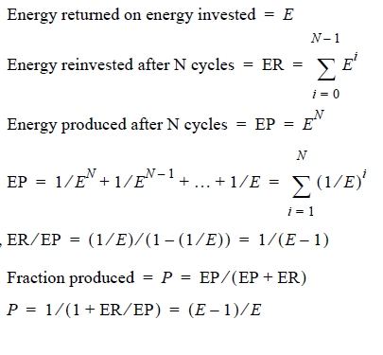

This becomes a form of net oil to refer to the loss due to reinvestment. One thing for certain — it will only get worse in the future as we use petroleum with lower and lower values of EROEI.

Someone may posit the question of why would we reinvest everything we extract? Apart from the fact that, yes, indeed no oil company would reinvest their entire stock, this analysis gives the upper bound on what the industry can potentially do. The more you reinvest, the more you can possibly get as payout. So, the carrot in front of the horse remains human greed.

Let’s say you happened across a broken slot machine in Las Vegas. You put in $1 and out pops $10. It happens three times in a row. Would you keep putting in the coin until someone stopped you? Or would you walk away with only $30?

The answer to that question, albeit on a much larger scale, tells you the size of the dice that the energy industry plays with.

**Other Forms of Energy**

Optimists have pointed to other sources of energy such as nuclear, solar, wind and others to take the slack away from diminishing supplies of petroleum. The significant rub lies in the argument that none of these will easily fly an airplane or provide the convenience for our current way of life. Transforming other sources of energy into ethanol or hydrogen will work but we will have to face the facts of EROEI.

We will sit back and watch as the global “all fuels” oil production show increases labelled as “barrels of oil equivalent”, yet we must remember that: [Ref 326]

1. This composite contains biofuels, which can have disastrous consequences for several reasons and for which EROEI lurks probably not too far from unity.
2. Non-crude oil liquids contain a large fraction of natural gas liquids (NGL’s) which have only about 70% the volumetric energy content of crude. This component has been steadily rising as a fraction of total liquids.

EROEI of crude will likely continue to fall as newer and smaller fields and unconventional oil take up an increasing fraction of the crude total.

**The Stochastic Arc**

By modelling the entire oil depletion process, we can project the most likely scenario for future availability and come up with a prognosis. This trajectory provides the best ammunition for planning purposes. Anything on either side of the curve — either more pessimistic or more optimistic scenarios — could occur but with lower probability. For planning, the stochastic arc will govern which the decisions we make. Depending on how smoothly and softly the trajectory lands, we can schedule a period to conserve or make investments in new energy technologies. Just like simulated global warming outcomes need to consider the most likely scenario, everything outside the envelope on the optimistic side will turn into a gamble if we decide to plan outside that arc.

Despite having applied a set of mostly crude-oil discovery data to the original model and then applying it to crude-oil+ production data (See “The Results. Which data sets support the model?” 225.), it falls amidst some equally pessimistic projections. Trying to deconstruct a heterogeneous mish-mash of production data for a homogeneous input remains a challenging problem. If we want to reach the goal of pinning the peak date precisely, remember that a few years plus-or-minus with a beginning date of 150 years ago doesn’t sound so wildly off. In any case, the most recent shock model with a dispersive discovery input gives a value closer to 2008 (see “Applying the Combined Model to Global Crude Oil Production” )

“Original Model(peak=2003) < No NGL(peak=2008) < Shell data of BOE(peak=2010)”

On a wider time, scale in the following figure, the oil shock model projection again sits right dab in the middle of the other pessimistic estimates, nearly matching Stanford’s median logistic model in the out years.

**The Default Prognosis**

The oil shock model does not quite follow a fixed temporal shift in the discovery curve. It comprises a sequence of convolutions (or low-pass filtering stages) that has the appearance of shifting the curve. The convolutions also smooth out the discovery fluctuations, leaving only economic shocks to generate the fine detail. The filtering enables us to use a stochastic discovery model, in particular dispersive discovery, as a replacement for actual data. So as one looks at the discovery dates of the fields, one can basically imagine how the shock model will reliably play out by simply time shifting discovery forward by a certain amount to predict future oil flows.

You don’t see any noise on this curve because it is pure probability, and it can extrapolate to out-years as it incorporates reserve growth as part of its derivation.

When I first worked the model out, I over-simplified by not separating the types of oil to use in matching to the production curve. The discovery curves essentially estimated only crude, but as non-crude became more important, the published production curves started including the other grades of oil. With the new mix of grades, one can appreciate that applying crude-discoveries to all oil production curves will consistently make the projections fall short by a few years. So, by using the best estimate of crude discoveries (with reserve growth) and applying it to estimate basic crude production, the number comes out to 2008.

Yet looking at more optimistic discovery data from Shell Oil, which basically labels the discoveries as “Barrels of Oil Equivalent” and doing an extrapolated dispersive discovery fit, the peak only marginally shifts to 2010. This aligns against an “all oil” production profile, which essentially echoes the sentiment that Matt Simmons has also stated [Ref 309]: essentially the peak of crude coincides roughly with the peak of all oil. I think this happens because we often find high quality oil over the same time intervals as poor quality oil, and it becomes a matter of saving up the poorer quality of oil a couple of years before that also starts depleting. If we treat high quality crude like gold, and the poorer stuff as near-gold, nothing really rules out that the will not get developed just as fast, especially with developing and BAU industrialized nations involved. In other words, any echoes of “Eureka!” for lower grades of crude will fade away rapidly after we tap the prime oil.

Not putting in the effects of lower EROEI as we follow the trajectory down makes the model more optimistic than it might possible play out. But then it gets balanced by the fact that dispersive discovery does not include “big fields first”, which makes the projection a bit more pessimistic, see “The Effect of Field Size” . So, in general, we are shooting for minimizing the bias by not making any unwarranted assumptions. In other words, if we don’t know, we leave the model alone. [[167]](#footnote-167)

Future (Oil) Shock

As discussed earlier, dips in production due to effects like demand destruction do provide suppression or plateauing of the peak, but the continuing production maintains a flow great enough that a long-enough interval of this behavior will prevent the production from bouncing back up. Unless producers can increase the extraction rates enough to make up for depletion of reserves due to the sand-in-the-bottle of lost time, we will likely have lower production for the foreseeable future and likely longer. And that makes anything we do, including both demand destruction and limited conservation, clearly not sustainable activities. So, any current or future recessions will act more like short-term modulators than a permanent kick-in-the- pants. Only during the 70’s and 80’s did we recover from a suppressive shock, and that had to do with a large reserve base.

# Volume 2 — Renewal

In the first part of this book, we laid out an analytical framework to understand oil depletion. We justified our arguments by incorporating stochastic mathematics.

For consideration of renewable energy we can reuse much of the mathematics used for depletion analysis. This has practical utility in several disciplines, many of them related to energy sources, climate, ecology, and other factors in society and the environment. In some situations, we can add to the body of knowledge such that it may perhaps lead to further breakthroughs.

Consider something as simple as popcorn popping. The trajectory of a popcorn shows remarkable mathematical similarity to the lifecycle of oil extraction (a few pops, then maximum popping activity, and then decline). So that studying the stochastic math of popcorn popping, may hold deeper significance in areas totally unrelated. That’s a description of the branches of science known as applied mathematics and applied physics.

The generally positive aspects of these models lead us to call this part of the book Renewal. Enough of the analysis can get reused in research areas such as photovoltaics, wind energy, and others gives it deeper meaning in its applicability.

## CHAPTER 12 Introduction and Energy Transition - Applying Probabilities

We often see unrelated phenomenon that shows some rather similar characteristics. In fact, the behaviors observed often have a common mathematical origin. In the situations that we cover here, the behaviors by themselves don’t necessarily diverge from basic intuition. Yet the effects of disorder and specifically that of entropy require us to use notions of probabilities to understand them. In this chapter, we provide some of the intuitive background to help guide us through the case studies.

***Odds and Uncertainty***

In writings and correspondence, the scientist E.T. Jaynes took an opinionated approach to defending his ideas and challenging the status quo. Known best for relating entropy and probability to many areas of science and information technology, Jaynes took on the proponents of the classical statistics school, known as the “frequentists”. Although he did not necessarily disparage their work, he could never understand why the classical statisticians had such difficulty embracing alternate ideas, such as those coming from the Bayesian perspective.

The “probabilistic” school (which included Jaynes) continued to make great practical strides in solving many thorny physics problems, yet the frequentists resisted the idea that Bayesian approaches could effectively subsume their doctrine. Jaynes showed in fact that ideas from probability could encompass some classical statistics ideas, going so far as to provocatively labeling probability theory as **The Logic of Science**. Similarly, the useful law known as Cox’s Theorem justified a “logical” interpretation of probability.

Jaynes has described how the mathematician Laplace had worked out many of the fundamental probability ideas a couple of hundred years ago (Jaynes lived in the 20th century and Laplace in the 18th), yet became marginalized by a few petty arguments. One of the infamous arguments Laplace offered, the Sunrise problem, has since supplied ammunition for opponents of Bayesian ideas over the years. In this example, Laplace essentially placed into quantitative terms the probability that the sun would rise tomorrow based on the count of how many times it had risen in the past. We can categorize this approach as Laplace’s precursor of Bayes’ rule, originally known as the rule of succession. In current parlance, we consider this a straightforward Bayesian (or Bayes-Laplace) update, a commonplace approach among empirical scientists and engineers who want to discern or predict trends. Yet, legions of mathematicians disparaged Laplace for years since his rule did not promote much certainty in the fact that the sun would indeed rise tomorrow if we input numbers naively. Instead of resulting in a probability of unity (i.e. absolute certainty), Laplace’s law could give numbers such as 0.99 or 0.999 depending on the number of preceding days included in the prior observations. Many scientists scoffed at this notion because it certainly did not follow any scientific principle, yet Laplace had also placed a firm warning to use strong scientific evidence when appropriate. In many of his writings, Jaynes has defended Laplace by pointing out this caveat, and decried the fact that no one heeded Laplace's advice. As a result for many years hence, science had missed out on some very important ideas relating to representing uncertainty in data.

Jaynes along with the physicist R.D. Cox, have had a significant impact in demonstrating how to apply probability arguments. We inhabit a world rife with uncertainty and disorder. In some cases, such as in the world of statistical mechanics, one finds that predictable behavior can arise out of a largely disordered state space; Jaynes essentially reinterpreted statistical mechanics as an inferencing argument, basing it on incomplete information on the amount of order within a system.

In the oil depletion analysis covered in the first part of this book, one can see how much that models of randomness play into the behavior. Missing pieces of data together with the lack of a good quantitative understanding motivate our attempts at arriving at some fundamental depletion models.

Jaynes spent much time understanding how to apply the Maximum Entropy Principle (MaxEnt) to various problems. We applied the MaxEnt principle with regards to oil because all the oil production and discovery numbers are not readily available. Unsurprisingly, that approach works quite effectively in other application areas as well and perhaps in many future situations. As Jaynes had suggested, the duality of its use for both statistics and statistical physics makes it a solid analysis approach:

“Any success that the theory has, makes it useful in an engineering sense, as an instrument for prediction. But any failures which we might find would be far more valuable to us, because they would disclose new laws of physics. You can't lose either way.” — E.T. Jaynes

The oil industry have actually used the Max Entropy principle quite heavily over the years. Mobil Oil published one of the early classic Jaynes texts based on a symposium they funded under the banner of their research laboratory. Also during this era, academic geophysicists such as J.P. Burg had used Jaynes ideas to great effect. Burg essentially derived the approach known as Maximum Entropy Spectral Analysis. Not limited to geophysics, this technique for uncovering a signal buried in noise has become quite generally applied. The reliability researcher Myron Tribus pointed out this early success, demonstrating Burg’s own personal victory whereby he ate his own dog food and used the algorithm at an abandoned oil field he christened “Rock Entropy #1”. The profits he made from the oil he extracted helped to fund his own research [Ref 204].

So given that the petroleum and geology fields contributed a significant early interest in the field of MaxEnt, we carried this approach forward with our depletion models. Jaynes has often pointed out that some of the applications work out so straightforwardly that an automaton, given only the fundamental probability rules, could figure out the solution to many of these problems — presumably oil depletion included.

“We're not going to ask the theory to predict everything a system could do. We're going to ask, is it possible that this theory might predict experimentally reproducible phenomena” — E.T. Jaynes

Jaynes has said that thinking about maximizing entropy parallels the idea that you place your bets on the situation that can happen in the greatest number of ways. Then because enough events and situations occur over the course of time, we end up with something that closely emulates what we observe.

“Entropy is the amount of uncertainty in a probability distribution” — E.T. Jaynes

This involves estimating the underlying probability distribution. This sounds hard to do but, the basic rules for maximizing entropy only assume the constraints; so that includes things like assuming the mean or the data interval.

“No matter how profound your mathematics is, if you hope to come out with a probability distribution, then some place you have to put in a probability distribution” — E.T. Jaynes

Given all that as motivation, and noting how well MaxEntropy works at estimating oil reservoir field sizes and other measures, we can see what other ideas shake out. So based on a MaxEnt of the aggregation of reservoirs over time, we previously came up with the following cumulative probability distribution for field sizes:

|  |  |
| --- | --- |
|  | 21-1 |

Everyone seems to understand how gambling works, particularly in the form of sports betting, where a man-off-the-street comprehends how the odds function works. Odds against for some competitor to win is essentially cast in terms of the probability P:

|  |  |
| --- | --- |
|  | 21-2 |

So, in terms of odds, we can rearrange the first equation into the odds formulation by using either the definition of odds for, Odds=P/(1-P), or odds against, Odds=(1- P)/P.

When plotted the odds distribution appears like the following curve:

When rearranged, the odds of finding a reservoir larger than a certain size, assuming we randomly pick from the sample population come out to:

|  |  |
| --- | --- |
|  | 21-3 |

So, we can give the odds of discovering a size of a certain reservoir in comparison to the median characteristic value just by taking the ratio between the two values. This equates well to the relative payout of somebody who beat the odds and thus beat the house median.

This becomes even more obvious when we compare with the following figure:

This simple result gives us some great insight. It essentially tells us that the greater the size of the reservoir desired, the progressively smaller the odds that we would come across at least that size. For the USA, the value of C comes out less than 1 million barrels, so that finding a field of at least 10,000 MB is 1:10,000. This assumes that we randomly draw from a sample of newly discovered fields.

On the other hand, if we want the odds of drawing from the sample and expecting at least a 1 MB field, we put in the formula and get 1:1, or basically even odds. So, if we want to somehow maintain our current rate of domestic production by placing safe bets, we must find an many small reservoirs.

We could also place our bets on the long payoff but need to realize that the probability size distribution starts to asymptotically limit for large sizes and the odds factor blows up

|  |  |
| --- | --- |
|  | 21-4 |

as the odds does this

|  |  |
| --- | --- |
|  | 21-5 |

This gives similar odds for a small reservoir, still close to 1:1, but the odds for getting a large reservoir no longer scale. For example, if we use a max size L of 20,000 MB, then the odds of a size of 10,000 MB is one half the odds without the maximum size. And the odds for getting anything bigger than 20,000 MB become essentially 1 in infinity.

This all comes about from assuming a maximum entropy distribution on the accumulation of the reservoirs and then applying a constraint on the time that these reservoirs accumulate. As Jaynes said, we can do much with incomplete information.

The same arguments apply to the dispersive discovery model which places fixed limits on the cumulative production based on similar incomplete information.

King Hubbert clearly never applied any of Jaynes’ principles, except perhaps at some deep intuitive level. But as Jaynes himself might have concluded, that would have worked out just as well since one intent of probability theory has always tried to place quantitative terms on human insight, the so-called subjective probability approach. So, Hubbert gave us some of the insight, and the rest of the probability- based models, such as dispersive discovery and the oil shock model in Volume 1 provides the mathematical foundation.

Dispersion

The odds function is a good starting point, as it has intuition behind it. As Jaynes would suggest, this has become part of our Bayesian conditioned belief system. But many other processes obey a similar dispersive effect.

One of the constraints is that the cumulative probability sums to one over the rank histogram; which is another intuitive aspect, in that probabilistically every event must eventually be covered.

In many areas of applied mathematics, one can often finds a purely analytic result solved strictly by equations of probability. Often one will find references to a Monte Carlo simulation. This actually results from an inversion of the analytical function, simply run through a random number variate generator. Many mathematicians do a Monte Carlo analysis to check their work and for generating statistical margins.

Finding “outlier” data in a simulation is important as this can reveal important fat-tail behaviors. Moreover, often these outliers do not show up in Monte Carlo runs unless the rest of the histogram gets sufficiently smoothed out by executing a large sample space.

Consider that the human mobility plot has an exceedingly simple rationalization given there is dispersion in human behaviors. We have the following derived equation that gives the probabilities of how far a sample population has moved in a certain time, based on the dispersion principle.

|  |  |
| --- | --- |
|  | 21-6 |

To simulate this behavior, we need to take a few straightforward steps. First, we simply must draw from a uniform random distribution for distance (x) and secondly draw another number for a random time span (t). Or we can do it from two inverted maximum entropy exponential draws (doesn’t really matter to achieve the fat-tail statistics). You then divide the two to arrive at a random velocity, i.e. v=x/t.

We need nothing simpler than this formula or formulation. The ranked histogram for the Monte Carlo simulation of 10,000,000 trials of independent draws appears like the following points with the dispersion formula in red:

The random draws converge to the derived Maximum Entropy dispersion derivation. The program takes a few lines of source code.

**Back to Oil**

As a very general technique we can apply the equivalent of breakthrough analysis across many domains. The usual problem remains that different application domains use different terminology. In volume 1, I did not use breakthrough analysis terminology because no one does controlled experiments when they look for or extract oil. After all, oil exploration remains a commercial enterprises and oil prospectors get what they can, while they can, and don't necessarily ponder any deeper meaning. Yet, I view the over-riding dispersion analysis as a very general concept and I simply apply the same technique in oil depletion by making the analogy to dispersion in human-aided discovery search rates. The fact that it also occurs for physical processes such as contaminant flow in groundwater, carrier transport in amorphous semiconductors, or heat dispersion should not surprise anyone.

Over 50 years have lapsed since the day that Hubbert first sketched a Logistic curve to model oil depletion, and I think the science establishment has had a mental block concerning the dispersion issue throughout this time. As we demonstrated in Volume 1, we can easily and simply explain the dynamics of the oil production life- cycle by using closely related ideas from dispersion analysis.[[168]](#footnote-168)

It takes a bit of intuition to determine the situations where disorder rules and where it does not. If you can appropriately apply the arguments you can often start to understand the mysterious “anomalous” dynamics. In much the same way that we can understand the dynamics of the Hubbert curve via dispersion so to can we understand the transient of an amorphous semiconductor time-of-flight experiment by applying dispersion. As a bottom-line, we often can use fundamental concepts of disorder to understand the dynamics of these behaviors. As a result, absolutely nothing about any of these empirical observations would I consider anomalous. It all depends on your perspective.

**Abstract:** Models of the physical environment play an important role in supporting Model Based Engineering (MBE).This paper describes how fundamental principles of thermodynamics and statistical physics can be applied to create compact parameterized models capable of statistically capturing the patterns exhibited in wide range of environmental contexts. Such models will allow more efficient and systematic assessment of the strengths and weaknesses of candidate designs than is possible using benchmark datasets or test tracks, and this can play an important role in using computer simulation to produce better designs of complex cyber-physical systems more quickly, affordably, and reliably. This is the first in a series of papers on the statistical description of natural processes. Subsequent papers in this series will treat specific examples in greater detail than provided in this overview.

Preface

Models of natural and man-made environmental contexts are important for a variety of purposes, in particular to support computational assessment of the performance of candidate designs for engineered systems. Vehicles perform on roads or other terrain, and both mobile and static engineered structures must contend with wind, waves, precipitation, and corrosion. Much of the value of engineered systems comes from their performance in the context of the environments in which they operate. Consequently, reliable assessment of candidate engineering designs requires models of potential operational contexts that accurately capture both the variability and overarching patterns presented by these environments.

Without computer simulation, candidate designs must be physically tested on sample deployed environments, for example test tracks. One aspiration for Model Based Engineering (MBE) is to achieve cost and other savings by replacing physical testing with testing through simulation. This requires validated models of the context environment that perform at least as well as a physical test in revealing design problems. However, simulation based testing can provide value beyond the elimination of physical testing. A significant cause of design failure often relates to providing an insufficient safety margin to deleterious environmental factors and contextual variables, such as an exceedingly rough terrain or corrosive atmospheric elements. Environmental context models that parametrically span the range of possible environmental challenges can provide a means for establishing the level of challenge at which a design will fail, generating considerably more information than produced by benchmark tests.

Environmental models that can replicate data derived from a wide range of actual environments are highly valuable, both through potential reuse across many design activities, and by supporting the creation of more robust and adaptable systems. Many of the patterns observable in contextual environments stem from fundamental processes derived from statistical mechanics and thermodynamics. Consequently, significant insight can be gained by approaching the patterns from first-principles physics. A combination of data and physical theory can result in models that extrapolate and accurately infer behavior outside of the data sets used for modeling. This approach results in models that are much more reliable for prediction and verification tasks than can be achieved through generic statistical modeling uninformed by physical considerations

This paper introduces a set of research results relating to stochastic modeling of environmental contexts. We first provide some background to probability theory and for formulating the building blocks for stochastic analysis — in particular, that of *probability density functions* and Markov and semi-Markov processes. These building blocks comprise the core fundamentals of stochastic modeling, whereby we can reason about probabilities, sampling, and uncertainty. The more sophisticated techniques of autocorrelation and power spectrum densities are elaborated in an associated report on terrain characterization, and models of dispersive growth and uncertainty propagation are described within an associated report on diffusion process context models.

Background: Environmental models for cyber-physical systems

Two criteria are central in crafting probabilistic models for observed behavior: (1) the importance or impact of observed events and (2) the associated likelihood of the event. For MBE, context models are needed for phenomena that play a significant role either through their frequency of occurrence or the severity of their impact. Context models portray the distribution of a metric of the phenomenon of interest. Metrics must be measurable or countable and could involve extensive variables such as volumes or consist of ratios such as rate (i.e. volume over time).

Table 2 : The use of probabilities can describe high likelihood and high impact events.

|  |  |  |
| --- | --- | --- |
|  | High Likelihood | High Impact |
| Terrain | RMS roughness | Steep slopes |
| Rainfall | Humid climates | Heavy downpours |
| Wind | Prevailing winds | Gusts |
| Waves | Chop and swell | Rogue waves |
| Particulates | Aerosols | High density volcanic dust |

The fundamental building block in the creation of context models is the use of probability density functions (PDF) to model sample spaces. These facilitate the characterization and modeling of natural phenomena that are prevalent in human environmental contexts, including distribution of terrain slopes, wind velocities, rainfall amounts, etc. These can both model the high likelihood events through sampling of the meat of the distribution curves, but also provide for the rare cases through the concept of exceedance probabilities [1] . Models that can be expressed as fairly simple analytical forms will be more broadly useful. For disordered systems and data containing uncertainty, techniques such as the *maximum entropy principle* (MaxEnt)[2] and *superstatistics*[3] will be applied; these often have a more formal basis than the heuristic fractal models[4] often employed.

To discover patterns in data, data analysis techniques such as rank histogram plots are useful. A set of data, binned according to frequency of occurrence for the parameter of interest reveals most of the structure of the probability density. These views can be manipulated or marginalized against conditional or joint probabilities.

One of the significant observations that one can make about typical environmental parameters is in the extent of their randomness. On occasion an environmental parameter, such as temperature, can exist within a narrow range of values and thus become well-suited for a normal Gaussian distribution model, but more commonly, skewed (i.e. asymmetric) and fat-tail distributions are much more applicable. In these cases, the data along with some physical reasoning will direct the modeler away from a normal distribution toward a higher variance distribution.

Environmental context modeling relies on knowledge of exogenous behavior – that behavior that exists outside the confines of the vehicle or other engineered system we are designing. Any behavior that we have little control over needs to be regarded as uncertain, and will in general require stochastic models. Recent advances in our understanding of stochastic phenomena have benefited greatly from the availability of data from a variety of sources. In the past, modeling of physical behavior has often been hampered by the lack of sufficient statistics to substantiate the original formulation. In combining stochastics and information elements for modeling, we can incorporate probability and information theory (Jaynes[2], Shannon[5]), pattern theory (Mumford[6], Grenander[7]), fat-tail statistics (Mandelbrot[8], Taleb[9], Sornette[10] ), and superstatistics and complexity theory (Beck[3], Gell-Mann[11]) and then apply these contemporary ideas to the characterization of environmental contexts.

Probability theory as advanced by E.T. Jaynes[2] suggests using probability as an extended logic, and we should consider inference and plausible reasoning under various levels of uncertainty. The key idea of Jaynes is to meld Shannon’s information theory concept of entropy together with the statistical mechanics definition of entropy. Many important and non-trivial applications exist where Jaynes’ maximum entropy principle is the only tool we may need, as it describes the minimal application of prior knowledge when appropriate — often a mean value is all that is required.

Pattern theory as advanced by Mumford[6] and Grenander[7] seeks to identify the hidden variables of a data set, characterizing real world observations as patterns. The approach uses the observed patterns to infer information about the unobservable factors, formulating prior distributions for those too complex or difficult to observe. If we can determine efficient inferential models for the observed variables by modeling observations as partly stochastic and partly deterministic, and apply the randomness and variability of these distributions along with considering their natural structures and constraints   
(i.e. symmetries, independences of parts, and marginals on key statistics) we can create classes of stochastic models by applying transformations to patterns. We can then synthesize (sample) from the models, and the stochastic factors affecting an observation exhibit strong conditional independence, making it easily decomposable. We will see this approach demonstrated when we consider terrain characterization.

The analysis of fat-tail statistics as advanced by Sornette[10] and Taleb[9] has shown promise for the prediction of crises and extreme events in complex systems and risk management, both for social[12] and natural systems. The general theory encompasses scale-free properties, fractals, and power-laws, and provides an alternative to normal or Gaussian statistics. This introduces black and gray swan terminology and the idea of rare dragon-kings which relates to extreme value analysis (EVA)[13] , and evidenced via the scarcity of 100-year events.

Considerations of complexity theory as advanced by Gell-Mann[11] leads to the idea that :*“when defining complexity, it is always necessary to specify a level of detail up to which the system is described, with finer details being ignored”*. Seemingly complex representations can often be represented by rather concise descriptions and we can apply concepts such as dispersion and coarse graining to simplify the complexity. One such idea is that of superstatistics[3], which ties in closely to the ideas of maximum entropy [14]. The essential approach here is to admit that randomness can exist on different scales and by combining these scales, the underlying real-world statistical distributions are revealed.

The awareness that we can indeed use probability to characterize larger scale phenomena has often been fought tooth-and-nail by opposing schools of thought. For example, Mumford[15] describes how classical statisticians opposed contextual Bayesian modeling when they claimed that *“this approach denies that statistical inference can have anything to do with real thought because real-life situations are always buried in contextual variables and cannot be repeated.”* In this case, the contextual variables appear to get in the way of our understanding of the desired effect, whereas they should become part of the understanding of the *system*: i.e. the context of the vehicle within the environment. In reality, we can and have created very useful models by incorporating prior contextual knowledge to infer possible and potential behaviors. The key is that many of the contextual variables are governed by properties of nature that repeatedly occur under conditions of the thermodynamic arrow of time, which always leads to greater amounts of entropy. In this sense, nature can perhaps be more predictable than we think, and at worst, we can expect that it remain predictable in its unpredictability, and thus we can make progress by applying a stochastic characterization to the empirical observations.

Maximum Entropy Principle Modeling

To apply context modeling effectively one has to approach the environmental domains pragmatically. We want to find solutions with the minimal amount of complexity that conversely generates the most general benefit. A model with a very detailed representation will typically apply only in specific cases and be of little use. So we first seek the simplest possible approach and find out if that has general applicability.

Fortunately, nature helps us out with the bookkeeping, through its implicit use of information theory, or as it is known in the physical sciences world – statistical mechanics. Thermodynamics and the essential notion of entropy both derive from statistical physics. The essential idea behind information theory is to try to describe an observed phenomenon with the least amount of words as possible.

A simple example of connectivity patterns drawn from Gell-Mann[11] demonstrates this point. Consider Figure 1 below, a series of networks showing increasing levels of seeming complexity. Graph **A** seems the least complex as it has no connections, while Graph **F** seemingly shows the most amount of complexity as it has all nodes interconnected.



Figure 1: Gell-Mann’s connectivity patterns. Increasing levels of complexity shown as an interconnected graph.

Using information theory, we can estimate the actual complexity by algorithmically describing each of the connectivity arrangements. Graph **A** can be described as *“no nodes connected”*, while Graph **F** can be described as *“all nodes connected”*. These therefore have very close to the same information content, because they can be reduced to an equally concise description. The graphs in between these end-points have higher complexity because they will require a more elaborate description.

In physics, this approach has long been applied to describe topics such as the ideal gas law, which stems from seminal ideas of statistical mechanics. Ensembles of particles, though complex at a micro-scale, can be described more concisely at the macro-scale, with the connecting thread elegantly applied from entropy and information theory.

These ideas can be applied to other natural phenomena. The key idea that we propose to apply is that of the Maximum Entropy Principle (MaxEnt)[2] . The principle of maximum entropy states that those configurations described by the least amount of constraints and moments (such as mean, variance, and higher-order moments) will tend toward probability density functions that maximize entropy. The MaxEnt solution is essentially to maximize **S** = entropy subject to constraints of probability, *f* (*pi*).

(1)

In practice, MaxEnt gets routinely applied, even without the knowledge of the practitioners. For example, with the assumption of only a mean and a standard deviation in a set of empirical observations, the conventional approach is to apply the standard Gaussian or normal statistical distribution. That indeed coincides with the MaxEnt derived probability distribution for that particular set of moments. The canonical example of this is a manufactured component with a tight tolerance; this would routinely show a Normal distribution in the measurements of the produced parts. (A description of this example for an RLC[[169]](#footnote-169) circuit using ratio distributions can be found in a report from DARPA’s Adaptive Vehicle Make META program[16]).

Another simple example is that of a dye mixing in a glass of water. The eventual spatial distribution of the dye in the volume will approach a uniform level over time. This is straightforwardly modeled as a MaxEnt calculation given the boundary conditions of the volume. There is no preference for the dye occupying one subvolume over another so that we can only apply the known physical constraints. The barometric pressure law with altitude is one of the simplest examples of adding an energy constraint to Jaynes’ formulation; and this gives the characteristic damped exponential decrease of pressure with altitude.

In addition, countless other phenomena, especially those showing great amounts of disorder, do not follow either a Normal distribution, or the uniform distribution or exponential just described. This includes many of the so-called “fat-tail” distributions, popularized by recent events[9]. Further, some of the fat-tails come about not from any intrinsic physical property, but from a derived property of the measure space (such as the ratio distribution mentioned parenthetically above).

Uncertainty Quantification

In addition to the natural random variation in the values of a particular environmental observable (**Type 1**: aleatoric uncertainties), our limited abilities to quantify the numbers can lead to a further uncertainty spread (**Type 2**: epistemic or systemic uncertainties). Whether the epistemic uncertainties allow us to capture the underlying randomness depends on the strength of the characterization and modeling. For example, we can have uncertainty in the actual measurements due to calibration or precision errors, uncertainty due to counting statistics, and uncertainty in the applicability of a model.

If the observable has a wide dynamic range and is readily quantified, the uncertainty in measurement is often absorbed in the natural randomness and has minimal impact on the data characterization. For counting statistics, uncertainty is minimized by drawing from a sufficient sample size that represents the complete dynamic range of the observable. By accumulating data over time, using approaches such as Bayes rule via additional prior knowledge, the additional evidence will reduce this uncertainty.

The applicability of the model for describing a natural phenomenon is referred to as the *likelihood* of the model and of its parameters. The certainty or confidence we have in a particular model is ultimately best gauged by comparison to an alternative model in which we can apply standard inference metrics such as conditional entropy, maximum likelihood, log-likelihood, and information entropy criteria such as Akaike Information Criterion (AIC) or Bayes Information Criterion (BIC) [17]. The information criteria techniques are valuable because they penalize models that contain too many fitting parameters. Models based on first-principles with minimal parameterization (such as those derived from the Maximum Entropy Principle) will always score higher than, for example, a naïve high-order polynomial fit that contains many adjustable parameters.

The goal of context modeling is to converge to only **Type 1** uncertainty, where we can apply what we consider the most likely model and use its probability distribution function to provide Monte Carlo or importance sampling for design verification. In previous work[16] we applied propagation of uncertainty in combination with various physical and information-entropy-based models to arrive at estimates of a probabilistic certificate of correctness (PCC) for a given design. This included exogenous artificial effects and sets of metrics dealing specifically with exogenous variables, those variables whose value is determined outside the model in which it is used:

* Manufacturing variance (the RLC example)
* Semantic network links
* Travel dispersion
* Wireless signal latency
* Human reaction times

This approach is based upon application of the maximum entropy formulation and a careful consideration of the measure space[[170]](#footnote-170). By applying minimal information to stochastic models of various behaviors, that we can infer the essential probability distributions, and therefore concisely model contextual behaviors suitable for conversion (in reverse) to uncertainty bounds — necessary for tasks such as verifying vehicle or system environmental suitability. This choice results in a modeling approach for disordered systems and data containing uncertainty, using techniques such as the maximum entropy principle and superstatistics, has a more formal basis than the heuristic or fractal models conventionally used to empirically fit data.

In the following sections, we describe the basics of this approach. More sophisticated analyses can be developed on this foundation, for example:

* Growth curves
* Generalized correlation functions in the real-space domain
* Combining correlation functions with spectral representations, both in the spatial and temporal domains of system context.

These analyses will be covered in subsequent volumes (see Appendices B, C, D).

Characterization to Modeling

Fundamentally, context modeling involves applying the scientific method to describe the physical world. Figure 2 below shows the process going from (1) initial observations, to (2) characterization, and then to (3) modeling.

Figure 2: Process of Modeling

Stage 1 represents gathering the initial data from observations and measurements.

Stage 2 transforms the raw data to usable information —characterization imparts deeper categorical qualities and meaning to the data. In characterizing the initial data, we may not yet know the process or theory explaining how the data was generated, but inferences can be made from information made available, through for example a graphical form or as a lookup table. Such characterization of categorized data will allow the differentiation from other sets of data. For example, by charting the frequency of slopes in an environmental terrain data set, we can tell if one region is on average steeper than another region.

Stage 3 transforms the information to real knowledge via scientific modeling. By modeling we can bring a much deeper understanding to the information at hand than someone who only has lookup tables. To provide one benefit, we can extrapolate to regions outside the scope of our data ranges. Then, we can not only say how much steeper one area is than another but we can explain the reason and thus have additional knowledge to infer from. In other words, we can extend our reasoning capability.

We will treat these models in as concise a formulation as possible to avoid undue complexity, and we apply physical first principles to justify their description

Context Modeling of Environmental Domains

To better convey how this final modeling step is performed, we now provide examples applying maximum entropy principles and superstatistics to several practical examples: (1) wind speed, (2) terrain slopes, (3) rainfall intensity, (4) wave crest heights, and (5) electro-magnetic signal clutter. These all share a common foundation, as each draws from energy from the environment to give a range in intensity of some measure. In each case, the intensity is a readily measured observable, with the general trend of higher intensity values occurring less frequently than the low intensity values. The zero energy state is indeed the most common in all these measures.

An initial set of questions to consider from a context modeling perspective is what general characterization can we make from these observables, and then what universal modeling approaches can we apply?

Drawing from the perspective of maximum entropy, we first consider that the probability of a high energy configuration is typically treated as a variation of a Boltzmann factor:

where *EA* is the activation energy for occurrence. In this approach, the likelihood of higher energies becomes exponentially damped, scaled by the activation energy constant. The connection to maximum entropy is that we can treat this factor as a probability and then apply it as a probability density function of the measure of interest:

The choice of the exponential in terms of MaxEnt is that it is the least biased estimator considering that *EA* is the **average** energy of the configuration. If we happened to know the variance of the ensemble configuration, this would lead to a normal, Gaussian PDF. Yet, since we in general lack this knowledge, we need to rely on the least amount of information available, and this is the exponential, or Boltzmann factor.

Next we consider the application of the activation energy for the individual cases. For wind distributions, the kinetic energy is related to the square of the wind speed, *v*. This turns into the Rayleigh distribution.

Electromagnetic signal clutter follows a similar derivation as the energy is the square of the amplitude of the electric signal.

For terrain distributions, we can to first order suggest that a potential energy is directly proportional to the terrain slope.

For rainfall intensity, we consider the potential energy associated with a volume of water under gravitational forces. The larger the volume, the greater the encapsulated energy, which gets released scaled to the rate intensity of the rainfall.

Finally, for aquatic wave crests, the energy of the waves is proportional to square of the crest height. This works only to some level, as shoaling and non-linear fluid mechanics can prevent or attenuate taller waves.

Now consider that in each of these cases, the value of the activation energy can vary depending on regional or environmental conditions. For the case of rainfall, the intensity of the rainfall can be predicated on other conditions besides the volume of the water vapor alone. This leads to the idea of a super-statistical distribution. Here we not only apply the exponential PDF to the measures of interest, but we grant that probability an extra layer of uncertainty. That uncertainty would commonly apply to the value of *EA* or to some other constant of proportionality.

Based upon activation energy proportionality or some other variant measure, different kinds of statistical distributions can be derived. For example, by considering variations in capacity and growth time, such phenomena as cloud sizes, lake sizes, and particulate sizes can be modeled. These become fat-tail distributions due to the weighting of the rate calculation, as a strong variant situated in the denominator of a stochastic ratio turns into a heavy weighting in the tail of a distribution.

The foregoing are exemplars of the general superstatistical approach we apply to natural context domains. The table below describes several of the practical examples. For many of these natural phenomena, empirical data sets can be used as samples from the observational space. By inferring information from a model that more accurately represents the underlying behavior than can a generic statistical distribution more fundamental insights may be inferred. This has a number of benefits, including conciseness of representation and potentially better estimation of rare events.

Table 3: List of stochastic models

|  |  |  |  |
| --- | --- | --- | --- |
| Stochastic Metric | Elements | Description | Data |
| Wind | PDF, ME, SS | Model of wind speeds | Bonneville Power Authority[18] |
| Rainfall | PDF, ME, SS | Model of rainfall amount | Hydrometeorology Lab University of Iowa[19] |
| Clutter | PDF, ME, SS | Model of EMI |  |
| Clouds | PDF, ME | Model of cloud sizes | NASA Goddard[20] |
| Lakes | PDF, ME | Model of lake sizes | Global Lakes and Wetlands Database[21] |
| Particles | PDF, ME | Model of particle sizes | NASA JPL [22] |
| Waves | PDF, ME | Model of crest heights | CDIP[23] and US Army Corps of Engineers[24] |
| Terrain slopes | PDF, ME, SS | Model of inclination | USGS DEM [25] |

Examples

We now provide examples of almost predictable unpredictability that can arise in many natural environmental contexts, such as variability in terrain slopes, as well as in artificially man-made situations, such as a large highly-interconnected network [26]. These models can be applied in either analytic form or in a form suitable for Monte Carlo-type simulations.

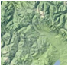 Slope modeling and Topography

The first example is of a longitudinal slope context distribution. The macroscopic slope model of USA terrain follows closely that described by the Maximum Entropy Principle (MaxEnt).

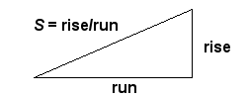How do we model and thus characterize disorder in the earth's terrain? Can we actually understand the extreme variability we see? If we consider that immense forces cause upheaval in the crust then we can reason that the energy can also vary slope topography widely. The process that transfers potential energy into kinetic energy to first order has to contain elements of randomness. To the huge internal forces within the earth, generating relief textures equates to a kind of Brownian motion in relative terms — over geological time, the terrain amounts to nothing more than inconsequential particles to the earth's powerful internal engine.

We take the terrain slope *S* as our random variable (defined as rise/run).

The initial premise is the higher the slope, the more energetic the terrain. Applying the Maximum Entropy Principle to a section of terrain, we can approximate the local variations as a MaxEnt conditional probability density function, where E is the local mean energy and c is a constant of proportionality. But we also assume that the mean E varies over a larger area that we are interested in, as in the superstatistical sense of applying a prior distribution, where k is another MaxEnt measure of our uncertainty in the energy spread over a larger area.

The final probability is an integral over the marginal distribution consisting of the conditional multiplied by the prior. This integrates as a modified BesselK function of the zero order, *K0*.

The average value of the terrain slope for this distribution is simply the value *S0*.

The validity of the model thus derived can be assessed by comparing to a large set of data. The digital elevation model (DEM) data for the 1 degree quadrangles (aka blocks/tiles) in the USA from the USGS web site was characterized. This consists of post data at approximately 90 meter intervals (i.e. a fixed value of run) at 1:250,000 scale for the lower 48 USA and some spillover into Canada. From individual DEM files, we calculate the slopes between adjacent posts yielding an average slope (rise/run) of 0.039, approximately a 4% grade or 2.2 degrees pitch. The characterization takes the absolute values of all slopes so that the average is not zero.

The cumulative plot of terrain slopes for all 5 billion calculated slope points appears on the following chart[26]. The cumulative probability distribution of the BesselK model is plotted with the calculated average slope as the single adjustable parameter.

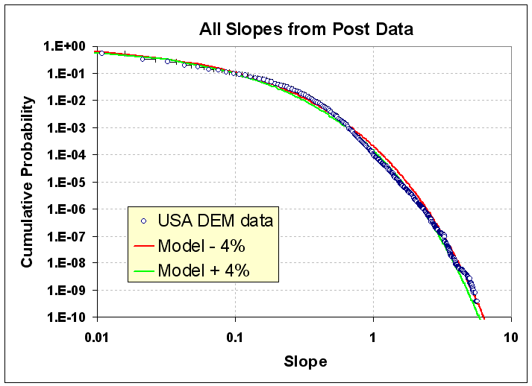

Figure 3: Longitudinal slope cumulative distribution function for the USA. The BesselK model with a small variation in S0 (+/-4% about the average 0.037 rise/run) demonstrates sensitivity to the fit.

The good agreement occurs because random forces contribute to maximizing the entropy of the topography. Enough variability exists for the terrain to reach an ergodic limit in filling the energy-constrained state space. As supporting evidence, we can generate a distribution that maps well to the prior by estimating the average slope from the conditional PDF of each of the 922 quadrangle blocks and then plotting this aggregate data set as another histogram.

For context modeling, a library function is used to generate Monte Carlo sample draws for the BesselK model without requiring a probability inversion. The resulting algorithm turns out surprisingly simple. First, draw two independent random samples from a uniform [0.0 .. 1.0] interval, then apply the natural log to each, multiply them together, and then multiply by the BesselK *S0* scaling constant.

This random draw algorithm will give the following cumulative if done 5 billion times, which is the same sample size as the real USA DEM data sample (see Figure 4). The only statistical noise is at the 10 -9 level, which is roughly the same as in the DEM data set.

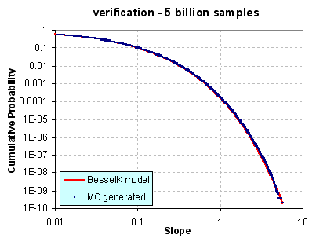

Figure 4: Drawing random samples to approximate slope distribution

Practically speaking, we see the variability in slopes expressed at the two different levels: the entire USA at the integrated (BesselK model) level and the aggregated regions at the localized (exponential prior) level. These remain consistent as they agree on the single adjustable parameter *S0*.

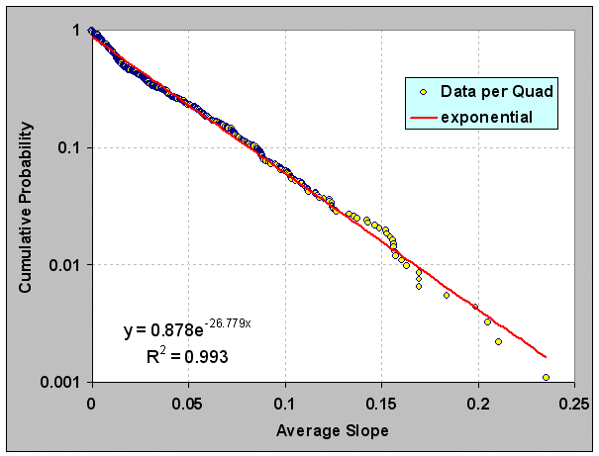

Figure 5: Generation of the prior distribution by taking the average slope of each of nearly 1000 quadrangles. The best fit generates a value of S0 (1/ 27=0.037) close to that used in the previous figure.

The modeled distribution has many practical uses for analysis, including mobility studies and fuel efficiency planning (see Appendix F). Obviously, vehicles traveling up slopes use a significant amount of energy and a context modeler would need a model to base an analysis on without having to rely on the raw data by itself. Further, spatial correlations also exist and will prove useful as well. A survey of recent research gives no indication that others have discovered this rather simple model (See further Vico[27] Gagnon[28], Gonçalves[29], Guarnieri[30]

 Wind Distribution

Wind velocities demonstrate a wide dynamic variability, ranging from calm to gale force. However intuitive the concept of “windiness”, we may often miss the underlying mathematical simplicity behind wind speed variability. The complexity of the earth’s climate and environment actually contributes to this simplicity as it generates more states for the system to exist within (see the Gell-Mann argument), which can also increase the likelihood of variability. With minimal knowledge as to the origin of the wind variance, we can apply the maximum entropy principle to its energy content.

The derivation of wind dispersion follows a few straightforward steps. We start with the premise that every location on Earth has a mean or average wind speed. This speed has a prevailing direction but assume that it can blow in any direction. Next we safely assume that the kinetic energy contained in the aggregate speed goes as the square of its velocity. If we assume only temporally-averaged mean wind energy and then relate the energy, ***E***, as the square of the wind speed, ***ν*2**, the resultant maximum entropy probability distribution matches the Rayleigh distribution.

This comes about from the Newtonian kinetic energy law ½*mv*2 and it shows up empirically as the aeronautical drag law (i.e. wind resistance) which also goes as the square of the speed.[[171]](#footnote-171) Then apply the principle of maximum entropy to the possible states of energy that exist and come up with a probability density function that has no constraints other than a mean value (with negative speeds forbidden). In the equation above *c* is a constant and 1/*c* defines the mean energy (i.e. essentially acting as the Boltzmann activation energy). This describes a declining probability profile, with low energies much more probable than high energies. To convert to a wind dispersion PDF we substitute velocity for energy and simplify.

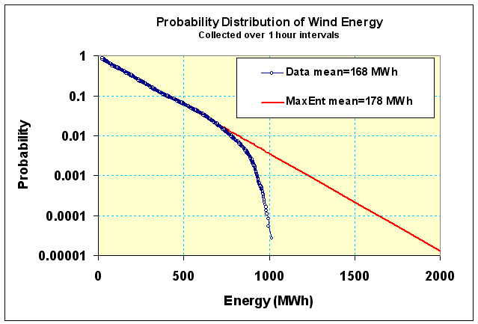

Figure 6: Wind distribution follows Rayleigh distribution closely. This data was collected from an archive of wind energy statistics collected in Ontario. The upper level cut-out is due to turbine governor regulation at high wind speeds.

Figure 6 shows an empirically observed wind speed distribution, showing a peak away from zero wind speeds and a rapid decline of frequency at higher velocity. Heuristically, many scientists refer to the model as following a Rayleigh or Weibull distribution. The Rayleigh comes out as the simpler model because it derives from first principles and any deviation from the quadratic exponent works as a refinement. The first data set shown consisted of about 36,000 sequential hourly measurements in terms of energy (kilowatt-hours) for Ontario.

By adding more data to our knowledge on wind dispersion, we can observe how dispersion in wind speeds has a universal character. The second data set (Figure 7) comes from northwest Germany and consists of wind power collected at 15 minute intervals.

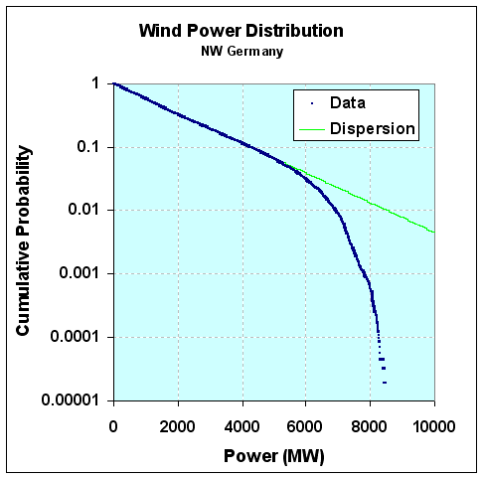

Figure 7: Wind variations for Germany. The curve has all the same characteristics as that for Ontario, demonstrating the universal behavior in wind speed variability.

Note that the same wind dispersion holds as for Ontario. Both curves display the same damped exponential probability distribution function for frequency of wind power (derived from wind speed). We also see the same qualitative cut-out above a certain power or wind energy level.

**Adding More Variability.** Since *EA* can vary from region to region, we leave it as a conditional, and then set that as a maximal entropy estimator as well

then we integrate over the conditional's range according to standard practice and arrive at a cumulative.

This results in a simple lookup in your favorite comprehensive table of cataloged integration formulas, which leads to the following solution:

where *K1* is the modified BesselK function of the second kind, in this case of order 1, which is found in any spreadsheet program (such as Excel). Note that this is the same function that we used for the distribution of terrain slopes.  The order 1 is the variant used for the *cumulative* distribution function  
  
We tested this formulation against wind data from [Bonneville Power Administration](http://http/transmission.bpa.gov/Business/Operations/Wind/MetData.aspx), which has over 20 meteorological stations set up around northern Oregon. The download consisted of over 2.5 million data points collected at 5 minute intervals, archived over the span of a little less than 2 years.

|  |
| --- |
| [http://1.bp.blogspot.com/-yPtFex5vI1w/TzWsB_ZLQUI/AAAAAAAAA84/lOAPPxYKB_E/s400/bpa_wind_all_semilog.gif](http://1.bp.blogspot.com/-yPtFex5vI1w/TzWsB_ZLQUI/AAAAAAAAA84/lOAPPxYKB_E/s1600/bpa_wind_all_semilog.gif)  Figure 8: Cumulative distribution function of wind energies from Bonneville with model fit. |
|  |

For the fit of this curve, the average energy was derived directly by computing the mean over the entire set of data separately. This corresponded to a value of 12.4 MPH, and placed a pair of positive and negative tolerances to give an idea of the sensitivity of the fit.  
  
As this is a single parameter model, the only leeway we have is in shifting the curve horizontally along the energy axis, and since this is locked by an average, the fit becomes essentially automatic with no room for tweaking and little for argument. The probabilities are automatically normalized.  
  
Figure 9 shows the log-log plot, which reveals a departure at high wind speeds. This shows that excessive gale force winds (greater than 60 MPH) did not occur over the extended region during the span of two years data collection.

Wind dispersion analysis has obvious applications for context modeling. Fuel efficiency is impacted by aerodynamics and drag goes up as the square of the wind speed. Vehicle cooling also is impacted by convection due to local winds. Applying this approach for context modeling has the benefit of allowing simple sampled data generation for verification and PCC bounding, similar to that applied for terrain slopes.

|  |
| --- |
| [http://2.bp.blogspot.com/-J9DijugJnqc/TzWsBu4qBbI/AAAAAAAAA8w/TDgxdZgEFb0/s400/bpa_wind_all_loglog.gif](http://2.bp.blogspot.com/-J9DijugJnqc/TzWsBu4qBbI/AAAAAAAAA8w/TDgxdZgEFb0/s1600/bpa_wind_all_loglog.gif)  Figure 9: Cumulative distribution function of wind energies on a log-log plot. |
|  |

The previous maximum entropy derivation assumed only a known mean of wind energy levels (measured as power integrated over a fixed time period). From this simple formulation, one can estimate or extrapolate a wind speed probability. Knowing the probability of wind speed, one can also perform all kinds of interesting extrapolations — for example, we can project the likelihood of how long it would take to accumulate a certain level of energy[31].

 Rainfall Intensity

As a premise, we want to consider whether a simple stochastic model can generate statistical patterns of rainfall events. We postulate that a critical point exists for rain to fall. The volume and density at which nature decides it reaches this critical point has much to do with the rate at which a cloud develops in its intensity and payload.   
  
We assume a maximum entropy probability distribution function which assumes an average energy of rainfall rate for a storm, ***i***:

The rationale for this is that the rainfall's energy is proportional to the rate of the rainfall, since that amount of moisture had to be held aloft by gravity.

Yet we know that the *Ei* can vary from storm to storm, so we leave it as a conditional, and then set that as a maximal entropy estimator as well

then integrating over the conditional's range.

This leads to the following solution:

where *K*1 is the modified BesselK function of the second kind, in this case of order 1. This is the same general derivation as we performed for wind speed.  
  
This analysis was compared against this recent paper by Papalexio: ["Can a simple stochastic model generate rich patterns of rainfall events?"](http://itia.ntua.gr/getfile/1174/1/documents/2011JoH_RichRainfallPatterns.pdf) [19], and graphed as shown below in Figure 18. The green points constitute the BesselK fit which lies right on top of the blue empirical data set.

|  |
| --- |
| [http://1.bp.blogspot.com/-NuRFrFyQYy4/T0QystbAeII/AAAAAAAAA9o/_6KyR6Xu9Cc/s400/mergedIowaRainfall.gif](http://1.bp.blogspot.com/-NuRFrFyQYy4/T0QystbAeII/AAAAAAAAA9o/_6KyR6Xu9Cc/s1600/mergedIowaRainfall.gif)  Figure 18: Cumulative rainfall distribution statistically gathered from several storm events. |
|  |

From the table below reproduced from the paper, we can see that the mean value used in the BesselK distribution was *exactly the same* as that from the standard statistical moment calculation

Table 4: Rainfall moments

|  |  |  |  |  |  |  |  |  |
| --- | --- | --- | --- | --- | --- | --- | --- | --- |
| **Event#** | **1** | **2** | **3** | **4** | **5** | **6** | **7** | **All** |
| SampleSize | 9697 | 4379 | 4211 | 3539 | 3345 | 3331 | 1034 | 29536 |
| Mean(mm/h) | 3.89 | 0.5 | 0.38 | 1.14 | 3.03 | 2.74 | 2.7 | **2.29** |
| StandardDeviation(mm/h) | 6.16 | 0.97 | 0.55 | 1.19 | 3.39 | 2.2 | 2 | 4.11 |
| Skewness | 4.84 | 9.23 | 5.01 | 2.07 | 3.95 | 1.47 | 0.52 | 6.54 |
| Kurtosis | 47.12 | 110.24 | 37.38 | 5.52 | 27.34 | 2.91 | -0.59 | 91 |
| HurstExponent | 0.94 | 0.79 | 0.89 | 0.94 | 0.89 | 0.87 | 0.97 | 0.89 |

In contrast, Papalexio tried to apply Hurst-Kolmogorov statistics to the problem in search of a power law solution, claiming significance for the finding of a power law tail of -3. Instead we suggest that the slight deviation in the tail region is likely caused by insufficient sampling in the data set. A slight divergence starts to occur at the 1 part in 5,000 resolution level and since there are only 30,000 points in the merged data set, indicating that statistical fluctuations could account for the difference. See Figure 19 below which synthesizes a BesselK distribution from the same sample size, and can clearly duplicate the deviation in the tail.

|  |
| --- |
| [http://3.bp.blogspot.com/-PCEQC8B1v4I/T0RZQgtpLlI/AAAAAAAAA9w/VLx7HEAEgJU/s400/rainfall_mc.gif](http://3.bp.blogspot.com/-PCEQC8B1v4I/T0RZQgtpLlI/AAAAAAAAA9w/VLx7HEAEgJU/s1600/rainfall_mc.gif)  Figure 19: Monte Carlo sampling from a synthetic BesselK distribution reveals the same departure at low probability events. |
| Fluctuations of 1 in 30,000 are clearly seen at this level, so care must be taken to not read fat-tail behavior that may not exist. |

The bottom-line is that this simple stochastic model outperforms Papalexio’s fractal model, which doesn't seem as well-grounded with respect to first-principles once we apply an elementary uncertainty analysis to the data. The only physical premise needed to derive the physics grounded model specification is the intuition that rainfall buildup is a potential energy argument. This translates to a Boltzmann/Gibbs probability with a large spread in the activation energy. The large spread is modeled by maximum entropy — since the activation energy is unknown we assume a mean and let the fluctuations about that mean vary to the maximum amount possible. That is the maximum entropy activation which is proportional to a mean rainfall rate — the stronger the rate, the higher the energy.

That essentially becomes the premise for predicting the probability of a given rainfall rate within the larger ensemble defined by a mean. Note that Papalexio[19] seems to imply that the PDFs can go beyond the variability of a BesselK and into fatter tail territory (such as the MiejerG distribution, which is exponentially mixed prior with the Bessel). That is certainly acceptable as it will simply make it into a higher probability of outlier distribution, and if a fatter tail matches the empirical observations on a grander ensemble scale, then that might be a better characterization of the natural process [41].

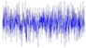 EMI Clutter

The intermittent nature of wind power has a fundamental explanation based on entropy arguments. This same entropy-based approach explains some other related noisy and intermittent phenomena that modelers have to deal with. One case involves the use of mobile wireless gadgets such as WiFi devices, cell phones, and global positioning system (GPS) navigation aids in an imperfect (i.e. noisy) environment crowded out by electro-magnetic interference (EMI).

These wireless devices are often used in cluttered environments where ideal transmitted power mixed with EMI noise results in frustrating fadeouts that we need to patiently wait out. An example of Rayleigh fading appears in Figure 20 below. Signal interference-based explanations for why this happens can be found, originating via the same intentional phase cancellations that occur in noise-cancelling headphones. The electronics in noise-cancelling headphones flip the phase so all interferences turn destructive, but for wireless devices, the interferences turn random, some positive and some negative, so the result gives the random signal shown. In the limit of a highly interfering environment the amplitude distribution of the signal shows a Rayleigh distribution, the same observed for wind speed.

|  |  |
| --- | --- |
| http://www.wirelesscommunication.nl/reference/images/raysampl.gif | http://www.wirelesscommunication.nl/reference/images/phasorr1.gif |

Figure 20: Noisy variation of signal amplitudes (left) is typically explained as a quadrature summation of randomly directed vector amplitudes (right). The variation in noise amplitude levels with time and the effect this has on a signal is known as Rayleigh fading.

Our knowledge of the situation reduces to that of knowing only the average power level of the signal. In that case, we can use Maximum Entropy Principles to estimate the amplitude from the energy stored in the signal, just like one can derive it for wind speed. So, as a starting premise, if we know the average power alone, then we can derive the Rayleigh distribution. The following figure shows the probability density function of the correlated power measured from a GPS signal. Since power in an electromagnetic signal relates to energy as a flow of constant energy per unit time, then we would expect the energy or power distribution to look like a damped exponential, in line with the maximum entropy interpretation. And it does exactly match a damped exponential.

This matches the observation of noise power level as shown in Figure 21.

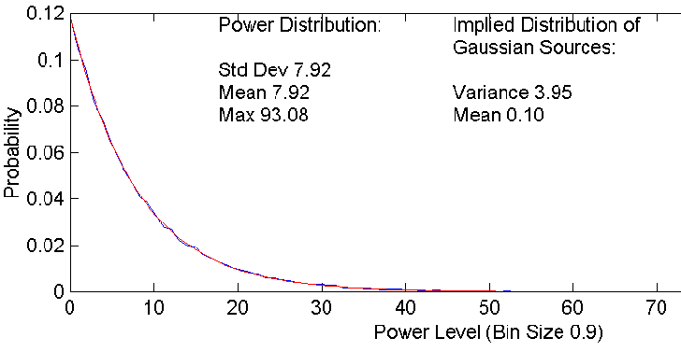

Figure 21: Note that the standard deviation equals the mean, a clear indication of a damped exponential. (from Watson[42])

Yet since power (*E*) is proportional to Amplitude squared, we can derive the probability density function by invoking the chain rule.

This precisely matches the Rayleigh distribution, implying that Rayleigh fits a Maximum Entropy (MaxEnt) distribution. So too does the uniformly random phase in the destructive interference process qualify as a MaxEnt distribution, which will range from 0 to 360 degrees (which gives an alternative derivation of Rayleigh). So all three of the distributions, the Exponential, Rayleigh, and Uniform, work together; and this provides a rather parsimonious application of the maximum entropy principle.

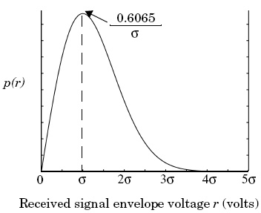

Figure 22: The Rayleigh Distribution of signal strength.

The most interesting implication of an entropic signal strength environment relates to how we deal with this power variation in our electronic devices. In a GPS, a vehicle's navigation system will experience this when trying to acquire a GPS signal from a cold-start. The amount of time it takes to acquire GPS satellites can range from seconds to minutes, and sometimes we don't get a signal at all, especially if we have tree cover with branches swaying in the wind.

Explaining the variable delay in GPS comes out quite cleanly as a fat-tail statistic if we consider how the GPS locks into the set of satellite signals. The solution assumes the entropy variations of the signal strength and integrating this against the search space that the receiver needs to lock-in to the GPS satellites. Since the search space involves time on one axis and frequency in the other, it takes in the limit ~*N 2* steps to decode a solution that identifies a particular satellite signal sequence for a particular unknown starting position. This gets reduced because of the mean number of steps needed on average in the search space. Dynamic programming matrix methods and parallel processing (perhaps using an FFT) can be used to get this to order *N*, so the speed-up for a given rate is *t 2*. So this will take a stochastic amount of time according to the MaxEnt criteria.

However, due to the Rayleigh fading phenomenon, we don’t know how long it will take to integrate our signal with regard to the rate *R*. This rate has a density function proportional to the power level distribution, then according to the rules for marginal distributions the conditionals line up to give the probability of acquiring a signal within time *t*.

This leads to the dispersion result where *a* is an empirically determined number derived from *k* and *c*. This is not considered an extremely fat tail because the acceleration of the search by quadrature tends to mitigate very long times.

**Data Analysis.** Data was collected from a GPS project that has a goal to speed up wild-fire response times by cleverly using remote transponders[43]. They published data for cold-start times as shown in the histogram below. Note that the data shows many times that approach 1000 seconds. The single parameter entropic dispersion fit (a=62 seconds) appears as the blue curve, and it fits the data quite well.

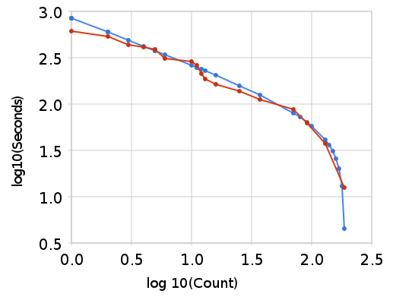

Figure 23: Fit of GPS acquisition times to a dispersive model

Beyond the Rayleigh, we will also find the BesselK PDF, as that is what describes the K-distributed clutter which appears in large regions collected by radar stations against random terrestrial and oceanographic features. The heterogeneous nature of that environment will generate clutter with longer tails than the Rayleigh [7]. The fatter tails of K-distributed clutter has implications for triggering false alarms when trying to distinguish signal from noise [44].

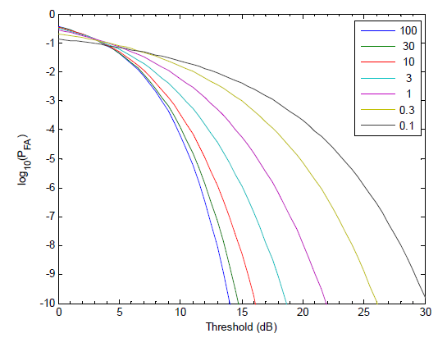

Figure 24: Probability of false alarm for a single pulse return from K-distributed clutter, for different values of the shape parameter ν. Adapted from Bocquet [44]

 Clouds

If we assume that clouds develop by some sort of preferential attachment, then the uncertainties at which the preferential attachment process increases with time balanced against the uncertainties in the critical point contribute to the dispersion. This is an analysis based on work by Yuan at NASA Goddard, “Cloud macroscopic organization: order emerging from randomness” [20]

The cloud size distribution follows a variant of the Zipf-Mandelbrot law, which also fits several other natural characterizations, such as oil field volume[26] and lake size distributions (see next section).

We first assume that water vapor disperses through the atmosphere freely. The rate ***r*** at which it does this we treat as a stochastic variable with a probability density

This introduces two concepts at once: the idea that we do not assume a single rate (i.e. assume instead *dispersion*) together with the idea that we can only assume at best a mean (as the growth rate ***g****) and* to treat the standard deviation as equivalent to the mean. This type of assumption makes the least presuppositions as to what has happened — we know we have a mean value but beyond that, the rate can vary to the maximum entropy limit.

If we next assume that a collection of these rates can act to sweep out a selected uniform unit of volume, then over time we can imagine that a cloud will capture this moisture.

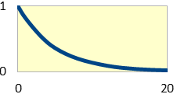

varying rates

capacity

Figure 25: Cloud formation process leads to dispersion in sizes

Suppose that the water vapor diffuses outward, so for a given time period ***t***, the moisture will diffuse over a distance ***x*** = ***r t***, a simple variable change gives

Over time, the probability that some moisture will migrate at least a length *x*0 distance is:

Alternatively, the following relation tells us the cumulative probability of the distance covered by material after time ***t***. This again assumes a distance travelled ***x = r t***.

This relation also crops up in terms of the *population balance equation*. It basically relates a conservation of particles law, in that we do not lose track of any material due to a flow.

So next we have to accumulate this over a volume or depth at which a cloud develops. The simplest approximation assumes that the water droplets get distributed to a mean height (*H*) with a similar exponential distribution — this is like a capacity for the cloud formation (see Figure 25):

Combining the two relations turns into an *a priori* probability for the expected cumulative transfer after time t through the volume. Integrating over the atmospheric layer over which clouds can form, gives the average water volume accumulated:

For the last assumption, we note that if ***t*** gets evenly spread from the over time, then the value ***gt*** becomes the effective collected thickness ***W*** of a distribution of clouds, where we add a factor ***k*** to indicate collection efficiency. Alternatively, we can interpret the stochastic variable ***W*** as the maximum net cloud thickness that would develop over a diffusion time ***t***. The term ***kH*** sets the potential maximum net thickness achievable turning it into a hyperbolic discounting probability distribution.

Or as we first surmised:

The agreement to the collected data is remarkable over several orders of magnitude..

|  |  |
| --- | --- |
| C:\Users\pukitepa\AppData\Local\Microsoft\Windows\Temporary Internet Files\Content.Word\aqua_figure.gif | C:\Users\pukitepa\AppData\Local\Microsoft\Windows\Temporary Internet Files\Content.Word\terra_figure.gif |

Figure 26: Cloud statistics using two different telemetry systems[20]. The same power law holds over several orders of magnitude.

Cloud size modeling may have some limited utility for nominal weather prediction (such as expected durations of shade and estimating the potential for lightning), but it does demonstrate well the wide aleatory uncertainty in a natural phenomena, and how widespread it is.

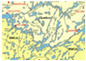 Lake sizes

Our environment shows great diversity in the size and abundance in natural structures. Freshwater lakes accumulate their volume in a dispersive manner. Over geologic time, water drifts into a basin at various rates and over a range in collecting regions. As lakes capture most of their volume through water drainage, one can imagine that the rate of influx plays a factor in how large a lake can become. The Maximum Entropy prediction of the size distribution leads to the following expression, exactly the same as for cloud formation:

Surveys of lake-size show the same reciprocal power law dependence, with the exponent usually appearing arbitrarily close to one. In the Figure 27 below, the data plotted on a ranked plot clearly shows this dependence over several orders of magnitude.

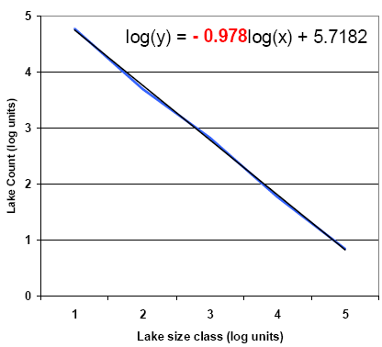

Figure 27: Northern Quebec lakes map and size distribution adapted from Telmer [45].

More revealing is that in Figure 28 below, we can observe the bend in the curve that limits the number of small lakes in exact accordance to the equation shown above. The agreement with such a simple model suggests that of a universal behavior.

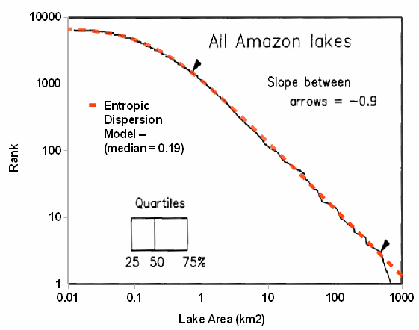

Figure 28: Amazon lake size distribution from “Estimation of the fractal dimension of terrain from Lake Size Distributions”[46]

This general trend is repeated for lakes around the world. All that is required is to have a median value for lake area and the rest of the distribution will rougly scale to this factor.

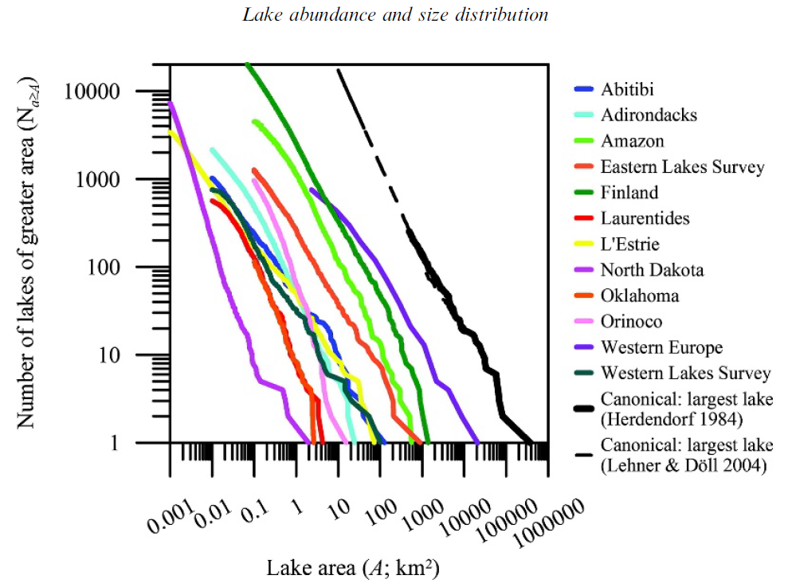

Figure 29: Near universal scaling of lake size distributions across the world [21]

Models of lake size distribution may have utility for vehicle fording and amphibious vehicle simulations.

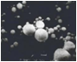 Particulates

The role of entropy overrides other factors enough so that some simple dispersion arguments can explain the size distribution completely. Take as an example the formation of ice crystals in a cirrus cloud. Depending on the surrounding temperature, a crystal nucleates on some foreign particle and then starts growing. The atmospheric conditions have enough variety that the growth rate will disperse to the maximum entropy amount given a mean rate value. The end state for volumetric growth will also show the same amount of variation, where x is the size variate and S is the mean size.

The following particle size distribution (PSD) graph, Figure 30, shows measurements taken from high altitude cloud experiments [47][48][22]. The size gets measured along a single length dimension and the density of the particles takes the place of a probability.

The main profile follows a power-law in volumetric growth, where *S*is the median volume (see [26]):

Crystal sizes get reported as a length and we have to convert that to a volume. This means the derivative has to include a chain rule to convert the volume x to a length parameter L, x ~ L3 generates dx/dL ~ L2.

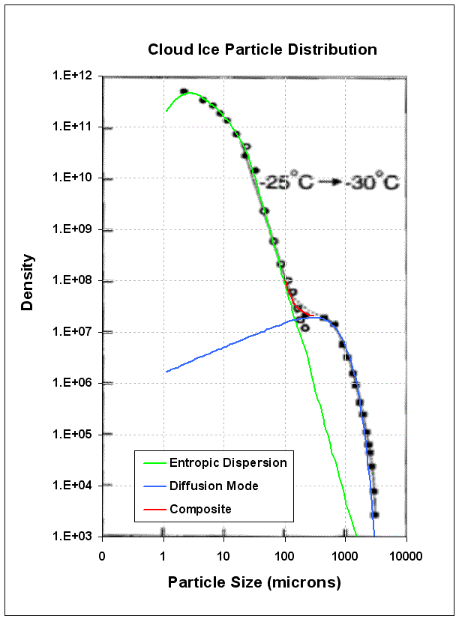

Figure 30: Cloud ice particle number density n(D) vs. the long dimension of particles as observed at the temperature range of - 25C and -30 C (from Platt[47]]). It shows a bimodal structure in the ice crystal distribution with the second peak at ~500 microns.

The data fits the dispersion model nicely (green line), but notice at low density that an extra mode shows up as the blue line. This clearly has a sharp exponential drop so likely has a non-dispersive origin. In terms of the higher density entropic model, this stands out as an ordered nucleation regime in the midst of a sea of disordered ice crystal growth modes. Applying a prior distribution is similar to integrating profiles of different weight (aka *superstatistics*) to come up with a power-law as shown below. By comparing this to the empirical sized distribution one can see how a distinct peak could occur.

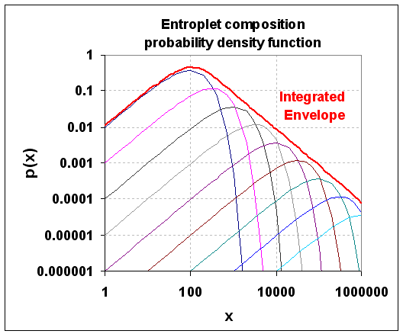

Figure 31: Superposition of exponential density profiles leads to a entropic dispersion envelope. The maximum entropy distribution as a prior distribution acts to smooth the envelope, but a strong component could stand out. Indeed this is typical in particle size distributions.

Physically why does this bump occur? Some unknown nucleation process has provided an optimal growth environment for these crystals to deviate from the entropic distribution. Hypothesizing, this could take the form of a catalyst or an accommodating growth substrate. With a power tail of -3/2 this might well have a strong diffusive growth component. However, the nuclei occur rarely enough so they do not drown out the much more common random or spontaneously occurring growth centers. It thus shows up as a clear non-dispersive growth mode in a sea of non-uniformity.

On a micro-level, we do have a population of reproducible structured shapes to bind against — as the airborne particulate world shows some uniformity in its density. This original analysis may prove of some help to those looking at particle size distributions of volcanic ash (see the figure below). Researchers routinely apply a log-normal fit to the data — yet one that uses a MaxEnt dispersion formulation with the appropriate volume/diameter exponent often can work just as well. Below, we use a root 1/2 dispersive growth rate on volume which may indicate a diffusion-controlled rate.

To account for wear/tear/corrosion modeling, one could apply particulate and ash models (Figure 32 and Figure 33, the latter featuring multi-modal size features) that feed into models for physical breakdown.

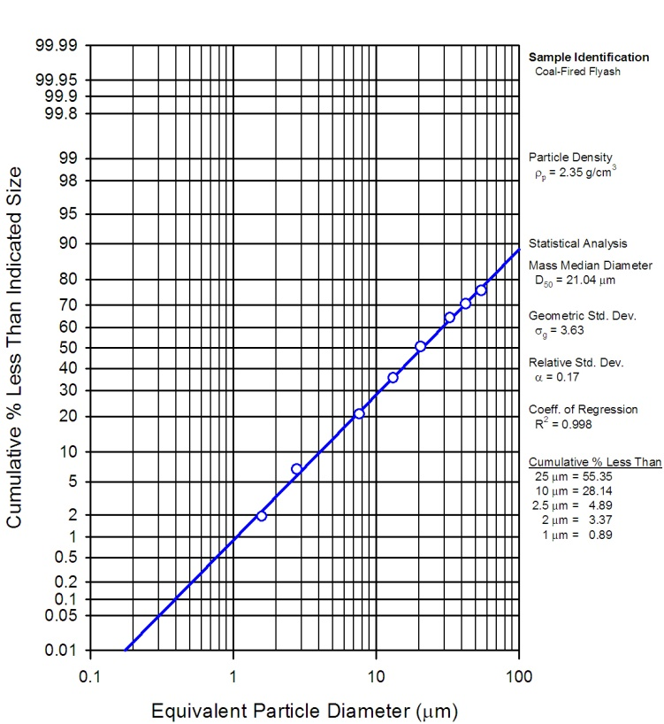

Figure 32: Wiki data for fly ash size distribution[49].

The signature feature of volcanic ash plumes is that they have dense populations of certain sized particulates (Figure 33), having derived from a homogeneous environment.

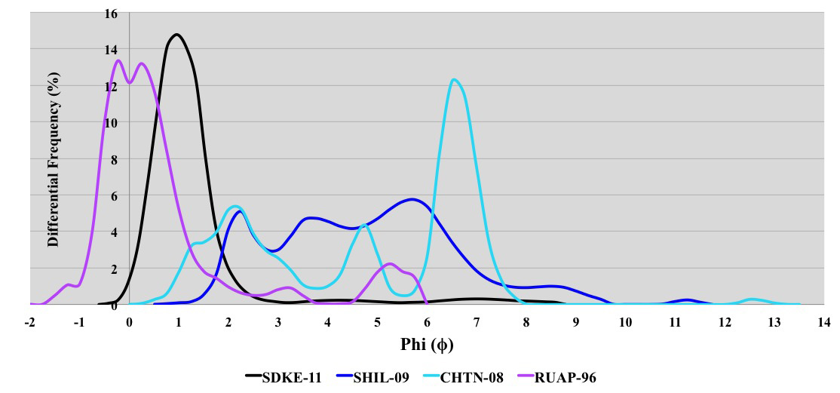

Figure 33: Volcanic Ash [50]. This is on the Krumbein phi (φ) particle size scale [51] which is negative of the log base 2 of the particle diameter. That means smaller diameters are to the right side of the scale.

Discussion

This study has described the characterization and modeling of natural phenomena in a form suitable for contextual use. We have provided examples of slope distribution, wind speed, rainfall rates, lake sizes, etc. Most of the models reduce to fairly simple analytical forms.

The probability measures derived from theory and applied to the data are often snapshots in time of a continuous growth process. Physical processes can accumulate or discard material following rates of material flow. While this may seem overly simplistic to consider, it does set the stage for revealing patterns in behavior.

For example, a statistically measured volume could be the result of various rates operating over varying time spans. Along with this variation, the concept of an average or mean value plays a role into modeling the behavior.

Generally speaking, two categories of models exist:

* *Models of variations around a mean energy*: Measures are bound by uncertainty in the mean energy value of a measured value, such as wind, rainfall rate, clutter, terrain slopes, wave crest height; these all generate the same universal curve, the ubiquitous modified Bessel of the second kind.
* *Models of variations around a rate and enclosed volume*: Several measures are bound by considerations of the rate of accumulation and the uncertainty of the eventual volume: such as clouds, particles, and lake sizes give the same entropic power law.[[172]](#footnote-172)

We also described how the statistical spreads come about, via the concept of dispersion and maximum entropy. One of the outcomes of modeling is that a significant amount of data, 5 billion in the case of USA terrain and several hundred million for just the Lake Michigan wave data, can be expressed in a much more concise form.[[173]](#footnote-173) This has a practical implication of allowing a terse model to summarized voluminous data to usefully assess candidate engineering designs. Further, as these models are parameterized by physical variables such as mean energy, the concise formulation allows exploration of extreme conditions extrapolated from but not exemplified by existing data sets.

Sampling approaches for simulation are often very straightforward for these distributions. We described several efficient applications of random sampling for transcendental functions such as the BesselK. We can further apply techniques such as importance sampling to reduce the sample size needed or to reduce the variance of the statistics.

In certain cases it may be possible to invert the stochastic models in order to support assessment of assume-guarantee conditions on component engineering models and to derive Probabilistic Certificates of Correctness (PCCs). The classical case is for normal distributions, but for fat-tail distributions such as the hyperbolic power law, this is also rather straightforward. To make sampling efficient, particularly for rare events, techniques such as importance sampling may be required. If a probability for a certain state is 10 orders of magnitude more rare than the most frequent state, the rule of thumb is that 1010 more samples may be required to catch this event. Importance sampling can cut the required number of samples down if the density function is well-characterized.

The fact that many of these models follow similar patterns makes it them useful for model automation. Abstract interfaces for common distributions such as the BesselK and hyperbolic power law can be generated and are of broad utility (see Volume 4).

Other characterization techniques such as the multiscale entropy measure[52] can be applied to temporal and spatial scales covering a wide dynamic range. This reveals the amount of disorder and uncertainty in the data, which is important as a quick characterization metric.

Summary and path forward

In general, support for context modeling and the general notion of Internet-based data collection allows us to leverage a vast amount available data and reduce its dimensionality and scope by careful characterization and modeling. Certain elementary characteristics related to probability density functions were covered in this paper.

Frequency characteristics and correlations will be described in the second paper in this series, “Terrain Characterization” (see Volume 2).

The third paper in this series, “Diffusive Growth” uses universal principles to apply the same pattern to characterize other disparate natural phenomenon, such as corrosion and thermal dispersion (see Volume 3).

Furthermore, by applying ontology-based approaches for organizing models and techniques we can set the stage for broader collections of such models discoverable by a general community of designers and analysts. Together with standard access protocols for context modeling these innovations provide the promise of making environmental context models generally available and reusable, significantly assisting the routine application of model based engineering. That is the scope of the fourth paper in this series (see Volume 4).

**Abstract:** Environmental models of growth processes contain a great deal of uncertainty. Since the underlying process behavior is rarely well-ordered, any model characteristics will carry along with it a level of aleatory uncertainty governed by the natural disorder. This paper applies novel uncertainty quantification approaches to classes of diffusion problems which illustrate the benefit of assuming natural variability, such as varying rates of oxidation and corrosion.

Introduction

Modeling with uncertainty quantification has application to such phenomena as oxidation, corrosion, thermal response, and particulate growth. These fall into the classes of phenomena governed substantially by diffusional processes. At its most fundamental, diffusion is a model of a random walk. Without a strong convection or advection term to guide the process (e.g. provided by an electric or gravitational field), the kinetic mechanism of a particle generates a random trajectory that is well understood based on statistical physics principles. The standard physics approach is to solve a master diffusion equation under transient conditions. This turns into a kernel solution that we can apply to an arbitrary forcing function, such as provided by an input material flux or thermal impulse.

Yet, the environment that the particle resides in may not be as homogeneous as the ideal diffusion model would imply. Enough uncertainty in the essential diffusion parameters may exist that we need to ask some fundamental questions:

* Why do we assume the diffusion coefficient is a constant?
* How can we know the diffusional interface so precisely?

Within a heterogeneous media, the characteristic diffusion coefficient does not have to remain a fixed value. Varying material composition and amounts of defects can modulate the natural hopping rate and thus smear the diffusion coefficient well beyond the narrow tolerance that is typically assumed. In general, the assumption of a single diffusion coefficient works well for many behaviors ─ as the observed results are already smeared due to diffusion, while a greater level of uncertainty will not change the mean value of the diffused measures. This mean value approximation works well as a result of applying the central limit theorem of statistics.

Yet, under certain circumstances, the uncertainty in the diffusion coefficient or uncertainty in the experimental geometry will have a subtle yet measurable impact on the diffusional transient behavior. This departure from ideality usually occurs over the short initial growth time, but will also manifest itself via the application of a modified impulse response function.

As an example, if we consider the heat equation, which models the thermal evolution of a transient heat impulse, we immediately note that the standard solution admits an infinite speed of propagation of the initial thermal transient, due to a singularity in the kernel solution expression. That first random walk step is instantaneous according to the math, yet we need to either integrate this transient out or invoke a model such as relativistic diffusion [1][2] to account for the real system behavior. Furthermore, *and just as plausibly*, the initial transient is likely modified by unaccounted natural uncertainty and disorder in the thermal characteristics and environment, i.e. within the *thermal context*.

This uncertainty also manifests itself in other diffusion models. Deviations from the expected Fickian diffusional growth model lead to the Deal-Grove model[3] for Si oxide growth on a silicon wafer as a practical yet non-ideal heuristic.

In this paper, we apply straight-forward uncertainty quantification. The essential idea is to admit some uncertainty in the diffusion coefficient and in the interface location. By propagating the uncertainty into the diffusion response, certain issues disappear. For example, the infinite speed becomes finite and the kernel solution comes out very clean. This becomes part of the initial condition uncertainty that we know must exist in practice.

In the following work we apply two levels of uncertainty

* Vary the diffusion coefficient to maximum uncertainty with known mean
* Vary the diffusional interface to maximum uncertainty with known mean

As a result we generate a simple diffusion kernel that is much easier to reason with, and can explain several subtle anomalous diffusion behaviors

Example: SiO2 growth

We first consider the well-known characterization of silicon dioxide, SiO2 as an example of dispersive growth. Originally characterized by Bruce Deal and Andrew Grove in the 1960’s, a careful application of a diffusion-based oxide growth model partially enabled the semiconductor revolution. As illustrated in **Figure 1**, the Deal-Grove model works as a heuristic model in so far as a rigorous first-principles derivation does not exist.



**Figure 1:** Chemical simulation of oxidation of silicon. A large degree of disorder is evidenced by the mixture of pure Si, SiO2, and SiO and as indicated in the histograms by light gray bars, green bars, and red bars, respectively. Black and red arrows indicate the growth direction of the oxidized and silica (SiO) layers, respectively (from [4])

The following derivation improves on the Deal-Grove model by assuming that the diffusion coefficient and location of the growing oxide layer is smeared by a maximum entropy amount; i.e. we can estimate the mean but we leave higher-order moments to vary to maximize the entropy.

Diffusion Solution

The standard approach for solving diffusion problems starts from master diffusion equation

|  |  |
| --- | --- |
|  | (1) |

also known as Fokker-Planck, this is a one-dimensional representation and only lacks the convective or drift term from the general formulation of Fokker-Planck. We also assume that *D* does not change with respect to spatial coordinates.

We can easily derive the solution of the response function if we think of the diffusion from a planar source outward. The kernel solution gives:

|  |  |
| --- | --- |
|  | (2) |

We place an impulse of reactants at x=0 and want to watch the evolution of the con­centration, *n*, with time. As the concentration drops, we assume that the diffused material from that amount contributes to the growth of the oxide layer.



**Figure 2:** Mechanism for diffusion (from [5])

Consider first that the kernel function represents a one-dimensional concentration profile, in units of number of atomic elements per thickness. The expression *n(t,x)* describes how quickly the atomic concentration decreases from its initial value. So the accumulated concentration, representing the growth outward from the interface, is the spatial integral of the concentration density. Early on we assume that the region of the interface is spread over a width *X*.

|  |  |  |  |
| --- | --- | --- | --- |
| |  |  | | --- | --- | |  | (3) | |  |

The average flux of atoms outward from the interface, *J(t|X, D)*, is proportional to the gradient of *n*, and we apply the diffusion coefficient as the standard proportionality term at position *X*:

|  |  |
| --- | --- |
|  | (4) |

Next, suppose we have an idea of a mean value for the diffusion coefficient, *D*, but don’t know how much it varies. Lacking that information, we apply a maximum entropy estimate for the variance assuming a mean value *D0*.

|  |  |  |  |
| --- | --- | --- | --- |
| |  |  | | --- | --- | |  | (5) | |  |

We can then integrate the concentration across the diffusion probability density function, and the solution reduces to:

|  |  |  |  |
| --- | --- | --- | --- |
| |  |  | | --- | --- | |  | (6) | |  |

We also need to consider that for a highly disordered layer, we should place a max­imum uncertainty around the value of *X*.

|  |  |
| --- | --- |
|  | (7) |

Once again we can apply a probability density function, this time to the flux, which marginalizes *X* according to the following integration:

|  |  |
| --- | --- |
|  | (8) |

As a last step, we need to integrate the average flux over time to arrive at the grow­ing width, *W*, of the oxide layer:

|  |  |  |  |
| --- | --- | --- | --- |
| |  |  | | --- | --- | |  | (9) | |  |

The time integral of this flux is the accumulated concentration of material with a constant inflow of material (i.e. molecular or elemental oxygen) from the surround­ings. By integrating the diffusional response, we can demonstrate how the step input transiently supplies reactants to the growing interface. The second factor is the newly realized suppressive effect due to disorder. For small *t*, this compensates the lead term to pro­vide a linear growth factor, which is the original heuristic in the Deal-Grove growth law.

In summary, we applied a two step maximum entropy estimation process to model the disorder in the growing oxide layer. Without any knowledge about the distribu­tion of *D* and *X*, apart from asserting that they must exist, we applied the following series of trans­forms:

|  |  |  |  |
| --- | --- | --- | --- |
| |  |  | | --- | --- | |  | (10) | |  |

This provides a diffusional response due to a continuously applied step concentra­tion to model a growing thickness. For oxide growth, a step input of oxygen is sup­plied from one side of the interface, and the substrate supplies silicon atoms, see **Figure 2.** The figure below provides a model fit to recent data from a set of SiO2 growth experiments.



**Figure 3**: Comparison of dispersive diffusion model against the convention Deal- Grove model (empirical dotted) and a detailed simulation based on reaction kinetics. For silicon, an immediate oxide layer is formed which generates a baseline thickness of about 1 nanometer (data and simulation from [5])

Over time, the response will attain a square root growth law, indicative of the Fick's law regime of what is often referred to as parabolic growth[[174]](#footnote-174). The larger the mean diffusion coefficient or the smaller the uncertainty level *x0*, the more quickly that the response will diverge from the short-term linear growth regime.



**Figure 4**: In the Fickian growth regime, the dispersive diffusion formulation follows a square- root time dependence, and can be confirmed with an online SiO2 growth calculator[[175]](#footnote-175)

General Applicability

The uncertainty quantification proposed here has more general applicability than just to oxide growth on silicon. Any diffusional process that contains a degree of uncertainty in its parameters is a candidate for this simplification.

The general dispersed response to an impulse at the smeared origin is generated by the marginalization of Eq. 2 with Eq.5 and Eq.7 with the result:

|  |  |
| --- | --- |
|  | (11) |

This describes the damping of the peak concentration profile with time, cast in terms of a one-dimensional density. Alternatively, by scaling with a time constant, the impulse response can be normalized:

|  |  |
| --- | --- |
|  | (12) |

Here, is a diffusional time constant, indicating how slowly the concentration disperses from the origin. This is also a measure of the persistence of a material to remain localized (see [6]). The scaling implications are important to allow us to generalize the behavior over a range of conditions [7].

In fact, the dispersive formulation can extend to mathematically related behaviors such as corrosion and particulate growth. Corrosion acts very similar to oxidation in that the rate of the corrosive materials has to depend on diffusion of the reacting species with the replenishment of fresh substrate. Further, we can evaluate how well this applies to thermal diffusion, which uses the heat equation in a mathematical formulation very similar to particle diffusion.

Example: Thermal Dispersive Diffusion

The master model for thermal diffusion is referred to as the *heat equation*. This has the same formulation as Eq(1) with the role of material concentration played by temperature (which represents the local thermal excitation). In many practical applications, we may want to know the dissipation of heat from a source. In the case of a planar source of heat such as the surface of a CPU, we can use a one-dimensional model to illustrate the principle. Or we can demonstrate the flow of heat through a rod for different thermal conductivities (see **Figure 5**).

The ideal non-disordered impulse response should follow

|  |  |
| --- | --- |
|  | (13) |

The disordered variation of this is

|  |  |
| --- | --- |
|  | (14) |

Since each of the rods consists of a uniform homogeneous metal, one would expect that the response should be near to what theory predicts, and that is the case [8] .

For each of the materials of **Figure 5**, the idealized impulse response works well (Eq. 13), while the disordered variant (Eq. 14) reveals a larger dispersive spread.

**Figure 5**: Experimentally measure thermal diffusion profiles for various metals showing excellent agreement with ordered diffusion. The dispersed diffusion profile is shown alongside.

Where we would like to apply the disordered response is to an interface that has a thermal stimulus on one side and an outlet on the other, which turns out to be a realization of a compartmental or box model for thermal dynamics.



**Figure 6:** A box model for thermal dynamics assumes a stimulus representing an initial transient (1) convolved against a dissipative transfer function (2) to produce a modulated response (3).

The role of the box model is to model a thermal input along with a response which will allow an alternate path for dissipation of heat. In **Figure 6**, the input stimulus is a unit step which immediately creates a Fickian square root buildup near the interface (subgraph 1). This gets dissipated by a smeared impulse response function (subgraph 2) and the result is shown as a modulated response (subgraph 3) showing a slower buildup than the square root rise. The modulated reduction results from heat that is dissipated from non-specific paths as described in [8], described by **Figure 7**.

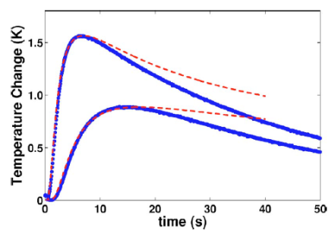

**Figure 7:** Red lines indicate the theoretical profile under a non-lossy thermal environment.

To analyze the thermal response we use the concept of a convolution to drive the response from a combination of input delta temperature change and the transfer function representing heat dissiation following secondary paths.

|  |  |
| --- | --- |
|  | (15) |

At the origin of the thermal impulse, the smeared diffusive response is:

|  |  |
| --- | --- |
|  | (16) |

This agrees with measurements from experiments, as shown in **Figure 8**.

.

**Figure 8:** Impulse response from a unit step thermal stimulus applied to an earthen mass (data from [9][10] ).

If we take a strong dispersive diffusive decline and convolve with a Fickian growth curve to model the loss:

|  |  |
| --- | --- |
|  | (17) |

The result is a modulated response:

|  |  |  |
| --- | --- | --- |
|  |  | (18) |
|  |  |  |

A contour of the response surface is shown in **Figure 9**.

**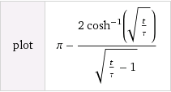**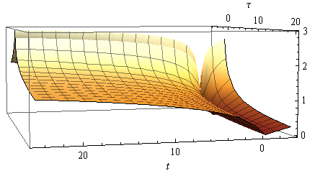

**Figure 9:** Response surface of the dissipative dispersion function

This formulation accounts for the dispersed heat losses arising from diffusion through dispersed paths.

**Figure 10**: Dispersed impulse response measured away from the stimulus. Note the crossover point separating the cosh -1( ) and cos -1 ( ) behavior (from [11]).

By applying a sequence of thermal impulse steps we can demonstrate how to model piecewise transients (see **Figure 11**).



**Figure 11**: Series of hot and cold unit step impulses applied to an earthen mass measured as a transient response (data from [10] to a groundwater (GW) or reference sink.

In addition to the utility for large scale geothermal transients as just described, we can also apply this dispersive thermal approach to smaller scale contexts, such as a component or subsystem heat sink. **Figure 12** shows typical thermal transients observed under various dissipation paths for a powered-up CPU card. Depending on whether the environment contains a well defined heat sink and cased enclosure, the transient will display markedly different apparent time constants. This by itself is not too surprising, but the dispersive diffusion response allows us a simple model to match up with the empirical results. In particular, where we have uncertainty in the environment, this approach excels, as it only requires a mean value estimate for the composite thermal diffusion coefficient or conductivity.



**Figure 12**: Thermal transients observed within a CPU housing.

Example: Corrosive Growth

The salient principle behind the corrosion of metals is that rust growth mirrors that of the oxide growth of silicon. The number of random environmental factors involved in corrosion suggests that it would make an ideal candidate to apply the dispersive diffusion model. In the oxidation of steel, several different varieties of oxide are involved with varied atmospheric levels of corrosive reagents.

**Figure 13** (linear scale) and **Figure 14** (log scale) show an oxide growth model and the results of experimental measurements for a steel composed structure left to weather under different climatic conditions. The behavior specified in Eq(7) was applied directly to the data with assumed mean values for an effective diffusion coefficient.

**Figure 13:** Corrosion growth rates on a linear scale

Uncontrolled rusting also has the propensity for peeling off thick layers, thus exposing fresh layers which will start the oxidation process over again. That tendency allows for the possibility for a growth power law of ½ combining with a linear growth law leading to the rough 0.7 power law observed. This is the same rate observed for the dispersive diffusion model with an uncertainty in the transition zone during the early oxidation process, see Eq(9) rewritten below with ***x*** representing the corrosion depth.

|  |  |
| --- | --- |
|  | (19) |

The dynamic range is limited but the rate of growth suggests an initial linear regime, which then bends into the mixed power law growth of Eq(19). The model works well for the highly corrosive regimes of *marine* and *industrial* environments but diverges for the milder environments at longer times.

**Figure 14**: Corrosion growth rates on log scale compared against data from [12].

**Ornstein-Uhlenbeck correction:** Due to its origins as a random walk process, a pure diffusion model of particles will show unbounded excursions given a long enough time duration. This is characterized by the unbounded Fickian growth law showing a dependence for a pure random walk with a single diffusivity.

In practice, the physical environment of a particle may prevent unbounded excursions. It is physically possible that the environment may impose limiting effects on the extent of motion, or that it will place some form of drag on the particle’s hopping rate the further it moves away from a mean starting value.

We can use the Ornstein-Uhlenbeck process to model mathematically how this pure random walk becomes bounded. The Ornstein-Uhlenbeck process has its origins in the modeling of Brownian motion with a special “reversion to the mean” property in motion excursions. The following expression shows the stationary marginal probability given a stochastic differential equation which models a drag on an excursion [13]

The rationale for this limiting process to occur in a corrosive environment may arise from a barrier to diffusion beyond a certain critical thickness. As we demonstrated in volume 2 (see Appendix B), the Ornstein-Uhlenbeck process is very common at both gross and granular scales when it comes to describing terrain excursions, and the same process likely occurs at micro scales – perhaps occurring in a similar fashion to when it was first formulated to describe Brownian motion in the presence of drag on particle velocities.

The O-U correction is straight-forward to apply on our dispersive corrosive growth formulation, we only need apply a non-linear transformation to the time-scale.

and then apply this to the corrosion growth Eq(19):

This has the equivalent effect of appearing to slow down time at an exponential rate. This exponential rate turns out to be much faster than the Fickian growth law can sustain, so that an asymptotic limit is achieved in the diffusional or corrosive growth extent.

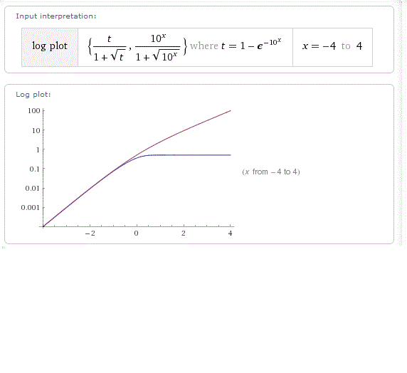

**Figure 15:** The reversion to the mean process of the Ornstein-Uhlenbeck process will limit the growth of a diffusional process

The caveat on this is that we are only applying this correction based on empirical observations. As an example, if the corrosion appears to flatten out as observed in the *urban* and *rural* rates of corrosion in **Figure 14**, we can model this behavior by assuming an Ornstein-Uhlenbeck reversion-to-the-mean process. In **Figure 16** below we apply the O-U limiting factor to model these two least corrosive environments.

As an explanation for a limiting effect on corrosive growth, it may be that a protective oxide — think in terms of something akin to the self-limiting growth of aluminum oxide Al2O3 — or perhaps some anodizing agent which forms after some time duration to limit further growth.

Whatever the rationale, the result of our characterization suggests that a rather simple formulation can be used to model the corrosive growth laws, with enough flexibility to handle the observed growth profiles.

Table 5: Parameterization for the corrosion model with Ornstein-Uhlenbeck reversion-to-the-mean drag, a.

|  |  |  |  |  |  |
| --- | --- | --- | --- | --- | --- |
|  | Marine(severe) | Industrial | Marine(mild) | Urban | Rural |
| D | 90,000 | 45,000 | 12,000 | 6,800 | 5,300 |
| X0 | 600 | 400 | 100 | 50 | 500 |
| a | 1.00E-08 | 1.00E-08 | 1.00E-08 | 0.4 | 0.2 |

**Figure 16**: Model fits assuming the Ornstein-Uhlenbeck process. The urban and rural corrosion rates show a stronger asymptotic trend, indicating a reversion to the mean.

In the following we consider examples on a larger scale which show the generality of the dispersion characterization technique and how Ornstein-Uhlenbeck process may apply.

*Example* : Diffusive Flow from Hydraulically Fractured Volumes

Recently, oil and natural gas extraction has shifted from conventional techniques to unconventional approaches as depletion of natural reserves sets in [6][14][15][16]. The replacement approaches rely on novel mechanisms to enhance the recovery of what is often referred to as *tight oil* within less-porous and permeable deposits of shale and limestone.

The most common technique involves the hydraulically-induced fracturing of shale deposits. The fracturing of shale into crevices and fissures allows the trapped oil and natural gas to escape along random seams to collection points along the horizontally aligned drilling path. **Figure 17** illustrates the behavior that the trapped oil will show when released from the trapped state. As the fracturing reveals a random pattern of paths, the flow of oil will also reveal a random diffusional flow away from the regions of originally high concentration as it follows the random paths.

**Figure 17 :** Diffusional Flow from fractured porous media

Captured  
diffusional flow



***x***

The cross-sectional capture of oil is represented mathematically as the integrated flow of oil away from a dispersed volume of point sources. The uncertainty both in (1) the volumetric extent and (2) the variable diffusivity within a multiphase porous media, makes the analysis amenable to similar MaxEnt formulations used to describe diffusion-assisted oxide growth described earlier in this paper.

**Figure 18** below shows the application of the dispersive diffusive flow derived in Eq. 12 to the cumulative production of a typical Bakken well [17]. The two parameters of the model, a median diffusion time and a scaling cumulative were adjusted to give the smallest residual error to the data.

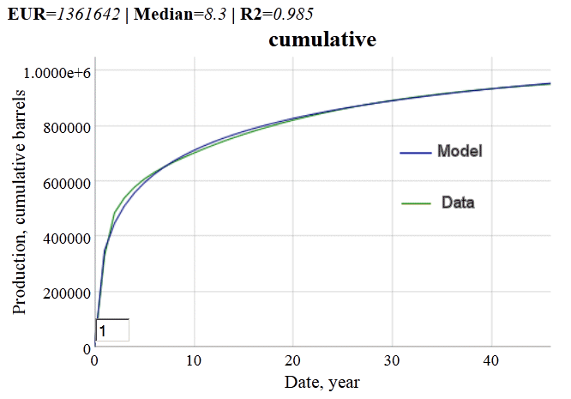

**Figure 18**: Cumulative production from what is referred to as a typical hydraulically fractured well in the Bakken shale formation of North Dakota. The cumulative production was monitored as a function of time from the start of extraction.

Not every well will show this good an agreement with the model (see the Annex for an independent and unbiased substantiation of the model fit), since what are referred to as “above ground” decisions can modulate the flow of oil, but in terms of a statistical average, this formulation can prove useful to estimate the *expected ultimate recovery* (EUR) of the typical well, after a few initial data points become available.

|  |  |
| --- | --- |
|  |  |

The model shown as Eq. 12 can be linearized to the following form, where *P(t)* indicates cumulative production and *n0* is the ultimate production:

|  |  |
| --- | --- |
|  |  |

When plotted and a least-squares regression is applied, the value of the intercept generates the reciprocal of the EUR, as shown below:

**Figure 19**: Linearization of diffusive model generates an estimate of ultimate recovery.

Another “typical” well from the North Dakota Industrial Commission report [18] does not show as good agrement with the classical dispersed diffusion model (see **Figure 20**), but when Eq. 12 is modified by the reversion-to-the-mean characteristic of an Ornstein-Uhlenbeck process, the fit markedly improves while the expected cumulative is cut nearly in half in this particular case.

The drag-factor-limited diffusion in the O-U process essentially prevents the oil from traveling too far from its starting point, thus limiting the collection of oil at the well bore. The classical diffusion model thus provides an optimistic projection of ultimate recovery, while the O-U model generates a pessimistic prediction. Unfortunately, the inflection point is only visible after a sufficient duration has elapsed, meaning that the linearization technique is not as effective.

**Figure 20**: The Ornstein-Uhlenbeck process suppresses the diffusional flow by limiting the extent at which the mobile solute can travel, thus generating a constrained asymptote below that of drag-free diffusion.

Besides oil, this model has applicability to hydrolically fractured natural gas production, as that it likely follows a similar diffusion process as for oxide and corrosion growth. This is a single impulse response profile. A typical decline curve from a set of shale gas wells is shown in **Figure 21** (see page 59 of [19]).

|  |  |
| --- | --- |
|  | *Data source* |

**Figure 21**: Typical decline curve for Barnett shale gas wells, based on the last five years of data from[19]. From the fit to the curve, production may have started on average 3 months prior to the first month plotted.

The data source description states that the numbers were taken from the most recent 5 years of production. Since we do not know the start date, we add a term ***t0*** to indicate this uncertainty. The instantaneous production is the derivative of the cumulative:

|  |  |
| --- | --- |
|  |  |

As a best fit, the median is 203 months or 16.9 years and ***t0*** is 3 months, with ***n0*** = 3.7 trillion ft3.

The general trend described by the diffusive model is also supported by recent studies of shale gas located in the Barnett formation, where they report that “decline rate is the function of permeability, porosity and well depth and is proportional to ” [20]. This agrees with the above formula for small times.

Petroleum engineers and geologists who specialize in fossil fuel reservoir modeling likely have similar analyses and heuristics (such as hyperbolic decline models) at their disposal, yet the dispersive diffusive model provides a useful explanation to the layman interested in future oil and natural gas supplies of a finitely constrained resource [6]. For example, the number of fractured wells showing a diffusive fall-off needed to keep up with demand leads to a *Red Queen* race of extraction activity [21][22][23].

*Example* : Diffusive Sequestering of Carbon Dioxide

The life-blood of the earth’s biota is the carbon cycle. Elemental carbon resides in the land, aquatic, and atmospheric realms, and is continuously interchanged into various molecular forms as flora and fauna process other carbon-based lifeforms or extract what they can from the environment.

The addition of excess carbon into the atmospheric environment is not automatically handled by the biota, as they have been ecologically tuned to deal with the steady state value of around 280 to 300 PPM (parts per million) through gradual evolution and regional adaptation. This becomes a critical issue as the emitted carbon turns into carbon dioxide (CO2) which acts as a greenhouse gas and can contribute to global warming and climate change[24][25]. **Figure 22** below estimates the gross amount of carbon emitted to the atmosphere over the years [26].

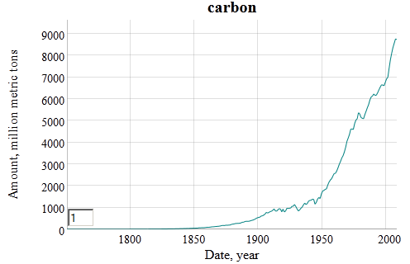

**Figure 22**: Industrial carbon outputs estimated since 1850, data supplied from [27]

The estimated time it takes for CO2 to be sequestered has been modeled as a multiple-pathway mechanism, referred to as the Bern model [28][29]. By applying the same model we use for dispersive diffusion we can align the somewhat complex Bern model with a relatively simple two-parameter equivalent as shown in **Figure 23** below. We also apply the Ornstein-Uhlenbeck limiting factor to emulate the strong negative drag to diffusional sequestering after 500 years. Diffusion and drag both contribute to the fat-tail that naïve first-order sequestering models ignore [30].

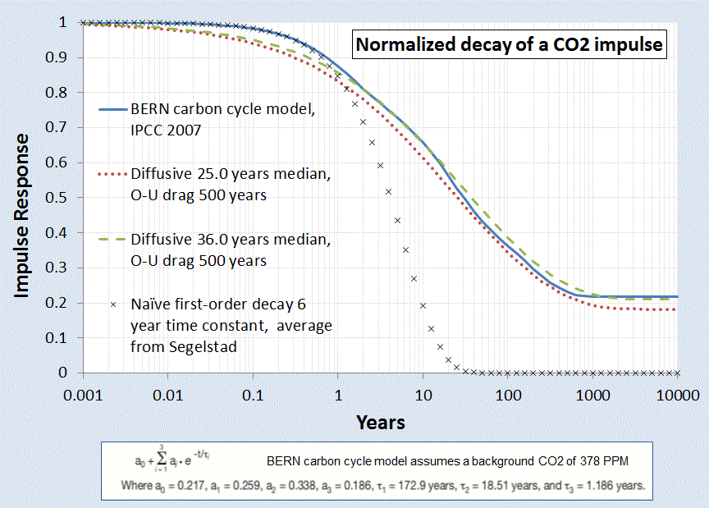

**Figure 23**: Impulse Response of the sequestering of Carbon Dioxide to a normalized stimulus. The solid blue curve represents the generally accepted model, while the dashed and dotted curves represent the dispersive diffsuion model

The CO2 evolution is mathematically descibed as the convolution of the carbon stimulus with the impulse response of CO2 sequestering.

|  |  |
| --- | --- |
|  |  |

The baseline CO2 level has a temperature, *T*, dependence which reflects the seasonal and climatic changes. But apart from this factor, the large fraction of attributable increase of excess atmospheric CO results from the essential convolution of **Figure 22** and **Figure 23** along with a temperature dependence (0.21 eV solubility activation energy [31][32] and temperature data from [33]) which then produces **Figure 24**.

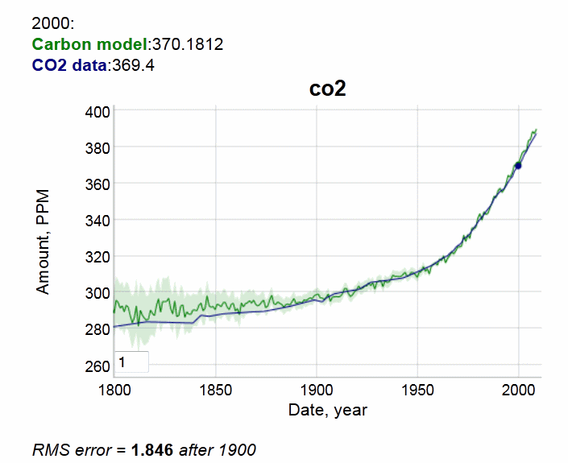

**Figure 24**: The remainder of CO2 that is not sequestered by natural processes contributes to the excess atmospheric concentration measured by climatologists. The solid blue line is data derived from sensor readings from Mauna Loa since 1958 and patched with older historical records [34]

The global concern that this model reveals is that the inertia to changes in carbon emission influence the excess CO2 only gradually. Because of the fat-tail due to slow diffusional sequestering, the excess CO2 will continue to build-up despite the cessation of emissions [35][6].

*Example:* Ocean Heat Content Model

The ocean heat content continues to increase and perhaps accelerate[36], as expected due to global warming. Much of the reduction in global temperature and especially land versus ocean surface temperatures results from significant heat sinking characteristics of the oceans[37].

[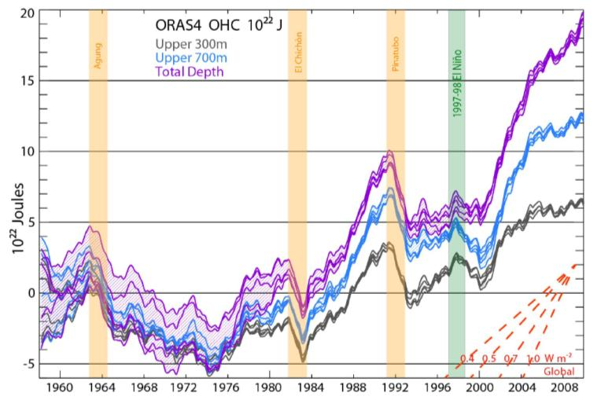](http://www.skepticalscience.com/pics/BTK13Fig1.jpg)

**Figure 25**: Ocean Heat Content from BTK [36]

The objective is to create a simple model which tracks the transient growth as shown in the recent paper by Balmaseda, Trenberth, and Källén (BTK) [36] and described in **Figure 25.**

We will assume a diffusive flow of heat as described in J.Hansen’s 1981 paper [2]. In general, the diffusion of heat is qualitatively playing out according to the way Fick’s law would apply to a heat sink. Hansen also volunteered an effective diffusion that should apply, set to a round number value of 1 cm2/second.  
  
In the following we provide a mathematical explanation which works its way from first principles to come up with an *uncertainty-quantified* formulation. After that we present a first-order sanity check to the approximation.

We have three depths that we are looking at for heat accumulation (in addition to a surface layer which gives only a sea-surface temperature or SST). These are given as depths to 300 meters, to 700 meters, and down to infinity (or 2000 meters from another source [38]), as charted on **Figure 25**.  
  
We assume that excess heat (mostly infrared from the greenhouse effect) is injected into the ocean's surface and works its way down through the depths by an effective diffusion coefficient.  The kernel transient solution to the planar heat equation is given by Eq. 13. In this case *D* is the thermal diffusion coefficient, and *x* is the depth.  The delta temperature is related to a thermal energy or heat through the heat capacity of salt water, which we assume to be constant through the layers. Any scaling is accommodated by the pre-factor, *c*  
  
As a first level of uncertainty, we choose a *maximum entropy prior* and apply that to the diffusion coefficient to approximate the various pathways that heat can follow downward.  For example, some of the flow will be by eddy diffusion, and other paths by conventional vertical mixing diffusion.  If we apply a maximum entropy probability density function, assuming only a mean value for the diffusion coefficient as in Eq. 5 then we get the formulation of Eq. 14.

The next uncertainty is in capturing the heat content for a layer. The incremental heat across a layer depth, *L*, we can approximate as:

This results in the excess heat response, the following concise equation:

This is also the response to a delta forcing impulse, but for a realistic situation where a growing atmospheric CO2 concentration forces the response (explained in the previous example), we simply apply a convolution of the thermal stimulus with the thermal response.  The temporal profile of the increasing aCO2 generates a growing thermal forcing function.

If the thermal stimulus is a linearly growing heat flux, which roughly matches the GHG forcing function (see previous example)

Then, assuming a starting point *t0* = 0:

A good approximation is to assume the thermal forcing function initiated approximately 50 years ago, circa 1960. We can then plot the equation for various values of the layer thickness, *L*, and a value of *D* = 2.5 cm2/s, which is slightly higher than Hansen’s model (which depends on the definition of diffusivity[[176]](#footnote-176)). Values between 1.3 and 2.5 cm2/s are used in other models [39].

[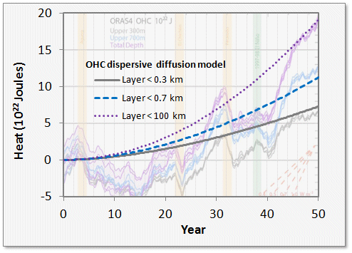](http://img819.imageshack.us/img819/7860/ohc.gif)

**Figure 26**: Thermal Dispersive Diffusion Model applied to the OHC data

Another view of the OHC includes the thermal mass of regions that comprise the land, atmosphere and cryosphere regions (see **Figure 27**). This data appears smoothed in comparison to the raw data of **Figure 26**.

An alternate unstacked version of **Figure 27** is shown as **Figure 28** which is based on characterization of Levitus [40]. The dispersive diffusion models for the two depths are displayed as dashed green lines.

[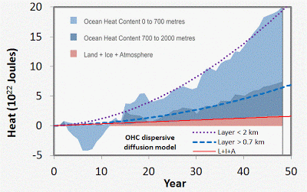](http://2.bp.blogspot.com/---w59rfoDCw/UVQ1UGZLDmI/AAAAAAAADYA/nfeF3GoiJds/s1600/SkS_OHC.GIF)

**Figure 27**: Alternate view of growing ocean heat content [38]. This also includes non-oceanic regions which generate a slightly increasing baseline.

|  |
| --- |
|  |
|  |

[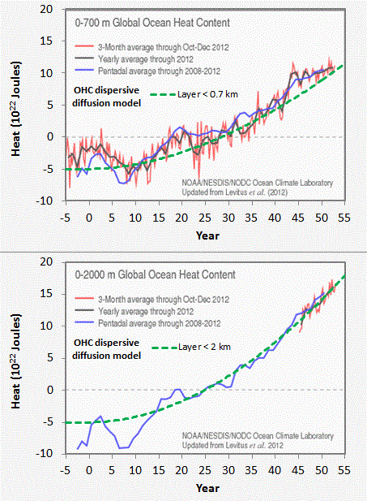](http://2.bp.blogspot.com/-BbuNFfz37Ag/UVbtbw5KhAI/AAAAAAAADYc/hZCTyOJnLck/s1600/noaa.GIF)

**Figure 28:** Non-stacked version of **Figure 27** (<http://www.nodc.noaa.gov/OC5/3M_HEAT_CONTENT>)

In the latter figure, the agreement with the uncertainty-quantified theory is more striking. A single parameter, Hansen's effective diffusion coefficient *D*, along with the inferred external thermal forcing function is able to reproduce the temporal profile accurately.   
  
The strength of this modeling approach is to lean on the maximum entropy principle to fill in the missing gaps where the variability in the numbers remains uncertain.  In this case, the diffusion and ocean depths hold the uncertainty, and we use first-order physics to do the rest.

*The following is a sanity check for the above formulation*.  
  
An application of Fick’’s Law is to approximate the amount of material that has diffused (with thermal diffusion coefficient *D*) at least a certain distance, *x*, over a time duration, *t*, by

For greater than 300 meters, *Q/Q\_0* is 13.5/20 read from **Figure 1**.  
For greater than 700 meters, *Q/Q\_0* is 7.5/20

Where *Q\_0*=20 is the baseline for the total heat measured over all depths (i.e. between x=0 and *x*=infinite depth) reached at the current time. No heat will diffuse to infinite depths so at that point *Q/Q\_0* is 0/20.  
  
First, we can check to see how close the value of scales, by fitting the *Q/Q\_0* ratio at each depth.

For *x*=300 meters, we get *L*=763  
For *x*=700 meters, we get *L*=713

These two are close enough to maintaining invariance that the Fick’s law scaling relation holds and we can infer that the flow is by an effective diffusion [37].  
  
We then use an average elapsed diffusion time of *t*=50 years and assume an average diffusion depth of 740, and *D* comes out to 3.65 cm2/s. Hansen used an estimated value of diffusion of 1 cm2/s, which is within an order of magnitude of this value and the value of 3 cm2/s derived via temporal curve fitting.  
  
This gives an approximate solution to the more general solution, which convolves an impulse function with a forcing function and watching that evolve according to **Figure 1** and **Figure 2** for the full temporal profile.

The analytical model assumes a ramped forcing function as a simplification of a more realistic effective forcing as described by Hansen [41]. Instead of using a ramp forcing function which gives the previous monotonically increasing analytical result, a realistic forcing (which takes into account perturbations due to volcanic events) is numerically convolved with the diffusive response function, *I(t)*.

Note that the volcanic disturbances are clearly visible in the response, although they do not show as sharp a transient decrease after the events, perhaps half of what **Figure 25** shows. The suppression due to the 1997-1998 El Nino is also not observable, but that of course is not an effective forcing and so would not be expected to appear in the convolution result.

[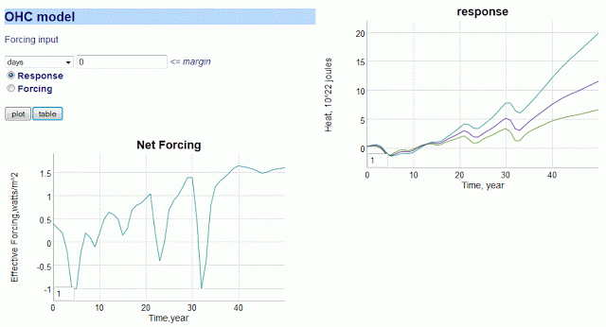](http://2.bp.blogspot.com/-hHs8FuF7SWY/UVe39CUosSI/AAAAAAAADYs/i7RVxRx6wmE/s1600/hansen_forcing_diffusive_response.GIF)

**Figure 29:** Numerical convolution of effective forcing (lower left) is convolved with the diffusive transfer function to give the response (upper right).  The three curves are < 300 m, < 700 m, and < 2000 m.

Contrasting the early predictions of Hansen with the recent experimental measurements, we should note that nothing looks out of the ordinary for the OHC trending if we compare it to what conventional thermal physics would predict. The recent data has quantified the total heat absorbed along with cross-sectional estimates, which allows us to estimate the effective diffusion coefficient by evaluating how the heat contents vary with depth. We add a maximum uncertainty modifier to the coefficient to model the disorder in diffusivity (some of it eddy diffusivity, some open-ocean vertical, etc) and that allows us to match the temporal profile accurately.

*Example:* Dispersive Diffusion in Lithium-Ion Batteries

Modern rechargeable battery technology still relies on the principles of electro-chemistry and a reversible process, which hasn’t changed in fundamental terms since the first lead-acid battery came to market in the early 1900’s. What has changed is the combination of materials that make a low-cost, lightweight, and energy-efficient battery which will serve the needs of demanding applications such as electric and hybrid-electric vehicles (EV/HEV).   
  
As energy efficient operation is dependent on the properties of the materials being combined, it is well understood that characterizing the materials is important to advancing the state-of-the-art (and in increasing EV acceptance).   
  
Of vital importance is the characterization of diffusion in the electrode materials, as that is the rate-limiting factor in determining the absolute charging and discharging speed of the material-specific battery technology. Unfortunately, because of the competitive nature of battery producers, many of the characteristics are well-guarded and treated as trade secrets. For example, it is very rare to find diffusion coefficient characteristics on commercial battery specification sheets, even though this kind of information is vital for optimizing battery management schemes [42][43].

In comparison to the relatively simple diffusional mechanisms of silicon oxide growth described earlier, the engineered structure of well-designed battery cell presents a significant constraint to the diffusional behavior. In **Figure 30** below we show a schematic of a single lithium-ion cell and the storage particles that charge and discharge. The disordered nature of the storage particles shown in the right figure is often described by what is referred to as a *tortuosity* measure [44] of local imperfections and inhomogeneities.

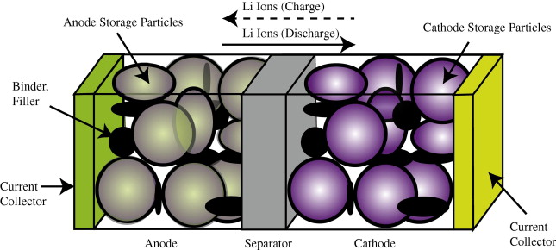 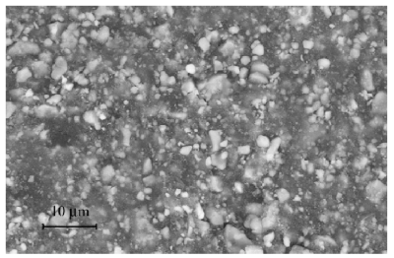

**Figure 30**: (Left) Exaggerated three-dimensional view of a lithium-ion battery cell and the direction of current flow during charging and discharging  
(Right) Realistic view of the heavily disordered nature of the LiFePO4 storage particles [45].

The constraints on the diffusion limit the scale to that of the radius of the storage particle. The length scale is limited essentially to the values *L* to *Lmax* shown in **Figure 31** below. The lithium -ion charge is spread throughout this particle and can only enter the electrolyte by diffusing outward from the inner region of this volume.

|  |
| --- |
| <http://img109.imageshack.us/img109/7131/churikovschematic.png>  **Figure 31**: Diffusion of ions takes place through the radial shell of the LiFePO4 spherical particle [1]. During the discharge phase, the ions need to migrate outward through shell and through the SEI barrier before reaching the electrolyte. At this point they can contribute to current flow [45]. |
|  |

The size of the particles also varies as shown in **Figure 32** below.  The two Lithium-ion materials under consideration, LiFePO4 and LiFeSO4F, have different materials properties but are structurally very similar (matrixed particles of mixed size) so that we can use a common analysis approach.  This essentially allows us to apply uncertainty in the diffusion coefficient and uncertainties in the particle size to establish a common diffusional behavior formulation.

|  |
| --- |
| <http://img708.imageshack.us/img708/1729/lithiumparticlesizedist.png>  **Figure 32**: Particle size distribution of FeSO4F spherical granules [2]. The variation in lengths and material diffusivities opens the possibility of applying uncertainty quantification to a model of diffusive growth [46]. |
|  |

**Dispersive Diffusion Analysis of Discharging:** The diffusion of ions through the volume of a spherical particle does have similarity to classical regimes such as the diffusion of silicon through silicon dioxide.  That process (as described earlier in this paper) leads to the familiar Fick's law of diffusion, whereby the growing layer of oxide follows a so-called parabolic growth law with a thickness proportional to .  
  
In a similar formulation that we used earlier for oxide and corrosive growth, the model that we can use for Li+ diffusion derives from the classic solution to the Fokker-Planck equation of continuity (neglecting any field driven drift).

Here *C* is the lithium -ion concentration and *D* is the spatial diffusion coefficient.  Ignoring the spherical orientation of a particle, we can assume a solution along a radial one-dimensional outward axis, *x*:

This is a marginal probability which depends on the diffusion coefficient. Since we do not know the variance of the diffusivity, we can apply a maximum entropy distribution across *D*.

This simplifies the representation to the following workable formulation.

We now have what is called a kernel solution (i.e. Green's function) that we can apply to specific sets of initial conditions and forcing functions, the latter solved via convolution.  
  
**Fully Charged Initial Conditions**  
Assume the spherical particle is uniformly distributed with a charge density *C*(0, *x*) at time *t* = 0.  
  
**Discharging Transient**  
For every point along the dimensions of the particle of size *L*, we calculate the time it takes to diffuse to the outer edge, where it can enter the electrolytic medium.  This is simply an integral of the *C*(*t, x*) term for all points starting from *x'* = *d* to *L*, where *d* is the inner core radius from **Figure 31**.

This integrates straightforwardly to this concise representation:

Note that this does not quite approximate the distribution of charge; in reality a spherical particle will have more matter closer to the surface than near the core, in proportion to *r*2, but this is a starting point which can be more fully refined as needed (the integration is not difficult for a spherical representation, and the diffusion exponential is retained [47]).

The voltage of the cell is essentially the amount of charge available, so as this charge depletes, the voltage decreases proportionally.   
  
We can test the model on two data sets corresponding to a LiFePO4 cell [45] and a LiSO4F cell [46]. In **Figure 33** below, we show the model fit for LiFePO4 as the red dotted line. This should be level-compared to the data designated by the solid black line labeled 1. The other curves labeled 2,3,4,5 are alternative diffusional model approximations applied by Churikov *et al* [45] that clearly do not work as well as the dispersive diffusion formulation derived above.

|  |
| --- |
| <http://img5.imageshack.us/img5/6225/lifepo4.gif>  **Figure 33**: Discharge profile of LiFePO4 battery cell [45], with the red dotted line showing the parameterized dispersive diffusion model.  The curves labeled 1 through 5 show alternative models that the authors applied to fit the data. Only the dispersive diffusion model duplicates the fast drop-off and long-time scale decline. |
|  |

**Figure 6** below shows the fit to voltage characteristics of a LiFeSO4F cell, drawn as a red dotted line above the light gray data points. In this case the diffusional model by Delacourt [46]shown in solid black is well outside acceptable agreement.

|  |
| --- |
| LiFeSO4f.gif  Figure 34: Discharge profile of LiFeSO4F battery cell [46], with the red dotted line showing the parameterized dispersive diffusion model. The black curve shows the model that the authors applied to fit the data. |
|  |

**Constant Current Discharge**  
Instead of assuming that the particle size is fixed at *L*, we can assume that the *L* is an average value and apply the same maximum-entropy as a spread in sizes. The PDF is now a damped exponential range of particle sizes, and we integrate the time it takes to traverse the size.

This integrates straightforwardly to this concise representation, similar to that used earlier to describe oxide and corrosive growth:

In addition to perhaps act as a better model of the disorder, the reason we do this is to allow us to recursively define the change in charge to a current. In this case, to get current we need to differentiate the charge with respect to time.

This differentiates to the following expression

But note that we can insert *C(t)* back in to the expression

Finally, since *I(t)* is a constant and we can set that to a value of *Iconst*. Then the charge has the following profile:

Or we can represent it as a voltage decline since stored charge is proportional to voltage:

For a set of constant current values, we can compare this formulation against experimental data [48] for LiFePO4 (shown as gray open circles) shown in **Figure 35** below. A slight constant current offset (which may arise from unspecified shunting and/or series elements) was required to allow for the curves to align proportionally.  Even with that, it is clear that the dispersive diffusion formulation works better than the conventional model (solid black lines) except where the discharge is nearing completion as it depletes the initial storage of charge.

|  |
| --- |
| <http://img221.imageshack.us/img221/5063/lithiumcurrentconstant.gif>  **Figure 35**: Constant current discharge profile [48]. Superimposed as dotted lines are the set of model fits which use the current value as a fixed parameter. |

The question is why does this simple formulation work so well for these open circuit and constant current discharge profiles? As with many similar cases of characterizing disordered material (see e.g. dispersive transport in photovoltaic semiconductors [6]), the fundamentally derived solution needs to be adjusted to take into account the uncertainty in the parameter space.  However, this step is not routinely performed for battery models (see for example [49]) ; and adding modeling details to try to make up for a initially poor fit works only as a cosmetic heuristic.   In contrast, by performing the uncertainty quantification on a simplified model, as done here by stochastically varying the diffusion coefficient and particle size, the first-order solution works surprisingly well with less need for the additional detail.

We can also model battery charging [50] but the lack of information on the charging profile makes the discharge behavior a simpler study, and one that demonstrates the application of dispersed diffusion and uncertainty quantification to a parametric model.

Conclusions

We have presented a series of physics-inspired models that approximate assorted diffusion phenomena well enough to be useful for model based engineering, providing significant advantages over both physical testing and reliance solely on data tables drawn from past testing. It should be noted that the question of when an approximate model is sufficiently accurate for a specific use depends upon the requirements that intended use places upon the model.

The statistician George E.P. Box wrote a famous quote concerning the validity of models. Box’s oft-quoted statement of *“All models are wrong, but some are useful”* can be (and at times has been) misinterpreted. The original quote in full, drawn from the book “Empirical Model-Building and Response Surfaces” by Box and Draper, provides useful context:[51]

“The fact that the polynomial is an approximation does not necessarily detract from its usefulness because all models are approximations. Essentially, all models are wrong but some are useful. However, the approximate nature of the model must always be borne in mind.”

On the rest of that page, Box and Draper present a concise description of the differences between *epistemic* and *aleatoric* uncertainty, which is a crucial distinction for understanding the range of valid use for the models we present here. Epistemic uncertainties are the systematic errors (model uncertainty) that one can introduce in a statistical model, while aleatoric errors are those that are fundamental in the natural behavior itself (parametric uncertainty), be it noise or some other random effect.

The distinction between epistemic and aleatory uncertainty is central to understanding the scope of applicability of the oxide growth and thermal modeling described in this paper, and of the validity of environmental models in general. We can understand the basic mechanisms of oxide growth over many orders of magnitude via the parabolic Fickian diffusion law, but we may miss important details in how we choose to numerically model the fundamental equations. To remedy this situation, we treated the diffusion coefficient and the Si/SiO2 interface location with the correct amount of aleatory uncertainty. Epistemic uncertainty remains potentially effecting the validity of the model we applied, which is addressed in accurately we can measure against the empirical observations.

The decision on whether a specific model is valid for a given use thus depends on how closely the problem at hand corresponds to data against which the model has been compared. Were the observational results and applicationidentical across available data sets, applying a sophisticated model, beyond a heuristic to match the data, would not be necessary. Repeatability leading to predicatibility is the key here, and that is why characterization in the semiconductor industry has been historically a critical factor in producing working chips.

If, on the other hand the case at hand is a serious extrapolation from past experience, careful consideration must be made of what effects the model may be neglecting and whether these effects could make the model’s behavior misleading for the extrapolated case. Between the situations where a model is unnecessary and one where it is perhaps inappropriate (due to lack of information, etc), are a range of valid uses where the question at hand is how much error should be expected in model outputs. Our treatment of aleatory uncertainty provides a means to estimate expected error, when the question of model uncertainty has been appropriately addressed.

In that sense we can cast Box’s phrase as essentially cautioning for appropriate care in determining appropriate use of models and for estimating numerical errors in statistical modeling. To interpret Box’s quote as questioning the validity of using models in the first place would clearly be an incorrect argument — look at how far mathematical engineering based on models has gotten us! The Deal-Grove model essentially allowed oxidation processes to become well characterized and predictable, which was central to revolutionizing the integrated circuit manufacturing process. The dispersive diffusion model derived in this paper should be taken in that spirit, a pragmatic model that could become useful in characterizing a fundamental physical process.

## CHAPTER 13 Wind Energy

More disorder

Relying on wind energy as a future energy source brings up the notion of predictable unpredictability. We realize that wind does not blow all the time, yet that consumers demand for energy (primarily electrical) remains constant over time. Unless we can reduce that variability, through energy storage or geographic distribution, wind will have that mark against it. This section explains with some very elementary considerations of entropy why wind will remain a random phenomenon that we will have to learn to deal with. Its enduring persistence makes it an unending source of energy if we can predictably harness it.

**Wind Dispersion, the Renewable Hubbert Curve**

Most critics of wind energy points to the unpredictability of sustained wind speeds as a potential liability in widespread use of wind turbines. Everyone can intuitively understand the logic behind this statement as they have personally experienced the variability in day-to-day wind speeds.

However comfortably we coexist with the concept of “windiness”, people don’t seem to understand the mathematical simplicity behind the wind speed variability. The complexity of the earth’s climate and environment contributes to this simplicity as it generates more states for the system to exist within, which increase the likelihood of variability[[177]](#footnote-177).

Let me go through the derivation of wind dispersion in a few easy steps. I start with the premise that every location on Earth has a mean or average wind speed. This speed has a prevailing direction but assume that it can blow in any direction.

Next, we safely assume that the kinetic energy contained in the aggregate speed goes as the square of its velocity.

|  |  |
| --- | --- |
|  | 27-1 |

This comes about from the Newtonian kinetic energy law ½mv2 and it shows up empirically as the aeronautical drag law (i.e. wind resistance) which also goes as the square of the speed. (Note that we can consider E as an energy or modified slightly as a power, since the energy is sustained over time)

As usual, I apply the Principle of Maximum Entropy to the possible states of energy that exist and come up with a probability density function (PDF) that has no constraints other than a mean value (with negative speeds forbidden).

|  |  |
| --- | --- |
|  | 27-2 |

where k is a constant and 1/k defines the mean energy. This describes a declining probability profile, with low energies much more probable than high energies. To convert to a wind dispersion PDF we substitute velocity for energy and simplify:

|  |  |
| --- | --- |
|  | 27-3 |

This gives the empirically observed wind speed distribution, showing a peak away from zero wind speeds and a rapid decline of frequency at higher velocity. I would consider this as another variation of an entropic velocity distribution. Many scientists refer to it as a Rayleigh or Weibull distribution. The excellent agreement in the figure below between the model and empirical data occurs frequently.

Many engineers use the heuristic family of Weibull curves. The Rayleigh comes out as the simpler model because it derives from first principles and any deviation from the quadratic exponent works as a refinement. In the following curve, the value of 1.95 works for all practical purposes the same as 2.

Contrary to other distributions, the wind PDF does not qualify as a fat-tail distribution. This becomes obvious if you consider that the power-law only comes about from the reciprocal measure of time, and since we measure speed directly, we invoke the entropic velocity profile directly as well.

So, the interesting measure relates to the indirect way that we perceive the variations in wind speed. Only over the span of time do we detect the unpredictability and disorder in speed — whether by gustiness or long periods of calm.

We can then pose all sorts of questions based on the entropic wind speed law. For example, how long would we have to wait to generate an accumulated amount of energy?

We can answer this analytically by simply equating the steady-state wind speed to a power and then integrating over all possibilities of the distribution that meet the minimum accumulated energy condition over a specific time duration.

The naive answer is trivial with the time PDF turning into the following fat-tail power-law:

|  |  |
| --- | --- |
|  | 27-4 |

This equation corresponds to the following graphed probability density function (where we set an arbitrary E of cv 2 = 25). It basically illustrates the likelihood of accumulating a specific energy goal within a given Time.

Because of the scarcity of high wind speeds and the finite time it takes to accumulate energy, one observes a short ramp-up to the peak. Typical wind-speeds round out the peak and the relatively common slow speeds contribute to the long fat-tail.

But since power has an extra velocity factor (Power = Drag\*velocity, see Betz' law), it takes longer to integrate the low power values and the exponent changes from a quadratic value of 2 to a value of 5/3, via a chain rule.

|  |  |
| --- | --- |
|  | 27-5 |

As you can see in the graph below, the fat-tail becomes fatter and the ramp-up a bit sooner for roughly the same peak value.

That gives us the power-law and a shape that looks surprisingly close to the time depletion curve for an oil reservoir. In fact, since probabilities have such universal properties, the curvature of this profile has the same fundamental basis as the Hubbert oil depletion profile. The huge distinction lies in the fact that wind energy provides a renewable source of energy, whereas oil depletion results in a dead-end.

So, the hopelessness of the Hubbert curve when applied to peak oil turns to a sense of optimism when you realize that wind power generates a case of a Renewable Hubbert Curve. In other words, anytime you spin-up the wind-turbine with the goal of achieving a desired energy level you can always obtain a mini Hubbert cycle, if you have patience, just like you need patience with a train schedule (cue foreshadowing).

subtitle: Wind is entirely predictable in its unpredictability

Canada

Wind Energy Dispersion Analysis

The previous maximum entropy derivation assumed only a known mean of wind energy levels (measured as power integrated over a fixed time period). From this simple formulation, one can get a wind speed probability graph. Knowing the probability of wind speed, you can perform all kinds of interesting extrapolations — for the prior example, we can project the likelihood of how long it would take to accumulate a certain level of energy.

One can find abundant data on wind speed distribution in power coop archives. One data set consisted of about 36,000 sequential hourly measurements in terms of energy (kilowatt-hours) for Ontario. The following chart shows the cumulative probability distribution function of the energy values. This shows the classic damped exponential function, which derives from either the Maximum Entropy Principle (probability) or the Gibbs-Boltzmann distribution (statistics). It also shows a knee in the curve at about 750 KW-h, which comes from a regulating governor of some sort designed to prevent the wind turbine from damaging itself at high winds.[[178]](#footnote-178)

I also charted the region around zero energy to see any effect in the air flow transfer regime (which should be strong near zero). In this regime, the probability would go as sqrt(E)\*exp(-E/E0) instead of exp(-E/E0).

Yet only a linearized trend appears courtesy of the Taylor’s series expansion of the exponential around E=0. Remember that this data consists of a large set of independent turbines. You might think that because of the law of large numbers that the distribution might narrow or show a peak. Instead, the mixture of these turbines over a wide variation in the wind speed provides a sufficiently disordered path so that we can apply the maximum entropy principle.

With a gained confidence in the entropic dispersive model, we can test the prior nagging question behind wind energy — How long do we have to wait until we get a desired level of energy?

I generated a resampled set of the data (only resampled in the sense that I used a wraparound at the 4-year length of the data to create a set free from any boundary effects). The output of the resampling essentially generated a histogram of years it would take to reach a given energy level. I chose two levels, E(T)=1000 MW-hrs and E(T)=200 MW-hrs.

I plotted the results below along with the predetermined model fit next to the data.

The model described previously predicts the behavior applied to the two sets of data:

|  |  |
| --- | --- |
|  | 27-6 |

where T is the average time it will take to reach E(T). From the exponential fit in the first figure, this gives T= 200/178 and T=1000/178, respectively, for the two charts. As expected we get the fat-tails that fall off as 1/t2 (not 1/t1.5 as the velocity flow argument would support).

The models do not work real effectively at the boundary conditions, simply because the wind turbine limiting governors prevent the accumulation of any energy levels above 1000 MWh level; this occurs either in a short amount of time or at long times as a Poisson process of multiple gusts of lower energy[[179]](#footnote-179). That said, any real deviations likely arise from short-duration correlations between wind energy measurements spaced close together. We do see this as the lower limit of E(200) shows more correlation curvature than E(1000) does. Wind speeds do change gradually so these correlations will occur; yet these seem minor perturbations on the fundamental entropic dispersion model, which seems to work quite well under these conditions.

**Germany**

As a bottom-line, this analysis tells us what we already intuited. Because of intermittency in wind speed, it often takes a long time to accumulate a specific level of energy. Everyone knows this from their day-to-day experience dealing with the elements. However, the principle of maximum entropy allows us to draw on some rather simple probability formula so that we can make some additional estimates for long-term use.

By adding more data to our knowledge on wind dispersion, we can observe how dispersion in wind speeds has a universal character. I picked up the previous data set from several years’ worth of output from Ontario. This set hails from northwest Germany and consists of wind power collected at 15-minute intervals.

Note that the same entropic dispersion holds as for Ontario. Both curves display the same damped exponential probability distribution function for frequency of wind power (derived from wind speed). We also see the same qualitative cut-out above a certain power or wind energy level. Once again, note that we don’t gain much by drawing from these higher power levels as they occur more sporadically than the nominally rated wind speeds at the upper reaches of the curve. The following figure explains the cutout above the “max” wind speed.

Too many people get the idea that the sporadic nature of wind confronts us with problem or issue to deal with. I instead suggest that we must get used to a different way of thinking about wind. The entropic dispersion of wind acts much like a variation of the Carnot cycle. In the Carnot cycle of engine efficiency, we must live with a maximum level of energy conversion based on temperature differences of the input and output reservoirs. With wind, the earth’s environment and atmosphere provides the temperature-like differences which leads directly to the variability over time.

So, we can easily imagine achieving very high usage efficiency if we acknowledge the entropic characteristics of the wind. This amounts to a law of nature. We need to talk about efficiencies within the constraints of the physical laws just as with the Carnot cycle. We will observe intermittency because of entropic dispersion and we must get used to it. We should not call it a fundamental “problem”, as we cannot change the characteristics of entropy (apart from adding energy, and that just moves us back to square one).

Consider this from a different prospective: certain people would suggest that the fundamental problem with farming derives from the intermittent nature of the rain. With farming, we adapt — likewise with wind energy. Instead of a problem, we need to call it an opportunity and deal with the predictable unpredictability. The derivation essentially becomes the equivalent of a permanent weather forecast. We should realize that the windspeed will eventually pick up and not to fret too much about it[[180]](#footnote-180).

If that still bothers someone, we should always remember that electrical power as it stands right now comes from distributed sources. Considering that wind shows variability, distributing power from turbines in geographically separated areas will help regulate the flow, as different regions will ebb and flow in wind speed.5

**Dispersion in human mobility**

Without a doubt, our reliance on petroleum for travel outweighs many of its other uses. Certainly, air travel would become virtually impossible without such a convenient, concentrated form of energy. And air travel remains the best way to get from point A to point B fast and usually on-time. It boils down to the essential fact that we may need to trade-off speed for predictability. This section brings up the analysis of human travel in terms of statistical data — how much of the time we spend in various modes of travel and how dependable the modes measure up. Once again, the concept of entropy can simplify the discussion.

Dispersion Statistics in Human Travel

This discussion centers around an intriguing paper on the statistics of human travel published in Nature magazine [Ref 198]. In the past, most researchers have found it hard to collect data on the topic. Yet with the use of clever techniques, such as using the internet or cellular network records, we suddenly have a trove of information to weed through. In the first case, the researchers collected indirect travel information by compiling the spread of money, via the bill tracking system http://www.whereisgeorge.com. This becomes a so-called “proxy” measure for human travel data.

Travel Dispersion in human mobility

I can’t argue the basic premise behind the approach. The authors assume that people disperse throughout a geographic region and then make the claim that you can essentially track their motion (indirectly) by following the trajectory of the money they carry. They also make the correct interpretation that dispersion via random walk mechanisms plays a big role in the spread. That part seems quite reasonable. And the utility of understanding this phenomenon holds great promise. For example, one can use it to understand the implications of reducing the travel overhead as we enter an energy-scarce era, as well as understanding the dynamics of pandemics. Yet, considering how important the concept is and the prestige of the journals that publish the work, they miss some of the important and simple conceptual mathematics behind the phenomena. By that I mean they made the result far too complex and opaque.

I assert that if they had used the correct formulation of dispersion, the agreements to their premise would have shown a very simple universality; yet they invoke some sophisticated notion of Levy flights and other esoteric models of stochastic mathematics to derive an overly complex result. Eventually they come up with a scaling law exponent which they affix with the value 0.59 and 1.05. They claim these numbers holds some notion of “universality” and claim that this results in some new form of “ambivalent” process. This seems a bit pretentious and in what follows we will derive some actual, much more practical models.

The statistics of what they want to model stems from sets of collected data from time-stamped geographical locations. The figure below shows typical vector traces of travel across the USA.The collected information appears very comprehensive and the fact that everyone uses money, attests to the fact that the approach should show little bias with minimal sample error. The sophisticated random-walk model they use derives from the same Scher-Montrose Continuous Time Random Walk (CTRW) model that we saw other researchers apply to the physics in the last two chapters[[181]](#footnote-181). Instead of such overt statistical physics formality, I would set up the mathematical premise straightforwardly. We have a dispersion of velocities described by a maximum entropy probability distribution function (PDF).

|  |  |
| --- | --- |
|  | 28-1 |

The PDF above describes a mean velocity with a standard variance equal to the mean. This places all moments as finite values and becomes an intuitive minimally biased estimate considering no further information is available. We next assume that the actual distance traveled happens over a duration.

The authors first describe a PDF of money traversing a distance r in less than 4 days.

|  |  |
| --- | --- |
|  | 28-2 |

This becomes very easy to solve. We only need to assume that the distance traveled gets uniformly distributed across the interval — another maximum entropy estimator for that constraint.

So, for any one time, we express the cumulative distance traveled at any one time by the following cumulative distribution function (CDF), with r scaled as a distance:

|  |  |
| --- | --- |
|  | 28-3 |

The term ? has the units of time/distance. As we haven’t considered the prospects of waiting time variation yet, this point provides a perfect place to add that to the mix.

Intuitively, money does not constantly stay in motion, but instead may sit in a bank vault or a piggy bank for long periods of time. So, we smear the term ? again with a maximum entropy value.

|  |  |
| --- | --- |
|  | 28-4 |

But we still must integrate this over all smeared values, with respect to P(r,t). This gives the equation

|  |  |
| --- | --- |
|  | 28-5 |

To generate the final PDF set, we take the partial derivative of this equation with respect to time, t, to get back the temporal PDF, and with respect to r, to get the spatial PDF (ignoring any radial density effects).

|  |  |
| --- | --- |
|  | 28-6 |

So, we can generate a PDF for r for a specific value of T=4 days and then fit the curve to a value for ?. So ? becomes the average velocity/waiting time for a piece of paper money (the bank note the authors refer to) between the times it makes trips from place to place. The fact that time acts as the dispersive parameter and this goes in the denominator of velocity=r/t, implies that the fat tails appear in both the spatial dimension and the temporal dimension.To verify the model, the authors plot the results in two orthogonal dimensions. First against time:

|  |  |
| --- | --- |
|  | 28-7 |

The constrained curve fits are shown below with ? set to 1 kilometer per day. The various sets of data refer to 3 classes of initial entry locations (metropolitan areas, intermediate cities, and small towns).

The short-distance spatial curve has some interesting characteristics. From the original paper, a plot of normalized probabilities shows relative invariance of distance traveled with respect to time for short durations of less than 10 days.

Time appears bottle-necked for around 10 days on the average. This is understandable as the waiting time between transactions can contain 5 distinct stages. As most of these transactions may take a day or two at the minimum, it is easy to conceive that the total delay is close to T=10 days between updates to the bill reporting web site. So, this turns into a weighted hop invariant to time but scaled to reflect the average distance that the money would travel.

If we plot our theory on a similar color scale, it appears like the 2-dimensional profile shown next:

Note that these look different than the first contour color scale in Figure 28-2 554 since the authors multiplied the probability values by r to maintain a similar dynamic range across all values. Otherwise the probability values would diminish at large r or t.

The bottom-line is that the actual model remains simple and both CTRW and the scaling-law exponent do not come into play. Brockmann also curiously called the process “ambivalent”, which seems to imply uncertainty. I consider it the opposite of ambivalent and the solution remains rather straightforward. They perhaps did not consider Occam's razor, in that the simplest explanation works the best. Consider this as a typical oversight when it comes to understanding dispersion.

Another article in Nature supports the human mobility patterns observed with a different proxy mechanism [Ref 199]. The model seems to match the observed trends even more precisely and further reinforces the fundamental idea of entropic dispersion of travel velocities. Instead of using a paper money tracking system as in the previous Brockmann article, the authors (Gonzalez et al) used public cell-phone calling records — this seems to perform more directly rather than the indirect mechanism of proxy records of bill tracking to monitor human mobility.

Given that money is carried by individuals, bank note dispersal is a proxy for human movement, suggesting that human trajectories are best modeled as a continuous time random walk with fat tailed displacements and waiting time distributions.

...

Contrary to bank notes, mobile phones are carried by the same individual during his/her daily routine, offering the best proxy to capture individual human trajectories.

...

Individuals display significant regularity, as they return to a few highly frequented locations, like home or work. This regularity does not apply to the bank notes: a bill always follows the trajectory of its current owner, i.e. dollar bills diffuse, but humans do not.

Even though the proxy records give the same general fat-tail trends, the essential problem with the bank note process remains the transaction process. The very likely possibility exists that a dollar bill exchanges hands among three unique individuals at a minimum between reporting instances, yet the cell-phone records an individual at more randomized and therefore less deterministic intervals (refer to Figure 28-5 556). So, I don’t expect the average rates of travel to agree between the two datasets.

The following fit uses the same model as I used previously, with data sampled at one-week intervals. Notice that the data fits the Maximum Entropy Dispersion (the green curve) even better than bill tracking at 10-day intervals.

|  |  |
| --- | --- |
|  | 28-8  Not partial |

The value of ? for this data set is 0.36 instead of 1 for the bill dispersion data set. I placed a cutoff on the dispersion by preventing a smearing into faster rates of 400 km/day and above, but this seems reasonable as the model otherwise works over 5 orders of magnitude. It works so well that it detects a probability offset in the original data calibration; the probability PDF should sum to one over the entire interval yet the Gonzalez data exhibits a bias as it creeps up slightly over the normalized curve. This shift appears real as their own heuristic function (when I took the time to plot it) also shows a normalization bias.

Another figure that Gonzalez plots mines the data according to a different sampling process, yet the general trend remains.

Moreover, the researchers almost got the Maximum Entropy dispersion function right by doing a blind curve fit, but ultimately could not explain it. Instead of the predicted power law exponent of -2, they use -1.75. Yet since they do not normalize their curve correctly with the beta parameter that a probability distribution requires, they think this value of -1.75 holds some significance. Instead the -1.75-power law is likely an erroneous fit and -2 works better — while not violating Occam's law and performing more parsimoniously.

Entropy always wins out on these phenomena and it really tells us how (in the sense of having no additional information, i.e. a Jaynesian model of entropy) people will statistically use different forms of transportation. The smearing occurs over such a wide range because people will walk, bicycle, residentially drive, freeway drive, or take air transportation. The entropy of all these different velocities serves to generate the dispersion curve that we empirically observe. The fact that it takes such little effort to show this with a basic probability model truly demonstrates how universal the model remains. That a single parameter indicating a median value of dispersive velocity can map over several orders of magnitude2 fits again well within Occam’s Rule3.

Ultimately, I puzzle on why the researchers in the field seem to flail about trying to explain the data with non-intuitive heuristics and obscure random walk models.

Gonzalez et al have gotten tantalizingly close to coming up with a good interpretation, much closer than Brockmann in fact, yet they did not quite make the connection. If I could tell them, I would hint that their random walk is random but the randomness itself is not randomized. That explains so many phenomena yet they can’t quite grasp the fundamental underlying concept.

As far as using the simple model for crafting future policy regarding optimizing human travel in an energy constrained environment, I say why not. It essentially features a single parameter and covers the entire range of data. In terms of potential usage, one applies it for modeling the propagation of infectious diseases (a public health concern) or trying to minimize travel (an energy policy view).

As a caveat, I ignored the diffusional aspects and the possibility of random walk in two-dimensions, yet I believe these largely get absorbed in the entropic smearing and the USA is not as much of a random two-dimensional stew as one may imagine. But as with all these simple dispersion arguments, I get the feeling that somehow this entire analysis approach has been unfortunately over- looked over the years.

2. With a second-order correction at the end-points having to do with the constrained physical breadth of the USA and how fast people can ultimately travel in a short period of time.

3. A complexity metric called Aikake Information Criteria (AIC) penalizes a model for having too many parameters, which is a variant of Occam’s Rule put into practice.

Dispersion and Train Delays

Since nothing I write about contains any particularly difficult or obscure math, I thought to present this post as a word problem.

Say you reside in England. Consider taking a train from point A to point B. You have an idea of how long the trip will take based on the current train schedule but have uncertainty on its latency (i.e. possible time delay). The operators of the trains only tell you at best the fraction that arrive within a few minutes of their scheduled time. In other words, you have no idea of the fatness of the tails, and whether you will get delayed by tens of minutes on a seemingly short run.

How would you derive the probability of a specific lateness of time dt based only on the knowledge of the distance X between point A and B, the maximum train speed Vm, and an average train speed (same as distance X divided by the average trip duration t)?

I won’t solve this problem in anyway remotely that I would consider a classical approach. Instead I will assume based on the principle of maximum entropy with the constraint of least amount of available information. So, let us see how close we can come to the empirical distribution of train delay times observed based on assuming very limited information.

First, I have rather limited experiences travelling by train in England. I do know that the speed of a train can vary quite a bit as I have experienced the crawl from Heathrow to Victoria Station. I also know that the train has some maximum speed that it won’t exceed. You realize this when you notice that the train rarely arrives early. So, the average train speed and maximum train speed provides a pair of constraints that we can use for estimating a train velocity probability density function (PDF).

I assert via maximum entropy (MaxEnt) arguments that the train velocity (or speed for purists) PDF likely appears like this:

In accordance with the constraints, MaxEnt predicts an exponential profile up to the maximum value, which ends at 1.44 miles/minute in the histogram. I would describe it as a dispersive velocity profile following a reverse damped exponential[[182]](#footnote-182):

|  |  |
| --- | --- |
|  | 28-9 |

where v ranges from 0 to vm. The factor ?v relates to the average speed by

|  |  |
| --- | --- |
|  | 28-10 |

The smaller that ?v becomes, the closer that the average speed approaches the maximum speed. Since we don't know anything more about the distributions of speeds, MaxEnt suggests that this exponential “approximation” will work just fine.

The only remaining step we need to do involves some probability theory to relate this velocity distribution to a time delay distribution. As the most straightforward approach, we determine the cumulative probability of velocities that will reach the destination in time T. This becomes the integral over p(v) from a just-in-time speed X/T to the maximum speed vm:

|  |  |
| --- | --- |
|  | 28-11 |

This results in the cumulative probability distribution function (upper-case P):

|  |  |
| --- | --- |
|  | 28-12 |

To turn this into a probability density function, we simply need to take the derivative with respect to T.

|  |  |
| --- | --- |
|  | 28-13 |

We can also cast it in terms of the time delay by

|  |  |
| --- | --- |
|  | 28-14 |

so

|  |  |
| --- | --- |
|  | 28-15 |

This might seem like a complicated expression but all of the parameters are well known but one, ?v . And even in this case, we can estimate ?v from some data. The following plot illustrates how the PDF changes with ?v . Note that as ?v becomes small, the probability of arriving on time becomes closer to 1 (e.g. the Swiss or German train system)

We have a fat-tail probability distribution because the density follows off as an inverse square power law.

So, we need some data to check how good this distribution works. The topic of train scheduling arose from a paper [Ref 201] by an expert in the field of superstatistics [Ref 200]. Superstatistics may work as an alternate technique to solve the problem but as used by Briggs and Beck, it requires a couple of arbitrary parameters to fit the distribution to. This points to the difference between solving a problem as I am trying to do, versus blindly employing arbitrary statistical functions as Briggs and Beck attempt.

In any case, the authors did the hard work of collating statistics of over 2 million train departures covering 23 train stations in the British Rail Network.

Most of the statistics look generally similar but I take the route from Reading to London Paddington station as a trial run.

Both the superstatistics approach and my entropic dispersion solution fit the data remarkably well. One can see clearly that the profile neither follows Poisson statistics (which would give a straight line) nor does it follow normal Gaussian statistics (which would show an upside-down parabolic shape on a semi-log graph).

The shape of the tail points to the real fat-tail probabilities that occur on British rail lines — as we can see long delays do occur and the power law likely comes from the principle of entropic dispersion.

So, to recap, the values I used stem from real observables:

X = 36 miles (exact)

vm = 1.44 miles/minute (from the schedule, see below)

?v = 0.26 miles/minute (from the curve fit or alternatively from the average latency)

I stated earlier that most people would approach this problem from the perspective of Poisson statistics using time as the varying parameter. Briggs and Beck do this as well, but they use another layer of probability, called superstatistics to “fatten” the tail. Although I appreciate the idea of superstatistics (see the description of hyperbolic discounting of an example of a doubly integrated distribution function), I believe that entropic dispersion of velocities gives a more parsimonious explanation.

This approach shows consistency with the data on human travel yet it provides a narrower focus on the application of entropic dispersion.

Marathon Dispersion

I originally began my studies of dispersion outside of the oil extraction realm by looking at dispersion in the finishing times for marathon races [Ref 129]. The dispersion results from human variability but due to (self) censoring in the population of runners, we never see complete dispersion like we would in oil exploration and discovery.

The figure on the right shows how the finishing times get dispersed in time due to variations in the running speeds of the competitors. This shows a limiting max speed and truncated slow speeds as the very slow runners would rather not punish themselves for long periods of time, resulting in censorship of the velocity data over slower velocity ranges. The following chart with numbers that I collected from the finishing times of a typical Honolulu marathon show this truncation quite clearly. If all potential runners, comprised mostly of those not so physically fit, the tails of finishing times would extend for a long while.

Taking a different marathon (Portland) with a laxer finishing time cut-off, one can see that the maximum entropy rates of speed follow more closely the damped exponential. A possible bulge also occurs at the fastest times, but the possibility of prize money for the top several finishers may explain this, thus adding to another piece of information preventing this from becoming the most optimal example of maximum entropy in practice. The missing pieces of information and constraints that we know exist yet cannot accurately quantify prevent us from applying the exponential distribution effectively.

Verifying Dispersion

Maximum entropy modeling works to the extent that you can only model based on observable measurements you can make. These generate the moments and constraints for the probability distributions. Any other information you may want to include can lead to unwarranted assumptions. So maximum entropy provides a way of dealing with limited information.

So, if we did have more information, then we would get different results. Marathon finishing times gives a good example of this behavior. Humans show a huge variation in athletic abilities and you should see this in the distribution. Hard constraints exist in the maximum speed of a runner but not necessarily in the minimal speed of a runner. But then you add in other constraints such as the artificial cut-off time in a specific race, and it modifies the finishing time distribution in the tails. All the people that could race at the slower speeds won’t enter the race because they know that they won’t make the cut-off time. We also see a bulge in the top runners due to the lure of prize money, thus artificially attracting from outside of a uniform sampling pool. So, we can know about these things in the information sense and thus adjust the model and get different results, in keeping with the maximum entropy principle

On the other hand, when we start piling up the constraints and information, it becomes harder and harder to model entropy this way, unless the combination of constraints also starts to become random. Then we can again start to reason about the situation. As the best example of this situation, consider the distribution of human travel times that we discussed earlier in the chapter. The maximum entropy principle applied to this problem gives very parsimonious agreement with the data. Most of these scale-free probability distributions occur because the dimensionality of the problem disappears. So, a short time resulting from a slow rate operating over a short distance looks the same as a very fast rate operating over a larger distance. We essentially got rid of the constraints of the marathon finishing times by just describing a situation where everyone in the entire country wants to get somewhere else, but neither the finish line nor the cut-off time gets specified. Even though the problem looks way more complex, the solution drops out very straightforwardly — a great example of the counterintuitive notion of greater complexity leading to simpler results that we fore-shadowed in “Innovation and Evolution. How ideas spread”.

**Spatial and Temporal Correlations of Wind**

In terms of climate statistics, we always have more data than we know what to do with. The challenge is in reducing the data into meaningful bits of information which can be characterized and modeled succinctly.  
  
So this short note describes an example of where enough data exists that we can get a deeper understanding of climate phenomena; in this case of the spatial and temporal correlations of prevailing winds.  
  
One source of data comes from measurements of winds at altitude, taken by jet airliners as part of their regular flight routes and then post-processed and analyzed [1]. This gives an indication of spatial correlation over a large dynamic range, stretching a little over three orders of magnitude.  Once collected, the post-processing involved applying an autocorrelation to the data over all spatial scales.  The power spectral density (PSD) is the Fourier transform of the autocorrelation, and that is shown in **Figure 1** below, along with a suggested model achieving a good fit to the actual meridonal wind PSD.

|  |
| --- |
| [http://2.bp.blogspot.com/-7ZmFDUTiwN0/UUff4cpCvKI/AAAAAAAADMg/66LbzdiqvD0/s400/zonal_meridional.gif](http://2.bp.blogspot.com/-7ZmFDUTiwN0/UUff4cpCvKI/AAAAAAAADMg/66LbzdiqvD0/s1600/zonal_meridional.gif) |
| ***Figure 1*** *: Zonal and Meridional wind speed PSD. The dashed line model fit works well apart from deviations near the noisy shorter wavelengths.* |

The chosen model is simply the PSD of an exponentially damped cosine autocorrelation (see [2] for examples in meteorology).

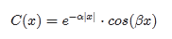

The Fourier transform of this autocorrelation gives a PSD that is best described as a shifted Cauchy or Lorentzian profile.  In **Figure 1**, the shape is obvious as it shows a peak and then a concave-upward inflection following the peak.

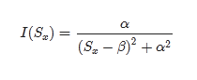

This specific profile is generated by a semi-Markovian process.  The "semi" part captures the periodic portion while the Markov contributes the memory for close-proximity coupling. Specifically, the Markov term is the alpha-factor damping which gives the overall 1/S^2 roll-off, while the beta-spatial shift indicates a semi-Markov ordering feature indicating some underlying longer-range spatial periodicity.

*β*=2*π*/*L*=1.3e-6 rad/m

*α* =7.63e-7 rad/m

This gives a weak periodicity of L=4833 km.   For a prevailing wind-stream of 30 MPH, this spans approximately 4 days of flow between a peak and a lull in wind speed.    
  
The spatial correlation intuitively leads to the concept of a temporal correlation in wind speed, and the question of whether this characteristic can be measured and contrasted to the spatial correlation.  
  
For temporal correlation, we used the same data from the BPA which we had previously applied to a [probability density function (PDF) analysis](http://theoilconundrum.blogspot.com/2012/02/wind-speeds-of-world.html).

|  |
| --- |
| [http://1.bp.blogspot.com/-IgMdIZWdiLM/UUfsfT_6PUI/AAAAAAAADMw/g9qOfMMJYfY/s400/roosevelt_island_wind_autocorrelation.gif](http://1.bp.blogspot.com/-IgMdIZWdiLM/UUfsfT_6PUI/AAAAAAAADMw/g9qOfMMJYfY/s1600/roosevelt_island_wind_autocorrelation.gif) |
| ***Figure 2 :*** *Temporal autocorrelation of wind speed* |

The temporal autocorrelation of the Roosevelt Island site shows some periodic fine structure. Using the Eureqa equation fitting software, we get the following empirical autocorrelation match.

*c*(*t*)=0.02934⋅*sin*(0.5012−1.626*t*)+0.01668⋅ *cos*(0.8645+6.203*t*)+*exp*(−1.405*t*)−0.02134⋅*sin*(1.088−0.599*t*)

The first and second terms are periodicities of 3.86 days and ~1 day, the latter easily explained by daily (diurnal) variations.  There is also a strong damping factor with a half-life less than a day. The last term is a 10 day period which generates a longer term modulation (and also has more uncertainty in its weighting).  
  
The 3.86 day periodicity is likely due to a principle oscillation pattern in unstable meandering baroclinic [Rossby waves](http://en.wikipedia.org/wiki/Rossby_wave) as detected through a separate statistical analysis [3]

[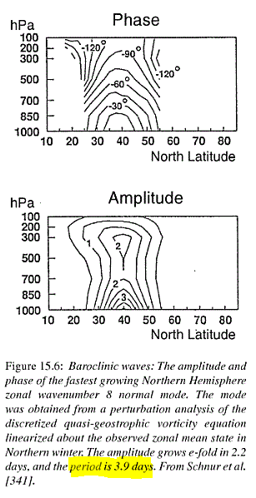](http://1.bp.blogspot.com/-gmsCx8JsHDA/UUh-d-inEZI/AAAAAAAADNQ/d1cKdjL843c/s1600/storch_rossby.GIF)

This demonstrates how the spatial correlation relates to the temporal correlation. As the tropospheric wave patterns propagate and disperse, they influence the local wind patterns.  These are quite subtle effects yet they can be detected and perhaps can be put to good use in battling the intermittency in wind power.

## CHAPTER 14 Solar Energy

Dealing with disorder

“Often in physics, experimental observations are termed “anomalous” before they are understood.”

— Richard Zallen, “The physics of amorphous solids”, Wiley-VCH, 1998

Scientists have struggled with converting sunshine to electricity inexpensively for years. They realized early on that high-quality crystalline semiconductors had superior efficiencies to poorly fabricated materials, but that the high-quality materials also costed much more to produce. For the kinds of applications necessary to bring solar energy, such as expansive areas of photovoltaic (PV) grids, to widespread acceptance, this cost needs to come down, or the sub-par materials somehow improved.

Disorder in the PV material’s crystallinity lay at the root of the problem, and we can use some of the same techniques that get used in analyzing liquid transport through porous material (a disordered medium) to model some of the anomalous PV characteristics. This section navigates these waters with a different perspective than you will find in current textbooks. One take is quite simple and the other more fundamental, yet they arrive at nearly identical conclusions.

**Dispersive Transport**

To get the cost of photovoltaic (PV) systems down, we will have to learn how to efficiently use sub-optimal materials. By sub-optimal I mean that mass-produced PV materials will end up getting rolled or extruded or organically grown. Unless we perfect the process, most everything will turn out non-optimal. We already know the difference between clean-room cultivated single crystal semiconducting material and the defect-ridden and often amorphous materials that nature and entropy drives us to. For performance-sensitive applications such as communications and computing we would only rarely consider disordered material as a candidate semiconductor. Certainly, the performance of these materials makes them unlikely candidates for high speed processing — yet for solar cell applications, they may serve us well. In the end, we just must learn how to understand and deal with poor quality materials and devices. This analysis sets forth a baseline for the characterization of a maximally disordered semiconductor.

Background

The prehistoric 1949 Haynes-Shockley experiment first measured the dynamic behavior of charged carriers in a semiconducting sample. It basically confirmed the solution of the diffusion (Fokker-Planck) equation and it demonstrated diffusion, drift, and recombination in a conceptually simple setup.

This setup works according to theory for an ordered semiconductor with uniform properties but apparently gets a bit unwieldy for any disordered or non-uniform material sample. I inferred this as conventional wisdom since most scientists either punt or use heuristics partially derived from the inscrutable work of a select group of random-walk theorists [Ref 244].

We initially applied a very straightforward interpretation to the problem of carrier transport in disordered material. This dispersion analysis essentially set aside the Fokker-Planck formalism for a mean value approximation where we applied the Maximum Entropy Principle. It matches intuition in a conceptually simple way once you get into a disordered mind-set.

In the classical Haynes-Shockley experiment, a pulse gets injected at one electrode, and a nearly pure time-of-flight (TOF) profile results. The initial pulse ends up spreading out in width a bit, but the detected pulse usually maintains the essential Gaussian sigmoid shape. How much this profile smears out has to do with relative strengths of drift, diffusion, and dispersion. When this smearing of the dispersive transport reaches a certain magnitude depending on the material, they refer to it as anomalous behavior.

Why is dispersion anomalous?

If this question sounds familiar after reading Volume 1, it should, as we have seen similar bewilderment concerning reserve growth[[183]](#footnote-183).

Often in physics, experimental observations are termed “anomalous” before they are understood. Once theory succeeds in explaining and illuminating the observations, they are no longer “anomalous” and instead come to be regarded as “obvious”. A crucial paper can trigger such an “anomalous => obvious” transition, and in the present case that key role was played by a 1975 paper by Scher and Montroll. That landmark paper has become basic to our understanding of a striking characteristic of carrier motion (now called dispersive transport) which is a common occurrence in amorphous semiconductors, though foreign to our experience with crystals. — Richard Zallen, “The physics of amorphous solids” [Ref 248]

The term anomalous in scientific code-speak essentially means “don’t know”. We should admit that we don't understand lots of things, largely due to issues of complexity, observability, or just too much noise. Yet that doesn't prevent us from trying to extract a fundamental meaning of some strange behavior that we observe.[[184]](#footnote-184)

The applied mathematicians Scher and Montroll originally tried to explain the concept of anomalous behavior of photo-conductivity in amorphous semiconductors.

Scientists had long understood the complementary non-anomalous behavior in non- amorphous materials. To set the stage see the schematic figure to the right.

In a crystalline semiconductor with a contact electrode at each end, a pulse of light incident at one electrode will, upon the effect of an electric field or potential drop between the electrodes, generate an almost immediate flow of current across the load lasting as long as the transit time of the photoinduced carriers. The carriers, either electrons or holes depending on the polarity of the electric field bias relative to the absorbing electrode, will drift from the site

Experimentalists consider the behavior well characterized; the mobility of the carriers at temperature, the strength of the electric field, and the contact separation, d, determine the transit time, tT, of the output current pulse. Because the carriers scatter against lattice imperfections, the speed does not continuously accelerate but instead achieves a bounded drift velocity, v0.

This drift mobility has an intuitive real-world analog — think in terms of a drag coefficient for the analogous situation of a falling body under gravitational forces, which eventually achieve what we call terminal velocity. For all practical purposes, the equivalent terminal velocity occurs almost immediately in a semiconductor (a short relaxation or quenching time) and sets the bound for the transit time duration.

Ideally, the pulse appears like a perfect square wave with temporal duration tT. In terms of a mathematical expression, the current behaves as

|  |  |
| --- | --- |
|  | 25-1 |

where u(t) is the unit step (or Heaviside operator) operator with magnitude K.

Because of carrier diffusion, the actual drop-off in current has rounded leading and trailing edges as the charged carrier pulse spreads out a bit into a Gaussian packet as it propagates. This relatively innocuous but well-understood form of dispersion, known as diffusion, occurs from random walk excursions as the carrier makes its way across the transit width. In the ideal case, the diffusion constant varies linearly with the mobility (or drag for particle systems) according to the Einstein relation.

For high mobilities and small contact separations, the amount of diffusion that occurs does not appreciably round the pulse edges. The prized high mobility solid-state material allows device manufacturers to fabricate ultra-high-speed photo- detectors as the sharp transition and short transit time generates an excellent and well-characterized frequency response.

This class of semiconductor has an ordered structure due to the crystalline lattice structure and it has properties such as carrier mobility which remain uniform through the sample. Such behavior shows little dispersion, either through diffusion or disorder. The narrower the distribution of velocities, the sharper the transition. Scientists have generally understood this for years and no one raises the specter of anomalous behavior.

The truly anomalous behavior observed occurs in amorphous versions of certain semiconductors. The narrow pulse of carriers seen in an ordered sample now shows a huge spread in its concentration profile as it makes its way between the contacts. Obviously, dispersion plays some role in this behavior, as it goes by the name “dispersive transport”. Scientists had known about this “anomalous dispersion” since 1957 but it took nearly two decades before Scher and Montroll presented the solution to the problem mathematically [Ref 247].

The following two figures give a qualitative view of the dispersive transport that occurs in a disordered semiconductor. The first figure describes what we think happens internally and the second figure provides a view of the observable result. The next two figures illustrate a couple of experimental results of widely studied amorphous (a-As2Se3) and organic materials (TNF-PVK) ([Ref 248][Ref 249][Ref 250]). [[185]](#footnote-185)

**Dispersive Transport**

The anomaly in the title of the Scher-Montroll paper referred to the fact that no one previously could formally explain the long tails in the response (so called “time of flight”) measurements. Other researchers clearly had an inkling that it had something to do with the high amounts of disorder leading to greater amounts of diffusion and dispersive spread than in an ordered material. Amorphous materials naturally have many inhomogeneities, defects, and carrier traps that can lead to varying delays in transit time. Scher and Montroll derived a statistical formulation of random walk called the Continuous Time Random Walk (CTRW) that they then applied to the experimental results.

Most experimentalists around that time got good results using the CTRW formulation so that it has become well accepted in semiconductor circles for the last 30 years. The math gets hairy in spots, and soon experimentalists began to simply use the empirical sloped lines to get at the Scher-Montroll disorder parameter ( ? ). High values of alpha indicate more order and low values more disorder (0 < ? < 1).

Research continues in understanding dispersive transport as new electronic materials come on line. Physicists have had a long-standing interest in disorder, as the finding of an order/disorder transition easily classifies as a type of “holy grail” discovery, certain to elicit recognition from their colleagues. As the figure to the right shows, one can add a controlled amount of disorder to a sample and observe the results of diffusive transport. The upper TOF trace shows linear transport while the lower trace shows the effects of dispersive transport. In the latter case, the disorder comes in the way of the intentional introduction of impurities, apparently forming electronic traps which slow down the carrier motion as it traverses the width of the sample.

Generally, I have noticed that the basis for much of the current research results from finding some novel aspect of dispersion relating somehow to material properties. The rather mundane effect of randomness due to heterogeneity likely plays a far more important role. For many of these materials, we simply can't control the distribution of defects and traps and the disorder evolves into a garden variety randomness, with which we have a single mean rate, say average drift velocity, to characterize the behavior.

If you look at the curve to the inset, the red line shows my simple assumption for maximum disorder. I had noticed this same shaped curve in studies of dispersive discovery for oil in Volume 1, and had a hunch that I could use the same formulation in the semiconductor case. After all, as I assert that dispersion is just dispersion, and I have enough experience dealing with semiconductor physics that I didn't expect any “gotchas”. As for the ideas of Scher and Montroll, I turn their formulation upside down and don't even consider a random walk premise, as this leads to overly complex math [Ref 244][Ref 251]. Follow the logic of the next section for a more formal analysis, which brings in the Fokker-Planck formulation.

Adding Disorder: Fokker-Planck for Disordered Systems

For the time-of-flight for a disordered system, the “intuitive” Maximum Entropy solution appears like:

|  |  |
| --- | --- |
|  | 25-2 |

This essentially states that the expected amount of charge accumulated at one end of the sample (at a distance w) at time t, follows a maximum entropy probability distribution. The varying rates described by ? and D disperse the speed of the carriers so that a broadened profile results from the initial pulse spike.

The equation above formed the baseline for the interpretation I described initially. Yet let’s go through the complete analysis as well.

For completeness, we can apply the basic diffusion laws. If I can produce an equivalent solution by applying the Maximum Entropy Principle directly to the Fokker- Planck (F-P) equation, then this would give a better foundation for the “inspection” result above.

The F-P diffusion equation gets expressed as a partial differential equation with a conservation law constraint:

|  |  |
| --- | --- |
|  | 25-3 |

In this case D1= ? (carrier mobility) and D2=D (diffusion coefficient), and n(x,t) is the carrier concentration. Ignoring carrier recombination, the solution in one- dimension appears like:

|  |  |
| --- | --- |
|  | 25-4 |

This of course works for well-ordered semiconductors, but D and ? will likely vary for disordered material. I made the standard substitution via the Einstein Relation for

|  |  |
| --- | --- |
|  | 25-5 |

where Vt = ? /q stands for the chemical or thermal potential at equilibrium (usually ? equals kT where k is Boltzmann's constant and T is absolute temperature). At equilibrium, the stochastic force of diffusion exactly balances the electrostatic force F = qE.

From the basic physics, we can generate a maximum entropy density function for D

|  |  |
| --- | --- |
|  | 25-6 |

then

|  |  |
| --- | --- |
|  | 25-7 |

This looks hairy but the integral comes out straightforwardly as (ignoring the constant factors)

|  |  |
| --- | --- |
|  | 25-8 |

where

|  |  |
| --- | --- |
|  | 25-9 |

If we evaluate this for carriers that have reached the drain electrode at x=w, the total charge collected n is:

|  |  |
| --- | --- |
|  | 25-10 |

The measured current is the mean value rate of change of charge from 0 to w.

|  |  |
| --- | --- |
|  | 25-11 |

At this point we want to generalize the solution. This makes it potentially applicable to notions of transport physical transport of material in porous matter. This would include the motion of oil underground, CO2 in the air, and perhaps even spilled oil at sea.

In the one-dimensional model of applying an impulse function of material, the concentration n will disperse according to the following equation:

|  |  |
| --- | --- |
|  | 25-12 |

where the force F=qE

|  |  |
| --- | --- |
|  | 25-13 |

The term z takes the place of a time-scaled distance, which can speed up or slow down under the influence of a force F (i.e. gravity, or electric field for a charged particle). The characteristic distance L represents the effect of the stochastic force

? (aka Boltzmann's constant) and ties in the diffusional aspects of the system. The specific parameterization of the exponential results in the fat-tail observed.

Intuitively one may not have to go through the trouble of solving the FPE, simply because intuition would suggest that the dispersive envelope would cancel out most of the details of the diffusion term. In the intuitive dispersive transport model of the first equation, the dispersion would at most follow the leading wave-front of the drifting diffusional field as or even as + z .

One can imagine that the diffusion term would follow as the square root of time according to Fick's first law and that drift would follow time linearly, with only an idea of the qualitative superposition of the terms in my mind.

**Entropic Dispersion Analysis**

As implied earlier, we can use an inspection technique to come up with a non-Fokker-Planck derivation to the dispersive transport problem. I started to look at this problem because I had a nice intuitive way of modeling dispersive behavior in oil production and figured that I could try applying the general dispersive model to dispersive transport. And that I could do it much more simply than the approach by Scher and Montroll. At certain places in their seminal papers and review articles, I find passages that amount to “... and then a miracle occurs” and knew that this meant some messy first-principles work had gone missing. The way I turned their model on its head basically amounted to working in the rate domain, corresponding to velocities, instead of the time domain. The latter derives from the classical work used to describe everything from Brownian motion to large scale diffusion. The former relates to a pragmatic view of the world which relies on entropy considerations instead of the statistics of hopping over energy barriers with small probabilities.

As a basic premise, I use the Maximum Entropy Principle to select a stochastic rate probability density function (PDF or more precisely PMF for probability mass function) in which I can then derive dispersive transport[[186]](#footnote-186) that corresponded to random-walk hopping (see figure). [Ref 254]

One way to choose the “right” distribution p is by using the principle of maximum entropy. This principle states that the least biased probability assignment is that which maximizes the system entropy subject to the constraints supplied by the available information [Ref 253].

For the constrained system of interest, all we really know is the mean carrier transport velocity. If we don't know the higher order moments, MaxEnt says to use a damped exponential as the PDF to maximize entropy. In a general sense, this maximizes the amount of disorder that exists in this quasi-equilibrium system. It says that many slow carriers exist, with an exponentially diminishing supply of fast carriers. For the fixed geometry shown in the schematics at the top, the normalized expression for the time dependence of dispersed current reaching the far contact derives as follows:

For a pulsed light source, the entire impulse response equation boils down to a simple charge conservation problem. We know that charge builds up as the photons excite the carriers, but we only know the mean rate of the dispersive terms and we let the Maximum Entropy Principle figure out the rest. The concentrations build up as the following form, with g(t) acting as the transport growth term across a region of width w:

|  |  |
| --- | --- |
|  | 25-14 |

This essentially describes the integral over a PDF of normalized velocities

|  |  |
| --- | --- |
|  | 25-15 |

for carriers that have swept through a portion of the transport layer, anywhere within the interval form x=0 to x=w.

|  |  |
| --- | --- |
|  | 25016 |

We then make the subtle replacement of

v0t ? g?t?

to generalize the transport

position from a linear term to an arbitrary growth function. The

|  |  |
| --- | --- |
|  | 25-17 |

Crucially the formulation maintains the moments of the distribution. If the velocity distribution becomes dispersed as a damped exponential then the cumulative position distribution of a particle/carrier also advances by a damped exponential. We then make a guess to the growth term as follows:

|  |  |
| --- | --- |
|  | 25-18 |

where D is the diffusivity, w is the active width, u is the charge mobility, and E is the electric field strength (E = Voltage/w). The total number of excited carriers is C0, and this number provides the maximum amount of current that gets collected. Common to all stochastic probability problems, the conservation of probability becomes a strong constraint.

The current derives as the amount that we can detect moving through the transport region:

|  |  |
| --- | --- |
|  | 25-19 |

Note the dg(t)/dt term (with the factor below) keeping only the drift term.

|  |  |
| --- | --- |
|  | 25-20 |

Plotting the original fitted curve trace with the extra chain-rule term, we can actually see the initial transient due to the term. In the normalized case, we show the response profile below superimposed on the figure from Kao [Ref 249]. At a subjective level, it follows the qualitative plateau/decline behavior quite well.

The key to understanding physics is to keep it simple, but not too simple[[187]](#footnote-187). In fact, the maximum entropy formulation that I had used previously in the dispersion analysis for oil field sizes, discovery, and reserve growth, I retain in this analysis. Also known as the “method of least information”, it essentially relies on using common sense in not trying to under- or over-estimate the variance of the dispersive spread. In one sense, the interpretation I make appears like the schematic at the left. I assume the equivalence of multiple mobility pathways through the device.

Alternatively, we can use a growth expression involving time as shown below [Ref 255]

|  |  |
| --- | --- |
|  | 25-21 |

This essentially incorporates the concurrent diffusion component along with the drift component of the velocity as a root-mean-square estimate. The drift velocity v0 relates to the electric field by v0 = ? E, where ? is the carrier mobility and E is the electric field strength. Think of this as a case where we can maintain moments of the distributions across dimensions, <t>/tT = <x>/w.

Qualitatively the constant (drift) velocity drops as 1/t2 while diffusional velocity drops by 1/t. I am not certain whether the formulation by Scher and Montroll take this into account. They simply say that long-range correlations go as 1 ? t– ? – 1

when they set up their CTRW model. I believe this step links my exponentially damped rate dispersion to their long-range time correlations.

As one might expect, the derived entropic FPE solution borrowed from a little of each of these guesses for an RMS-like value, essentially averaging between the two:

|  |  |
| --- | --- |
|  | 25-22 |

So, the solution to the dispersive FPE form for a disordered system turns out entirely intuitive, and one can almost generate the result from inspection. The difference between the intuitive entropic dispersion derivation and the full FPE treatment amounts to a variable factor of 2 in the FPE solution. You can see this by comparing the two approaches for the case of L=1 and unity width for the dispersive transport current model.

The simple entropic dispersive expression and the Fokker-Planck result obviously differ in their formulation, yet the two show the same asymptotic trends. For an arbitrary set of parameters, one can't detect a practical difference. Use whichever you feel comfortable with as the overall profile won’t change too much.[[188]](#footnote-188)

If we go back and look at Scher and Montroll’s original motivating data set, one can see how immediately practical the simplified expression becomes.

Organic Semiconductor Applications

The photocurrent profile displayed below came from Andersson [Ref 252] analyzing the transport in a specific organic semiconducting material, the polymer APFO.

The collected current profile appears like the following

The blue line drawn through the set of traces follows the entropic dispersion formulation. The upper part of the curve describes the diffusive spike while the lower part generates the fat-tail due to the drift component (this shows an inverse square power law in the tail).

Most scientists when discussing this shape have either (1) referred to Scher/Montroll and the vague heuristic ?, (2) dismissed these features, or (3) labelled them as uninteresting. Andersson follows suit:

At best this transient, as the high ? value indicates, might be possible to evaluate in a meaningful way with a bit of error and at worst it is of no use. Either way the amount of material and effort required is rather large compared to the usefulness of the results. APFO-4 is also the polymer that, among the investigated, gives the ”nicest” transients. The conclusion from this is that if alternative measurement techniques can be used it is not worthwhile to do TOF [Ref 252].

Not to dismiss the hard work that went into Andersson's experiment, but I would beg to differ with his assessment of the worthiness of the approach. When characterizing a novel material, every measurement adds to the body of knowledge, and as the interpretation of the aggregation of data becomes more cohesive, we end up learning much more of the internal structure. As I have learned, if someone does not understand a phenomenon, they tend to dismiss it

By their very nature, disordered systems contain a huge state space and we really can’t afford to throw out any information. Witness the organic semiconductor material that Montroll and Scher originally referred to in 1975 as following their CTRW model. As fitted in the figure below, the simplified entropic dispersion model does an arguably better fit by fine tuning essentially a single parameter.

Which brings up another interesting set of TOF experiments that I dug up. These also deal with organic semiconducting materials — the polymers with the abbreviations ANTH-OXA6t-OC12 and TPA-Cz3d. The following figures show the TOF results for various applied voltages. I superimposed the entropic dispersion equation form as the red line with the derived mobility in the caption below each figure. The research team had applied the Scher & Montroll Continuous Time Random Walk (CTRW) heuristic as indicated by the intersecting sloped lines. The CTRW model clearly fails in this situation as the slopes need quite a bit of creative

The number of papers I find, especially when dealing with organic semiconductors, that cannot apply the Scher/Montroll theory indicates that the CTRW theory lacks generality. In other words, it works poorly for describing suboptimal material. I will also say the theory has some very serious flaws, including the claim that an ? = 1 defines a non-dispersive material. How could a power-law of -2 be anything but dispersive?

Transport in a-Si:H

Amorphous semiconductors have a huge influence on the solar cell and photovoltaic industry. In general, it costs much less to manufacture amorphous materials as the fabrication facilities do not have to follow as strict a material process. Unfortunately, the performance characteristics of the amorphous silicon in comparison to its crystalline brethren leaves lots of room for improvement. Although not as important for solar cells, the photo-response time for an incident light stimulus shows the long tails characteristic of diffusive transport.

The fact that the novel entropic dispersion formulation works on any disordered material makes it much more general. Several years ago, Scher wrote a popular article for Physics Today extolling the wonders of his theory, and how it seemed to fit a variety of disordered systems [Ref 245]. He mentioned how well it fit amorphous silicon based on the number of orders of magnitude that his piece-wise line segments matched. Well, the entropic dispersion does just as well:

And nothing mysterious about that slope of 0.5; that results from the diffusion having a square root dependence with time.

For any one pathway, the advance in the particles motion has a diffusive component as well as a drift component. To discriminate between the effects of drift and diffusion one can vary the electric field. [Ref 259] provides a comprehensive study of the photo-response of amorphous hydrogenated Silicon (a-Si:H). This material was undoped and the investigation looked specifically at hole carriers. It leans toward questioning the applicability of Scher and Montroll's original formulation in terms of an alternate model that they formulate.

Take a close look at the figure below with data from [Ref 259], and observe how well the curve matches all the inflection points, and works over several orders of magnitude.

You can work the fit in a more elaborate fashion; the more time you spend with better values of width and electric field, the better an estimate you can make of the average mobility, ?, and diffusivity, D. Suffice to say, no extra factors play into the equations. For the curve fits to the above left, I used the coefficients as stated in the legend and the table below.

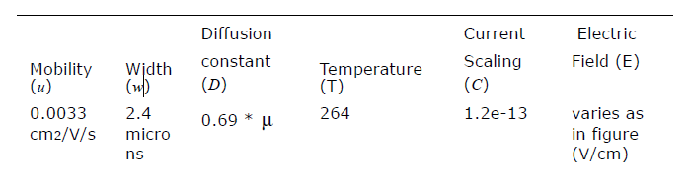

(1) For one, in this case the relation between mobility and diffusion constant does not obey the Einstein relation but this rarely happens in non-ideal and disordered materials as the energy states get sufficiently smeared across the bandgap. The general Einstein relation relates the diffusion constant D to the energy distribution of the carrier states. [Ref 256]

|  |  |
| --- | --- |
|  | 25-23 |

As the energy distribution follows an exponential Maxwell-Boltzmann distribution, the derivative retains the exponential, and the kT term drops out, leading to the conventional Einstein relation D= ? kT/q

Diffusion exists in the absence of an electric field and so thermal energy acts as the only stimulus to allow a carrier to move to an adjacent site. For a narrow variation of Ec around the Boltzmann distribution8, the relation D= ? /kT/q holds as an invariant, but as Ec spreads out — and in the maximum entropy case of a large variance knowing only the mean — the diffusion constant tracks Ec more than it does temperature, T. I worked this out and D= ? (kT+Ec)/q in that case. Since Ec typically exceeds the statistical value of thermal energy, kT, we will see a higher diffusivity than one would expect from an ordered solid (see [Ref 247]).

(2) Also, the initial transient spike having to do with fast diffusing carriers occurs at very short time frames. Because of this short time span, the transient waveform may become much more sensitive to capacitive effects. This means that the shape of this transient does not hold as much importance as the total charge underneath that part of the curve.

The authors apply their own model to the results and suggest that the dispersion is wider than Gaussian as the figure to the left margin shows, yet they also curiously indicate that is a Gaussian non-dispersive transport.

Much of the confusion arises from the original Scher-Montroll formulation which demarcates the curves into ordered or non-disordered instead of what I would like to see — a dispersed diffusion-dominated regime versus a dispersed drift-dominated regime.

8. The Maxwell-Boltzmann approximates the actual Fermi-Dirac distribution at higher temperatures.

The upshot of the good agreement of my fundamental model with the results means that any smart electrical engineer can start using the simple formulation right now, and should that engineer want to calculate frequency response or impulse response of an amorphous material device, they should use these equations, either the Fokker-Planck derived ones or the entropic dispersion approximations. They can do FFT or Laplace transforms or anything they want since they have an analytical result which they can plop into their notebook or spreadsheet or Matlab and develop. I guarantee no one would want to mess with the Montroll-Scher result as it gets way too unwieldy and I dare say that no one understands it. I consider this simplicity a huge benefit. (The only caveat: you need a disordered material to apply this to.... but, of course, that goes with the premise.)

As I said before, no one in the semiconductor industry seems to use this simple dispersive formulation, preferring to hand-wave and heuristically account for the fat- tails of the transient. Importantly, this impulse response function both explains the behavior seen, and derives from the simplest particle counting statistics (i.e. maximum entropy randomness), so it likely serves as the most canonical model for dispersive transport in disordered materials.

Many experimental results show the knee in the curve of Scher and Montroll, but with usually not much dynamic range. I looked at a few material studies done recently to see how well the simple theory works.

Transport in SiO2

For verifying any theoretical formulation, you usually want to match the behavior to as wide a dynamic range as experimentally feasible. The larger the dynamic range in the measured quantities, the more confidence that you have in its worth or value.

The case of carrier transport across SiO2 insulating layers for MOS devices provides some cases of amazing dynamic range, up to 8 orders of magnitude in current [Ref 250]. The fundamental idea remains the same in this situation as the photo- response experiment, although a different form of ionizing radiation supplies the pulse of carriers — in this case holes become the charge carrier instead of electrons. Otherwise, the same diffusive transport occurs, with the authors trying to explain the results by applying the same unwieldy Scher-Montroll formulation. As a side note, these kinds of measurements need a delicate touch as the dose of the radiation can affect the field due to space charge formation[1].

In any case the fits to the data using the simple diffusive transport model works over a large dynamic range in ordinates. The sharp bend near the top indicates the potential start to the plateauing, and one can observe that some of the pairs of data indeed do flatten out. The other gradual bend indicates the transition between diffusion transport and drift transport. The universality of this bend does not scale perfectly as drift does depend on the electric field whereas the diffusion doesn't. And as we will see in the next example, the temperature may not play a big role in deviations from universality.

Quantum Dots

Scientists have looked to unique materials including a variety of organic semiconductors in the hope of creating structures suitable for quantum dot devices. This paper [Ref 260] provides a few time-of-flight curves in terms of a completely different material system. These TOF's appear to obey the same simple maximum entropy model for dispersive transport as you can see below.

Of course, good agreement means that the disorder in the systems must agree with the maximum entropy model. Nothing precludes different diffusion mechanisms or even further disorder, implying even fatter tails than 1/t. Some systems likely exist with a mix of order and disorder, such as crystalline semiconductors with many defects. In that case, one could conceivably separate out the effects.

The Unification of Diffusion and Drift with Dispersion

Solving the Fokker-Planck equation (FPE) under maximum entropy conditions provides the fundamental unification between dispersion, diffusion and drift. For fans of Taleb and Mandelbrot, this shows directly how “thin-tail” statistics become “fat- tail” statistics without resorting to fractal arguments. The Fokker-Planck equation shows up in many different disciplines. Really, anything having to do with diffusion or drift has a relation to Fokker-Planck. Thus, you will see FPE show up in its various guises: Convection-Diffusion equation, Fick's Second Law of Diffusion, Darcy's Law, Navier-Stokes, Shockley's Transport Equation, Nernst-Planck; even something as seemingly unrelated as the Black-Scholes equation for finance has applicability for FPE (where the random walk occurs as fractional changes in a metric).

Because of its wide usage, the FPE tends to take the form of a hammer, where everything it applies to acts as the nail.[[189]](#footnote-189) Since the solution of FPE results in a probability distribution, it gives the impression that some degree of disorder prevails in the system under study. I find this understandable since the concept of diffusion implies an uncertainty exactly like a random walk shows uncertainty. In other words, no two outcomes will turn out the same. Yet, in mathematical terms, the measurable value associated with diffusion, the diffusion constant D, has a fixed value for random motion in a homogeneous environment. When the parameters change, you enter in the world of stochastic differential equations; I won't descend to deeply into this area, only to relate this as a basic concept. The diffusion and mobility parameters have a huge variability that we have yet adequately accounted for in many disordered systems.

For that reason, the FP equation really applies to ordered systems that we can characterize well. Not surprisingly the ordinary solution to FPE gives rise to the conventional ideas of normal statistics and thin-tails.

So, for phenomenon that appear to depart from conventional normal diffusion, as the so-called anomalous diffusion, we have two distinct camps and corresponding solution paths to choose from. The prevailing wisdom suggests that an entirely different kind of random walk occurs (Camp 1). No longer does the normal diffusion apply, giving rise to normal statistics; instead we get the statistics of fat-tails and random walk trajectories called Levy flights to concretely describe the situation (see Figure 25-7 491). The mathematics quickly gets complicated here and most of the results get cast into heuristic power-laws. It takes a leap of faith to follow these arguments.

The question comes down to whether we wish to ascribe anomalous diffusion as a strange kind of random walk (Camp 1) or simply suggest that heterogeneity in diffusional and drift properties adequately describes the situation (Camp 2). I take the stand in the latter category and stand pretty much alone in this regard. Find some academic research article on anything related to anomalous diffusion and very few will accept the most parsimonious explanation — that a range of diffusion constants and mobilities explain the results. Instead the researcher will punt and declare that some abstract Levy flight describes the motion.

Above all I would rather think in practical terms, and simple variability has a very pragmatic appeal to it, and understandability to boot.

## CHAPTER 15 Battery Technology

Modeling with uncertainty quantification has application to such phenomena as oxidation, corrosion, thermal response, and particulate growth. These fall into the classes of phenomena governed substantially by diffusional processes. At its most fundamental, diffusion is a model of a random walk. Without a strong convection or advection term to guide the process (e.g. provided by an electric or gravitational field), the kinetic mechanism of a particle generates a random trajectory that is well understood based on statistical physics principles. The standard physics approach is to solve a master diffusion equation under transient conditions. This turns into a kernel solution that we can apply to an arbitrary forcing function, such as provided by an input material flux or thermal impulse. In the case of a rechargeable battery, such as Li+, the flux is charged ions under the influence of an electric field.

Dispersive Diffusion in Lithium-Ion Batteries

Modern rechargeable battery technology still relies on the principles of electro-chemistry and a reversible process, which hasn’t changed in fundamental terms since the first lead-acid battery came to market in the early 1900’s. What has changed is the combination of materials that make a low-cost, lightweight, and energy-efficient battery which will serve the needs of demanding applications such as electric and hybrid-electric vehicles (EV/HEV).   
  
As energy efficient operation is dependent on the properties of the materials being combined, it is well understood that characterizing the materials is important to advancing the state-of-the-art (and in increasing EV acceptance).   
  
Of vital importance is the characterization of diffusion in the electrode materials, as that is the rate-limiting factor in determining the absolute charging and discharging speed of the material-specific battery technology. Unfortunately, because of the competitive nature of battery producers, many of the characteristics are well-guarded and treated as trade secrets. For example, it is very rare to find diffusion coefficient characteristics on commercial battery specification sheets, even though this kind of information is vital for optimizing battery management schemes [1][2].

In comparison to the relatively simple diffusional mechanisms of silicon oxide, the engineered structure of well-designed battery cell presents a significant constraint to the diffusional behavior. In **Figure 1** below we show a schematic of a single lithium-ion cell and the storage particles that charge and discharge. The disordered nature of the storage particles shown in the right figure is often described by what is referred to as a *tortuosity* measure [3] of local imperfections and inhomogeneities.

 

**Figure 1**: (Left) Exaggerated three-dimensional view of a lithium-ion battery cell and the direction of current flow during charging and discharging  
(Right) Realistic view of the heavily disordered nature of the LiFePO4 storage particles [4].

The constraints on the diffusion limit the scale to that of the radius of the storage particle. The length scale is limited essentially to the values *L* to *Lmax* shown in **Figure 2** below. The lithium -ion charge is spread throughout this particle and can only enter the electrolyte by diffusing outward from the inner region of this volume.

|  |
| --- |
| <http://img109.imageshack.us/img109/7131/churikovschematic.png>  **Figure 2**: Diffusion of ions takes place through the radial shell of the LiFePO4 spherical particle [1]. During the discharge phase, the ions need to migrate outward through shell and through the SEI barrier before reaching the electrolyte. At this point they can contribute to current flow [4]. |
|  |

The size of the particles also varies as shown in **Figure 3** below.  The two Lithium-ion materials under consideration, LiFePO4 and LiFeSO4F, have different materials properties but are structurally very similar (matrixed particles of mixed size) so that we can use a common analysis approach.  This essentially allows us to apply uncertainty in the diffusion coefficient and uncertainties in the particle size to establish a common diffusional behavior formulation.

|  |
| --- |
| <http://img708.imageshack.us/img708/1729/lithiumparticlesizedist.png>  **Figure 3**: Particle size distribution of FeSO4F spherical granules [2]. The variation in lengths and material diffusivities opens the possibility of applying uncertainty quantification to a model of diffusive growth [5]. |
|  |

**Dispersive Diffusion Analysis of Discharging:** The diffusion of ions through the volume of a spherical particle does have similarity to classical regimes such as the diffusion of silicon through silicon dioxide.  That process (as described elsewhere) leads to the familiar Fick's law of diffusion, whereby the growing layer of oxide follows a so-called parabolic growth law with a thickness proportional to .  
  
In a similar formulation that we used earlier for oxide and corrosive growth, the model that we can use for Li+ diffusion derives from the classic solution to the Fokker-Planck equation of continuity (neglecting any field driven drift).

Here *C* is the lithium -ion concentration and *D* is the spatial diffusion coefficient.  Ignoring the spherical orientation of a particle, we can assume a solution along a radial one-dimensional outward axis, *x*:

This is a marginal probability which depends on the diffusion coefficient. Since we do not know the variance of the diffusivity, we can apply a maximum entropy distribution across *D*.

This simplifies the representation to the following workable formulation.

We now have what is called a kernel solution (i.e. Green's function) that we can apply to specific sets of initial conditions and forcing functions, the latter solved via convolution.  
  
**Fully Charged Initial Conditions**  
Assume the spherical particle is uniformly distributed with a charge density *C*(0, *x*) at time *t* = 0.  
  
**Discharging Transient**  
For every point along the dimensions of the particle of size *L*, we calculate the time it takes to diffuse to the outer edge, where it can enter the electrolytic medium.  This is simply an integral of the *C*(*t, x*) term for all points starting from *x'* = *d* to *L*, where *d* is the inner core radius from **Figure 2**.

This integrates straightforwardly to this concise representation:

Note that this does not quite approximate the distribution of charge; in reality a spherical particle will have more matter closer to the surface than near the core, in proportion to *r*2, but this is a starting point which can be more fully refined as needed (the integration is not difficult for a spherical representation, and the diffusion exponential is retained [6]).

The voltage of the cell is essentially the amount of charge available, so as this charge depletes, the voltage decreases proportionally.   
  
We can test the model on two data sets corresponding to a LiFePO4 cell [4] and a LiSO4F cell [5]. In **Figure 4** below, we show the model fit for LiFePO4 as the red dotted line. This should be level-compared to the data designated by the solid black line labeled 1. The other curves labeled 2,3,4,5 are alternative diffusional model approximations applied by Churikov *et al* [4] that clearly do not work as well as the dispersive diffusion formulation derived above.

|  |
| --- |
| <http://img5.imageshack.us/img5/6225/lifepo4.gif>  **Figure 4**: Discharge profile of LiFePO4 battery cell [4], with the red dotted line showing the parameterized dispersive diffusion model.  The curves labeled 1 through 5 show alternative models that the authors applied to fit the data. Only the dispersive diffusion model duplicates the fast drop-off and long-time scale decline. |
|  |

**Figure 6** below shows the fit to voltage characteristics of a LiFeSO4F cell, drawn as a red dotted line above the light gray data points. In this case the diffusional model by Delacourt [5]shown in solid black is well outside acceptable agreement.

|  |
| --- |
| LiFeSO4f.gif  Figure 5: Discharge profile of LiFeSO4F battery cell [5], with the red dotted line showing the parameterized dispersive diffusion model. The black curve shows the model that the authors applied to fit the data. |
|  |

**Constant Current Discharge**  
Instead of assuming that the particle size is fixed at *L*, we can assume that the *L* is an average value and apply the same maximum-entropy as a spread in sizes. The PDF is now a damped exponential range of particle sizes, and we integrate the time it takes to traverse the size.

This integrates straightforwardly to this concise representation, similar to that used earlier to describe oxide and corrosive growth:

In addition to perhaps act as a better model of the disorder, the reason we do this is to allow us to recursively define the change in charge to a current. In this case, to get current we need to differentiate the charge with respect to time.

This differentiates to the following expression

But note that we can insert *C(t)* back in to the expression

Finally, since *I(t)* is a constant and we can set that to a value of *Iconst*. Then the charge has the following profile:

Or we can represent it as a voltage decline since stored charge is proportional to voltage:

For a set of constant current values, we can compare this formulation against experimental data [7] for LiFePO4 (shown as gray open circles) shown in **Figure 6** below. A slight constant current offset (which may arise from unspecified shunting and/or series elements) was required to allow for the curves to align proportionally.  Even with that, it is clear that the dispersive diffusion formulation works better than the conventional model (solid black lines) except where the discharge is nearing completion as it depletes the initial storage of charge.

|  |
| --- |
| <http://img221.imageshack.us/img221/5063/lithiumcurrentconstant.gif>  **Figure 6**: Constant current discharge profile [7]. Superimposed as dotted lines are the set of model fits which use the current value as a fixed parameter. |

The question is why does this simple formulation work so well for these open circuit and constant current discharge profiles? As with many similar cases of characterizing disordered material (see e.g. dispersive transport in photovoltaic semiconductors), the fundamentally derived solution needs to be adjusted to take into account the uncertainty in the parameter space.  However, this step is not routinely performed for battery models (see for example [8]) ; and adding modeling details to try to make up for a initially poor fit works only as a cosmetic heuristic.   In contrast, by performing the uncertainty quantification on a simplified model, as done here by stochastically varying the diffusion coefficient and particle size, the first-order solution works surprisingly well with less need for the additional detail.

We can also model battery charging [9] but the lack of information on the charging profile makes the discharge behavior a simpler study, and one that demonstrates the application of dispersed diffusion and uncertainty quantification to a parametric model.

## CHAPTER 16 Thermal Sources

Thermal Entropic Dispersion

As we learn how to extract energy from disordered, entropic systems such as amorphous photovoltaics and wind power, we can really start thinking creatively in terms of our analysis. Most of the conventional thinking goes out the window as considerations of the impact of disorder requires a different mindset.

We just solved the Fokker-Planck diffusion/convection equation for disordered systems and demonstrated how well it applied to transport equations; we gave examples for both amorphous silicon photocurrent response and for the breakthrough curve of a solute.

Both these systems feature some measurable particle, either a charged particle for a photovoltaic or a traced particle for a dispersing solute.

Similarly, the conduction of heat also follows the Fokker-Planck equation at its most elemental level. In this case, we can monitor the temperature as the heat flows from regions of high temperature to regions of low temperature. In contrast to the particle systems, we do not see a drift component. In a static medium, not abetted by currents (as an example, mobile ground water) or re-radiation, heat energy will only move around by a diffusion-like mechanism.

We can’t argue that the flow of heat shows the characteristics of an entropic system — after all temperature serves as a measure of entropy. However, the way that heat flows in a homogeneous environment suggests more order than you may realize in a practical situation. In a perfectly uniform medium, we can propose a single diffusion coefficient, D, to describe the flow or flux. A change of units translates this to a thermal conductivity. This value inversely relates to the R-value that most people have familiarity with when it comes to insulation.

For particles in the steady state, we think of Fick’s First Law of Diffusion. For heat conduction, the analogy is Fourier’s Law. These both rely on the concept of a concentration gradient, and functionally appear the same, only the physical dimensions of the parameters change. Adding the concept of time, you can generalize to the Fokker-Planck equation (i.e. Fick's Second Law or the Heat Equation respectively).

Much as with a particle system, solving the one-dimensional Fokker-Planck equation for a thermal impulse you get a Gaussian packet that widens from the origin as it diffuses outward. See the picture below for progressively larger values of time. The cumulative amount collected at some point, x, away from the origin results in a sigmoid-like curve known as a complementary error function or erfc.

Yet in practice we find that a specific medium may show a strong amount of nonuniformity. For example, the earth may contain large rocks or pockets which can radically alter the local diffusivity. The same thing occurs with the insulation in a dwelling; doors and windows will have different thermal conductivity than the walls. The fact that reflecting barriers exist means that the effective thermal conductivity can vary[[190]](#footnote-190). I see nothing radical about the overall non-uniformity concept, just an acknowledgment that we will quite often see a heterogeneous environment and we should know how to deal with it.

Previously, I solved the Fokker-Planck equation for a disordered system assuming both diffusive and drift components. In that solution, I assumed a maximum entropy (MaxEnt) distribution for mobilities and then tied diffusivity to mobility via the Einstein relation. The solution simplifies if we remove the mobility drift term and rely only on diffusivity. The cumulative impulse response to a delta-function heat energy flux stimulus then reduces to:

|  |  |
| --- | --- |
|  | 26-26 |

There is no erfc in this equation (which by the way makes it useful for quick analysis). I show the difference between the two solutions in the graph below. The uniform diffusivity form (red curve) shows a slightly more pronounced knee as the cumulative increases than the disordered form (blue curve) does. The fixed D also settles to an asymptote more quickly than the MaxEnt disordered D does, which continues to creep upward gradually. In practical terms, this says that things will heat up or slow down more gradually when a variable medium exists between yourself and the external heat source. Because of the variations in diffusivity, some of the heat will also arrive a bit more quickly than if we had a uniform diffusivity.

For small times, the differences appear in the figure below. Overall the differences appear a bit subtle compared to what would occur if a convective field applied to the system.

The subtlety has as much to do with the fact that diffusion already implies disorder, while the MaxEnt formulation simply makes the fat-tails fatter than the normal diffusivity generates. The extra disorder essentially disperses the heat more efficiently — some gets to its destination faster and a sizable fraction later.

Which brings up the question of how we can get some direct evidence of this behavior from empirical data. With drift, the dispersion becomes much more obvious, as systems with uniform mobility with little disorder show very distinct knees (ala photocurrent time-of-flight measurements or solute breakthrough curves for uniform materials). Adding the MaxEnt variation makes the fat-tail behavior obvious, as you would observe from the anomalous transport behavior in amorphous semiconductors. You can also drive the drift by varying the drift field, either by gravity for a solute or an electric field for charged particles. With diffusion alone, the knee automatically smears, as you can see from the figure to the left for a typical thermal response measurement.

Heat Exchanger Evidence

Much of the interesting engineering and scientific work in characterizing thermal systems comes out of Europe. This paper [Ref 269] investigating earth-based heat exchangers contains an interesting experiment. As a premise, they wrote the following, where incidentally they acknowledge the wide variation in thermal conductivities of soil:

The thermal properties can be estimated using available literature values, but the range of values found in literature for a specific soil type is very wide. Also, the values specific for a certain soil type need to be translated to a value that is representative of the soil profile at the location. The best method is therefore to measure directly the thermal soil properties as well as the properties of the installed heat exchanger.

This test is used to measure with high accuracy:

• The temperature response of the ground to an energy pulse, used to calculate:

— the effective thermal conductivity of the ground

— the borehole resistance, depending on factors as the backfill quality and heat exchanger construction

• The average ground temperature and temperature - depth profile.

• Pressure loss of the heat exchanger, at different flows.

The authors of this study show a measurement for the temperature response to a thermal impulse, with the results shown over the course of a couple of days. I placed a solid red and blue line indicating the fit to an entropic model of diffusivity in the figure below. The mean diffusivity comes out to D=1.5/hr (with the red and blue curves ± 0.1 from this value) assuming an arbitrary measurement point of one unit from the source. This fit works arguably better than a fixed diffusivity as the variable diffusivity shows a quicker rise and a more gradual asymptotic tail to match the data.

This experiment measures the temperature of a buried sensor situated at some distance below the surface after we apply an impulse of thermal energy. The physics solution to this problem considers the heat kernel function as the impulse response or Green’s function for that variation of the master equation. However, we do not know the diffusion coefficient to any degree of precision. The earthen material that the heat diffuses through shows heterogeneous disorder, and at best we can guess a mean value for the diffusion coefficient. By inferring through the maximum entropy principle, we can say that the diffusion coefficient has a PDF with an exponentially distributed with a mean value D.

We then work the original heat equation solution with this smeared version of D, and then the kernel simplifies to a exp() solution. But we also don’t know the value of x that well and have uncertainty in its value. If we give a Maximum Entropy uncertainty in that value, then the solution simplifies to

|  |  |
| --- | --- |
|  | 26-27 |

where x0 is a smeared value for x.

The following figure is an alternate fit to the experimental data. There are two parameters to the model, an asymptotic value that is used to extrapolate a steady state value based on the initial thermal impulse and the smearing value which generates the red line. The slightly noisy blue line is the data, and one can note the good agreement.

Notice the long tail on the model fit. The far field response in this case is the probability complement of the near field impulse response. In other words, what diffuses away from the source will show up at the adjacent target. By treating the system as two slabs in this way, we can give it an intuitive feel.

The transient thermal response tells us much about how fast a natural heat exchanger can react to changing conditions. One of the practical questions concerning an exchanger’s utility arises from how quickly the mechanism will adapt to temperature changes. Ultimately this relates to extracting heat from a material showing a natural diffusivity and we must learn how to deal with that law of nature. Much like we must acknowledge the entropic variations in wind or cope with variations in CO2 uptake, we must deal with the variability in the earth if we want to take advantage of our renewable geothermal resources.

## CHAPTER 17 Wave Energy

Application to Aquatic Waves

We first consider aquatic wave spectra because these have a more consistent character than land terrain. Gravity plays a critical role as it automatically detrends the data to maintain a level profile over the distances of interest. Sea waves also are very sensitive to long-range *coherence*, that is, the ability to maintain phase relationships over many wavelengths such as seen with capillary waves[17][18] or over a significant distance as with cnoidal swells[19]. The term coherence is defined as correlation when applied specifically to wave-like properties [20]. This is noteworthy also when one considers that a dispersion relation holds between the spatial frequencies and temporal frequencies of aquatic waves.

Spatially Incoherent Wave Spectra

In the wild, waves usually display little coherence over long spatial scales. In other words, the knowledge that one has about one wave has limited implications regarding another wave separated by several undulations.

We make a maximum entropy estimation of the energy of a one-dimensional propagating wave driven by a prevailing wind direction. The mean energy of the wave is a function of the square of the wave height, **H**.[21] This makes sense because a taller wave needs a broader base to support that height, leading to a scaled pseudo-triangular shape, as shown in the figure below.

|  |  |
| --- | --- |
| waves_snap.GIF |  |

Figure 10: (left) The goal is to model the spectral density of waves. Enough disorder exists in open water that periodic coherence between spatially separate waves is not maintained, measurement from wave buoy in north Atlantic.(from [3]). (right) The initial assumption is that waves contain energy proportional to their width and height. This proportionality scales independent of volume. Total energy in a directed wave goes as the square of the height, and the macroscopic fluid properties suggest that it scales to size. This leads to a dispersive form for the wave size distribution.

|  |
| --- |
|  |

 Since the area of such a scaled triangle goes as **H**2, the MaxEnt cumulative probability is:

where *a* is related to the mean energy of an ensemble of waves. This relationship is empirically observed from measurements of ocean wave heights over a sufficient time period. However, we can proceed further and try to derive the dispersion results of wave frequency, which is the typical oceanography measure. So we consider — based on the energy stored in a specific wave — the time, *t*, it will take to drop a height, *H*, by the Newton's law relation:

and since *t* goes as 1/*f*, then we can create a new PDF from the height cumulative as follows:

where[3]

then

**(5)**

which is just the Pierson-Moskowitz wave spectra that oceanographers have observed for years (developed first in 1964, variations of this include the JONSWAP, Bretschneider and ITTC wave spectra[22]).  
  
This concise derivation works well despite not applying the correct path of calculating an auto-correlation from *p***(***f***)** and then deriving a power spectrum from the Fourier Transform of *p***(***f***)**. As smooth ocean waves approach a sinusoidal ideal, a single wave will contribute a Fourier component at that frequency alone and the spectrum can be evaluated almost by inspection. This convenient shortcut remains useful in understanding the simple physics and probabilities involved.  
  
 The utility of this derived form can be demonstrated using data[23] obtained from public-access stations. The following data is extracted from a pair of measuring stations located off the coast of San Diego [24].



Figure 11: The CDIP data source provided archival wave energy statistics for assessing models.

The data shown here is averaged wave spectra for the entire day 1/1/2012. The red points in Figure 12 correspond to best fits from the derived MaxEnt algorithm applied to the blue data set. [[191]](#footnote-191)

|  |  |
| --- | --- |
|  |  |

Figure 12: Wave energy spectra from two sites off of the San Diego coastal region.   
The Maximum Entropy estimate is in red.

Like many similar spectra such as wind and EMI, the wave spectrum derives simply from maximum entropy conditions.

Note that we did not need to invoke the full spectral decomposition model presented earlier in this paper. The correlations are short over the sinusoidal shape of an individual wave and so those frequency components show up strongly in the energy density PSD. The implications are that the driving forcing function needed to provide order in the case of natural waves is missing, and this makes sense as the main stimulus, wind energy, on its own is highly disordered. The wind simply stimulates the wave to maximize its entropy subject to the kinetic and potential energy that are provided.

On the other hand, under controlled or reinforcing (positive interference) conditions, more order can be supplied to make the waves appear more coherent over a spatial distance.

Spatially Coherent Wave Spectra

Coherent waves are easier to generate in the laboratory than in nature, apart from the occasional cnoidal swells peculiar to a region. A large wave tank, with waves generated by a consistent wind will clearly expose any ordered features in the PSD [25].

In Figure 13 below, taken from [26], the measured PSD clearly shows clear harmonic peaks strongly suggestive of longer-range order in the wave periodicities. Superimposed on the data profile (shown in black) is a model adapted from the derivation of the previous section of this paper. Note that from the spatial/temporal dispersion relation, the time- domain frequency scale with the spatial-domain frequencies, as short, choppy waves have much smaller periods or cycle-times than the large, rolling waves. This means that we can apply a spatial analysis to infer the temporal characteristics with some generality (and vice versa).

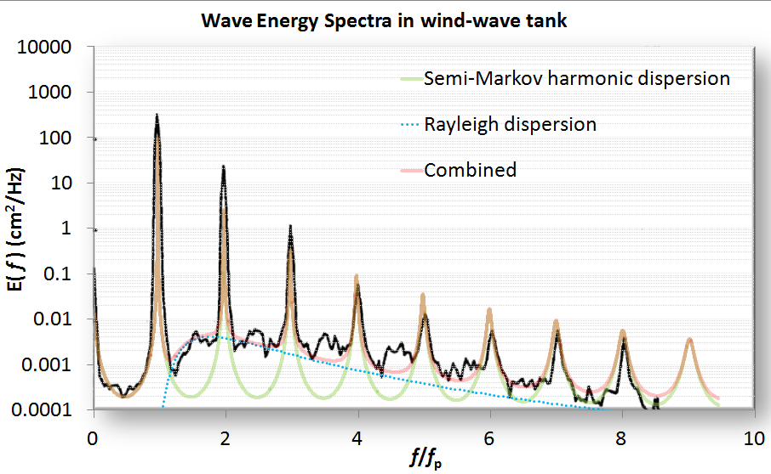

Figure 13: Highly ordered waves with all harmonics generated in a wave tank. This is in terms of temporal frequency and the spatial frequency can be recovered via the dispersion relation.

The basic model is to choose a *P*(*L*) wave density such that it reproduces the spacing and envelope of the harmonics. One of the simplest density functions is known as the shifted exponential. This maintains a minimum spacing with the possibility of an occasional longer wavelength:

**(6)**

This generates a Fourier transform

And then the full power spectrum assuming a coherent relationship exists (see **Equation** **1**):

**(7)**

**(8)**

These two formulations, scaled accordingly, generate the semi-Markov harmonic dispersion model shown in Figure 13. The first equation (7) generates an odd-harmonic waveform due to a symmetric view of up and down steps. The second equation (8) assumes an all-harmonic composition derived by assuming a surface with a saw-tooth set of steps, which is likely nearer the real situation for stimulated waves.

Note that as *L0* approaches zero, then the Markov random walk is recovered (see equation **4**). Thus a simple parametric model with the two coefficients related by a *characteristic period,* < *L* >, can emulate the continuum of order to disorder:

As *L0* approaches < *L* > the spectrum will show strong harmonics. As *L0* approaches 0, the random aspect will suppress the harmonics. As an example of this continuum consider Figure 14 which shows very weak harmonics and higher disorder than the waves of Figure 13: [27]

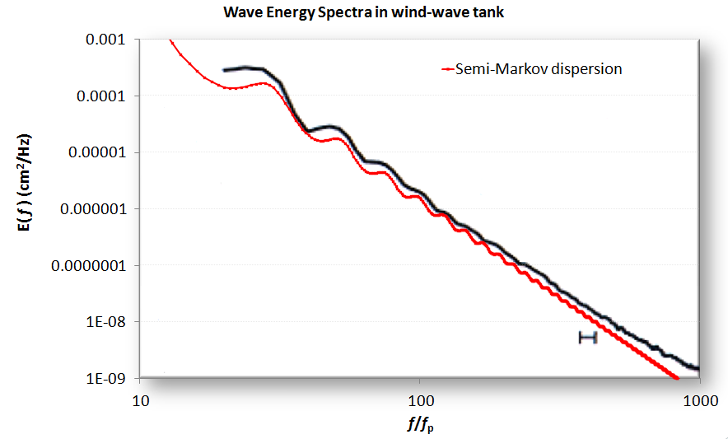

Figure 14: A PSD from a wave tank showing ripples

Note that the dispersion model does, by definition, generate square or sharp edges. Unless there are breakers in the waves, the actual profiles will get rounded. By applying a low-pass filter to the model, the actual waveform will reveal reduced high frequency components and give better agreement with the spectral data. Another example, fit from a simulated wave [28] is shown in Figure 15:

Figure 15: A simulated wave which emulates crest-focused dynamics shows intermediate order

In general, aquatic wave coherence showing strong harmonics occurs under more controlled conditions than normally exist in the wild.

 Aquatic Waves

Ocean waves exist in as disordered and unpredictable state as the wind. We may not always notice this as the scale of waves is smaller and often takes the form of a regular lapping of swells. In practice, the wind and wave energy distributions relate via similar maximum entropy disorder considerations. The following derivation assumes a deep enough water such that the wave troughs do not touch bottom  
  
First, we make a maximum entropy estimation of the energy of a one-dimensional propagating wave driven by a prevailing wind direction. The mean energy of the wave is related to the wave height by the square of the height, ***H***. This makes sense because a taller wave needs a broader base to support that height, leading to a scaled pseudo-triangular shape of a *gravity* wave, as shown in Figure 10 below.

|  |
| --- |
| Figure 10: Total energy in a directed wave goes as the square of the height, and the macroscopic fluid properties suggest that it scales to size. This leads to a dispersive form for the wave size distribution |
|  |

Since the area of such a scaled triangle goes as *H*2, the MaxEnt cumulative probability is:

where *α* is related to the mean energy of an ensemble of waves. This relationship is empirically observed from measurements of ocean wave heights over a sufficient time period. This looks at height alone.

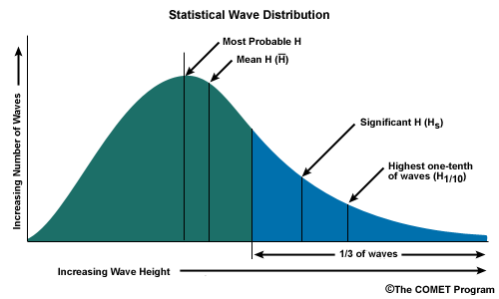

Figure 11: Statistical Wave Distribution (source: NOAA UCAR COMET Program)

Long-lived ocean and lake measuring stations have recorded historical records of wave crest data over the span of decades. From the US Army Corps of Engineer’s Wave Information Studies project[24], the following figure collects chop and swell data from over several hundred million data points on Lake Michigan:

Figure 12: Lake Michigan wave height PDF on log-linear scale.

The probability density function for significant wave height empirically follows a modified Bessel function of the second kind. This essentially derives from a maximum entropy distribution for a wave height with a mean energy value, which is then dispersed again by maximizing the uncertainty in the energy. With precisely the same pattern that we derive the Bessel function from a range in wind speed values, we can derive the PDF for wave energy.

The Bessel fit works well for small wave heights but then starts to diverge when the wave height starts to exceed a critical level. This critical level is essentially the cresting limit of a wave given the average depth of the water. At this point we can apply an empirical correction factor first proposed by Jahns and Wheeler[32] and further analyzed by Haring [33]. This factor is essentially a 2nd-order polynomial which gradually suppresses the wave height from exceeding the critical cresting value.

The rationale for the factor arises from the remote likelihood of a wave height from exceeding the average water depth (*d*) in a region.

Based on data collected from coastal waters of two large lakes, Superior and Michigan, and that along the eastern USA seaboard of the Atlantic Ocean, we can see the characteristic bend on the PDF at approximately 10 meter height.[[192]](#footnote-192)

According to Figure 13, the same basic Jahns/Wheeler correction is applied across the bodies of water. Both Michigan and Superior use a Bessel function of order 1, while the Atlantic uses a Bessel of order 2, which is generated by assuming an uncertainty that is not a maximum entropy exponential in the mean, but a MaxEnt that is a gamma of order 2 (i.e. two exponentials convolved which reduces the variance in ½)

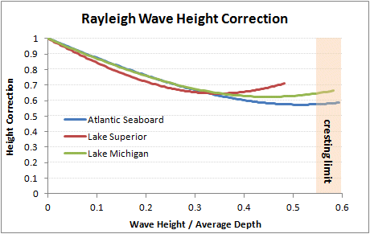

Figure 13: The Jahns/Wheeler correction applied to various bodies of water. The Lake Superior used coefficients closer to the heuristic J/W values (see Table 3) but Atlantic and Michigan appeared to asymptotically merge at the Nelson cresting limit of 0.55 for the wave height / average depth ratio.[34] [35].

Table 6: Heuristic Jahns/Wheeler correction used different coefficients to achieve the best fit.

|  |  |  |  |  |
| --- | --- | --- | --- | --- |
|  | Atlantic Seaboard | Lake Superior | Lake Michigan | Haring |
| Inferred Average Depth | 25.13 m | 22.82 m | 13.75 m | - |
| Haring Coefficient 1 | 2.52 | 4.86 | 3.03 | 4.37 |
| Haring Coefficient 2 | 1.03 | 0.69 | 0.90 | 0.57 |

To evaluate the fit across the extreme values, Figure 14 shows the model profile on a log-log scale. The long tails are important for evaluating the probabilities of high sea-state values.

Figure 14: Lake Michigan log-log scaled version of wave height PDF

Lake Superior measurements (Figure 15) were sparse, yet the same profile is observed.

|  |  |
| --- | --- |
|  |  |

Figure 15: Lake Superior wave height PDF log-linear (left) and log-log (right)

Wave measurements from the Atlantic Coast along the length of the USA were less widely dispersed (see below). It is much more unlikely to find very calm waters in the data set. In this case, a higher order BesselK function was used to model the wave height distribution.

|  |  |
| --- | --- |
|  |  |

Figure 16: Atlantic Coast wave height PDF plotted as log-linear (left) and log-log (right)

In general, the divergence between the BesselK maximum entropy estimator for wind and that for waves is due to nonlinear effects at large wave-height. The heuristic Jahns/Wheeler correction factor is physically modeled by wave cusping, which generate larger heights than the triangular base wave predicts. This essentially rationalizes the sharpened crests and flattened troughs before it hits the cresting limit. We used a heuristic, but other corrections are available, such as derivations from the Rayleigh-Stokes (Tayfun model[36] [37]) process which is classified as a narrow-banded random process[38].

For use in simulations, other factors also play in such as, the probability of consecutive waves and the fact that phase velocity increases with the increase in wave steepness[39] .

Even with the complexity inherent in modeling turbulence, the modeling at the PDF level has some predictive power. For example, using the Atlantic model parameters we can estimate the wave height for the Mediterranean coast of Greece [40]. In this sense, waves have universal characteristics.

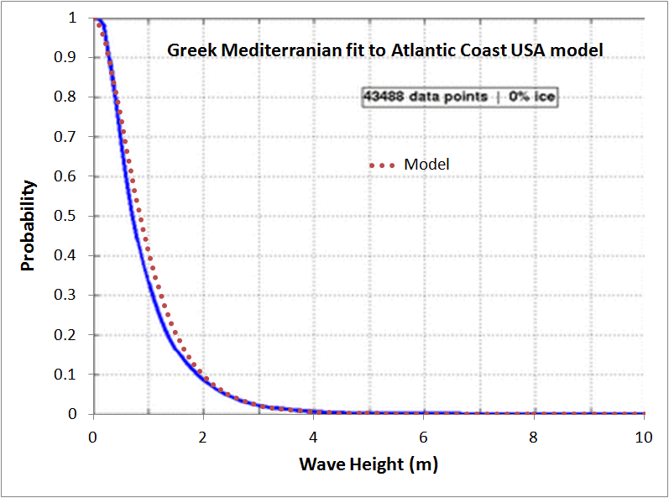 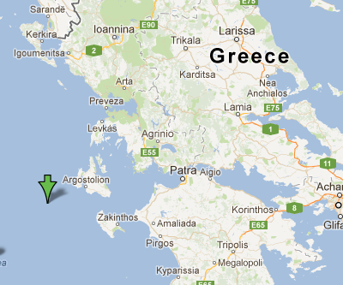

Figure 17: Mediterranean sea wave height assuming Atlantic coast model

## CHAPTER 18 Climate

**Rainfall**

Entropic dispersion also occurs in daily rainfall data. I happened across research work at the National Center for Atmospheric Research under the title “Extreme Event Density Estimation”[[193]](#footnote-193). The researchers there seem to think the following graph has some mysterious structure. It basically displays a histogram of daily rainfall in January at a station in North Carolina.

This data doesn’t appear highly dispersed as the tail stays thin, yet if look at this fit, we can understand the extreme value aspects:

You need to understand first that a critical point exists for rain to fall. The volume and density at which nature decides it reaches this critical point has much to do with the rate at which a cloud develops in its intensity and payload. If we assume that clouds develop by some sort of preferential attachment, then the uncertainties at which the preferential attachment process increases with time balanced against the uncertainties in the critical point contribute to the entropic dispersion:

|  |  |
| --- | --- |
|  | 30-2 |

The term g(x) essentially measures the preferential attachment accelerated growth rate:

|  |  |
| --- | --- |
|  | 30-3 |

This has the mechanism for preferential attachment since dg/dx = a \* (g(x)+k), which describes exponential growth plus a linear term. When plotted, we get the curve shown plotted along with the data points, where r=1, a=1/17 years and k=2 (dimensions in mm). Coincidentally, this is just the logistic sigmoid function; we never see the characteristic peak or inflection point since it starts off well up the towards the halfway point of the cumulative. See the following graph where I used r=10 to accentuate the sigmoid peak.Despite the good fit, this curve has a limited locality: consisting of one rainfall station in North Carolina. What happens when we look at the distribution of rainfall on a global scale?

The global curve below does not work as well for the exponential growth (bright green) but it does work very well for the power-law growth model (cumulative growth ~ x5, bright turquoise)[[194]](#footnote-194). The values shown here are in inches of rainfall, not millimeters as in the previous figure.

Since we can expand an exponential in terms of a Taylor series and see a sum of power terms, it makes some sense that the t5 term may emulate the exponential growth (or vice versa), or perhaps generate the limiting trend. Exponential growth eventually moderates and the 5th power may provide the major effect along the curve over the remainder of the fat tail. Note that the cumulative power is 6 in the model because we measure rainfall linearly while growth of water content goes as volumetric density, cubed as a radial growth, so a high-power law is not inconceivable.

The graph below shows an exponential morphing into a x6 dependence by limiting the Taylor series expansion of the exponential to 6 terms.

As the arguments for oil discovery (also a power law, as uncertain acceleration in technology along an uncertain volume) emulate rain strength (uncertain acceleration in cloud/droplet growth along an uncertain critical volume/density), I consider this a further substantiation of the overall entropic dispersion formulation.

Yet I've got to wonder: do climate scientists think this way? The hydrology researcher Koutsoyiannis, who identified the power-law dependence in the previous figure, seems to have followed this path [Ref 273]. His multiple Markov chain remains a bit unwieldy as he can only generate a profile via simulation, yet that may not matter if we can use a power-law argument directly as I did for dispersive discovery. This needs a deeper look as it exposes a few remaining modeling details in a comprehensive theory.

CO2

**Fossil Fuel Emissions and CO2 levels**

In case you missed the salient premise behind climate change, increased levels of CO2 form a greenhouse effect that can lead to global warming. I would rate the graph below of the concentration of atmospheric CO2 measured at Mauna Loa as one of the most famous charts in the annals of science, rivalled only by its close kin, the “hockey stick” graph[[195]](#footnote-195):

From just a technical perspective, it has an interesting composition — a committed research team that has collected data for some 50 years, measurements showing very little noise, the fascinating periodic cycle due to seasonal variations, and Al Gore to present it.

I don’t think many people realize how easy one can derive this curve. You only need a historical record of fossil fuel usage, a few parameters and conversion factors, and the knowledge of how to do a convolution. Since the Oil Shock model uses convolutions heavily, doing this calculation fits in well with an oil production profile. And since oil production leads to CO2 emissions, you can get the rest of the picture.

So, the way I view it, the excess CO2 production becomes just another stage in the set of shock model convolutions, which model how fossil fuel discoveries transition into reserves and then production as described in Volume 1. The culminating step in oil usage becomes a transfer function convolution from fuel consumption to a transient or persistent CO2 (depending on what you want to look at). Add in the other hydrocarbon sources of coal and natural gas and you have a starting point for generating the Mauna Loa curve.

The Recipe. First, we can roughly anticipate what the actual CO2 curve will look like, as it will lie somewhere between the two limits of immediate recapture of CO2 (the fast-transient regime hovering just above the baseline) and no recapture or sequestering (the persistent integrated regime which keeps accumulating). See the figure below.

Although this transient can show very long persistence and a very fat tail, as I will eventually get to, we only need an average rate to generate the initial rise curve[[196]](#footnote-196).

So, the ingredients:

1. Conversion factor between tons of carbon generated and an equivalent parts- per-million volume of CO2. This is generally accepted as 2.12 Gigatons carbon to 1 ppmv of CO2. Or ~7.8 Gt CO2 to 1 via purely molecular weight considerations.

2. A baseline estimate of the equilibrium CO2, also known as the pre-industrial level. This ranges anywhere from 270 ppm to 300 ppm, with 280 ppm the most popular (although not necessarily definitive).

3. A source of historical fossil fuel usage. The further back this goes in time the better. I have three locations: one from the Wikipedia site on atmospheric CO2, one from the Carbon Dioxide Information Analysis Center at Oak Ridge National Labs, and another from the NOAA site.[[197]](#footnote-197)

4. A probability density function (PDF) for the CO2 impulse response. If you don't have the actual PDF, use the first-order reaction rate exponential function, R(t)=exp(-kt).

5. A convolution function, which you can do on a spreadsheet with the right macro.

The convolution of carbon production Pc(t) with the impulse response R(t) generates C(t):

|  |  |
| --- | --- |
|  | 30-13 |

Multiplying the result by a conversion factor k; then adding this to the baseline L generates the filtered Mauna Loa curve as a concentration in CO2 parts per million.

The sticky part. If you follow climate science research, you may often read about different estimates for the “CO2 Half-Life” of the atmosphere. This becomes the impulse response function, R(t), we just described. Unfortunately, the value for this quantity has elicited much debate. I have heard numbers as short as 6 years and others as long as 100 years or more.

ClimateProgress.org -- Strictly speaking, excess atmospheric CO2 does not have a half-life. The distribution has a very long tail, much longer than a decaying exponential.

As an approximation, use 300-400 years with about 25% ‘forever’.

....

ClimateProgress.org -- David is correct. Half-life is an inappropriate way to measure CO2 in the atmosphere. The IPCC uses the Bern Carbon Cycle Model. See Chapter 10 of the WGI report (Physical Basis) or http://www.climate.unibe.ch/

~joos/OUTGOING/publications/hooss01cd.pdf

This issue has importance because CO2 latency and the possible slow sequestering time has grave implications for rebounding from a growing man-made contribution of CO2 to the atmosphere. A typical climate sceptic response will make the claim for a short CO2 lifetime:

Endangerment Finding Proposal

Lastly; numerous measurements of atmospheric CO2 resident lifetime, using many different methods, show that the atmospheric CO2 lifetime is near 5-6 years, not 100-year life as stated by Administrator (FN 18, P 18895), which would be required for anthropogenic CO2 to be accumulated in the earth's atmosphere under the IPCC and CCSP models. Hence, the Administrator is scientifically incorrect replying upon IPCC and CCSP -the measured lifetimes of atmospheric CO2 prove that the rise in atmospheric CO2 cannot be the unambiguous result of human emissions.

The model of the carbon cycle describes the detailed mass balance of carbon between the atmosphere and the earth’s surface. The surface can be either land or water, it doesn’t matter for argument’s sake. We know that the carbon-cycle between the atmosphere and the biota is relatively fast and most of the exchange has a turnover of just a few years. Yet, what should really interest us is the deep exchange of the carbon with slow-releasing stores. This process is described by diffusion and that is where we can use a master diffusion equation to represent the flow of CO2.

We can’t debate this as it describes the flow of particles; they call it the master equation because it invokes the laws of probability and the basic random walk that just about every physical phenomenon displays.

The origin of the master equation is best described by considering a flow graph and drawing edges between compartments of the system. This is often referred to as a compartment or box model. The flows go both ways and are random, and thus model the random walk between compartments.

Fig 34 is a Markov model consisting of 50 stages of deeper sequestering with each slab having a constant but small hop rate. The single interface between the atmosphere and the earth has a faster hopping rate corresponding to faster carbon cycling.

First thing one notices about the graph is that after a rapid initial fall-off it only slowly decreases over time. The physical meaning is that, due to diffusion, the concentration randomly walks between the interface and deeper locations in the earth. The fat-tail time dependence is a classic trait of all random walks and you can’t escape seeing this if you have ever watched nature in action. That is just the way particles move around.

Not knowing much about the specific chemistry involved but understanding that CO2 reaction kinetics has much to do with the availability of reactants, I can imagine the profile may vary, specifically as a function of location and altitude. CO2 at higher altitudes would have fewer reactants to interact with while reactivity with the land and sea to deep sequestering can also vary.

**Deriving the Fat-Tail in CO2 Persistence**

So, what happens if we have a dispersed rate for the CO2 reaction?

Say the CO2 mean reaction rate is R=0.1/year (or a 10-year half-life). Since we only know this as a mean, the standard deviation is also 0.1. Placing this in practical mathematical terms, and according to the Maximum Entropy Principle, the probability density function for a dispersed rate r is:

|  |  |
| --- | --- |
|  | 30-14 |

One can’t really argue about this assumption, as it works as a totally unbiased estimator, given that we only know the global mean reaction rate.

So, what does the tail of reaction kinetics look like for this dispersed range of half- lifes? Assuming the individual half-life kinetics act as exponential declines then the dispersed calculation derives as follows

|  |  |
| --- | --- |
|  | 30-15 |

This expression when integrated gives the following simple expression:

|  |  |
| --- | --- |
|  | 30-16 |

which definitely gives a fat-tail as the following figure shows (note the scale in 100's of years). I can also invoke a more general argument in terms of a mass-action law and drift of materials; this worked well for oil reservoir sizing. Either way, we get the same characteristic entroplet shape.

For the plot above, at 500 years, for R=0.1, about 2% of the original CO2 remains. In comparison for a non-dispersed rate, the amount remaining would drop to e-50 or ~2 10-20% !

Now say that R holds at closer to a dispersed mean of 0.01, or a nominal 100 year half-life. Then, the amount left at 500 years sits at 1/(1+0.01\*500) = 1/6 ~ 17%.

In comparison, the exponential would drop to exp(-500/100) = 0.0067 ~ 0.7% Also, 0.7% of the rates will generate a half-life of 20 years or shorter. These particular rates quoted could conceivably result from those volumes of the atmosphere close to the prime sequestering sites.

Now it gets interesting ... Climatologists refer to the impulse response of the atmosphere to a sudden injection of carbon as a key indicator of climate stability. Having this kind of response data allows one to infer the steady state distribution. The IPCC used this information in their 2007 report.

**Current Greenhouse Gas Concentrations**

The atmospheric lifetime is used to characterize the decay of an instanenous pulse input to the atmosphere, and can be likened to the time it takes that pulse input to decay to 0.368 (l/e) of its original value. The analogy would be strictly correct if every gas decayed according to a simple expotential curve, which is seldom the case.

...

For CO2 the specification of an atmospheric lifetime is complicated by the numerous removal processes involved, which necessitate complex modeling of the decay curve. Because the decay curve depends on the model used and the assumptions incorporated therein, it is difficult to specify an exact atmospheric lifetime for

CO2. Accepted values range around 100 years. Amounts of an instantaneous injection of CO2 remaining after 20, 100, and 500 years, used in the calculation of the GWPs in IPCC (2007), may be calculated from the formula given in footnote a 213 of that document. The above-described processes are all accounted for in the derivation of the atmospheric lifetimes in the above table, taken from IPCC (2007).

The following graph shows impulse responses from several sets of parameters using the referenced Bern IPCC model[[198]](#footnote-198). This result shows an unusual asymptotic trend to a constant baseline, and the model parameters reflect this. For a system at equilibrium, the impulse response decay should go to zero. I believe that it physically does, but that this model completely misses the fact that it eventually should decay completely. In any case, the tail shows a huge amount of “fatness”, easily stretching beyond 100 years, and something else must explain this fact.

If you think of what happens within the earth’s crust, the migration of CO2 from active carbon-cycle regions to deeper sequestering regions can only occur via the process of diffusion. We can write a simple relationship for Fick's Law diffusion as follows:

|  |  |
| --- | --- |
|  | 30-17 |

This states that the growth rate dG(t)/dt remains proportional to the gradient in concentration it faces. As a volume gets swept clean of reactants, G(t) gets larger and it takes progressively longer for the material to “diffuse” to the side where it can react. This basically describes oxide growth as well which we covered in Volume 1.

The outcome of Fick's Law generates a growth law that goes as the square root of

time, t . According to the dispersion formulation for cumulative growth, we sim-

ply must replace the previous linear drift growth rate with the diffusion-limited growth rate.

|  |  |
| --- | --- |
|  | 30-18 |

or in an alternate form where we replace the probability P(t) with a normalized response function R(t):

|  |  |
| --- | --- |
|  | 30-19 |

At small time scales, diffusion can show an infinite growth slope, so using a finite width unit pulse instead of a delta impulse will create a reasonable picture of the dispersion/diffusion dynamics.

Diffusion Solution. We can easily derive the solution of the response function if we think of the diffusion from a planar source outward. The diffusion kernel resulting from solving the Fokker-Planck equation (sans drift term) is:

|  |  |
| --- | --- |
|  | 30-20 |

We place an impulse of concentrate at x=0 and want to watch the evolution of the concentration with time. We have an idea of a mean value for the diffusion coefficient, D, but don’t know how much it varies. The remedy for that is to apply a maximum entropy estimate for the variance assuming a mean value D0.

|  |  |
| --- | --- |
|  | 30-21 |

So, then we can apply this to the kernel function:

|  |  |
| --- | --- |
|  | 30-22 |

This comes out quite clean

|  |  |
| --- | --- |
|  | 30-23 |

This gives us a result that shows a singularity at t=0 for x=0. In practice, the value of x is not precise, so that we can also place an uncertainty around the value of x.

|  |  |
| --- | --- |
|  | 30-24 |

We can apply this to the concentration, marginalizing x out of the picture:

|  |  |
| --- | --- |
|  | 30-25 |

This integral is very straightforward

|  |  |
| --- | --- |
|  | 30-26 |

which is precisely the equation, apart from normalization, estimated from the dispersional formulation applied to Fick’s law described earlier

Remarkably, this simple model reproduces the IPCC model accurately, with the appropriate choice of the disordered diffusion coefficient. The analytically calculated points lie right on top of the lines in the figure above, which makes it hard to see the excellent agreement. I find it very useful that the model essentially boils down to a single parameter of entropic rate origin (while both diffusion and dispersion generates the shape).

You don’t see it on this scale, but the tail will eventually reach zero, but at a rate asymptotically proportional to the square root of time. In 10,000 years, it will reach approximately the 2% level (i.e. 2 ? CO2 adjustment time. 10000 . This defines the concept of a lengthy

Two other interesting observations grow out of this most parsimonious agreement.

First, why did the original IPCC modelers from Bern not use an expression as simple as the entropic dispersion formulation? Instead of using a three-line derivation with a resultant single parameter to model with, they chose an empirical set of 5 exponential functions with a total of 10 parameters and then a baseline offset.

That makes no sense unless their model essentially grows out of some heuristic fit to measurements from a real-life carbon impulse[[199]](#footnote-199). I can only infer that they never made the connection to the real statistical physics.

Secondly, the simple model really helps explain the huge discrepancy between the quoted short lifetimes by climate sceptics and the long lifetimes stated by the climate scientists. These differ by more than a magnitude. Yet, just by looking at the impulse response in the preceding figure, you can see the fast decline that takes place in less than a decade and distinguish this from the longer decline that occurs over the course of a century. This results because of the mechanism of random walk diffusion and that of entropy within the carbon-cycle, leading to a large dispersion in reaction rates, and the rates limited by diffusion kinetics as the CO2 migrates to sequestering sites.

The fast slope evolving gradually into a slow slope has all the characteristics of the “law of diminishing returns” characteristic of diffusion, with the accurate fit occurring because I included dispersion correctly and according to maximum entropy principles. Note that the previous section on cloud ice crystal formation kinetics shows this same parsimonious agreement to the data.

Think of it this way: if this simple model didn’t work to describe the CO2 adjustment time kinetics, one would have to explain why it failed or didn’t apply.

Production Emissions Stimulating CO2 levels

So, we see how a huge fat tail can occur in the CO2 impulse response. What kind of implication does this have for the long term?

A disconcerting trend for one, and that brings us to the point that the point that climate scientists have made all along. With a fat-tail, one can demonstrate that a CO2 latency fat-tail will cause the responses to forcing functions to continue to get worse over time.

As this paper notes [Ref 303] and we will derive, applying a stimulus to a fat-tail generates a non-linear impulse response which will look close to the Mauna Loa curve shape. Not surprisingly but still quite disturbing, applying multiple forcing functions as a function of time will not allow the tails to damp out quickly enough, and the tails will gradually accumulate to a larger and larger fraction of the total. Mathematically you can work this out as a convolution and use some neat techniques in terms of Laplace or Fourier transforms to prove this analytically or numerically.

As a first sanity check let’s assume that the incoming stream of new CO2 from fossil fuel emissions is called P(t). This becomes the forcing function. Then we can describe the system evolution by the equation

|  |  |
| --- | --- |
|  | 30-27 |

where the operator ? is not a multiplication but signifies convolution. For the forcing function P(t) we use a growing power law.

|  |  |
| --- | --- |
|  | 30-28 |

where N is the power and k is a scaling constant. This roughly represents the atmospheric emissions through the industrial era if we use a power law of N=4.

So, all we really want to solve is the convolution of P(t) with the fat-tail r(t). By using Laplace transforms on the convolution expression, the answer comes out surprisingly clean and concise. Ignoring the scaling factor:

|  |  |
| --- | --- |
|  | 30-29 |

With that solved, we can now answer the issue of where any “missing CO2” resides. This is an elementary problem of integrating the forcing function, F(t), over time and then comparing the concentration, c(t), to this value. Then this ratio of c(t) to the integral of F(t) is the amount of CO2 that remains in the atmosphere.

Working out the details, this ratio is:

|  |  |
| --- | --- |
|  | 30-30 |

Plugging in numbers for this expression, q=1, and N=4, then the ratio is about 0.28 after 200 years of growth. This means that 0.72 of the CO2 is going back into the deep-stores of the carbon cycle, and 0.28 is remaining in the atmosphere. If we choose a value of q=2, then 0.56 remains in the atmosphere and 0.44 goes into the deep store. This ratio is essentially related to the effective diffusion coefficient of the carbon going into the deep store.

This essentially explains the “25% forever” in the ClimateProgress comment. Diffusion and dispersion of rates essentially prohibit the concentrations to reach a comfortable equilibrium. The man-made forcing functions keep coming and we have no outlet to let it dissipate quickly enough.[[200]](#footnote-200)

We can now try to apply these numbers to the full response recipe. I used R(t)=exp(-t/T), where T=42 years and L=1280 ppm baseline and data from Figure 30-19 607 for Pc(t), giving the following fit.

I also applied a curve fit model of the carbon generated, which followed a Time4 acceleration, and which had the same cumulative as of the year 2004. You can see subtle differences between the two which indicates that the rate function does not completely smooth out all the yearly variations in carbon emission. So, the two convolution approaches show some consistency with each other, but the fit to the Mauna Loa data appears to have a significant level shift. I will address this in a moment.

The precise form of the impulse response function, other than the average rate selected, does not change the result too much. I can make sense out of this since the strongly increasing carbon production wipes out the fat-tails of slower order reaction kinetics (see the figure below). In terms of the math, a Time4 power effectively overshadows a weak 1 ? Time or 1/Time response function. However, you will

see start to see this tail if and when we start slowing down the carbon production. This will give a persistence in CO2 above the baseline for centuries.

Once we feel comfortable doing the convolution, we can add in a piecewise extrapolated production curve and we can anticipate future CO2 levels. We need a fat-tail impulse response function to see the long CO2 persistence in this case (unless 42 years is long enough for your tastes).

The Loose End. If you look at the fit in Figure 30-18 606, you can obviously see an offset of the convolution result from the actual data. This may seem a little puzzling until you realize that the background (preindustrial) level of CO2 can shift the entire curve up or down. I used the background level of 280 ppm purely out of popularity reasons. More people quote this number than any other number. However, we can always evaluate the possibility that a higher baseline value would fit the convolution model more closely. Let’s give that a try.

The following figure shows a different CO2 data set which includes the Mauna Loa data as well as earlier proxy ice core data. Based on the levels of CO2, I surmised that the NOAA scientist that generated this graph subtracted out the 280ppm value and plotted the resultant offset. I replotted the data convolution as the dotted gray line.

Note that the curve consistently shows a shift 14ppm below the actual data (note the logscale). This indicates to me that the actual background CO2 level sits 14ppm above 280ppm or at approximately 294ppm. When I add this 14ppm to the curve and replot, it appears like:

Although the data does not go through a wide dynamic range, I see a rather parsimonious agreement with the two-parameter convolution fit.

Just like in the oil shock model, the convolution of the stimulus with an impulse response function will tend to dampen and shift the input perturbations. If you look closely at the figure above, you can see faint reproductions of the varying impulse, only shifted by about 25 years. I contend that this “delayed ghosting” comes about directly because of the 42-year time constant I selected for the reaction kinetics rate. This same effect occurs with the well-known shift between the discovery peak and production peak in peak oil modeling. Even though King Hubbert himself pointed out this effect years ago, no one else has explained the fundamental basis behind this effect, other than through the application of the shock model. That climate scientists most assuredly use a convolution approach as well points out a potential unification between climate science and peak oil theory. Rutledge of CalTech has looked at this connection closely, particularly in relation to future coal usage.

Bottom Line. To believe this model, you must convince yourself that 294 ppm marks the real background pre-industrial level (not 280), and that 40 years works as a pretty good time constant for CO2 decomposition kinetics. Everything else follows from first-order rate laws and the estimated carbon emission data.

Some other forcing inputs could easily make up the 14-ppm offset from the generally accepted 280 ppm. For example, changing agriculture and forestry patterns, and other human modifications of the biota could alter the forcing function during the 200+ year time-span since the start of the industrial revolution. Although recyclable plant life should eventually become carbon neutral, the fat-tail of the CO2 impulse response function means that sudden changes will persist for long periods of time. A slight rise from time periods from before the 1800’s coupled with an extra stimulus on the order of 500 million tons of carbon per year (think large-scale clearcutting and tilling from before and after this period) would easily close the 14 ppm CO2 gap and maintain the overall fit of the curve.

However, we would need to apply the fat-tail response function, g ? ?g + t? , to maintain the offset for the entire period as the clear-cutting has subsided. So, what happens if we use the fat-tail response for the entire convolution? A commenter pointed this useful insight:

Comment by EoS:

I don't think it is useful to think of an average CO2 lifetime. That implies a lumped linear model with only a single reservoir, hence an exponential decay towards equilibrium. In reality there are lots of different CO2 reservoirs with different capacities and time constants. So any lumped model had better use several reservoirs with widely varying time constants at a minimum, or else it will get the time behavoir seriously wrong.

It turns out that the variation or dispersion in reaction rates makes very little difference in the slope on the climb up. That is fundamental and I addressed that in Figure 30-20 607. The reason for this is very simple mathematics — the climb up in CO2 arises by power laws on the order of N>3 or by exponential increases. That comes directly from accelerating fossil fuel usage. In contrast, the reaction rates of CO2 have exponents that are negative or have inverse power laws of very low order, the so-called fat-tail distributions. When you put these together, the power law increase essentially crushes the long-tails and all you see are the average value of the faster kinetics. I put in the analytical solution so you can see this directly in the convolution results.

Alternately, apply a simple convolution of accelerating growth [exp(at)] with a first-order reaction decline [exp(-kt)] and you will see what I mean. You get this:

|  |  |
| --- | --- |
|  | 30-31 |

The accelerating rate a will quickly overtake the decline term k. If you put in a spread in k values as a distributed model, the same result will occur, substantiating the inexorable incline. Climate scientists should realize this as well since they have known about the uses of convolution in the carbon cycle for years [Ref 276].

The following figure uses fossil fuel data from the ORNL Carbon Dioxide Information Analysis Center over the last 260 years, and we apply the diffusion fat-tail response function shown in the inset.

Scaled and overlaid on the estimated atmospheric CO2 levels, one can again see the generally good agreement in the figure below:

Yet, if we were to stop burning hydrocarbons today, then we would see the results of the fat-tail decline. Again, I think the climate scientists understand this fact as well but that idea gets obscured by layers of computer simulations and the salient point or insight doesn’t get through to the layman. This is understandable because these are not necessarily intuitive concepts.

This following figure models CO2 uptake if we abruptly stop growing fossil fuel use after the year 2007. We don’t simple stop using oil and coal, we simply keep our usage constant.

Up to that point in time a dispersive (i.e. variable) set of rate kinetics will be virtually indistinguishable from a single rate. And you can see that behavior as the curves match for the same average rate. But once the growth increase is cut off, the dispersive/diffusive kinetics takes over and the rise continues. With the first-order kinetics the growth continues but it becomes self-limiting as it reaches an equilibrium. This works as a plain vanilla rate theory with nothing by the way of feedbacks in the loop. When we include a real positive feedback, that curve can even increase more rapidly.

Recall that this analysis carries over from studying dispersion in oil discovery and depletion. The rates in oil depletion disperse all over the map, yet the strong push of technology acceleration essentially narrows the dispersed elements so that we can get a strong oil production peak or a plateau with a strong decline. In other words, if we did not have the accelerating components, we would have had a long drawn out usage of oil that would reflect the dispersion. That explains why I dislike the classical derivation of the Hubbert Logistics curve, as it reinforces the opinion of peak oil as some “single-rate” model.

In fact, just like climate science, everything gets dispersed and follows multiple pathways, and we need to use the appropriate math to analyze that kind of situation.

Climate scientists understand convolution, but peak oil analysts don’t, except in the context of the shock model. That basically outlines why I want to share these ideas with climate scientists and unify the concepts. It will help both camps, simply by dissemination of fresh ideas and unification of the strong ones. Doing this exercise has turned into an eye-opener for me, as it didn’t really occur to me how straight- forward one can derive the CO2 results. Of course, this simple model does not take into possible positive feedback effects such as CO2 outgassing from increasing temperature [Ref 304] and see figure below, yet it does give one a nice intuitive framework to think about how hydrocarbon production and combustion leads directly to atmospheric CO2 concentration changes and ultimately climate change.

Do we believe that the dispersion of CO2 lifetimes actually exists? Applying Bayesian reasoning to the uncertainty in the numbers that people have given, I would think it likely. Uncertainty in people’s opinions usually results in uncertainty (i.e. dispersion) in reality (see the sidebar). By collecting the statistics for the equivalent rates, it turns out that the standard deviation approximately equals the mean (0.17/ year) — this supports the idea that the uncertainty in rates found by measurement matches the uncertainty found in nature, thus giving the entropic fat tail.

The following paper addresses many of the uncertainties underlying climate change: “The shape of things to come: why is climate change so predictable?”

The framework of feedback analysis is used to explore the controls on the shape of the probability distribution of global mean surface temperature response to climate forcing. It is shown that ocean heat uptake, which delays and damps the temperature rise, can be represented as a transient negative feedback. This transient negative feedback causes the transient climate change to have a narrower probability distribution than that of the equilibrium climate response (the climate sensitivity). In this sense, climate change is much more predictable than climate sensitivity. The width of the distribution grows gradually over time, a consequence of which is that the larger the climate change being contemplated, the greater the uncertainty is about when that change will be realized. Another consequence of this slow growth is that further efforts to constrain climate sensitivity will be of very limited value for climate projections on societally-relevant time scales.

Finally, it is demonstrated that the effect on climate predictability of reducing uncertainty in the atmospheric feedbacks is greater than the effect of reducing uncertainty in ocean feedbacks by the same proportion. However, at least at the global scale, the total impact of uncertainty in climate feedbacks is dwarfed by the impact of uncertainty in climate forcing, which in turn is contingent on choices made about future anthropogenic emissions.[Ref 302]

In some sense, the fat-tails may work to increase our certainty in the eventual effects — we only have uncertainty in the when it will occur. Analysts tend to think that fat-tails only expose the rare events. In this case, they can reveal the inevitable That knotty and long CO2 residence time combined with fossil fuel combustion leads to the inevitable rise that we will describe in the next section.

I contend that entropy and disorder in physical processes plays such a large role that it ends up controlling a host of observations that we have covered so far. Unfortunately, most scientists don’t think in these terms; they still routinely rely on deterministic arguments alone. Which gets them in the habit of using heuristics instead of the logically appropriate stochastic solution.

Which leads me to realize that the first two observations have the unfortunate effect of complicating the climate change discussion. I don't really know, but might not climate change skeptics twist facts that have just a kernel of truth? Yes, certainly “some” of the CO2 concentrations may have a half-life of 10 years, but that misses the point completely that variations can and do occur. I am almost certain that sceptics that populate sites such as ClimateAudit.org see that initial steep slope on the impulse response and convince themselves that a 10-year half-life must happen, and then decide to use that to challenge climate change science. Heuristics give the skilled debater ammo to argue their point any way they want.

I can imagine that just having the ability to argue in the context of a simple entropic disorder can only help the discussion along, and relying on a few logically sound first-principles models provides great counter-ammo against the sceptics.

## CHAPTER 19 Travel and Terrain

Randomness in ground and topography

**Abstract:** Environmental models by their nature contain a great deal of uncertainty. Since the underlying behavior of the model is rarely controlled by an ordered process, any model characteristics will carry along with it a level of aleatory uncertainty governed by the natural disorder. This paper applies novel uncertainty characterization approaches to classes of topographic models to demonstrate how to quantify the natural order and distinguish from artifical (man-made) order.

Preface

Comprehensive vehicle testing requires *environmental context* models to evaluate a design’s robustness and fitness for use. For a ground vehicle designed for both on-road and off-road use, interactions with the terrain provide an important testing context. For amphibious vehicles, the environmental context extends to sea states and aquatic currents. As an overriding factor, being able to traverse and navigate successfully various surface topographical features plays a large role in verifying that a vehicle’s requirement specifications can be met.

To streamline the verification process, terrains need to be first well characterized and then modeled comprehensively enough that probability of correctness approaches can be applied. Without the ability to quantify for the probability of occurrence for a specific environmental effect, any requirements based on topography, such as traverse grade, can’t be propagated to a virtual test of the vehicle’s design ─ and thus we cannot substantiate with any degree of certainty or accuracy whether the vehicle meets the customer’s needs.

This paper applies general methods for stochastic modeling of environment contexts described in a companion paper (volume 1 of this series) “Stochastic Analysis for Context Modeling” (see Appendix A).

Primer on Characterization and Modeling

To develop some breadth, the models described here will cover both land and aquatic topographies. The landform aspects we refer to as *terrain* *modeling* [2] and the aquatic as *wave* (or *wave energy*) *modeling*[3].

For terrains, we consider a rigid model of altitudes as a function of lateral dimension. Often, a one-dimensional path, with provision for left and right tracks, is sufficient to characterize a terrain. The interaction of the vehicle with this type of terrain path provides enough of a context to virtually verify requirements such as absorbed power at speed and fuel efficiency on inclined grades.

*Stochastic models*[4] work very effectively to describe natural as well as artificial, man-made terrain. Enough disorder and randomness exists in the natural world, and even within an artificial world of cobblestones, chatter bumps, rumble strips, and wave machines, that a synthetic model using probability concepts appears indistinguishable from an empirically measured set of real-world data[5].

The stochastic tools of the trade include probability distribution functions, autocorrelation functions, power spectral densities, and moment distributions [6].

*Probability density functions* (PDF) model sample spaces. A single PDF graph facilitates the characterization of natural phenomena that are prevalent in context modeling, including terrain slope distributions as well as wind, rainfall, lakes, cloud, etc.[7] Many of these models reduce to fairly simple analytical forms. For disordered systems and data containing aleatory uncertainty[8], we use techniques such as the *maximum entropy principle*[9]and *super-statistics*[10], which have a more formal basis than heuristic models can provide[[201]](#footnote-201). For narrow distributions, we can apply Normal or Gaussian statistics.

*Autocorrelations* (ACF) and *power spectral densities* (PSD) are tied closely together. In basic terms, an autocorrelation describes the amount of similarity between two points separated spatially or temporally [11]. For static terrain this is a purely spatial consideration, but at a constant vehicle speed, an autocorrelation turns into a temporal characteristic, as time equates to motion across a terrain. A PSD contains the same information as an ACF but works in the inverse space, either the wavenumber (*k*) space in the spatial domain, or frequency (ω) space in the time domain. The decision to select an autocorrelation function or power spectral density will depend on the application. A spectral representation can easily provide reconstructed instances for either spatial or temporal domains in a general system context. The power of the real space autocorrelation is that it can recover a synthetic representation of the local terrain as a random walk model, while the PSD can approximate a varied terrain as a superposition of sine waves.

In addition, certain *multiscale* metrics[12] are useful to further characterize and in particular disambiguate potentially degenerate model descriptions. In particular, the multiscale entropy measure can be applied to temporal and spatial scales covering a wide dynamic range, and multiscale variances are sensitive to asymptotic behavior. What this tells us is the amount of disorder and uncertainty in the data, which is important as a concise supporting characterization metric.

Table 7: Stochastic Model Categories

|  |  |  |  |
| --- | --- | --- | --- |
| Stochastic Model |  | Includes and Related |  |
| Probability Density Function | PDF | Cumulative Distribution Function, Histogram | Position Independent |
| Autocorrelation Function | ACF | Correlation, Autocovariance | Relative |
| Power Spectral Density | PSD | Power Spectrum, Periodogram, Fourier Spectrum | Relative |
| Multiscale Analysis | MSA | Multiscale Variance, Multiscale Entropy | Relative |

**Table 1** above categorizes the stochastic models used to characterize terrain and waves. These can work together to model some sophisticated profiles. For example, a probability density function can model a length distribution, which then gets applied to a semi-Markov formulation for an autocorrelation analysis. By then applying a *Fourier transform* to the autocorrelation, we can arrive at a very concise representation. We will describe this in the analysis section.

Data Characterization

The rules for construction of probability density functions follow from some elementary principles. Samples from experimental data are ranked, and then normalized to the largest (i.e. scarcest) sample. This establishes a cumulative probability of unity when integrated over the sampled data space. The rank histogram is then converted to a cumulative distribution function by interpolating across a continuum, and then a PDF derives from the first derivative with respect to the random variate. Strictly speaking, a PDF is a discrete (binned) form while a probability mass function (PMF) is the continuum, but we will uniformly use the term PDF, even though we generally assume the continuum.

Given that *X* is some variate of interest, then a PDF described by *f* (*X*) can be used to generate moments of the distribution, such as the expected value **E** [*X*].

Autocorrelation functions consider the pair-wise expected value of all samples separated by a distance measure. This describes the affinity for localized interactions that a PDF lacks sensitivity to. The computational complexity of calculating an autocorrelation can go as N2, but a full computation is not always necessary for determining only closely separated distance correlations. Due to the *Wiener-Khinchin* theorem, the Fourier Transform of the data itself, calculated as a power spectrum of magnitude squared, is equal to the Fourier Transform of the autocorrelation, so that an inverse Fourier Transform of the directly calculated power spectrum will recover an autocorrelation. Due to the efficiency of a FFT, the computational time is order N×log(N), so this is often used to produce an ACF and a PSD with only frequency spectrum tools.

The power spectrum and autocorrelation are related by the following equation:

Where the autocorrelation is defined as

The double *xx* indicates that the expected value is between pairs of points along the terrain, with the τ serving as the sample-to-sample distance measure. (The asterisk indicates the complex conjugate, which does not apply for these signals.)

Foundation of Stochastic Model Analysis

The analysis of real-world PDF’s is aided by the fact that independence is assumed in the sample space. Each draw from a PDF is by definition independent and *stationary* with respect to the sampling point. We don’t always have to understand and assert independence but enough empirical studies have been done to understand when the premise will work and when it doesn’t.

For distributions based on energetic processes, the *principle of maximum entropy* often results in parsimonious fits to collected data (later will show extended examples for ocean waves and terrain). The selection of the variate and how to apply the prior is important, as the shape of the distribution can be thin-tailed (exponential or Normal distributed) or fat-tailed (a power-law) depending on its modeled derivation. For example, a timing distribution may be fat-tailed because the analyzed variate is velocity (which would ostensibly give a thin-tail) but since time appears in the denominator with respect to velocity, the eventual PDF generates much more weight in the tail (i.e. a ratio distribution [4]).

For an ACF, the typical realization is via a random-walk model, often described by a *Markov* or *semi-Markov* process [11]. Higher order localized interactions beyond that, such as the near-neighbor memory-less Markovian random walk, can generate smoothed/filtered or ordered/periodic profiles, depending on the signs and strengths of the interactions. This has significance for decoding both an ACF and a PSD. An important consideration for autocorrelations is the concept of *coherence* length. A coherence length is that distance at which long-range correlations cease to factor in. Beyond that point, the state of the system could just as easily be determined by a draw from a PDF. This has significant implications on whether to apply a Fourier Transform on a model to match a power spectrum or to simply treat the PSD as an inverted probability density function in the frequency spectrum.

The interplay between the use of PDF and ACF profiles for characterization is abetted by some very practical aspects of working in the spatial frequency domain. One novel way of looking at the problem derives from the world of diffraction spectroscopy, where because of the micro-scales involved, the only way possible to get insight is to immerse oneself in the inverse of the spatial domain, into the spatial frequency domain, in what is known as *reciprocal space.* [13]

We will work in reciprocal space here, not because we can’t detect the spatial features with measurements, but because the convenient mating of stochastic processes combined with powerful spectral algorithms, allows us to develop an analysis with greater rigor and statistical accuracy. This has huge implications for generating synthetic terrains based on limited real-world data (for example, where the actual course is classified but the PSD is not).

Unified Autocorrelation Analysis

Our analysis based on characterizing stationary profiles. This approach is fully documented elsewhere[13] in which we derive the *pair correlation* (autocorrelation) functions of arbitrary surfaces. The derivation assumes a path in essentially a 2-dimensional slice. One dimension is the distance along the path of traversal and the other dimension is the elevation of the point along that path.

A surface is constructed with *Nc* rigid cells arranged in the x- and z-directions. In a discrete approximation, the cell spacing in the x-direction is *a,* and in the z-direction is *d.* This surface is described by a function *f(x,* z) which is equal to 1 if there is a surface cell at coordinates *(x, z)* and 0 otherwise. The Fourier power spectrum is defined as:

Where is the vector wavenumber defined in the reciprocal space of *(x, z)* as *(Sx, Sz).* This can be rewritten as the equivalent Weiner-Khinchin relation:

Where is a real-space vector and

is the pair correlation function on the surface. It is the probability of finding two cells on the surface separated by a vector . By including the array of cells as a sum of delta functions, this equation can be changed to the integral form:

Where *C*(*x*, *ld*) is the continuum portion of written expressed along the two dimensions of interest. This can be rewritten making use of the *convolution theorem* as:

Where is the convolution operator, which expands the embedded summations. By taking the Fourier transform of the first term:

The second term repeats along the periodicity of the cell spacing, which is the result of a discrete representation, and is what we are interested in for a continuous system. Expanding the pair correlation term *C*(*x*, *ld*), we first consider a surface in which the surface cells are allowed to be on any of an infinite number of levels as illustrated below. (Note that infinite specifically applies to the number of levels; for finite level systems, only the x-distance is infinite.)

|  |
| --- |
| x  z |

Figure 1: A surface composed of terraces separated by levels

The probability of finding a cell at the origin and at a position (*x*, *ld*) away is the sum of the probabilities of all possible configurations of steps that separate these two points. For example, assume for the moment that all steps are same height and are always in the same direction as in the classic descending stair. And suppose that a sequence of levels with lengths *(L1, L2, …, Ln,)* separate a cell at an origin that is *L0* away from the first step from a cell at *(x, ld)* which is *Ln* away from the last step. Then the probability of this configuration is

Where the *Pi(Li)* with i = 1, 2,· . . , *n* -1 are the probabilities per unit length of a terrace of length *Li* occurring on the *i* th level of the surface. The function *P0(L0)* is the probability per unit length that there is a cell at the origin that is *L0* before the first step. The function *Pi(Li)* is the probability that there is a cell *Ln* away from the last step. The middle *n* - 1 *Pi(Li)* are identical and equal to *P(Li)* for the infinite surface. This equation implicitly assumes that the “terrace” lengths are statistically independent from one another. The length of one does not determine the length of subsequent terraces except in so far as the sum of the *Li* equals the total x-coordinate and that the number of steps is *I,* which is equal to *n* for the strictly descending staircase. To determine the pair correlation function, one must integrate over all possible configurations of steps that satisfy these constraints.

If in addition, we allow the step heights to be any multiple of the level separation, either positive or negative, with probability distribution *H*(*h*i)for a step of height *hi d,* then the correlation function *C*(*x*, *ld*) is

This formulation is equivalent to a convolution integral of all the possible configurations of steps. The right hand side of this equation integrates over all possible configurations of terrace lengths, *Li*,and sums over all possible step heights, *hi d ,* which will add to give a displacement *(x, ld)* from the origin. The plus sign in the superscript indicates the correlation function for the positive *x* and *z*-directions; to obtain the negative directions, simply replace *x* by –*x* and *z* by –*z*. *Nl* is the total number of levels involved and is required to approach infinity. The function *P0f(x)* is the probability that there is a cell at the origin and one *x* away on the same terrace with no jumps in between.

The two distribution functions *H( h)* and *P( L)* are normalized according to

The functions *P0(L)* and *Pf (L)* can be written in terms of the terrace length distribution function *P(L). P0(L)* is the probability that there is a cell at the origin and the first step is *L* away. It is given by the product of the probability that there is a cell at the origin, which is given by the coverage *ϴ,* and the number of configurations that allow the first step to be at *L*. For the infinite staircase, the coverage is 1/*Nl* and

Where

To find *Pf(L)* it is important to realize the asymmetry of the method. Since the probability of being at step *n* is 1 by construction, *Pf(L)* is simply given by the probability that the step is followed by a terrace of length *T* > *L.* Thus it is given as

For the important case of no level changes, or the *n* = 0 portion of the summation, *P0(L0)* and *Pf(Ln)* must be replaced by

as this is the correlation function of a single level. Similar derivations of the preceding probabilities applied to a microscopic domain can be found in [13].

To calculate the PSD, we want the Fourier transform of the correlation function for *C+*(*x*, *ld*) For this, first substitute the delta function representations

into the long equation and define *P*(*Sx*) and *H*(*Sz*) by

to be the Fourier transforms of the individual probability density functions. Also, the Fourier transforms of the other probability functions can be written in terms of *P(Sx)* according to

Then the correlation function becomes

Taking the transform to generate a PSD, we obtain:

Here, the subscript 0 on the power spectrum intensity indicates the Fourier transform of the continuum part of the correlation function. Calculating the geometric sum, the result is

**(1)**

One simple realization of a surface forms a staircase of steps. Each step descends or ascends in one direction. For this case, the transform of the step height distribution function, *H(Sz),* becomes *.* We also assume that the staircase is not perfectly regular so that the sum in the equation always converges.

**(2)**

If we then flatten the staircase, this emulates a sawtooth pattern of topography, either a set of breaking waves or a graded terrain with that structure. To level the reciprocal space, all we need to do is follow a path along the equality *x+z*/θ, as shown in the figure below. This maps the average terrain slope onto an affine transformed coordinate system that is flat from the perspective of the viewer. In reciprocal coordinates, the transformed path is *Sx + Sz θ*

|  |
| --- |
| x  z  Staircase  θ  x+z/θ  Sawtooth |

Figure 2: A descending staircase is used to derive an autocorrelation and then the coordinate system is rotated to model a sawtooth terrain profile.

The general approach falls under the categorization of a *semi-Markov* analysis. We allow the distribution for *P*(*Sx*) and H(*Sz*) to take on any form. To recover the elementary Markov spectrum, we apply a maximally disordered distribution to *P*(*L*).

This selection results in the Fourier transform for *P*(*Sx*)

**(3)**

Applying the same transform to the step height, the resulting PSD is the Cauchy or Lorentzian profile:

**(4)**

This has the classic PSD second-order power-law fall-off of a random terrain, shown below. The deviations from this fall-off are due either to further order in the terrain relief or filtering of the data set. This particular data was extracted from an unclassified military test course and from data gathered by one of the authors[14][15] on the Gerotek facility vehicle testing track[[202]](#footnote-202).

|  |  |
| --- | --- |
|  |  |

Figure 3: (left) Power Spectral Density (PSD) plot from a declassified military test course, with a random walk terrain profile overlaid as 1/S2.   
(right) High Resolution PSD of Gerotek rough track rock bed course, with Cauchy model overlay

The data and spectra from Figure 3 are taken from a historical unclassified test document. Figure 4 presents data from the present day “rough road” test track data from a Mercedes-Benz course[16], note the reduced fluctuation noise and wide dynamic range in the data.

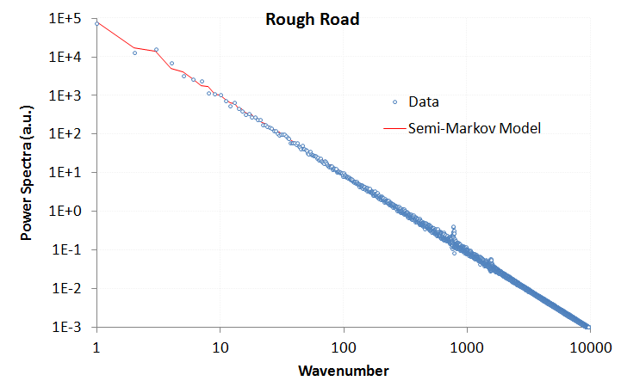

Figure 4: PSD of data collected from a higher resolution and more extensive terrain data set from a Mercedes-Benz test track. Note the weak high frequency spike with a definite even harmonic signal. The overall tendency of the terrain profile follows a random semi-Markov model very well.

Figure 5: Monte Carlo generated course based on random walk model

The power of the analysis is that it can detect asymmetries in the surface relief. For example, a terrain that shows sawtooth waves will contain even harmonics (note the weak harmonic in Figure 4), while a terrain that contains symmetric square or rolling pseudo-sinusoidal waves will contain odd harmonics.

Additionally, for the surface shown above, much detail may be obscured by a long-wavelength trend in the underlying terrain. The slope for the “rough road” example of Figure 4 is fairly large and this contributes to a strong 1/*S*2 tail above a certain wave number, i.e. a linear slope in real space generates an inverse squared response in reciprocal space according to Fourier analysis. This can also be inferred by the reduction of noise at high wave numbers, since a static slope is deterministic and dominates over the stochastic fluctuations. This also explains why a course profile needs to be “detrended” for it to be practical for determining actual roughness. A non-detrended course will generate a 1/*S*2 and provide less value in extracting the smaller scale roughness.

**Regular features:** If on occasion, we come across a terrain structure with extremely regular or periodic features (such as a highway rumble strip or a lengthy grated section), the PSD calculation simplifies to a Fourier series.

Figure : A perfectly ordered sequence of steps of periodicity L

Figure : A perfectly ordered sequence of steps of periodicity L

*L*

… repeat *f (x)*

*f (x)*

This reduces to the following intensity, with the PSD described as a series of harmonic peaks of very narrow width modulated by an envelope determined by the Fourier transform of one cycle

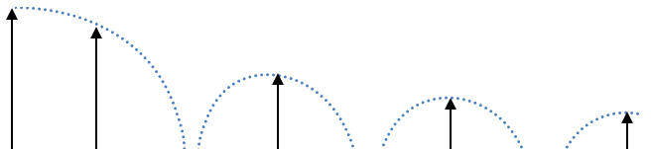

Figure 8: The PSD of ordered steps has delta-function harmonic peaks,   
modulated by the Fourier transform envelope of a single period.

These insights derive from a the Fourier series decomposition of periodic waveforms, but our goal is to apply this technique to stochastically varying waveforms – as stochastic profiles are very prevalent in artificial (see the following figure) and natural terrain. In the following sections, we will look more closely at the spectral features of disordered aquatic and land terrain.

|  |  |
| --- | --- |
| road.gif | road-bright.gif |

Figure 9: Examples of roads with random and pseudo-periodic cracks and patches

Application to Landforms and Terrain

For terrains we use the same approach as for wave spectra. The significant geometric scale distinction between terrain profiles and aquatic wave profiles is that the former can have very long range variations, stretching to the scale of mountain ranges.

Incoherent Terrain Correlations

Statistics over an extensive large-scale terrain database provides the best example of incoherent variations in surface topography. Figure 16 derives from a detailed terrain slope case study reported in a previous study [7]. The derivation assumed that maximally sloped regions had larger potential energy and a maximum entropy (MaxEnt) statistical distribution would follow. The chart in Figure 16 is from a single region and that of Figure 17 from the entire country. The former data follows an exponential distribution and the latter super-statistical data follows a Bessel distribution.

|  |  |
| --- | --- |
| Figure 16 : Probability density function of terrain slopes for an isolated region | Figure 17 : Probability density function for a wide area |

In this case, the term incoherent implies that the slopes at two points separated by a distance can lose correlation at wide spatial separations. In other words, the slope at one terrain point is independent of the value at another point. This is certainly an approximation that does not hold as the two points decrease in spatial separation and merge onto a single location.

Markov Terrain Correlations

We can use a random walk model as a very useful first-order approximation to characterize terrain correlations. Random walk applied in this way falls into the category of a Markov model, where the correlations occur between near-neighbor steps. In general, a pure random walk model featuring stochastic up-and-down steps will show an unbounded variance. This means that the probability of two points separated by any elevation is uniformly distributed between zero and infinity — *given a large enough surface separation*.

A pure random walk defined in this way is impractical and unphysical, as elevation differences are in fact finitely bounded. To allow for the boundedness of real terrains, a random walk process that has *reversion to the mean* properties is required. The classic reversion-to-the-mean variation to the random walk model is known as the Ornstein-Uhlenbeck process.

If one assumes the mean is the average terrain elevation for a localized region, the Ornstein-Uhlenbeck is the simplest stochastic behavior that will retain both Markov properties and a Gaussian spread in elevation changes. It also generates the commonly observed damped exponential pair-correlation (or autocorrelation) function.

Given a stationary run of random walk transitions, there are known solutions to the Ornstein-Uhlenbeck process, calculated from solving the Fokker-Planck equation; this solution turns out fairly concise in terms of representation.

For a transition probability of elevation change (*z*) given a surface translation (*x*)

z

x

Here, represents a drag term for reversion to the mean, and *D* is the random walk diffusivity or a relative hopping rate in a discrete simulation. The term is an initial condition necessary for representing a starting point away from the mean. If we assume a stationary run, the term disappears and the expression reduces to:

The factor serves as an asymptotic limit which prevents the elevation (*z*) excursions from getting too large, as a non-linear scaling factor gets applied to create an *effective* surface translation.

A normalized view of the marginal translation probability is shown in Figure 18 below, where *y* takes the place of *z*. Note that the contour profile of shows a roughly parabolic shape and this shape begins to asymptotically approach a horizontal along the x-axis. In contrast, for a classic random walk which does not have Ornstein-Uhlenbeck reversion-to-the-mean tendencies, this profile would continue to rise with increasing *x*, in keeping with a Fickian square-root growth law characteristic of a pure diffusional process. It is this asymptotic behavior which keeps the variance of z-excursions bounded.

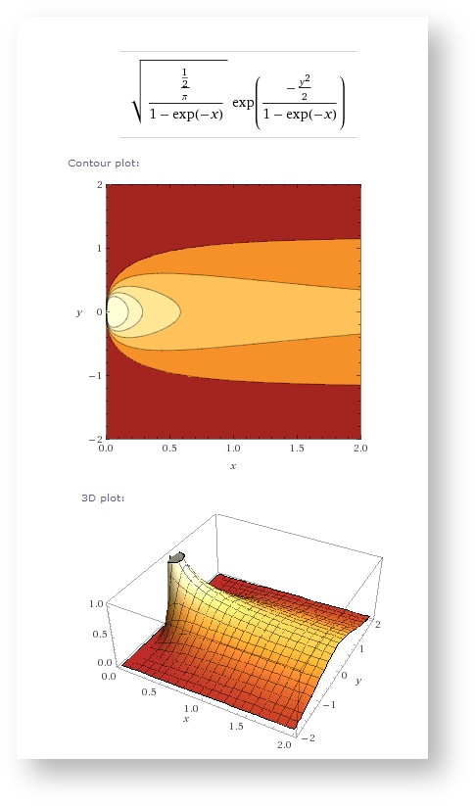

Figure 18: Contour plots of transition probability for the Ornstein-Uhlenbeck process

For an alternative view of what is happening, consider that the marginal transition probability for a pure random walk is given by:

An Ornstein-Uhlenbeck random walk assumes the transformation

This provides a reversion-to-the-mean property, which prevents large or infinite excursions from occurring in a pure unconstrained random walk.

For small x relative to 1/, this reverts to pure random walk, where

For the following derivation, we leave this in the pure random walk formulation and mix in a probability density function reflecting uncertainty in *D*. We initially assume maximum entropy uncertainty, where we characterize the value of *D* by its mean value *<D>*.

Then by integration over marginal probabilities, we can estimate a “fuzzy” Ornstein-Uhlenbeck random walk PDF.

This appears like a complicated integral, not amenable to closed form evaluation since the variate *D* shows up in both the numerator and denominator of an exponential, as well as within a square root. Yet, this does indeed reduce to a very manageable expression thanks to a key integral identity, available from any comprehensive integration table reference. The resultant expression is

where *<D>* replaces the original *D* in the original random walk formulation, assuming the role of the mean diffusivity. No new parameters are added to the original, as we have simply swapped out certainty in *D* with uncertainty characterized by *<D>*. To get to the Ornstein-Uhlenbeck model we simply apply the x-transformation.

To mix-in any other probabilities, we simply need to factor in marginal prior probabilities for different values of *<D>*. So for instance, assume that very low diffusion, *D0*, areas are mixed in by a fraction *f*, where 0 < ***f*** < 1. Then

In general, a model fit would require parametric values for *<D>* and , and potentially *f* and *D0,* if an extra inhomogeneity is suggested from the empirical data. The prime example of this would be flat regions that occur due to absorbing boundary conditions via a natural random walk, or due to non-random features such as bodies of water, graded roads, or flatter agricultural regions.

This foundational analysis gives us some room to work with when we try to characterize actually topographies. The premise is that the Ornstein-Uhlenbeck formulation with a single diffusivity *D* may map well to terrains with a homogeneous random character, while the maximum entropy “fuzzy” Ornstein-Uhlenbeck formulation works better with terrain regions that have mixed heterogeneous character, in the sense that the diffusivity *<D>* has a (prior) range in values which match the variability of the region.

We tested out the two formulations with respect to a set of digital elevation models (DEM) representing the lower 48 states. Each DEM file corresponded to a section that was 1° in latitude by 1° in longitude. This corresponded to approximately 90 meter post spacing in the north-south direction and a variant amount below that value in the east-west direction for increasing latitudes. Each “post” contains an elevation value with respect to sea-level reported to the nearest meter (there are 2401×2401 posts in total per DEM section).

What we wanted to demonstrate was how well an Ornstein-Uhlenbeck model works to describe correlated elevation transitions for relatively small surface translations (< 40 post spacings, or < 4 kilometers). The data from a DEM section was sampled uniformly to capture good counting statistics.

In Figure 19 below, raw histogram counts are shown for an area around Yuma, CA (the El\_Centro DEM section). What is readily apparent is the trend toward a contour profile such as that shown in Figure 18.

|  |  |
| --- | --- |
| https://babelfish.arc.nasa.gov/confluence/download/attachments/20513203/yuma1800-30.png?version=1&modificationDate=1349283607880&effects=border-simple,blur-border | https://babelfish.arc.nasa.gov/confluence/download/attachments/20513203/yuma3600-30.png?version=1&modificationDate=1349283615202&effects=border-simple,blur-border |

Figure 19: Raw histogram counts for a DEM section around Yuma, California.

A relief plot is shown below, along with a log-scaled contour plot:

|  |  |
| --- | --- |
| https://babelfish.arc.nasa.gov/confluence/download/attachments/20513203/image2012-10-4+16%3A1%3A50.png?version=1&modificationDate=1349384510501&effects=drop-shadow  Figure 20: Relief plot | https://babelfish.arc.nasa.gov/confluence/download/attachments/20513203/image2012-10-4+16%3A2%3A55.png?version=1&modificationDate=1349384576192&effects=drop-shadow  Figure 21: Contour plot of marginal probability |

To demonstrate the relative fitting abilities of the conventional Ornstein-Uhlenbeck model against the maximum entropy O-U model, we searched the DEM database for examples that gave good qualitative fits to each model.

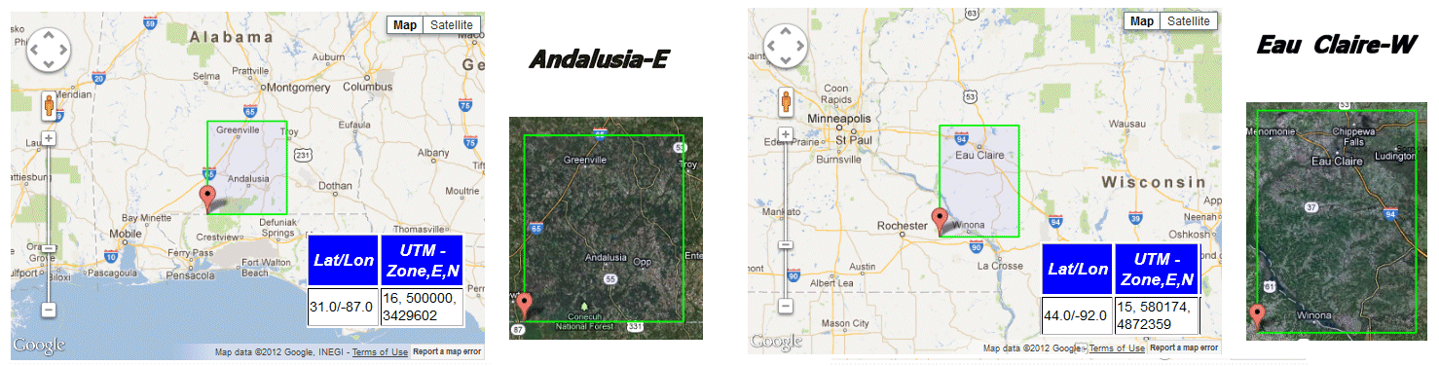

Figure 22

The *Andalusia-E* DEM section is located in mid-south Alabama, with terrain that is in between the flatness of the Gulf lowlands and the hilly terrain of the start of the southern Appalachians.

The *Eau Claire-W* DEM section is located in southwestern Wisconsin, with terrain that features hills and valleys that are remnants of one of the few un-glaciated areas of the upper Midwest. To get an appreciation for the topography, the following image is converted from a portion of this DEM located in southeastern Minnesota.

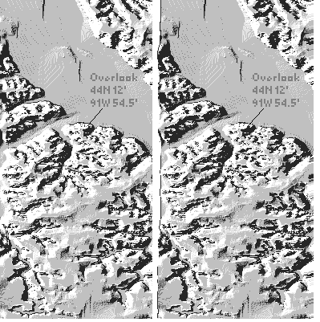

Figure 23 : A stereoscopic rendering of the southwest portion of the Eau Claire-W section. The GPS reading is next to the Upper Mississippi River National Wildlife and Fish Refuge with a view northeast across to Wisconsin.

The fitting of the appropriate O-U model to each data set was accomplished by minimizing the log of the error between the model and the data for each separation and elevation. For the pure Ornstein-Uhlenbeck process, Figure 24 illustrates the salient features, which includes a rounded profile in the relief plot, indicating a single diffusivity. Note that the plots are one-sided as the negative elevation excursion is removed due to symmetry.

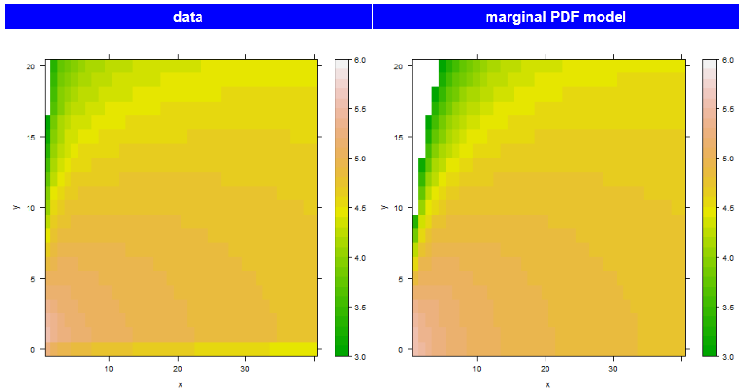

Figure 24: Andalusia-E contour plot

For the maximum entropy Ornstein-Uhlenbeck process, the profile shown in Figure 25 has more of a tail, indicating a spread in diffusivities. This indicates that the unglaciated region of the Eau Claire section has greater variability in its terrain makeup.

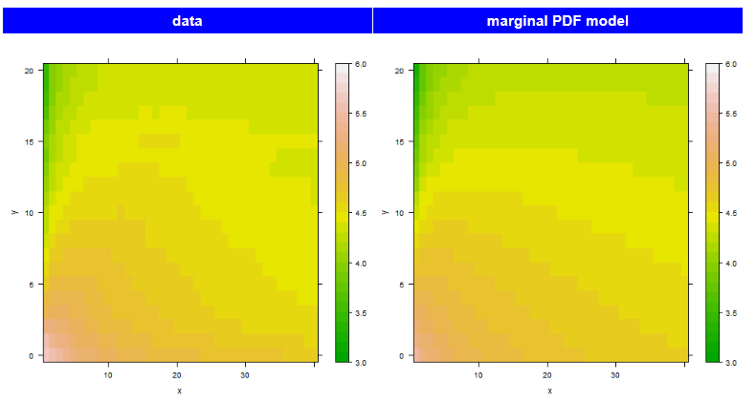

Figure 25: Eau Claire-W contour plot

In Figure 26, we place the data plots along the center to indicate which way the profiles tend toward. For the upper Andalusia contour, the color contours indicate closer agreement to the Ornstein-Uhlenbeck model, while for the lower Eau Claire data, the contour lines map more closely to the Max Entropy prior of the Ornstein-Uhlenbeck model.

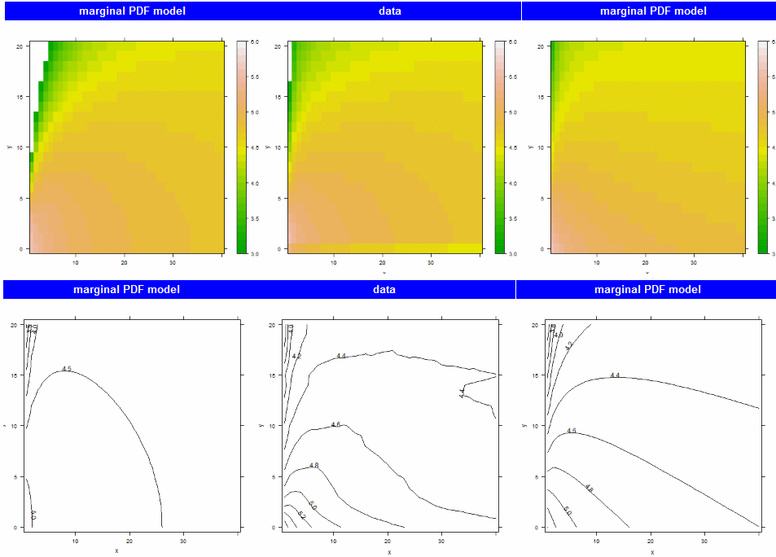

Figure 26: Regions trend either toward an Ornstein-Uhlenbeck profile (left column) or a Maximum Entropy prior of the O-U profile (right column).

A very strong case can be made for the effectiveness of the maximum entropy model in remote topography regions that contain little human terrain modification.

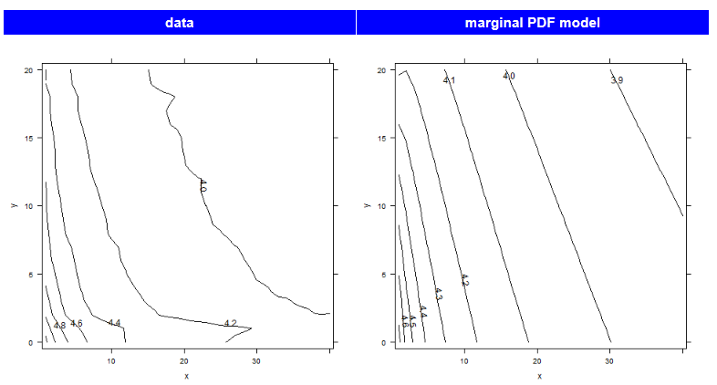

Figure 27: Knoxville-W contour plot of elevation difference probabilities. This is in the middle of the Great Smoky Mountains region, and has very low integrated error against the Maximum Entropy prior of the Ornstein-Uhlenbeck model.

We can use the maximum entropy formulation directly to calculate the censored (or truncated) variance and mean for the data sets and compare that to the theoretical values. A censored variance means that only the collected data points go into the calculation and those that contribute to the true variance ignored. Figure 28 shows the RMS deviation in elevation and the mean elevation as a function of surface translation for the *Knoxville-W* data set.

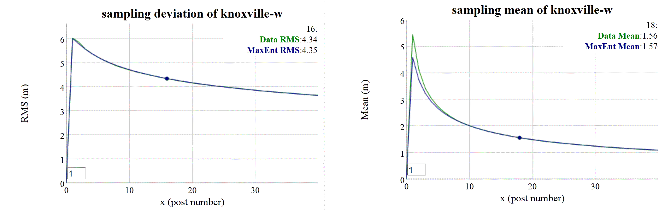

Figure 28: Sampling RMS deviation (left) and mean (right) of Knoxville section data against the Maximum Entropy prior of the Ornstein-Uhlenbeck model. The RMS deviation for both model and data align precisely enough that the curves cannot be distinguished.

The alignment between data and model of this measure mirrors that of the contour plots. This supports the idea that the terrain in these locations is well suited to a MaxEnt-varied random walk model. The simulation of the disordered random walk involves drawing a sample of a diffusion coefficient and then applying that to an Ornstein-Uhlenbeck random walk (see next section).

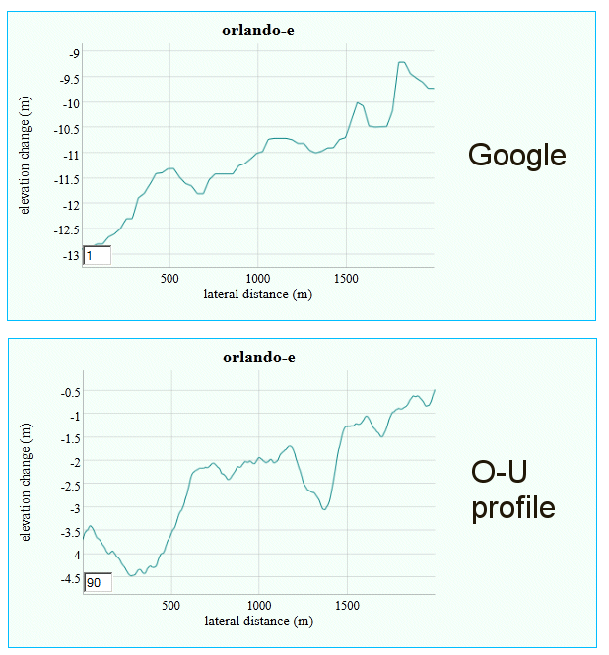

Figure 29: Simulated random walk applied to the Orlando DEM section. Above is an extracted Google elevation profile from a random location within that section. The scale of the excursions match the diffusivity of the random walk.

In addition, the effects of systemic errors and non-stochastic anomalies are readily apparent from the marginal probability density. If artificial correlations exist, they will appear as high density regions in the contour plot (see the strong horizontal bar at elevation changes of ~15m shown in the right inset of Figure 30). The correlations in question come about from a propensity of surveying crews to report elevations to the nearest 50 foot round-off. For example, one can see that red dotted lines in Figure 30 passing through 1800’, 1850’, 1900’, and 1950’ contour levels map to elevation areas that tend to flatten out over short intervals. This can only be ascribed to poor data collection or data translation and is systemically observed in DEM data sets that were taken over the relatively flat terrain of the Midwest USA .

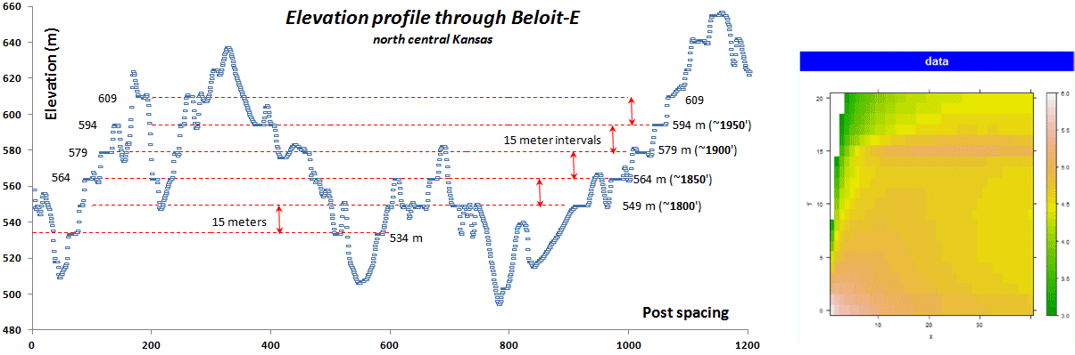

Figure 30: Determining anomalies in terrain elevation modeling. Notice the systemic correlations between elevations separated by rounded 50 foot elevation contours.

The utility of this approach is dependent on the quality and the availability of the data. Mapping out the lower 48 states into 1º sections, we can clearly discern the high diffusivity regions of the country’s terrain, bounded by the western and eastern mountains.

We have used this approach to infer models which we can use for formal verification and model checking, as further detailed in Appendix F.

Semi-Markov Terrain Correlation

Terrain correlations also exist on a much shorter scale, which can also show subtle periodic features. The objective is to model the fine terrain, both random roughness as described in Figure 4, and more periodic features such as cobblestones[29] and washboard[30] as shown in Figure 31 below: [31]



Figure 31: (left) Cobblestone test track and (right) Washboard test track

The Mercedes-Benz test track data used in Figure 4 was also applied to a particular style of road cobblestone paving known as *Belgian Block*. This data was supplied in *OpenCRG* format[16], and covered the track shown in the Google Earth snapshot shown below in Figure 15.

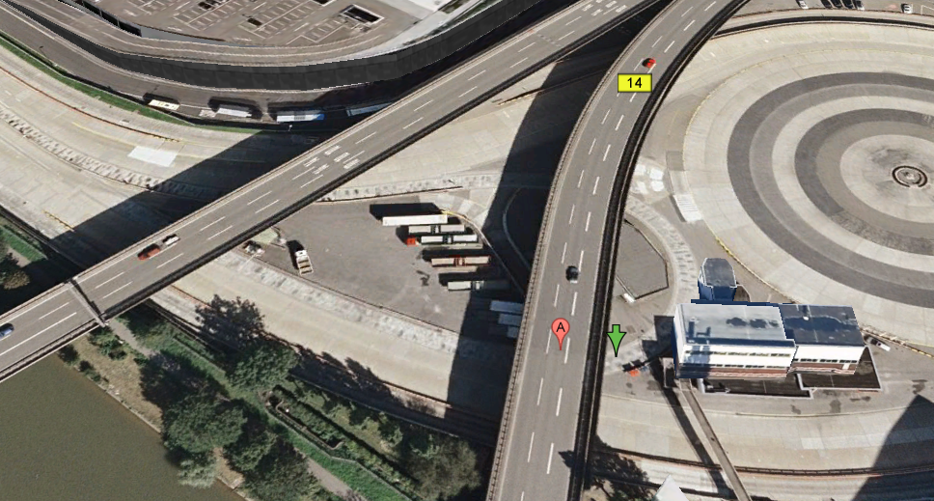

Figure 32: The OpenCRG terrain format features a header which indicates the geospatial location of the data set. This winding Belgian Block course was located underneath an overpass on the Mercedes-Benz campus in Stuttgart, with the start of the path indicated by the green arrow.

A typical one-dimensional profile trace is shown below in Figure 33. Clearly visible are two levels of terrain variability. One variation on the order of 10 cm height contributes to swales on the test track and the other, a fine-grained roughness on the order of 1 cm, are caused by the cobblestone blocks themselves.

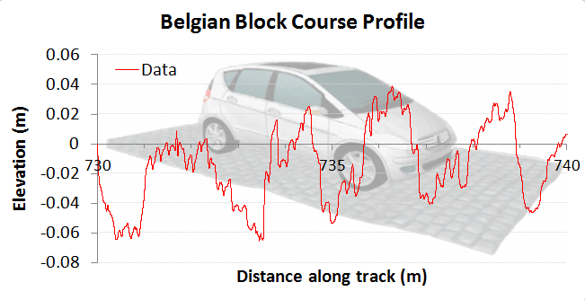

Figure 33: A profile trace along a short path of the test track indicates the roughness.

The fine resolution of the data is shown in Figure 34, which is on the order of 1 cm in the lateral dimension.

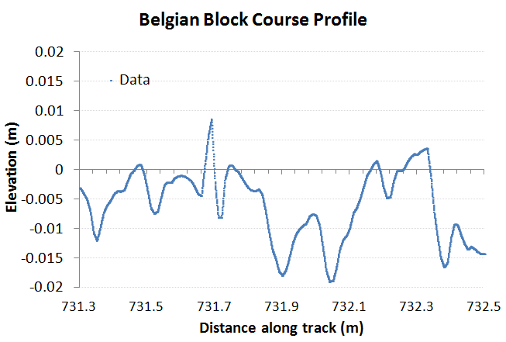

Figure 34 : A very short profile along the test track showing the Belgian Block variability.

The PSD calculated for this course is shown in Figure 35. Although the harmonics are not as striking as that shown for the aquatic wave PSD of Figure 13, their positions correlate well with a model of the terrain consisting of varying degrees of order (shown by the blue curve). The low-frequency odd harmonics correspond to washboard-like swales on the order of 1.5 meters. These are odd-harmonics because they show a tendency to an asymmetric slant or tilt. The higher frequency even harmonics are caused by the Belgian block perturbations which are about 10 cm in lateral spacing.

The overall envelope suggests that a strong random walk component also exists, with a low density filter cutting off the high frequency sharpness in the terrain roughness. Over time, the cobblestones will wear down their sharp edges, and this is observed in the filtered trace.

The idea of using a superposition of various profiles from **Equation 7** makes intuitive sense since the various periodicities have very little mutual coherence, and the pair correlations are additive in contributing to the power spectrum.

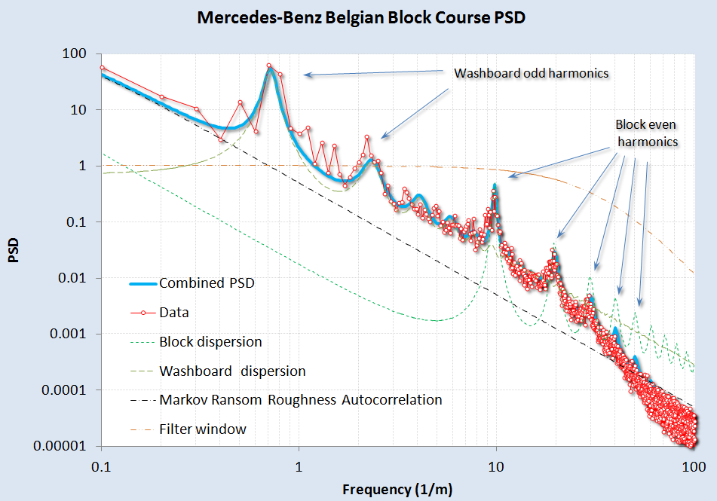

Figure 35: A model fit to the Belgian Block course PSD. A rich variety of surface textures can be gleaned from the harmonics. At high wavenumbers, a change in slope is detected, likely due to a smoothing spatial filter applied to the fine terrain relief and partly due to interpolation for the OpenCRG data set

For the Belgian block course, the data was not detrended prior to computing a spectrum. A slight tilt does exist in the data as can be gleaned from Figure 36, where several sections of 2D Fourier Transform PSD’s for simulated (left and right) and real (center) terrains. The general approach of treating both the *Z* and *X* dimensions in a full power spectrum allows us to sensitively test for stepped or staircase surfaces.

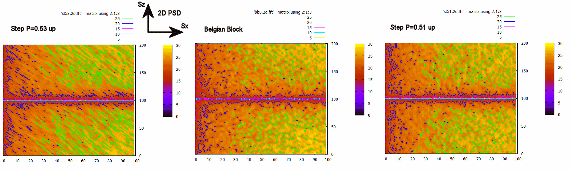

Figure 36: Using the full 2D power spectrum, we can discern subtle changes in slope from any staircase pattern by looking at slanted texture. The center is the real data, and the two side maps show a slightly higher slope (left) and a slightly lower slope (right). The logarithm was taken of the PSD after the transform was multiplied by Sx2 and Sz2

As a control study, we also collected PSD data from a military test course and compared the results in Figure 37. This data was detrended prior to use, and was the only unclassified data available for analysis. Similar features are observed as with the Mercedes-Benz Belgian Block course, with the same washboard and block harmonics. These are slightly shifted in period, an effect likely due to different road construction and maintenance procedures.

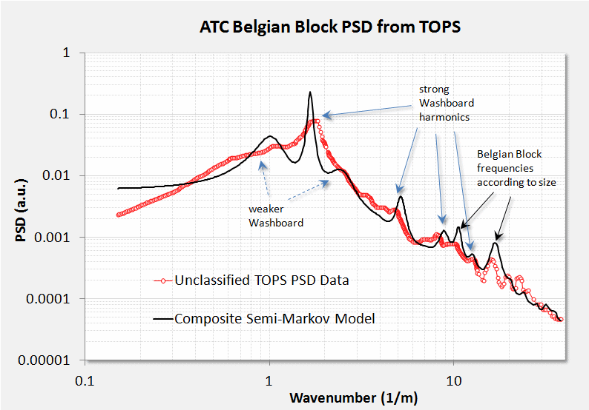

Figure 37: Belgian Block course from a military test operational procedure (TOP) document.

A few other profiles are worth considering. For Figure 38, from [32], we aligned an even-harmonic semi-Markov PSD with the empirically calculated PSD. The strong harmonics of a washboard road are expected as the repeated travel of vehicles over the course reinforces the washboard resonant frequency.

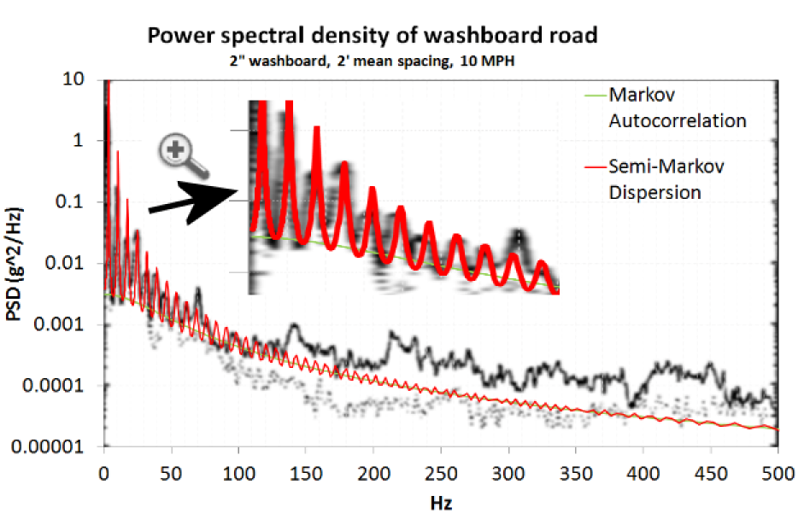

Figure 38: A model fit to a pure washboard. The x-axis is expressed in Hz to indicate the test vehicle was maintaining travel at a constant speed.

We can also return to the rough road power spectrum of Figure 4. We noted that this course likely contained a long-wavelength (deterministic) slope. The data was detrended as shown in Figure 39 below.

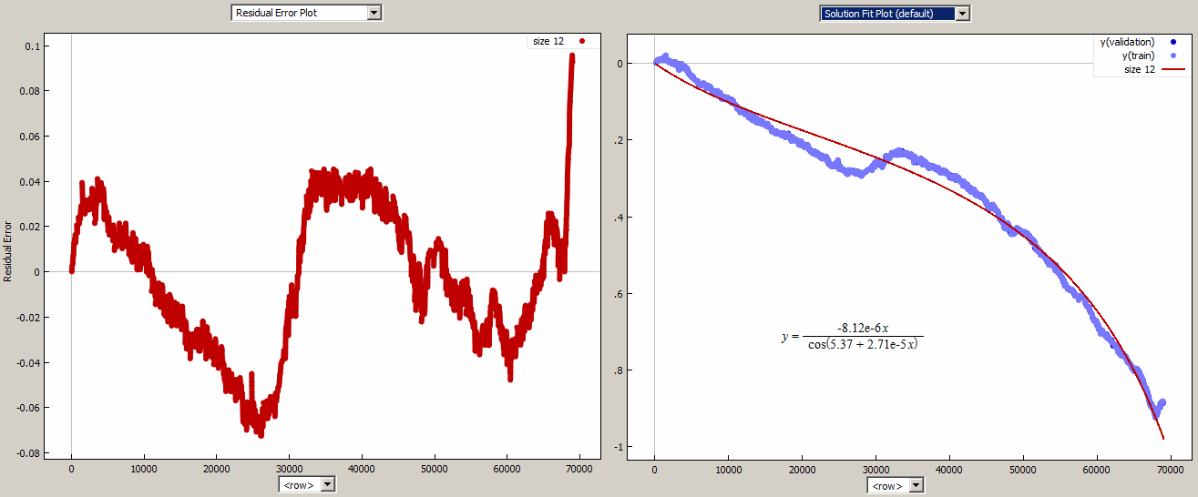

Figure 39: The elevation trend in the rough road data set (right) was removed by a curve fitting program (**Eureqa**). The detrended residuals are shown to the left.

After detrending the terrain profile, the rough-road PSD was calculated and fit to a semi-Markov model with one low-frequency component and a high-frequency periodic component as shown in Figure 40. The harmonics on the high-frequency spikes suggested that the underlying roughness was shaped similarly to a cobblestone surface. The first and second harmonics are strong, but the third roughly cancels out. By creating a two-level surface where the troughs were half as long as the tops, we could duplicate the missing third harmonic as shown by the solid red line in the figure.

A sinc function filter was added to reproduce the reduced strength of wavenumbers above 10/m.

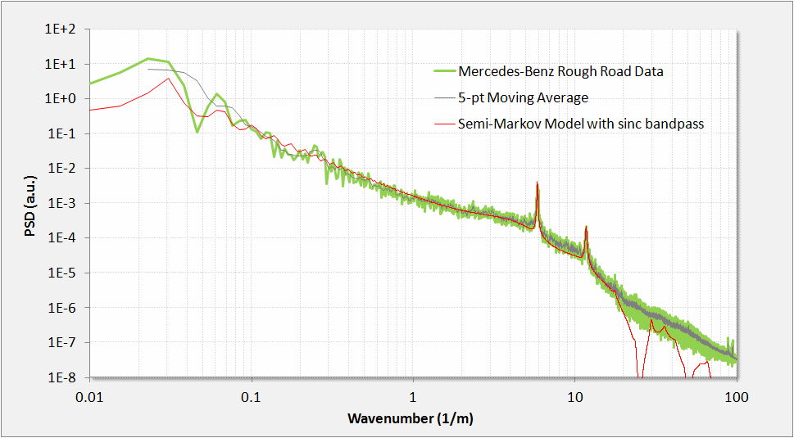

Figure 40: Rough road PSD. From the location and spacing of the harmonics, we can infer a periodic structure very close to a Belgian block structure.

The two-level spectrum is a generalization of the result shown in **Equation 8**.

**(9)**

Here each level has its own probability density of lengths, which allows for a surface with wider plateaus and narrower grooves.

A simulated random walk for this terrain relief is shown in Figure 41 alongside an arbitrary path length from the actual terrain. To mimic the sinc filter, a rectangular window moving average was applied to the random walk profile. Note that after calibration of the relative step heights, very good qualitative agreement exists with the actual surface.

The simplified expression from **Equation (9)** is complicated only because of the number of cross terms needed to pair correlate the two levels

To generate a synthetic terrain, each level is treated as a sampling distribution drawn from the distributions from each level (see next section).

Figure 41: Simulated random walk for the rough road terrain.

As a check to determine whether we can recover the PSD from the simulated semi-Markov random walk, we applied a Fourier transform to 10 sets of simulation traces and squared the amplitude. Note the close alignment with the peaks and with the sinc filter poles. This demonstrates the general utility of switching between a stochastic analytical representation and a Monte Carlo generated simulation.

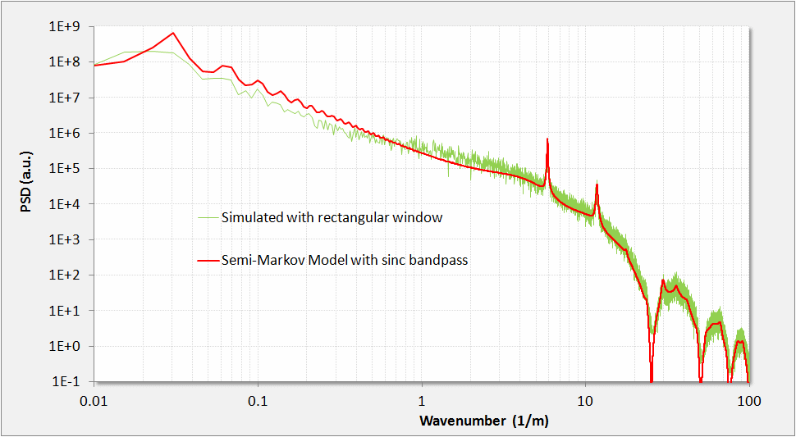

Figure 42: A Monte Carlo simulation of the rough road semi-Markov behavior reveals nearly the same feature amplitudes for the assumed pair-correlation weightings. Contrast this with Figure 40

High Resolution Data

To verify the utility of the semi-Markov approach, we evaluated a fitting procedure against several high-resolution profiles of real vehicle test courses; specifically we chose the Gerotek site in South Africa as this was being measured with advanced profiling tools[14] [33].

To calibrate the data format and determine the limits of resolution, we started with a simulated pothole course. We experimented with the size of the data set so as to clearly reveal features in the PSD, which are shown in Figure 43.

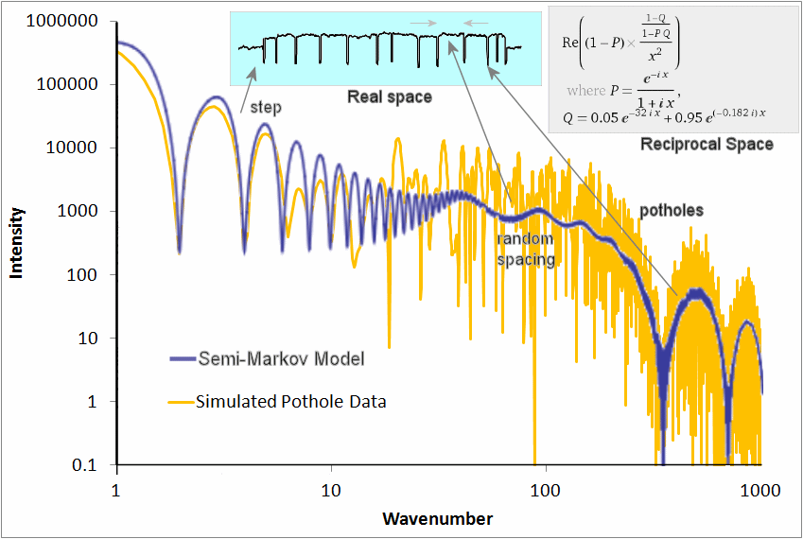

Figure 43: Simulated pothole course PSD. The typical fitting procedure uses knowledge of the underlying terrain profile (top middle inset, showing a pot-hole course with steps) and a stochastic representation of the PSD (upper right inset) to match the PSD calculated from the data.

For another course at the Gerotek site, we chose the “corrugated” track, consisting of approximately 20 cm high bumps, separated at rather regular intervals. This also provided a very accurate fit to a semi-Markov model (see Figure 44), with the PSD showing a suppressed high harmonic at the spatial frequency predicted by the ratio of the length of the bump to the average spacing.

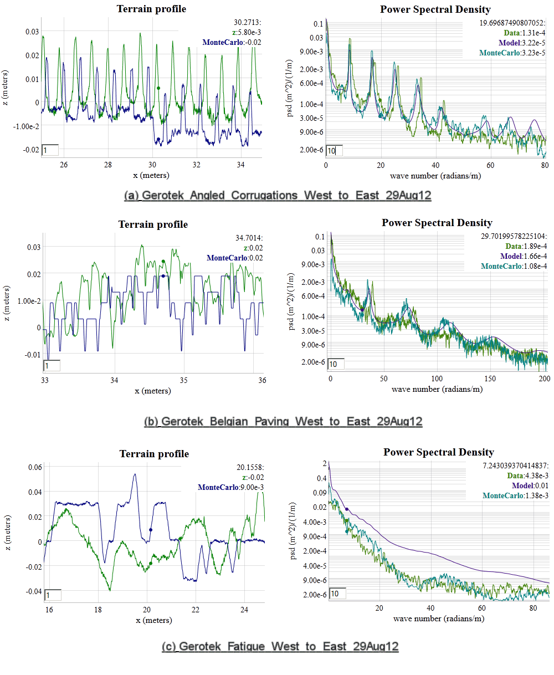

Figure 44: Gerotek Corrugation course. (left) track profile and simulated profile (right) PSD data, simulated PSD, and analytical data

The semi-Markov model with very few parameters is thus able to reproduce a data set containing potentially gigabytes of data.

Generating Synthetic Terrains and Waves and Monte Carlo Sampling

Having a stochastic model of the terrain allows one to generate instances of synthetic terrain that have the same spectral content as the real terrain. This becomes useful for mapping out an *ergodic* representation of possible terrain states suitable for *sampling* (i.e. *Monte Carlo*) simulations.

Several mechanisms exist to generate a random walk, which includes the classical Brownian motion based on a Markov model, the semi-Markov step transition, and the Ornstein-Uhlenbeck random walk process.

Classical Random Walk Model

The simplest *random walk* models will generate a PSD with a 1/*S*2 fall-off, and exemplified by the empirical data in Figure 4. The problem with the simple random walk profile is that it will generate an infinitely high spike for *S*=0, as a random walk is unbounded and will show undulations of infinite length and height. For an example of a typical algorithm for generating a Markov random walk in discrete steps, assume *R* is a sample drawn as a uniform variate: .

-- classical random walk = rw

rw(Diffusion,  Z)

    random(R)

    if R < 0.5 then

        Z = Z + Diffusion

    else

        Z = Z - Diffusion

    end

Ornstein-Uhlenbeck Process

The issue with a pure random walk model is that the absolute excursions become unbounded, whereas real data shows bounds in altitude in the terrain or waves. One way around this, which does not impact the spectral fall-off, is to attach a *reversion-to-the-mean* correction term to the random walk algorithm. This procedure is known as the *Ornstein-Uhlenbeck* random walk process[5], and derives from a physical model of an attractor or potential well which “tugs” on the random walker to bring it back to the mean state (see Figure 45 below).



Figure 45: Representation of an Ornstein-Uhlenbeck random walk process for terrain elevation changes. The hopping rate works similarly to a potential well, with a greater resistance to hopping the further excursion ways from a quiescent elevation (Zq) changes.

The following pseudo-code snippet sets up an Ornstein-Uhlenbeck random walk model with a reversion-to-the-mean term. The *diffusion* term is the classical Markovian random walk transition rate. The *drag* term places an attractor which opposes large excursions in the terrain elevation term, *Z*.

-- Ornstein-Uhlenbeck random walk = ou

ou(X1, X2, Z)

    random(R)

    if R < 0.5 then

        Z = Z\*X1 + X2

    else

        Z = Z\*X1 - X2

    end

--  This is how it gets parameterized

ou\_random\_walker (dX, Diffusion, Drag, Z)

    X1 = exp(-2\*Drag\*dX)

    X2 =  sqrt(Diffusion\*(1-exp(-2\*Drag\*dX))/2/Drag)

    ou(X1, X2, Z)

To determine whether an Ornstein-Uhlenbeck process is apparent on a set of data, one can apply a simple multiscale variance (or a multiscale entropy measure [12]) to the result of a *Z* array of length *N* :

variance(Z,N) {

L = N/2

while(L > 1) {

Sum = 0.0

for(i=1; i<N/2; i++) {

Val = Z[i] - Z[i+L]

Sum += Val \* Val

}

print L “ “ sqrt(Sum/(N/2))

L = 0.95\*L;

}

}

So that for a given random walk simulation, the asymptotic variance will tend to saturate at longer correlation length scales. A typical multiscale variance plot will look like Figure 46.

The autocorrelation of the Ornstein-Uhlenbeck process is, where =*Drag*:

Even though this shows a saturation level, the power spectrum still obeys a 1/*S2* fall-off.[34]

Figure 46: Ornstein-Uhlenbeck process saturates on variance

The Orenstein-Uhlenbeck process is often referred to as *red noise* and the two parameters of Diffusion and Drag can be determined either from the autocorrelation function or from the PSD. For the PSD, on a log-log plot, this involves reading the peak near *S*=0 and then determining the shoulder of the power-law roll-off. Between these two measures, one can infer both parameter values.

Semi-Markov Process

The key to mapping to semi-Markov distributions is to draw from the appropriate PDF. For example, the delayed exponential (see **Equation 6**) is simply a draw from an exponential distribution with a fixed offset (i.e. the delay) added to the variate.

The step deltas and terrace deltas can both draw from a semi-Markov distribution; taking the PSD of the resulting step sequence will generate a noisy **Equation 7**, depending on the amount of samples taken.

The algorithm for generating this semi-Markov model is as follows, where **P** is a probability of stepping up or down after each length. This has no offset in length. If **P** is not 0.5 precisely, then the two-dimensional PSD will show an asymmetry reflecting the asymmetry of the terrain profile.

BEGIN {

N = 100000

h = 0

srand()

i = N

while(i>0) {

n = - 10.0 \* log(rand())

for(j=0; j<n; j++) {

i--

print h

}

if(rand()>P) {

h += +0.0008 \* log(rand())

} else {

h += -0.0008 \* log(rand())

}

}

}

The “rough road” data model shown previously was generated according to this recipe.

As for the analytical analog semi-Markov model which reproduces the spectral characteristics, consider Figure 47 below and compare it to the Monte Carlo simulation which generates Figure 36. This again is the simplest semi-Markov model, a damped exponential size for both step length and step height.

|  |  |
| --- | --- |
|  |  |

Figure 47 : 2D contour plot of power spectrum for a randomly ascending staircase. To illustrate a 2D power spectrum in terms of the orthogonal wavenumbers Sx and Sz, we multiply by the wavenumber squared and then take the logarithm to give the greatest dynamic range.

The Belgian Block course suggests an asymmetry 0.51± 0.01 as shown in Figure 36, indicating sensitivity to incline.

Process of Fitting to Synthetic Terrain

If we have a terrain that indicates some periodicity, these steps will synthesize a semi-Markov profile:

1. Get terrain data [***x***, ***z***] as distance/displacement pairs
2. Run FFT on data assuming ***x*** equally spaced, and take magnitude squared
3. Fit the FFT curve to  *w* I(, *L*)  
   *w* = scaling  
    = local order  
    = quasi-periodicity   
   *s* = wavenumber
4. Draw a number of Monte Carlo samples from the PDF => P(*x* | , *L*).   
   For each sample, use the cookbook inversion of a PDF to generate a step length, ***x***
5. Move the step up and down alternately with amount corresponding to the RMS weighting of **w**  
     
   (if we need to detrend the data against large excursions, apply Ornstein-Uhlenbeck to ***z***)
6. Save the step lengths and step heights as a compact array of [***x***, ***z***] pairs

Verifying the synthetic PSD

1. Get [***x***, ***z***] data from last terrain synthesis and discretize so that ***x*** is on equal intervals (for the FFT)
2. Run FFT and the magnitude squared
3. Compare the curves. Adjust the step size if magnitude is not to scale

The intensity of a rough or cobbled terrain with differing lengths of troughs and tops is more complicated than that shown here. For the “rough road” model, we need to modify the step lengths to alternate depending on whether they lie on a trough or a top. The approach is straightforward but the pair correlation increases the number of terms in the intensity profile ( *I(s)* ) quadratically (see Equation 10).

Process Filters

If we wish to add a second-order Markovian feedback, we can filter the data with beyond near-neighbor interactions, i.e. not only **Z[i]** and **Z[i-1]** but **Z[i-2]** and beyond. This adds an additional 1/*S2* factor as it acts as a low-pass smoothing filter. In the case of an autocorrelation for a second-order step change:

This will generate a power spectrum of order 4:

Ordinarily, we can apply the class of filters known as autoregressive models - AR(*p*), where *p* indicates the interaction order of the model, or in terms of digital processing, finite impulse response (FIR) filters. In general, these will all tend to smooth the simulation step changes, rounding out the edges as a low-pass filter is designed to work. Applying autoregressive models to terrain is an active area of research. [35][36]

Superposition of Waves

A non-stochastic method for generating a synthetic terrain involves extracting the Fourier coefficients from the PSD and superposing sine waves to recreate the original real-space terrain profile. This kind of inversion will generate a repeat sequence with multiples of the longest time period in the spectrum. No phase information is available from the power spectrum, so any long range coherence is artificially introduced, unlike that from a pair correlation. Although potentially useful and practical[37], the superposition approach will definitely not traverse a complete state space and so is not ergodic. It will also not capture skewness and kurtosis in the terrain profile[38], of which the stochastic model can more easily (see Figure 41).

A good application of the spectral superposition approach is for generating aquatic waves for various sea-states in the incoherent regime. Since aquatic waves are already close to sinusoidal, they do not need extra harmonics with phase relationships to match angular shapes (as a terrain might). And the randomness in superposing incoherent waves is visually familiar. This is why most graphics applications use the superposition approach for rendering waves [39].

Calibration of Spectra

The calibration of simulated terrains and their corresponding PSD curves to PSD calculations of actual terrains is aided by the application of Parseval’s theorem [40]:

This states that the statistical variance in the terrain elevation displacement is equivalent to the integrated power spectrum. In practice, as long as the variance in the real space sampling is stored, then the reciprocal space curve can be shifted by a constant scaling factor to match the variance.

Discussion

Stochastic terrain modeling as described within this study finds practical application for vehicle test and verification applications [41], with the terrain and energy models providing an environmental context for such activities as safety testing. We are essentially trying to map out the *Importance* × *Likelihood* space for the users of the context models. The users must know the impact or significance of the model effects as well as it likelihood of occurring.

The relevance for a particular topographical model depends on its intended usage. For example, one needs to ask the basic questions:

* What is the importance or impact of the event?
* What is the likelihood of the event?

These occupy largely orthogonal roles as shown in Figure 48 and Table 2 below:

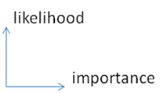

Figure 48: Likelihood versus importance

In the case of terrain, a vehicle operating over a rough profile would experience nuisance effects (vibration and absorbed power) that persistently occur. It could also potentially experience a critical effect (extreme slope) that rarely if ever occurs.

The overall goal is to provide models of environmental stimulus for design verification, using the probabilities inferred from the stochastic models to estimate correctness of the designs.

Note that assessing the impact for a specific design requires composing the context model with a performance model for the design being tested. The context model serves as a stimulus, and the simulation for the design being tested then generates a response. Assessment of a design in terms of probability of failure or probability of satisfying a requirement, involves a likelihood weighted sampling of impact, in general done with Monte Carlo techniques.[[203]](#footnote-203) Note that as failure conditions will typically be rare, and it is desirable to estimate probably of failure accurately, importance sampling techniques are frequently needed. This is true even though highly parallel computer hardware now allow many thousands of cases to be executed in parallel.

Table 8: Orthogonal spaces

|  |  |  |
| --- | --- | --- |
|  | Description | Examples |
| High Likelihood | Environmental stimulus that have high likelihood, but only a cumulative impact | Persistent and perpetual nuisance effects   * Terrain roughness and vibration * Wear and tear * Abrasion * Wind friction and rolling resistance |
| High Impact | Environmental stimulus that have high impact but often low likelihoods | A critical effect that rarely if ever occurs   * A large shock * Accidents * 100-year climate events * … lots of other possible cases * … or some other pathological or unknown cases |

Conclusion

A unified approach for characterizing and modeling topographies has definite advantages for environmental context applications. We have demonstrated how often simple probability density functions (PDF) can characterize the impact/likelihood factors for various environmental behaviors. A stochastic basis for the models provides an explanation for empirically observed behavior that heuristics often miss. Further, unifying an established set of scientific and ontological criteria helps us to derive and classify the models. This creates an opportunity to establish a collection of context models as a community resource, with supporting technology facilitating its correct utilization for a given purpose. Such a resource can substantially improve the utility of available data for supporting Model Based Engineering, and also create opportunities for improving existing design methods by facilitating the discovery of highly resilient designs.

**What about Topography?**

Entropy makes its mark everywhere. Take the case of modeling topography. How can we model and thus characterize disorder in the earth's terrain? Can we understand the extreme variability we see?

If we consider that immense forces cause upheaval in the crust then we can reason that the energy can also vary all over the map, so to speak. The process that transfers potential energy into kinetic energy to first order must contain elements of randomness. To the huge internal forces within the earth, generating relief textures equates to a kind of Brownian motion in relative terms — over geological time, the terrain amounts to nothing more than inconsequential particles to the earth's powerful internal engine.

In a related sense, the process also resembles the pressure distribution in the earth’s atmosphere, a classic application of maximum entropy that we can re-apply in the case of modeling terrain slope distributions.

Premise. We take the terrain slope S as our random variable (defined as rise/run). The higher the slope, the more energetic the terrain. Applying Maximum Entropy to a section of terrain, we can approximate the local variations as a MaxEnt conditional probability density function:

|  |  |
| --- | --- |
|  | 26-28 |

where E is the local mean energy and c is a constant of proportionality. But we also assume that the mean E varies over a larger area that we are interested in, as in the super-statistical sense of applying a prior distribution.

|  |  |
| --- | --- |
|  | 26-29 |

where k is another MaxEnt measure of our uncertainty in the energy spread over a larger area.

The final probability is an integral over the marginal distribution consisting of the conditional multiplied by the prior:

|  |  |
| --- | --- |
|  | 26-30 |

This integrates as a BesselK function of the zero order, K0, available on any spreadsheet program.

|  |  |
| --- | --- |
|  | 26-31 |

The average value of the terrain slope for this distribution is simply the value S0.

Now we can try it on a large set of data. I downloaded all the digital elevation model (DEM) data for the 1-degree quadrangles (aka blocks/tiles) in the USA from the USGS web site[[204]](#footnote-204).

This consists of post data at approximately 92-meter intervals (i.e. a fixed value of run) at 1:250,000 scale for the entire USA. I concentrated on the lower 48 and some spillover into Canada. From individual DEM files and calculate the slopes between adjacent posts and came up with an average slope (rise/run) of 0.039, approximately a 4% grade or 2.2 degrees pitch. I take the absolute values of all slopes so that the average is not zero.

The cumulative plot of terrain slopes for all 5 billion calculated slope points appears on the following chart. I also added the cumulative probability distribution of the BesselK model with the calculated average slope as the single adjustable parameter.

This kind of agreement does not just happen because of coincidence. It occurs because random forces contribute to maximizing the entropy of the topography. Enough variability exists for the terrain to reach an ergodic limit in filling the energy-constrained state space.

As supporting evidence, it turns out that we can generate a distribution that maps well to the prior by estimating the average slope from the conditional PDF of each of the 922 quadrangle blocks and then plotting this aggregate data set as another histogram (see Figure 26-27 537).

Practically speaking, we see the variability in slopes expressed at the two different levels. The entire USA at the integrated (BesselK model) level and the aggregated regions at the localized (exponential prior) level. These remain consistent as they agree on the single adjustable parameter S0.

The modeled distribution has many practical uses for analysis, including transportation studies and planning. Obviously, vehicles traveling up slopes use a significant amount of energy and you might like to have a model to base an analysis on without having to rely on the data by itself (As a caveat, I did not include any of the spatial correlations that must also exist and might prove useful as well)

Perusing the recent research, I couldn’t find anyone that had previously discovered this simple model [Ref 293] [Ref 294] [Ref 295] [Ref 296]. Not that they haven’t tried, coming up with a good slope distribution model seems to amount to a mini Holy Grail among geophysicists.

If someone wants to generate Monte Carlo statistics for the BesselK model without having to do the probability inversion, the algorithm turns out surprisingly simple. Draw two independent random samples from a uniform [0.0 .. 1.0] interval, apply the natural log to each, multiply them together, and then multiply by the S0 scaling constant.

This random draw algorithm will give the following cumulative if done 5 billion times, which is the same size as the real USA DEM data sample.

The only statistical noise is at the 10-9 level, same as in the DEM data set.

**The Stretched Exponential**

Interesting that this BesselK distribution does not give as fat a tail as the power-law, which in contrast does occur for earthquake magnitudes (See “Earthquakes” 587.). The BesselK function as applied for topography follows somewhat closely a stretched exponential with a e– 2S dependence in the leading terms.

The cumulative of a stretched exponential turns into a Weibull distribution. The Weibull provides an alternative to the fat-tail we used in reliability analysis (See “Reliability. Entropy and how things break down” 457.) and arises not surprisingly in radar ground-clutter statistic and the Weibull in wind dispersion analysis described in the next section

Laherrere and Sornette describe the stretched exponential further in [Ref 51]. Sornette details the general derivation of the stretched exponential in [Ref 271] noting that it fills the gap between a power law and the exponential distribution. Both the power-law and the stretched exponential can come about from superposition of exponentials but the actual result depends on how the exponential arguments play together during the integration step. We leave that as an exercise inferred from the integrations described in this text.

## CHAPTER 20 ? other

**Lakes**

Freshwater lakes accumulate their volume in a manner analogous to the way that an underground reservoir accumulates oil. Over geologic time, water drifts into a basin at various rates and over a range in collecting regions. As lakes capture most of their volume through water drainage, one can imagine that the rate of influx plays a factor in how large a lake can become. This behavior gets described in “The Facts in the Ground. Where do we find oil reservoirs?” and the Maximum Entropy prediction of the size distribution leads to the following expression:

|  |  |
| --- | --- |
|  | 30-1 |

Surveys of lake size show the same reciprocal power law dependence, with the exponent usually appearing arbitrarily close to one. In Figure 30-1 582, the data plotted on a ranked plot clearly shows this dependence over several orders of magnitude.

More revealing, in Figure 30-2 582, we can observe the bend in the curve that limits the number of small lakes in exact accordance to the equation shown above. The agreement with such a simple model suggests that a universal behavior links the statistics between environmental phenomena as seemingly distinct as those of lakes and oil reservoirs.

This provides other intuitive clues to how to think about reservoir sizing. Consider the fact that very few freshwater lakes reach gigantic portions, the Great Lakes serving as a prime example. Similarly, the rare occurrence of “super-giant” reservoirs follow from the same principles. We clearly won’t find any new huge freshwater lakes, while the future occurrence of super-giant oil reservoirs remains very doubtful just from the statistics of oil reservoirs found so far. Finding substantial numbers of super-giant reservoirs would result in deviations from the size distribution plot, making it very unlikely.

The rest of this chapter covers other environmental models that arise from equally simple and straightforward arguments.

**Earthquakes**

What causes the relative magnitude distribution in earthquakes?

In other words, why do we measure many more small earthquakes than large ones? And why do the extremely large earthquakes happen only occasionally enough to classify as Mandelbrotian gray swans?

Of course, many physicists want to ascribe it to the properties of what they call critical phenomena and some researchers makes the claim for a universal model of earthquakes [Ref 274].

Because only critical phenomena exhibit scaling laws, this result supports the hypothesis that earthquakes are self-organized critical (SOC) phenomena [Ref 274].

I consider that a strong assertion because you can also read it as implying that scaling laws would never apply to a noncritical phenomenon.

In just a few steps I will show how garden-variety disorder will accomplish the same thing.

First the premises

1. Stress (a force) causes a rupture in the Earth resulting in an earthquake.

2. Strain (a displacement) within the crust results from the jostling between moving plates which the earthquake relieves.

3. Strain builds up gradually over long durations by the relentlessness of stress.

This build-up can occur over various time spans. We don't know the average time span, although one must exist, so we declare it as a dispersive Maximum Entropy probability distribution around ?

|  |  |
| --- | --- |
|  | 30-4 |

Next the cumulative probability of achieving a strain (x) in time T is the integral of p(t) for all t such that t is less than x/v.

|  |  |
| --- | --- |
|  | 30-5 |

The term x/v acts as an abstraction to indicate that x changes linearly over time at some velocity v. This results in the conditional cumulative probability:

|  |  |
| --- | --- |
|  | 30-6 |

At some point, the value of x reaches a threshold where the accumulated strain caused by stress breaks down. This appears like the breakdown of a component's reliability, see adjacent figure reproduced from “Reliability. Entropy and how things break down” . We don’t know this value either — but we know an average exists, which we call X — so by the Maximum Entropy Principle, we integrate this over a range of x.

|  |  |
| --- | --- |
|  | 30-7 |

This results in:

|  |  |
| --- | --- |
|  | 30-8 |

So we have an expression that has two unknown constants given by X and T and one variate given by a velocity v (i.e. the stress). Yet, since the displacement x grows proportionally as v\*T, then rewrite this as

|  |  |
| --- | --- |
|  | 30-9 |

This gives the cumulative distribution of strains leading to an earthquake. The derivative of this cumulative is the density function which has the power-law exponent 2 for large x.

If we plot this as a best fit to California earthquakes in the article referenced above, we get the following curve, with the green curve showing the entropic dispersion:

This becomes another success in applying entropic dispersion to understanding disordered phenomena. Displacements of faults in the vertical direction contribute to a potential energy that eventually will release. All the stored potential energy gets released in proportion to the seismic moment. The magnitude measured follows a 2/3 power law since seismometers only measure deflections and not energy. The competing mechanisms of a slow growth in the strain with an entropic dispersion in growth rates, and an entropic (or narrower) distribution of points where the fault will give way.

The result leads to the inverse power-law beyond the knee and the arguably good fit to the data. So, we have an example of a scaling law that arises from a non-critical phenomenon according to the conventional definition. It becomes more like the failure of a part that we described earlier.3

3. Research physicists have this impulsive behavior of having to discover a new revolutionary law instead of settling for the simple parsimonious explanation. One belief says that self-organized critical phenomena (associated with something akin to a phase transition) causes earthquakes. In my opinion, explaining things away as arising simply from elementary considerations of randomness and disorder within the Earth's heterogeneous crust and upper mantle won't win any Nobel prizes. The originator of self-organized criticality apparently had a streak of arrogance: A sample of Prof. Bak's statements at conferences: After a young and hopeful researcher had presented his recent work, Prof. Bak stood up and almost screamed: “Perhaps I'm the only crazy person in here, but I understand zero - I mean ZERO - of what you said!”. Another young scholar was met with the gratifying question: “Excuse me, but what is actually non-trivial about what you did?” Was it possible that other physicists quaked in their boots at the prospect of ridicule for proposing the rather obvious? We must always look for the simple explanation first.

Laherrere and Sornette have also incorporated the parabolic fractal model based roughly on an inverse power law (which Laherrere also used to model reservoir size distributions) to observations such as the distribution in earthquake magnitudes [Ref 51]. I believe the linear growth rate and dispersion links the phenomena.

## CHAPTER 21 Resilience, Durability, Reliability.

Entropy and how things break down

A consumption-oriented society ultimately depends on the eventual wear-out of goods we purchase. This obviously keeps people working by supplying us with replacement items. But this steady production also places demands on our resource base. If we had more durable and dependable products, we could conceivably conserve our energy and material resources, but at the expense of productive economic growth. These remain as trade-offs we will need to consider. Many of the creative interpretations surrounding reliability use ideas of entropy and disorder to understand when something will fail. Predicting the appearance of new oil reservoirs has much in common with predicting when something will fail; dispersion in the characteristic behaviors has much to do with the eventual outcomes.

**Reliability Modeling**

We can look at the first-order modeling of failure rates to gauge how reliably a given system will operate. This uses the same general dataflow and state transition diagrams as the shock model, and has an extended set of literature to describe its applicability. See textbooks on Markov modeling for reliability analysis.

The study of reliability also has some other parallels with oil depletion modeling. A discipline called “physics of failure”, which aids in understanding individual cases of failure, serves in an analogous way to the characterization of individual oil fields and their depletion rates. But reliability modelers will typically generalize the failure physics and describe it in “rolled-up” terms of probability and statistics and come up with something practical. The analysts see the futility of accounting for the myriad of failure possibilities and instead opt for an ensemble approach based on collecting experimental and observational data and then associating that with a mean probability of failure per unit time (aka a hazard function). As in oil depletion modeling, all the variations smooth out and we can use the mean value which incorporates a built-in variance. So, we don’t look at the science of reliability and how failures come about, but instead use the empirical data and use that to predict metrics such as mean-time-between-failures (MTBF).

TABLE 1.

State Description

P1 Primary component is operational P2 Standby component has been

switched in and is operational

P3 System failure

FIGURE 22-10. State diagram of a single component with a standby spare forming a fault-tolerant system. The probability flows from left to right. Initially, the system starts with a probability of one in the first state, but eventually the system ends up in the last state with a certainty of one.

The above figure shows a typical state diagram for estimating the reliability of a fault-tolerant system. The various stages map the probability flow from a perfectly operational system to one with some degree of failure.

Like oil running out, eventually every system will fail. This makes the Markov model for reliability analysis a very analogous situation to oil depletion. Simply by replacing failure rates with depletion rates, we can use a similar analysis approach.[[205]](#footnote-205)

**Predictably Unreliable**

During the summer of 2010, we have watched the unexpected and unpredicted blow-out of the Deepwater Horizon oil well (the ultra-rare 1 out of 30,000 failures according to conventional wisdom) and waited for the successful deployment of relief wells.

We also have the unnerving situation of knowing that something will eventually fail, but with uncertain knowledge of exactly when. Take the unpredictability of popcorn popping as a trivial example. We can never predict the time of any particular kernel but we know the clear majority will pop[[206]](#footnote-206).

In a recent episode that I went through, the specific failure also did not come as a surprise. I had an inkling that an Internet radio that I frequently use would eventually stop working. From everything I had read on-line, the specific model had a power-supply flaw that would eventually reveal itself as a dead radio. Previous customers had reported the unit would go bad anywhere from immediately after purchase to a few years later. After about 3 years it finally happened to my radio and the failure mode turned out the same as everyone else’s — a blown electrolytic capacitor and a possible burned out diode.

The part obviously blew out because of some heat stress and power dissipation problem, yet like the popcorn popping, my interest lies in the wide range in failure times.

The radio failure in fact appears like the classic Markov process of a constant failure rate per unit time. In a Markov failure process, the number of expected defects reported per day equate proportionally to how many units remain operational. This turns into a flat line when graphed as failure rate versus time. Customers that have purchased the model will continue to routinely report the failures for the next few years, with fewer and fewer reports as that model becomes obsolete.

Because of the randomness of the failure time, we know that any failures should follow some stochastic principle and likely that entropic effects play into the behavior as well.

When the component goes bad, the unit’s physical state and the state of the environment governs the actual process; engineers call this the physics of failure. Yet, however specific the failure circumstance, the variability in the component’s parameter space ultimately sets the variability in the failure time.

So, I see another way to look at failure modes. We can either interpret the randomness from the perspective of the component or from the perspective of the user. If the latter, we might expect that someone would abuse the machine more than another customer, and therefore effectively speed up its failure rate. Except for some occasional power cycling this likely didn't happen with my radio as the clock stays powered in standby most of the time. Further, many people will treat their machine gingerly.

So, we have a spread in both dimensions of component and environment.

If we look at the randomness from a component quality-control perspective, certainly manufacturing variations and manual assembly plays a role. Upon internal inspection, I noticed the radio needed lots of manual labor to construct. Someone posting to an online forum noticed a manually extended lead connected to a diode on their unit — not good from a reliability perspective.

This provides some background to my view of thinking about failures, a view which doesn’t always match the conventional wisdom in reliability circles. In certain cases, the result derives as expected, but in other cases the result diverges from the textbook solution.

Fixed wear rate, variable critical point: To model this to first-order, we assume a critical-point (cp) in the component that fails and then assume a distribution of the cp value about a mean. Maximum entropy would say that this distribution would approximate an exponential:

|  |  |
| --- | --- |
|  | 24-1 |

The rate at which we approach the variable cp remains constant at R (everyone uses/abuses it at the same rate). Then the cumulative probability of failure is

|  |  |
| --- | --- |
|  | 24-2 |

This invokes the monotonic nature of failures by capturing all the points on the shortest critical path, and anything “longer” than the R\*t threshold won't get counted until it fails later. The solution to this integral becomes the expected rising damped exponential.

|  |  |
| --- | --- |
|  | 24-3 |

Most people will substitute a value of ? for cp/R to make it look like a lifetime. This is the generally accepted form for the expected lifetime of a component to first-order.

|  |  |
| --- | --- |
|  | 24-4 |

So even though it looks as if we have a distribution of lifetimes, in this situation we have as a foundation, a distribution in critical points. In other words, I get the correct result but I approach it from a non-conventional angle.

Fixed critical point, variable rate: Now turn this case on its head and say that we have a fixed critical point and we have a maximum entropy variation in rate assuming some mean value, R.

|  |  |
| --- | --- |
|  | 24-5 |

Figure described later.

Then the cumulative integral appears like

|  |  |
| --- | --- |
|  | 24-6 |

Note carefully that the critical path in this case captures only the fastest rates and anything slower than the cp/t threshold won't get counted until later. The result derives to

|  |  |
| --- | --- |
|  | 24-7 |

This has the characteristics of a fat-tail distribution because time goes into the denominator of the exponent, instead of the numerator. Physically, this means that we have very few instantaneously fast rates and many rates proceed slower than the mean.

Variable wear rate, variable critical point: In a sense, the two preceding behaviors act complementary to each other. So, we can also derive P(t) for the situation whereby both the rate and critical point vary.

|  |  |
| --- | --- |
|  | 24-8 |

This results in the exponential-free cumulative, which has the form of an entroplet.

|  |  |
| --- | --- |
|  | 24-9 |

Plotting the three variations side-by-side and if ? =1, we get the following set of cumulative failure distributions. The full variant nestles in between the two other exponential variants, so it retains the character of more early failures (ala the bathtub curve) yet it also shows a fat-tail so that failure-free operation can extend for longer periods of time.

To understand what happens at a more intuitive level we define the fractional failure rate (or hazard function) as

|  |  |
| --- | --- |
|  | 24-10 |

Analysts use this form since it makes it more amenable to predicting failures on populations of parts. The rate then applies only to how many remain in the population, and the ones that have failed drop out of the count.

Only the first case above gives a failure rate that approaches the Markov ideal of constant rate over time. The other two dip below the constant rate of the Markov simply because the fat-tail cumulative requires a finite integrability over the time scale, and so the rates will necessarily stay lower.

Shortly we will provide a full account of what happens when we generalize the first-order linear growth on the rate term, letting R=g(t). The full variant ultimately gives dg/dt /(1+g(t)), so that if g(t) starts rising we get the complete bathtub curve.

If we don't invoke other time dependencies on the rate function g(t), we see how certain systems never show failures after an initial period. Think about it for a moment — the fat-tails of the variable rate cases push the effective threshold for failure further and further into the future.

In effect, normalizing the failures in this way explains why some components have predictable unreliability, while other components can settle down and seemingly last forever after the initial transient. Pandey agrees with the way I think about the general problem [Ref 242].

Enjoy your popcorn, it should have popped by now. You will find out why in the next section.

Popcorn Popping as a Dispersive Process

In the search for the perfect analogy to oil depletion that might exist in our experiential world, I came across the most mundane yet practical example that I have encountered so far — while microwaving some popcorn. It struck me that the dynamics of the popping in some sense captured the idea of simulated annealing, as well as reproducing the envelope of peak oil itself.

The fundamental question is: Why don't all the kernels pop at the same time?

It took me awhile to lay out the groundwork, but I eventually came out with a workable model, the complexity of which mainly involved reaction kinetics. Unsurprisingly, the probability and statistics cranked out straightforwardly as it parallels the notion of dispersion that I have worked out in terms of the Dispersive Discovery Model in Volume 1. First, we define the basic premise with the aid of this figure:[[207]](#footnote-207)

In obvious ways, the envelope makes sense as experience and intuition tells us that a maximum popping rate exists which corresponds to the period of the loudest and densest popping noise. Certainly, if you stuck a thermometer in the popcorn medium you would find the average temperature rising uniformly until it reaches some critical temperature.

Naively, you could them imagine everything popping at once or within a few seconds of one another — after all, water in a kettle seems to boil quite suddenly after it reaches a certain threshold. But from the figure above, the spread seems wide for popcorn. The key to the range of popping times lies in the dispersive characteristics of the popcorn. This dispersion essentially shows up because of the non- uniformity among the individual kernels. Intuitively this may get reflected as variations in the activation barrier of the kernels or in the micro-variability in the medium.

Some may suggest that the temperature spread may occur simply because of the effects of the aggregation of the popcorn kernels interacting with each other as they pop. For example, one kernel popping may jostle the environment enough to effectively cool down the surrounding medium, thus delaying the effects of the next kernel. However, that remains a rather insignificant effect. I thought about doing the experiment myself until I ran across an impressively complete study executed by a team of food scientists. Measured painstakingly against temperature, the cereal scientists placed individual kernels in a uniformly heated pot of oil, and tabulated each kernel’s popping time. They then plotted the cumulative times and determined the rate constants, trying to make sense of the behavior themselves (curiously, this experiment was only completed for the first time about 5 years ago).

“Kinetics of Popping of Popcorn”, J. E. Byrd and M. J. Perona [Ref 243] Anyone who has made popcorn knows that in a given sample of kernels, the kernels fortunately do not all pop at the same time. The kernels seemingly pop at random and exhibit a range of popping times (Roshdy et al 1984; Schwartzberg 1992; Shimoni et al 2001). The model described above does not explain this observation. It explains why popcorn pops, but has nothing to say about when a kernel will pop. The goal of this work was to use the methods of chemical kinetics to explain this observation. More specifically, we performed experiments in which the number of unpopped kernels in a sample was measured as a function of time at a constant bath temperature. This type of experiment has not been reported in the literature, and the data are amendable to the methods of chemical kinetics. In addition, we formulated a quantitative kinetic model for the popping of popcorn and have used it to interpret our results. The literature contains no kinetic model for the popping of popcorn.

If you read the article you note that the idea of a rate constant comes into play. In fact, you can think of the individual kernels obeying the laws of physics as they plot their own trajectory until they reach a critical internal pressure and ultimately pop. In other words, they pop at a rate that does not depend on their neighbors (since they have no neighbors in the experiment). I suggest that two mechanisms come into play with respect to the internal dynamics of the popcorn kernel. First, we have the mechanism of the starchy internal kernel which heats up at a certain rate and starts to build up in pressure over time. This happens at an average rate but with an unknown variance; let us say that has a maximum entropy such that the standard variance equals the mean; in other words, the maximum entropy principle applies if we only know the mean.

Second, we have the average rate itself accelerating over time, so that the pressure both builds up and breaks down the underlying medium at a faster and faster pace. Finally, we have variations in the kernel shell (i.e. the thickness of the pericarp layer) which acts as an activation barrier, thus defining the effective exit criteria for the kernel to pop. However, this latter mechanism does not exhibit as large of a variance, as that would trigger more immediate popping and not as explosive an effect.[[208]](#footnote-208) The overall process has analogies to the field of study known as physics of failure elaborated in the previous section; each popcorn kernel eventually fails to maintain its rigidity as it pops, and just like real failure data, this is dispersed over time. Physics of failure relies on understanding the physical processes of stress, strength and failure at a very detailed level, and I apply this at a level appropriate for understanding popcorn.

Given this premise, the math works out exactly to the approach formulated for Dispersive Discovery. I use the generalized version which applies the Laplace transform technique to generate a cumulative envelope of the fraction of unpopped popcorn over time=t and oil temperature=T.

|  |  |
| --- | --- |
|  | 24-11 |

The term f(t,T) represents the mean value of the accelerating function, and the terms A and B reflect the amount of dispersion in the shell characteristics; if B=1 and A=0 the shell has a fixed breakthrough point and if B=0 and A=1 the shell has an exponentially damped breakthrough point (i.e. lots of weaker kernels). The latter set defines the complement of the logistic sigmoid, if f(t,T) accelerates exponentially.

|  |  |
| --- | --- |
|  | 24-12 |

The basic physics of failure is encompassed in the exponential term f(t,T) which states that the likelihood of failing increases exponentially over time, as the internal structure of the popcorn starts to compound its failure mechanisms. At T=Tc and below that temperature nothing ever pops. At higher temperatures than the critical temperature, the rate correspondingly increases according to a power law (see below).

Temperature as related by the parameter k is the dial of the accelerator. The parameter c acts as the delay time for how long it takes the kernel to reach the equilibrium temperature of the oil. The set of data from the Byrd and Perona experiment is shown below, along with the temperature dependent dispersive model shown as the colored lines for A = 0.5, B = 0.5, c = 0.1/degree, Tc =170 degrees, and k = 0.00008/ degree2/second. The solid lines black lines are the fit to their model which essentially adjusts each parameter for each temperature set. I left the model minimally parametric over the temperature range and adjusted only the oil temperature for each curve — in other words, they all share the base parameters.

The authors of the study don't use the same formulation as I do because the theorists don’t tend to apply the fat-tail dispersion math that I do. Therefore, they resort to a first-order approximation which uses a Gaussian envelope to generate some randomness. They essentially do the equivalent of setting the B term to 1 and the A term to 0. This really shows up in the better fit at low temperatures at early popping times — see the green curve at T=181.5 degrees in Figure 24-5 466 which tends to flatten out at earlier times than their model.

Overall the fit works extremely well over the range of curves, as I contend that any deviations occur because of the limited sample size of the experiments. It gets awfully tedious to measure individual popping times and the fluctuations from the curve will surely arise. You can see this in a magnification of the low temperature data set shown in the inset figure. If you notice some of the 200-degree data points pop later than the 190-degree data points. These occur solely due to statistical probability artifacts due to the small sample size (between 50 and 100 kernels per experiment at the temperature measured). If they had at least 500 measurements per data set the fluctuations would have decreased by at least a factor of two. You can also observe that the statistical fluctuations show up very well if plotted as a frequency histogram in the figure below. Compare this set against Figure 24-3 462, which smooths out the curve via larger bins.

Each one of the curves gets transformed into something approaching a logistic curve as the temperature accelerates in temperature and then keeps rising. You can think of the individual pops as those kernels meeting the criteria for activation. The laggards include those kernels that haven’t caught up, either intrinsically or because of the non-uniformity of the medium (as a counter-example, water is uniform and it mixes well as it boils).

Failure is the Complement of Success

As I started looking at dispersion to explain the process of oil discovery, it seemed likely that it would eventually lead to the field of reliability. You see, for every success you have a failure. We don’t actively seek a failure, but they lie ready to spring forth at some random unforeseen time. In other words, we can never predict when a failure occurs; just as when we look for something at random — like an oil reservoir, we will never absolutely know when we will find it.Volume 2 — Renewal 467

Reliability. Entropy and how things break down

So, the same dispersion in search rates leading to a successful oil find also leads to the occurrence — in that same parallel upside-down universe — of a failure. As we saw in the last section, what does the seemingly random popping of a popcorn kernel indicate but a failure to maintain its hard-shell robustness? And by the same line of reasoning, what is a random discovery but a failure by nature to conceal its inner secrets from an intrepid prospector?

The Classic Failure Premise: The classic approximation for a random failure involves a single parameter, the failure rate r. This gets derived at least empirically from the observation that if you have a pile N of working components, then the observed failure rate goes as:

|  |  |
| --- | --- |
|  | 24-13 |

so, the rate of loss relative to the number operational remains a constant throughout the aggregated lifetime of the parts. The solution to the differential equation is the classic damped exponential shown below:

Now this works very effectively as a first-order approximation and you can do all sorts of reliability studies with this approximation. For example, it matches the conditions of a Markov process, and the fact that it lacks memory means that one can solve large sets of coupled equations[[209]](#footnote-209).

Deviation from the Classical Premise: However, the classic approximation doesn’t always hold. As often observed, the failure rate of a component does not remain constant if measured empirically over a population. Instead the shape over time ends up looking something like a bathtub.

One can see three different regimes over the life-cycle of a component. The component can either fail early on as a so-called “infant mortality”, or it can fail later randomly (as a lower probability event), or eventually as a process of wear-out.

Together, the three regimes when pieced together form the shape of a bathtub curve. Curiously, a comprehensive theory for this aggregated behavior does not exist (some even claim that a unified theory is impossible) and the recommended practice suggests one create an analysis bathtub curve in precisely a piece-wise fashion. Then the analyst can predict how many spares one would need or how much money to spend on replacements for the product's lifecycle.

Although one can get by with that kind of heuristic, one would think that someone has unified a concept that doesn't require a piece-wise approximation. As it turns out, no one has really solved the problem of deriving the bathtub curve simply because they haven't set up the correct premise with a corresponding set of assumptions.

The Dispersive Failure Premise: Instead of going directly to the classic failure rate approximation, let's break the failure mechanism down into a pair of abstractions. First, recall the classic description of the irresistible force meeting the immovable object. Let’s presume the battle between the two describes the life-cycle of a component. In such a situation, we must contend with modeling the combination of the two effects, as eventually the irresistible force of wear and tear wins out over the seemingly immovable object as its integrity eventually breaks down.

In other words, failure arises from a process governed by a time rate of change (of the irresistible force) which operates against a structure that maintains some sense of integrity of the component (the immovable object).

To set this up mathematically, consider the following figure. We scale the integrity of the component as a physical dimension; it could be a formally defined measure such as strain, but we leave it as an abstract length for the sake of argument. The process acting on this abstraction becomes a velocity; again, this could be a real force, such as the real measure of stress. Now, when something breaks down, the irresistible force has been applied for a certain length of time against the immovable object. The amount of time it takes to cover this distance is implicitly determined by the integral of the velocity over the time. However, due to the fact that real-life components are anything but homogeneous in both (1) their integrity and the applied wear-and-tear, we have to apply probability distributions to their nominal values. Pictorially it appears like a range of velocities trying to reach the effective breakdown dimension over the course of time.

Some of the trajectories will arrive sooner than others, some will arrive later, but a mean velocity will become apparent. This variation has an applicable model if we select an appropriate probability density function for the velocities, denoted by p(v) (and justified later for the integrity of the structure, a corresponding p(L)). Then we can devise a formula to describe what fraction of the velocities have not reached the “breakdown” length. The probability of no breakdown as a function of time is the integral of p(v) over time for those velocities not reaching the critical length, L.

|  |  |
| --- | --- |
|  | 24-14 |

For the maximum entropy PDF of p(v) = a e(–av) this mathematically works out

|  |  |
| --- | --- |
|  | 24-15 |

for a set of constant velocities probabilistically varying in sample space. This becomes essentially a dispersion of rates that we can apply to the statistical analysis of failure. If we then apply a maximum entropy PDF to the set of L’s to model randomness in the integrity of the structure

|  |  |
| --- | --- |
|  | 24-16 |

and integrate over L, then we get

|  |  |
| --- | --- |
|  | 24-17 |

This has a hyperbolic envelope with time. The complement of the probability becomes the probability of failure over time. Note that the exponential distributions have disappeared from the original expression; this results from the alpha and beta densities effectively canceling each other out as the fractional term ? / ? . The ? is a 1/velocity constant while the ? is a 1/length constant so the effective constant is a breakdown time constant, ? = ? / ?.

|  |  |
| --- | --- |
|  | 24-18 |

The assumption with this curve is that the rate of the breakdown velocities remains constant over time. More generally, we replace the term t with a parametric growth term

|  |  |
| --- | --- |
|  | 24-19 |

If you think about the reality of a failure mode, we can conceivable suspend time and prevent the breakdown process from occurring just by adjusting the velocity frame. We can also speed up the process, via heating for example (as the popcorn example shows). Or we can imagine placing a working part in suspended animation, nothing can fail during this time so time essentially stands still. The two extreme modes roughly analogize to applying a fast forward or pause on a video.

A realistic growth term could look like the following figure. Initially, the growth proceeds linearly, as we want to pick up failures randomly due to the relentless pace of time. After a certain elapsed time, we want to speed up the pace, either due to an accelerating breakdown due to temperature or some cascading internal effect due to wear-and-tear. The simplest approximation generates a linear term overcome by an exponential growth.

This becomes a classic example of a parametric substitution, as we model the change of pace in time by a morphing growth function.

Now onto the bathtub curve. The failure rate is defined as the rate of change in cumulative probability of failure divided by the fraction of operational components left.

|  |  |
| --- | --- |
|  | 24-20 |

this results in the chain rule derivation

|  |  |
| --- | --- |
|  | 24-21 |

for the g(t) shown above, this becomes

|  |  |
| --- | --- |
|  | 24-22 |

which appears like the bathtub curve below for a specific set of parameters, a=1, b=0.1, c=0.1, ? =10.0.

The detailed shape will change for any other set but it will still maintain some sort of bathtub curvature. Now, one may suggest that we have too many adjustable parameters and with that many, we can fit any curve in the world. However, the terms a,b,c have a collective effect and simply describe the rate of change as the process speeds up due to some specific physical phenomena. For the popcorn popping example, this represents the accelerated heating and subsequent breakdown of the popcorn kernels starting at time t=0. The other term, ?, represents the characteristic stochastic breakdown time in a dispersive universe. For a failed (i.e. popped) popcorn kernel, this represents a roll-up of the dispersive variability in the internal process characteristics of the starch as it pressurizes and the dispersive variability of the integrity of the popcorn shell at breakdown (i.e. popping point). We use the maximum entropy principle to estimate these variances since we have no extra insight to the quantitative extent of this variance. As a bottom-line for the popcorn exercise, these parameters do exist and have a physical basis and so we can obtain a workable model for the statistical physics. I can assert a similar process occurs for any bathtub curve one may come across, as one can propose a minimal set of canonical parameters necessary to describe the transition point between the linear increase and accelerated increase in the breakdown process.

The keen observer may ask: whatever happened to the classical constant failure rate approximation as described in Equation 1? No problem, as this drops out of the dispersion formulation if we set b= ? and a=0. This essentially says that the acceleration in the wear and tear process starts immediately and progresses as fast as the characteristic dispersion time ?. This is truly a zero-order approximation useful to describe the average breakdown process of a component.

So, the question remains: why hasn't this rather obvious explanation become the accepted derivation for the bathtub curve? I can find no reference to this kind of explanation in the literature; if you read “A Critical Look at the Bathtub Curve” [Ref 202], from several years ago, you will find them throwing their hands up in the air in their attempt to understand the general bathtub-shaped profile.

**Creep Failure**

We can also look at a behavior that illustrates the early failure profile in a less abstract and perhaps more realistic manner. Due to dispersion, a linear rate of growth in the breakdown process will lead to an early spike in the failure (or hazard) rate. This becomes the characteristic leading downward slope in the bathtub curve.

The enhanced early probability of failure arises purely through the spread in the failures through disorder mechanisms just as in the popcorn popping experiment. This in general leads to a bathtub shape with an analogy to the life-span of the human body (infant mortality, maturity, old age). For mechanical equipment, the shape in (b) provides a more realistic portrayal according to some engineers.

I earlier had abstracted away the velocity of the failure stimulus and integrity of the component to generate a parametric expression for the failure rate.

|  |  |
| --- | --- |
|  | 24-23 |

In a real situation, the velocity/integrity abstraction might occur as a stress/strain pairing particularly in a mechanical component. In this case, a mechanism called creep can play a significant role in determining the failure dynamics. Creep happens to a load under a constant stress condition over a period. This leads to a curve as shown below, which demonstrates a relatively quick rise in strain (i.e. deformation) before entering a linear regime and then an exponential as the final wear-out mechanism becomes too great.Although the stress/strain relationship can get quite complex, to first-order, we can compare the curve in Figure 24-10 472 to the general creep curve above. The monotonic increase in the abstract growth term, g(t), remains the same in both cases, with both a linear and exponential regime noticeable in the middle (secondary) and late (tertiary) periods. The big difference lies in the early (primary) part of the curve, where due to elastic and plastic deformation[[210]](#footnote-210) the growth increases rapidly before settling into the linear regime. This fast “settling-in” regime intuitively provides a pathway to an earlier failure potential than a purely accumulating process would.

One can approximate the general trend in the primary part of the growth either by a rising damped exponential or by a parabolic/diffusive growth that rises with the nth root of time. The following figure uses a combination of a square root and the exponential growth to model the creep growth:

|  |  |
| --- | --- |
|  | 24-24 |

Applying this growth rate to the dispersive failure rate, g(t), we get the following bathtub curve.

Clearly, the early part of the curve becomes accentuated relative to the linear growth mechanism, and a more asymmetric V-shape results, characteristic of the mechanical failure mode of (b) in Figure 24-12 474.

**Dealing with Built-In Obsolescence**

The model of reliability in this chapter has some significance in an energy-constrained world. We specifically need to embrace uncertainty, and start to value resiliency[[211]](#footnote-211). Why must we accept products with built-in obsolescence that break down way too soon? Why can't we take advantage of the understanding that we can glean from failure dispersion and try to make products that last longer? Conservation of products could become as important as conservation of energy, if as things play out in a finite world and oil continues to become more and more expensive.

Curiously this analysis also relates to understanding oil discovery. As I stated at the outset, a failure essentially defines the flip-side of success. When we search for oil, we encounter initial successes around time=0 (think 1860). After that, as more and more people join the search process and we gain technological advances the accelerated search takes over. Eventually we find all the discoveries (i.e. failures) in a large region (or globally) and something approaching the classic logistic results. In this case, the initial downward slope of the oil discovery bathtub curve becomes swamped by the totality of the global search space. The mathematics of dispersive failures and the mathematics of dispersive discovery otherwise match identically.[[212]](#footnote-212)

Thus, you see how the popcorn popping statistical data looks much like the Hubbert peak, albeit on a vastly different time scale. In the inverted world of failure statistics, the popcorn popping experiment stands as an excellent mathematical analogy for dispersive discovery. If we consider the initial pops that we hear as the initial stirrings of discrete discoveries, then the analogy holds as the popping builds to a crescendo of indistinguishable pops as we reach peak. After that the occasional pop makes its way out. We effectively accelerated through peak.

This happens with oil discovery as well, as the occasional discovery pop can occur well down the curve, as we have defined the peak in the early 1960’s.

Bardi has suggested that we come up with a “mind-sized model” to described the Hubbert Peak [Ref 315]. This makes some sense as we still have the problem of trying to convince politicians and ordinary citizens of what constitutes the issue of peak oil and more generally peak oil.

Why we try to do this has some psychological basis. At one time, I came across an explanation of the three stages of learning. Understanding does not come about instantaneously, and instead progresses through various psychological stages. This explanation basically amounted to a cone of experience conceptual model, with a progression through these stages. The most basic amounts to a type of hands-on learning through first-hand experience and the most sophisticated to the levels of analogies and potentially mathematics for the sophisticated learner.

The fundamental problem with understanding peak oil is that the first stages occur on the most abstract level. We just cannot comprehend the global scope of the problem and can only reduce it to our day-to-day interactions and what we see at a local level. Therefore, only when we experience, or hear about something like gas station queues and price hikes do we make a connection to the overriding process at work. But these observations serve merely as side-effects and do not ultimately explain the bigger picture of oil depletion. In Bardi’s view, it does not represent a good mind’s eye view of peak oil.

Bardi tried to do this by comparing oil depletion to a Lotka-Volterra (L-V) model of predator-prey interactions. This works on levels of learning, culminating in an abstraction that demonstrates the Hubbert Curve in mathematical curves. That would work perfectly... if it modeled the reality of the situation. Unfortunately, the Lotka-Volterra model doesn't cut it and it will misrepresent our continued understanding of the situation. In other words, we cannot use Bardi’s analysis as a tool for practicing depletion management. Our learning basically ends up in an evolutionary dead-end, and even though it effectively works on an emotional and psychological level to fill in our cone of experience, it misses the mark completely on mathematical correctness.

Other people try to make the symbolic connection by comparing the oil discovery process as searching through a pile of peanuts or cashews for edible pieces. This works on a qualitative level, but until we have some quantitative aspects, it ends up short on the symbolic mathematical level. I myself have used the analogy of finding needles in the haystack (see “Finding Needles in a Haystack. How we discover oil” ), which brings in the formal concepts of dispersion. The idea of popcorn popping fills in more of the hands-on levels of our experience (who hasn’t waited in agonizing expectation of the furtive last few pops?) and the experiments themselves demonstrate the math involved — the process of accelerating discovery as our reserve bag of popcorn inflates, followed by a peak in maximum discoveries, followed by a slow decline as the most stubborn kernels pop. The production cycle culminates as we consume the popped popcorn later.

To compare this understanding against Bardi's Lotka-Volterra or of the Verhulst formulations shows the limitations of the predator prey model, as it simply does not consider the stochastic environment of exploration. For example, what if we had applied an L-V formulation to the popcorn experiment, what would we get? Since it is deterministic, it would come out like a spike with the cumulative showing as a step function. All the L-V can do is work on the mean value, so that it misses the real dynamics of random effects. With L-V, all the popcorn would pop at the same time.

Moreover, the L-V model also assumes that some collective feedback plays a large role, as if the amount we have found or the amount remaining (as to in the Verhulst equation) determines the essentials of how depletion comes about. Yet, as the single kernel popcorn experiment bears out, the feedback term does not really exist. All we really must understand is that certain stubborn pockets will remain and we need to keep accelerating our search if we want to maintain the Hubbertian Logistic-like shape. In other words, the natural shape does not decline as some intrinsic collective property. On an intuitive level, the popcorn kernels that have popped don’t tell their buddy kernels to stop popping once the bag nears completion.

The L-V predator-prey model tells us that is the reality and Bardi wants us to believe that interaction happens. Yet only a good model fosters a better understanding of the situation, and if you go down the wrong path it only makes it worse. So, in effect, with the correct mathematical model, we develop the popcorn dynamics from first principles and use that as a predictive tool for some future need. This is the kind of mind-sized model that we have just worked out.

## CHAPTER 22 Pollution and Environment.

Like the sun, the earth’s core will remain a reliable source of energy for the foreseeable future, pending any galactic calamities. But since the earth gives up its heat energy grudgingly and at its own pace, we should show patience in extracting the heat and adapting it for practical uses. This section simplifies some of the discussion relating to practical limits on increasing the thermal extraction rates.

Entropy once again rules, and we should learn to deal with it.

But first, I will go through the derivation of what I consider a very overlooked and simple argument having to do with the transport of materials in porous media — much as what you would find in tracing a contaminant though a groundwater basin. Or what may happen if you “frac” for natural gas and open new pathways to a drinking water aquifer. Or how oil will migrate to a reservoir over time, feeding the production output of a stripper well for years. Or what happens if you spill oil in a waterway.

Solute Transport through Porous Media

Hydrologists study the movement of water through the ground, gaining knowledge from measurements of carefully constructed and controlled experiments. To do the measurements in a fresh and uncharacterized location could take quite a bit of preparation and effort, so anything that they can do in the analysis realm will help in understanding unexpected variations in flow rates. With that knowledge, they can anticipate how water will flow or drain in any area.

Obviously, oil has many of the same fluid properties as water and fundamentally obeys the same flow laws. The dynamics of water and oil flow has huge ecological significance when we consider the effect of chemical and oil spills. Furthermore, it can help answer the question of how underground hydraulic fracturing, intended to loosen up fossil fuel deposits, could also lead to contamination of aquifers.

Yet looking through the literature, we see very little concise analysis of the effects of flow in disordered environments. A large watershed, underground reservoir, or aquifer has natural variability built in and researchers struggle to make analytical sense of the flow data. They perform massive simulations with complicated configurations and detailed physical models, and attempt to calibrate against the empirical data. Many seem to claim success, but other researchers such as Lange [Ref 258]and Haag [Ref 257] say the results show little sensitivity to the specifics of a model. So, perhaps we need to step back and consider how we can use entropy to simplify the analysis, particularly if the complexity of the environment verges on disorder.

Putting this another way, we can try to reason about variations in gravel, fractures, rock, and soil up until we realize that it all amounts to a pile of entropic rubble. And in making that assumption, we can leverage some very simple principles and create what amounts to universal behaviors that we can use to describe the observations. What would normally occupy an entire PhD thesis due to its potential complexity, we can effectively reduce and thus describe very concisely[[213]](#footnote-213).

Dispersive Transport in Porous Media.

I got sidetracked into the dispersive transport behavior of carriers in disordered solid-state materials as I searched for ideas that might substantiate the oil depletion models that I had worked on. I have long asserted that much of the behavior of oil, from reservoir sizes, to oil discovery, and on to reserve growth has as a basis the effects of dispersion. Just as the disorder in amorphous semiconductors causes a dispersion in carrier velocities, as we saw in the last chapter, so too does the randomness and disorder in aspects of the macro process. We essentially derived a new math shorthand to describe oil, and generalized this derivation to apply equally well to a field totally removed from the macroscopic. The math essentially went from the macroscopic to the microscopic, and now back again to substantiate the original conjecture.

Solute Transport through Porous Media

Whether the randomness of dispersion results from varying velocities in the drift of oil over eons or the variance of human search efforts, these all lead to the same fundamental formulation for dispersive analysis. Moreover, any chaotic or complex behavior gets smoothed out by the filter of dispersion. That has become a recurring theme in the analysis.

Recall again the two scientists Scher and Montroll, who originally formulated the CTRW theory to explain dispersive carrier transport, which we laid out in the previous chapter. They essentially worked as applied mathematicians and had gained quite a bit of recognition for their ideas. Since their original research in 1975, Scher[[214]](#footnote-214) continued applying the same formalism to other application areas including

… you guessed it … the transport of materials underground via porous structures.

And this defines pretty much the same life-cycle that petroleum operates under. So Scher essentially transitioned from the microscopic world of semiconductors to the macroscopic world of the earth. In this century Scher worked as a consultant for a group of geologists and environmental scientists that use the CTRW theory to explain the way that contamination and other solutes spread over time via diffusive transport. Since then, others have used CTRW theory in the context of geological materials, see [Ref 263][Ref 264]

As I noted earlier, I have problems with the CTRW theory in that at a certain step in the derivation, the authors invoke the legendary “and then a miracle occurs” argument into the proof. This turns into the essential observation that long-range correlations go as -1-- , where ? serves as a disorder parameter.

t?

In our formulation, we introduce disorder by invoking the maximum entropy principle on the variance of velocities. In this case, the inverse time power-law behavior naturally takes over and an integral exponent depending on the mean velocity from the specific type of motion occurring — either diffusion (t-1) or drift (t-2). If a combination of the behaviors occurs, just solve the classical equations of motion assuming Fick’s Law and calculus, and the characteristic dispersive formula appears, just as for dispersive transport in amorphous semiconductors.

Double Breakthrough

1. Consider a contaminant that enters an aquifer in a single dose

2. Predict how long it will take to pass by a downstream location

3. How do you solve this problem?

A large-scale experiment typically appears like this scenario to the left.

And you get a result that appears like the following figure. Intuitively, one would expect that the concentrated dose will disperse as it travels downstream and that the original concentration will spread out in time. The red curve that goes through the data gives you a feel for what I will derive via a simple model.

As a main premise, I assume that disorder plays a big role in providing a variety of pathways from source to sink. One can imagine that some paths might occur on the main waterway, providing a maximum speed or path of least resistance. Other paths may follow obstructions or diversions which will either slow down or speed up the flow from the main path.

Most of the solute transport measurements use something called breakthrough curve analysis. Measuring breakthrough curves enable a researcher to estimate the amount of dispersion occurring in a flow of solute (or contamination or whatever) in a media. This has an analog to the time-of-flight measurements used in photo- response studies described earlier.[[215]](#footnote-215)

For a nondispersive flow, the breakthrough curve appears like a unit step where the tracer material is detected abruptly at a specific time at a certain point downstream. But due to randomness and variability in the media due to pore structures (for example), the dispersion smears the breakthrough curve over a broad time window.

A very simple model for a breakthrough curve involves solving the equation for a maximum entropy spread in velocities (for a given mean velocity) at a distance L. Given the average time taken is T=L/v, and a random variate would take time = t, then the breakthrough curve appears like exp(-L/vt). If you plot this curve it appears like what some people refer to as a reciprocal exponential. It doesn't follow the classic exponential because the time parameter goes in the denominator. That happens because we deal with rates, and not time as the stochastic variant.

Next, we must realize that an idealized breakthrough curve assumes a fixed separation, L, in a very controlled experimental environment. The distance L's become spread out over space and for a maximum entropy PDF of L, an uncontrolled cumulative breakthrough curve will have a temporal behavior that appears like 1/(1+L/vt), where L becomes the mean separation, or e-L/vt if we have a fixed L. This looks exactly like the formula for enigmatic reserve growth in oil discoveries that I derived before in “The Reserve Growth. How estimates of oil evolve” .

I rationalize using a maximum entropy estimator for the dispersion because the effects could occur due to a range in factors. So, in a sense, variability overrules complexity and if we can concentrate on understanding the mean value, we have a very simple way to characterize the system. Look at the figure in the margin from a hydrogeology experiment [Ref 262]. Granted, I do not know the details of the experiment, yet I assert that I can do a better job of fitting to the results solely because I do not place a bias on my estimator. I simply apply maximum entropy to randomize the effect, making the only assumption the mean transport rate.

I see some indication that Scher and his colleagues have at least considered this simple premise. From the following extract, note that they imply that some sort of ensemble average acts as a precondition to further analysis. In other words, they make the presupposition that geology is random and uncontrollable, just like amorphous semiconductors and human processes.

The point average of v and D can be very sensitive to small changes in the local volume used to determine the average. Conversely, if one fixes the volume to a practical pixel size (e.g., 10 m3) the use of a local average v and D in each volume can be quite limited, i.e., the spreading effects of unresolved residual heterogeneities are suppressed [e.g., Dagan, 1997]. We will return to this issue in a broader context in section 4. It essentially involves the degrees of uncertainty and its associated spatial scales. We start, at first, with an ensemble average of the entire medium and discuss the role of this approach in the broader context. [Ref 261]

The Fokker-Planck equations used for electrical charge transport can apply directly as solutions to Darcy’s law when it comes to describing the flow of material in a disordered porous media. Yet we should not act surprised by this result. The actions of multiple processes acting concurrently on a mobile material will generally result in a universal form governed by maximum entropy. It doesn't matter if we model carriers in a semiconductor or particles in a medium, the result will look the same. In a hydraulic conductivity experiment, Lange treated the breakthrough curve of a trace element through a natural catchment as a FPE convection-dispersion model, and came up with the same results independent of the fractionation of the media [Ref 258].

By applying the simple dispersion model (blue curve below) to Lange’s results, one sees that an excellent fit results with the fat-tail exactly following the hyperbolic decline that reservoir engineers often see in long-term flow behavior!

Moreover, the amount of diffusion that occurs appears quite minimal. For this case, adding a greater proportion of diffusion does not improve the overall fit of the curve. Just as in the semiconductor case, the shape has a significant meaning when analyzed from the perspective of maximum entropy. Nothing complicated about this other than admitting to the fact that heterogeneous disordered systems appear everywhere and we must use the right models to characterize their behavior.

The details of this experiment are described in two papers [Ref 257][Ref 258]. The authors have mixed feelings about the applicability of modeling bio- geochemical systems and speculate whether we should use any kinds of models for “ecological risk assessment”. They point out that ecological systems obviously can adapt under certain circumstances and no amount of physical modeling can predict which way the system will go. Will spilled oil decompose faster as the environment adapts around it? Will that make dispersion less relevant? They leave the interpretation open.

Still the work of modeling the physical process alone has enormous value as Haag and Kaupenjohann point out:

Despite not being a ‘real’ thing, “a model may resonate with nature” (Oreskes et al. 1994) and thus has heuristic value, particular to guide further study. Corresponding to the heuristic function, Joergensen (1995) claims that models can be employed to reveal ecosystem properties and to examine different ecological theories. Models can be asked scientific questions about properties. According to Joergensen (1994), examples for ecosystem properties found by the use of models as synthesizing tools are the significance of indirect effects, the existence of a hierarchy, and the ‘soft’ character of ecosystems. However, we agree with Oreskes et al. (1994) who regard models as “most useful when they are used to challenge existing formulations rather than to validate or verify them”. Models, as ‘sets of hypotheses’, may reveal deficiencies in hypotheses and the way biogeochemical systems are observed. Moreover, models frequently identify lacunae in observations and places where data are missing (Yaalon 1994).

As an instrument of synthesis (Rastetter 1996), models are invaluable. They are a good way to summarize an individual research project (Yaalon 1994) and they are capable of holding together multidisciplinary knowledge and perspectives on complex systems (Patten 1994).

While models as a product may have heuristic value, we would like to emphasize also the role of the modeling process: “[…] one of the most valuable benefits of modeling is the process itself. These benefits accrue only to participants and seem unrelated to the character of the model produced” (Patten 1994). Model building is a subjective procedure, in which every step requires judgment and decisions, making model development ‘half science, half art’ and a matter of experience (Hoffmann 1997, Hornung 1996). Thus modeling is a learning process in which modelers are forced to make explicit their notions about the modeled system and in which they learn how the analytically isolated components of a system can be ‘glued’ (Paton 1997). As modeling mostly takes place in groups, modeling and the synthesis of knowledge has to be envisaged as a dynamic communication process, in which criteria of relevance, the meaning of terms, the underlying concepts and theories, and so forth are negotiated. Model making may thus become a catalyst of interdisciplinary communication.

In the assessment of environmental risks, however, an exclusively scientific modeling process is not sufficient, as technical-scientific approaches to ‘post-normal’ risks are unsatisfactory (Rosa 1998) and as the predictive capacity and operational validity of models (e.g. for scenario computation) is in doubt. The post-normal science approach (Funtowicz & Ravetz 1991, 1992, 1993) takes account of the stakes and values involved in environmental decision making. Following a ‘postnormal’ agenda, model development and model validation for risk assessment should become a trans-scientific (communication) task, in which “extended peer communities” participate and in which nonequivalent descriptions of complex systems are made explicit, negotiated, and synthesized. In current modeling practice, however, models are highly opaque and can rarely be penetrated even by other scientists (Oreskes, personal communication). As objects of communication, models still are closed systems and black boxes.

We need to really take up the charge on this as our future depends on understanding the role of entropy in nature. For too long, we have not shown the intellectual curiosity to model how much oil we have underground, what size distribution the reservoirs take, and how fast that they can empty, even though some perfectly acceptable models can describe this statistically, using dispersion no less!

Disordered Behavior

We can elementarily describe the process of disordered flow. In a well-drained watershed, a primary stream will provide a well-defined maximum speed as well as many alternate pathways that move more slowly.

If a well-defined primary stream does not exist, but we can deduce that an average flow does occur, the Maximum Entropy Principle would suggest that the probability density of the velocity flow would approximately follow an exponential distribution where v0 indicates the average flow:

|  |  |
| --- | --- |
|  | 26-1 |

This dispersive effect essentially describes the concept of disordered drift, disordered advection, or disordered convection, terms which essentially identify the same behaviors but which appear in different disciplines. The distinguishing feature between the forms lies in the driving force and the particle responding to the force — gravity for liquid or solute and an electric field for charged particles.

Additionally, the concept of diffusion describes the field-independent motion of the solute, as it spreads from regions of high concentration to regions of low concentration.

The Fokker-Planck equation provides the general form for describing diffusion and drift.

|  |  |
| --- | --- |
|  | 26-2 |

The last term describes loss of particles to the environment either through environment capture or carrier charge recombination.

In one dimension, the solution to Fokker-Planck assuming a delta function stimulus at time t=0 is the following:

|  |  |
| --- | --- |
|  | 26-3 |

This does work well for a homogeneous or uniform environment, but what happens if we allow both the diffusion coefficient and mobility coefficient to vary? In the case of electrical conduction, the two coefficients likely vary in unison according to the Einstein relation D/ ? =kT/q. In the last chapter, I solved this assuming a common probability distribution for D and ? . But in the more general case, one can imagine that the two coefficients will vary independently. For the maximum entropy condition of assuming only knowledge about the average values of the coefficients, we can solve this analytically.

MaxEnt Solution to Fokker-Planck

First let us assume that D has a mean value D0 and some probability density function. Then we can integrate the solution over all possible values of D

|  |  |
| --- | --- |
|  | 26-4 |

For the maximum entropy condition, the diffusion coefficient varies as:

|  |  |
| --- | --- |
|  | 26-5 |

Solving this requires an amazingly useful integration identity,

|  |  |
| --- | --- |
|  | 26-6 |

so the result drops out as the symmetrically pleasing

|  |  |
| --- | --- |
|  | 26-7 |

For the drift or convection term we can substitute an effective velocity to the mobility-force term:

|  |  |
| --- | --- |
|  | 26-8 |

and then consider the maximum entropy distribution of velocities:

|  |  |
| --- | --- |
|  | 26-9 |

Because of the analytically integrable exponential form, this should be trivial to solve, but the absolute value requires us to keep track of the slope discontinuities and solve it in two parts, one part for *x > vt* and for *x < vt*. When worked out, the result turns out only slightly complicated, although certainly not something you will find referenced in any textbooks or reference books:

|  |  |
| --- | --- |
|  | 26-10 |

If we set D0 arbitrarily close to zero, then the concentration profile reduces to a much simpler expression:

|  |  |
| --- | --- |
|  | 26-11 |

We will get back to this later through an alternate derivation. For now, we should note the effect of the diffusion coefficient on the tail behavior. The following figure shows the difference in the concentration profile with and without diffusion (x = vm = 1). This has a broad concentration dispersion, largely because of the maximum entropy spread in velocities.

Interestingly, the tail behavior on rescaling does not noticeably change. At long times, the drift component will necessarily overcome the fast diffusers.

We can also integrate the disordered formulation of the Fokker-Planck equation to account for velocity profiles other than the MaxEnt declining exponential. In many situations, the maximum entropy constraints should consider more than just an average velocity. For the consideration of a primary flow, we can imagine that a maximum velocity would occur and all other velocities would range below this maximum value.

|  |  |
| --- | --- |
|  | 26-12 |

In this model, the coefficient ? describes the sharpness of the velocity profile, which approaches a delta function at v = v0 for large ? . The solution requires an explicit piecewise evaluation

|  |  |
| --- | --- |
|  | 26-13 |

Although complicated, this reproduces much of the fat-tail behavior one would expect from dispersion. Even with a strong primary flow component, the dispersive element does appear in what experimental analysts refer to as the classical breakthrough curves.

The tail of the data points lies a bit higher than the model would suggest. The following figure uses a log scale where you can see the measurement noise.

In general, the literature shows models with too much complexity and we can get much better agreement with simple entropy arguments.

**Breakthrough Curve Simplified**

As a relatively simple concept, the breakthrough experiment introduces a tracer material (which could represent a contaminant or a solute) at some point in the watershed, and then the analyst collects measurements of solute concentration downstream at some point X. The deconvolution of the measured concentration, while allowing for diffusion and drift will tell us how long the solute takes to travel the course. If analyzed correctly, this will also generate a velocity distribution, and thus a direct indication of the amount of disorder in the watershed’s pathways.

Based on the principle of least action, only one route will reach the destination in the fastest time, following the path of gravity and winding around any obstacles. This will give a maximum velocity v0=X/ts, where t is the shortest time measured for the fastest particle detected.

If we disallow diffusion and recombination, the Fokker-Planck equation reduces to the following expression for a delta stimulus:

|  |  |
| --- | --- |
|  | 26-14 |

for the solute current flow, which we need for rate measurements, it reduces to

|  |  |
| --- | --- |
|  | 26-15 |

We can solve these equations quite trivially and thus use them to provide some sanity checks to the full Fokker-Planck equation and perhaps use it for more complicated velocity profiles. Using the properties of the delta function

|  |  |
| --- | --- |
|  | 26-16 |

This remarkably simple formulation allows us to directly apply the distribution of velocities and through a parameter transformation, determine the expected down- stream concentration. This would also work for the electrical current analog to first order if we didn’t consider diffusion (which is problematic due to the Einstein relation). However, since diffusion works as a second order effect in a watershed with a strong primary flow, we can get away with this approximation.

We can see how this works in a typical application. First, let us assume that a strong primary flow exists with maximum velocity v0. Then make the model that deviations from the primary velocity occur as a drag term, vdrag.

|  |  |
| --- | --- |
|  | 26-17 |

We can approximate the drag term by either of two ways. Initially, we can say that the drag itself has an average value and then an entropic distribution about this point.

|  |  |
| --- | --- |
|  | 26-18 |

alternately, we can derive the drag velocity as a ratio distribution from the changes in path over the changes in time over many intervals.

|  |  |
| --- | --- |
|  | 26-19 |

This leads to a scale-free approximation to the drag velocities:

|  |  |
| --- | --- |
|  | 26-20 |

We can then invert this value, and come up with a probability distribution for the drift component

|  |  |
| --- | --- |
|  | 26-21 |

The profile of this distribution for vd « v0 shows an accelerating increase from a finite probability for small velocities to a sharp maximum when v = v0 . We can readily convert this to a concentration profile that can measure in a breakthrough curve experiment.

|  |  |
| --- | --- |
|  | 26-22 |

This has the characteristics of a Cauchy or Lorentzian profile which goes as a symmetric 1/t2 shape

Again, this derivation ignores the effects of diffusion, but as we showed in the exact solution to the Fokker-Planck for a disordered system, diffusion has a narrow range of impact. Diffusive spread can start out strong by broadening the profile quickly, but the drift component sustains the shape for longer times.

With some finite probability, a particle can leave the system. The last term in the Fokker-Planck equation represents this possibility with a time constant ? . We can easily add this term to our Fokker-Planck solution by inspection. We start with our proposed modification, which involves a multiplicative exponential with the time constant ? .

|  |  |
| --- | --- |
|  | 26-23 |

Yet, the Fokker-Plank equation adds a n?x? t? ? ? factor to account for the particle loss so our proposed multiplicative term exactly balances the Fokker-Planck equality. This has significance in that we can estimate the particle loss time constant from the residuals of the curve fit. Our fat-tails will not go on forever, and this likely corrects for the difference between experiment and the fit of the entropic drift.

Experiment

We can plot the previous equation and compare it to the measurements from a breakthrough curve experiment. The exact nature of the experiment shouldn’t matter as long as it travels through a disordered environment, such as a natural watershed or through mixed porous or fractured earth.

The first set of data comes from Benson [Ref 266]. Importantly, only two degrees of freedom control the fit of the curve. The first controls the peak concentration time and the second does the density scaling. This turns it into a very simple and potentially universal fit to any entropic flow.

We can also invert the concentration profile and generate the velocity profile fig 26-14.

Another set of data comes from a very carefully controlled laboratory experiment by Borgne [Ref 267]. I model this as a main path that has a mean velocity v0 and the other paths have probabilities that range below this, with some mean deviation vm from v0. A distribution that maximizes entropy while holding to these two minimal constraints appears like the following graph.

Next, we apply the Maximum Entropy Principle to generate a velocity distribution as shown in the figure above:

|  |  |
| --- | --- |
|  | 26-24 |

No other distribution has a higher entropy given that mean and an absolute deviation from the mean, so it ranks as the least biased estimator for that set of constraints. (Note that this does not describe the normal or Gaussian distribution as that requires a second-moment, i.e variance, constraint. It turns out that the mean deviation distribution, also known as the Laplace, is a smeared Gaussian where we have MaxEnt uncertainty in ? -squared. So, Laplace entropy is higher than the Gaussian entropy)

To generate a concentration at some downstream location x.

|  |  |
| --- | --- |
|  | 26-25 |

The experiment relied on a customized apparatus for making precise measurements of the contaminant, a fluorescent dye called uranine. The value of this experiment lies in the large dynamic range of the resultant data. The concentration runs over 4-orders of magnitude and the time scale 2-orders. Their own model, although generating a good fit to the data, needed a numerical calculation to solve, violating my assertion that we can model via simpler mechanisms.

The following figure allows for the wide dynamic range by plotting the concentration (also known as a breakthrough curve) on a log-log scale. The red triangles fit the Maximum Entropy dispersion model, n(x,t), for a fixed value of x and a value of vm/v0 = 0.18. By inverting the concentration, we can get the probability distribution of velocities in the bottom figure; on a semi-log plot a symmetric two-sided exponential appears like a perfect isosceles triangle. Based on the outstanding fit and symmetric distribution I find it blatantly obvious that entropic mechanisms generate the dispersion observed. You won't get this parsimonious a fit from such a simple model — with essentially a single parameter vm/v0 — unless it has some real merit.

Finally, we go back to the maximally disordered data. The data from Lange [Ref 258] fits a Cauchy velocity profile best.

The simplicity of the model also points out how readily fat-tail effects emerge from entropic disorder. The power law drop-off obeys a 1/time behavior that certainly has consequences in terms of how long a contaminant will remain in a groundwater basin. Velocity dispersion with a mean MaxEnt constraint will always lead to a power-law drop-off in time. The following figure demonstrates how the velocity profiles compare over the different experimental configurations. These do not have to yield symmetric profiles, and in particular the Benson data drops off faster on the high velocity side, but these do demonstrate the first-order characteristics to the breakthrough curves. They range from the highly disordered Lange and Mathias data to the less disordered Benson and Borgne experimental data.

I would suggest that the detailed physical modeling of these kinds of porous structures provides less insight than we would think. The underlying disorder caused by the multitude of pathways maximizes the entropy of the system, which in turn will tend to obscure the physics that researchers try to unearth (so to speak). In other words, you could not model a more complex system given those constraints if you tried. Nature will always win out with entropy in its back pocket. We can try but we need to model the disorder first.

**Waste Half-Life**

The disastrous Gulf Oil Spill of 2010 had everyone thinking about the half-life of the leaking crude oil and the expanding slick. First, the oil will biodegrade over time. We don't have the situation as in CO2 where a sizable fraction will wander around the atmosphere trying to find a suitable location to react and form solutes.

Most of the oil will stay on the surface where it will get plenty of attention from aerobic microoganisms. Some of the oil will sink into the ocean and find anaerobic conditions at the bottom and essentially become inert or wash up on shore as sticky globs. Also, the composition of crude oil includes many different hydrocarbons, some of which biodegrade at much slower rates, due to their molecular structure [Ref 305].

So, I imagine that we can't calculate the half-life of the spilled oil in terms of a single rate constant, k. This kind of first-order kinetics would likely show an exponential decline, which proceeds quickly once you get past the half-lifetime, 1/k. Instead we will get a mix of various rates, with the fast rates occurring initially and the slower rates picking up the slack.

Radioactive waste-dumps also show a mix of decay constants [Ref 306]. Nominally, radioactive material will show a single Poisson emission rate, leading to an exponential decline over time. But when the different radioactive materials get combined, the Geiger counter will pick up this mixture of rates, and the decline will turn from an exponential to a fat tail distribution. See the red curve below.

A maximum entropy mix of decay rates (where a high decay rate indicates a potentially more energetic state) will generate the following half-life decline profile:

|  |  |
| --- | --- |
|  | 30-32 |

where k is the average of the individual rates. This looks the same as the hyperbolic decline of reservoirs that we covered in Volume 1.

For the derivation, we assume that we have a mean energy E0 and then a probability density function will show many small energies and progressively fewer high energies.

|  |  |
| --- | --- |
|  | 30-33 |

but the decomposition rate R depends on E, so that

|  |  |
| --- | --- |
|  | 30-34 |

|  |  |
| --- | --- |
|  | 30-35 |

|  |  |
| --- | --- |
|  | 30-36 |

As you can see, the combined activity shows a much larger equivalent half-life since the tail has so much meat in it. In the limit of a full dispersion of rate constants, the average half-life will slowly diverge as the log of infinity. However, it never reaches this because the slowest decay rate will eventually dominate and that will not diverge.

In any case, this gives a good qualitative description of a random composition waste dump. If I make the same MaxEnt assumption for crude oil and assume that the most energetic oil (by the bond strength of the hydrocarbon) will likely prove the most difficult to decompose, then the half-life may also show a similar kind of fat-tail as that of a waste dump. It appears like benzene breaks down much slower than diesel oil for example.

As usual, disordered natural phenomena show many of the same dispersive characteristics, driven largely by maximizing entropy.

Environmental Prospects

For the climate case, the poor response comes from CO2 molecules wandering around aimlessly trying to find a good resting place. For the disordered semiconductor, the carrier of electricity (the electron or hole) encounters so many trapping states and scattering centers, that it effectively takes much longer for the charge to cross a region. It does have the advantage of the assist of an electric field, but the low effective transport rate makes an amorphous semiconductor such as hydrogenated amorphous silicon (a-Si:H) marginally useful for any time-sensitive applications — yet eminently usable as a photo-voltaic.

Still, knowing the physical characteristics helps to understand the nature of the material, and could unlock some secrets beneficial to future applications of material such as polycrystalline or amorphous silicon, or any disordered semiconductor. In the future, we will make mass quantities of this material for the PV industry and we won't have the luxury of single crystal material.

The fact that dispersive transport does have the help of an electric field, makes it amenable to experimentation. By applying various electric fields, one can distinguish between a drift component and a diffusive component (of the photoelectric current, for example). With no electric field, any photo-generated carriers will wander around until they recombine. This can take relatively long times, especially in comparison to a piece of single crystal silicon. As the electric field increases, the carriers get swept out faster and the diffusion plays less of a role.

The fact that the atmosphere has no drift role apart from turbulent diffusion, means that CO2 plays the analogous part of an electronic device with generated carriers, but nowhere to remove them (alas, we have no electrodes attached to the atmosphere). So, I wanted to get a bit of insight by looking at the carrier transport problem, and as a goal, perhaps find a way to increase the removal of CO2 by something equivalent to an electric field, and particularly to ask if this could reduce the CO2 mean residence time.

Disorder around us

Our environment shows great diversity in the size and abundance in natural structures. Since we extract oil from random structures in our environment, it stands to reason that many of the same mechanisms leading to oil formation could also reveal themselves in more familiar natural phenomena. Take the size distribution of lakes as an example.

**Disordered Growth in Ice Crystals**

Although on a totally different size scale (microns) and time scale (hours) than that of oil reservoir growth (million barrels and eons/ages), the essential behavioral notions behind the two cases of growth remain much the same.

I suggest that in the most disordered environments, the role of entropy overrides other factors enough so that some simple dispersion arguments can explain the size distribution completely.

Take as an example the formation of ice crystals in a cirrus cloud. Depending on the surrounding temperature, a crystal nucleates on some foreign particle and then starts growing. The atmospheric conditions have enough variety that the growth rate will disperse to the maximum entropy amount given a mean rate value. The end state for volumetric growth will also show the same amount of variation. Put these two factors together and we end up with the same size distribution as we have for oil reservoir sizes.

|  |  |
| --- | --- |
|  | 30-10 |

where x is the size variate and S is the mean size. This becomes the entroplet form of a probability density function. Plotting this on a logarithmic size scale, the envelope looks the following. I roughly plotted how the dispersed velocity components play into the aggregation of the full profile (note that this serves as a mirror image of the other way of thinking about growth, that of varying end-states).

In some sense, the entroplet aggregates the non-dispersed rate functions which show individually much steeper exponential declines.

Graphically, these individual curves do not stand-out on their own since the entropic disorder smooths and disperses the curves efficiently. Keep this in mind for a moment.

The following particle size distribution (PSD) graph shows measurements taken from high altitude cloud experiments [Ref 275]. The size gets measured along a single length dimension and the density of the particles takes the place of a probability. I assume that they have plotted the density as a mass function along the x- axis. I convert this to a volumetric size growth problem, integrate the growth for a time duration corresponding to the cloud formation period, and plot the entropic dispersion model result below. The value for S is 2 and the integration scale is 16.

By smearing over start time, we can essentially broaden the peak but retain the power law tail. Convert the linear growth to a time varying parameter (x=kt) and then treat the growth as an evolving pattern which starts from multiple points in time as the cloud develops.

|  |  |
| --- | --- |
|  | 30-11 |

This is a cumulative so take the derivative with respect to x to get the PDF.

|  |  |
| --- | --- |
|  | 30-12 |

As described in “Innovation and Evolution. How ideas spread” , this broadening also applies to species diversification and for oil field growth. The only complicating factor in this analysis is that oil reservoir is a volume, yet crystal sizes get reported as a length and we must convert that to a volume. This means the derivative must include a chain rule to convert the volume x to a length parameter L, x ~ L3 generates dx/dL ~ L2.

The data fits the entropic dispersion model nicely (green line), but notice at low density that an extra mode shows up as the blue line. This clearly has a sharp exponential drop so likely has a non-dispersive origin. In terms of the higher density entropic model, this stands out as an ordered nucleation regime amid a sea of disordered ice crystal growth modes. Compare to the first figure again and one can see how a distinct peak could occur.

Why or how physically can this bump occur? One can understand this in the context of a completely unrelated analysis, that of marathon finishing times. In a race composed of ordinary citizens, mixed in with some elite runners (bribed by prize money), the elites will form a low-density bump in a histogram of finishing times.

The incentives and training and good genetics of the elites separate them from the recreational athlete enough so that they generate a statistically measurable deviation from the trend. Anyone who follows sports understands how this can happen.

I assert that an ice crystal growth model could show this same behavior. Some unknown nucleation process has provided an optimal growth environment for these crystals to deviate from the entropic distribution. Hypothesizing, this could take the form of a catalyst or an accommodating growth substrate. With a power tail of -3/2 this might well have a strong diffusive growth component. However, the nuclei occur rarely enough so they do not drown out the much more common random or spontaneously occurring growth centers. It thus shows up as a clear non-dispersive growth mode in a sea of non-uniformity.

On a micro-level, we do have a population of reproducible structured shapes to bind against — as the airborne particulate world shows some uniformity in its density. I would venture that nothing like this would ever happen on the scale of oil reservoirs, black swans notwithstanding. On the scale of oil reservoirs, no two substrates will ever have a common origin, so that the entropic trends will dominate.

This original analysis may prove of some help to those looking at cloud-based climate change forcing functions, or particle size distributions of volcanic ash (see the figure below). It opens some possibilities to thinking in a different way. Researchers apply a log-normal fit to the data — yet one that uses an entropic dispersion formulation with the appropriate volume/diameter exponent often can work just as well. Below, I use a root 1/2 dispersive growth rate on volume which may indicate a diffusion-controlled rate.

## CHAPTER 22 Analysis and Behavioral Modeling

Considering analogies

“Math can do anything … it can fix the economy.”

— IBM TV commercial 2009

Several authors have tried to rationalize the utility of probability and statistics in larger contexts. The first of these three you can find freely available on the internet.

1. Dawning of the Age of Stochasticity, David Mumford [Ref 298]

Mumford wrote a short position paper on the prospects of using probability to solve problems in the future. From the introduction: “From its shady beginnings devising gambling strategies and counting corpses in medieval London, probability theory and statistical inference now emerge as better foundations for scientific models, especially those of the process of thinking and as essential ingredients of theoretical mathematics, even the foundations of mathematics itself”.

2. Probability Theory: The Logic of Science, Edwin T. Jaynes [Ref 299]

Jaynes almost finished his treatise on probability as a unifying field. From the body: “Our theme is simply: probability theory as extended logic. The ‘new’ perception amounts to the recognition that the mathematical rules of probability theory are not merely rules for calculating frequencies of ‘random variables'; they are also the unique consistent rules for conducting inference(i.e. plausible reasoning) of any kind and we shall apply them in full generality to that end.”

3. On Thinking Probabilistically, M.E. McIntyre [Ref 300]

A white paper that provides a compatible view to Jaynes and R.T.Cox.

4. The Black Swan and Fooled by Randomness, N.N. Taleb [Ref 37][Ref 301] Popular books on probability in everyday life.

5. Critical Phenomena in Natural Sciences, Didier Sornette [Ref 271]. The math behind what Taleb discusses.

A probability map of all the applications on what I refer to as entropic dispersion in Figure 22-1

Physical Analogies for Dispersion

In many of the following case studies, we run across a simple construct that we refer to as dispersion; let us call this ?. What does the term ??really signify? A good analogy, although not perfect, comes from the dynamics of an endurance race consisting of thousands of competitors of hugely varying skill or with different handicaps. If one considers that at the start of the race, the basic extent of the mob has a narrow spread, roughly equal to the distance traveled. The value of

? over distance traveled describes the increase in spread or dispersion of the mob in relation to the average distance that the center of mass of the mob has traveled. Overall, we empirically observe enough stragglers that the standard deviation of the dispersive spread may to first-order match this average distance. The original analogy to what we worked out in Volume 1 comes about when we equate the endurance racers to a large group of oil prospectors seeking oil discoveries in different regions of the world. The dispersion term ? signifies that the same spread in skills would occur in the discovery cycle just like it does in an endurance race1. The more varied the difficulties that we as competitors get faced with, the greater the dispersion will become and a significant number of stragglers will always remain. The notion of stragglers then directly corresponds to the downside of a discovery profile — we will always have discovery stragglers exploring the nooks and crannies of inaccessible parts of the world for oil.

What follows are a few analogous formulations found in other domains that match the mathematical fundamentals of dispersive discovery.

**From Crystal Growth to Oxide Growth**

The USGS has sponsored research into investigating crystal growth mechanisms [Ref 131]. I could find no explicit admission of the strong analogy to reservoir growth as dispersion plays a significant role in crystal growth rates. Although the time scale differs by orders of magnitude, the dispersion in growth rates of primordial reservoirs caused the fat-tail distribution of discovery sizes we see today — just as varying environmental growth conditions causes the distribution of crystalline particles.

We can consider the well-known characterization of silicon dioxide, SiO2 as an example of dispersive growth. First characterized by Bruce Deal and Andrew Grove in the 1960’s [Ref 329], a careful application of a diffusion-based oxide growth model partially enabled the semiconductor revolution. The Deal-Grove model works as a heuristic model in so far as a rigorous first-principles derivation does not exist.

The following derivation improves on the Deal-Grove model by assuming that the diffusion coefficient and location of the growing oxide layer is smeared by a maximum entropy amount; i.e. we can estimate the mean but we leave higher-order moments to vary to maximize the entropy.

Diffusion Solution. The standard approach for solving diffusion problems starts from the master diffusion equation (also known as Fokker-Planck):

|  |  |
| --- | --- |
|  | 22-1 |

We can easily derive the solution of the response function if we think of the diffusion from a planar source outward. The kernel solution gives:

|  |  |
| --- | --- |
|  | 22-2 |

We place an impulse of reactants at x=0 and want to watch the evolution of the concentration, n, with time. As the concentration drops, we assume that the diffused material from that amount contributes to the growth of the oxide layer.

Consider first that the kernel function represents a one-dimensional concentration profile, in units of number of atomic elements per thickness. The expression n(t,x) describes how quickly the atomic concentration decreases from its initial value. So the accumulated concentration, representing the growth outward from the interface, is the spatial integral of the concentration density. Early on we assume that the region of the interface is spread over a width X.

|  |  |
| --- | --- |
|  | 22-3 |

The average flux of atoms outward from the interface, J(t|X, D), is proportional to the gradient, and we apply the diffusion coefficient as the standard proportionality constant at X:

|  |  |
| --- | --- |
|  | 22-4 |

Next, we have an idea of a mean value for the diffusion coefficient, D, but don’t know how much it varies. Lacking that information, we apply a maximum entropy estimate for the variance assuming a mean value D0.

|  |  |
| --- | --- |
|  | 22-5 |

We can then integrate the concentration across the diffusion probability density function, and after applying a few integration tricks, the solution reduces to:

|  |  |
| --- | --- |
|  | 22-6 |

We also need to consider that for a highly disordered layer, we should place a maximum uncertainty around the value of X.

|  |  |
| --- | --- |
|  | 22-7 |

Once again, we can apply a probability density function, this time to the flux, which marginalizes X according to the following integration:

|  |  |
| --- | --- |
|  | 22-8 |

As a last step, we need to integrate the average flux over time to arrive at the growing width, W, of the oxide layer:

|  |  |
| --- | --- |
|  | 22-9 |

The time integral of this flux is the accumulated concentration of material with a constant inflow of material (i.e. molecular or elemental oxygen) from the surroundings. By integrating the diffusional response, we can demonstrate how the step input transiently supplies reactants to the growing interface. The second factor is a suppressive effect due to disorder and for small t, compensates the lead term to provide a linear growth factor, which is the heuristic in the Deal-Grove growth law.

In summary, we applied a two-step maximum entropy estimation process to model the disorder in the growing oxide layer. Without any knowledge about the distribution of D and X, apart that they must exist, we applied the following series of transforms:

|  |  |
| --- | --- |
|  | 22-10 |

This provides a diffusional response due to a continuously applied step concentration to model a growing thickness. For oxide growth, a step input of oxygen is supplied from one side of the interface, and the substrate supplies silicon atoms, see Figure 22-3 393. The figure below provides a model fit to recent data from a set of SiO2 growth experiments.

Over time, the response will attain a square root growth law, indicative of the Fick's law regime of what is often referred to as parabolic growth (somewhat of a misnomer). The larger the mean diffusion coefficient or the smaller the uncertainty level x0, the more quickly that the response will diverge from the short-term linear growth regime.[[216]](#footnote-216)

Interpretation. The statistician George E.P. Box’s oft-quoted statement of “All models are wrong, but some are useful” not surprisingly misses some important context. We can find the original context in the book “Empirical Model-Building and Response Surfaces” by Box and Draper:

“The fact that the polynomial is an approximation does not necessarily detract from its usefulness because all models are approximations. Essentially, all models are wrong but some are useful. However, the approximate nature of the model must always be borne in mind.”[[217]](#footnote-217)

In this case the context is to be careful in numerical computations so that the model numbers match the observations.

On the rest of the page, Box and Draper present a concise description of the differences between epistemic and aleatoric uncertainty, which is really the scope of the oxide growth modeling described in this section, and of environmental modeling in general, which covers the scope of this volume. Epistemic uncertainties are the systematic errors that one can introduce in a statistical model, while aleatoric errors are those that are fundamental in the natural behavior itself, be it noise or some other random effect.

So, in this case, we can understand the basic mechanisms of oxide growth over many orders of magnitude via the parabolic Fickian diffusion law, but we may miss important details by how we numerically model the fundamental equations. To remedy this situation, we treated the diffusion coefficient and the Si/SiO2 interface location with the correct amount of aleatory uncertainty. Our epistemic uncertainty remains in the validity of the model we applied, and how accurately we can measure against the empirical observations.

So, Box essentially described why we should be careful in numerical errors in statistical modeling, while many people have interpreted Box’s quote to question the validity of using models in the first place. That is clearly an incorrect argument — all one must consider is that all mathematical engineering is based on models, and look at how far that has gotten us! The Deal-Grove model essentially allowed oxidation processes to become well characterized and predictable, which essentially revolutionized the integrated circuit manufacturing process. The dispersive diffusion model that I derived in this section should be taken in that spirit, a model that could become useful in characterizing a fundamental physical process.

Dispersive Transport

Few people in science and engineering seem to understand disorder. Where understanding exists, it often makes the difficult jump into topics such as anomalous diffusion as described by Levy flights and fractional random walks. Less complicated approaches can derive the observed physics behavior, if we simply assume entropic disorder as we have applied in Volume 1 and the previous oxide growth example.

If by the process of dispersion, we want the particles to dilute as rapidly as possible, we need to somehow accelerate the rate or kinetics of the interactions. This becomes a challenge of changing the fundamental nature of the process, via a homogeneous change, or by introducing additional heterogeneous pathways that provide alternate pathways to faster kinetics. From this perspective, dispersion describes a mechanism to divergently spread-out the rates and dilute the material from its originally concentrated form. One can analogize in terms of a marathon race; the initial concentration of runners at the starting line rapidly disperses or spreads out as the faster runners move to the front and the slower runners drop to the rear. In a typical race, you see nothing homogeneous about the makeup of the runners (apart from their human qualities); the elites, competitive amateurs, and spur-of-the-moment entrants cause the dispersion. Whether we want to achieve a homogeneous dispersion or not, we must account for the heterogeneous nature of the material. In other words, we rarely deal with pure environments so must solve for much more than the limited variability we originally imagined. Generalizing from the rather artificial constraints of a marathon race, dispersion in other contexts (such as crystal growth or reservoir growth) results from an increase of disorder as a direct consequence of entropy and the second law of thermodynamics.

In terms of the spread in dispersion, we might often observe a tight bunching or a wide span in the results. The wider dispersion usually indicates a larger disorder, variability, or uncertainty in the characteristics — a “fat-tail” to the statistics so to speak. So, when we introduce a dispersant into the system, we add another pathway and basically remove order (or introduce disorder) into the system. Dispersion may thus not accelerate a process in a uniform manner, but instead accelerates the differences in the characteristic properties of the material. This again describes an entropic process, and we must add energy or find exothermic pathways to fight the tide of increasing disorder.

This seems like such a simple concept, yet it rarely gets applied to most scientific discussions of the typical disordered process. Instead, particularly in an academic setting, what one usually reads amounts to pontificating about some abnormal or anomalous kind of random-walk that must occur in the system. The scientists have a noble intention — that of explaining a fat-tail phenomenon — yet they don’t want to acknowledge the most parsimonious explanation of all. They simply do not want to consider heterogeneous disorder as described by the maximum entropy principle.

The complicating factor in discussions about dispersion involves the intuitively related concept of diffusion and convection or drift. Diffusion also derives from the statistics of disorder and describes how particles can spontaneously spread out without a real driving force, apart from the uniform environment, for example from the thermal background. The analysis of a particle undergoing random walk leads directly to the concept of diffusion.

Random walk ideas seem to intrigue mathematicians and scientists because it places the concept of diffusion into a real concrete representation. In some sense, everyone can relate to the idea of a particles bouncing around, but not necessarily to the idea of a gradient in concentration.

Convection and drift describe the motion of particles under an applied force, say charged particles under the influence of an electric field (Haynes-Shockley), or of solute or suspended particles under the influence of gravity (Darcy's Law). This essentially describes the typical constant velocity, akin to a terminal velocity, that we observe in a pure semiconductor (Haynes-Shockley) or a uniformly porous media (Darcy's).

Dispersion can affect both diffusion and drift, and that establishes the premise for the some of the analysis we will describe.

Climate change and Dispersants

This volume will also address some recent challenges regarding environmental concerns.

Climate. To attach some significance to oil depletion, let us consider this analogy:

• Year-to-year oil discovery fluctuations act like the weather.

• The envelope of the slowing cumulative of oil production functions analogously to climate.

We can barely predict the weather (or near-term oil discoveries) yet we have a good chance of getting the climate right (or long-term production decline). We know that the availability of oil has long term implications for a productive economy, just as we know that the levels of CO2 in our atmosphere has long term implications for climate change.

An even deeper analogy exists that links the two via the analysis of dispersion; in general, I think the premise of “dispersion” of rates in oil depletion analysis have equivalents in climate change research. The same dispersion that fits into the dispersive discovery model and reserve growth confronts the climate change skeptics with a different problem to ponder. For climate change, you will find that not one single time constant rules over the temperature time series that the analysts pour over, as CO2 has a mix of short and long-term residence times. Interestingly, the dispersion has positive effects on oil resources, in that it leads to greater reserves than we may currently believe, but the same effect has negative consequence as the longer time scales in GW analysis lead to lags in heating that we get tricked into not compensating for.

Do climate change models had approximately the same level of complexity as oil depletion models? I contend that scientifically modelling peak oil shows orders of magnitude less complexity than predicting global warming. Consider this analogy:

Oil Depletion: An exercise in estimating the extraction of fluids from a container. Climate Change: An exercise in non-linear fluid dynamics of N-dimensionality.

As you can almost surmise, in many cases the dispersion math describing what happens to CO2 as it enters the atmosphere essentially matches that of dispersive transport in semiconductors. A peculiar behavior in the transport that provides an initial photocurrent spike acts identically to the initially fast diffusive rate of CO2. In other words, a fraction of charged carriers that can diffuse quickly to a recombination site (i.e. an electrode) act precisely the same as CO2 that reacts quickly and removes itself from the atmosphere. Yet the long tails in the dispersion remain, both in the disordered semiconductor, and in the disordered atmosphere. The fat-tails will kill us in atmospheric CO2 build-up, just like the fat-tails in amorphous semiconductors make it useless to use in a fast microprocessor or in a cellphone receiver.

Impulse responses of electrical devices have a direct analogy to the impulse response of the atmosphere as it confronts a stimulus of CO2:

|  |  |
| --- | --- |
|  | 22-11 |

**Dispersants**. As we will see in the following chapters, the dispersive transport also acts on solute in other medium. Credit the Gulf oil disaster with allowing the words dispersion and dispersants to enter our common vocabulary. In the context of the spill, the use of dispersants on the oil causes the potentially sticky coagulating oil to split apart into finer granularity drops and somehow make it more amenable to breaking down. Dispersion in terms of a chemical definition simply means spreading out particles in the medium, in this case seawater. So, a dispersant breaks it up and dispersion scatters it about.

The BP team apparently wanted to break up the oil up so that it could easily migrate and essentially dilute its strength within a larger volume. So instead of allowing a highly concentrated dose of oil to impact a seashore or the ocean surface, the dispersants would force the oil to remain in the ocean volume, and let the vast expanse of nature take its course. Somebody in the bureaucratic hierarchy made the calculated decision to apply dispersants instead of the alternatives (including doing nothing). I can’t comment on the correctness of that decision but this volume can expound on the topic of dispersion, a behavior that lay-people as well as scientists have often equal trouble understanding completely.

For a brief period during the crisis, as the media has forced us to listen to jargon- filled technical terms such as “top kill”, “junk shot”, and “top hat” used to describe all sorts of wild engineering fixes, we take a turn toward the more fundamental notions of disorder, randomness, and entropy to explain that which we cannot necessarily control. I believe that if we can understand concepts such as dispersion from first principles, we have a good chance of understanding how to apply it to a range of processes besides oil spill dispersal. In other words, well beyond this rather specific interpretation, we can apply the fundamentals to other topics such as greenhouse gases, financial market fluctuations, and oil discovery and production, amongst a host of other natural or man-made processes. Really, it turns into that fundamental a concept.

That just touches the tip of the iceberg and will apply models of dispersion extensively in the following chapters.

Physical analogies for the shock model

Along with physical analogies to dispersion used in discovery, we can find mathematical analogies to the oil shock model.

Resistive/Capacitive Circuit

We can cast the continuous oil shock model into a simple electrical RC (resistive/ capacitive) circuit, with Kirchoff’s law describing the differential equation.

|  |  |
| --- | --- |
|  | 22-12 |

I(t) acts as the forcing function (the black circle with the arrow pointing up), a source of current representing the tapped reserves. If you think of electrons as equivalent to oil molecules, then electron current becomes the amount of oil filling up our reserve capacity per unit of time and voltage V(t) represents cumulative charge of oil. Note how the capacity, lo and behold, turns into the capacitance C of the circuit. If the forcing function gets turned off (note the switch), then the amount drained off as oil production becomes the V(t)/R(t) term. Actually, 1/R(t) represents the reciprocal of resistance, i.e. conductance, of the circuit, which indicates the proportional amount bled from the reservoir capacity. The arrow through the resistor symbol makes it variable, as in a potentiometer. [[218]](#footnote-218)

Cascaded Circuits

By tinkering some more with the schematic circuit analogy, we can try to generalize it to the oil shock model, and came up with this:

This essentially demonstrates the effects of stochastic latencies that occur in a peak oil model.

I used a freeware CAD tool / SPICE simulator[[219]](#footnote-219) to create the schematic and generate the response curve. Read the x-axis coordinates as years instead of seconds, and it starts to make sense, i.e. 60s stands for the 1960's. The odd-looking schematic symbol connecting the RC meshes signifies a voltage to current generator which serves to isolate them, and by analogy to a stochastic system, makes them statistically independent.

**Compartmental Models**

The concept of compartmental models comes up primarily with respect to the data flow construction of the Oil Shock model. The literature on this has proven a bit spotty and discipline-specific. Some Stochastic Compartmental Models (SCM) refer to drug delivery models in the field of pharmacokinetics as well as to the global circulation models used for studying climate change. From the implicit assumption that any rate of extraction or flow is proportional to the amount available and nothing more (past and future history do not apply), SCM essentially describes the equation for the output compartment in a multi-compartment system interacting with the outside world. This also has some applicability in climate science where forcing functions, impulse responses, and convolutions become part of the analysis tool set.

This models the fluxes of material between distinct states, with parameters defining the proportional rates that transfer the amount of material among different stages of the material (data) flow graph. For example, if one has N compartments linked in a unidirectional chain graph, the output goes as the weighted sum of N exponential decay terms, or as inputs to physics-based models that relate the constants to the properties of the systems.[[220]](#footnote-220)

If nothing else, this analysis substantiates the assumptions used in the foundation of the Oil Shock model. The petroleum engineering concepts of fractional flow and material balance ([Ref 172]) also derives from the same compartment models of pharmacology. Fractional flow of oil underground also ties into diffusion and Darcy’s law. To first-order, diffusion properties derive from concentration differentials and the flow stays proportional to the magnitude on the high side, so one can model diffusion through a series of stages separated by permeable membranes. Due to the slow nature of this effect, it likely plays into reserve growth.

Shocklet Data Flow

We can perform a few experiments that tie in the concepts of dispersion and compartment flow. In the following analysis, I ran the shocklet model through a commercial program, which has some practical benefit to those used to looking at a pure dataflow formulation of the model.

So that covers some of the physical analogies to the oil depletion models described in Volume 1. The subsequent chapters will describe in some depth applications of dispersion and data-flow.

## CHAPTER 23 Noise and Uncertainty - Communications

Entropy in data

The advent of network and mobile devices has transformed the way that we communicate with one another. This has relieved some of the burden on our petroleum-based transportation infrastructure, from shipping information via land and air to one based on electronics. This has also become quite a reliable means of transmitting information. Yet, even digital communications show the sometimes-subtle influences of entropy and disorder. It doesn’t take much effort to find this if you know where to look. This section describes some of these issues, which like oil depletion deals with garden-variety variability as much as anything else.

Network Dispersion

To give a hint as to how natural dispersion works, we take an example from a physical process, that of network round-trip time (RTT) dispersion of TCP/IP network packets. Computer scientists know that these network packets have non-guaranteed delivery times, routinely caused by collisions and other latencies. The following figure provides a typical example of packet dispersion, caused by slight differences in transmission rates of messages (taken from SLAC experiments[[221]](#footnote-221))

Communications Entropy in data

The equation showing maximum entropy in rates (akin to the rates used in disorderdrift) gives the cumulative P?t? = e–T ? t or the PDF as follows:

|  |  |
| --- | --- |
|  | 29-1 |

matches the general shape of the curve drawn on a semi-log scale in the figure below. I assumed a simple dispersion of rates and fixed round-trip distance, using T=50 microseconds as the mean latency: Although the authors of this study chose to use a heuristic fit, the phenomena also has some basis in what researchers refer to as “asymptotic dispersion rate” and “average dispersion rate”. If we say that the maximum entropy in rates drops off from a perfect “collisionless” path then the following distribution may apply better:

|  |  |
| --- | --- |
|  | 29-2 |

To solve this for a probability flow, we use the following formulation.

|  |  |
| --- | --- |
|  | 29-3 |

This gives the result

|  |  |
| --- | --- |
|  | 29-4 |

This gives a simple distributed latency caused by a maximally dispersed network transport rate. The equation above gives the 1/t2 slope shown below adjusted for the log density along the horizontal axis.

Some uncertainty exists in the minimum measurable round-trip time at around 1ms, but the rest of the curve agrees with the simple entropic dispersion discussed elsewhere in this volume.

“1/f” Noise

It turns out the routine observation of a certain class of noise spectrum has much to do with dispersion of processes. Noise that shows much more prevalence at low frequencies than at high frequencies comes about from a superposition of processes that essentially act at different rates. The random superposition of these processes produces the so-called “1/f” noise observed in many different real-world applications[[222]](#footnote-222). Many engineers and scientists perceive that 1/f noise has some mysterious origin — as in not very well understood

Do we understand 1/f noise? My impression is that there is no real mistery (sic) behind 1/f noise, that there is no real universality and that in most cases the observed 1/f noises have been explained by beautiful and mostly ad hoc models. [Ref 191]

The analogy to dispersion in latencies, as described by TCP/IP experiments, remains tenuous only because latencies arise from real space (i.e. time) considerations whereas we measure 1/f noise in the frequency space (i.e. 1/time). If we relate low frequencies to slow processes and the more rarely occurring high frequencies to fast rates than we can analogize to the familiar power-law distribution that occurs in real space. A key finding in 1/f research leads to the observation that the actual distribution in rates does not matter too much and the fat Pareto-like tails come out just the same [Ref 191].

The electronic noise pioneer van der Ziel [Ref 192] first made the superposition argument in 1950 as he postulated that energetic electrons would exhibit motion over a range of velocities due to the way Boltzmann’s Law works in semiconductors. He indirectly suggested that time constants show a PDF envelope as shown in the following relationship:

|  |  |
| --- | --- |
|  | 29-5 |

This shows a much broader distribution than we use in Eq 4-1, but it gives the same result in the observed fat tail. Machlup [Ref 270] later suggested that this has greater applicability than just in the semiconductor physics realm, and made connections to earthquake and thunderstorm fractal noise sources if the above scale-invariant relationship held.

From this launching point, researchers who study 1/f noise in depth have a seeming handle on how to go about unifying several different heuristics: from the mechanisms of fractal processes, to the observation of log-normal distributions, to the Pareto rule [Ref 271]. Montroll [Ref 190] ties some of the loose ends together, showing how the log-normal distribution fits in given a highly dispersed distribution. This also falls under the category of “long memory” time series analysis. In what follows, we give an elementary derivation of 1/f noise.

Telegraphing Monkeys, Entropy, and 1/f Noise. The observed behavior known as 1/f noise seems to show up everywhere. They call it 1/f noise (also known as flicker or pink noise) because it follows an inverse power law in its frequency spectrum. It shows up both in microelectronic devices as well as emanating from deep space. Its ubiquity gives it an air of mystery and the physicist Bak tried to explain it in terms of self-organized critical phenomena. I find no need for that level of contrivance, as ordinary entropic disorder will work just as well.

With that as an introduction, I have a pretty simple explanation for the frequency spectrum power law based on a couple of maximum entropy ideas.

Something called random telegraph noise (RTS) (or burst or popcorn noise) can occur for a memory-less process. One can describe RTS by simply invoking a square-wave that has a probability of B to switch states at any dt time interval. This turns into a temporal Markov Chain kind of behavior and the typical noise measurement appears like the following monkeys-typing-at-a-telegraph trace and sounds like popcorn popping in its randomness. It pretty much describes an ordinary Poisson process.

The Markov Chain pulse train as described as above has an autocorrelation function that appears like a two-sided damped exponential. The correlation time equals 1/B.

The autocorrelation (related to a self-convolution) of a stochastic measure has some interesting properties. In this case, it does have maximum entropy content for the two-sided mean of 1/B — MaxEnt for the positive axis and MaxEnt for the negative axis. In other words, this is the maximum entropy distribution given the constraints of knowing only the absolute value of a mean |1/B|.

In addition, the Fourier Transform of the autocorrelation gives precisely the frequency power spectrum. This comes out proportionately to:

|  |  |
| --- | --- |
|  | 29-6 |

where w is the angular frequency. The figure below shows the B=1 normalized result.

Now consider that this result only gives one spectrum of the many Markov switching rates that may exist in nature. If we propose that B itself can vary widely, we can solve for the super-statistical RTS spectrum.

Suppose that B ranged from close to zero to some large value R. We don't have a mean but we have these two limits as constraints. Therefore, we let maximum entropy generate a uniform distribution for B.

To get the final spectrum, we essentially average the RTS spectrums over all possible intrinsic rates:

|  |  |
| --- | --- |
|  | 29-7 |

This generates the following result

|  |  |
| --- | --- |
|  | 29-8 |

If R becomes large enough then the arctan converges to a constant ? /2 and reduces to the 1/f spectrum if we convert w=2 ? f.

|  |  |
| --- | --- |
|  | 29-9 |

If we reduce R in the limit, then we get a regime that has a 1/f component and a 1/f

2 above the R transition point, where it reverts to a telegraph noise power-law.

Milotti eliminated some of the mystery behind 1/f noise in his review paper [Ref 191]. He takes a slightly different tact but comes up with the same result that I have above, essentially challenging Bak's theory and said that no universality stands behind the power-law, just some common sense.

As an even simpler first order derivation of 1/f noise, consider the following maximum entropy argument. If the noise represents electromagnetic radiation, then one can perhaps generate an even simpler derivation. The energy of a photon is E(f)=h\*f where h=Plank's constant and f is frequency. According to maximum entropy, if energy radiation remains uniform through the frequency spectrum, then we can only get this result if we apply a 1/f probability density function:

|  |  |
| --- | --- |
|  | 29-10 |

**Rayleigh Fading, Wireless Gadgets, and a Global Context**

The intermittent nature of wind power has a fundamental explanation based on entropy arguments (see the previous chapter). It turns out that this same entropy- based approach explains some other related noisy and intermittent phenomena that we deal with all the time. The obvious cases involve the use of mobile wireless gadgets such as WiFi devices, cell phones, and global positioning system (GPS) navigation aids in an imperfect (i.e. intermittent) situation. The GPS behavior has the most interesting implications which I will get to in a moment.

First, consider that we often use these wireless devices in cluttered environments where the supposedly constant transmitted power results in frustrating fadeouts that we have all learned to live with. An example of Rayleigh fading appears to the left margin. You can find some signal interference-based explanations for why this happens, originating via the same intentional phase cancellations that occur in noise-cancelling headphones. For the headphones, the electronics flip the phase so all interferences turn destructive, but for wireless devices, the interferences turn random, some positive and some negative, so the result gives the random signal shown.

In the limit of a highly interfering environment the amplitude distribution of the signal shows a Rayleigh distribution, the same observed for wind speed.

|  |  |
| --- | --- |
|  | 29-11 |

Our knowledge of the situation reduces to that of knowing only the average power level of the signal. In that case, we can use Maximum Entropy Principles to estimate the amplitude from the energy stored in the signal, just like one can derive it for wind speed. So, as a starting premise, if we know the average power alone, then we can derive the Rayleigh distribution.

The following figure shows the probability density function of the correlated power measured from a GPS signal. Since power in an electromagnetic signal relates to energy as a flow of constant energy per unit time, then we would expect the energy or power distribution to look like a damped exponential, in line with the maximum entropy interpretation. And sure enough, it does exactly match a damped exponential as shown in Figure 29-10 577.

|  |  |
| --- | --- |
|  | 29-12 |

Yet since power (E) is proportional to Amplitude squared (r 2), we can derive the probability density function by invoking the chain rule.

|  |  |
| --- | --- |
|  | 29-13 |

which precisely matches the Rayleigh distribution, implying that Rayleigh fits the bill as a Maximum Entropy (MaxEnt) distribution. So too does the uniformly random phase in the destructive interference process qualify as a MaxEnt distribution, which will range from 0 to 360 degrees (which gives an alternative derivation of Rayleigh). So, all three of these distributions, Exponential, Rayleigh, and Uniform all act together to give a rather parsimonious application of the maximum entropy principle.

The most interesting implication of an entropic signal strength environment relates to how we deal with this power variation in our electronic devices. If you own a GPS, you experience this when trying to acquire a GPS signal from a cold-start.

The amount of time it takes to acquire GPS satellites can range from seconds to minutes, and sometimes we don't get a signal at all, especially if we have tree cover with branches swaying in the wind.

Explaining the variable delay in GPS comes out quite cleanly as a fat-tail statistic if you understand how the GPS locks into the set of satellite signals. The solution assumes the entropy variations of the signal strength and integrating this against the search space that the receiver needs to lock-in to the GPS satellites.

Since the search space involves time on one axis and frequency in the other, it takes in the limit ~N2 steps to decode a solution that identifies a satellite signal sequence for your unknown starting position[[223]](#footnote-223). This gets reduced because of the mean number of steps needed on average in the search space. We can use some dynamic programming matrix methods and parallel processing (perhaps using an FFT) to get this to order N, so the speed-up for a given rate is t2. So, this will take a stochastic amount of time according to MaxEnt of:

|  |  |
| --- | --- |
|  | 29-14 |

However, because of the Rayleigh fading problem we don’t know how long it will take to integrate our signal with regard to the rate R. This rate has a density function proportional to the power level distribution:

|  |  |
| --- | --- |
|  | 29-15 |

then according to the rules for marginal distributions the conditionals line up to give the probability of acquiring a signal within time t:

|  |  |
| --- | --- |
|  | 29-16 |

this leads to the entropic dispersion result of:

|  |  |
| --- | --- |
|  | 29-17 |

where a is an empirically determined number derived from k and c. I wouldn't consider this an extremely fat tail because the acceleration of the search by quadrature tends to mitigate very long times.

Data Analysis. I collected data from a GPS project that has a goal to speed up wild-fire response times by cleverly using remote transponders [Ref 272]. They published a good chunk of data for cold-start times as shown in the histogram below. Note that the data shows many times that approach 1000 seconds. The single parameter entropic dispersion fit (a=62 seconds) appears as the blue curve, and it fits the data quite well:Dealing with Disorder. The GPS acquisition problem raises an intriguing possibility in how we manage and deal with disorder. Interesting how we can sharpen the tail in a naturally entropic environment by applying an accelerating technology (see dispersive effects of oil discovery in Volume 1). Put this in the context of a diametrically opposite situation where the diffusion limitations of CO2 slow down the impulse response times in the atmosphere, creating even bigger fat-tails which will inevitably lead to climate change.

If we can think of some way to accelerate the CO2 removal, can we shorten the response time, just like we can speed up GPS acquisition times or speed up oil extraction. Or should we have just slowed down oil extraction to begin with? Ultimately, those kinds of questions come up when we start to comprehend the impact of disorder on our environment.

## CHAPTER 24 Innovation and Evolution. Econophysics and Information Science.

How ideas spread

“One of the principle objects of theoretical research in any department of knowledge is to find the point of view from which the subject appears in its greatest simplicity.” — Josiah Willard Gibbs (1839–1903)

The concept of “diffusion of innovations” fits well with the idea that we can’t predict behavior with any degree of certainty. When some idea with merit happens to come along, we rarely see instant acceptance, but rather a gradual uptake that gathers speed and then hits an asymptotic level.

The rate of adoption is defined as: the relative speed with which members of a social system adopt an innovation

The rates of adoption set the stage for achieving the adoption level over time. The result ends up looking like a logistic curve with an asymptote of diminishing return.

Cognitive researchers have found that at the lowest and most innate level, humans demonstrate randomness in their response times. The randomness typically shows up as a dispersion in rates as shown in Figure 23-2 408 [Carpenter et al]. The distribution in rates of response turns into a fat-tailed distribution of response times or latencies. This fundamental behavior turns up time and time again, as the uncertainty in rates translates into a distinctly recognizable asymmetric profile. As the diagram shows, even a uniform distribution of rates will project geometrically as an asymmetric curve. This becomes a fundamental and universal behavior of all rate dispersion models. And moreover, because these distributions have stable properties, under the effects of multiple convolutions, they retain the fat-tail in the time domain. This occurs in both physical and biological situations.

Natural Language Growth

One pattern that has evaded linguists and cognitive scientists for some time relates to the quantitative distribution in human language diversity. Much like how plant and animal species diversify in a specific pattern, with very few species dominating within an ecosystem and relatively few species exceedingly rare, the same thing happens with natural languages. You find a few languages spoken by many people, and very few spoken rarely, with the largest number occupying the middle.

Consider a simple model of language growth whereby adoption of languages occurs over time by dispersion. The cumulative probability distribution for the number of languages is:

|  |  |
| --- | --- |
|  | 23-1 |

This form derives from the application of the maximum entropy principle to any random variate where one only knows the mean in the growth rate and an assumed mean in the saturation level. I refer to this as entropic dispersion.

The key to applying entropic dispersion is in understanding the growth term g(n). In many cases n will grow linearly with time so the result will assume a hyperbolic shape. In another case, an exponential growth brought up by technology advances will result in a logistic sigmoid distribution. Neither of these likely explains fully the language adoption growth curve.

Intuitively one imagines that language adoption occurs in fits and starts. Initially a small group of people (at least two for arguments sake) must convince other people on the utility of the language. But a natural fluctuation arises with small numbers as key proponents of the language will leave the picture and the growth of the language will only sustain itself when enough adopters come along and the law of large numbers starts to take hold. A real driving force to adoption doesn't exist, as ordinary people have no real clue as to what constitutes a “good” language, so that this random walk or Brownian motion must play an important role in the early stages of adoption.

So, with that as a premise, we should determine how to model this effect mathematically. Incrementally we wish to show that the growth term gets suppressed by the potential for fluctuation in the early number of adopters. A weaker steady growth term will take over once a sufficiently large crowd joins the bandwagon.

|  |  |
| --- | --- |
|  | 23-2 |

In this differential formulation, you can see how the fluctuation term which goes as

1 ? suppresses the initial growth until it reaches a steady state as the K term

becomes more important. Integrating this term once and we get the implicit equation:

|  |  |
| --- | --- |
|  | 23-3 |

Plotting this for C=0.007 and K=0.000004, we get the following growth function.

This makes sense as you can see that growth occurs very slowly until an accumulated time at which the linear term takes over. That becomes the saturation level for an expanding population base as the language has taken root.

To put this in stochastic terms if the actual growth terms disperse across boundaries, we get the following cumulative dispersion (plugging the last equation into the first equation to simulate an ergodic steady state):

|  |  |
| --- | --- |
|  | 23-4 |

I took two sets of the distribution of population sizes of languages (DPL) of the Earth’s spoken languages from the references below and plotted the entropic dispersion alongside the data [Ref 216]. The first reference provides the DPL in terms of a probability density function (i.e. the first derivative of P(n)) and the second as a cumulative distribution function. The values for C and K were the same. The fit works parsimoniously well and it makes much more sense than the complicated explanations offered up previously for language distribution.

In summary, the pieces to the puzzle assume dispersion according to the maximum entropy principle, and a suppressed growth rate due to fluctuations during the early adoption [Ref 218]. This gives two power law slopes in the cumulative; half in the lower part of the curve and unity in the higher part of the cumulative curve. This provides an example of a complex system reduced to simple terms.

**Information and Crude Complexity**

**Complexity**

The tug-of-war between complexity and simplicity is illustrated well by the provocative book “The Quark and the Jaguar: Adventures in the Simple and the Complex” by the physicist Murray Gell-Mann.

Gell-Mann contributes several nuggets of general advice. First, when a behavior gets too complex, certain aspects of the problem can become simpler. We can rather counter intuitively actually simplify the problem statement, and often the solution. Secondly, when you peel the onion, much of the internal behavior can start to look alike. For example, the simplicity of many power-laws may work to our advantage, and we can start to apply them to map much of our current understanding[[224]](#footnote-224). As Gell-Mann states concerning the study of the simple and complex in the preface to the book:

It carries with it a point of view that facilitates the making of connections, sometimes between facts or ideas that seem at first glance very remote from each other. ([Ref 211] p. ix)

He calls the people that practice this approach “Odysseans” because they “integrate” ideas from those who “favor logic, evidence, and a dispassionate weighing of evidence”, with those “who lean more toward intuition, synthesis, and passion” (ibid p. xiii). This becomes a middle ground between a heuristic belief system approach and deeper analysis. He also cautions that at least some fundamental and basic knowledge underlines any advancements we will achieve.

Specialization, although a necessary feature of our civilization, needs to be supplemented by integration of thinking across disciplines. One obstacle to integration that keeps obtruding itself is the line separating those who are comfortable with the use of mathematics from those who are not. (Gell-Mann p.15)

The most famous example that Gell- Mann provides involves Einstein's reduction of Maxwell's four famous equations in complexity to two short concise relations. Einstein accomplishes this by invoking the highly non-intuitive notion of the space-time continuum. Gell-Mann specializes in these abstract realms of science, yet uses concepts such as “coarse graining” to transfer from the quantum world to the pragmatic tactile world, with the name partially inspired by the idea of a grainy photograph (Gell-Mann p.29). In other words, we may not know the specifics but we can get the general principles, like we can from a grainy photograph.

Hence, when defining complexity it is always necessary to specify a level of detail up to which the system is described, with finer details being ignored. (Gell-Mann p.29)

The non-intuitive connection that Gell-Mann suggests involves the use of probabilities in the context of disorder and randomness. Not all people understand probabilities, and how we apply them in the context of statistics and risk[[225]](#footnote-225), yet they don't routinely get used in the practical domains that may benefit from their use. How probabilities work in terms of complexity becomes considerably more straightforward when presented in terms of entropy. And that presents a bit of a challenge since entropy ranks as a mostly non-intuitive concept.

**Simplicity**

Gell-Mann suggests that applying a simple model should not immediately raise suspicions that we have taken shortcuts in combatting complexity. Much of modeling involves building up an artifice of feedback-looped relationships (see the Limits to Growth system dynamics model for an example), yet that should not provide an acid test for acceptance. The large models that work consist of smaller models built up from sound principles[[226]](#footnote-226).

So, I try to make simple connections to other disciplines, essentially the Odyssean thinking that Gell-Mann supports.

I would argue that the fundamental trajectory of oil depletion provides one potentially simplifying area to explore. For example, no one has explained exactly why the classical heuristic, i.e. Hubbert's logistic curve, often works. So, I have merged that understanding with the fact that I can use it to also understand related areas such as:

1. Popcorn popping times

2. Anomalous transport

3. Network TCP latencies

4. Reserve growth

5. Component reliability

6. Fractals and the Pareto law

I collectively use these to support the dispersive discovery model[[227]](#footnote-227).

Gell-Mann predicted in his book that this unification among concepts would occur if you continue to peel the onion. To understand the basics behind the simplicity/complexity approach, consider the complexity of the following directed graphs of interconnected points.

Gell-Mann asks us which graphs we would consider simple and which ones we would consider complex. His answer relates to how compactly or concisely we can describe the configurations. So even though (A) and (B) appear simple and we can describe them simply, the graph in (F) borders on ridiculously simple, in that we can describe it as “all points interconnected”. So, this points to the conundrum of a complex, perhaps highly disordered system, that we can fortunately describe very concisely. As humans, the fact that we can do some pattern recognition allows us to discern the regularity from the disorder.

One area that we can rigorously apply this formulation to has to do with the distribution of human travel times. Brockmann et al [Ref 213] reported in Nature a scalability study that provoked some scratching of heads8. The data seemed very authentic as at least one other group could reproduce and better it, even though they could not explain the mechanism [Ref 214]. The general idea, which I will describe later, amounts to nothing more than tracking individual travel times over a set of distances, and thus deriving statistical distributions of travel time by either following the cookie trails of paper money transactions (Brockmann) or cell phone calls (Gonzalez). This approach provides a classic example of a “proxy” measurement; we don't measure the actual person with sensors but we use a very clever approximation to it. Proxies can take quite a beating in other domains, such as historical temperature records used by climate scientists, but this set of data seems very solid.

Note that this figure resembles the completely disordered directed graph shown by F in Figure 23-5 417. This gives us some hope that we can derive a simple description of the phenomenon of travel times. We have the data; thus, we can hypothetically explain the behavior. As the data has only become available recently, likely no one has thought of applying the simplicity-out-of-complexity principles that Gell-Mann has described.

So how to do the reduction[[228]](#footnote-228) to first principles? Gell-Mann brings up the concept of entropy as ignorance. We don’t know (or remain ignorant of) the spread or dispersion of velocities or waiting times of individual human travel trajectories, so we do the best we can. We initially use the hint of representing the aggregated travel times — the macro states — as coarse-grained histories, or mathematically in terms of probabilities.

Now suppose the system is not in a definite macrostate, but occupies various macrostates with various probabilities. The entropy of the macrostates is then averaged over them according to their probabilities. In addition, the entropy includes a further contribution from the number of bits of information it would take to fix the macrostate. Thus the entropy can be regarded as the average ignorance of the microstate within a macrostate plus the ignorance of the macrostate itself. (Gell- Mann p.220)

In the way Gell-Mann stated it, I interpret it to mean that we can apply the Maximum Entropy Principle for probability distributions. In the simplest case, if we only know the average velocity and don't know the variance we can assume a damped exponential probability density function (PDF). Since the velocities in such a function follow a pattern of many slow velocities and progressively fewer fast velocities, but with the mean invariant, the unit normalized distribution of transit time probabilities for a fixed distance appears like the figure to the left. To me it looks very simple, although people virtually never look at exponentials this way, as it violates their intuition. What may catch your eye is how slowly the curve reaches the asymptote of unity (which indicates a power-law behavior). If normal statistics acted on the velocities, the curve would look much more like a “step” function, as most of the transits would complete at around the mean, instead of getting spread out in the entropic sense.

Further since the underlying exponentials describe specific classes of travel, such as walking, biking, driving, and flying, each with their own mean, the smearing of these probabilities leads to a characteristic single parameter function that fits the data as precisely as one could desire. The double averaging of the microstate plus the macrostate effectively leads to a very simple scale-free law as shown by the blue and green maximum entropy lines I added in the figure below.

I present the complete derivation in a subsequent chapter. If you decide to read in more depth, keep in mind that it really boils down to a single-parameter fit — and this over a good 5 orders of magnitude in one dimension and 3 orders in the other dimension. Consider this agreement in the face of someone trying to falsify the model; they would essentially have to disprove entropy of dispersed velocities.

It has often been emphasized, particularly by the philosopher Karl Popper, that the essential feature of science is that its theories are falsifiable. They make predictions, and further observations can verify those predictions. When a theory is contradicted by observations that have been repeated until they are worthy of acceptance, that theory must be considered wrong. The possibility of failure of an idea is always present, lending an air of suspense to all scientific activity. (Gell- Mann p.78)

Further, this leads to a scale-free power law that looks exactly like the Zipf-Mandelbrot law that Gell-Mann documents, which also describes ecological diversity (the relative abundance distribution) and the distribution of population sizes of cities, from which came the serendipitous reference that Gell-Mann made to Gabaix.

Barring the fact that it hasn't gone through a rigorous scientific validation, why does this formulation seem to work so well at such a concise level? Gell-Mann provides an interesting sketch showing how order/disorder relates to effective complexity, see the figure below. At the left end of the spectrum, where minimum disorder exists, it takes very little effort to describe the system. As in Gell-Mann’s connectivity diagram, “no dots connected” describes that system. In contrast, at the right end of the spectrum, where we have a maximum disorder, we can also describe the system very simply — as in the “all dots connected” figure. The problem child exists in the middle of the spectrum, where enough disorder exists that it becomes difficult to describe and thus we can't solve the general problem easily.So, in the case of human transport, we have a simple grid where all points get connected (we can't control where cell phones go) and we have a maximum entropy in travel velocities and waiting times. The result becomes a simple explanation of the empirical Zipf-Mandelbrot Law. The implication of all this is that using cheap oil for powering our vehicles, we as humans have dispersed almost completely over the allowable range of velocities. It doesn't matter that we have one car that is of a brand and that an airliner is prop or jet, the spread in velocities while maximizing entropy is all that matters.

Acting as independent entities, we have essentially reached an equilibrium where the ensemble behavior of human transport obeys the second law of thermodynamics concerning entropy.

Entropy is a useful concept only when a coarse graining is applied to nature, so that certain kinds of information about the closed system are regarded as important and the rest of the information is treated as unimportant and ignored. (Gell- Mann p.371)

Consider one implication of the model. As the integral of the distance-traveled curve in Figure 23-7 420 relates via a proxy to the total distance traveled by people, the only direction that the curve can go in an oil-starved country is to shift to the left. Proportionally more people moving slowly means that fewer proportionally will move quickly — easy to state but not necessarily easy to intuit. That is just the way entropy works.

Scaling

So, consider rate dispersion in the context of oil discovery. Recall that velocities of humans become dispersed in the maximum entropy sense. Well, the same holds for prospecting for oil. I suggest that like human travel, all discovery rates have maximum dispersion subject to an average current-day-technology rate.

A significant eye-opener occurred when I encountered Gell-Mann's description of depth of complexity. I consider this a rather simple idea because I had used it in the chapter “Finding Needles in a Haystack. How we discover oil” where I called it “depth of confidence”. It again deals with the simplicity/complexity duality but more directly in terms of elapsed time. Gell-Mann explains the depth of complexity by invoking the “monkeys typing at a typewriter” analogy. If we set a goal for the monkeys to type out the complete works of Shakespeare, one can predict that due solely to probability arguments they would eventually finish their task. It would look something like the following figure with the depth D representing a crude measure of generating the complete string of letters that comprises the text.

No pun-intended, Gell-Mann coincidentally refers to D as a “crude complexity” measure; I use the same conceptual approach to arrive at the model of dispersive discovery of crude oil. The connection invokes the (1) dispersion of prospecting rates (varying speeds of monkeys typing at the typewriters) and (2) a varying set of sub-volumes (different page sizes of Shakespeare's works). Again, confirming the essential simplicity/complexity duality, the fact that we see a connectivity lies more in the essential simplicity in describing the disorder than anything else.

The final connection (3) involves the concept of increasing the average rate of speed of the typewriting monkeys over a long period of time. We can give the monkeys faster tools without changing the relative dispersion in their collective variability[[229]](#footnote-229) If this increase turned out as an exponential acceleration in typing rates (see Figure 23-14 431), the shape of the Depth curve would naturally change. This idea leads to the dispersive discovery sigmoid shape — as our increasing prospecting skill analogizes to a speedier version of a group of typewriting monkeys. See the figure in the margin for a Monte Carlo simulation of the monkeys at work.

de Sousa gives a short explanation of how the deterministic Verhulst equation leads to the Logistic and it remains the conventional heuristic wisdom that one will find concerning the Hubbert Peak Oil curve [Ref 311]. However, Verhulst generated determinism does not make sense in a world of disorder and fat-tail statistics, as only stochastic measures can explain the spread in discovery rates. This becomes the mathematical equivalent of “not seeing the forest for the trees”. Pragmatically, the details of the geology do not matter, just like the details of the car or bicycle or aircraft you travel in does not matter for modeling of human travel.

This approach encapsulates the gist of Gell-Mann's insights on gaining knowledge from complex phenomena. His main idea is the astounding observation that complexity can lead to simplicity. In an abstract sense, the following figure represents where I think some of the models reside on the complexity sphere. Notice that I place the “Limits to Growth” System Dynamics model right in the middle of the meatiest complexity region. That of type model has perhaps too many variables and so will mine the swamps of complexity without adding much insight (or in more jaded terms, any insight that you happen to require). Many people assume that the Verhulst equation, used to model predator-prey relationships and the naive Hubbert formula of oil depletion, is complex since it describes a non-linear relation. However, the Verhulst proves too limited, as it includes no disorder, and doesn't really explain anything but a non-linear control law. The only reason that it appears like it works is that the overly simplistic model has a fortuitous equivalence[[230]](#footnote-230) to the simplified but more complex model, which exists as the dispersive discovery model on the other right-hand side of the spectrum. On the other hand, consider that the export land model (ELM) remains simple and starts to include real complexity, approaching the bottom-up models that many oil depletion analysts typically use.

Further to the left, I suggest that the naive heuristics such as BAU and dead reckoning don't fit on this chart. They assume an ordered continuance of the current state, yet one can't argue heuristics in the scientific sense as they have no formal theory to back them up[[231]](#footnote-231). The complementary effect way to the right suggests enough disorder that we can’t even predict what may happen, the so-called Black Swan theory proposed by Taleb.

On the bulk of the right side, we have other dispersive models. These all basically peel the onion, and follow Gell-Mann's suggestion that all reductive fundamental behaviors will show similarities at a coarse graining level.

Gell-Mann used the example of earthquakes and the relative scarcity of very large earthquakes to demonstrate how phenomenon can appear to “self-organize”. Laherrere has used a parabolic fractal law, a pure heuristic to model the sizing of reservoirs (and earthquakes) [Ref 51], whereas I use a simple dispersive model to generate large reservoirs.

These dispersive forms all fit together very tightly. That essentially explains why I think we can use simple models to explain complex systems13.Applying the Ideas

I found many other insights in Gell-Mann's book that expand the theme of this analysis and so seem worthwhile to point out.

Running through the entire text is the idea of the interplay between the fundamental laws of nature and the operation of chance. (Gell-Mann p.367)

Gell-Mann also has quite a few opinions on the state of multi-disciplinary research, with interesting insight regarding different fields of study. He treats the problems seriously as he believes certain disciplines have an aversion to accommodating new types of knowledge.

And these concerns don't sit in a vacuum, as he spends the last part of the book discussing sustainability and ways to integrate knowledge to solve problems such as resource depletion.

The lnformational Transition

It is essential, therefore, that society assign a higher value than heretofore to integrative studies, necessarily crude, that try to encompass at once all the important features of a comprehensive situation, along with their interactions, by a kind of rough modeling or simulation. Some early examples of such attempts to take a crude look at the whole have been discredited, partly because the results were released too soon and because too much was made of them. That should not deter people from trying again, but with appropriately modest claims for what will necessarily be very tentative and approximate results.

An additional defect of those early studies, such as Limits to Growth, the first report to the Club of Rome, was that many of the critical assumptions and quantities that determined the outcome were not varied parametrically in such a way that a reader could see the consequences of altered assumptions and altered numbers. Nowadays, with the ready availability of powerful computers, the consequences of varying parameters can be much more easily explored. (Gell-Mann p. 362)

Further, to have any chance of controlling the behavior we need good observability via good measurements. A human mobility metric is just one example of this, one simple to model, which gives us a good understanding, and one that we can monitor in the future.

For these three cases, (1) biodiversity, (2) oil abundance, and (3) human mobility, I will describe a few simple models based on entropy principles (maximum entropy dispersion, the “entroplet”) and working with barest and most minimal information available to us. We will see how far that can take us. The discipline of complex and resilient systems remains wide-open for discussion.

When I first approach a problem involving some type of disorder, I try to characterize the observed behavior according to whether it follows a predictable, unpredictable, or random/noisy process. I rarely use the categories of complex or chaotic. In my mind, if you do that, you give up some hope in solving the problem.

In the previous section, I used the writings of Murray Gell-Mann to guide the narrative. He basically explained how seemingly complex systems often possess the simplest descriptions. To extend this context, I will use Edwin T. Jaynes research on probability and entropy to help justify the simplicity premise. According to Jaynes, we just scratch the surface of the practical applications of entropy if we consider it only as something that arises out of thermodynamics. Instead, if we treat entropy as a first-class measure of the disorder in a system, it can prove useful in many other scientific investigations.

The earth itself acts as both the test and the control. For that reason, if we can find unifying global behaviors, we gain confidence by the accumulation of these “proxy” explanations. As a side effect, you may end up finding quite a few interesting emergent results from the case studies.

An analogous behavior: the case of Oil Reservoir Size Distributions

I use essentially the same entropic dispersion formulation to describe the variation of reservoir sizes in the context of oil exploration. Instead of searching for living organisms and ranking the relative abundance, we sample geological formations and rank order the sizes of reservoirs we find. I have gone through the details of this approach in Volume 1 so won’t repeat the details here. The fact that a dispersion form works just as well for oil as it does for species has to do with the disordered range in rates that go into reservoir formation. The figure below shows the agreement for entropic dispersion for North Sea reservoir data.

I find it intriguing the similarity between the large population of a few species of living organisms and the large size of just a few oil reservoirs. The same MaxEnt math generates the same fat-tail distributions.

Another interesting analogy in reservoir size distribution relates to how the dispersion factor varies significantly in different regions of the world. The USA has a dispersion factor that appears lower than elsewhere. Fitting the values for the USA, we see a value of around 1, whereas the North Sea has a value of 21 (see Figure 23-12 427).[[232]](#footnote-232)

I use the same interpretation here as I use in species adaptation. If I assume that the isolated North Sea region “evolved” from a point in time long ago, then the single entroplet fits the data well. However, the entire USA shows a much more heterogeneous nature, partly due to its geographic area, and we can use a maximum entropy estimator to uniformly spread the entroplet functions over a range in start times (i.e. the MEP estimator for a fixed range is a uniform density). So, if we apply this to the USA, the fit becomes better and the dispersion factor increases to better match that observed in other parts of the world (usually between 10 and 30). In other words, the North Sea acts as a localized community and the USA provides a metacommunity in the analogous ecosystem sense. The solid black line overlays the data points; we could interpret the range as occurring between 500 million years ago and 0.5 million years ago, with anything shorter than this time spilling beyond the MaxRank of 14,000 fields (from field data of 1986).

The flattening of the PDF that occurs in the Amazonian case for tree diversity also occurs in the USA for reservoir size diversity. The uniform time-shifted aggregation of the entroplets does not affect the tails but makes the mid-range of sizes more equally abundant. As a bit of insight, this likely accounts for the greater percentage of low volume stripper wells in the USA.

The knee in Figure 10 becomes a flatter top, but the fat-tails remain unaffected.

As one premise, the USA could have expended more effort in finding small reservoirs than other oil-producing countries, which may contribute to a lower range of values for D. The geological rate of reservoir formation also could have progressed on average much more slowly here than elsewhere. Or, more likely according to this model, it has started from a more recent geological epoch, so it hasn't matured as much as the rest of the world. Whether this has consequences, or remains an inconsequential data point will have to wait until we get better data.

In a sense, the diversity of reservoir sizes around the world has effectively reached that of a set of biological species; the origin of oil formation in geological terms occurred long ago, but geological activity has likely allowed the movement of oil to effectively “restart” many times over epochs. Since I showed that the greater diversity of USA oil follows the pattern of Amazonian tree species, we should also find a more uniform density of oil reservoir sizes around the knee of the curve across the global spectrum.

However, unlike the resilience of a diverse biological population, no rebound effect occurs for oil depletion. Once we deplete oil, it doesn't come back. The size of the reservoir doesn't matter. Other smaller size reservoirs can take up the slack, but unlike the diversity of living organisms, dead organisms do not recover.

Many other analogs exist between species search and reservoir discovery. For example, shown below is the species equivalent of a creaming curve (from Species Abundance Patterns). The rate at which we find oil reservoirs has a close analogy to the rate at which we find species. In terms of the reserve growth issue, this has the same uncertainty in knowing when you have reached an asymptote.

The third case: Distribution of Human Travel

A final analogy has a purely human element. Human travel and mobility patterns in the USA show the same dispersion formulation with excellent agreement to recent data. We might imagine that human travel patterns would follow some complex behavior, yet if we simply assume that the delta X position changes and the delta T time changes each follow maximum entropy probability density functions, then the travel patterns reduce to a simple dispersive result (shown in Figure 23-7 420).

The green curve generates a single parameter fit to measured cell-phone usage data. The expression shown in the inset is a heuristic developed by the authors of the original Nature article in which they describe a “magic” exponent, beta. That fits equally well but has no basis in fundamental understanding. The beta term shown happens to come close (1.75±0.15) with the entropic dispersion exponent of 2.

Unfortunately, the academic discussions surrounding human mobility appear even more sophisticated than that for eco-system diversity and the simple understanding gets lost.

As an interesting experiment, the dispersive function can be generated via a Monte Carlo (MC) simulation drawing from two MaxEnt variants, delta A and delta T, and then dividing the two, resulting in a set of sampled rates. One such MC run appears like Figure 21-4 387, with the analytical result overlaid. In the real world, the effect of reduced sample space generates the noise observed.

The resilience to human travel patterns in the face of dwindling oil supplies will become important in the future. In terms of the dispersive model, the value of D will likely shift to smaller values without changing the nature of the curve. We will still live in an entropic world, but the energy that allows us to move around easily will inhibit our resiliency.

The simple theory defined here certainly does not qualify as blind curve fitting. Although abstractly defined, the assumptions follow from scientifically valid premises. As Jaynes suggests, you use maximum entropy arguments when you face any degree of uncertainty in your numbers. If you have better numbers, you can use those. The Maximum Entropy Principle has a close relative in Bayes Rule in this respect. As it stands, like Bayes, the model helps to manage our uncertainty by including valid prior information.

Dispersion: The effects of disorder result in variation of adaptation rates as a form of dispersion. This has more to do with entropy than energy flow.

Diversity: The huge changes in relative abundance comes about from the dispersion. I do not consider this emergent complexity, instead it describes diversity predicated on disorder. One man's perceived complexity is another's effective simplicity.

Resilience: The significant diversity derived simply from disorder considerations leads to the possibility of resilience against potential collapse. Since species may not have as much interdependence as assumed, it seems intuitive that the diversity can act as a buffer against extinctions. If one species becomes extinct, another more slowly evolving species may take over.

Discussion. Using the same arguments as for species adaptation, we have arrived at similar results for human travel and reservoir sizing. The rather simple logical arguments should prove useful in any analytical context that proceeds under disordered, entropic conditions. In this regime, you can't use deterministic models such as Lotka-Volterra, and you need instead to consider probabilities for all your measures. Jaynes had it right when he titled his final book as “Probability Theory: The Logic of Science”.

Besides Jaynes, the pioneers of fat-tail and fractal statistics have contributed some interesting insight, especially in pointing out that fat-tail statistics occur more often than common wisdom dictates. Taleb's admonition to not overuse Gaussian/normal statistics becomes very important when working under maximum uncertainty. As an example, the fact that we know the variance of a process, would suggest that we use a normal distribution, yet we have no knowledge of the standard deviation of any of our data sets. We barely have knowledge of the mean as it stands.

**Econophysics and Information Science.**

**Insurance Payouts**

A conceptual actuarial algorithm would start with a probabilistic model of the insurable incidents and then try to balance the policy owner's potential payouts against the reserves built up from the incoming premiums. As an objective, an insurance company wants to always keep its head above water, by keeping the balance positive:

|  |  |
| --- | --- |
|  | 31-28 |

For the earthquake model (See “Earthquakes” 587.), a simple expected pay-out scheme would multiply the strength of the earthquake (S) against the probability of it occurring p(S). In other words, the larger the earthquake, the more the damages and the more the payout.

|  |  |
| --- | --- |
|  | 31-29 |

The entroplet for the earthquake:

|  |  |
| --- | --- |
|  | 31-30 |

leads to an indefinite integral that will diverge as a logarithm if Size extends to infinity:

|  |  |
| --- | --- |
|  | 31-31 |

An infinite payout won't happen due to physical constraints but it does demonstrate precisely why the fat-tail of low-probability events have such an impact on an actuarial algorithm. They essentially drive the time-averaged payout to a surprisingly large number over a policy-owner's lifetime. (In contrast, a thin-tail probability distribution such as a damped exponential will pay-out only on the average earthquake size and not the maximum)

This essentially explains why fat-tail distributions can wreak havoc on our predictions. If we know that a given data set follows a thin distribution such as a Normal or Exponential, a large outlier will not affect the results. But for a fat-tail distribution, when a “gray swan” outlier occurs, it will act to sway the expected value considerably, especially if we did not previously account for its possibility. This happens because if we want to keep the mean to a finite value, we should place limits on our integration range. Yet once we find a data point outside this range, we must update our average with this knowledge, and this will push the average up. This does not happen with the thin-tail functions because any new data always stays within range and it will only update the mean if you treat it as a Bayesian update of the entire data set. So, the trade-off lies between keeping a large enough range to accommodate gray swans versus keeping the range small so as not spook people with large premiums.

**Abstract:**  This paper describes a semantic web architecture based on patterns and logical archetypal bulding-blocks well suited for comprehensive environmental modeling framework. The patterns span a range of features that cover specific land, atmospheric and aquatic domains intended for terrestrial and amphibious vehicles. The modeling engine contained within the server relied on knowledge-based inferencing capable of supporting formal terminology (through the SWEET ontology and a domain specific language) and levels of abstraction via integrated reasoning modules.

Introduction

The design of ruggedly complex systems such as advanced ground vehicles requires knowledge of the environmental contexts that occur during operational deployment. For example, the nominal and extreme terrain and weather conditions have an impact on the choices made in the vehicle design. A test vehicle has to endure and even thrive in extreme conditions to earn the title of a ruggedized design.

|  |
| --- |
| If you want to know whether a vehicle can travel over hilly terrain, it’s a good idea to understand the extent of the hilliness in the region, and characterize that in terms of probability of elevation changes.  If you want to estimate how a vehicle will respond to a rocky road, it makes sense to characterize the bumpiness and fine relief structure and formulate that in terms of a suspension and chassis simulation model.  If you want to predict how a vehicle will respond to windy conditions, it is useful to have estimates and likelihood of the extreme conditions that may arise for that climate. |

**Figure 1:** Examples of rationale for characterization and context modeling. Our concentration is on the invariant aspects of the environment that exist independent of the subject’s role. These are considered non-compliant one-way relationships, as a vehicle can’t impact certain exogenous properties.

Based on these considerations, we need a comprehensive approach for aggregating model knowledge. The approach that we outline below extends from research describing the elements necessary to create workflow architectures for vehicle design[1]. In particular, the building blocks that originated from design-centric semantic web features together with knowledge-based reasoning were deemed general enough to find applicability to an environmental modeling framework (see **Figure 2**).

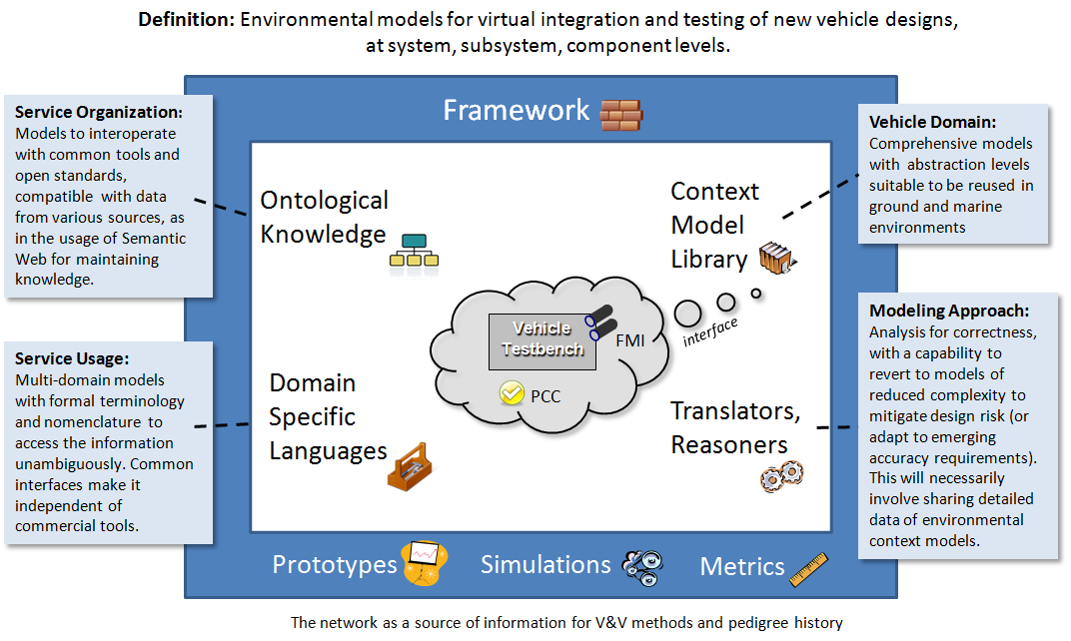

**Figure 2**: View of context modeling framework with emphasis on vehicle design. For virtual simulation, the innermost vehicle test-bench needs to interface to the environmental context model.

Starting from a general design and workflow approach outlined elsewhere[1] , we applied comparable knowledge-based patterns to environmental modeling (see **Figure 3** below). At the modeling level, we consider abstractions, organization, search, and logical reasoning to improve the convenience and usability across the suite of models.

Since the models are quantitative and often statistical in nature, we employ a concise descriptive language to declaratively specify their behavior. Simulation abstractions allow us to transition between purely data-driven and probabilistic views of models. The convenience of automated searching and reasoning benefited from the semantic-based organization of the underlying knowledge-base.

|  |  |  |  |
| --- | --- | --- | --- |
|  |  | Examples | Benefits |
| Domain Specific Language |  | Statistical, complex, and matrix math. | Concise, symbolic, declarative, with formal representations |
| Abstraction Levels | http://localhost:3020/html/images/map.gif | Local/global spatial levels, probability distributions | Comprehensive, detailed, and aggregated views of environmental contexts |
| Organization | http://localhost:3020/html/images/browse.gif | Semantic web ontologies such as SWEET | Classification, maintenance, services, library curation |
| Searching | http://localhost:3020/html/images/search.gif | Linked data elements, keyword and classification | Models discovered through requirements linkage, etc |
| Reasoning | http://localhost:3020/html/images/workflow.gif | Workflow and parametric modeling | Guided model generation and usage. |

**Figure 3**: Knowledge-based modeling patterns

The objective is to present the environmental view of the system as a dynamic context server (DCS). This provides a flexible framework for handling interactive applications such as guided workflows, artifact viewing, and reusable web services.

The DCS was organized with a breadth-first view to make sure that the essential semantic, ontological, logical, and mathematical capabilities were at least tangentially covered. We start with a set of categorical domain features which cover land, atmosphere, and aquatic environments, and then apply a set of facets to these categories to allow the user various levels of access to the knowledge. The orthogonal axes are illustrated in **Figure 4**.

The basis for the modeling is described in a set of foundation papers [2][3][4] which applied stochastic patterns to the empirical observations, leading to a set of concise formulations. The semantic organization provided a means to manage the growing array of patterns. Much as a scientific library provides organization among the subject domains, the semantic layers afforded a similar discipline to the model hierarchy. In practical terms, we applied the concept of archetypes as patterns of use[1] and organize our knowledgebase at the semantic level to take advantage of the reuse and commonality available by suitable classification.

|  |  |  |  |  |  |  |  |  |  |
| --- | --- | --- | --- | --- | --- | --- | --- | --- | --- |
| Fine  Terrain | Gross Terrain | Aquatic | Wind | Clutter | Inland  Water | Particles | Thermal | Rain | Corrosion |
| **User Facets** | | | | | | | | | |

**Figure 4**: The general semantic organization corresponds to modeling domain features arranged against user facets. The features provide semantic keying for various levels of search. In terms of the SWEET ontology, the features correspond to environmental categories, while the facets are human-centric.

Building Blocks

The foundation of the context server is built on a knowledgebase based on triple-store technology and managed by a declarative first-order logic language. The language chosen, Prolog[5], bridged the gap between the (1) low-level structures of the underlying triple-store database and the (2) declarative structure of an abstracted user interface[6]. The rules and inferencing capabilities of the language provided sufficient expressivity to allow the context server to function as a flexible semantic web-server[7].

In the following overview, we will cover the following building blocks at least briefly:

* Integration with triple-store (RDF, OWL, SWEET)
* Knowledge base and logic formulation
* Entailment – creating rules that abstractly appear as triple store
* Search and query – Semantic Web servicing – integration of queries as services
* Processing data formats such as XML and JSON
* Ontology graphing
* Generators for code production and data
* Math and complex math
* Array and list processing
* Symbolic and dimensional unit processing
* Integration with statistics framework such as R
* Artifact generation such as plots for PDF and PSD

Triple Store: The triple-store data format is the backbone of the semantic web. A triple consists of a *(Subject, Predicate, Object)* tuple which can be linked to other triples in seemingly infinite combinations, leading to significant flexibility and robustness in a database.

The structure of a triple, cast in a conventional *resource description format* (RDF)[8] or by the XML-free Turtle format, essentially reduces to mapping against what is referred to as a Prolog functor. So the following query maps directly to a RDF triple-store:

rdf(Subject, Predicate, Object)

From a programmatic level, that is all there is to interfacing Prolog to a triple-store. The semantics turns out to be equivalent to that of a SPARQL query[9], where the binding of the arguments to either variables or ground terms determines what will be returned from the query. Several useful guides are available which describe the essential match between the Prolog binding mechanics and that governing SPARQL queries and description logic written in straight RDF. Further work has been done in mapping to higher level descriptions built on top of RDF, such as in the *web ontology language* known as OWL[8].

We take advantage of a ready-made OWL classification system set up for environmental sciences modeling by using the terminology defined by the OWL-based *Semantic Web for Earth and Environmental Terminology* (SWEET) ontology[10][11]. The key to using ontologies such as SWEET is to create triple-store instance data which subclasses or keys off the classification system defined by the SWEET environmental hierarchies (see **Figure 5**).

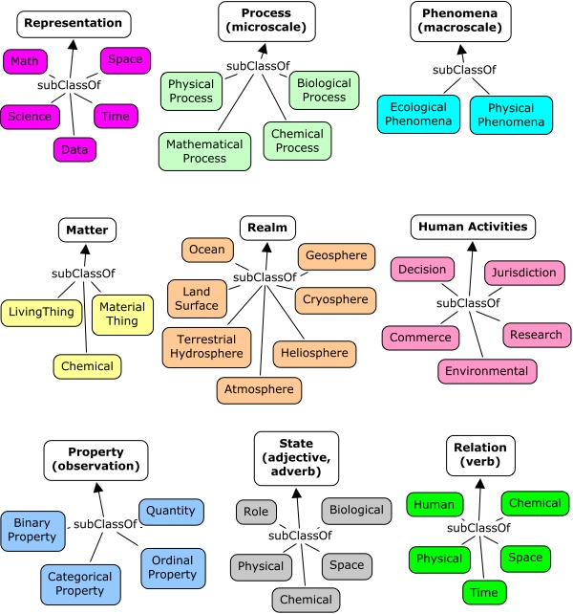

**Figure 5:** SWEET hierarchies and environmental classifications. The enclosed terminology is sufficient to define the majority of the context modeling knowledge.

We apply an additional abstraction, which is quite common in practical semantic web applications, which is to define a namespace layer between the instance data and that defined by SWEET. In Figure 6 below, we show several DCS-defined sub-classed resources that start with the letter ‘a’, and associate that with the SWEET terminology class that it best fits into.

|  |  |
| --- | --- |
| Context Server Resource | SWEET (rdfs:subClassOf) |
| ent:atm | |  | | --- | |  |   reprSciUnits:Unit |
| ent:atomicUnit | matrParticle:Atom |
| ent:averageAlbedo | propFraction:Albedo |
| ent:averageSolarInsolation | propEnergyFlux:Insolation |
| ent:avogadrosNumber | propQuantity:PhysicalConstant |

Figure 6: First several instances in graph ent = http://entroplet.com/terms# sorted by label

Suffice to say that the SWEET terminology supplies very complete coverage to the environmental modeling features required in the context server, and we have updated SWEET in the few areas that were deficient in representation power.

Knowledgebase**:** The context server knowledgebase is a composite of all the information stored in the triple-store database and the rules and facts stored in the Prolog repository. The most elementary form of a rule is to express the logic as some form of constraint, relationship, query, etc.

Rules can be used to define a specific closure or find a specific closure in the underlying triple-store database (see Figure 7)

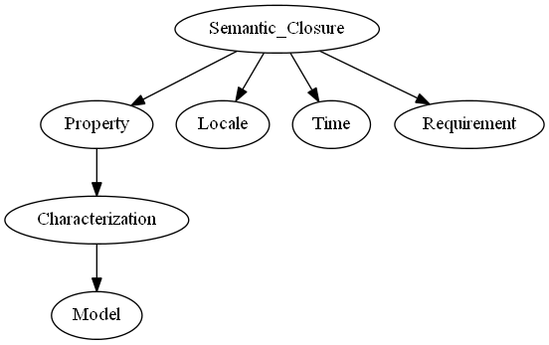

Figure 7: Linked triple-store features from a top-level rule define a semantic closure.

Entailment**:** A powerful feature of the correspondence between the declarative semantics of Prolog and a triple-store query is that we can create rules that abstractly function as triple stores (or that can extend the triple store). Per the semantic definition, *entailment* is the principle that the truth of one statement ensures the truth of a second statement. For example, we can extend an RDF query[12] that returns a resource with a real-valued component, so that we do not have to perform further parsing to convert the string to a float.

rdfR(Subject, Predicate, RealObject)

Search and Query**:**  We use a version of Prolog that contains a complete web servicing library (called Cliopatria[6]). This allows searches and queries to be composed as web requests. For example, the following URL request searches for resources that fit within a specific SWEET category (in this case a wind category):

http://localhost:3020/context\_search/list\_cats?name=phenAtmoWind:Wind

This works on two levels, the first stage of processing decomposes the URL into an internal format via REST (representational state transfer) semantics, and the second level, which searches the triple-store database (or Prolog knowledgebase) for matches, and then presents the results to the client.

As another example, this query requests a model of ocean clouds (see Annex B)

http://localhost:3020/context\_model/apply?loglog=false&model=Ocean\_clouds

Semantic web servicing and specifically the integration of queries as services allow us to build up the capabilities of the context server. In that sense, we can use (1) queries as model services, (2) queries to generate algorithms and code, (3) queries to generate artifacts and metrics, and so on.

Data Formats**:**  Processing data formats such as XML and JSON is important with respect to reading from externally stored knowledge and to providing data to the user. Prolog is essentially a list-processing language and much of the XML and JSON translation is conveniently available through the built-in libraries.

Ontology Graphing**:** Also built-in as a library is graphical representation for the knowledgebase and its semantic hierarchy. For example, the image below represents the sub-classing of a context modeling class, ent:pdf\_distribution, with respect to the SWEET terminology.



Code Generation**:** Many environmental models are stored as mathematical representations, intended to express a model’s behavior as closely to its original abstract form as possible. If this format is unambiguous and thus amenable to straight-forward parsing, the representation can easily be transformed into any software language that can also represent the mathematical expressions.   
  
In certain cases, we have chosen to represent models in a symbolic math format. Here, we can create a suite of translators for conversion from that format to an arbitrary language with the necessary mathematical expressiveness. We have shown below an example for a temperature model, where **T** is the calendar time and **S** returns the symbolic temperature expression.

% Generate a symbolic algebraic expression

calculate\_symbolic\_temperature(Site, T, S) :-

rdfS(U, ent:name, Site),

rdfR(U, ent:t0, T0),

rdfR(U, ent:ty, Ty),

rdfR(U, ent:dT, DT),

rdfR(U, ent:td, Td),

rdfR(U, ent:a, A),

rdfR(U, ent:b, B),

rdfR(U, ent:c, C),

PI is pi,

S = T0+Ty\*sin(2\*PI/365\*T+A)+(DT\*sin(2\*PI/365\*T+B)+(Td-DT))\*sin(2\*PI\*T+C).

The expression **S** can be evaluated directly as below, where the term “ is ” directs the interpreter to evaluate the expression

% Generate a numeric from symbolic

calculate\_numeric\_temperature(Site, T, Temperature) :-

calculate\_symbolic\_temperature(Site, T, Symbolic\_Temperature),

Temperature is Symbolic\_Temperature.

Since **S** is a symbolic representation, it can straightforwardly be translated to C-code, Python, etc. We will demonstrate this later.

Math and Complex Numbers**:** To minimize the potential complexity of the mathematical representations, we can take advantage of certain idioms that are heavily used and maintain those as domain specific representations. In that sense, we can create a domain specific language to handle the essential and common aspects of math-based models.   
  
Standard Prolog is expressive enough to handle much of the math load as shown with the code production example described previously, yet we find that a mini-language is useful to handle array processing and complex number math.   
  
As an example of the potential conciseness of representation, the complete declarative representation of a recursive Fast Fourier Transform (FFT) is the following (the *product\_and\_sum* and *evens\_and\_odds* are helper functions, and *w* is a lookup table).

% Fast Fourier Transform

fft(1, Ft, Ft) :- !.

fft(N, F, Ft) :-

N > 1,

N2 is N // 2,

evens\_and\_odds(F, E, O),

fft(N2, E, Et),

fft(N2, O, Ot),

w(1, W1),

w(2, W2),

w(N, Wn),

product\_and\_sum(Et, Ot, W2, Wn, Gt, []),

product\_and\_sum(Et, Ot, W1, Wn, Ft, Gt).

The function *product\_and\_sum* illustrates how we have abstracted the expression evaluator “ is ” (described in the previous code production example) to “ isx ” which now evaluates expressions involving complex numbers. A complex number is represented as *a + i b*, where *i*  represents the imaginary number .

product\_and\_sum([], [], \_, \_, Ft, Ft).

product\_and\_sum([E| Et], [O| Ot], Wk, Wn, [F| Ft], Fu) :-

Temp isx O \* Wk,

F isx E + Temp,

Wk1 isx Wk \* Wn,

product\_and\_sum(Et, Ot, Wk1, Wn, Ft, Fu).

This complex number formulation is used for calculating terrain profile power spectral densities (PSD) based on input data with array sizes of several hundred thousand elements.

Array and List Processing**:** Concise list array processing is useful to represent and generate the data elements described in most of our stochastic environmental models. Complex number list processing is used for calculating PSD’s as shown in the complex math FFT example, while lists comprised of real numbers are used for calculating probability density functions (PDF).

As a domain specific representation we chose to apply list and array operators with *infix* notation wherever possible. The processing function then reads as *Y results from applying against* *X*.

Y **mapdot** X

Map Dot is a dot product of individual elements, retaining the list structure.

For this specific case we take an example from the Matlab world where the operator “ .\* ” is defined to multiply a scalar by a vector, so that the following relation holds:

[20,40] mapdot 2 .\* [10, 20]

This expresses the invariant that 20 is the doubling of the first element in the list, and 40 is the doubling of the second element of the list.

For further expressiveness, the term “ ~>” is used to indicate a map apply to a list:

[2.0, 4.0] mapdot 2 \* sqrt ~> [1.0, 4.0]

A number of specialty array and list processing functions follow this infix idiom:

Y **range** [From, To]

Range of numbers into a list

Y **dot** A\*B

Dot product of two arrays or lists of the same length

Y **convolve** A\*B

Convolve (convolution operator) list with another list.

Y **correlate** A\*B

Pair correlates one list with another list.

Y **derivative** A/B

Take the derivative of one list with respect to another list.

Y **integrate** A\*B

Take the integral of one list with respect to another delta list.

Y **difference** A-B

Take the difference of one list with respect to another list.

Y **tuple** A+B

Create a tuple list from two lists.

Y **unbias** X

Remove the mean from a list of values, so the sum is zero.

Y **normalize** X

Normalize a list of values, so the sum is unity.

Y **pdf** X

Create a PDF from a list of values.

Y **zshift** A-B

Do a DSP z-shift from a list.

Y **window** X/A

Y **window** X\*A

Do a lag-window or centered window on a list.

Y **shrink** A/B

Shrink a list to match the second.

Y **expand** A+B

Expand a list to match the second.

Y **cat** X

Flatten a list.

Y **offset** X

Offset a list by N elements.

Y **ordinal** X

Create an ordinal (counting) list from a list.

Y **split** X

Split pairs of values into two sequential lists.

As an example of the sophistication of use, these four lines generate a number line, a sine and cosine valued list and then a list of (*X, Y, Z*)-tuples suitable for plotting as a graph:

X range [1,50]/0.1,

Y mapdot sin ~> X,

Z mapdot cos ~> X,

Graph tuple X + Y + Z

Or consider this case of concisely generating a cumulative density function against an *X* variate of a given range, and then producing a probability density function from that result

X range [0,100]/0.1,

Y mapdot exp(10) ~> X, % create CDF of exponential with damping factor 10

Z pdf Y

The final objective was to be able to abstractly represent fairly sophisticated list computations in as concise a form as possible. As is the case with many of these domain specific idioms, the result is that a user can scan the code and be able to quickly determine the transformation that is being applied.

Statistical Integration**:** A language such as Prolog is well-suited for (1) general purpose logic programming, (2) creation of domain specific languages (as shown with the complex and list processing DSLs described above) and (3) application development such as is required for a semantic web server.

Where it falls short is in the area of special-purpose computing such as in statistical and scientific computation, which may require extensive matrix handling and comprehensive math libraries [13][14]. The open-source statistical computational tool known as **R** is well-suited to corners of the statistical and mathematical world that basic Prolog does not have a foothold in[[233]](#footnote-233) .  
  
Fortunately, the version of Prolog used on this project has an API to **R** and features a domain specific language abstraction defined specifically for data processing. Similar to what we use for list processing, an equivalent list processing interface is defined to **R**.

In particular, the infix operator “ <- ” is used to generate an input/output transfer from Prolog to **R** (and the reverse). So in the following, we generate a list profile called *Input*, but then request that **R** perform a *BesselK* function lookup on that list and attach it to an **R** state vector called *y*.

Input mapdot sqrt ~> 2.\*[0.00001,0.0001,0.001,0.01,0.1,1.0,10.0,100.0],

y <- besselK(Input,1),

Y <- y,

Output mapdot Input \* Y

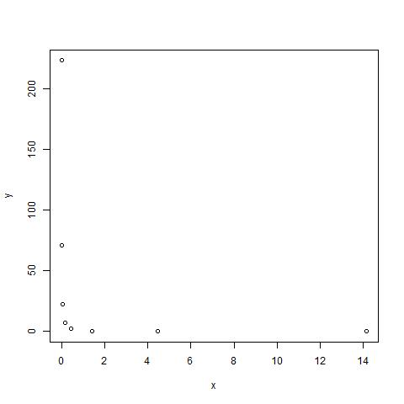The rationale for doing this is that Prolog does not have a library of transcendental functions such as the set of modified Bessel functions (which are used in PDF models), yet **R** does contain a comprehensive library, largely due to its statistics underpinnings. The fact that the list processing idioms that we have in place match well with the list I/O of the **R** library makes this a good combination for corner-case modeling needs, and where more sophisticated graphing is needed (see the contour plots in Section X for an example). The combination of Prolog with **R** is comparable to the capabilities of Matlab.

The statistical leverage that **R** provides to the semantic web server is crucial for further enhancements to context modeling.

HTML Development**:** The semantic web library includes convenient mechanisms for developing HTML code, well suited for making sophisticated interactive web pages. The declarative style of programming used in Prolog allows a very similar but much more concise and powerful representation than does the XSLT (Extensible Stylesheet Language Transformations) language[15] used in conventional web page development.

The library uses what is called definite clause grammars (DCG) to generate valid HTML[16], with the code remaining very readable. A DCG is much like a XSLT fragment, allowing for recursion and pattern matching, but presented in a much more compact and concise style.

dispatch(wind) -->

html([h1('Wind models'),

\g(search,

a([href('/context\_model/navigate?characteristics=windSpeed'),

target(target\_iframe)], 'Wind PDF models')),

\(ref\_search('phenAtmoWind:Wind', 'Wind references')),

\g(browse,

a([href('/context\_browse/navigate?term=atmospheric')],

'Browse atmospheric characteristics')

)

]

).

This HTML, when rendered, appears as the following style-sheet-based representation (see **Figure 8**):

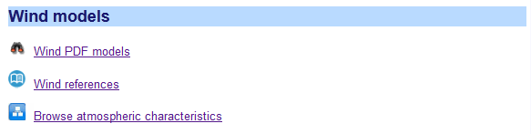

**Figure 8 :** Rendered HTM from a Prolog DCG rule.

The terms leading with the character ‘\’ call out user-defined DCG functions which will create in-place snippets of HTML code. In practice, by generating the majority of the HTML code using a mix of logic and meta-logic, we employ what amounts to a hybrid of a PHP hypertext preprocessor[17] (executed on the server side) and the declarative nature of XSLT (but without the excessively verbose syntax of the latter).

In general and for most HTML coding we use this idiom, and only for certain applications, such as in form input look-ahead and interactive graphing, do we drop into JavaScript.

Plot Artifacts**:** Generating artifacts such as plots of PDF and PSD models is facilitated by the use of open-source JavaScript libraries that feature dynamic interaction.

From either models or data, we use dynamic graphs to construct PDF, CDF, and PSD profiles, along with expected value plots of annual, diurnal, etc measures and various growth curves.

The graphing interactive features include linear or log scales, adjustable noise filtering, the inspection of data points, and panning and scaling.

As an example, we extend the list processing example described earlier to plot a dynamic graph, which consists of two trigonometric functions separated by a phase shift:

dygraph\_test(\_) :-

X range [1.0,50.0]/0.1,

Y mapdot sin ~> X,

Z mapdot cos ~> X,

Graph tuple X + Y + Z,

reply\_html\_page([title('chart'), \(con\_text:style\_cliopatria)],

[\(context\_graphing:dygraph\_native(

false,

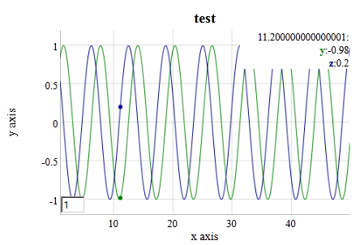 ['x', 'y', 'z'],

'x axis',

'y axis',

'test',

Graph))]).

\

Random Number Generation**:** A module for random number generation is an important building block for Monte Carlo simulations. A uniform random variate generator can be used in conjunction with invertible PDF profiles to create sampled data for exponential, Bessel, Rayleigh, fat-tail, and several other distributions.

Terrain profile generators also rely on a random number generator to create random walk profiles of Markov and semi-Markov character. For aquatic wave generation, random superposition of sine waves is effective in modeling the empirical characteristics observed.

Dimensional Units Checking**:** The framework uses an embedded Prolog reasoner to parse and pattern match if dimensional unit conversion is required on some measure. The unit symbology is retained as lexical terms with both proportional scaling or inverse scaling allowed, depending on whether a “\*” or “/” appears in the unit dimensionality string. A database of root units and at least one relation to another unit of the same measure is kept in the local knowledgebase so any combination can potentially be parsed and evaluated.

As an example of a relatively complex unit string, we take the Stefan-Boltzmann constant specified in terms of SI units, 5.67e-8\*j/s/m^2/k^4, and can use the unit checking module to convert this value to a hybrid mix of English units:

?- context\_units:convert(5.67e-8\*j/s/m^2/k^4, SB\*btu/hr/ft^2/r^4, SB).

SB = 1.7121822360279162e-9.

Where j=joules, s=seconds, m=meters, k=kelvin on the original, and btu=BritishThermalUnits, hr=hour, ft=foot, and r=Rankine on the desired conversion.

This feature is valuable in reducing the amount of translation code that is required, as the number of combinations is nearly unlimited but the parser is able to perform the reduction symbolically.

Diagramming Relationships**:**  Similar to the library for **R** interoperability, the semantic web infrastructure also integrates to the directed-graph library known as *Graphviz*. The *Graphviz* rendering generates SVG (scalable vector graphics) which is compatible with most HTML browsers.

This capability allows us to visualize closure of rules as a directed graph, and look at hierarchy and cloud diagrams.

Summary of Building Blocks**:** The portability of the semantic web infrastructure has been tested against Windows, Linux, and a cloud computing environment. The maintenance of the context model library is abetted by automated features such as web-served browsing of source code and triple-store data elements, site roadmaps and documentation, statistical usage, and password authentication for administration of repository and web server options.

In summary, the integration of a logic processor with triple-store semantic data formatted with RDF and Turtle works effectively as a building block foundation. Using the triple-store for input data files and as a knowledge repository interoperates well with the base logical language. The SWEET ontology provides comprehensive classification and we can build an extensible knowledgebase on top of the SWEET terminology

The domain-specific language for creating stochastic context models includes list processing of n-tuples, math operations on lists, constructors of linear and log range ordinals, dot product and mapping on lists, the latter which we can apply functions and scaling. Specialty functions such as convolution, pair correlation, Z-difference, integral, derivative, histogram, and simple translation of tuple-lists to graphs make it very convenient for data processing applications.

The domain-specific language for complex-number processing has arithmetical infix operators for multiply, addition, division, power, etc which allows for concise semi-Markov terrain profile modeling, and a built-in FFT for PSD calculation.

The following table lists the categorized building blocks so far described:

Table 9: The set of Domain Specific Language building block elements for environmental modeling covers math and logic functionality

|  |  |  |  |  |
| --- | --- | --- | --- | --- |
| Functionality | Terms | Description | Examples | |
| complex math | isx (evaluation)  & (constructor) | Manipulating complex numbers used for generating PSD curves. | | Num isx 1&2 \* 2&1 |
| array math | dot (scalar result)  mapdot (array result)  ~>  (apply function) | High-level array manipulation. | | Z dot Array1 \* Array2,  Amp mapdot sqrt ~> PSD \* Sx |
| statistical | <-  (translate to R ) | Interface to the R statistics package | | y <- BesselK(1.0,0.0),  Y <- y |
| geospatial | shape  point  line | Description of geometric shapes and lines | | shape(point(52.3325,4.8673)) |
| markup | html, table, p, b, body, etc. | Definite clause grammar for generating markup | | table([border(1)], [tr([th('Mean'),th('Sampled')]), tr([td(Mean\_Slope), td(S)])]) |
| semantic | rdf | Library for interfacing to RDF and OWL knowledge | | rdf(U, dcterms:’URI’, Link) |
| symbolic logic | Prolog terms (including symbols and variables) | Overall logic programming, dimensional checking, code generation translation, etc. | | Distance = 10.0 \* meters |
| ordinary math | is (evaluation)  Prolog terms | Set of math operators and libraries built-in to the language, used for models and Monte Carlo simulations | | Y is A + B random(Sample) |
| chart plot | library calls | Integrated JavaScript for artifact display | | context\_graphing:plot(…) |
| directed graph | library calls | Translation of triple-store links to directed graph | | graphviz:context\_graph |

One row from this table was not used but has implications for environmental context modeling. The geospatial functionality is very useful for inferring information on locality. For example, say that temperature statistics are not known for a particular area, but data from nearby locations is available. A geospatial engine can aggregate and select data from weather stations in close proximity and use that to interpolate the statistics. This is built into the semantic web library, yet we deferred applying it until a future need arises.

Pattern Architecture

Based on the modeling described in our foundational research [2][3][4], where we discovered and collected patterns in various environmental contexts, we can start to encode these patterns to build up a comprehensive suite of interactive context models.

We first recognize that many of the context models have similar representation or archetypes, so for example, we can assert that PDF patterns use functional mapping on lists. And we also note that similar representational formats allow reusable artifacts in the form of plots. The basic application of these patterns results in an organization hierarchy shown in **Figure 9**, where we can apply the same development abstractions to each of the contexts that we wish to include. In this case, we consider a terrain context, and realize the same patterns of usage for modeling, language, reasoning, and metrics apply. This may seem overly pedantic, but the patterning approach applies to the development[18] just as it does to the model characterization[19], and it allows the framework to grow and scale. Declarative programming further facilitates pattern-matching, as a set of declarative rules can pattern match automatically on new information.

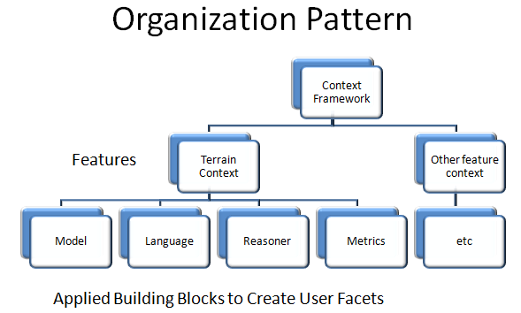

**Figure 9:** Pattern of associating domain features with building blocks which allow the creation of user facets and web services, maximizing reuse and maintainability.

An example of a basic semantic pattern that we can apply is to parameterize models for different geospatial locations (or locales, for short). One locale may be labeled as “**conus**” (shorthand for the continental USA), and used as a semantic node to attach various properties and characteristics to. **Figure 10** below shows the semantic closure graph for how the information gets attached to a locale node. Note that each graph edge represents a predicate in terms of a (*subject, predicate, object*) triple-store, so that the labeled arrow is the *predicate*, the source of the arrow is the *subject*, and the destination of the arrow is the *object*. This then creates a directed graph of triple-store links.

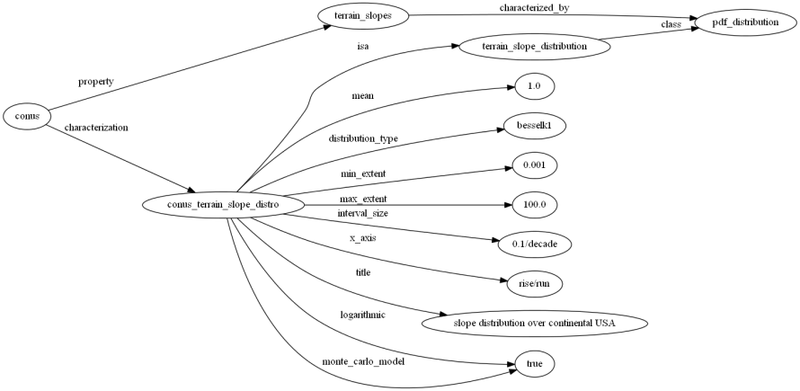

**Figure 10 :** Semantic closure graph of triple-store relations associated with a locale “conus” and terrain slope properties. Most rules follow a similar scoping closure.

This approach allows us to create a pattern architecture based on semantic links.

Archetypal Domain Features: The *domain features* of the architecture are the environmental contexts that we are interested in modeling. The following iconified list provides the basic categorization levels.

|  |  |
| --- | --- |
| http://23.23.137.157/html/static_pages/gems/fine_terrain_icon.png | Fine Terrain Features — Models for representing power spectral densities (PSD) based on Markov and semi-Markov representations. Models of obstacle courses and data sets for friction and soil types. |
| http://23.23.137.157/html/static_pages/gems/gross_terrain_icon.png | Gross Terrain Features — Simple distribution for sampling likelihood of terrain slopes. Marginal distributions for elevation changes over various geographic locations. |
| http://23.23.137.157/html/static_pages/gems/wave_statistics_icon.png | Wave Energy Statistics — Simple approach for modeling PDFs of wave frequencies and wave heights. Models of sea-state wave distributions over various geographic locations. Water density and buoyancy tables. |
| http://23.23.137.157/html/static_pages/gems/wind_statistics_icon.png | Wind Energy Statistics— General results for modeling wind energy distribution and autocorrelations for temporal persistence. |
| http://23.23.137.157/html/static_pages/gems/clutter_modeling_icon.png | EMI Clutter Modeling — Maximum entropy models for electro-magnetic interference (EMI) and noise in the environment. Models of lightning rate. |
| http://23.23.137.157/html/static_pages/gems/lake_sizes_icon.png | Inland-water Statistics — Maximum entropy estimation for lake size distributions and river flow rates over various regions. |
| http://23.23.137.157/html/static_pages/gems/particle_sizes_icon.png | Particle Size Statistics — General method for modeling size distribution of particulates such as ash and ice crystals, and water droplets. |
| http://23.23.137.157/html/static_pages/gems/thermal_dispersion_icon.jpg | Thermal Dispersion — Simplification of thermal diffusion model to account for disorder and variability in the media. Seasonal and daily temperature models across geospatial regions. |
| http://23.23.137.157/html/static_pages/gems/rain_statistics_icon.png | Rainfall Statistics — General model for rainfall distributions within storms using composite process. Cloud size statistics. |
| http://23.23.137.157/html/static_pages/gems/corrosion_oxidation_icon.jpg | Corrosion and Oxidation — Model of oxidation and corrosion growth which improves on the Deal-Grove formulation, using reversion-to-the-mean diffusion kinetics. Table of corrosive categories. |

Information Resources: A number of commonly used properties and physical constants span several of these domain features. These can include:

* Physical constants such as water density, gravitational constant, etc.
* Lookup tables such as soil types, sea-state definitions,, etc.
* Nominal environmental and climate information such as standard atmosphere, solar insolation models, etc.
* Dimensional units such as SI and English
* Geospatial definitions and schema – such as UTM and Latitude/Longitude coordinate definitions
* Meta-information: Citations and references for models, algorithms, requirements
* Project specific context data sources
  + Verification & Requirements documents such as TOPS (Test Operating Procedures)[20][21][22]
  + Earth sciences archives such as NASA JPL PO.DAAC [23], US Army Corps of Engineers WIS [24], etc

Archetypal Usage Facets**:** The usage patterns follow an orthogonal axis that we refer to as usage facets.

Search — The discovery of models needed for a particular purpose is facilitated by various forms of search. A free-form search into the knowledgebase is provided by the search bar in the upper-right corner of the user-interface. This links to knowledge contained within the triple-store knowledgebase, largely independent of semantic context. Other more directed, semantically-driven searches are available from the main search page. Links between specific categories of knowledge and models available within the server are contained here. To accommodate this, specific models are tagged and allocated to specific environmental categories. This is aided by the application of ontologies such as SWEET.

Browse — Environmental and context knowledge follows a natural hierarchical organization. At the top level, we can break out the models into broad categories for Land, Atmosphere, and Aquatic. Below that level, the specific models are allocated to more finely refined categories such as terrain roughness. The basic hierarchy follows that of the SWEET ontology.

Workflows — A process workflow is defined as a software-guided navigation to problem solving. A composable workflow allows for a sequence of problem solving steps depending on the knowledge available. Several workflows to access probability density function (PDF) environmental models and power spectral density (PSD) models are provided. A supplemental system called OSCAR (Ontological System for Context Artifacts and Resources) provides semantic web discovery, registry, and editing/modification capability. The OSCAR workflow portal will facilitate users to find context models and associated metadata to enable their simulation (see Appendix E).

References — Each model has supporting documentation in the form of references and citations. We also distinguish between specifications, foundational research, requirements, and general reference material. The Zotero citation management system[25] is used to keep track of references and links and we use the SWEET ontology to tag the references with semantic environmental categories. For example, references relating to aquatic wave energy will get tagged with the *phenWave:GravityWave* class resource defined in SWEET.

Resources —Context modeling resources include interactive links to tables and supporting documents, such as environmental regulations, standards, specifications, and nominal or typical operational profiles.

Map View — The scope of environmental models is world-wide. This of course implies that environmental models will depend on the particular geologic and climatic characteristics of specific geospatial locations. Where models have locality links we can search regions of interest to find what is available.

Generic Query — The knowledgebase has SPARQL and native Prolog query support. The intent is that a user can explore the database interactively and reuse resources from the triple-store in other applications.

User Factory — Project-specific requirements provide a means to connect practical applications to information available from an environmental context library. For example, a project requirement that states that a vehicle should be able to operate on terrain of a specific roughness, suggests a link to certain context models available from the server. The links between the requirements and models are accomplished via semantic and ontological organization of the knowledge. In this case, certain keywords and phrases in a requirements document are tagged and allocated to specific environmental categories. This is aided by the application of ontologies such as SWEET.

Dynamic context server knowledgebase and reasoner

The fundamental triple-store data structure generates a substantial fraction of the knowledgebase for the semantic web server. Triple-stores as realized by RDF data sets provide the flexibility to chain and link data at the granularity that we are interested in for context modeling.

The dynamic context server provides interactive content for environmental modeling on demand (i.e. essentially “serving” content). The models are contained within an ontologically organized structure and so can be semantically accessed. The semantic organization allows various search mechanisms, while the information and terminology domains are grouped in data stores according to the bubbles shown in **Figure 11**below.

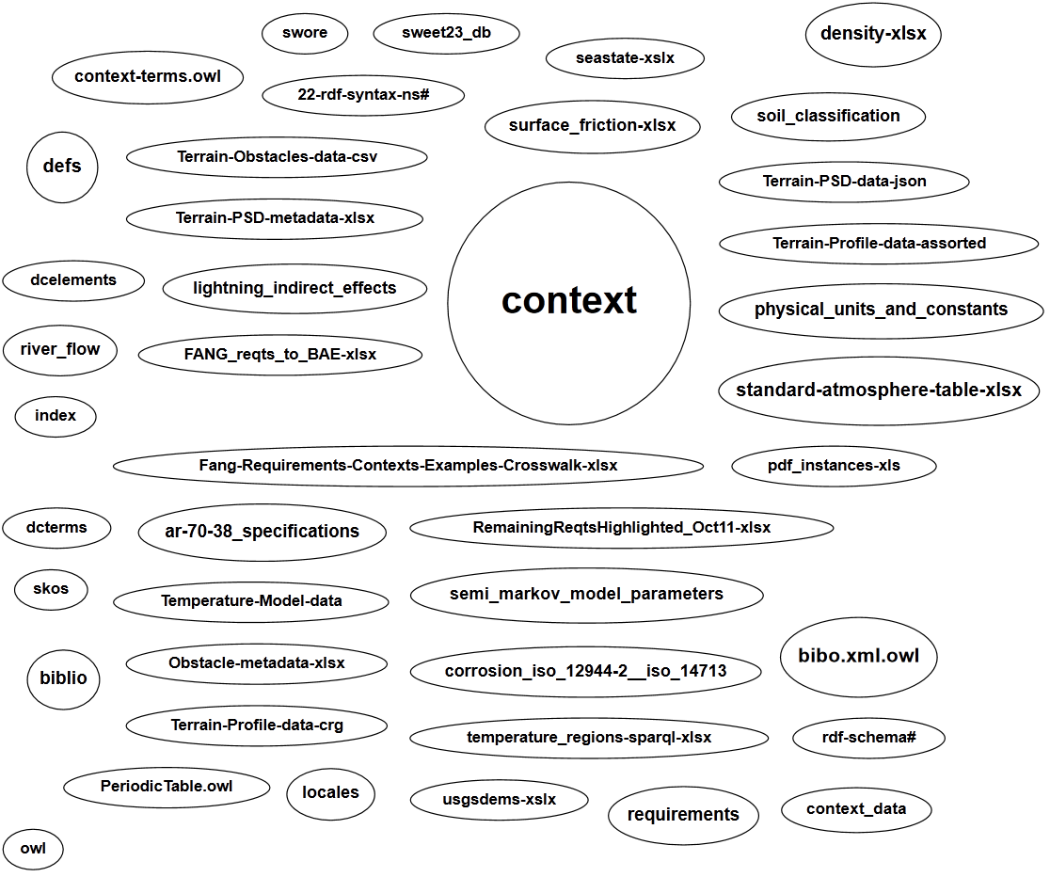

**Figure 11:** Cloud describing semantic data sets. The large circle labeled “context” contains the majority of the reference and citation data. Each ellipse corresponds to an RDF or Turtle triple-store data set

A context is defined as the surrounding environment for a specific intended use, such as may be applied to evaluating a vehicle design or its performance. The environment itself is wide-ranging so that individual contexts can be independently isolated and treated as domain features. This means that a domain feature such as fine-grained terrain can be isolated from the atmosphere domain or, more subtly, distinguished from the overall gross topography of a region. This has important ramifications in that we can encapsulate certain aspects of the environmental models without leaking abstractions across domain boundaries.

Further, as described in **Figure 1**, many of the environmental models are passive and *non-compliant* in terms of interactions with a subject under test. A *compliant* interface would be, for example, a terrain surface that demonstrates a significant give when interacting with a vehicle [26]. These kinds of compliant interfaces demand a more intimately coupled multi-physics interaction between the environment and subject, and is out of the scope of what a semantic context web server can offer in computational throughput and bandwidth. However, the set of passive interfaces remains quite significant and important in evaluating fitness-for-intended-use and other criteria for designs.

Example of Environmental Requirement

As an example of user requirements, consider the paces that a ground-based vehicle has to go through. A set of use-cases may involve the capability to traverse a cross-country course with a specific root-mean-square (RMS) deviation in the terrain roughness. If requirements phrases such as “cross-country” and “RMS ride courses” are captured in a semantic knowledgebase, rules can then be added to automatically link to a specific environmental model. This is shown in **Figure 12** below.



**Figure 12:** Requirements to workflow

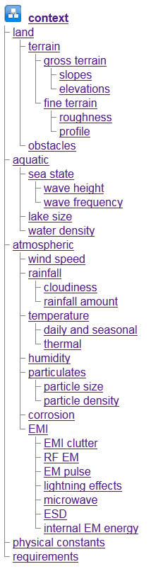If these phrases are captured beforehand and stored as persistent knowledge with links to categories, models and workflows, we can take advantage of “factory-level” automation when a new project requirements document is introduced. Individual requirements stored as triples within a data store (see the ellipses labeled in “Fang-req...” and “RemainingReqts…” in **Figure 11**) can be parsed by the expert system with the phrases highlighted within individual requirements. A tool such as OpenRefine[27] can help with the translation from a spreadsheet to a triple-store format such as RDF[28], N3, or Turtle.

In terms of a semantic web interface, the user is presented with a listing of phrases discovered within a semantic context, and then tabulated against a path to the appropriate workflow.

An aspect to this formulation guards against potential requirements churn. As new requirements come in with extra decomposition levels, new triple-store linkages can be added without upsetting any previous triples that may have previously existed. In other words, a perfect relational schema does not have to be maintained, which is an issue when applying the output from typical requirements databases. Adaptability of knowledge format is the key here, while keeping a balance between free-form textual association and tacit semantic relationships.

Browsing Interface

The server provides a browsing interface that is structured around the natural hierarchy that we employ of *land*, *aquatic*, and *atmospheric* domains.

Internally, we employ triple-store relationships to manage the links in the hierarchy. The hierarchy (see right) is extended to provide space for resources that may span features, see *physical constants*, and for those that may be user defined, *requirements*.

See the Annex A for a browser-guided narrative that is provided as part of the dynamic context server. This explains the rationale for the categorization chosen for the set of models.

Reference and Citation Linking

The context knowledgebase contains semantic information which allows it to be searched in a structured fashion. The set of references to research articles, specifications, and standards is managed by the [Zotero documentation citation system](http://www.zotero.org/about/) [29][30][25]. Individual citations are tagged with terms from SWEET within the Zotero browser component (as a Firefox plug-in) to indicate the environmental concepts that apply.

For non-structured information retrieval, the search bar in the upper-right corner finds information within the knowledgebase that is not semantically organized.

A typical semantically-based query is shown in **Figure 13**, shown below for a specific SWEET term signifying the *Temperature* property class. Regular references are distinguished from specifications () and model foundational documents (), the latter of which contain detailed information to support the construction of models for the context library.

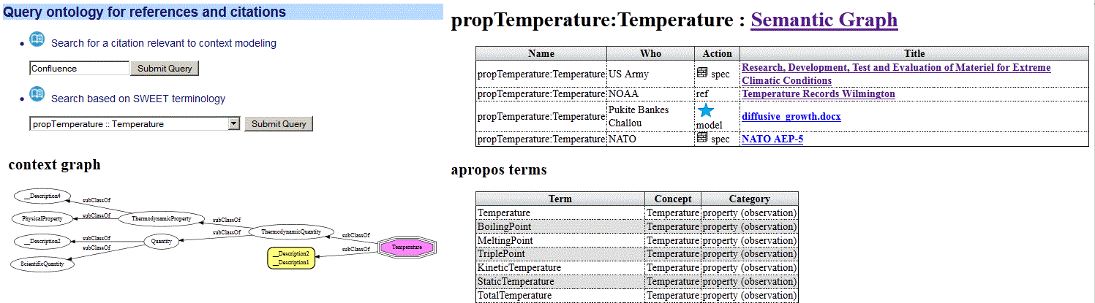

**Figure 13 :** View of the reference and citation search interface.

Capturing and integrating reference and citation knowledge via a standard citation management system and a standard ontology such as SWEET allows for future growth, aided by the fact that other users can contribute knowledge to the reference database.

Workflows

Workflow patterns follow the concept of economized development. We rely on patterns of workflow to reduce modeling work, simplify maintenance, and create a record of a project's provenance.

The supplemental workflow used to access statically defined context models for test-bench execution is called OSCAR (*Ontological System for Context Artifacts and Resources*).

OSCAR is a knowledge-based system providing semantic web discovery capability, limited according to the available context library ontology and instance data (see Appendix E). The goal is to provide guided discovery for users to find, register, or edit context models and associated metadata to be used in their simulation. The context models include collections of power spectral density profiles (PSDs) and other data sets, which provide the generators for model execution. This is considered an industrial strength component as it has a design lineage tracing to oceanography data content service architectures [31].

The other workflows available are intended to provide dynamic content for probabilistic evaluation, such as what is needed to perform PCC (probabilistic certificate of correctness)[1] and for support of formal verification. In these cases, probability density functions provide the constraints and likelihoods for testing extreme values or corner cases, with the distributions mathematically provided to allow Monte Carlo simulations to explore the required state space for test cases.

The workflows can also be used to quickly evaluate model characteristics and collect artifacts for later decision making. For example, the earlier example of requirements search is actually a guided workflow that starts from the captured requirements phrases.

A sampling of the workflows available is shown in Figure 14 below:



Figure 14 : Workflows available

Search

Many common environmental models share the same underlying stochastic pattern. In general, this means that we can use similar math to capture the characteristics of behavior across a range of domains, even though the measured quantities are not comparable.

The important case for PCC estimates is the probability density function (PDF) of environmental characteristics showing a spread in uncertainty in values.

PDFs and other models can be searched according to feature keywords or SWEET categories based on applicability to the context space as shown in **Figure 15**.

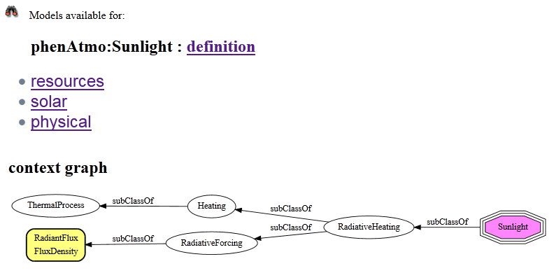

**Figure 15 :** Search results for a SWEET classification term

The general rule we apply for general content search is to base it on ontological terms (if not a free-form textual phrase) and then use that to restrict the resources that match.

The presentation of knowledge from the matching hits could be in HTML with links such as shown in **Figure 15** or in XML, JSON, CSV or other format suitable for external use.

The server also provides a more free-form textual search that evaluates contents of the triple-store, such as rdfs:comment instances, and then presents the results as a list of triples (see **Figure 16**):



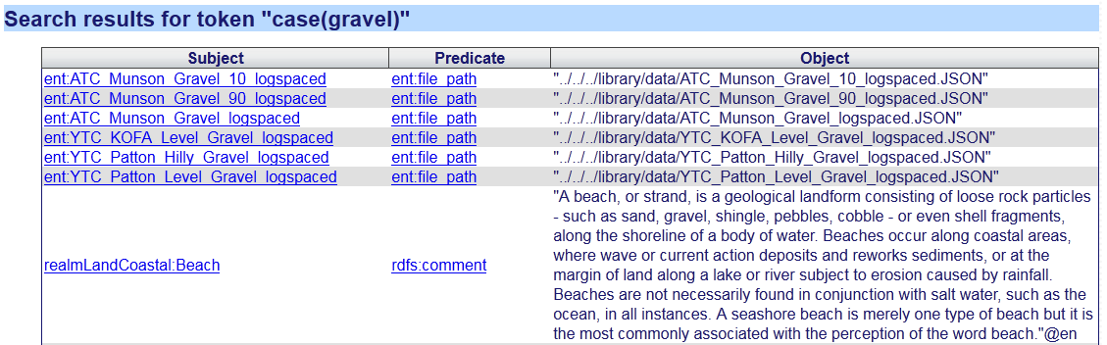

**Figure 16**: Free-form search partial results for the phrase “gravel”.

Resources

Models in the form of interactive standards are also provided via the context server. These are transcribed into semantic content from various standards documents. The semantic content enables the data to be used to automatically construct tables, graphs, or other structural forms (see **Figure 17**).



**Figure 17 :** List of resources (tables, charts, and data) taken from environmental standards.

Also units of dimensionality and physical constants are categorized here. For various dynamic artifacts, the applicable units are stored as resources and necessary conversions between units are done automatically.

Examples of tables from triple-store include the Periodic Table of Elements (**Figure 20**), a Coefficient of Friction table (**Figure 19**), and a Soil classification table (**Figure 18**).

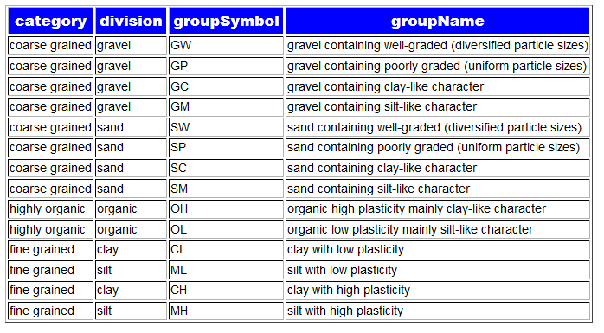

**Figure 18:** Soil Classification table featuring USCS two-character code automatically

The following coefficient of friction table **Figure 19** was generated from a table of values captured from engineering data[32] and then converted to RDF triples through the *OpenRefine* tool[27].

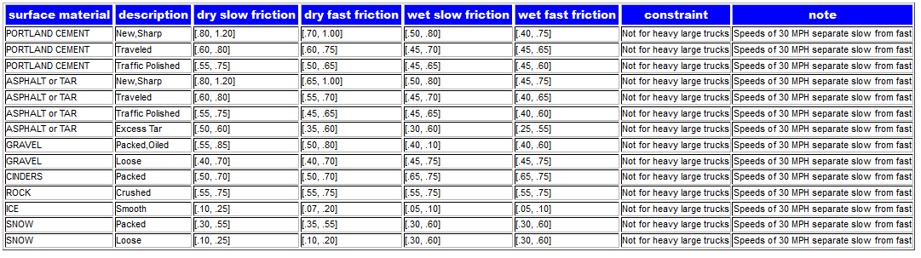

**Figure 19**: Coefficient of Friction table automatically constructed from semantic elements

Perhaps the most sophisticated semantic-based generation example is the periodic table of elements shown below, which uses supplemental logic rules for element placement and coloring.

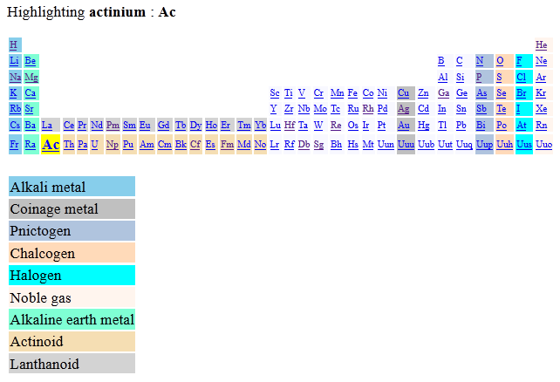

**Figure 20 :** Periodic Table of the Elements generated from semantic rules

Examples of generating graphs from triple-store include rendering of ideal gas curve and nominal temperature specifications for various climactic conditions (see **Figure 21**). These are taken from the environmental modeling handbook AR-38 [33].

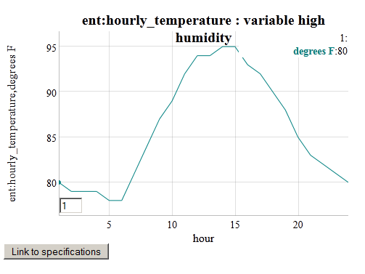

**Figure 21 :** Generating a plot from an environmental specification of nominal daily humidity swings.

Map/Location

Environmental models can either be general in terms of their suitability (such as water properties or a standard atmosphere), or specific to a geospatial location, which can further include daily or seasonal effects.

The locations are accessible through the semantic drop-down list or through indexed search terms with keystroke look-ahead.



Figure 22: Keystroke look-ahead for domain features linked to geo-spatial locations.

The map button indicates the location of the model or data, and the available button links to the modeling domain(s) available. A Google Map API window is also provided to illustrate the geospatial location and coordinates of the model or data. Both these features are shown in **Figure 23**.

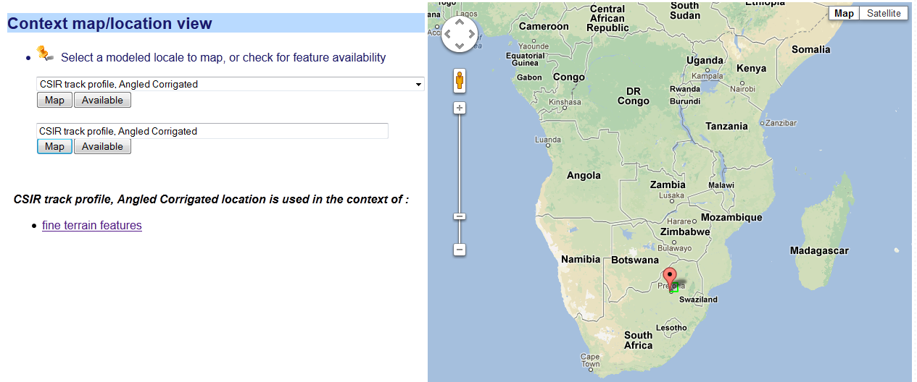

**Figure 23:** Google Map window for locating geospatial location of queried model, with link to model on left.

Knowledgebase and Server Technical Architecture

The internal structure of the dynamic contest server consists of a semantic reasoning engine and its accompanying set of knowledge. The interactivity with this underlying architecture via a web server allows for a user interface and potentially automated modes (see **Figure 24**) to remote data sources or to test benches.

The ontology is cast as a form of *description logic* [1], which consists of a terminology set (the so-called terminology box or *TBox*) and an asserted data store (the assertion box or *ABox*). The terminology and assertions can come from standard ontologies such as SWEET (for the TBox) and from qualified data and information sources (for the ABox). In other words, the former provide latter provides the classification and the latter provides knowledge and data.



**Figure 24:** Usage architecture for the semantic web server. The Dynamic Context Server handles artifacts and interactive services, while OSCAR handles static data and executables such as functional mockup units (FMU)

The logical rules work with the terminology and assertions to accomplish searches, execute algorithms, generate code, and otherwise perform general inferencing.

To interface concisely with the triple-store database, a set of *namespace prefixes* is specified and used by the reasoner. A subset of the prefix namespace is shown below in **Figure 25**. As the SWEET ontology provides a comprehensive view of natural terminology, this by necessity has the largest set of prefixes, largely to provide disambiguation for terminology that is borrowed across domains. For example, a *wave* could refer to an aquatic wave or an electromagnetic wave, with the namespace helping to provide a context.

The namespace called *ent:* holds special significance as it provides sub-classing and additional terminology to the SWEET ontology. By providing an additional level of abstraction, we can guard against changes made to the reused standard ontologies.

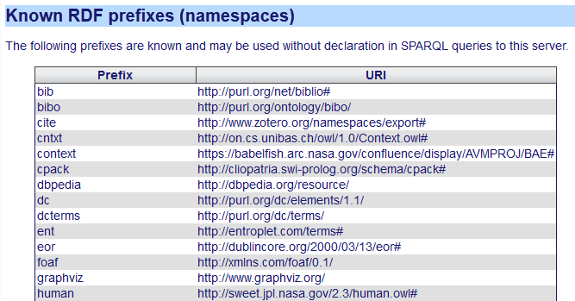

**Figure 25 :** Configured prefixes for URI name-spaces.

**As an example of the sub-classing, the resource ent:C4 refers to a specific classification of corrosive environment (see Figure 26). According to the semantic hierarchy, it sub-classes from both the SWEET procChemical:Corrosion class as well as the procCategorical:StandardIndustrialClassification class from SWEET. The directed graph also shows how these SWEET classes are sub-classed within that hierarchy. The C4 property is extended to include specific information relevant to this corrosion classification, such as qualitative descriptions of ent:environmental\_conditions and ent:exterior\_examples.**

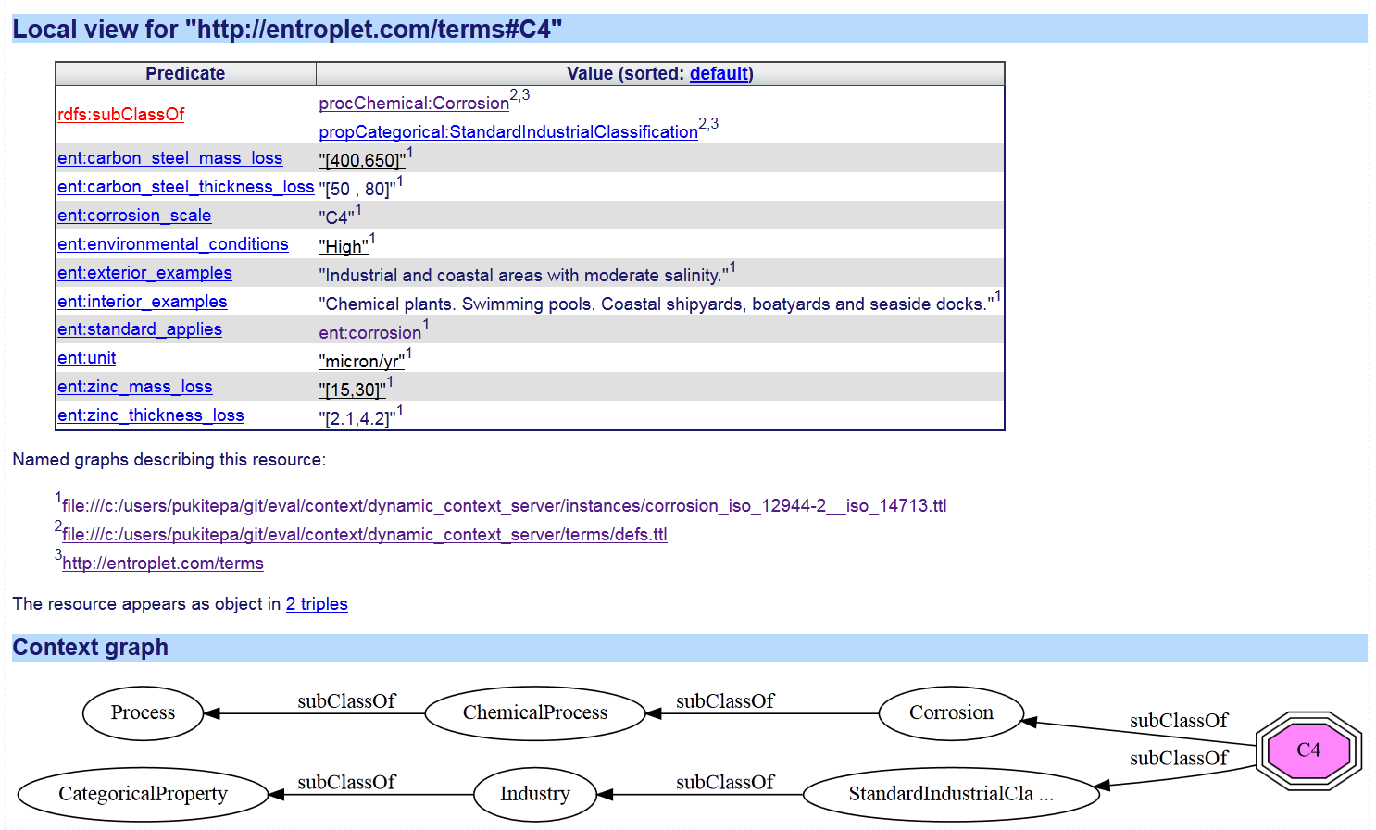

**Figure 26:** Local view of the ent:C4 resource represented as an octagon-shaped node

**To understand how this resource can be used, refer to the corrosion classification table in Figure 27 shown below. This is constructed based information contained in ISO standards** [34][35] **and then converted to triple-store. The semantic rules then enable the generation of the table.**

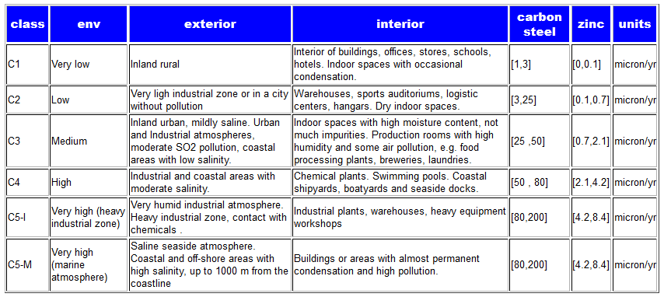

**Figure 27:** Corrosive classification table based on ISO 12944-2 and ISO 14713 constructed from semantic elements

The reasoner itself uses rules and logic that are embedded in run-time loaded modules. A partial list of logic modules is shown in **Figure 28**.

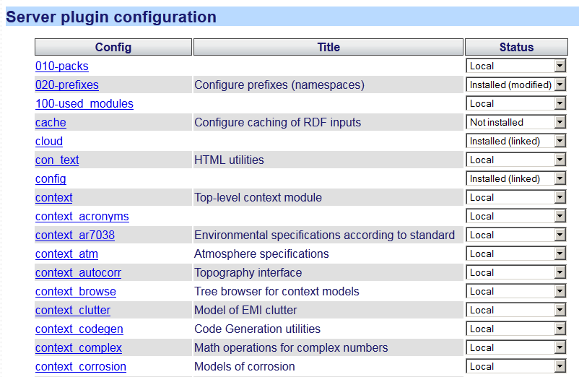

**Figure 28:** The web server Prolog run-time automatically loads all available modules specified by a configuration. These are considered the set of server plug-ins.

The cloud of **Figure 11** uses a manifest of triple-store data-sets. The manifest itself is an RDF list in Turtle format which describes the name and location of each of the triple sets loaded by the server. So the general strategy is to load the logic and data at run-time startup[[234]](#footnote-234).

The consistency of the knowledgebase is automatically tested on load and reload by a unit-test suite, which is equipped to execute whenever module-based changes are made to the knowledgebase,.

The final deployment is targeted for cloud computing, and the server can be accessed at initially an Amazon EC2 server located at <http://entroplet.com>. Statistics of usage are accessed from an administration level, with typical output shown in **Figure 29**.

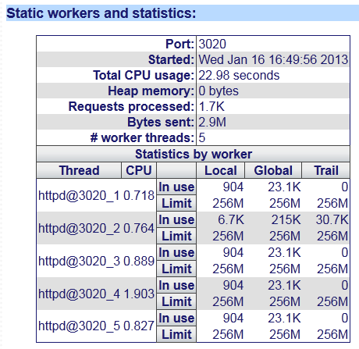

**Figure 29:** Administrative statistical view of server usage.

# Examples of usage

The following are examples of usage for the dynamic context server. These are selected to show a cross-section of capabilities available.

Sea State View

A sea-state model is used to provide a standard quantification for the significant wave height expected or measured for various coastal and inland bodies of water. A sea-state rating follows a scaling system starting at 0 for calm water. The objective and subjective description for a specific sea-state depends on the characteristics of the environment as defined by the World Meteorological Organization specification[36] (see **Figure 30**):

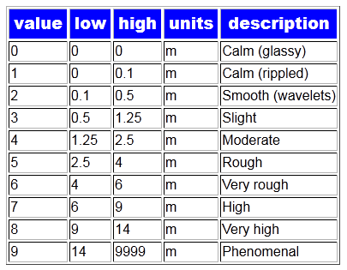

**Figure 30:** Semantically generated chart of sea-stat rating system

The wave elevation cumulative distribution function (CDF) maps to the sea-state for a given region, such that lower sea-state values are more common for smaller and shallower bodies of water. The mapping from sea-states to probabilities over a long term is shown in **Figure 31**.

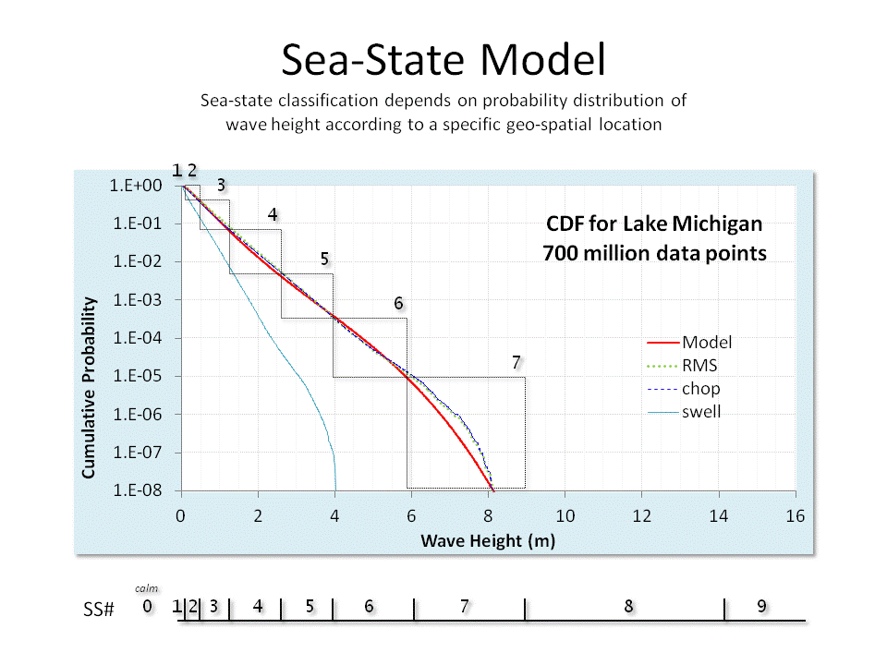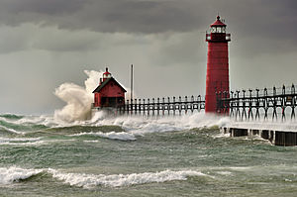

**Figure 31**: Sea-state rating mapped to a CDF culled from several years of Lake Michigan significant wave height data. Sea-state classification depends on probability distribution of wave-height according to a specific geo-spatial location. Sea-states of higher than index 7 have not been observed for this body of water.

To make the sea-state table practical for probability estimates in an interactive setting, we needed to attach the sea-state alignment to a particular region (se **Figure 32**).

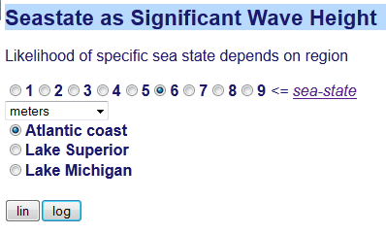

**Figure 32:** Sea-state selection window

If we select a sea-state and the Atlantic coast region with logarithmic scaling, the following cumulative distribution function (CDF) chart results (see **Figure 33**). The reasoner automatically intersects the low and high end of the significant wave height for the sea-state enumeration selected.

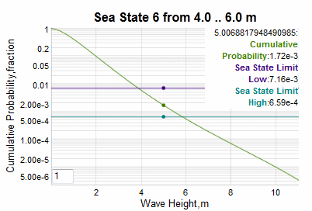

**Figure 33:** Selected interactive sea-state 6 classification for Atlantic coast

In the example chart above, the cumulative probabilities for a sea-state of index 6 are highlighted at the position of the cursor. The lower cumulative is given by the purple line and the upper (rarer) cumulative given by the high-end sea-state value is the bluish-green line.

The ranges depend on a model fit to the historical data culled from the selected aquatic region[2], so to add another region requires only an additional region and parameterized model to the triple-store database.

Obstacles

Not all terrain features have natural origins. We catalogued man-made terrain profiles as *obstacles* and captured and stored their geometric shape as deterministic segments. Most of the obstacle profiles were culled from specifications derived from vehicle test courses[22]. Since these test courses were created specifically for testing vehicles with a parallel wheel-base, we stored the data as double track profiles with a fixed separation between the two tracks.

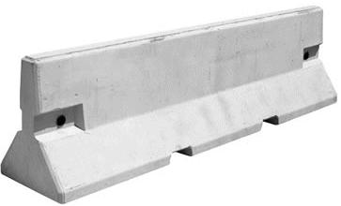 🡪 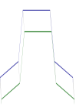

**Figure 34:** Jersey Barrier and two-track deterministic profile shown beside it.

The range of obstacles includes jersey barriers (**Figure 34**), washboard surfaces (**Figure 35**), cross-tie courses (**Figure 36**), half-round bumps, staircases, potholes, and ditches. To get a rough indication of the spatial orientation of a track, a feature for rendering the double tracks as a 3D image is provided. This extrapolates the detailed profile specification as an extruded three-dimensional projection (see **Figure 35**).

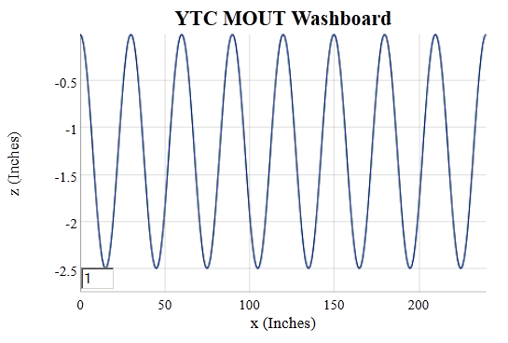

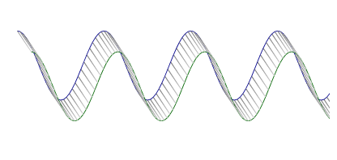

**Figure 35** : Washboard track. Detailed view (above) and 3D view (below).

A workflow was incorporated to guide the choice of obstacle profile data sets (**Figure 36**). In this case a cross-tie course is rendered in a schematic projection, along with the extrapolated 3D view. The green trace is the inside track and blue trace is the outside/far track of what could represent remnants of an old railroad track.

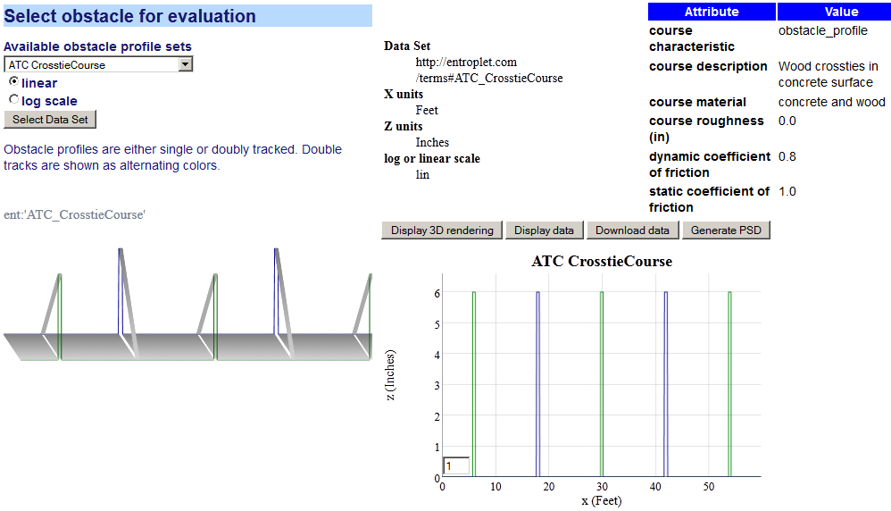

**Figure 36**: Obstacle evaluation workflow showing selection of a cross-tie track.

The deterministic nature of these tracks is evident when one considers that artificial washboards (or periodic cross-ties) as shown above have a defined periodicity while natural washboards created by vehicular traffic (or decomposing and shifting cross-ties) show a disordered range of periodicities. The latter are more suited to descriptions by a semi-Markov model, which is described next.

## Fine-relief Terrain View

We illustrate two complementary approaches to generating terrain profiles based on power spectral densities (PSD).

1. Superposition of randomly phased sine waves to accomplish a pseudo inverse Fourier transform of the PSD. This is essentially a Fourier series reconstruction
2. Fitting a semi-Markov autocorrelation model of random walk to the PSD (via the Weiner-Khinchin theorem [37])

Each approach has benefits and drawbacks

|  |  |
| --- | --- |
| Benefits | * The superposition approach is fast and automatic as it works as a rough heuristic * The semi-Markov autocorrelation function approach is based on stochastic properties of the terrain relief changes so can model properties such as phase and skew[3] |
| **Drawbacks** | * The superposition approach will show a repeat sequence based on the lowest spatial frequency and needs to approximate phase (no asymmetries possible) * The semi-Markov autocorrelation function approach requires a fitting process, and gets the most benefit from prior knowledge in addition to that provided by the PSD.  However, once the models are created, new models can easily be composed from the old ones. |

The terrain profile context models include both variants.

Markov and semi-Markov Processes

The fine-relief profile of natural terrain features can be characterized and modeled effectively by Markov and semi-Markov processes.

Mathematical Markov formulations such as the Ornstein-Uhlenbeck process[38] can model rough random terrain, while semi-Markov processes capture pseudo-random features with emerging periodicities[3]. We provide a workflow to guide the user in evaluating these kinds of models as shown in **Figure 37**.

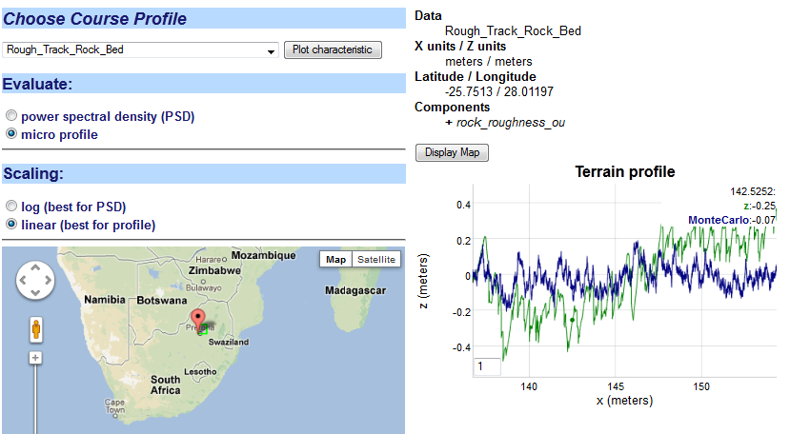

**Figure 37:** Micro profile simulation of a rough track (labeled z) overlaid with a Markovian Ornstein-Uhlenbeck random walk Monte Carlo simulation

To generate a profile, a Monte Carlo simulation draws a sequence of steps from sampling from the Markov or semi-Markov algorithm. This is compared to a profile from a high-resolution terrain taken from the Gerotek vehicle testing course, in this case a rough track rock bed.

For the PSD, the plot consists of two statistically equivalent representations starting from the Markov formulation, and the FFT of the data it is derived from (see **Figure 38** ):

* An analytical expression for the PSD derived stochastic representation
* A windowed FFT of the Monte Carlo profile drawn from the stochastic representation.
* The FFT spectrum of the data.

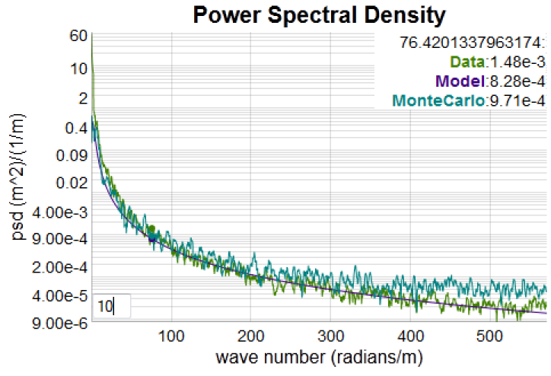

**Figure 38**: PSD of rough road

High-resolution data from CSIR is stored in the database (see the sets labeled GEROTEK and Rough Track) as well as a few other test sets taken from online archives[39].

The FFT can show substantial noise, so we use a moving average filter to reduce the noisy values so that the underlying spectrum is clearly delineated. The graph can be stretched and then filtered to reveal the signal (see **Figure 39**).

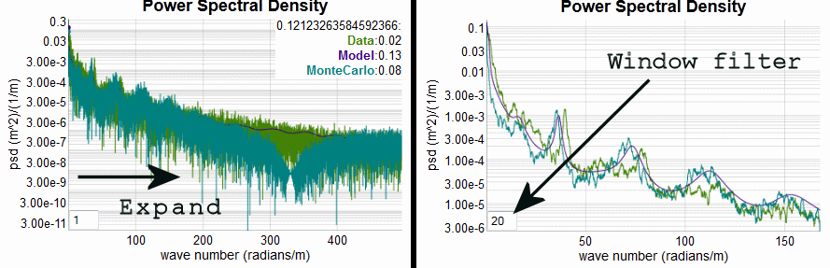

**Figure 39:** Use of interactive filter and drag selection to narrow in on a portion of the frequency spectrum. When the filter is used the underlying fine structure used for fitting is revealed.

The model contains parameters that are stored as a few triples, while the original data is also a triple but one that can contain several thousand data points. The general fitting strategy is shown in **Figure 40** and described in detail elsewhere[3].



**Figure 40** : The typical fitting procedure uses knowledge of the underlying terrain profile (top middle inset, showing a pot-hole course with steps) and a stochastic representation of the PSD (upper right inset) to match the PSD calculated from the data.

We essentially use the PSD to estimate the strength of the periodicity in the underlying terrain features. The sharper and stronger the harmonic peaks are, the stronger the periodicity.

For example, **Figure 41** shows the terrain and model for a corrugated course profile which shows strong periodic features.

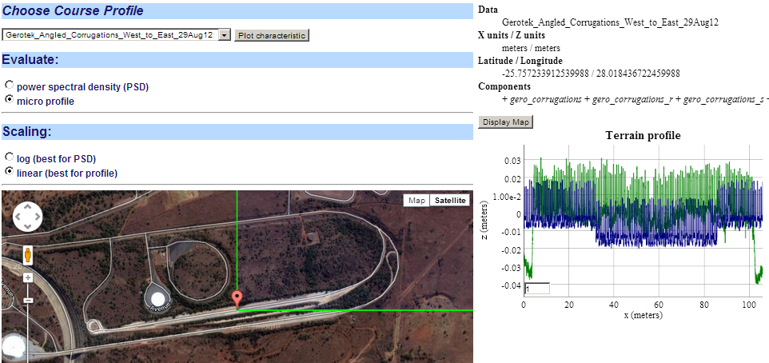

**↓ Map zoomed below**

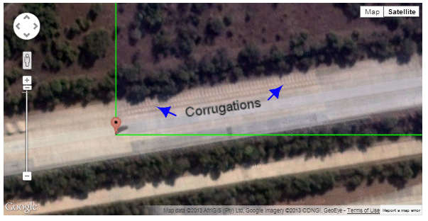

**Figure 41:** Workflow for Gerotek corrugated course. The terrain profile is indexed to a Google Map of that area and we can zoom in and pick up the scale of the highlighted corrugated features.

The following models (**Figure 42**) show a range in periodicities ranging from very strong (corrugated course), to easily detectable but disordered (Belgian block cobblestone course), to weak (random spaced obstacles).



**Figure 42:** Semi-Markov model fits for high-resolution Gerotek courrses. For each terrain, a profile of the actual terrain is shown as the bright green, and the model as the blur. Course (a) is a fairly reguler layout of square bumps. The missing harmonic at 50 radians/m is due to the width of the bump. Course (b) is a worn layout of Belgian block cobblestones, with periodicity emerging from the block spacing according to the PSD. Course (c) is a course with random obstacles and very weak periodicty.

Superposition of Sine approach

This is essentially a Fourier series reconstruction approach based on having only empirical PSD data available.

For each course, identifying characteristics are provided along with a PSD plot of the course profile. The plot is usually attached to an otherwise classified course layout (see **Figure 43**).

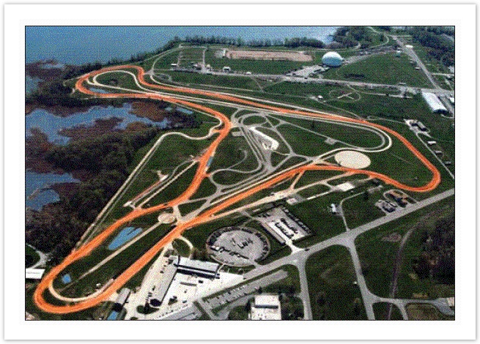

**Figure 43:** TOPS test course

The figure below shows the workflow for selecting from PSD course data (see **Figure 44**).This indexes against an ontologically categorized set of terrain PSD data cataloged from Test Operating Procedures (TOPS)[22]. The data set contains header information necessary to calibrate the scales.

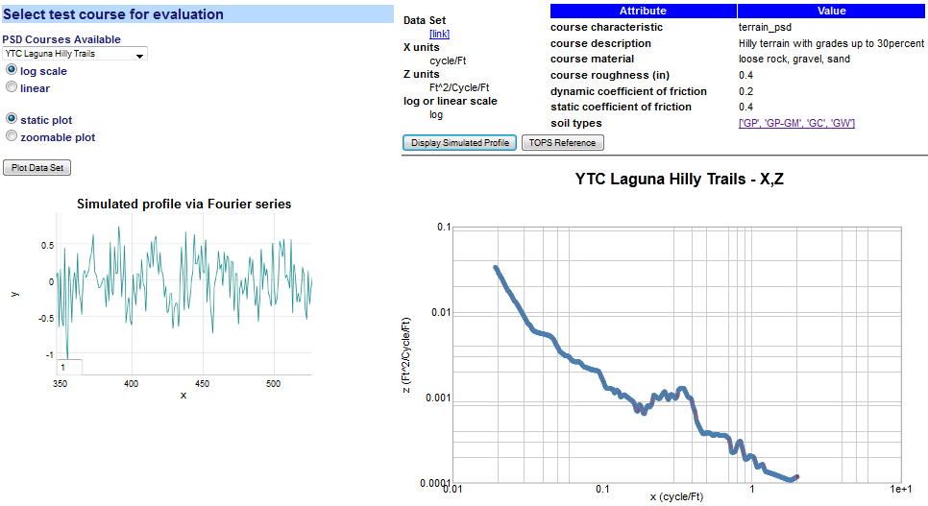

**Figure 44:** PSD workflow example. The PSD data set is selected from a drop-down list. The PSD is plotted on the lower right and a Fourier series reconstruction is displayed on the lower left.  
If soil types are available, they are linked to a soil classification table.

## Gross-Relief Topographic View

Terrain Elevation models marginal probabilities shown on a log scale indicating likelihood of an elevation change given a surface translation.

Terrain is characterized for the lower 48 states according to digital elevation model (DEM) [40][41][42] profiles. The surface translation is limited to 40 post-spacing’s, which corresponds to a range of less than 4000 meters and the elevation change is limited to 20 meters.

Fits for each 1 degree section are generated via a Gauss-Markov model following an Ornstein-Uhlenbeck (O-U) reversion-to-the-mean random walk process. Maximum entropy (MaxEnt) estimation generates uncertainty in the O-U model, which in general gives a better fit to the terrain data sets. (see further Appendix F for an application). For a selected point on the map (**Figure 45**) or the drop-down list of a named section (**Figure 46**), the enclosing 1º DEM quadrangle is analyzed for elevation correlations.

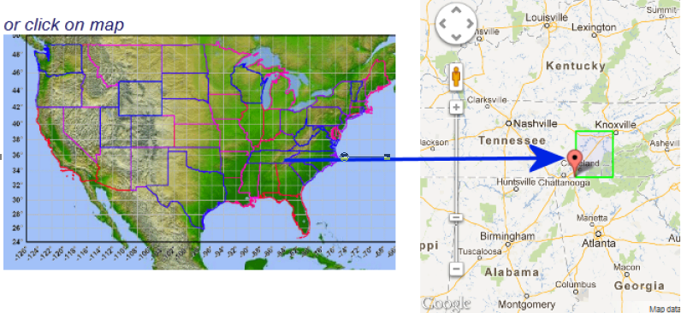

**Figure 45:** Map selection mode pick a 1 degree quadrangle, shown by the green outline on the right.

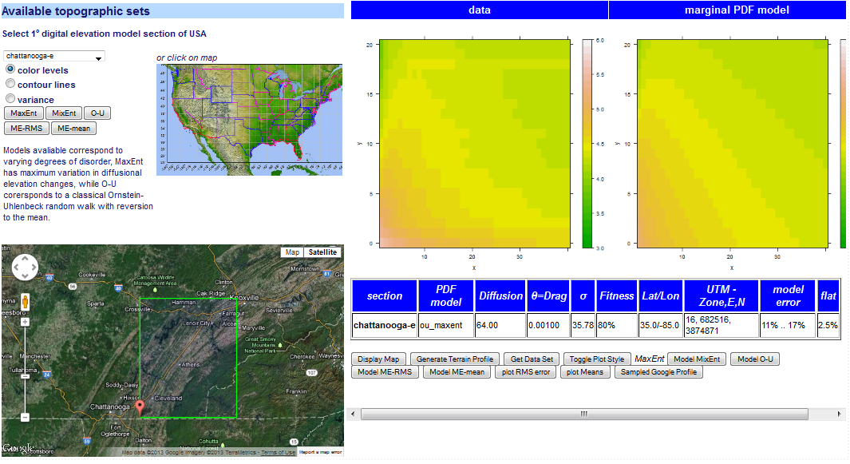

**Figure 46:** Elevation correlations are shown as color contour maps. The model fit is shown in the far right, which should match in levels to the data contour next to it. This is a correlation for the Chattanooga east DEM, shown in the lower left.

As the color contours may be difficult to delineate, a conventional line contour display is available as shown in **Figure 47**. Both types of contours were rendered via calls to the **R** statistics package.

If the model fit for a specific region matches the contour profile with relatively small error, then the model can be used to simulate a typical terrain elevation profile for that section. So the model essentially takes the place of actual contours from the region; for example **Figure 48** (a) is the model and **Figure 48** (b) is a randomly located sample from a Google Map query in that same section.

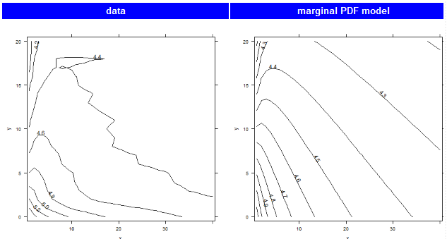

**Figure 47:** Contour plot variation

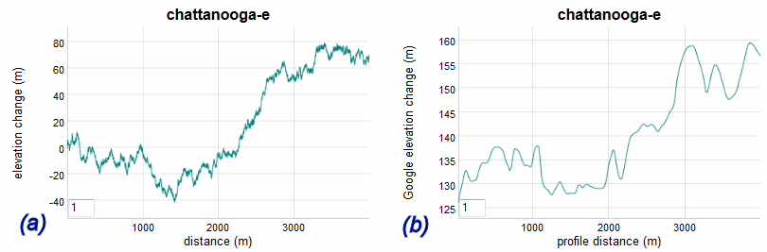

**Figure 48**: The fit to the DEM section via an Ornstein-Uhlenbeck model is translated to a random walk profile of terrain in (a). A sample profile extracted from a Google Map API query is shown in (b).

## Temperature

The characterization of temperature is obviously acutely dependent on geospatial location of the simulation, test, or use case. Although environmental standards handbooks provide nominal characteristics for cold and hot climates [33] (which we cover elsewhere in the ontology), the need often arises for providing temperature models for specific locales.

Seasonal Model

We leveraged linked semantic data from other open sources to demonstrate what is possible with the context server. The site **dbpedia.org** [43] provides average monthly climate data as part of their instance database, and other sites such as Wikipedia already rely on it. For this example, we demonstrate how it is integrated with the dynamic context server.

The server essentially takes two steps in its workflow reasoning. It first requests all available locations with temperature from **dbpedia**, and then once the user selects an available location, the monthly high and low averages are plotted (see **Figure 49**).

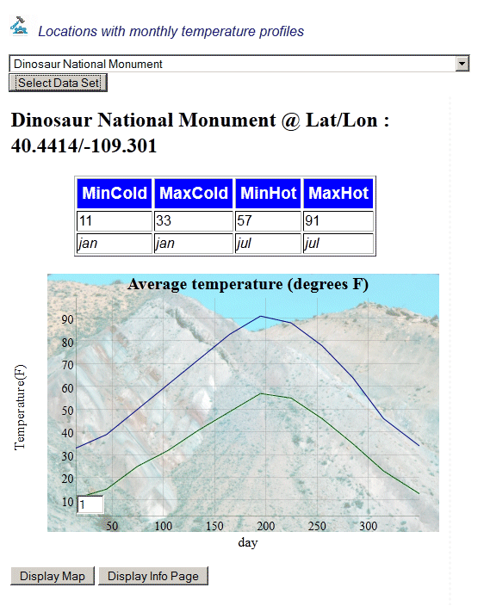

**Figure 49:** Average monthly high and low temperature extremes captured from **dbpedia**. The background image is also supplied as a linked data element to the geospatial location.

Other atmospheric measures are also available depending on whether a specific location (and dbpedia) has the data recorded. In **Figure 50** below, we show average precipitation for a semi-arid location in Oregon.

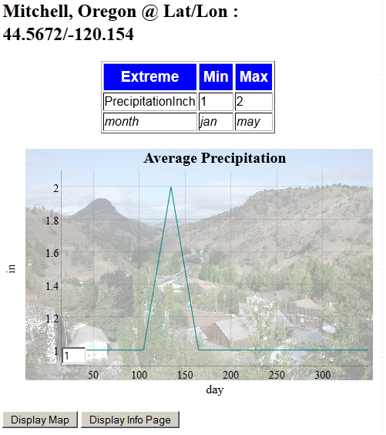

**Figure 50:** Average monthly precipitation of eastern Oregon acquired from **dbpedia**

Diurnal precision model

As part of the AVM project, we learned that context model users requested more temporally-detailed temperature records than were available from **dbpedia**. In particular, diurnal records were requested for Camp Lejeune in North Carolina and also for Aberdeen Proving Ground near Baltimore, Md.

For North Carolina, the closest sites we could find in NOAA national weather service records were the Wilmington and Morehead City sites. These are equally close to Camp Lejeune according to the NWS records (<http://www.erh.noaa.gov/>). This situation points to the hit-and-miss nature of raw non-semantically indexed records. The historical data at the Wilmington location was in a PDF file, so we had to extract the temperature data manually.  The Morehead City page had a slot but no data. Baltimore had a text file which required custom parsing. This is referred to as “unique local data”, and the culling of this data for semantically-aware context usage is part of the knowledge capture process, and which shows why the structured approach of **dbpedia** is so effective.

After extracting the data from the National Weather Service records for these two locations, expected value models were generated to give the “normal” temperature that a weather forecaster would provide for any calendar date and time-of-day (no statistical moments were generated). **Figure 51** shows the diurnal model over a calendar year. The higher resolution mode of the dynamic graph functions by dragging the cursor across a calendar range and then the daily periodic nature becomes obvious.

Some of the non-uniformity in reporting is being addressed by NOAA, and they have recently deployed the U.S. Climate Reference Network to streamline the reporting: <http://www.ncdc.noaa.gov/crn/>

**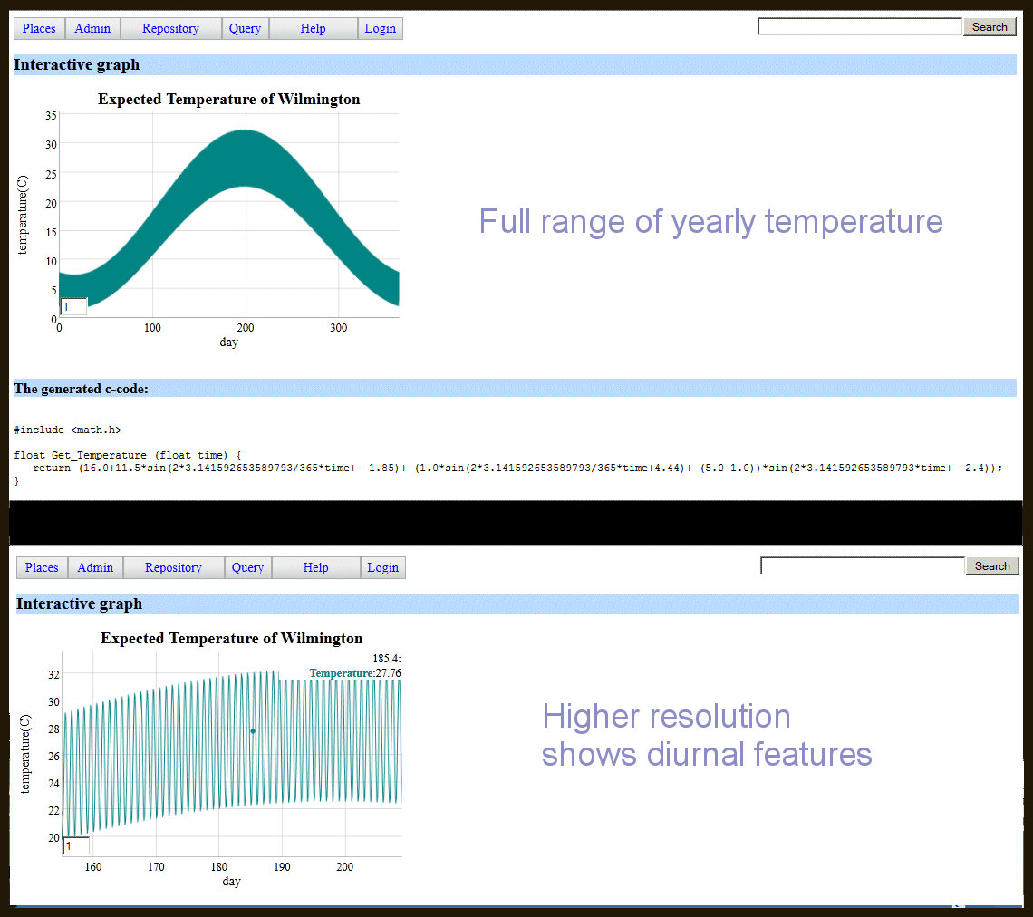**



**Figure 51:** Diurnal temperature model for Wilmington, NC.

As the functional form of the expected diurnal temperature profile is saved in symbolic format, the semantic reasoner can convert that to a source code output. Below is a C-code snippet that uses the triple-store parameterization for a specific location.

#include <math.h>

float Get\_Temperature (float time) {

return (16.0+11.5\*sin(2\*3.141592653589793/365\*time+ -1.85)+ (1.0\*sin(2\*3.141592653589793/365\*time+4.44)+ (5.0-1.0))\*sin(2\*3.141592653589793\*time+ -2.4));

}

The input (time) is in days since the first of the year, so noon on January 1st would be input as 0.5. Noon on the last day of the year is 364.5.

The semantic architecture can potentially apply geospatial reasoning[44] to pull in appropriate data. Indeed, geospatial functionality has found widespread use for inferring locality information. For example, say that temperature statistics are not known for a particular area, but data from nearby locations is available. A geospatial engine can aggregate and select data from weather stations in close proximity and use that to interpolate the statistics.

## Thermal Diffusion

Models of thermal transients follow the boundary conditions set by temperature constraints[4]. As temperature always seeks equilibrium, the boundary conditions will be compliant if large thermal masses added to the environment. This means that the thermal transient will likely asymptotically approach some intermediate value of temperature factored by the ratios of the thermal masses involved.

The model used here applies a thermal diffusion process with a range in uncertainty of the coefficient of diffusivity or conductance.

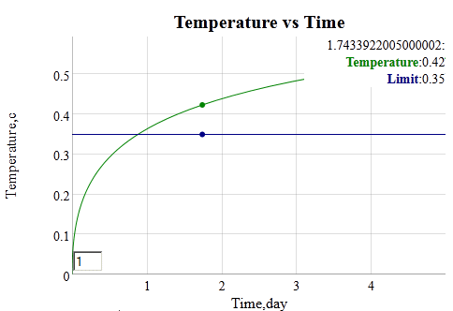

**Figure 52:** Thermal dispersion model assuming uncertainty in the coefficient of thermal conductivity, and a unit step thermal stimulus.

## Corrosion Example

Corrosion of metals is a slow process, accelerated by adverse environmental factors such as high levels of salt and acidity.

|  |  |  |  |  |  |
| --- | --- | --- | --- | --- | --- |
|  | Marine(severe) | Industrial | Marine(mild) | Urban | Rural |
| D | 90,000 | 45,000 | 12,000 | 6,800 | 5,300 |
| X0 | 600 | 400 | 100 | 50 | 500 |
| a | 1.00E-08 | 1.00E-08 | 1.00E-08 | 0.4 | 0.2 |

We apply a diffusional model of corrosion which emulates the temporal profile of the empirical observations while providing an intuitive understanding to the gradual processes involved.[4]

The empirical parameters were taken from a recent study which considered long term corrosive effects in variously categorized environments. **Figure 56**

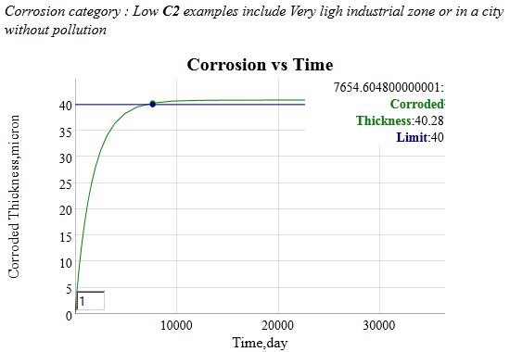

**Figure 56:** Example of a corrosive growth model parameterized from a low pollution site.

## Droplet Size

For particulates, we consider a standard specification of rainfall droplet size from an environmental standard[33].

**Table 10:** From AR 70-38 standard population density against raindrop size

|  |  |  |  |  |  |  |
| --- | --- | --- | --- | --- | --- | --- |
| Drop Diameter Range (mm) | | | | | | |
| density | 0.5 - 1.4 | 1.5 - 2.4 | 2.5 - 3.4 | 3.5 - 4.4 | 4.5 - 5.4 | 5.5 - 6.4 |
| # / m3 | 2626 | 342 | 45 | 6 | 1 | <1 |

The histogram in **Table 2** is an interpolated fit of the drop diameter data to a PDF based on two parameters, a mean droplet size that follows an exponential decline, mixed with a much lower exponential decline probability of a droplet with a higher size. The mix generates the slight knee in the curve shown in **Figure 57**.

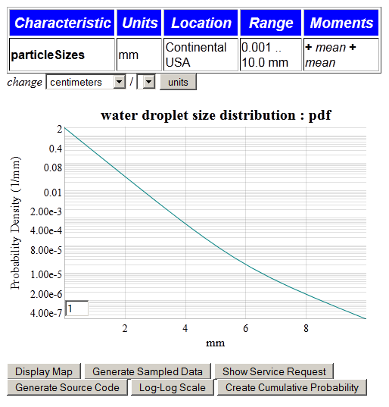

**Figure 57:** PDF of water droplet size distribution

This class of PDFs is indexed via the pattern described in Annex 2: PDF Models.

## Wind

We captured the wind velocity distributions from several regions of the world as a set of parameterized PDFs. The characterized distributions were fit to maximum entropy models as described elsewhere[2].

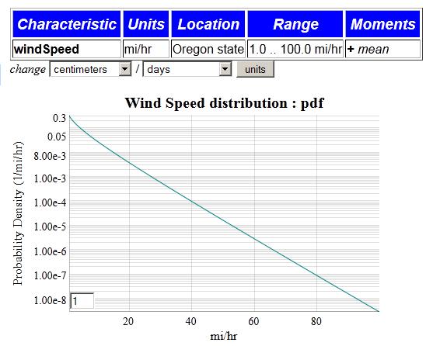

**Figure 58:** Wind speed probability density function for data from the Bonneville Power Authority in Oregon.

**Figure 58** shows the result of choosing a certain region (Oregon’s BPA data set) and then plotting the PDF from a BesselK wind speed distribution. The unit dimensionality rule was attached to allow the user to change the wind speed variate to any ratio of distance/time drawn from the triple-store unit definitions.

A sampling query is also available for drawing values from the PDF of the selected model. The BesselK requires two independent samples from an exponential damped distribution[2].

## Pressure

A set of standard atmospheric [46] profiles is encoded to allow a user to quickly estimate measures such as pressure at different altitudes [47]. A pre-selector for altitude units and altitude specified is used as input to generate the graph shown in **Figure 59**.



**Figure 59:** Pressure for standard atmosphere as a function of altitude.

The standard atmosphere as it relates to altitude, pressure, and temperature has very fundamental derivations with respect to quasi-adiabatic thermodynamic laws and accurate and concise representations are possible for mean values [48].

## Patterns of Usage

All the examples were created from rules operating on semantic triple stores. Many of the examples operated on a standard pattern; for example, the wind speed and rain droplet size used the same PDF generator (see Annex X for a complete list).

For general external use, triple stores that are exposed by the dynamic context server can be accessed via a query language such as SPARQL. For example, the SPARQL expression

select \* where{?s relaSci:hasNumericValue ?o

can be transformed into a web service query by prefixing a “sparql/?query=” to the SPARQL expression. Then the following service call

http://localhost:3020/sparql/?query=select \* where{?s relaSci:hasNumericValue ?o}

will return an XML list of all the triples that contain the predicate : relaSci:hasNumericValue.

So the examples of usage described in this section can get integrated with other semantically-aware languages that can either create web requests as URL expressions or as SPARQL queries. Having some facility with how to read triple-store graphs and construct URLs, a savvy developer can reuse the web services and/or browse through triple-store graphs

http://localhost:3020/browse/list\_graphs

# Summary

The Dynamic Context Server provides models and artifacts as part of a comprehensive environmental modeling library. To maintain the library with the necessary level of organization and categorization, we used the Semantic Web for Earth and Environmental Terminology (SWEET) ontology as a semantic and terminology base. The system was built as an interactive web server that consisted of the DCS with an adjunct model delivery service called Ontological System for Context Artifacts and Resources (OSCAR). OSCAR’s capabilities do not overlap with the DCS capabilities and in fact the two complement each other, with the two views integrated through a conventional web-service front-end.

The physical domain models represent the land, atmosphere, and aquatic realms. These have deterministic and stochastic representations; as an example from the terrain realm, the stochastic terrains characterized by PSD’s and Markov models, and the obstacles as deterministic fixed geometries.

As architected, DCS and OSCAR perform as portals for serving context models and knowledge which can meet the needs of vehicle design and test.

# Annexes

## Annex 1: Browser Narrative

The server supplies an online narrative that describes the library hierarchy of major environmental classifications, **Land, Aquatic, and Atmospheric.**  It is reproduced below.

The **Land** classification consists of all terrestrial models, specifically those attached to solid earth. This includes both natural terrain and man-made obstacles, and anything that deals with the terrestrial surface. Natural terrain is largely stochastic, with elements of determinism mixed in via certain man-assisted or physical processes.

**Terrain** is defined by the vertical and horizontal dimension of land surface. Characteristics of the terrain is usually expressed in terms of the elevation, slope, and orientation of terrain features

The **gross terrain** is also referred to as topography or land relief. The deterministic view of terrain is typically represented by a scaled elevation contour plot of a specific region of land. The stochastic view is represented by models of the topography, which is often cast in terms of a random walk process.

The **slope** of the terrain is characterized by the empirically measured rise/run of the local surface area. It is also known as the grade or pitch. By orientating perpendicular to the maximum slope, a pitch characterization becomes a roll characterization. 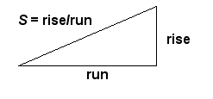In general, natural terrains show greater variation in slopes than do man-made features, such as roads or rail-road tracks, which will show signs of grading and switchbacks or other grade limitations.

A characterization of terrain **elevations** is usually correlated against a geospatial surface dimension. Analyzing pair correlations between elevations separated by a lateral surface dimension allow models of regional topography to be made. By using stochastic models of the terrain with well-characterized probability distributions, one can use that as an input or constraining stimulus for navigability and formal verification.

Characterization of **fine terrain** requires a scale much less than the topography or land relief of the local region. To remove this macroscopic effect of large scale elevation and slope changes, data is often detrended to reveal only the fine detail.

The fine terrain **roughness** is characterized by a pair correlation function and the frequency representation known as the power spectral density. The typical terrain roughness may follow a random enough pattern so that the information contained in a correlation function or PSD is enough to reveal the stochastic nature of the ground.

Oftentimes the fine terrain **profile** shows enough regularity that the addition of non-randomness to the model becomes effective in reproducing the spectral properties. Fine terrain with elements of randomness can include washboard surface and cobblestone roads. Individual profiles are often referenced for further evaluation and usually referred to as test tracks or courses when used in the context of vehicle evaluation. A stochastic model of the terrain, if it is characterized fully, can reduce the storage data requirements by orders of magnitude, leaving a few parameters to describe a specific course profile.

Discrete **obstacles** are always characterized by a geometrically defined spatial profile.

**Soil** classification schemes simplify the cataloguing of the variety of naturally occurring soils into a handful of types according to a few properties such as granularity.

The **aquatic** classification consists of all ocean and inland water models, and specifically those dealing with the surface characterization of a particular body of water. This can include wave height, lake sizes, and river current speed.

The **sea state** of the water surface at a specific location and time qualifies its general conditions by categorizing according to wave height and other related characteristics such as period and power spectrum. Higher sea-states correspond to rougher conditions, with zero indicating calm waters. 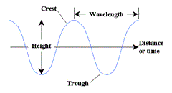

By empirically measuring the historical **wave height** in a specific location and attaching probabilities to the occurrence of various wave heights, we can generate the probability of encountering a particular sea state.

The **wave frequency** is closely related to wave height and wave frequency by a dispersion relationship. Because of the common hydrodynamic properties of water, it is often enough to consider only wave heights when inferring the frequency and wavelength of water.

The distribution of **lake sizes** and **stream currents** has a stochastic explanation, and models of these distributions can fit to empirically collected statistics.

Characterizing **water density** allows for the effects of buoyancy to be determined. Both temperature and salinity can subtly affect the density of water.

The category of **atmospheric** models contains phenomenon that relate insofar as they propagate through the air.

The variation of **wind speed** in specific geographic locations is predominantly a stochastic phenomenon. The general trend is of decreasing likelihood of wind speeds with increasing magnitude.

**Precipitation** in the form of rain and snow varies according to geographic location and season. Models of rainfall are available, as are environmental standards which give nominal conditions for certain regions and climates.

The statistics of **rainfall amount** has a foundation in extreme value theory, yet the commonly occurring measured rainfalls follow distribution functions that can be modeled.

Based on recently accumulated data, the areal extent of **clouds** has been shown to follow a simple stochastic model.

The modeling of atmospheric **temperature** has a lower spread in relative uncertainty than other environmental contexts. This has much to do with the large thermal inertia of the planet and of the predictably of diurnal and seasonal change. Thus, models of temperature are better suited to description by a mean value and small *relative* (on the Kelvin scale)

The model of **solar** insolation is deterministically predictable, abated only by sporadic cloud cover.

The diurnal or **daily and seasonal** temperature variations can be captured for specific geospatial locations and modeled over the course of a full year, including a moving average for the 24-hour period. In terms of nominal conditions, representative regions can be defined as "hot" to "extreme cold" and typical mean values can be generated to cover the expected values.

Models of transient response to **thermal** steady-state require compliance between the system under study and the environment. In general terms, this means that the system can influence the environment enough to affect the dynamics and the eventual steady-state point (if one exists).

The **humidity** of a particular region is given by nominal conditions. Since humidity only plays a contextual role over a long term, in say promoting corrosion, the nominal values are adequate. Therefore, environmental standards serve as better defining documents than models based on empirical data for a specific location.

Airborne **particulates** can show persistent or transient effects. After significant natural events such as the eruption of volcanoes, the density and size of particulates can increase rapidly. Otherwise, a heterogeneous mix of particles from different origins describes the typical distribution.

Airborne particulates can thus show great diversity in **particle size**. If the particles can grow over time, such as ice crystals, the steady-state distribution in parts reflects where the particle is in with respect to its life cycle. The same process occurs with suspended water-borne particulates.

Airborne particulates show ranges in **particle density** usually depending on the transient event.

Background noise from the environment is referred to as **clutter**

Radio and radar transmitters can present very high levels of energy and electromagnetic field strength to a system and the equipment and subsystems it contains. This type of environment is referred to as the external **Radio Frequency (RF) Electromagnetic Environment (EME)**. RF EME is described in terms of field strength as a function of frequency.

An **electromagnetic pulse** is a rare occurrence of either natural or man-made origin. One variation of this is high power high power microwave which can be a single pulse or transmitted as a repetitive waveform.

**Lightning effects** can be either direct or indirect. The direct effects refers to the situation were the lightning channel couples to the system, whereas indirect refers to situations where the lightning is observed only remotely through sound, flashes, vibration, or interference.

Static electricity can interact with the environment to create an **electrostatic discharge**

A vehicle can also generate **internal sources of EM energy**, which by way of proximity can interfere with objects in the environment.

## Annex 2: PDF Models

The set of PDF models follow a pattern of a variate with parameters that allow us to collect all of the information as triple-stores.

PDF mapdot K\*f(A,B,C) ~> X

What this does is apply a lambda function with scaling factor K and fixed parameters A,B,C to a variate list X ranging from Min to Max (with a step interval). The entire list is shown in **Figure 64**.

|  |  |  |  |  |  |  |  |  |  |  |
| --- | --- | --- | --- | --- | --- | --- | --- | --- | --- | --- |
| Characteristic | Model | Title | Xaxis | Location | Lat/Lon | PDF | Moments | Max | Min | Interval |
| cloudArea | [Ocean\_clouds](http://localhost:3020/context_model/apply?loglog=false&model=Ocean_clouds) | cloud diameter distribution | m | Pacific near Hawaii | 17.5/-162.5 | 1.0\*power\_law\_2(0.1,Dist) | [median] | 100000.0 | 1.0 | 1.1 |
| clutterPower | [Variable\_clutter](http://localhost:3020/context_model/apply?loglog=false&model=Variable_clutter) | clutter power distribution Rayleigh | w/m^2 | The World | 0.0/0.0 | 1.0\*exp(1.0,Dist) | [mean] | 10.0 | 0.01 | 1.1 |
| clutterPower | [Variable\_clutter\_maxent](http://localhost:3020/context_model/apply?loglog=false&model=Variable_clutter_maxent) | clutter power distribution MaxEnt | w/m^2 | The World | 0.0/0.0 | 1.0\*besselk0\_sqrt(1.0,Dist) | [mean] | 10.0 | 0.01 | 1.1 |
| lakeSize | [Amazon\_lakes](http://localhost:3020/context_model/apply?loglog=false&model=Amazon_lakes) | lake size distribution | km^2 | Amazon region | -5.0/-60.0 | 1.0\*power\_law\_2(0.19,Dist) | [median] | 1000.0 | 0.01 | 1.05 |
| lakeSize | [Canadian\_lakes](http://localhost:3020/context_model/apply?loglog=false&model=Canadian_lakes) | lake size distribution | km^2 | Northern Quebec | 54.0/-75.0 | 1.0\*power\_law\_2(0.1,Dist) | [median] | 1000.0 | 0.1 | 1.05 |
| particleSizes | [ice\_particles](http://localhost:3020/context_model/apply?loglog=false&model=ice_particles) | ice particle size distribution | micron | Continental USA | 38.0/-100.0 | [0.995\*power\_law\_2\_area(3.0,Dist), 0.005\*exp\_area(3000.0,Dist)] | [[median], [mean]] | 10000.0 | 1.0 | 1.1 |
| particleSizes | [particles](http://localhost:3020/context_model/apply?loglog=false&model=particles) | particle size distribution | nm | A Volcanic area | 63.0/-16.0 | [0.5\*exp(3.0,Dist), 0.5\*exp(0.1,Dist)] | [[mean], [mean]] | 10.0 | 0.001 | 1.1 |
| particleSizes | [rain\_drops\_standard](http://localhost:3020/context_model/apply?loglog=false&model=rain_drops_standard) | water droplet size distribution | mm | Continental USA | 38.0/-100.0 | [0.9951\*exp(0.489,Dist), 0.0049\*exp(0.996,Dist)] | [[mean], [mean]] | 10.0 | 0.001 | 1.1 |
| rainfall | [Iowa\_rainfall](http://localhost:3020/context_model/apply?loglog=false&model=Iowa_rainfall) | Rainfall Distribution | mm/hr | Iowa state | 41.658/-91.548 | 1.0\*besselk0\_sqrt(2.29,Dist) | [mean] | 100.0 | 0.001 | 1.05 |
| rateNumber | [lightning\_rate](http://localhost:3020/context_model/apply?loglog=false&model=lightning_rate) | lightning rate distribution | num/min | Continental USA | 38.0/-100.0 | 1.0\*diffusion\_accel(16,5.5,Dist) | [[diff], [accel]] | 100.0 | 0.1 | 1.1 |
| slopes | [CONUS\_slopes](http://localhost:3020/context_model/apply?loglog=false&model=CONUS_slopes) | Slope Distribution | rise/run | Continental USA | 38.0/-100.0 | 1.0\*besselk0\_sqrt(0.037,Dist) | [mean] | 10.0 | 0.01 | 1.05 |
| waveFrequency | [San\_Diego\_waves](http://localhost:3020/context_model/apply?loglog=false&model=San_Diego_waves) | Wave frequency Distribution | hz | Point Loma South | 32.67/-117.2419 | 1.0\*pierson\_moskowitz(0.085,Dist) | [mean] | 0.6 | 0.05 | 1.01 |
| waveFrequency | [San\_Diego\_waves](http://localhost:3020/context_model/apply?loglog=false&model=San_Diego_waves) | Wave frequency Distribution | hz | San Nicolas Island North | 32.25/-119.5 | 1.0\*pierson\_moskowitz(0.085,Dist) | [mean] | 0.6 | 0.05 | 1.01 |
| waveHeight | [Atlantic\_seaboard\_waves](http://localhost:3020/context_model/apply?loglog=false&model=Atlantic_seaboard_waves) | Wave height Distribution | m | Atlantic area | 35.0/-75.0 | 1.0\*bessel\_seastate(1,0.81,26.0,Dist) | [mean, depth] | 16.0 | 0.001 | 1.05 |
| waveHeight | [Michigan\_waves](http://localhost:3020/context_model/apply?loglog=false&model=Michigan_waves) | Wave height Distribution | m | Lake Michigan | 43.0/-87.0 | 1.0\*bessel\_seastate(0,0.56,12.5,Dist) | [mean, depth] | 10.0 | 0.001 | 1.05 |
| waveHeight | [Superior\_waves](http://localhost:3020/context_model/apply?loglog=false&model=Superior_waves) | Wave height Distribution | m | Lake Superior | 49.0/-90.0 | 1.0\*bessel\_seastate(0,0.85,16.0,Dist) | [mean, depth] | 12.0 | 0.001 | 1.05 |
| windSpeed | [Germany\_wind\_energy](http://localhost:3020/context_model/apply?loglog=false&model=Germany_wind_energy) | Wind Energy distribution | MW-Hr | Germany | 49.0/9.0 | 1.0\*exp(1737,Dist) | [mean] | 10000.0 | 1.0 | 1.05 |
| windSpeed | [Ontario\_wind\_energy](http://localhost:3020/context_model/apply?loglog=false&model=Ontario_wind_energy) | Wind Energy distribution | MW-Hr | Ontario | 52.0/-82.0 | 1.0\*exp(178,Dist) | [mean] | 1000.0 | 1.0 | 1.05 |
| windSpeed | [Oregon\_wind\_energy](http://localhost:3020/context_model/apply?loglog=false&model=Oregon_wind_energy) | Wind Speed as Energy distribution | MPH^2 | Oregon state | 43.0/-121.0 | 1.0\*besselk0\_sqrt(144,Dist) | [mean] | 10000.0 | 1.0 | 1.1 |
| windSpeed | [Oregon\_wind\_speed](http://localhost:3020/context_model/apply?loglog=false&model=Oregon_wind_speed) | Wind Speed distribution | mi/hr | Oregon state | 43.0/-121.0 | 1.0\*besselk0(12,Dist) | [mean] | 100.0 | 1.0 | 1.05 |

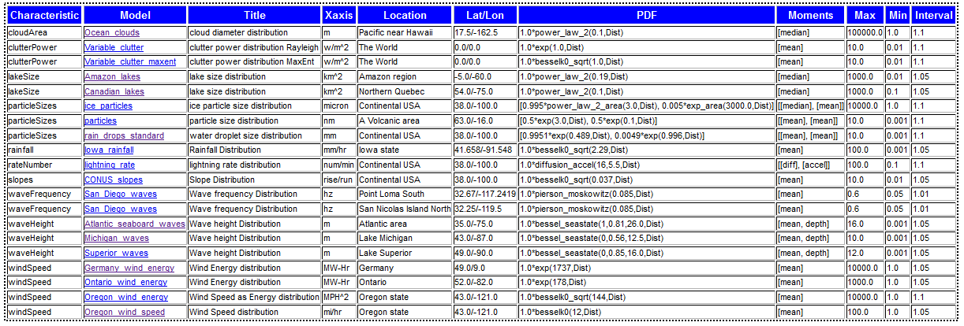

**Figure 64:** Listing of available PDF models, with compact served HTML table shown below it

## Annex 4 : Units

We have collected several standard properties and constants as categorized triple-stores.

### Standard Atmosphere properties

|  |  |
| --- | --- |
| Attribute | Value |
| Name | standardAtmosphere |
| Comment | standard temperature and pressure (STP) |
| Description | Specification of standard atmosphere |
| dryAdiabaticLapseRate | 9.8\*c/km |
| dryAdiabaticPressureHead | -0.116\*km |
| moistAdiabaticLapseRateTypical | 5.0\*c/km |
| molecularWeight | 28.966\*au |
| Pressure | 1.0\*atm |
| seaLevel | 0.0\*km |
| specificGasConstantDryAir | 287\*j/kg/k |
| specificGasConstantWaterVapor | 462\*j/kg/k |
| specificHeatRatio | 1.4 |
| Temperature | 70\*f |
| temperature | 273.15\*k |

### Water properties

|  |  |
| --- | --- |
| Attribute | Value |
| name | water |
| comment | fresh water properties |
| deltaHvap | 9717.1\*cal |
| deltaSvap | 26.04\*cal/k |
| molecular\_weight | 18.015268\*au |

### Solar

|  |  |
| --- | --- |
| Attribute | Value |
| name | solar |
| comment | average sunshine |
| averageAlbedo | 0.31 |
| averageSolarInsolation | 1366\*w/m^2 |

### Physical Constants

|  |  |
| --- | --- |
| Attribute | Value |
| name | physicalConstants |
| comment | commonly used physical constants |
| atomicUnit | 1.66053886e-24\*g |
| avogadrosNumber | 6.02214129e**+**23\*n |
| boltzmannConstant | 1.38065e-23\*j/k |
| dielectricConstant | 8.854187e-12\*fd/m |
| electricalCharge | 1.60218e-19\*coulombs |
| faradaysConstant | 96485.3383\*coulombs/mol |
| gasConstant | 8.314472\*j/k/mol |
| gasConstant | 1.9858775\*cal/k/mol |
| gravity | 9.80665\*m/s^2 |
| gravity | 32.174049\*ft/s^2 |
| planckConstant | 6.62607e-34\*j\*s |
| speedLight | 300000000.0\*m/s |
| stefanBoltzmann | 5.670373e-8\*w/m^2/k^4 |

### Units suitable for conversion

|  |  |
| --- | --- |
| Attribute | Value |
| All Units | symbolic |
| area | ft^2 |
| area | m^2 |
| density | g/cm^3 |
| density | kg/dm^3 |
| density | kg/m^3 |
| density | lb/ft^3 |
| density | mg/micron^3 |
| density | oz/in^3 |
| density | ton/km^3 |
| dimensionless | percent |
| length | cm |
| length | ft |
| length | in |
| length | kft |
| length | km |
| length | m |
| length | micron |
| length | mi |
| length | mil |
| length | mm |
| length | nm |
| length | yd |
| mass | kg |
| mass | lb |
| pressure | atm |
| pressure | bar |
| pressure | millibar |
| pressure | mpa |
| pressure | mtorr |
| pressure | pa |
| pressure | psi |
| pressure | torr |
| temperature | c |
| temperature | f |
| temperature | k |
| temperature | r |
| time | day |
| time | decade |
| time | hr |
| time | mics |
| time | min |
| time | s |
| time | yr |
| volume | cm^3 |
| volume | m^3 |

## Annex 5 : Table of Acronyms

|  |  |
| --- | --- |
| AC | Autocorrelation |
| ACF | Autocorrelation Function |
| APG | Aberdeen Proving Grounds |
| ATC | Aberdeen Test Center |
| BPA | Bonneville Power Administration |
| BesselK | Modified Bessel Function of the Second Kind |
| C2M2L | Component,Context,Manufacturing Model Library |
| CDF | Cumulative Distribution Function |
| CONUS | Continental United States region |
| CRG | Curved Regular Grid format for terrain description from OpenCRG |
| CSIR | Council for Scientific and Industrial Research (South Africa) |
| CSV | Comma-Separated Values |
| DCG | Definite Clause Grammar (what renders this text) |
| DCS | Dynamic Context Server |
| DEM | Digital Elevation Model for mapping |
| DOI | Department of the Interior |
| DSL | Domain Specific Language |
| E-M | Electro-Magnetic |
| EME | Electro-Magnetic Environment |
| EMI | Electro-Magnetic Interference |
| EMP | Electro-Magnetic Pulse |
| FFT | Fast Fourier Transform |
| FMI | Functional Mockup Interface |
| FMU | Functional Mockup Unit |
| FP | Fokker-Planck |
| FT | Fourier Transform |
| GIS | Geographic Information Systems |
| GPS | Global Positioning System |
| GW | Gravity Wave |
| HTML | hypertext markup language (what you are reading right now!) |
| JPL | Jet Propulsion Laboratory |
| JSON | JavaScript Object Notation |
| LL | log-log scale |
| MC | Monte Carlo random number simulation |
| ME | Maximum Entropy |
| MaxEnt | Maximum Entropy |
| NASA | National Aeronautics and Space Administration |
| O-U | Ornstein-Uhlenbeck random walk process model |
| OSCAR | Ontological System for Context Artifacts and Resources |
| OWL | Web Ontology Language |
| PCC | Probabilistic Certificate of Correctness |
| PDF | Probability Density Function (for documentation see Portable Data Format) |
| PSD | Power Spectral Density or Particle Size Distribution depending on context |
| RDF | Resource Description Format |
| RF | Radio Frequency |
| RMS | Root Mean Square |
| SWEET | Semantic Web for Earth and Environmental Terminology |
| SWH | Significant Wave Height |
| SoS | Superposition of Sine waves |
| TOPS | Test Operating Procedures |
| TTL | Turtle Triple-Store format |
| URL | Universal Resource Locator |
| USGS | US geological Survey |
| XML | Extensible Markup Language |
| YPG | Yuma Proving Grounds |
| YTC | Yuma Test Center |

## CHAPTER 25 Conclusion

“The result of any transformation imposed on the experimental data shall incorporate and be consistent with all relevant data and be maximally noncommittal with regard to unavailable data”

— The First Principle of Data Reduction (due to Ables in 1974 after Burg).

## BIBLIOGRAPHY

[1] P. Pukite, S. Iyer, and G. Scilla, “Ion beam enhanced diffusion of B during Si molecular beam epitaxy,” *Appl. Phys. Lett.*, vol. 54, no. 10, pp. 916–918, 1989.

[2] M. Waechter, F. Riess, H. Kantz, and J. Peinke, “Stochastic analysis of surface roughness -,” *EPL Europhys. Lett.*, vol. 64, no. 5, p. 579, 2003.

[3] R. H. Stewart, *Introduction to physical oceanography*. A & M University, 2003.

[4] A. Leon-Garcia, *Probability, Statistics, and Random Processes for Electrical Engineering*. Prentice Hall, 1994.

[5] D. Mumford and A. Desolneux, *Pattern Theory: The Stochastic Analysis Of Real-World Signals*. A K Peters, Ltd., 2010.

[6] P. R. Pukite and J. Pukite, “Digital signal processors for computation intensive statistics and simulation,” *SIGSIM Simul Dig*, vol. 21, no. 2, pp. 20–29, Dec. 1990.

[7] P. R. Pukite, *The Oil Conundrum: Vol. 1 Decline, Vol. 2 Renewal*, vol. 1,2, 2 vols. Daina, 2011.

[8] K. Chowdary, “Distinguising and Integrating Aleatoric and Epistemic Variation in UQ,” Brown University, 2011.

[9] E. T. Jaynes and G. L. Bretthorst, *Probability theory: the logic of science*. Cambridge Univ Pr, 2003.

[10] C. Beck, “Generalized statistical mechanics for superstatistical systems,” *Philos. Trans. R. Soc. Math. Phys. Eng. Sci.*, vol. 369, no. 1935, pp. 453–465, Dec. 2010.

[11] P. R. Pukite and C. L. Berman, “Defect cluster analysis for wafer-scale integration,” *Semicond. Manuf. IEEE Trans. On*, vol. 3, no. 3, pp. 128–135, 1990.

[12] P. Pukite and S. Bankes, “Entropic Complexity Measured in Context Switching,” in *Applications of Digital Siignal Processing*, vol. 17, InTech, 2011.

[13] P. R. Pukite, C. S. Lent, and P. I. Cohen, “Diffraction from stepped surfaces:: II. Arbitrary terrace distributions,” *Surf. Sci.*, vol. 161, no. 1, pp. 39–68, 1985.

[14] C. M. Becker, “Profiling of rough terrain.” University of Pretoria, 2008.

[15] P. H. Cronje and P. S. Els, “Improving off-road vehicle handling using an active anti-roll bar,” *J. Terramechanics*, vol. 47, no. 3, pp. 179–189, 2010.

[16] OpenCRG, “OpenCRG Homepage.” [Online]. Available: http://www.opencrg.org/. [Accessed: 26-Mar-2012].

[17] F. Behroozi and A. Perkins, “Direct measurement of the dispersion relation of capillary waves by laser interferometry,” *Am. J. Phys.*, vol. 74, p. 957, 2006.

[18] E. Falcon and C. Laroche, “Observation of depth-induced properties in wave turbulence on the surface of a fluid,” *EPL Europhys. Lett.*, vol. 95, p. 34003, 2011.

[19] Wikipedia, “Cnoidal wave - Wikipedia, the free encyclopedia.” [Online]. Available: http://en.wikipedia.org/wiki/Cnoidal\_wave. [Accessed: 31-Jan-2013].

[20] P. R. Pukite, *Reflection High Energy Electron Diffraction Studies of Interface Formation*. University of Minnesota, 1988.

[21] Patrick Holmes, PhD, “A Course in Coastal Defense Systems I Chapter 5 Coastal Processes: Waves,” *CDCM Professional Training Programme, 2001*. [Online]. Available: http://www.oas.org/cdcm\_train/courses/course21/chap\_05.pdf. [Accessed: 24-Apr-2012].

[22] FormSys, “Wave Spectra.” [Online]. Available: http://www.formsys.com/extras/FDS/webhelp/seakeeper/wave\_spectra1.htm. [Accessed: 24-Apr-2012].

[23] Huang, T.; Alarcon, C.; Bingham, A.; Henderson, M. L.; Kessling, M.; Takagi, A.; Thompson, C. K, “NASA ADS: Data-Driven Oceanographic Web Portal.” [Online]. Available: http://adsabs.harvard.edu/abs/2010AGUFMIN23A1350H. [Accessed: 12-Apr-2012].

[24] CDIP, “CDIP Homepage.” [Online]. Available: http://cdip.ucsd.edu/?units=metric&tz=UTC&pub=public&map\_stati=1,2,3. [Accessed: 24-Apr-2012].

[25] T. S. Rhee, P. D. Nightingale, D. K. Woolf, G. Caulliez, P. Bowyer, and M. O. Andreae, “Influence of energetic wind and waves on gas transfer in a large wind–wave tunnel facility,” *J Geophys Res*, vol. 112, no. C5, p. C05027, May 2007.

[26] F. Feddersen and F. Veron, “Wind effects on shoaling wave shape,” *J. Phys. Oceanogr.*, vol. 35, no. 7, pp. 1223–1228, 2005.

[27] W. B. Wright, R. Budakian, D. J. Pine, and S. J. Putterman, “Imaging of Intermittency in Ripple-Wave Turbulence,” *Science*, vol. 278, no. 5343, pp. 1609–1612, Nov. 1997.

[28] D. Ning, J. Zang, S. Liu, R. Eatock Taylor, B. Teng, and P. Taylor, “Free-surface evolution and wave kinematics for nonlinear uni-directional focused wave groups,” *Ocean Eng.*, vol. 36, no. 15, pp. 1226–1243, 2009.

[29] BTRC, “BTRC Track Features.” [Online]. Available: http://www.vss.psu.edu/BTRC/btrc\_track\_features.htm. [Accessed: 24-Apr-2012].

[30] E. E. Fitch, “Durability Analysis Method for Nontationary Random Vibration,” MIT, 1996.

[31] Automotive Directorate, “Test Operations Procedure (TOP) 1-1-010 Vehicle Test Course Severity (Surface Roughness),” ATEC, Aberdeen Proving Ground, MD, Final TOP 1-1-010, 2006.

[32] G. F. Sievert, “Effects of stabilizer bars on road vehicle ride quality,” Rice, 1994.

[33] C. Becker and P. S. Els, “GEROTEK data from CSIR for C2M2L program.” .

[34] B. Lindner, “A Brief Introduction to Some Simple Stochastic Processes,” *Stoch. Methods Neurosci.*, p. 1, 2009.

[35] L. Li, C. Sandu, and Society of Automotive Engineers, *Modeling and Simulation of 2D ARMA Terrain Models for Vehicle Dynamics Applications*. Society of Automotive Engineers, 2007.

[36] S. Wagner and J. B. Ferris, “Developing compact autoregressive characterisations of terrain topology profiles,” *Int. J. Veh. Syst. Model. Test.*, vol. 7, no. 1, pp. 12–25, 2012.

[37] J. E. Alexander, “Synthesis of a PSD Compatible Acceleration Time-History,” *Submitt. Shock Vib. Symp. Novemb. 5-9 2012*.

[38] A. Steinwoff and W. H. Connon III, “Limitations of the Fourier transform for describing test course profiles,” *Sound Vib.*, vol. 39, no. 2, pp. 12–17, 2005.

[39] J. Tessendorf, “Simulating ocean water,” *Simulating Nat. Realistic Interact. Tech. SIGGRAPH*, 2001.

[40] L. Romero and W. K. Melville, “Spatial Statistics of the Sea Surface in Fetch-Limited Conditions,” *J. Phys. Oceanogr.*, 2011.

[41] Jonathan Cameron, Abhi Jain, Terry Huntsberger, Garett Sohl, and Rudranarayan Mukherjee, “Vehicle-Terrain Interaction Modeling and Validation for Planetary Rovers,” NASA JPL, Dartslab, JPL Publication 10-15, 2009.

[42] M. Denny, “Introduction to importance sampling in rare-event simulations,” *Eur. J. Phys.*, vol. 22, p. 403, 2001.

1. See the “greedy algorithm” for how a constant demand is modeled. [↑](#footnote-ref-1)
2. Or water over the dam. I don’t know which fits the situation better. [↑](#footnote-ref-2)
3. Excepting those in the UK and Norway which have well-organized reporting mechanisms [↑](#footnote-ref-3)
4. Unlike the unknown effect of financial instruments on the global economy, I see an analogy between predicting peak accurately with the valuation of derivatives. We only have a vague understanding of how much oil is under the ground, and we only have a vague understanding on how much money is in derivatives. But then again, derivative valuation sounds like a virtual thing and it can get removed from the books at any time, whereas the oil is quite tangible, yet hidden from view. [↑](#footnote-ref-4)
5. The study of limnology introduces the concept of eutrophication. The term “entrophy” is an interesting combination of entropy and eutrophic describing the inexorable trend toward disorder. [↑](#footnote-ref-5)
6. . Or you can subscribe to insider oil periodicals for >$1000/year subscription fees. [↑](#footnote-ref-6)
7. We could just as easily discus the abundance of plant and animal species and the mathematical underpinnings would remain identical, see Volume 2 for this and other practical applications of the math. [↑](#footnote-ref-7)
8. Unfortunately, the same does not always hold for the engineers who blindly use a piece of simulation software without understanding the fundamentals of the algorithm inside. [↑](#footnote-ref-8)
9. The greedy algorithm used in many mathematical algorithms makes no judgement calls. [↑](#footnote-ref-9)
10. Limited by avoiding the prediction or psychology of collective human actions [↑](#footnote-ref-10)
11. . In chronological terms, I formulated the front end of the comprehensive life-cycle last as it took me the longest to generate a model for field-size distributions. So as a practical matter, and fitting into a reverse engineering theme, I spent most of my time working my way backward in the oil life-cycle timeline (right to left in the above figure). Although that gives a bit of the history into how I worked out the model, it makes sense to elaborate it fully from right to left, which follows the actual oil production life-cycle. [↑](#footnote-ref-11)
12. There are many practical similarities between the two processes. For example, instead of individual atoms and molecules, we deal with quantities on the order of million-barrels-of-oil; yet the fundamental processes remain the same: diffusion, drift, conservation of matter, rate equations, etc. [↑](#footnote-ref-12)
13. Another distribution often cited to describe reservoir sizes is called the Pareto distribution, aka Zipf’s Law [Ref 96]. This uses hyperbolic curves so it has convergence problems, so a truncation is usually applied. [↑](#footnote-ref-13)
14. By nomenclature convention, we define two classes of probabilities, which differ by how the probability densities normalize:

    conditional probability: p(random variable | parameters)

    joint probability: p(random var1, random var2) [↑](#footnote-ref-14)
15. This significant result also serves as a building block for the discovery model [↑](#footnote-ref-15)
16. The log-normal also gets used in derivations of small particle aerosol size distributions, which also show very few small particles because of energy considerations regarding surface tension in critical droplet formation (http://www.lassp.cornell.edu/sethna/Nucleation/). Also for molecular weight distributions. [↑](#footnote-ref-16)
17. This differs from the reserve growth of discovery discussed later only in the sense that the cumulative starts from 100% instead of zero; in other words, in a region near the origin, just about all reservoirs reach at least this size. [↑](#footnote-ref-17)
18. The USGS claims differently and assumes that reservoir sizing can predict ultimate reserves [Ref 15]. We will discuss this later in the section on reserve growth. [↑](#footnote-ref-18)
19. As some have suggested due to its origination as a singular meteor impact event [↑](#footnote-ref-19)
20. See [Ref 20]. Thanks to David Norwood for this data [↑](#footnote-ref-20)
21. Yet, the latter does make some sense considering how much more reserve growth that the USA shows than the rest of the world (and the number of stripper wells we have, averaging about 2 barrels/day). Slower reserve growth occurs for the same reason — slower relative dispersion in comparison to distance involved — as it does for dispersive aggregation. Again, I constructed the underlying model in identical ways, substituting natural discovery in Dispersive Aggregation for man-made discovery in Dispersive Discovery and Dispersive Reserve Growth. This foreshadows the analysis in subsequent chapters [↑](#footnote-ref-21)
22. If you plot a population’s yearly income on a rank histogram you will see this same effect, in this case due possibly to a similar truncation due to a slow income growth early in a person’s career, see Volume 2 [↑](#footnote-ref-22)
23. For field size distribution, Foucher plotted the top 170 fields discovered after 1920 in [Ref 21] The “big fields first” mantra keeps appearing, but it does not seem as strong a heuristic as most people claim. Physicists with an expertise in small-particle cross-section scattering would see reservoirs as the equivalent of small particles in a huge medium, and the size of the particle is completely overwhelmed by simple density and random collision considerations. This process may prove counterintuitive to the way people imagine that things would work. Size cross-section is therefore at best a 2nd order effect. We will further address this. See “The Effect of Field Size” 123.. [↑](#footnote-ref-23)
24. The Parabolic Fractal Law looks to me like a heuristic as I can’t find its derivation. Heuristics do not derive from physical models, only mathematical artifices. A heuristic does not have to explain anything, it just must describe the results. And describing the results in a mathematical equation does not always work well. Most Wall Street quantitative analysts rely on models based on heuristics — and that has not arguably worked out as envisioned. We will later discuss the naive “derivation” of the Logistic, versus a well-formulated model leading to a curve, surprise, with the same character (See “The Derivation of “Logistic-shaped” Discovery” 187.). [↑](#footnote-ref-24)
25. The latter factor would rule out something like a log-normal or Pareto distribution, which can have an unbounded mean. [↑](#footnote-ref-25)
26. This function does reach a clear asymptote, given by L0, however much it superficially looks as if it may grow indefinitely. This observation provides a breakthrough in understanding the “enigma” of reserve growth discussed later. [↑](#footnote-ref-26)
27. Note that parabolic growth is not the same as quadratic growth. Due to some historic conventions inherited from Silicon Valley, parabolic growth follows a fractional power-law growth, more precisely a square-root of time dependence. [↑](#footnote-ref-27)
28. See growth in wiki words for another real-world example of quadratic growth that occurs as we speak. [↑](#footnote-ref-28)
29. Maximum well depth chart culled from these sources: [Ref 135][Ref 136][Ref 137][Ref 138][Ref 139][Ref 140] [↑](#footnote-ref-29)
30. Gompertz dynamics will be discussed further in Chapter 10 and later. [↑](#footnote-ref-30)
31. I would still like to find a curve or two for a localized Gold Rush discovery profile. It would really surprise me if, say, the take of gold from a place like the Klondike or Deadwood did not display similar peak behavior. [↑](#footnote-ref-31)
32. To address this detail, see the Hybrid Shock Model [Ref 23]. [↑](#footnote-ref-32)
33. This variation of the derivation has an artificial constraint to it. It assumed that pockets of oil were distributed uniformly over a fixed/finite depth. The piece wise integration comes about because the first part integrates over the “filled” region and the second part over the “empty” region, below which you would find no more oil (but no one knows what this value is until you are well past it). This may be more intuitive to people not familiar with the properties of a stochastic variable, which must have a cumulative probability of unity over its range. A better variation described later has the distribution of depths as a true stochastic variable; by making this a continuous PDF, we can relax the piece-wise constraints. This eventually results in the Logistic curve — caused by exponential acceleration of discovery rates over time. (see “The Context of Discovery. How do we simplify the search model?” ) [↑](#footnote-ref-33)
34. Also known as the dead-reckoning model. Although, opinions on the origins of the term “dead reckoning” widely differ, one source puts it because of describing what happens if a ship keeps the same course oblivious to an iceberg in the path — they reckon to be dead. [↑](#footnote-ref-34)
35. The text by Dake on reservoir engineering provides some good background [Ref 172]. [↑](#footnote-ref-35)
36. The Arctic National Wildlife Refuge oil field gives a prime example of an outlier that has sat fallow for a long period of time [Ref 22]. The damped exponential function says that these events rarely occur, and the Alaskan reserve provides the evidence via a calculated decision to not extract for some 30 years. [↑](#footnote-ref-36)
37. Some forms of high quality crude oil can in fact come out of the ground raw and get used directly by diesel engines [Ref 186]. This idea got tossed about occasionally during news reports of the Iraq occupation, where analysts devised scenarios whereby US military vehicles could get refilled in the oil rich areas of the country. [↑](#footnote-ref-37)
38. Perhaps most of oil finds need externally applied pressure or external stimulus to extract the oil, either via pumps or water injection. [↑](#footnote-ref-38)
39. Much of the underestimation comes from SEC regulations on reporting. This prevents potential for fraud in terms of dishonest speculators. [↑](#footnote-ref-39)
40. Dead link (http://peakoil.com/post201356.html?sid=1efdc478f83a9275364a34e1c1fc6abf) [↑](#footnote-ref-40)
41. The operator will on average apply proportionately fewer resources as the source supply dries up, which forms the basis of the exponentially-damped decrease, also referred to as an exponential decline. [↑](#footnote-ref-41)
42. see http://spreadsheets.google.com/pub?key=prVeQf4uJHD26NosucXdIXw [↑](#footnote-ref-42)
43. Like the way a cruise control system works on a car. The feedback in this case arises due to an error signal coming from the difference between the car’s current speed and the driver’s intended speed. This works very well for this intended application but it may not in general work for arbitrary uncontrolled physical processes. [↑](#footnote-ref-43)
44. In the latter case, the popularity of one such feedback-controlled growth model, Logistic Growth, comes about primarily through an artifact of the feedback parameter clamping close to zero as soon as the decelerating growth term starts heading toward zero, and potentially negative values. Through a quirk of the math, this provides an extremely simplistic yet convenient heuristic to explain general trends. I have significant reservations about using this type of growth at all; in many cases it will violate causality as it may require some implicit knowledge of the future (i.e. the intended limiting value), something that does not happen very often in physical systems. And where it does indeed happen, for example, in the speculative financial control, the psychology of human behavior can modify the calculated effect. [↑](#footnote-ref-44)
45. Near the peak, birds sold for 1 to 2 cents per bird. [↑](#footnote-ref-45)
46. For example, through uses of dynamite [↑](#footnote-ref-46)
47. One professional geologist commented: “Remember that the Megagiant field size sits on the 99 percentile of world field size distribution, meaning that the chance of finding another is pretty slim.... As to the likelihood of finding more of them diminishing every day... that is only true if exploration efforts in areas where they are most likely to be found has been aggressive.” [↑](#footnote-ref-47)
48. The Laplace transform of the quadratic/feedback differential equation: P?s?

    = c ? ?s3 + a3? [↑](#footnote-ref-48)
49. Most people probably think that the root of the term convolution has some relationship to that of a convoluted argument. In colloquial terms, this indeed has a bad connotation, and anyone that tries to press forward while admitting that their argument contains inordinate complexity or twisted logic immediately has two strikes against them. For better or worse, people will tune out when someone tries to explain things via what they think amounts to convoluted reasoning. [↑](#footnote-ref-49)
50. Except for oil production drop-off aided by water injection recovery techniques. This not only maintains a high rate, it can spoil much of the contents as well. [↑](#footnote-ref-50)
51. E.L. Dake discusses the lack of a physical basis for most decline behaviors in [Ref 172] [↑](#footnote-ref-51)
52. They refer to a “The Maximum Depletion Rate Model” as “resource constrained in the sense that the amount of oil in the ground ultimately puts a limit to the rate of production.” [Ref 205] [↑](#footnote-ref-52)
53. That characteristic occurs commonly with a probabilistic model. Many classes of behavior get mixed in to the soup, and if the data follows a common distribution, the proportionate drawdown assumption remains valid. [↑](#footnote-ref-53)
54. As a technical aside, the suppressive dip in the output comes about mathematically from the exponential re-normalization, which essentially means a reduction in output. [↑](#footnote-ref-54)
55. As a fan of Occam, I normally try to use the simplest and most parsimonious explanation for phenomenon that I can get away with [↑](#footnote-ref-55)
56. See Volume 2 for electrical analogies [↑](#footnote-ref-56)
57. Note we can also generate the density profile via Laplace transforms, i.e. characteristic functions in central limit theorem parlance. [↑](#footnote-ref-57)
58. For an alternative derivation of the Gaussian convolution identity, look up the concept of Fourier transforms. The derivation works out simply if we use the identity that a convolution in the time domain corresponds to a multiplication in the frequency domain, and that the Fourier transform of a Gaussian results in a Gaussian. [↑](#footnote-ref-58)
59. Where the probability of intersecting a particle rises with the size of the particle, however this does not guarantee that a large particle collides or gets detected first [↑](#footnote-ref-59)
60. Thus, you begin to understand the more-or-less truthful BOE=“barrel of oil equivalent” in small lettering on the y-axis. And it’s not clear what their “Stochastic simulation” amounts to — a simple moving average perhaps? — while Shell Oil doesn’t have to disclose their methods [↑](#footnote-ref-60)
61. The basic idea behind the Oil Shock Model has at least some ancestry. “Compartmental models” describe similar concepts, although no one has seriously applied it to fossil fuel production as described here [↑](#footnote-ref-61)
62. Most of the growth charts are found from Senate hearings that Hubbert testified to. [↑](#footnote-ref-62)
63. A set of intermediate results aids in validating the model. In effect, the stage-1 part of the derivation benefits from a “show your work” objective evaluation, which strengthens the confidence level of the result. Lacking a better analogy, I would similarly feel queasy if I tried to explain why rain regularly occurs if I could not simultaneously demonstrate the role of evaporation in the weather cycle. And so, it goes with the oil discovery life-cycle, and arguably any other complex behavior. [↑](#footnote-ref-63)
64. The details of the derivation essentially substantiate the derivation of the L˜ equations of the previous chapter. The key terms include ? , which indicates cumulative footage, and the L , which denotes an average cross-section for discovery for that particular cumulative footage. [↑](#footnote-ref-64)
65. .“The United States has proved gas reserves estimated (as of January 2005) at about 192 trillion cubic feet (tcf)” and from NETL [Ref 41]this:

    U.S. natural gas produced to date (990 Tcf) and proved reserves currently being targeted by producers (183 Tcf) are just the tip of resources in place. Vast technically recoverable resources exist — estimated at 1,400 trillion cubic feet —yet most are currently too expensive to produce. This category includes deep gas, tight gas in low permeability sandstone formations, coal bed natural gas, and gas shales. In addition, methane hydrates represent enormous future potential, estimated at 200,000 trillion cubic feet. This together with the following reference indicate the current estimate of NG reserves lies between 1173 and 1190 TCF (Terra Cubic Foot = 1012 ft3).

    US NG Technically Recoverable Resources US NG Resources (EIA, 1/1/2000, Trillion ft3) (NPC, 1/ 1/1999, Trillion ft3) Non associated undiscovered gas 247.71 Old fields 305. Inferred reserves 232.70. New fields 847. Unconventional gas recovery 369.59. Unconventional 428. Associated-dissolved gas 140.89. Alaskan gas 32.32. Alaskan gas (old fields) 32. Proved reserves 167.41. Proved reserves 167. Total Natural Gas 1190.62. Total Natural Gas 1779. [Ref 40] [↑](#footnote-ref-65)
66. To get some extra insight into how to apply the log-normal, and also for what I see as a serious flaw in the USGS interpretation, see [Ref 15]. The log-normal distribution alone necessarily leads to a huge uncertainty in cumulative discovery as it assumes an infinite sampling volume. [↑](#footnote-ref-66)
67. This uses the standard trick for inverting an exponential distribution and a more detailed one for inverting the Erf() which results from the cumulative Log-Normal distribution. I have since found it much simpler and more logical to use the inversion from “The Facts in the Ground. Where do we find oil reservoirs?” This fits the size distribution better. [↑](#footnote-ref-67)
68. In this case a log-normal size proportional to the dimensionless dispersive variable ? . The choice of distribution does not make that big a difference in the noise observed. [↑](#footnote-ref-68)
69. Finding oil only occasionally coincides with natural gas discoveries so we assume that the discoveries comprised only crude oil, and any NGL would come from separate natural gas discoveries [↑](#footnote-ref-69)
70. . Which had the cryptic small print scale “boe” (i.e. barrels of oil equivalent) indicating that the “oil” could possibly represent any kind of hydrocarbon [↑](#footnote-ref-70)
71. An Infinite Impulse Response filter uses all previous time series values in averaging the filtered value. [↑](#footnote-ref-71)
72. At any one time, the amount of oil held in the strategic reserve caverns approximates only one-month worth of national consumption — a literal drop in the bucket compared to the reserves we will need to sustain us from new discoveries. [↑](#footnote-ref-72)
73. Referring to something as an “enigma” obviously implies it has an unknown behavioral origin. Once we establish a cause, it no longer remains enigmatic. [↑](#footnote-ref-73)
74. Not only does the USA use somewhat arbitrary reserve estimation techniques, but other countries do as well. The Kuwaitis (http://www.washingtonmonthly.com/archives/individual/2006\_01/ 008103.php) as well as other Middle Eastern countries appear to raise and lower their reserve numbers for no apparent reason [↑](#footnote-ref-74)
75. Outlier data mainly from heavy oil in the Kern River Basin extracted using enhanced recovery techniques, such as steam flooding. Most areas have not benefited from such an approach. [↑](#footnote-ref-75)
76. See [Ref 319] for a rationale explaining the importance of outliers. [↑](#footnote-ref-76)
77. As another approach to time window averaging, I selected the incremental fractional curve to integrate for Figure 9-9 and Figure 9-10. The math gets a bit more complex. This results in a perhaps closer fit to the reserve growth data as the A&R approach uses the yearly fractional as a generating function as well. You can detect subtle differences only in the initial growth burst around t=0 as the integration tends to favor delta functions arising from the 1/t behavior close to the origin. [↑](#footnote-ref-77)
78. Drift-diffusion models are covered in detail in Volume 2. [↑](#footnote-ref-78)
79. Dispersive discovery has a similar time dependence [↑](#footnote-ref-79)
80. Fick’s second law assumes that the concentrations can change over time, and a more complicated partial differential equation results. [Ref 174] [↑](#footnote-ref-80)
81. Trying to fit such a curve seems obvious, and of course had the semiconductor engineers of the last century thought that the oxide growth could only be “guessed” at, then we would never have advanced through the microelectronics revolution and process unpredictability would have killed us. We would still be working with crystal radio sets. No one would ever had established a process for creating million+ gate circuits!

    The fact that material scientists and engineers like Andrew Grove quickly characterized the phenomena within a few years’ time (mid 1960’s) and got their process down to a gnat’s eyelash speaks volumes about the difference between engineering in the quest for improvement versus making predictions to support the business bottom-line, i.e. a future scarcity of oil. On the face of it, we lack the motivation to really want to explain enigmatic reserve growth — yet explaining an “enigmatic” oxide growth becomes necessary. [↑](#footnote-ref-81)
82. The connection to oil reserve estimates mostly comes from making an analogy — that the geologists can only predict what they can measure, and they can measure the oil at the low concentration layer, having to wait years or decades for the high concentration layer to “diffuse” across the barrier. This is framed rather ambiguously, as the “diffusion” referred to may not reflect real diffusion but rather a difficulty in extracting material as we drill deeper, etc. We then will continually achieve diminishing returns, with an added real possibility of hitting hard limits. [↑](#footnote-ref-82)
83. By not including diffusion Darcy’s Law reverts to an equation that responds to pressure gradients, such as due to water injection, making it look more like Ohm’s Law, but more complex as the phenomenon of ionized B in Si subject to an electric field [Ref 206]. [↑](#footnote-ref-83)
84. The onset of harmonic decline occurs when the cumulative integral of production diverges under the assumptions of a hyperbolic decline. This happens when the inverse power is less than or equal to 1, as with the unbounded Fick’s first law of diffusion. [↑](#footnote-ref-84)
85. A bit of a misnomer, “parabolic” refers to the growth in time with thickness, not thickness with time, which would lead to proportional square-root growth. [↑](#footnote-ref-85)
86. USGS’s A&R have extrapolated to a value near this but give no asymptote [↑](#footnote-ref-86)
87. Peak oil contrarians such as Michael Lynch continue to have a field day in criticizing creeping increases in creaming curves — and without the benefit of a good model to confront his claims, I can imagine he has a point. [↑](#footnote-ref-87)
88. Hyperbolic decline in an oil field [Ref 172] differs from hyperbolic growth in reserves by definition. We will discuss further the unification of these ideas in a subsequent chapter. This overloading of terms results from a common entropy or disorder origin. [↑](#footnote-ref-88)
89. Not true in general though. For other non-linear growth rates, such as the Logistic curve used in peak modeling do not have the affine transformation property, making curve fitting not eyeball-friendly. [↑](#footnote-ref-89)
90. “PolicyPete” http://policypete.com/background(8).htm [↑](#footnote-ref-90)
91. D. Hvinden, “North Dakota Department of Mineral Resources Three Forks 2011 Presentation.” http://www.dmr.nd.gov/oilgas/presentations/WBPC2011Activity.pdf [↑](#footnote-ref-91)
92. See the white paper “Characterizing Diffusive Growth by Uncertainty Quantification” for a derivation of the Ornstein-Uhlenbeck random walk process. [↑](#footnote-ref-92)
93. S. Tinker, “Frequently Asked Questions (FAQ)–BEG Barnett Shale Assessment Study | JSG News,”

    Jackson School of Geosciences , February 28, 20013.

    http://www.jsg.utexas.edu/news/2013/02/frequently-asked-questions-faq-beg-barnett-shale-assessment-study/. [↑](#footnote-ref-93)
94. R. Likvern, “The Oil Drum | Is Shale Oil Production from Bakken Headed for a Run with ‘The RedQueen’?” http://www.theoildrum.com/node/9506. [↑](#footnote-ref-94)
95. The explosives used in forested areas were often supplemented with large nets to capture the falling birds. [↑](#footnote-ref-95)
96. Later, the brute force techniques took over which relied on aggressive industrial-strength processes to extract the gold. [↑](#footnote-ref-96)
97. The naive Logistic function relies on strict curve fitting. Otherwise it falls into a deterministic category of analyses, based on birth-death dynamics which does not model discovery. [↑](#footnote-ref-97)
98. Robert Rosen has pointed out that even Verhulst had reservations concerning the use of the equations in stochastic environments [Ref 308]. [↑](#footnote-ref-98)
99. A sigmoid is also known as an S-shaped curve [↑](#footnote-ref-99)
100. See the previous chapter concerning the central limit theorem and the law of large numbers “Special Case: The Central Limit Theorem”. [↑](#footnote-ref-100)
101. Trying to contradict the use of the Logistic or searching for a fundamentally correct derivation is hard because of the sunk costs relating to its popularity. [↑](#footnote-ref-101)
102. As a matter of fact, the theory and application of stochastic processes only became popularized to Western audiences in the mid-20th century (with classical English books on the subject by Feller and Doob appearing in the 1950’s) and for someone like Hubbert to make the connection would in retrospect have seemed very prescient on his part. [↑](#footnote-ref-102)
103. The power law seems to explain production better over the entire timeline of USA production, see “Production as Discovery?” [↑](#footnote-ref-103)
104. We use depth and volume interchangeably for describing the spatial density. Instead of using depth with a one-dimensional search space, essentially the same result applies if we consider a container volume with the search space emanating in 3 dimensions (see Figure 7-1). The extra two dimensions essentially reinforce the dispersion effects, so that the qualitative and quantitative results remain the same with the appropriate scaling effects. [↑](#footnote-ref-104)
105. Look at this comment: http://www.theoildrum.com/node/4785#comment-438075 and this figure in particular http://www.theoildrum.com/files/lhcumdiscoveries200810.gif [↑](#footnote-ref-105)
106. The solution to the delta plus finite constant reserve shock model is this set of equations:

     –kt

     P0?t? = ke — production from initial delta, for all t (EQ 1)

     –kt

     P1?t? = C?1 – e ? — production from reserve, for t < T (EQ 2)

     –kt kT

     P2?t? = Ce ?e – 1? — production from reserve, for t > T (EQ 3)

     Where C is the magnitude of the yearly reserve growth, k is the extraction rate, and T is the duration of reserve growth. Clearly the P0 and P1 terms cancel for the choice of k=C. This will force P0+P1 to maintain a constant level for kT, the curve enters the damped exponential regime. [↑](#footnote-ref-106)
107. “Now, if you have additional information (peak date, plateau duration, URR, etc.), you could use a more complex model such as the one used by Robelius in his Ph.D. thesis:

     Production figure from Robelius.

     I'm currently working on a more complex model.” http://canada.theoildrum.com/node/3958#comment-373680 [↑](#footnote-ref-107)
108. The Oil Shock model also considers the Discovery phase and Construction phase but we can ignore these for the purposes of this discussion [↑](#footnote-ref-108)
109. Shifting, scaling, and then accumulating many of these sampled waveforms in certain cases emulates the concept of convolution against an input stimulus. For a discovery stimulus, this relates directly to the Oil Shock Model. [↑](#footnote-ref-109)
110. Bentley draws a heuristic with a similar shape without providing a basis for its formulation, see the figure to the side [Ref 58] [↑](#footnote-ref-110)
111. In Volume 2, I explain this as the solution to a dispersive Fokker-Planck equation for solutes travelling through a porous media. [↑](#footnote-ref-111)
112. Some analysts equate depletion rate with extraction rate. If both derive from instantaneous fractional rate lost from current known reserves, they should remain equivalent. The distinction in this case probably comes from the reserve growth model assumed. [↑](#footnote-ref-112)
113. Although Michel had some insightful things to say, I thought he took an incorrect path by focusing on distribution of field sizes. In general, certain sections of the paper seemed to exist in an incorrectly premised mirror universe of what I view as the valid model. [↑](#footnote-ref-113)
114. In general, I find nothing really complicated about the convolution operation and find it really a shame that we don’t have this functionality built into the set of standard spreadsheet operators. So even though this alternative pipe approach looks incredibly simple in principle, enough people stay away from the command line that it will never achieve the popularity of a spreadsheet formulation. Something like Matlab of course has the convolution operator built-in but it costs much more and caters to the engineering crowd (of course). Alas, for the moment we will have to satisfy ourselves with pipes, or resort to a complicated spreadsheet. [↑](#footnote-ref-114)
115. For example, you can find UK North Sea oil data drawn in this fashion. This comes about because the UK government mandates very accurate accounting of field production data. [↑](#footnote-ref-115)
116. The discovery curve of Saudi Arabia likely follows Hubbert Linearization better since it shows fewer effects of geopolitical events, and other shocks. [↑](#footnote-ref-116)
117. This matched well to the triangular discovery curve that I used in the past for the oil shock model. Of course, the real discovery data does not show the piecewise shape of the triangular curve. [↑](#footnote-ref-117)
118. Foucher modified the shock model into something called the Hybrid Shock Model (HSM) to allow for an extrapolated reserve growth ala the logistic model. This prevents a sudden drop-off when the discovery data stimulus gets removed. [Ref 23] [↑](#footnote-ref-118)
119. Quadratic growth on a semi-log scale is concave downward. Exponential growth appears as a straight line. [↑](#footnote-ref-119)
120. This presentation [Ref 207] provides some good background on the interaction of the quota system with energy economics. And [Ref 208][Ref 2] gives some history on the politics behind the Texas oil men and the rise of Halliburton. [↑](#footnote-ref-120)
121. multiply figures by 6.290 to convert cubic metres to barrels [Ref 68] [↑](#footnote-ref-121)
122. Market-based and competitive pressures perhaps? [↑](#footnote-ref-122)
123. Apparently, those in the oil industry call this falloff by the phrase pump and dump because of the high cost of extraction. [↑](#footnote-ref-123)
124. The glitch occurring after 1984 looks benign but evidently carried some punch — according to one theory, Reagan had a hand in it:

     It seems likely that the Reagan administration, which took office in 1981, bearing in mind the economic havoc produced when US production peaked in 1981, followed by the Arab oil embargo and the “oil crisis” of 1973-74 and the deep recession that followed, decided to use the “oil weapon” to destabilize the USSR. Reagan embarked on a major military buildup, putting the Soviet Union under pressure to keep up. Meanwhile, declining prices after 1981 forced the USSR to pump more oil to supply its clients in Eastern Europe and to sell in world markets for hard currency. Then in 1985 Reagan persuaded Saudi Arabia to flood the world markets with cheap oil. Again, the USSR had to increase output to earn hard currency. This led to the second peak in 1988.[Ref 74] [↑](#footnote-ref-124)
125. Note that the BP data also shows this FSU oil production increase [↑](#footnote-ref-125)
126. The Soviet Union transformation into the FSU added lots of uncertainty into the amount of capability their infrastructure possessed. Lots of scrap metal likely traded hands. [↑](#footnote-ref-126)
127. The ASPO newsletter does not reveal their Mexico production projections [Ref 76]. That is one of the problems of sharing oil depletion analysis in general, as individual teams don’t always exhibit transparency, even though they may prove correct in the end. [↑](#footnote-ref-127)
128. “Mexico's state-run oil company, Pemex, said its 2008 production of crude oil fell 9.2 percent from 2007. Pemex said Wednesday that daily production last year dropped to almost 2.8 million barrels compared to three million barrels the year before.” [Ref 80] [↑](#footnote-ref-128)
129. Note that Laherrere/s discovery curve tries to “connect the dots” between years of discoveries, which has the unfortunate effect of indicating more earlier discoveries than warranted; check his cumulative curve to get the right data [↑](#footnote-ref-129)
130. Albeit, some of the gloom gets abetted by the rise in unconventional NG deposits. [↑](#footnote-ref-130)
131. Do we accept the conventional wisdom that they shut down quickly at the end of their lifetime? Results from recent NG shale deposits support this notion, which indeed demonstrate very short production life-cycles. [↑](#footnote-ref-131)
132. See New Zealand natural gas in the next section. [↑](#footnote-ref-132)
133. Which conversely also means that one can throttle the rate presumably just as easily. [↑](#footnote-ref-133)
134. On reviewing my only other natural gas model, New Zealand NG shows the same characteristic upswing in extraction rate on nearing a cliff. Note that USA extraction rate more than doubles in a similar time frame. [↑](#footnote-ref-134)
135. Spreadsheets don’t have a convolution function as far as I have found, one can use the Fourier transform on each function, do a complex multiplication, and then do an inverse transform on the result. This does the convolution effectively, albeit in a roundabout way [↑](#footnote-ref-135)
136. The Cauchy distribution, another 1/t2 behavior, also has an undefined mean. This is used by Mandelbrot to invoke “fat-tail” behavior [Ref 184]. Also known as Lorentzian [Ref 209]. [↑](#footnote-ref-136)
137. This also describes the effect of marathon runners dropping out before completing a race (or never attempting one to begin with). Ideally, a distribution of marathon finishing times would show a wide dispersion due to differences in athletic ability, but in fact this self-censoring truncates the resulting data and one never sees the long tails. The pain and suffering does not make up for the reward. See Volume 2 for more insight into this behavior. [↑](#footnote-ref-137)
138. Robert Rapier has commented extensively on the use of the logistic and particularly to its use for Hubbert Linearization [Ref 94]. [↑](#footnote-ref-138)
139. Shalizi points out the case of the Brusselator and other disproven nonlinear feedback models such as autopoesis in [Ref 239]. These serve as cautionary tales on the analysis of complex systems. [↑](#footnote-ref-139)
140. The derivative of the Logistic curve gives the familiar “Bell-shaped” Hubbert curve familiar to most people. [↑](#footnote-ref-140)
141. For example, the more I look at it, the more I dislike plotting Production/Cumulative Production against Cumulative Production. My father once told me a story long ago about going to a talk by another engineer who got very excited about this great correlation he found in his data set. His data points aligned very well, all falling along a straight line … the engineer had plotted X against X! This sad tale demonstrates what happens when you start mixing dependent variables together; you can too easily get biased correlations. [↑](#footnote-ref-141)
142. In nature, when you use the logistic model, it starts with a small population of discrete entities, and you let it proceed to (consume/infect/kill/bond) one entity. Then you can sit back and watch as the reaction propagates. The predator prey relationships work best on homogeneous populations. Another, but not the most important, reason to stay away from it. It becomes touchy too with respect to initial conditions, which always gets conveniently swept under the rug in modeling discussions. [↑](#footnote-ref-142)
143. The expression also reminds me of an RC (resistive-capacitive) circuit or an economics “Supply/ Demand” formulation. [↑](#footnote-ref-143)
144. See papers on birth-death models in chemistry and materials science [Ref 210]. These often reach carrying capacity based on purely stoichiometric considerations. The chemical constituents often reach a chemical equilibrium which can also undergo limit oscillations if perturbed. Oil does not do this because it never reverts to equilibrium — it gets extracted and used! [↑](#footnote-ref-144)
145. Or as Deffeyes remarked: “Oil wells don’t have babies”. Yet, later he makes the odd association that “In a crude sense, oil wells do raise families. Drilling a discovery well brings on a bunch of new wells to develop the oil field. Understanding the geology of a new oil field leads to a search for similar fields.” [Ref 96] This argument really taxes the imagination and stretches the analogy beyond usefulness. Besides, no one has tried to quantify this formulation. [↑](#footnote-ref-145)
146. Why and how oil extraction should follow a population growth model frankly is puzzling. Oil molecules do not fit into any predator/prey or birth/death. We choose to ignore the flaw in this basic premise to concentrate on the mathematical derivation beyond this point. [↑](#footnote-ref-146)
147. Look up what happens when a “butterfly flaps its wings in China” and you can get the picture. This only happens if the equations are sufficiently non-linear. [↑](#footnote-ref-147)
148. As noted in a previous chapter for the case of Hubbert Linearization. [↑](#footnote-ref-148)
149. The phrase popularized by former Secretary of Defense Donald Rumsfeld to indicate unforeseen events. In pop culture, the phrase “No one expects the Spanish Inquisition!” from Monty Python also applies. [↑](#footnote-ref-149)
150. . In contrast, “if you spend all your time thinking about Black Swans, you’ll be so risk averse you’ll never do a trade” [Ref 103] — the unboundedness of modeling Black Swans makes it nearly intractable. [↑](#footnote-ref-150)
151. These projections likely hold little significance, and perhaps cynically amount to oil industry analysts’ desperate attempts at meeting the expectations of their bosses [↑](#footnote-ref-151)
152. I struggled trying to resolve all these points simultaneously, achieving at best a progressive maturing in my own understanding. Much of this understanding occurred on the blogs. I started by looking at creaming curves. Next, I saw some intriguing data on huge reserve growth in the US reported by the USGS, and tried to brush it aside a bit pedantically. Then I almost convinced myself that reserve growth would have little impact at all. I tried modeling reserve growth by applying conventional parabolic growth mathematics. I finally caught on to understanding SEC regulations on reporting and added some thoughts on asymptotic limits to growth. Eventually I found a few places where reserve growth showed little potential and developed a model that included uncertainty and dispersion. And then determined that you could achieve infinite URR without asymptotic limits but that it makes little difference in the end. [↑](#footnote-ref-152)
153. They also show another chart that has a large order-of-magnitude increase for heavy oil. What constitutes heavy oil in the USA and Canada? Does this include oil shale and tar sands? [↑](#footnote-ref-153)
154. The fact that drilling through harder and more impenetrable layers is also diffusional and thus eventually counter-productive [↑](#footnote-ref-154)
155. The term creaming comes from the phrases “cream of the crop” or “cream rises to the surface”, which essentially creates a good analogy for what oil producers desire. [↑](#footnote-ref-155)
156. “Hubbert in 1956 was modelling bell-shaped oil production by hand without any equation (he adopted the logistic curve much later) and he was saying that the production curve mimics discovery curve with a certain lag. He was right and often I do not model production, I just show production and shifted discovery to guess the future production by looking at the discovery curve which is ahead of the production time” Laherrere[Ref 164] [↑](#footnote-ref-156)
157. Don’t take this as disparaging, the “greedy algorithm” used in computer science works because it provides the most efficient path to solving problems. [↑](#footnote-ref-157)
158. Ask anyone who has built an audio amplifier to explain the utility of negative feedback, and you can better appreciate how it might apply. [↑](#footnote-ref-158)
159. These perturbations formed one of the original motivations and basis for the shock model. [↑](#footnote-ref-159)
160. Single discovery spike in 1960, with rates of fallow=build=maturation=0.1/year. [↑](#footnote-ref-160)
161. The wolf at the door remains the vicious backside as we prolong the peak. i.e. No free lunch. [↑](#footnote-ref-161)
162. Some analysts have suggested arguments that peak oil in part may have caused the 2008+ recession [↑](#footnote-ref-162)
163. The long tail at minus infinity violate rules of causality; this means that the start of exponential growth has a finite value. [↑](#footnote-ref-163)
164. Not hard to imagine for the smallest independent republic in the world [↑](#footnote-ref-164)
165. Or the effects of constrained credit on speculative outlook in the bond and equity market [↑](#footnote-ref-165)
166. . If you think this curve a bit far-fetched, recall that some reserve growth predictions, by the USGS no less, generate parabolic growth laws. If real, these may even have longer tails than we show above. [↑](#footnote-ref-166)
167. By the same token, using discovery of “BOE” numbers helps create an error margin for other kinds of oil. What exactly is the sensitivity to the effects of EROEI reduction? We know it is in one direction, but will it change things by a few years or how much faster exactly is the depletion rate then? Could the increase in BOE exactly offset the decrease in EROEI? Not likely, but it might turn it into a second order effect. [↑](#footnote-ref-167)
168. Just apply an accelerating electric field to the TOF experiment and I guarantee the output will start looking like a Logistic. [↑](#footnote-ref-168)
169. RLC = resistive-inductive-capacitive. A configuration of RLC components will show a resonant frequency sensitive to the choice of parameter values. [↑](#footnote-ref-169)
170. See .This approach is not as common as one would think, considering the amount of detailed analysis undertaken with conventional statistical techniques (by non-domain experts who have a knowledge of statistics). We want to occupy the pragmatic middle ground and borrow insight from both physics and statistical camps. [↑](#footnote-ref-170)
171. Note that we can consider *E* as an energy or modified slightly as a power, since the energy is sustained over time [↑](#footnote-ref-171)
172. Plus oil reservoirs. [↑](#footnote-ref-172)
173. Archived data often gets stale, and eventually gets deleted via some bureaucratic measure. Possessing a model that can potentially condense 4 billion data points into a single function containing a single parameter has clear benefits. It amounts to a 4 Billion to 1 reduction in storage size and encapsulated domain knowledge. [↑](#footnote-ref-173)
174. Parabolic growth is somewhat of a misnomer because the actual growth is a square root with time. In other words it is parabolic with respect to the growth distance. [↑](#footnote-ref-174)
175. Go to [*http://www.cleanroom.byu.edu/ OxideThickCalc.phtml*](http://www.cleanroom.byu.edu/%20OxideThickCalc.phtml) [↑](#footnote-ref-175)
176. Note that often a value of 2*D* instead of *D* is used in Eq. 13 depending on the definition of the random walk. [↑](#footnote-ref-176)
177. I suggest that wind variability also could prove useful to understand the dispersion of airborne particulates, such as what occurred in the aftermath of the 2010 Icelandic volcano. [↑](#footnote-ref-177)
178. Gustiness contributes to energy losses as the inertia of the blades can’t adjust quickly enough to account for increases in energy. This may balance out the further gains we should have according to the velocity flow argument [↑](#footnote-ref-178)
179. Weathermen perform a useless function in this regard. Only something on the scale of massive global warming will likely effect the stationary results. [↑](#footnote-ref-179)
180. Again, both dispersive discovery and the entropic wind dispersion model use the same set of ideas from probability. The analysis can see through the complexity and discover the underlying elegance and intuitive power of simple entropy arguments, one a non-renewable resource and the second renewable. [↑](#footnote-ref-180)
181. The CTRW model applied to the solar cell photo response problem on a microscopic scale is similarly overly complicated [↑](#footnote-ref-181)
182. The damping takes place for smaller velocities, see the next chapter for a similar behavior describing TCP statistics [↑](#footnote-ref-182)
183. Or “enigmatic” as some have referred to the oil situation, see “The Reserve Growth. How estimates of oil evolve” [↑](#footnote-ref-183)
184. This touches on the nature of theoretical and experimental research and illustrates how a fundamental idea can take quite a circuitous route before it lodges in a remotely related application area. The acceptance of the original idea tends to create a momentum that makes it difficult to dislodge from the conventional wisdom and impenetrable to anyone but the cognoscenti.

     *This traverses the scale of applicability from statistical mechanics to environmental geology picking up arcs of connectivity along the way. I also buried a valuable nugget in here, presenting a surprisingly powerful analytical result that has laid dormant for over 30 years, perhaps even 20 years prior to that, and has huge implications for the analysis of solar cells, MOS technology, and quantum electronics.* [↑](#footnote-ref-184)
185. On a log-log plot, if the orders of magnitude scale is maintained, one can fit a curve simply by translation [↑](#footnote-ref-185)
186. One can use the Laplace transform to characterize the dimension of the disorder [↑](#footnote-ref-186)
187. As attributed to Einstein [↑](#footnote-ref-187)
188. The dynamics of the carrier profile in the animated GIF linked below. http://img8.imageshack.us/img8/3825/concentration.gif. The initial profile starts with a spike at the origin and then the profile broadens as the mean starts drifting and diffusing to the opposing contact. You don't see much from this perspective as it looks completely like mush. Yet, when plotted on a log-log scale, it does take on more character. [↑](#footnote-ref-188)
189. You don't see this more frequently than in finances, where Black-Scholes played the role of the hammer [↑](#footnote-ref-189)
190. Similarly, this arises in variations due to Rayleigh scattering in observations of wind and in wireless power levels, See “Rayleigh Fading, Wireless Gadgets, and a Global Context” 576.. [↑](#footnote-ref-190)
191. The dataset is available from :  
     http://cdip.ucsd.edu/?nav=historic&sub=data&units=metric&tz=UTC&pub=public&map\_stati=1,2,3&stn=167&stream=p1&xyrmo=201201&xitem=product25 [↑](#footnote-ref-191)
192. The data from Lake Superior was not as extensive as the other two bodies of water [↑](#footnote-ref-192)
193. Much more of the study of rainfall data and behaviors such as flooding comes under the category of extreme value analysis. EVA typically concentrates on the tails of the probability distributions, using a piece-wise approach to analyze empirical data. Our analysis differs in that we treat the entire distribution as a whole, while not making the distinction between extreme events and the expected situation. As an aside, public data for rainfall is hard to come by and so the data sets are not as comprehensive as one would like. [↑](#footnote-ref-193)
194. Note that this curve uses hydrologist's lingo, where the rate of return in years T equates to a histogram bin. The rate of return analogizes to the principle known as the “100-year storm” [↑](#footnote-ref-194)
195. The sketch of Hubbert’s Peak is unfortunately an also-ran in this contest [↑](#footnote-ref-195)
196. The oscillating part decomposes trivially as a seasonal response, and we can safely add that in later. [↑](#footnote-ref-196)
197. http://en.wikipedia.org/wiki/Carbon\_dioxide\_in\_Earth%27s\_atmosphere and http://www.noaanews.noaa.gov/stories2009/20090421\_carbon.html [↑](#footnote-ref-197)
198. found in “Parameters for tuning a simple carbon cycle model” http://unfccc.int/resource/brazil/carbon.html [↑](#footnote-ref-198)
199. perhaps data from paleoclimatology investigation of an ancient volcanic eruption [↑](#footnote-ref-199)
200. We also need to consider the CO2 saturation level in the atmosphere. The CO2 concentration may asymptotically reach this level and therefore stifle the forcing function build-up, but I imagine that no one really knows how this could play out. [↑](#footnote-ref-200)
201. The sample size needed to reduce the variance of the statistics can be reduced by efficient applications of random sampling such as importance sampling. [↑](#footnote-ref-201)
202. <http://www.gerotek.co.za/>, Pretoria, South Africa [↑](#footnote-ref-202)
203. techniques such as importance sampling[42] may be required [↑](#footnote-ref-203)
204. http://dds.cr.usgs.gov/pub/data/DEM/250/ (nearly 1000 files on the server.) [↑](#footnote-ref-204)
205. We can also lump in risk analysis models such as practiced in the insurance/actuarial fields. [↑](#footnote-ref-205)
206. Wind is likewise unpredictable, yet we know that it will work at least part of the time without knowing precisely when, while we can only guess when a catastrophe with such safety-critical implications will occur. [↑](#footnote-ref-206)
207. High school and college science teachers like to use popcorn popping experiments to introduce the procedures of statistical data collection and the scientific method. [↑](#footnote-ref-207)
208. A fixed exit criterion is like the finish line in a race. A random exit criterion is where the finish line varies. [↑](#footnote-ref-208)
209. This has application in the oil shock model [↑](#footnote-ref-209)
210. Particularly in a viscoelastic material [↑](#footnote-ref-210)
211. Resilience: the capacity to absorb shocks to the system without losing the ability to function. [↑](#footnote-ref-211)
212. As a side observation, a significant bathtub curve could exist in a small or moderately sized discovery region. This may occur if the initial discovery search started linearly with time, with a persistent level of effort. If after a specific time, an accelerated search occurred the equivalent of a bathtub curve could conceivably occur. It would likely manifest itself as a secondary discovery peak in a region. So, in general, the smaller exploration regions show the initial declining part of the bathtub curve and the larger global regions show primarily the upswing in the latter part of the bathtub curve. [↑](#footnote-ref-212)
213. This concise reduction is typical of behavior governed by entropic complexity [↑](#footnote-ref-213)
214. Montroll held advanced research director positions at IBM Research, Institute for Defense Analysis, and Office of Naval Research. [↑](#footnote-ref-214)
215. One significant difference is that solute does not induce a charge of current that we can measure. Instead the solute is measured directly as a concentration density. [↑](#footnote-ref-215)
216. Corrosion, mention in reliability section. [↑](#footnote-ref-216)
217. See screenshot of original page here: http://img59.imageshack.us/img59/269/allmodelsareapproximati.gif [↑](#footnote-ref-217)
218. . Get yourself a good programmable current source with a storage oscilloscope measuring the shunted current through the resistor, and you can make your own Analog Peak Oil Simulation. Or you can run the circuit through a Spice simulator, or you can try solving the equations using Laplace transformations. [↑](#footnote-ref-218)
219. Many semiconductor companies give away SPICE simulators in the hopes that engineers will buy their discrete or IC components. Linear Technologies sells one called LTSPICE/SwitcherCADIII which I used. See also http://www.groups.yahoo.com/ltspice. [↑](#footnote-ref-219)
220. e.g. volumes of quantities, flux constants etc. because under certain conditions of connectivity the two formulations are equivalent [↑](#footnote-ref-220)
221. The SLAC=Stanford Linear Accelerator requires a huge amount of data collection and fast performance [Ref 128] [↑](#footnote-ref-221)
222. Whether they show true noise or not; this is noticed in the distribution of audio frequencies in popular music recordings and in a variety of radio programs [Ref 191] [↑](#footnote-ref-222)
223. If you already know your position and have that stored in your GPS, the search time shrinks enormously. This is the warm or hot-start mode that is currently used by most manufacturers. The cold- start still happens if you transport a “cold” GPS to a completely different location and must reacquire the position based on unknown starting coordinates. [↑](#footnote-ref-223)
224. Power laws are also fat-tail laws, which has importance wrt Black Swan theory. [↑](#footnote-ref-224)
225. Except for sports betting of course. [↑](#footnote-ref-225)
226. Just ask Intel how they verify their microprocessor designs. [↑](#footnote-ref-226)
227. Yet it does bother me that no one has happened across this relatively simple probability formulation. You would think someone would have discovered all the basic mathematical principles over the course of the years, but apparently this one has slipped through the cracks. [↑](#footnote-ref-227)
228. In terms of coarse graining, explaining the higher level in terms of the lower is often called “reduction”. [↑](#footnote-ref-228)
229. In marathon races, the dispersion in finishing times has remained the same fraction even as the winners have gotten faster [↑](#footnote-ref-229)
230. See the derivation regaring Fermi-Dirac statistics from physics. This looks similar to the Logistic but comes about through a different mechanism.It has exactly the same functional form as the Hubbert Logistic sigmoid:

     F(E) = 1/(1+exp((E-Ef)/kT)))

     The "URR" in this case is 1 and Ef takes the place of time. Now, this has a specific derivation that has nothing to do with a deterministic outcome. If this was in fact deterministic, then physicists would have used this formula to derive it:

     dF/dEf = -C\*F\*(1-F)

     Try it out, the identity works, just like it works for the Hubbert curve.

     Yet physicists don't do this. Why? Because it is patently ridiculous to pursue this line of reasoning as it doesn't explain anything. Physicists recognize an identity when they see one. Ef in fact is a statistical measure of energy and the Fermi-Dirac derivation comes from a detailed analysis of counting statistics. It doesn't come from the solution to a differential equation. [↑](#footnote-ref-230)
231. Excepting perhaps short-term Bayes. Bayesian estimates use prior data to update the current situation. BAU is a very naive Bayes (i.e. no change) whereas dead reckoning is a first order update, the derivative. [↑](#footnote-ref-231)
232. This could result from simply a definition discrepancy; the USA counts reservoir while other areas count fields. [↑](#footnote-ref-232)
233. See <http://blog.revolutionanalytics.com/2012/07/a-big-list-of-the-things-r-can-do.html> for a list of R application areas.: Basic math and statistics, probability distributions, big data analytics, optimization and mathematical programming, signal processing, simulation and random number generation, statistical modeling, statistical tests, static and dynamic graphics. [↑](#footnote-ref-233)
234. The data-sets are cached and optimized for faster loading on subsequent start-ups. [↑](#footnote-ref-234)